Supplementary Information

The emergence of a dipole-like mode in Arctic atmospheric circulation conducive to European heat waves
Doo Young Lee, Sang-Wook Yeh, Yong-Han Lee, Wenju Cai, Guojian Wang,
and Young-Min Yang

Corresponding author: swyeh@hanyang.ac.kr

Submitted to Communications Earth & Environment

Table. S1 | Relationship of Arctic atmospheric modes between the pre-2000s (1980-1999) and post-2000s (2000-2020) in observation. Pattern correlation coefficients (70°–90° N) between the main two (2nd and 3rd) modes of the EOF analysis of the detrended JJA SLP anomalies over the Arctic during the pre-2000s (1980-1999) and post-2000s (2000-2020).

Pattern Correlation |  | PRE  (1980-1999, Reg. SLP)
 |  | EOF 2nd (13.5%) | EOF 3rd (9.8%)
POST  (2000-2020, Reg. SLP) | EOF 2nd (14.1%) | 0.001 | 0.82
POST  (2000-2020, Reg. SLP) | EOF 3rd (13.4%) | 0.76 | -0.36

Pattern Correlation
PRE  (1980-1999, Reg. SLP) | EOF 2nd (13.5%) | 0.12
PRE  (1980-1999, Reg. SLP) | EOF 3rd ( 9.8%) | 0.12
POST  (2000-2020, Reg. SLP) | EOF 2nd (14.1%) | -0.44
POST  (2000-2020, Reg. SLP) | EOF 3rd (13.4%) | -0.44

Table. S2 | Relationship between the main PC time series of Arctic atmospheric circulation in observation. Temporal correlation coefficients (TCCs) between the PC time series of the EOF analysis over the Arctic for the total period (1980-2020) and the PC time series for the pre-2000s (1980-1999) and post-2000s (2000-2020). All TCCs are statistically significant at the 99% confidence level based on a two-tailed Student’s t-test.

 | Total_PC2  (1980-2020, tripole-like mode) |  | Total_PC3  (1980-2020, dipole-like mode)
Temporal Correlation Coefficients  (TCC) | Pre_PC2  (1980-1999) | 0.95 | Pre_PC3  (1980-1999) | 0.84
Temporal Correlation Coefficients  (TCC) | Post_PC3  (2000-2020) | 0.89 | Post_PC2  (2000-2020) | 0.85

Table. S3 | Relationship of Arctic atmospheric modes between the pre-2000s (1980-1999) and post-2000s (2000-2020) in simulations. Pattern correlation coefficients (70°–90° N) between the main three (2nd, 3rd, and 4th) modes of the EOF analysis of the detrended JJA SLP difference anomalies over the Arctic between historical and climatological observed SST nudging simulations based on the fixed CO₂ (353 ppm) background climate during the pre-2000s (1980-1999) and post-2000s (2000-2020).

Pattern Correlation |  | PRE  (1980-1999, Reg. SLP)
 |  | EOF 2nd (15.5%) | EOF 3rd (10.5%) | EOF 4th (8.1%)
POST  (2000-2020, Reg. SLP) | EOF 2nd (14.2%) | 0.37 | -0.36 | 0.59
POST  (2000-2020, Reg. SLP) | EOF 3rd (12.3%) | 0.92 | -0.02 | -0.31
POST  (2000-2020, Reg. SLP) | EOF 4th (9.4%) | -0.01 | -0.11 | 0.48

Table. S4 | Relationship of Arctic atmospheric modes between the observation and simulation during the post-2000s. Pattern correlation coefficients (70°–90° N) between the same modes of the EOF analysis for observation (in Fig. 2) and simulations (in Fig. 3) over the Arctic during the post-2000s.

Pattern Correlation |  | OBS POST  (2000-2020, Reg. SLP)
 |  | EOF 2nd (14.1%) | EOF 3rd (13.4%)
Model POST  (2000-2020, Reg. SLP) | EOF 2nd (14.2%) | 0.87 | -
Model POST  (2000-2020, Reg. SLP) | EOF 3rd (12.3%) | - | 0.75

Table. S5 | Relationship between regional T2m variability and dipole-like modes for pre-2000s and post-2000s. Temporal correlation coefficients between the variabilities in temperature at 2m area-averaged over each region in Supplementary Fig. 7 and dipole-like modes of the observed EOF analysis for pre-2000s (1980-1999) and post-2000s (2000-2020). The asterisk marks * (**) indicate statistical significance at a 95% (99%) confidence level for a two-tailed Student’s t-test.

Temporal Correlation | Regions
Temporal Correlation | EUS | EEU | ESB
PRE (1980-1999)  PC3 (Dipole-like mode) | -0.45* | -0.36 | 0.03
POST (2000-2020)  PC2 (Dipole-like mode) | 0.48* | 0.64** | 0.61**

Table. S6 | Relationship between the temporal evolution of summer (JJA) heat wave frequency (HWF), soil moisture (SM), and mean surface sensible heat flux (MSSHF) in the post-2000s. Temporal correlation coefficients (TCC) between the observed JJA HWF and SM (MSSHF) area-averaged over Eastern Europe (20°–70° E, 40°–55° N) during the post-2000s (2000-2020). Asterisks (*) and (**) denote statistical significance at the 95% and 99% confidence levels, respectively, based on a two-tailed Student’s t-test.

Temporal Correlation Coefficients (TCC)  for Eastern Europe (20°–70° E, 40°–55° N) | HWF & SM | HWF & MSSHF | SM & MSSHF
Post-2000s  2000-2020 (21yrs) | -0.71** | -0.44* | 0.85**

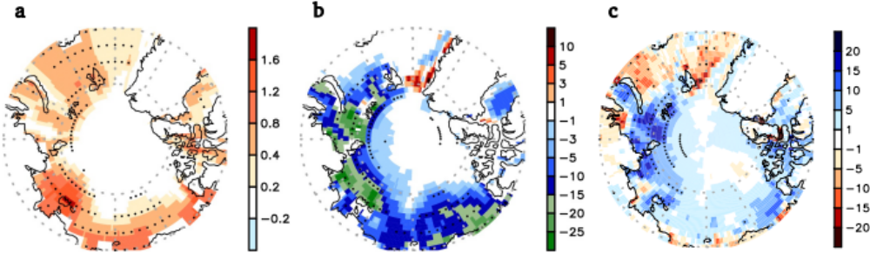

Fig. S1 | Linear trend of observed summer SST, SIC, and NSHF (2000-2020). a, Linear trend of summer (June to August, JJA) sea surface temperature (SST, °C decade⁻¹) for the period of 2000-2020. b, Same as (a), but for Arctic sea-ice concentration (SIC, % decade⁻¹). c, Same as (a), but for net surface heat flux (NSHF, W m⁻² decade⁻¹). Upward (Downward) fluxes are negative (positive). The stippled areas are statistically significant at a 95% confidence level for a two-tailed Student’s t-test.

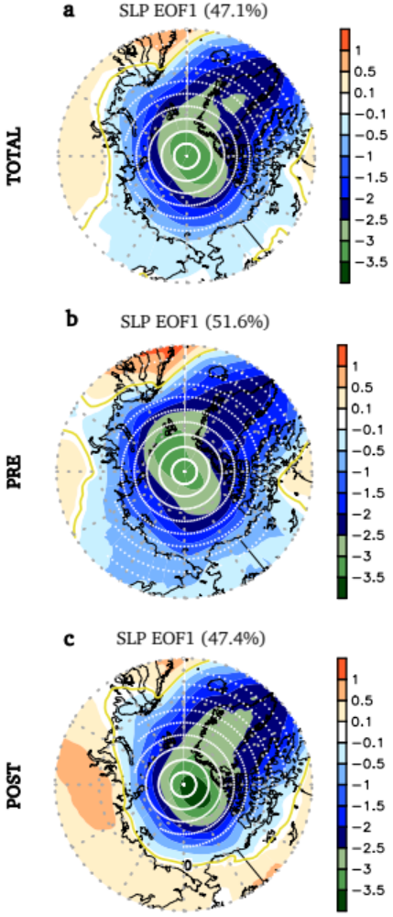

Fig. S2 | Arctic atmospheric 1st modes from EOF analysis using observed sea level pressure. a, Observed regression pattern of the detrended JJA sea level pressure (SLP, hPa) anomalies onto the standardized time series of the 1st mode of the EOF analysis of the detrended JJA SLP anomalies weighted by cosine latitude over the domain of 60°–90° N in the total period (1980-2020) b, Same as (a), but for the pre-2000s (1980-1999). c, Same as (a), but for the post-2000s (2000-2020). The stippled areas are statistically significant at a 95% confidence level for a two-tailed Student’s t-test. The explained variance by the EOF is indicated on top of each panel.

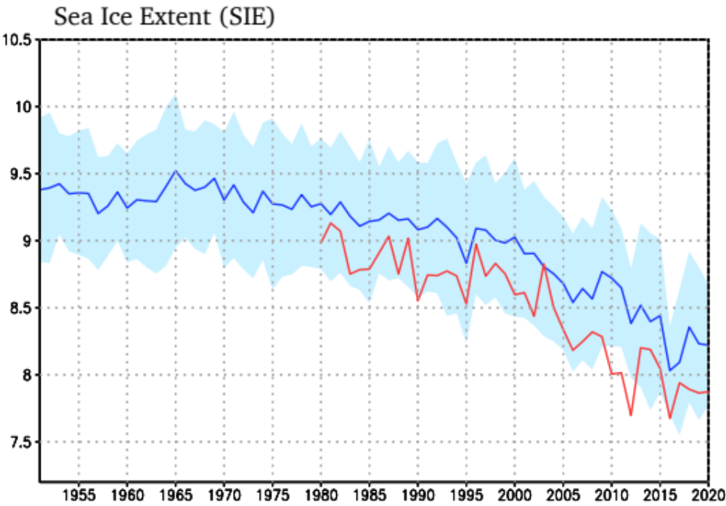

Fig. S3 | Time evolution of observed and simulated sea ice extent (SIE). Time series of JJA mean in observed (red line, 1980-2020) and simulated (blue line, 1951-2020) Arctic sea ice extents (SIE, 10⁶ km²). The blue line depicts the ensemble mean from the historical SST nudging GFDL simulations. The light blue shaded area indicates +/- 2 standard deviations between ensemble mean and members. The SIE means the integral sum of the areas of all grid cells with 15 percent or more sea ice concentration (SIC) in the domain, north of 70° N. Temporal correlation coefficient between observed and simulated SIEs (detrended SIEs) for 1980-2020 is 0.93 (0.56).

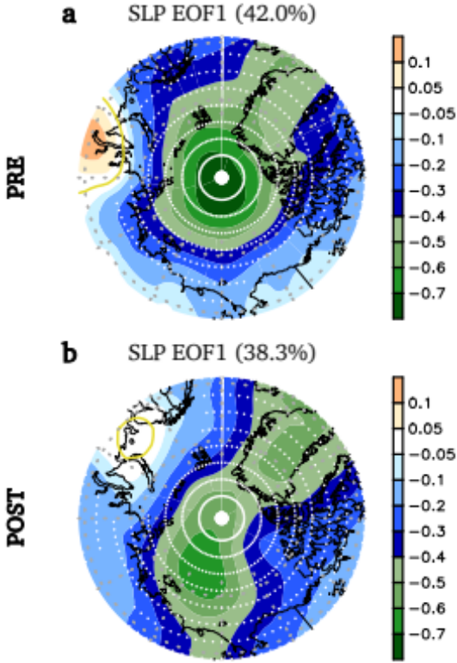

Fig. S4 | Arctic atmospheric 1st modes from EOF analysis using simulated sea level pressure. a, Simulated regression pattern of the detrended JJA sea level pressure (SLP, hPa) anomalies onto the standardized time series of the 1st mode of the EOF analysis of the detrended JJA SLP anomalies weighted by cosine latitude over the domain of 60°–90° N in the pre-2000s (1980-1999) b, Same as (a), but for the post-2000s (2000-2020). The stippled areas are statistically significant at a 95% confidence level for a two-tailed Student’s t-test. The explained variance by the EOF is indicated on top of each panel.

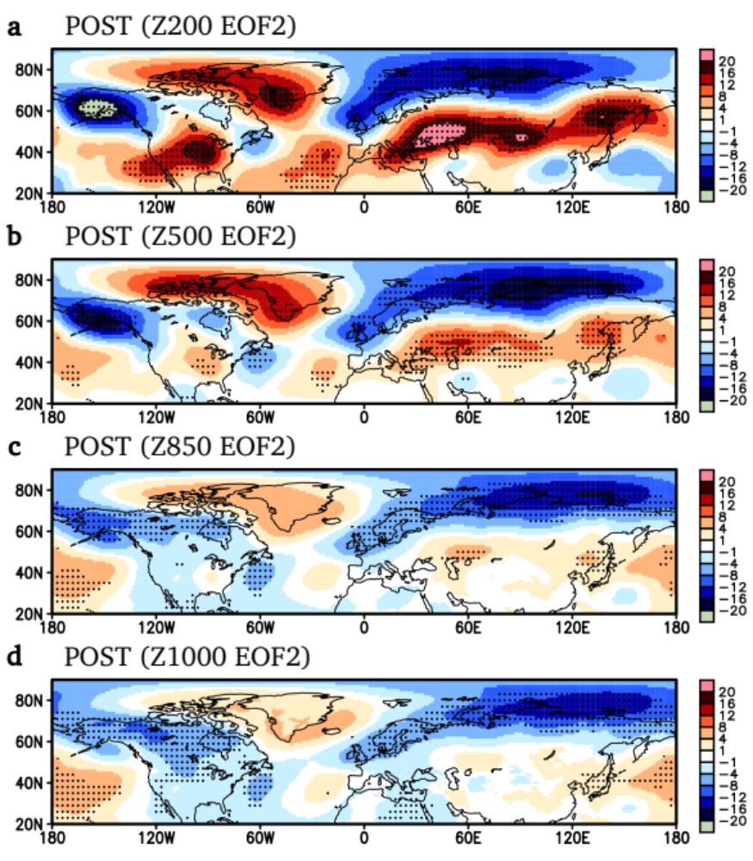
Fig. S5 | Vertical structures related to Arctic atmospheric 2nd EOF mode in post-2000s (2000-2020). a, Regression pattern of the detrended JJA 200 hPa geopotential height (m) anomalies onto the standardized time series of the 2nd mode of the EOF analysis of the detrended JJA SLP anomalies weighted by cosine latitude over the domain of 60°–90° N in the post-2000s (2000-2020). b, Same as (a), but for 500 hPa geopotential height. c, Same as (a), but for 850 hPa geopotential height. d, Same as (a), but for 1000 hPa geopotential height. The stippled areas are statistically significant at a 95% confidence level for a two-tailed Student’s t-test.

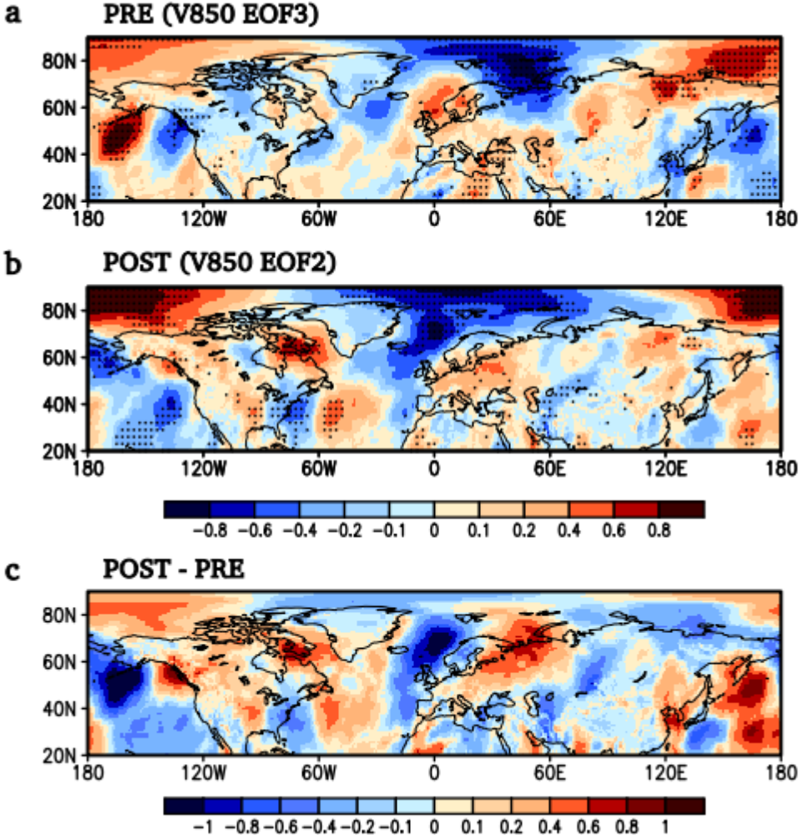

Fig. S6 | Meridional wind response to Arctic atmospheric modes for the pre-2000s (1980-1999) and post-2000s (2000-2020). a, Observed regression pattern of the detrended JJA 850 hPa meridional wind (V850, m s⁻¹) anomalies onto the standardized time series of the 3rd mode of the EOF analysis of the detrended JJA SLP anomalies weighted by cosine latitude over the domain of 60°–90° N in the pre-2000s (1980-1999). b, Same as (a), but for the 2nd mode of the EOF analysis in the post-2000s (2000-2020). c, The difference (m s⁻¹) in meridional wind between the post-2000s and pre-2000s. The stippled areas are statistically significant at a 95% confidence level for a two-tailed Student’s t-test.

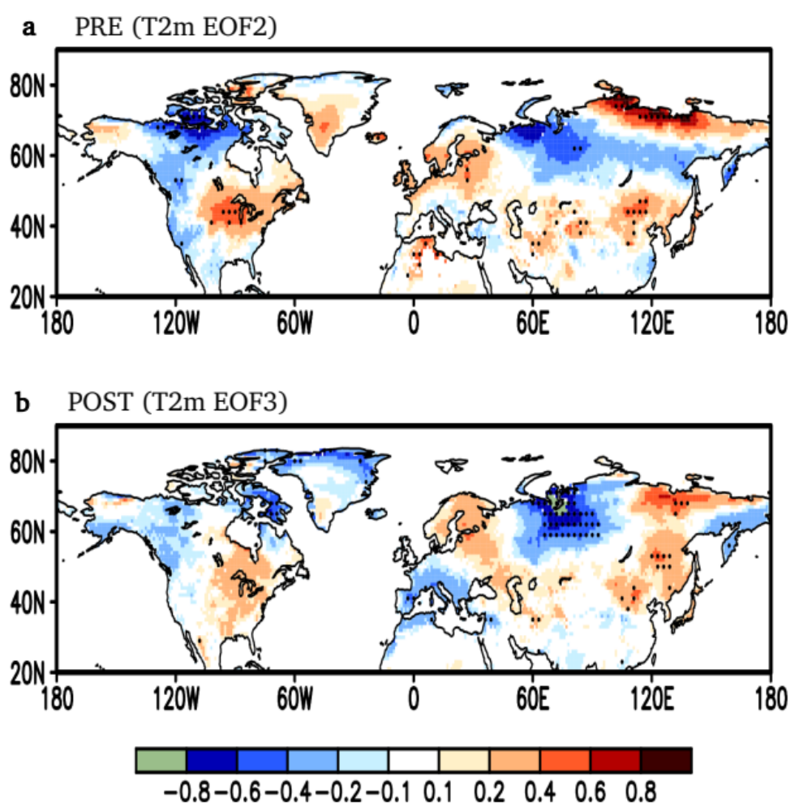

Fig. S7 | Temperature response to Arctic atmospheric modes for the pre-2000s (1980-1999) and post-2000s (2000-2020). a, Observed regression pattern of the detrended JJA 2m temperature (T2m, C°) anomalies onto the standardized time series of the 2nd mode of the EOF analysis of the detrended JJA SLP anomalies weighted by cosine latitude over the domain of 60°–90° N in the period of the pre-2000s (1980-1999). b, Same as (a), but for the 3rd mode of the EOF analysis in the period of the post-2000s (2000-2020). The stippled areas are statistically significant at a 95% confidence level for a two-tailed Student’s t-test.

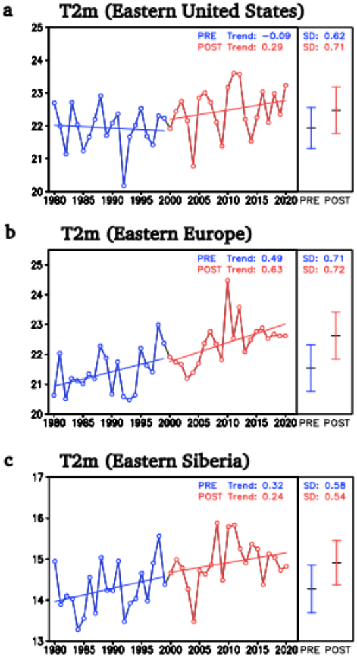

Fig. S8 | Historical change in temperature response to Arctic atmospheric modes. a, Temporal evolution (°C) and trend (°C decade⁻¹) of JJA T2m temperature area-averaged over Eastern United States (US, 30°–50° N, 110°–70° W, illustrated in Fig. 4b) in the pre-2000s (1980-1999) and post-2000s (2000-2020). The blue and red error bars depict the standard deviation (SD, °C), and the black center dashed marks represent the averages (°C) for the pre-2000s and post-2000s, respectively. Trend and SD values are displayed in the upper right corner. b, Same as (a), but for Eastern Europe (EEU, 40°–55° N, 20°–70° E). c, Same as (a), but for Eastern Siberia (ESB, 45°–70° N, 120°–155° E).

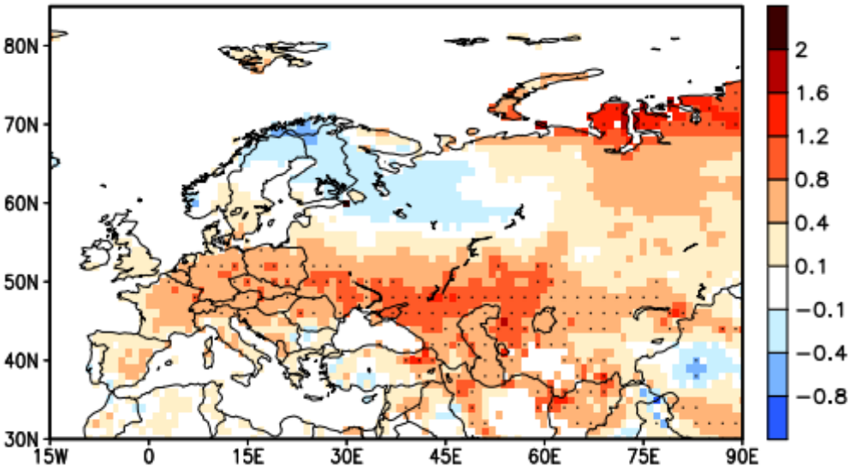

Fig. S9 | Trend of observed 2m temperature for the post-2000s (2000-2020). Trend pattern (°C decade⁻¹) of 2m temperature during the post-2000s (2000-2020). The stippled areas are statistically significant at a 95% confidence level for a two-tailed Student’s t-test.

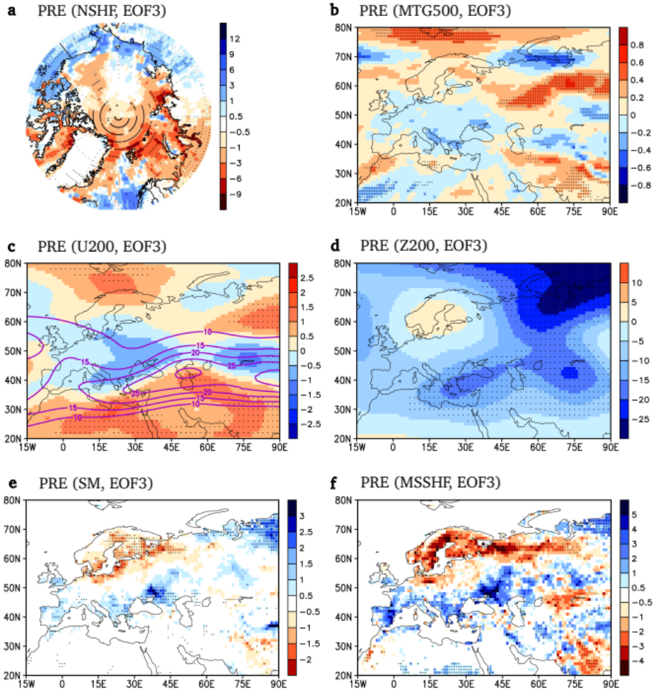
Fig. S10 | Responses related to Arctic atmospheric mode in the pre-2000s (1980-1999). a, Regression pattern of the detrended JJA mean net surface heat flux (NSHF, W m⁻²) anomalies onto the standardized time series of the 3rd mode of the EOF analysis of the detrended JJA SLP anomalies weighted by cosine latitude over the domain of 60°–90° N in the pre-2000s (1980-1999). Upward (surface to atmosphere) fluxes are negative. b, Same as (a), but for meridional temperature gradient at 500 hPa (MTG500, x10⁻⁶, °C m⁻¹). c, Same as (a), but for zonal wind at 200 hPa (U200, m s⁻¹). The purple contour is the climatological mean (m s⁻¹). d, Same as (a), but for geopotential height at 200 hPa (Z200, m). e, Same as (a), but for soil moisture (SM, x10⁻², m³ m⁻³). f, Same as (a), but for mean surface sensible heat flux (MSSHF, W m⁻²). Upward (surface to atmosphere) fluxes are negative. The stippled areas are statistically significant at a 90% confidence level for a two-tailed Student’s t-test.

