Supplementary Materials for

The Indian Plate subducting below the Tibet Plateau is tearing apart
Lin Liu*, Danian Shi, Simon L. Klemperer*
*Corresponding authors: Simon L. Klemperer; Lin Liu
Email: sklemp@stanford.edu; liulin1991@ouc.edu.cn

This PDF file includes:
Figs. S1 to S11

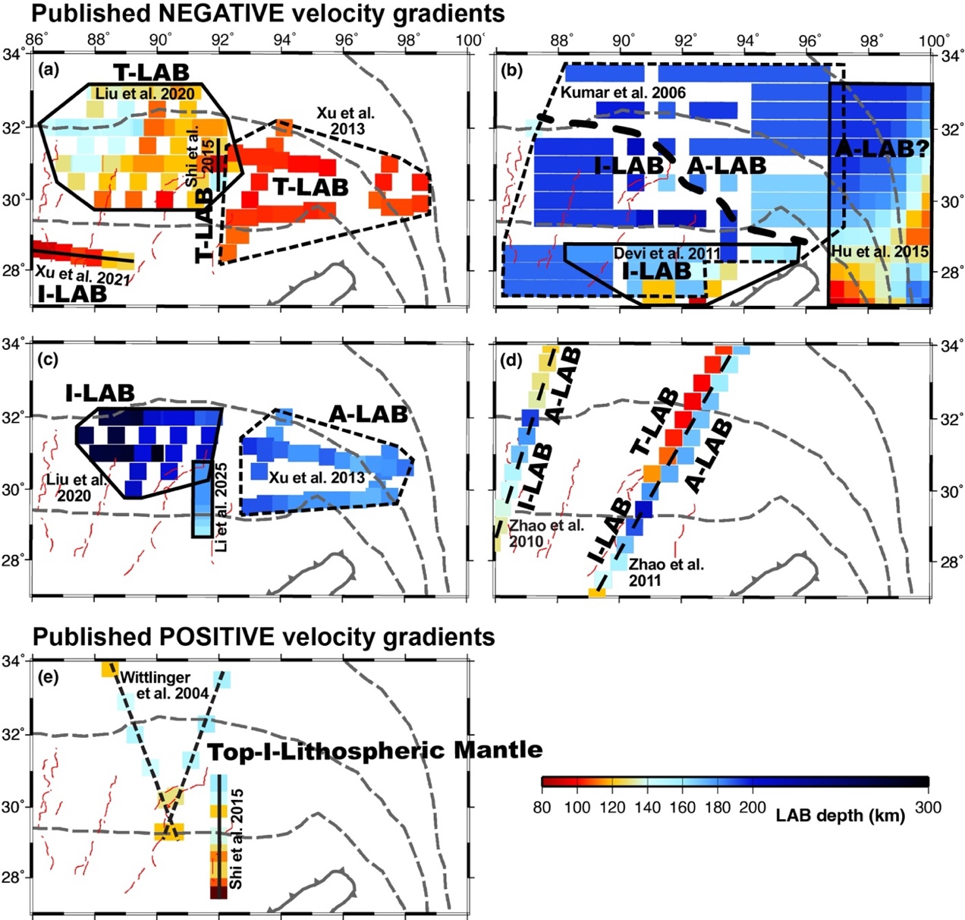
Fig. S1. (a-d) LAB depth (negative wavespeed gradient with depth) interpreted by previous SRF studies as Indian or Tibetan or Asian LAB (I-LAB or T-LAB or A-LAB). (a) Studies reporting LAB depths mostly <130 km. (b, c) Studies reporting LAB depths mostly >170 km; areal studies in (c) are the same as in (a). (d) Studies identifying multiple LABs on a single profile. Note conflicting results: in some locations picks differ by >50 km vertically in the same location, e.g. in the west-center of our study area compare interpretations of I-LAB at ~250 km (part c), ~200 km (part b), and ~150 km (part d). Note conflicting interpretations of the same converter, e.g. A-LAB (part c) spans both A-LAB and I-LAB (Part b); and the same interpretation of different converters, e.g. I-LAB (part a) cannot be the I-LAB (part b) because their depths differ by >100 km. Faults and suture zones as in Fig. 1a; area of figure matches Fig. 1. Maps are prepared from published studies ¹⁻¹⁰. (e) Depths to top of subducting Indian lithospheric mantle (positive wavespeed gradient with depth) interpreted by previous SRF studies, plotted with the same color-bar and all other symbols as Fig. S1a-d. Map is prepared from published studies ^{6, 11}.
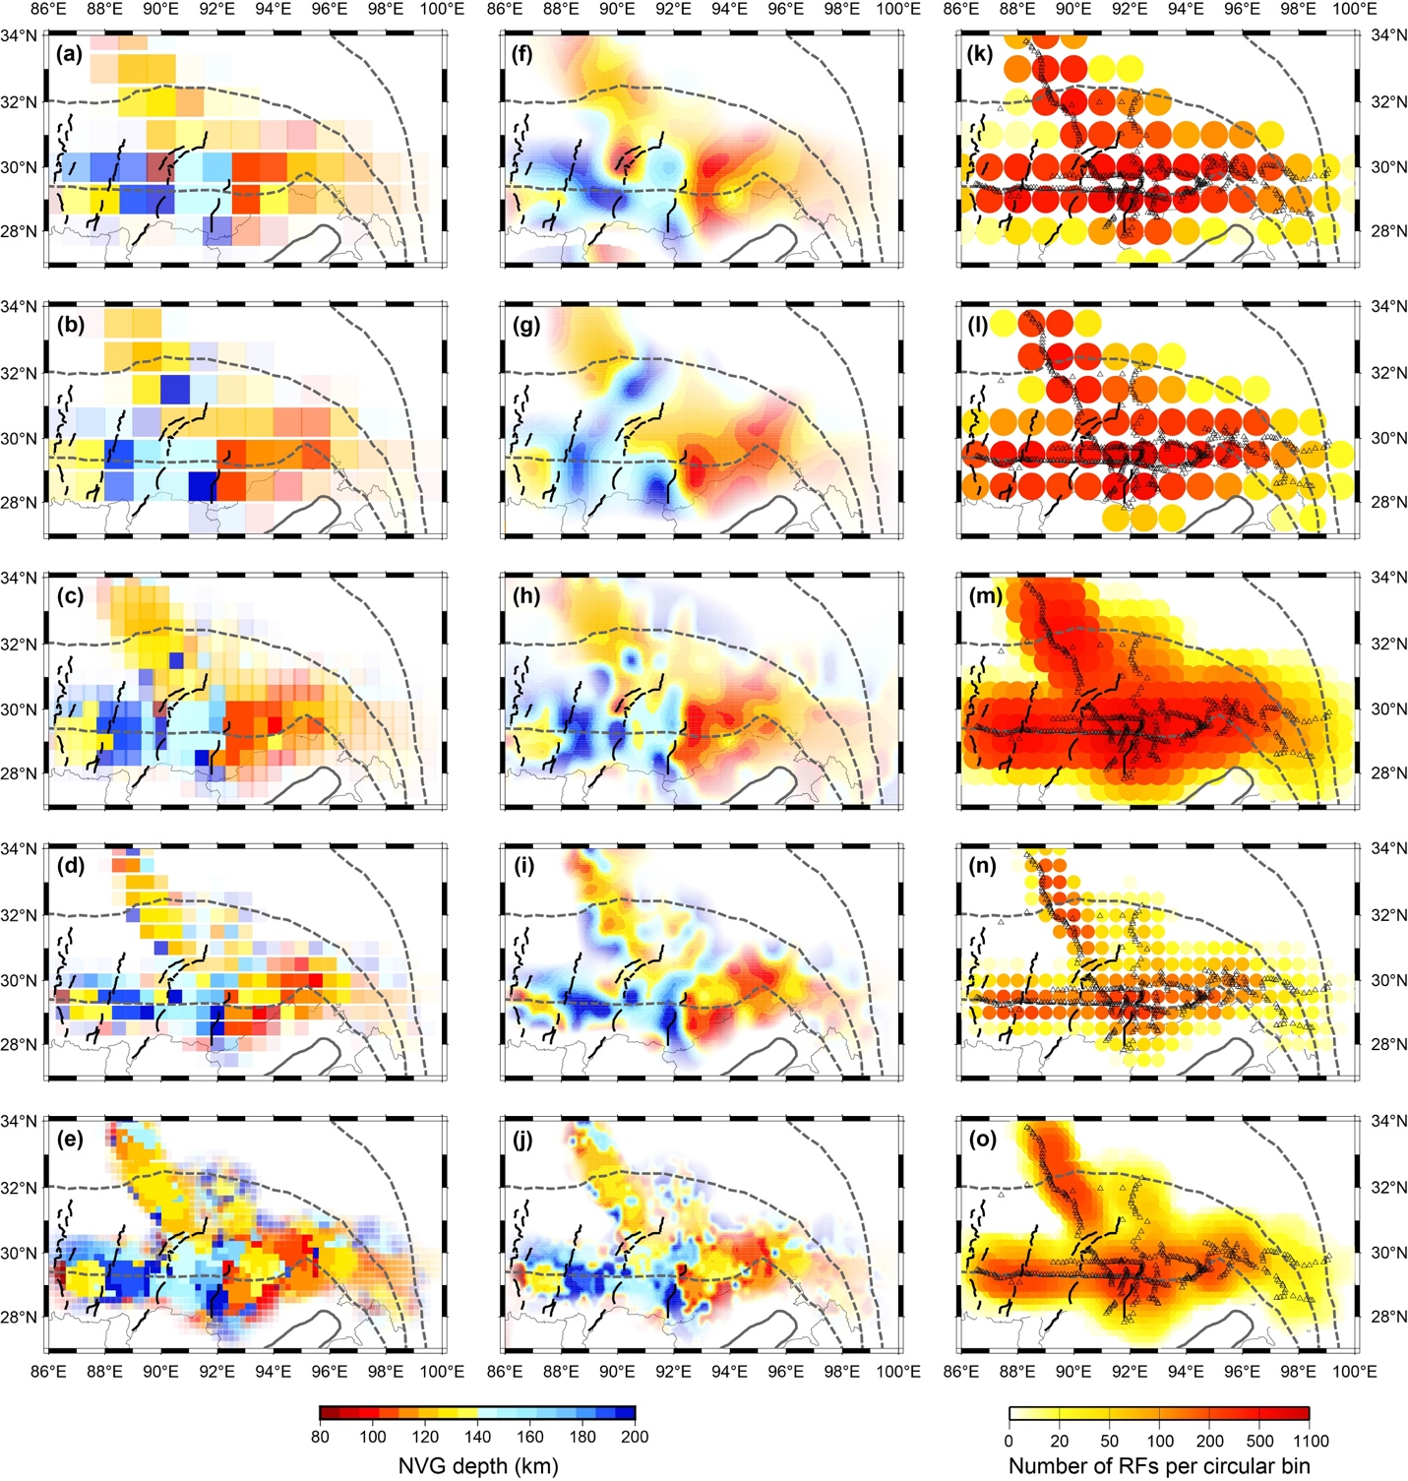
Fig. S2. Left column, a–e: Map of auto-picked negative-velocity gradient (NVG) depths determined using the IASP91 earth model for (a) 1°-radius circular bins spaced at 1°; (b) 1°-radius bins, with each bin center shifted 0.5° east relative to (a); (c) 1°-radius bins spaced at 0.5° (same as Fig. 2a); (d) 0.5°-radius bins spaced at 0.5° (same as Fig. 2f); (e) 0.5°-radius bins spaced at 0.2°. Middle column, f–j: Same as a–e, but map of NVG depths is smoothed. Although there is considerable variability between the maps, in every case the southwest region trends blue, the northeast region trends red. Right column, k–o: Number of SRFs per circular bin, overlain by seismic stations (black triangles) used in our study. In left and middle columns, intensity of color is proportional to the number of SRFs averaged in each bin.
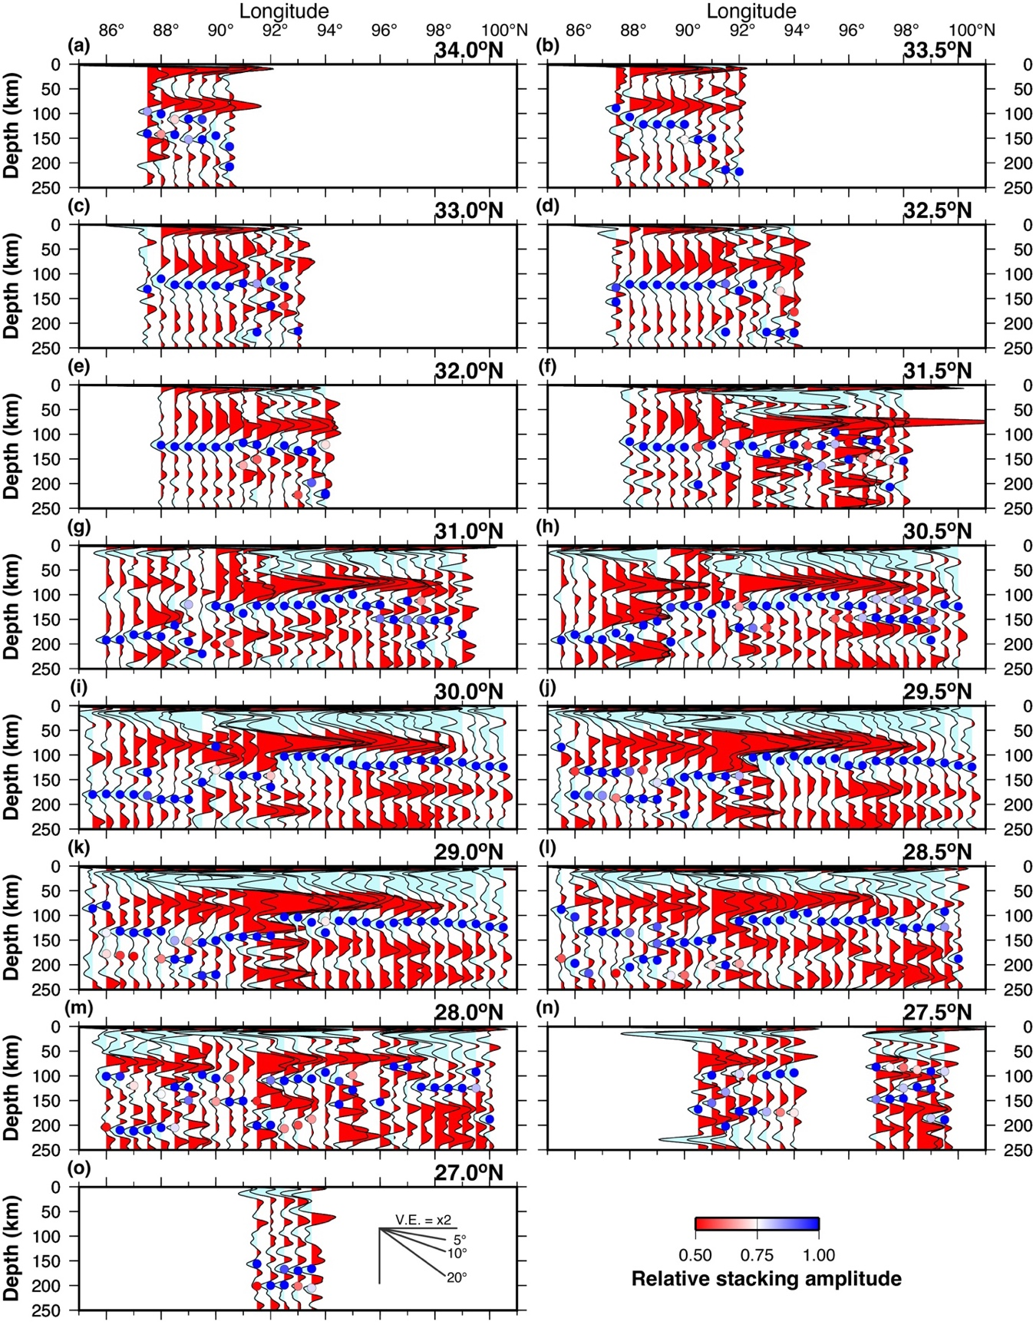
Fig. S3. (a–o) Record sections across Fig. 2a (1° bins) plotted along 15 latitudinal profiles, to show second and third largest NVGs on each trace whenever these have amplitudes >50% of the largest NVG. Each SRF trace is normalized to the largest NVG amplitude (= 1.0, dark blue), and all other negative trace excursions with amplitudes > 0.5 are also picked, and colored according to their relative amplitudes.
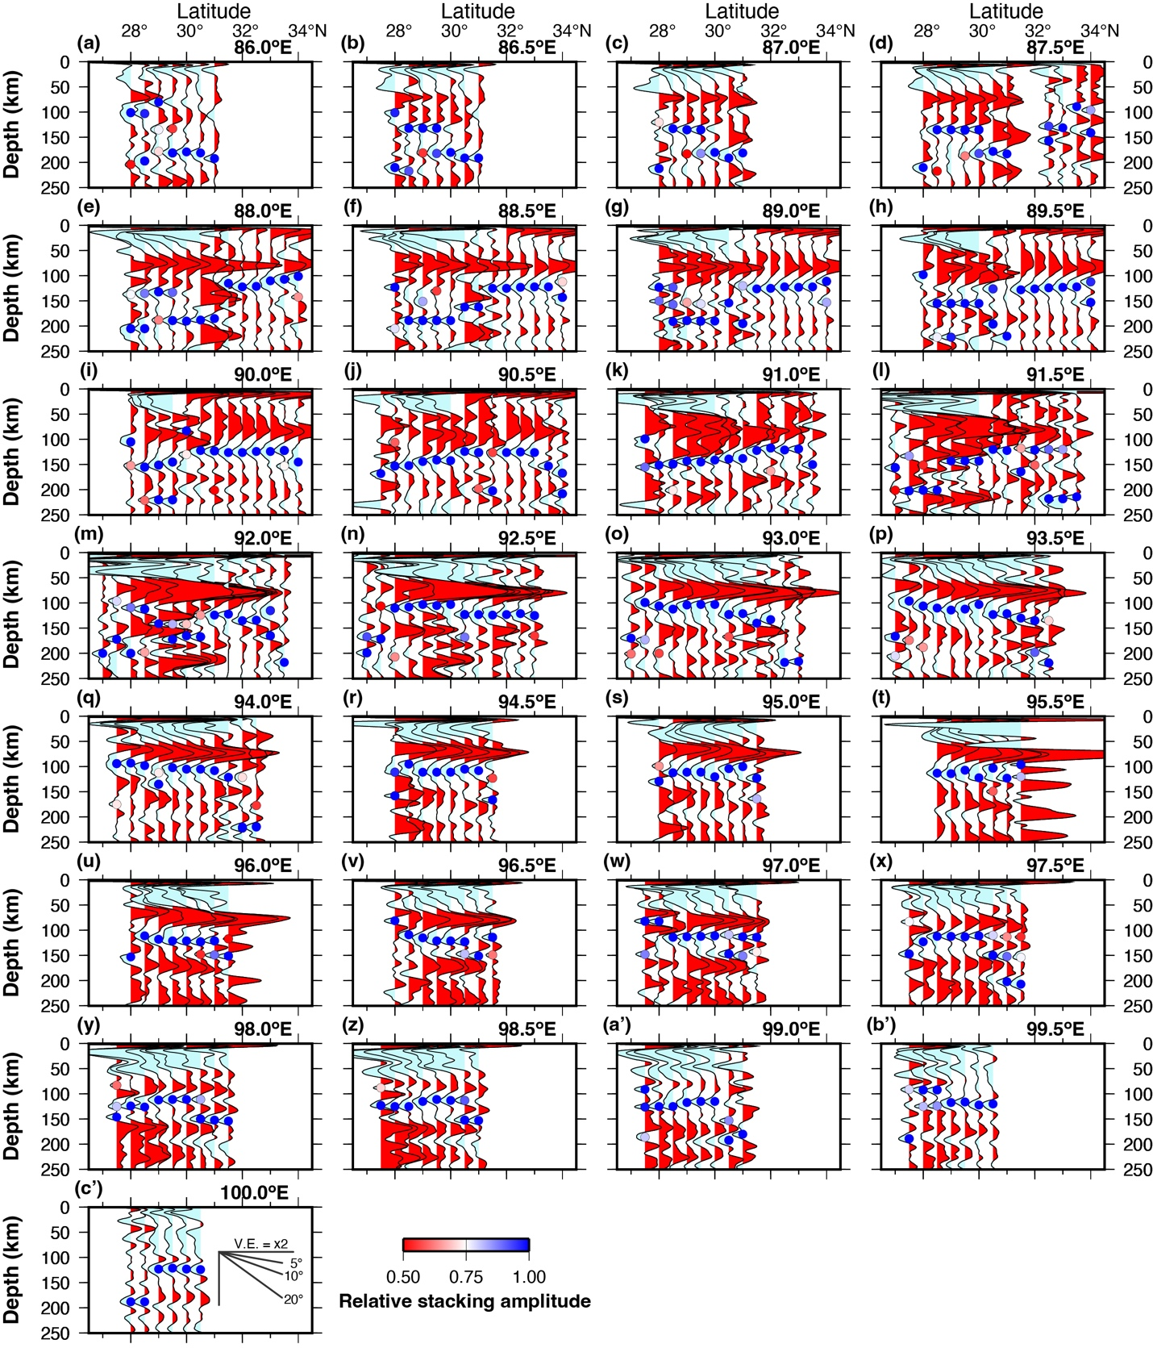

Fig. S4. (a–c’) Record sections across Fig. 2a (1° bins) plotted along 29 longitudinal profiles, with weaker NVGs also auto-picked and labelled as in Fig. S3.
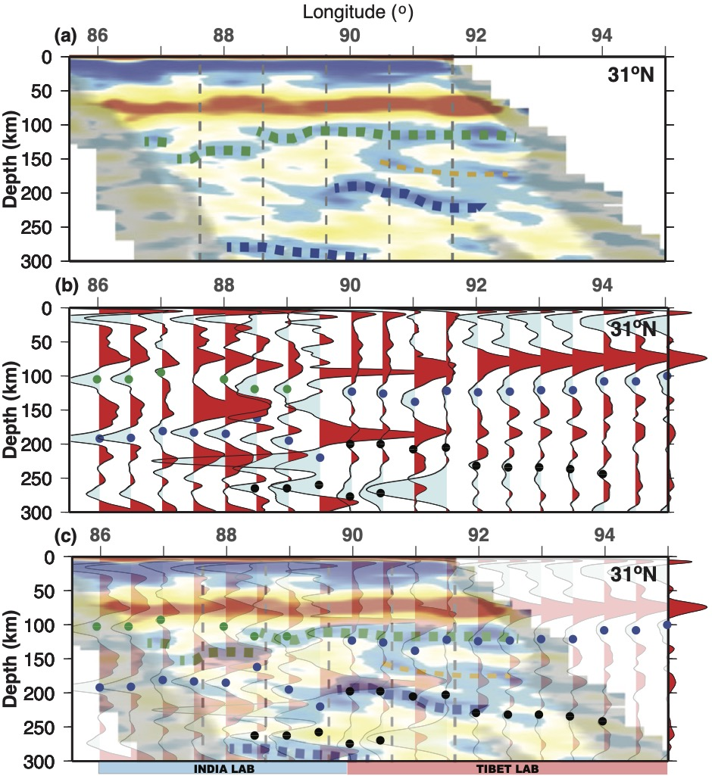

Fig. S5. Comparison of SRF images from ref. 5 and this paper along 31°N, using non-overlapping seismic datasets (no data are in common between these two studies; data used by ref. 5 from the “SANDWICH” and “31N” arrays were not available to us). (a) SRF image along 31°N (ref. 5, their figure 2d) shows their subjective interpretation of different negative polarity phases, as many as three on a single trace, and no indication of why some negative polarities are interpreted and others ignored: “The dark green dashed lines indicate the Tibetan LAB, the blue dashed lines indicate the Indian LAB, and the thin orange dashed lines indicate an uncertain discontinuity. The CCP images were smoothed with a bin of 20 km along the profiles, 1 km in vertical dimension and 70 km in width.” In the CCP images, “regions with stacked numbers of SRFs larger than 100 were highlighted” ⁵. (b) Our equivalent profile (Fig. 2d). As in Fig. S1, the largest negative amplitude on each trace from 80–220 km is highlighted with a blue dot, and other strong negative amplitudes possibly correlative with interpretations in (a) are highlighted with green and black dots. (c) The two sections are overlain to show the very close correspondence between picked negative phases, even though no seismic data are in common between the two sections.
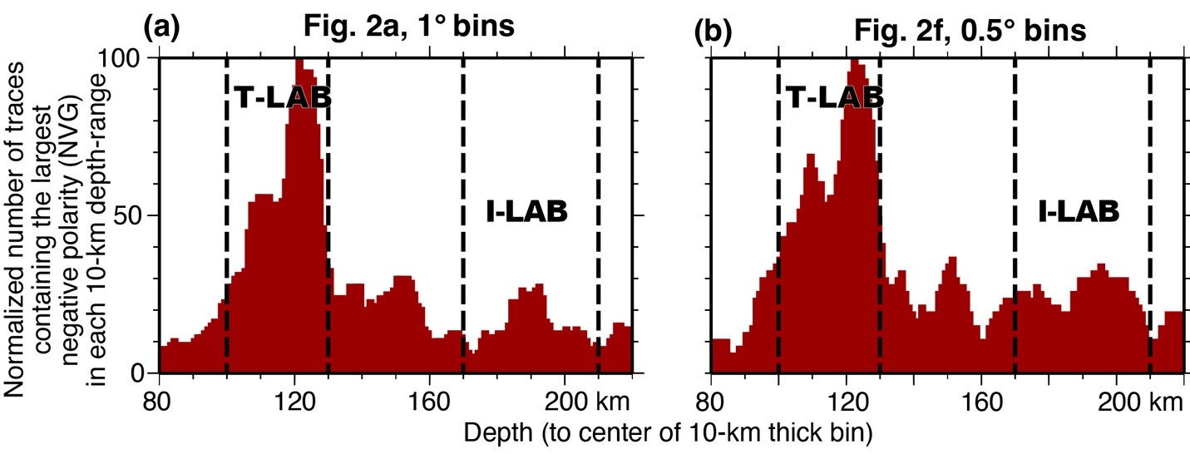

Fig. S6. Histogram of relative abundance of highest-amplitude negative converters in each 10-km depth range, measured in bins successively offset by 1 km, for (a) Fig. 2a (1° bins) and (b) Fig. 2f (0.5° bins). Large peak at 100–130 km depth represents T-LAB; a much weaker mode at 170–210 km depth corresponds to I-LAB. The weaker I-LAB mode is consistent with the global observation that cratonic LAB is lower-amplitude and more diffuse, spanning a greater depth range, than Phanerozoic LAB that is higher-amplitude and a more rapid transition in depth ^{12,13}.

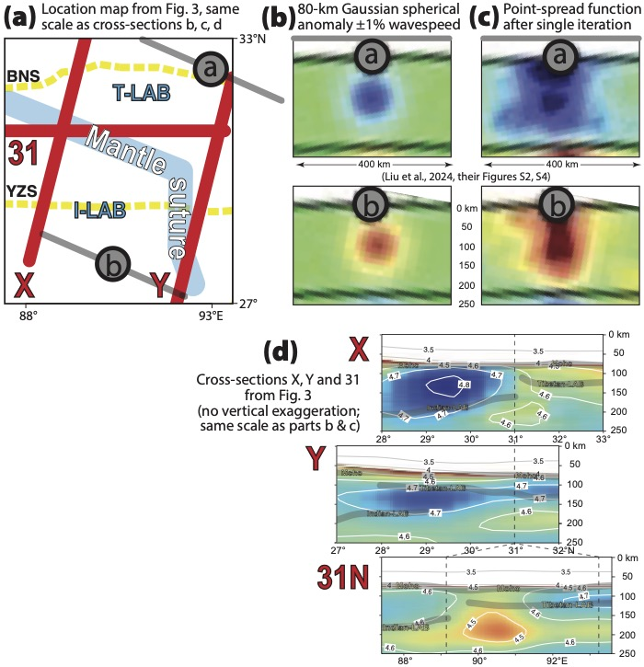
Fig. S7. Point-spread function tests (resolution tests) for the S-wave model shown in Fig. 4b. Map and all cross-sections are at the same scale, and true scale (no vertical exaggeration). (a) Inset map as in Fig. 3 showing location of Gaussian velocity anomalies a and b with a peak value of ±1% and a 40-km half-width. Grey lines are 400-km long. (b) Input velocity anomalies, at same horizontal scale (ref. 14, their Supplementary Figure S2). (c) Point-spread functions calculated for the S-wave velocity anomalies, shown after a single iteration due to computational costs, so likely a conservative estimate of true model resolution (ref. 14, their Figure S4). (d) Cross-sections X, Y and 31°N exactly as in Fig. 3, at same scale as resolution tests, plotted from the final ref. 14 tomography after multiple iterations. The vertical smearing of the point-spread functions (c) shows that the velocity anomalies in the tomography may represent smeared versions of the Moho and LABs more-precisely imaged by the SRFs.
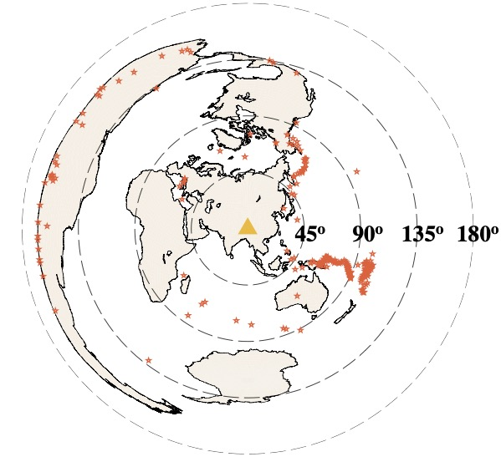

Fig. S8. Azimuthal-equidistant projection map showing the center of the study area (triangle) and distribution of 244 events used in the SRF study. Each star corresponds to an earthquake from which an SRF measurement was made at one or more of the 462 stations we analyzed.

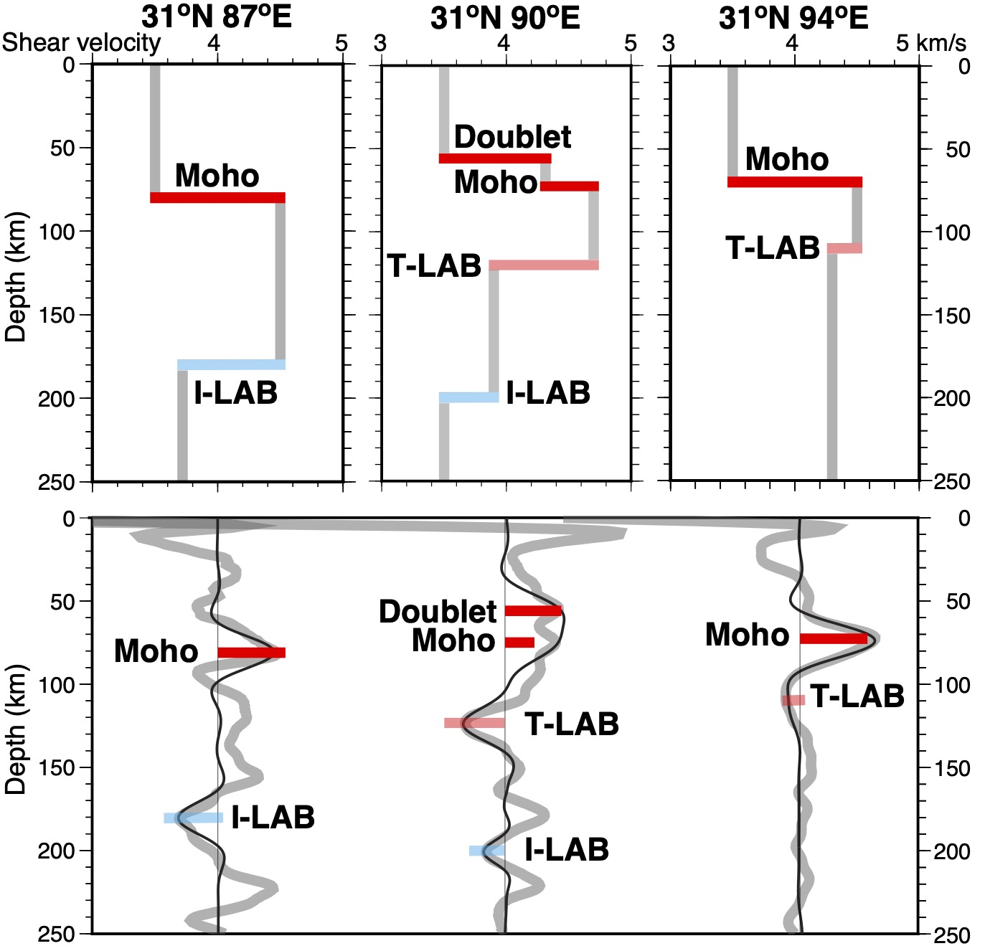

Fig. S9. Waveform forward modelling.
Top row: 1D velocity models used to compute theoretical seismograms at three different locations: Solid red bars: Moho, or Doublet and Moho, transparent cyan: Indian LAB (I-LAB), transparent red: Tibetan LAB (T-LAB). Velocity jumps at the Moho and LAB are based on observed amplitudes and depths at locations 31°N–87°E, 31°N–90°E and 31°N–94°E (Fig. 2c).
Bottom row: Observed SRFs (thick grey lines) and waveforms computed using a Butterworth four-second low-pass four-pole filter (black line). Only for the thinnest, lowest-impedance-contrast T-LAB is there a possibility of confusion of a Moho side-lobe with the LAB converter (31°N–94°E), and for those traces the large variability in amplitude ratio of NVG/Moho is evidence against the highest-amplitude NVG being only a Moho side-lobe.
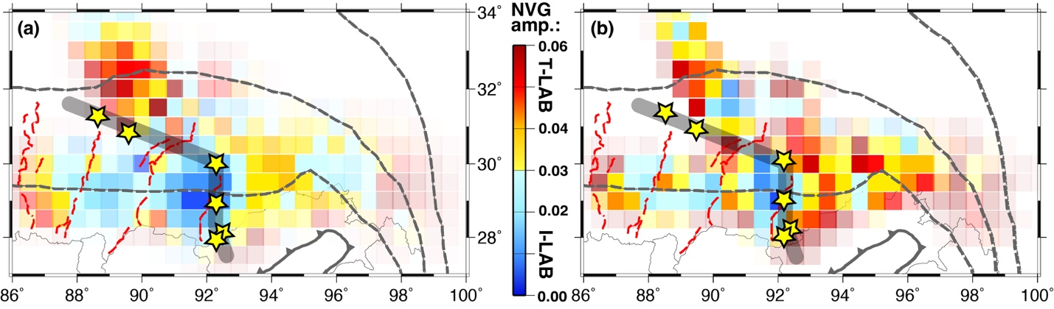

Fig. S10. Maps and record sections of amplitude of auto-picked largest NVG on SRFs stacked in (a) 1° and (b) 0.5° radius bins. Maps: Color scale: summed amplitude of all NVGs in each bin, scaled by N^{0.6} where N is the number of SRFs in that bin (NRF: Fig. S2m and n) and opacity is proportional to number of SRFs per bin (fully transparent if < 3 SRFs in a bin). Appropriate scaling is by N if each trace has high signal-to-noise (S/N) ratio (S>>N), and N^{0.5} if each component trace has very low S/N (S<<N). We used an intermediate value. Yellow stars and grey line mark locations of SRF boundary as in Figs. 2a,f. As expected, because amplitude is always harder to measure than travel-time, the pattern is not as clear as for the depth-to-LAB plots (Fig. S2, S11, etc.), but all the highest maximum amplitudes are in the shallow-NVG region (T-LAB) and all the weakest maximum amplitudes are in the deep-NVG region (I-LAB).
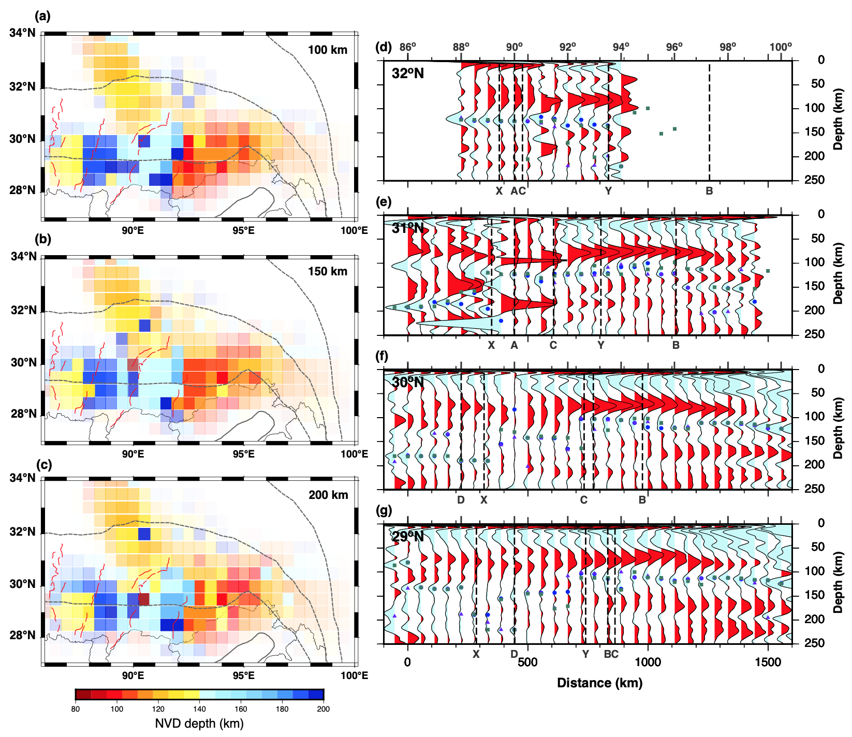

Fig. S11. (a-c) Maps of depth to auto-picked largest NVG on SRFs stacked in 1° radius bins (as in Fig. 2a) using different ray-piercing point depths of 100 km, 150 km and 200 km, respectively (Fig. S11b is identical to Fig. 2a). (d-g) Record sections in 1° radius bins calculated for 150-km-depth piercing points plotted along 32°, 31°, 30° and 29°N (same record sections as Fig. 2b–e), overlain by auto-picks of largest NVG from equivalent sections calculated using piercing-point depths of 100 km (purple triangles), 150 km (blue circles, as in Fig. 2b–e), and 200 km (green squares). Some green squares (200-km piercing points) appear at locations east of the traces calculated using 150-km piercing points, because deeper piercing points are further away from the recording station.

Supplementary References
1 Devi, E. U., Kumar, P. & Kumar, M. R. Imaging the Indian lithosphere beneath the Eastern Himalayan region. Geophys. J. Int. 187, 631-641, doi:https://doi.org/10.1111/j.1365-246X.2011.05185.x (2011).
2 Hu, J., Yang, H., Li, G. & Peng, H. Seismic upper mantle discontinuities beneath Southeast Tibet and geodynamic implications. Gondwana Res. 28, 1032-1047, doi:https://doi.org/10.1016/j.gr.2014.08.016 (2015).
3 Kumar, P., Yuan, X., Kind, R. & Ni, J. Imaging the colliding Indian and Asian lithospheric plates beneath Tibet. J. Geophys. Res.: Solid Earth 111, doi:https://doi.org/10.1029/2005jb003930 (2006).
4 Li, Z., Tian, Y., Zhao, D. & Feng, X. Role of Crust‐Mantle Detachment and Slab Delamination in the Plateau Uplift and Crustal Thickening Process in Southern Tibet. J. Geophys. Res.: Solid Earth 130, doi:https://doi.org/10.1029/2024jb029815 (2025).
5 Liu, Z. et al. Complex structure of upper mantle beneath the Yadong-Gulu rift in Tibet revealed by S-to-P converted waves. Earth Planet. Sci. Lett. 531, 115954, doi:https://doi.org/10.1016/j.epsl.2019.115954 (2020).
6 Shi, D. et al. Receiver function imaging of crustal suture, steep subduction, and mantle wedge in the eastern India–Tibet continental collision zone. Earth Planet. Sci. Lett. 414, 6-15, doi:https://doi.org/10.1016/j.epsl.2014.12.055 (2015).
7 Xu, Q., Zhao, J., Pei, S. & Liu, H. Imaging lithospheric structure of the eastern Himalayan syntaxis: New insights from receiver function analysis. J. Geophys. Res.: Solid Earth 118, 2323-2332, doi:https://doi.org/10.1002/jgrb.50162 (2013).
8 Xu, Q., Liu, H., Yuan, X., Zhao, J. & Pei, S. Eastward dipping style of the underthrusting Indian lithosphere beneath the Tethyan Himalaya illuminated by P and S receiver functions. J. Geophys. Res.: Solid Earth 126, e2020JB021219, doi:https://doi.org/10.1029/2020JB021219 (2021).
9 Zhao, J. et al. The boundary between the Indian and Asian tectonic plates below Tibet. Proceedings of the National Academy of Sciences of the United States of America 107, 11229-11233, doi:https://doi.org/10.1073/pnas.1001921107 (2010).
10 Zhao, W. et al. Tibetan plate overriding the Asian plate in central and northern Tibet. Nature Geoscience 4, 870-873 (2011).
11 Wittlinger, G., Farra, V. & Vergne, J. Lithospheric and upper mantle stratifications beneath Tibet: New insights from Sp conversions. Geophys. Res. Lett. 31, L19615, doi:https://doi.org/10.1029/2004GL020955 (2004).
12 Rychert, C. A., Harmon, N., Constable, S. & Wang, S. The Nature of the Lithosphere-Asthenosphere Boundary. J. Geophys. Res.: Solid Earth 125, e2018JB016463, doi:https://doi.org/10.1029/2018JB016463 (2020).
13 Liu, L., Klemperer, S. & Blanchette, A. Western Gondwana imaged by S receiver-functions (SRF): new results on Moho, MLD (mid-lithospheric discontinuity) and LAB (lithosphere-asthenosphere boundary). Gondwana Res. 96, 206-218, doi:https://doi.org/10.1016/j.gr.2021.04.009 (2021).
14 Liu, C. et al. A high-resolution seismic velocity model for East Asia using full-waveform tomography: Constraints on India-Asia collisional tectonics. Earth Planet. Sci. Lett. 639, doi:https://doi.org/10.1016/j.epsl.2024.118764 (2024).

