Concurrent atmospheric heatwaves intensify marine heatwaves through air-sea heat flux change in the Mediterranean Sea

Supplementary material
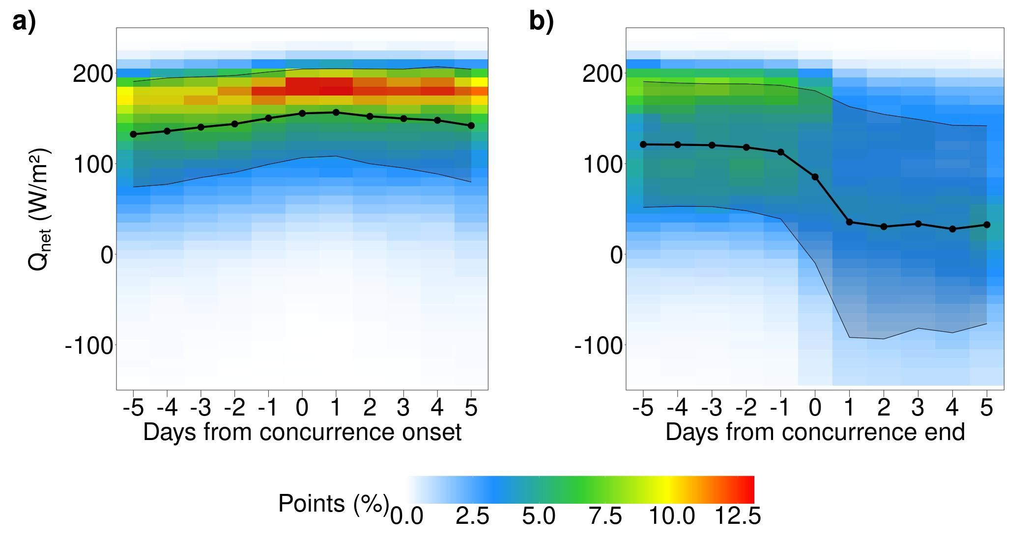
Figure S1. Qnet flux on concurrent AHW-MHW points at the transitions between concurrent days and before/after-concurrence phases. Qnet flux (W/m²) around a) the concurrence onset (from the five prior days to concurrence onset to the first five concurrent days) and b) the concurrence end (from the five last concurrent days and the five days after concurrence end) on concurrent points of concurrent AHW-MHWs from May to September 1940 to 2022. The coloured area represents the daily probability distribution of the Qnet flux (percentage of concurrent MHW points with a given Qnet flux). The dotted black line shows the daily mean, and the shadowed area between thin black lines depicts the daily standard deviation.

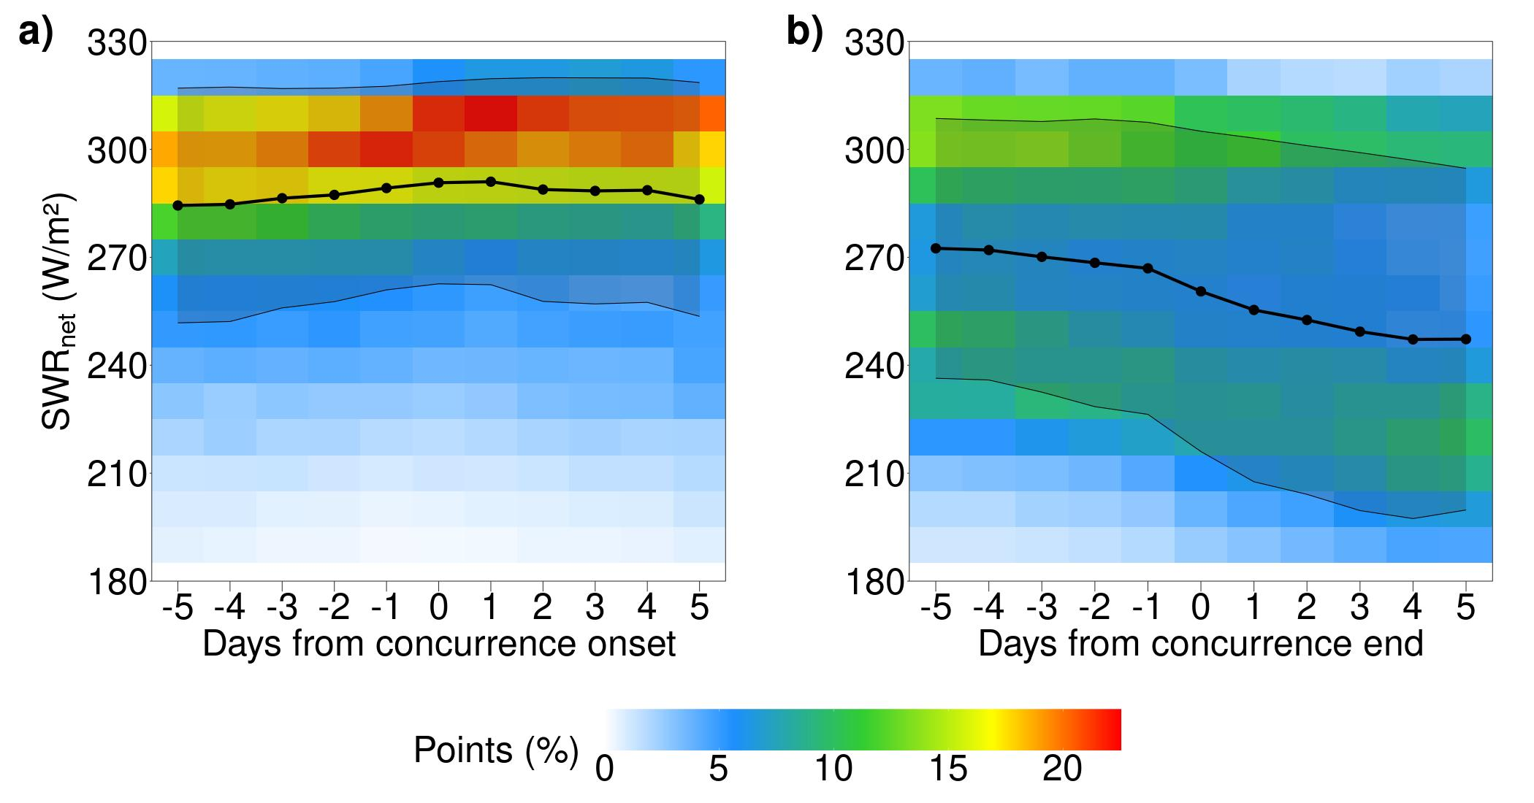

Figure S2. SWRnet flux on concurrent AHW-MHW points at the transitions between concurrent days and before/after-concurrence phases. SWRnet flux (W/m²) around a) the concurrence onset (from the five prior days to concurrence onset to the first five concurrent days) and b) the concurrence end (from the five last concurrent days and the five days after concurrence end) on concurrent points of concurrent AHW-MHWs from May to September 1940 to 2022. The coloured area represents the daily probability distribution of the SWRnet flux (percentage of concurrent MHW points with a given SWRnet flux). The dotted black line shows the daily mean, and the shadowed area between thin black lines depicts the daily standard deviation.

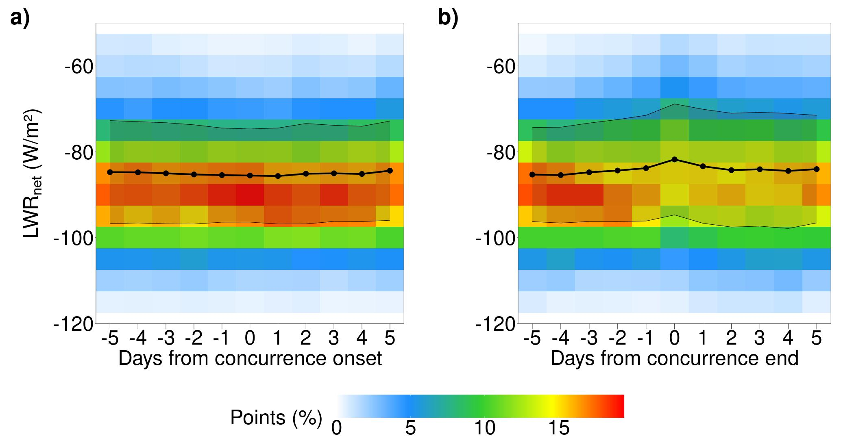

Figure S3. LWRnet flux on concurrent AHW-MHW points at the transitions between concurrent days and before/after-concurrence phases. LWRnet flux (W/m²) around a) the concurrence onset (from the five prior days to concurrence onset to the first five concurrent days) and b) the concurrence end (from the five last concurrent days and the five days after concurrence end) on concurrent points of concurrent AHW-MHWs from May to September 1940 to 2022. The coloured area represents the daily probability distribution of the LWRnet flux (percentage of concurrent MHW points with a given LWRnet flux). The dotted black line shows the daily mean, and the shadowed area between thin black lines depicts the daily standard deviation.

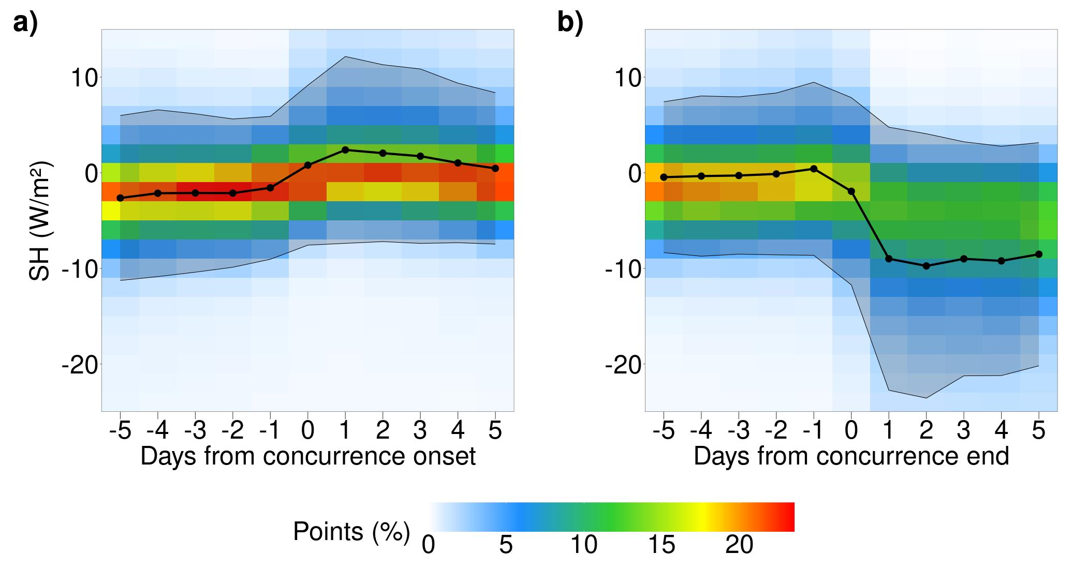
Figure S4. SH flux on concurrent AHW-MHW points at the transitions between concurrent days and before/after-concurrence phases. SH flux (W/m²) around a) the concurrence onset (from the five prior days to concurrence onset to the first five concurrent days) and b) the concurrence end (from the five last concurrent days and the five days after concurrence end) on concurrent points of concurrent AHW-MHWs from May to September 1940 to 2022. The coloured area represents the daily probability distribution of the SH flux (percentage of concurrent MHW points with a given SH flux). The dotted black line shows the daily mean, and the shadowed area between thin black lines depicts the daily standard deviation.

