Supplementary Information for

Dinosaur extinction can explain continental facies shifts at the Cretaceous-Paleogene boundary

Lucas N. Weaver*^{1,2}, Thomas S. Tobin^{3,4}, Courtney J. Sprain⁵, Paige K. Wilson Deibel⁶, Vera A. Korasidis⁷, Mónica R. Carvalho^{1,2}, Pim Kaskes⁸, and Isabel M. Fendley⁹

¹Museum of Paleontology, University of Michigan, Ann Arbor, MI 48109, USA; ²Department of Earth and Environmental Sciences, University of Michigan, Ann Arbor, MI 48109, USA; ³Department of Geological Sciences, University of Alabama, Tuscaloosa, AL 35487, USA; ⁴Alabama Museum of Natural History, Tuscaloosa, Alabama 35487, USA; ⁵Department of Geological Sciences, University of Florida, Gainesville, FL 32611, USA; ⁶Burke Museum of Natural History and Culture, Seattle, WA 98195, USA; ⁷School of Geography, Earth and Atmospheric Sciences, University of Melbourne, Victoria 3010, Australia; ⁸Archaeology, Environmental Changes & Geo-Chemistry, Vrije Universiteit Brussel, Pleinlaan 2, 1050 Brussels, Belgium; ⁹Department of Geosciences, Pennsylvania State University, University Park, PA 16802, USA

*Corresponding author: lukeweav@umich.edu

Table of Contents:
Supplementary Figures, pg. 2–7
Supplementary Figure 1, pg. 2
Supplementary Figure 2, pg. 3
Supplementary Figure 3, pg. 4
Supplementary Figure 4, pg. 5
Supplementary Figure 5, pg. 6–7
Supplementary Discussion, pg. 7–19
Acknowledgments, pg. 7
Continental K-Pg boundary sections outside of the Western Interior of North America, pgs. 8–9
Facies changes at the KPB in the Bighorn Basin, pgs. 9–10
Stratigraphic precision of KPB markers in continental settings, pgs. 10–11
All impact-identified KPBs are consistent with a facies shift, pgs. 11–15
Alternative hypotheses to explain the KPB facies shift, pgs. 15–18
Expected and observed patterns of extinction and floristic turnover across the KPB, pgs. 18–19
References, pg. 19–28
Supplementary Tables, pg. 28–31
Supplementary Table 1, pg. 28–30
Supplementary Table 2, pg. 30–31

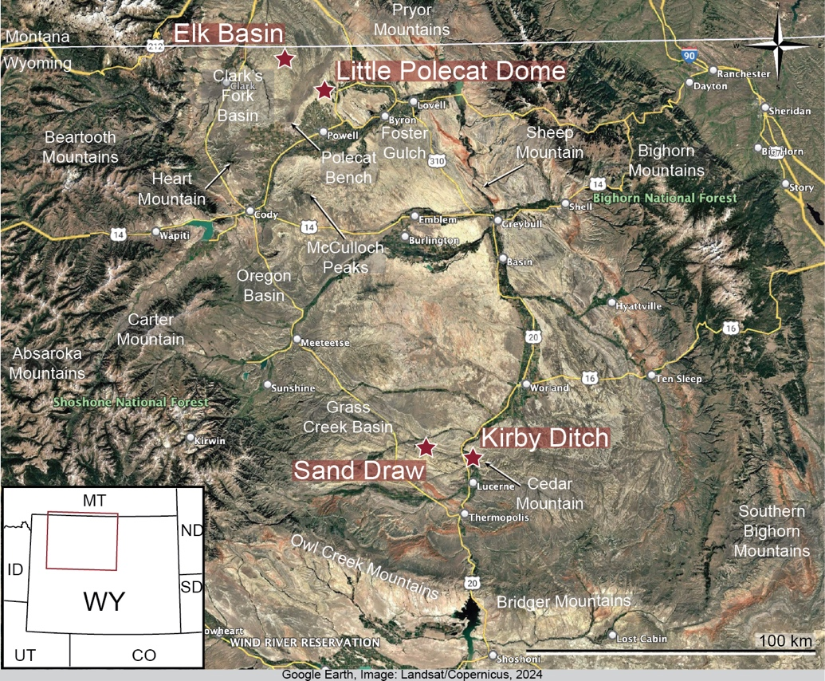

Supplementary Figure 1. Map of the Bighorn Basin, Wyoming, showing locations of the new KPB sections reported here in relation to well-known landscape features^{52,53}. Satellite image taken from Google Earth.

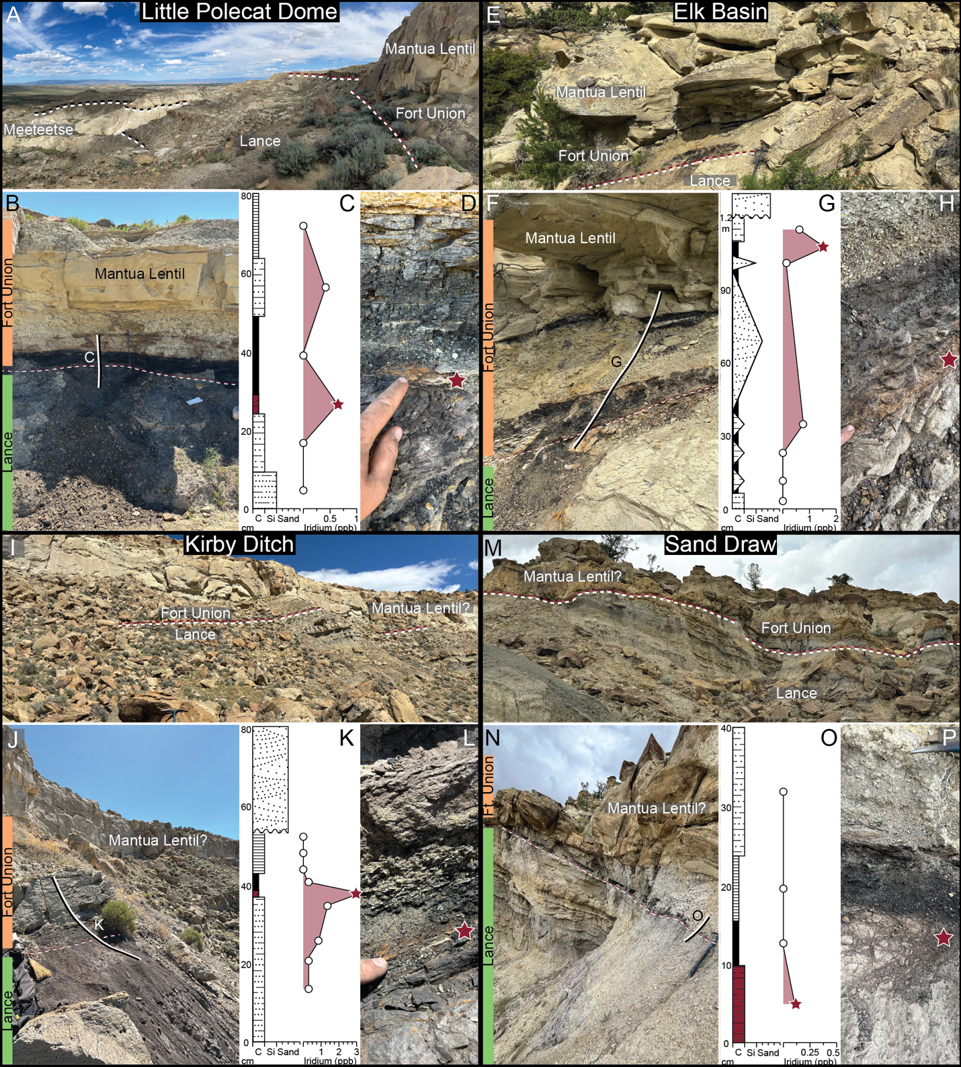

Supplementary Figure 2. New KPB sections from the Bighorn Basin, Wyoming. Zoomed-out views, close-ups of the sampling sections, stratigraphic logs and iridium concentrations, and zoomed-in views of the lithologies that produced the highest positive iridium anomalies for Little Polecat Dome (A–D), Elk Basin (E–H), Kirby Ditch (I–L) and Sand Draw (M–P).

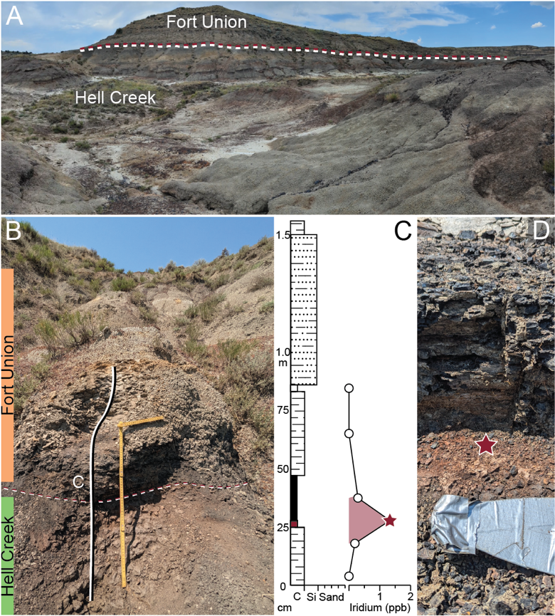

Supplementary Figure 3. New KPB section from Mill Iron near Ekalaka, Montana. Zoomed-out view (A), close-ups of the sampling sections (B), stratigraphic logs and iridium concentrations (C), and zoomed-in views of the lithologies that produced the highest positive iridium anomalies (D).

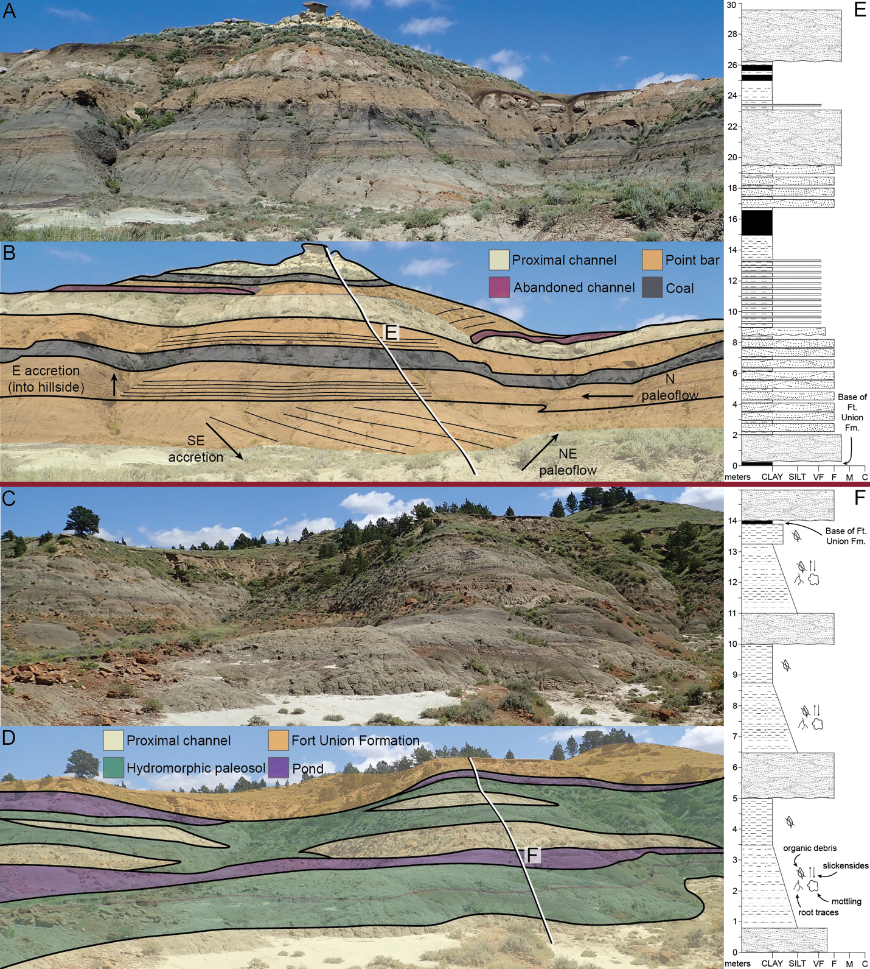

Supplementary Figure 4. Outcrop images, facies interpretations, and stratigraphic logs of the lowermost Paleocene portion of the Tullock Member of the Fort Union Formation (A, B, E) and uppermost Cretaceous portion of the Hell Creek Formation (C, D, F). Note that Fort Union strata are characterized almost entirely by fluvial-channel deposits, with coals representing the only distal floodplain units, whereas Hell Creek strata are dominated by immature, hydromorphic paleosols, ponds, and stratigraphically thin and laterally discontinuous channel deposits. Views in A–D are to the east, and both localities are from Garfield County, Montana.

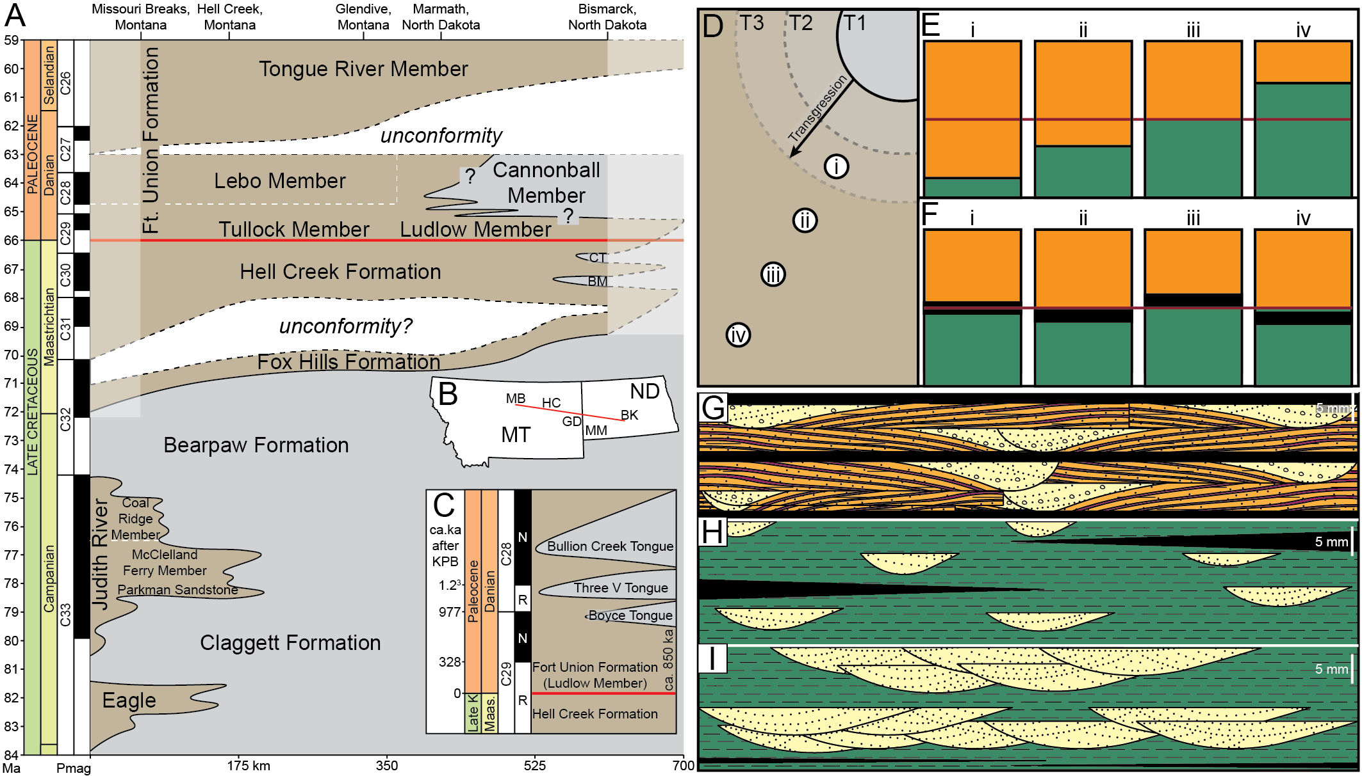

Supplementary Figure 5. Schematic illustrating chronostratigraphic relationships between continental (brown) and marine (gray) deposits in Montana and North Dakota across the KPB (A–C), expectations for the timing of continental facies changes during a marine transgression (D–F), and expectations for the architecture of continental sediments during marine transgression/highstand vs. regression/lowstand (G–I). Chronostratigraphic diagrams (A, C) are based on data from Sprain et al.¹⁴, Johnson et al.¹⁵, Rogers et al.²⁹, Peppe et al.^{32,72}, Hartman and Kihm⁷³, Catuneanu and Sweet⁷⁴, Murphy et al.⁷⁵, and Secord et al.⁷⁶; note that exposures of the Cannonball Formation are poor and geographically limited, so there is considerable uncertainty in its age and extent beyond its first appearance in the early Paleocene. No facies changes matching those at the KPB occur in pre-KPB continental deposits, despite prominent and frequent marine transgressions in the Late Cretaceous (A), and transgression of the Cannonball Sea occurred near the top of chron C29n, postdating the KPB by at least 850 ka (C). If KPB facies changes were driven by a marine transgression (D), then the shift from typical Late Cretaceous facies (green) to typical Paleocene facies (orange) should appear in localities closer to the seaway prior to those farther from the seaway (E). Instead, putative ‘time-transgressive’ facies changes merely reflect rare instances of KPBs occurring within, above, or below a coal and do not occur predictably away from the transgressive front (F). Marine lowstands are characterized by multistoried channel complexes, rare overbank clastic deposits, and thin discontinuous coal beds near their base (I). Marine transgressions are characterized by mostly clastic overbank deposits, sparse and single-storied channel sandstone beds, and thick but discontinuous coal deposits (H). The lower Fort Union Formation is characterized by multistoried channel sandstone beds, associated lateral accretion deposits, and thick, laterally continuous coal beds (G). The lower Fort Union Formation thus more closely matches expectations for marine regression or lowstand, but it is distinct in its scarcity of floodplain clastics and its laterally persistent coals. Abbreviations: BM, marine Breien Member of the Hell Creek Formation; BZ, Bismarck, North Dakota; CT, marine Cantapeta Tongue of the Hell Creek Formation; GD, Glendive, Montana; HC, Hell Creek area, Montana; MB, Upper Missouri Breaks National Monument, Montana.

Supplementary Discussion
Acknowledgments
We would like to thank: Greg Wilson Mantilla, who introduced many of us to the Hell Creek, the K-Pg boundary, and facilitated years of fieldwork; Alexis Licht, who first got LNW thinking about the mechanisms underlying Hell Creek–Fort Union facies changes; Tyler Lyson, whose skepticism and willingness to discuss our hypothesis at length greatly improved our manuscript; Tom Jerzykiewicz for generously reviewing an early draft of this manuscript and sharing photographs, publications, and insights about K-Pg boundary sections in the Alberta Foothills; Philip Gingerich, who encouraged us to look for a K-Pg boundary in the Bighorn Basin; and Bill Clemens, the giant upon whose shoulders we all stand. The ideas here were distilled and sharpened (but not necessarily endorsed) through conversations with: Catherine Badgley, Ray Rogers, Regan Dunn, Rich Barclay, Scott Wing, Ellen Currano, Joe Milligan, Brady Foreman, Alex Lowe, Henry Fulghum, Brody Hovatter, Jeff Wilson Mantilla, and Rory Sweedler. We are grateful to Kirk Johnson, Martin Gibling, and Mike Benton for providing thoughtful and constructively critical reviews of our manuscript—our paper is much improved as a result. Fieldwork in the Bighorn Basin was made possible by Tom Churchill, Philip Gingerich, Holly Smith, Henry Fulghum, Cretaceous Bighorn Project field teams, Amy Truman and the Ten Sleep Brewery staff, the U.S. Bureau of Land Management who provided paleontological permits, and Brent Breithaupt who facilitated those permits. Fieldwork in Montana was made possible by Hell Creek Land Owners, especially the Engdahl, Tharp, Twitchell, and Thomas families, Hell Creek Bar staff, Hell Creek Project field teams, the U.S. Bureau of Land Management and the Montana State Department of Natural Resources and Conservation who provided paleontological permits, and Greg Liggett, Doug Melton, and Patrick Rennie who facilitated those permits. PK thanks Philippe Claeys (VUB), Cem Berk Senel (VUB), and Johan Vellekoop (Institute of Natural Sciences, Brussels; KU Leuven) for support in K-Pg boundary fieldwork in the Raton Basin. Financial support was provided by the National Science Foundation (Graduate Research Fellowship and EAR- PF 2052992 to LNW; EAR-2321343 to TST; Awards 2016763, 2054605, 2245629, 2321344, and 2237807 to CJS; Graduate Research Fellowship to IMF; and David B. Jones Foundation (LNW and TST).

Continental K-Pg boundary sections outside of the Western Interior of North America
The vast majority of continental Cretaceous-Paleogene boundary (KPB) sections are from the Western Interior of North America (Western Interior, hereafter)^{12,22}, due in part to the long history of research on the Cretaceous-Paleogene (K-Pg) transition in vertebrate faunas that occur in those units^{77–88}. Consequently, researchers first began searching for, and discovering, evidence of the Chicxulub bolide impact in those Western Interior beds^{89–91}. In contrast to those well-studied sections in the Western Interior, continental KPB sections in other localities around the world are far less studied, likely due to their rarity or limited exposure in other places along with historical biases. Nonetheless, there are a handful of non-Western-Interior KPB sections that inform the patterns we discuss here. Future work is needed to better characterize those sedimentary sequences and, especially, interpret their depositional environments.
One of the earliest discovered continental KPB sections outside of the Western Interior are from New Zealand⁹². In the Greymouth coalfield in the western part of the South Island, two sections (Moody Creek Mine and Compressor Creek) are described from the Rewanui Member of the Paparoa Coal Measures, which yield a palynological extinction horizon and a fern spike^{93,94}. At Moody Creek Mine, the K-Pg boundary is located within a 10-cm-thick coal seam, yielding a positive iridium anomaly⁹³, and overlain by more coal-rich intervals. At Compressor Creek, the palynologically defined K-Pg boundary lies within a carbonaceous mudstone interval that yields a small iridium enrichment⁹⁵ and displays a slight lithological change to more sandy mudstone beds above the boundary⁹⁴. The Paparoa Coal Measures are interpreted as a subsiding floodplain paleoenvironment which was well-vegetated and incorporated peat-forming communities in permanently ponded settings. However, these two studied sections only report data from a limited vertical exposure of 2.1 and 3.5 m⁹⁴, respectively, hampering interpretations of larger scale facies change across the KPB. This area in New Zealand is heavily forested, making it hard to perform precise correlation between localities to cover a larger stratigraphic range¹². More recently, a KPB section was described near Cave Stream in central Canterbury which covers a patchy, but 80–90 m thick section⁹⁶ that should be studied in more detail to trace potential terrestrial facies changes across the KPB in New Zealand.
Two of the best-documented continental KPB sections in China coincide with formational contacts. In the Sichuan Basin, a continental KPB occurs at the contact between the Upper Cretaceous Guankou Formation and lower Paleogene Mingshan Formation⁹⁷. In the Nanxiong Basin, a continental KPB occurs at the contact between the Upper Cretaceous Zhenshui Formation and lower Paleogene Shanghu Formation⁹⁸. Thus, there is a facies change that occurs in both basins at the KPB, at least enough to warrant formational subdivision. Interestingly, neither of those depositional settings match those of the Western Interior: the Sichuan Basin KPB occurs within a deltaic to lacustrine section⁹⁷, and the Nanxiong Basin KPB occurs within a perched, semiarid depositional environment⁹⁸ (much different than the water-logged sediments and monsoonal precipitation characteristic of the KPB in the Western Interior). Although further work is certainly needed to better understand the exact facies changes occurring in these localities, it is notable that shifts in continental facies occur in a variety of depositional settings.
Precise KPBs are becoming increasingly well-documented in South America, but it is currently unclear whether they coincide with a facies shift due to the general lack of outcrop exposure. One KPB section in the Cesar-Rancheria basin in northern Colombia, confirmed by a positive platinum group element anomaly within the Colón Formation, is only known from one drilled sediment core showing an overall marine to fluvial transition⁹⁹. In southern Chile, in the upper Dorotea Formation in the Río de las Chinas Valley, a KPB is confirmed by a platinum group element enrichment within a ~1 m thick carbonaceous mudstone level that overlies thick coastal siliciclastic deposits¹⁰⁰. However, approximately 3 m above the reported KPB level an erosional unconformity has been identified overlain with middle Eocene deposits¹⁰⁰. This hiatus of ca. 20 million years hampers the study of long-term facies change.
Erosional unconformities also likely play an important role in the absence of a complete continental KPB interval in Europe, in combination with a large marine influence¹⁰¹. Sites from northeastern Spain and southern France preserve continental sediments with Cretaceous and Paleogene palynomorphs¹⁰¹, but no diagnostic boundary clay including shocked quartz and a geochemical anomaly has been found yet in these terrestrial deposits²².
In sum, the coincident facies change and taxonomic turnover characteristic of the KPB in the Western Interior may be a global phenomenon, but the current quality of the continental record elsewhere prevents unequivocal assessment of that at present.

Facies changes at the KPB in the Bighorn Basin
Four of the five new KPBs reported here come from the Bighorn Basin of northwestern Wyoming. The Mill Iron KPB, the fifth reported here, is from the southwestern portions of the Williston Basin, near Ekalaka, Montana, and the facies changes observed there are identical to those elsewhere in the Williston Basin, which were discussed at length in the main text. Here, we provide a brief description of the KPB facies changes in the Bighorn Basin.
The Lance Formation below the KPB in the Bighorn Basin is broadly similar to Lance and Hell Creek exposures elsewhere in the Western Interior. Most of the formation is composed of gray-green mudstone beds that exhibit root traces, slickensides, carbonized organic debris, and gleying, which are collectively indicative of hydromorphic paleosols, but thinly laminated gray–purple carbonaceous mudstone beds and shales are sparsely distributed throughout the unit. Underlying the Lance Formation in the Meeteetse Formation, those carbonaceous mudstone beds and shales give way to true lignites or coals in some places. Other than the absence of coals, the Lance Formation is primarily differentiated from the Meeteetse Formation by a greater preponderance of ledge-forming, trough-crossbedded channels and crevasse-splay sandstone beds that interrupt the otherwise mudstone-dominated unit. Thus, in outcrop, the Lance and Fort Union formations are often the resistant, cliff-forming units, whereas the Meeteetse Formation is recessive and valley forming.
The base of the Fort Union Formation in the Bighorn Basin is defined by the first appearance of a laterally continuous lignite or coal, which is in turn underlain by a thin, pinkish-red claystone layer yielding iridium anomalies (Extended Data Fig. 2). Other than the formation-defining coal bed, the lowest portions of the Fort Union Formation, best exposed at Little Polecat Dome and Kirby Ditch (Extended Data Fig. 1; Extended Data Fig. 2), are characterized by thin, alternating beds of claystone, siltstone, and sandstone. The alternating coarse-fine beds dip at an angle oblique to the structural dip direction; they are thus analogous to the ‘variegated beds’ or lateral-accretion deposits of the Fort Union Formation in the Williston Basin (see Fig. 2). Most striking, however, is the appearance of a thick (10–30 m) multistoried channel-sandstone complex that often overlies or scours through the lowest Fort Union coal (Fig. 1; Extended Data Fig. 2). At Little Polecat Dome, that giant sandstone complex has been termed the ‘Mantua Lentil’⁵⁹, and a similar (potentially the same) Mantua-Lentil-like sandstone complex occurs near the base of the Fort Union Formation throughout the western and central portions of the Bighorn Basin. In that way, the Mantua-Lentil complex of the Bighorn Basin resembles the ‘barren series’ of the Raton Basin^{21,49}.

Stratigraphic precision of KPB markers in continental settings
The facies shifts described here, which are often formational contacts, reflect macroscopic, landscape-scale changes in fluvial geomorphology that most workers agree are close (≤ 2 m) to synchronous with the KPB^{18,19}. In some continental sections, however, previous workers have placed the KPB near, but slightly below, within, or above a laterally persistent coal bed, the base of which was interpreted to precisely indicate the onset of the facies shift^{12,102,103}. Those discrepancies are often invoked to dismiss any correlation between the two phenomena, but we argue that the tools or proxies used to identify and place the KPB are often insufficiently precise to interpret a ≤ 2 m difference as meaningful. In the Western Interior, the KPB is defined by, and can be most confidently identified via, direct evidence of the Chicxulub asteroid impact, namely in recording a positive anomaly in the abundances of iridium (typically > 0.5 ppb Ir) and other platinum group elements (Ru, Rh, Pd, Os, and Pt)^{1,104}, glassy impact spherules (droplets of molten target rock that expelled out of the crater, cooled and quenched during flight, and that rained-out from the atmosphere)¹⁰⁵, and shocked minerals (formed by abrupt and catastrophic disruption of the mineral structure, most often in quartz¹⁰⁶ and zircon¹¹⁰)^{108,109}.
Palynostratigraphy^{12,110,111} and stable-carbon-isotope stratigraphy from bulk, sediment-bound organic matter¹¹² have been employed in sections with impact ejecta, and then used to place the KPB in sections without definitive impact evidence. Although we recognize that those techniques are helpful in constraining the placement of the KPB, we highlight the problems with using non-impact-related evidence to precisely (i.e., sub-meter) define the stratigraphic placement of the KPB, many of which have been highlighted previously¹⁹.
Patterns of plant extinction, recovery, and changes in community composition in response to the End-Cretaceous mass extinction have been well documented using palynofloras across the KPB in the Western Interior and numerous sections around the world^{12,22}. Pollen assemblages from uppermost Cretaceous strata in the Western Interior are characterized by the occurrence of diverse and abundant fern spores and angiosperm pollen, including triprojectate pollen (i.e., Aquilapollenites). Following the KPB (as identified via direct impactor evidence), there is a conspicuous ‘fern spike’, which coincides with the extinction of 30–40% of Cretaceous taxa (‘K-taxa’) followed by an increased relative abundance of conifer pollen and the appearance of numerous new angiosperm pollen taxa (i.e., Momipites)^{113–116}. That stereotyped palynofloral signature has been so well-correlated with definitive KPB sections in the Western Interior that palynostratigraphy is now often used as a proxy for the KPB in the absence of impact-related evidence¹². These distinctive palynological signatures likely mark the KPB at the outcrop scale, but fluvial-channel scouring in earliest Paleocene depositional systems and reworking of pollen (see below) may decrease stratigraphic precision (at the cm–m scale) in placing the KPB using only pollen.
Minor erosional unconformities between uppermost Cretaceous and lowermost Paleocene strata occur throughout the Western Interior, most famously in portions of the Williston Basin (e.g., the ‘Bug Creek Problem’^{91,117,118}), but also in the Bighorn Basin of Wyoming^{119–121}. (Note that these unconformities are localized occurrences, and conformable strata frequently span the KPB lateral to them). That these earliest Paleocene channel scours can rework vertebrate fossils has been well documented^{117,122}, yet the potential for channels to rework and redeposit plant microfossils has not received the same consideration until relatively recently^{19,109,123}. Recent work on the palynoflora from Paleocene-Eocene Thermal Maximum (PETM) sections in the Bighorn Basin, for example, has demonstrated extensive reworking and remobilization of pollen and other microfossils into PETM assemblages which, when left unaddressed, obscure palynological signatures of the PETM^{28,124}. This work highlights the ease with which pollen can be remobilized and redeposited, and refutes the notion that, in the absence of other impact-related evidence, pollen alone is a sufficient marker of the stratigraphically precise (< 2 m) KPB, even if it may be the best tool available in a particular location^{19,109,123}.
In the marine record, the KPB has been associated with a global, large amplitude, and abrupt carbon-isotope excursion in both inorganic^{125–127} and organic^{128–132} materials (in shallow and deep environments), leading carbon-isotope excursions to be considered characteristic of the KPB worldwide, at least in marine localities¹²⁷. A handful of studies have proposed that the same carbon-isotope excursion can be detected in the continental rock record and therefore be used as a stand-in for the KPB in absence of impact-related evidence^{112,133,134}. A recent study on carbon isotopes from long stratigraphic sections spanning impact-identified KPBs from the Hell Creek region of the Williston Basin in northeast Montana, however, demonstrated that carbon-isotope excursions of a similar or greater magnitude to that observed at the KPB itself occurred in most organic-rich strata²⁵. Further, as with pollen, organic carbon can also be reworked¹³⁵. Thus, carbon-isotope stratigraphy alone is an unreliable proxy for placing a precise KPB in continental settings.
Taken together, those recent studies indicate that although carbon isotopes and palynostratigraphy can be useful in many contexts, they are likely insufficiently precise to place the KPB at ≤ 2 m scales. This is particularly relevant when considering that most of the proposed KPB sites that do not obviously match with a facies shift have been identified via these imprecise proxies¹². In contrast, of the 51 Western Interior KPBs identified using direct evidence of impact-ejecta (including the five new sections reported here), 26 coincide precisely with a formational contact, and 19 coincide with an abrupt intraformational facies change (Fig. 1; Extended Data Table 2). Nonetheless, those intraformational facies shifts have been held up as exceptions to the KPB-facies-shift rule, along with the remaining six impact-identified KPBs that underlie or overlie a formational contact by ≤ 2 m¹². In the next section, we address these case-by-case and propose that, despite first appearances, they do indeed fit the criterion of a coincident KPB facies shift.

All impact-identified KPBs are consistent with a facies shift
Places where impact-identified continental KPBs do not obviously or immediately coincide with a facies shift have been used to dismiss any relationship between continental facies change and the end-Cretaceous mass extinction. Nevertheless, all those apparent exceptions either (i) represent synorogenic sedimentary packages adjacent to emerging mountain belts, (ii) occur in areas where lateral and vertical outcrop is limited, (iii) are obfuscated by historical trends in formational nomenclature, or (iv) some combination of those above three. Below, we address classically invoked exceptions to the KPB facies shift from KPB sections in the Raton, Denver, Alberta, and Williston basins of western North America, demonstrating that, once accounting for the confounding variables listed above, they are indeed consistent with the DEE hypothesis.
The Raton Basin of Colorado and New Mexico is where the first KPB was identified via iridium anomalies in continental sediments^{89,136}. Raton Basin KPBs occur within the Raton Formation, a synorogenic unit associated with Laramide thrusting along the ancestral Sangre de Cristo Mountains^{137,138}, specifically at the top of the ‘lower coal zone’^{136,139} or ‘lower Raton Formation’⁴⁹. Unlike the KPBs identified at formational contacts in the Williston and Bighorn basins, which are identified by the lowest local coal or lignite, the Raton Basin KPBs occur entirely within an already coal-bearing formation. The iridium anomaly and abundant shocked quartz minerals were discovered at ca. 20 sites in the Raton Basin in the so-called fireball layer¹⁴⁰. This layer is a ca. 0.5 cm thick carbonaceous shale situated right above a 2–3 cm kaolinitic claystone rich in altered microtektite spherules. The fireball layer is overlain by a lignite that shows at its base chemical signatures of the Chicxulub impact dust plume¹⁴¹. This lignite shows a consistent thickness of ca. 5 cm throughout the Raton Basin of Colorado and also displays the K-Pg boundary fern spike¹⁴². At the Madrid KPB sites, a thick (> 5 m), massive sandstone bed is situated directly above the 5-cm-thick lignite^{21,143,144}, indicating a major shift in sedimentary facies across the KPB (Fig. 1). Thus, the KPB does coincide with an abrupt facies shift in the Raton Basin, but that shift was not defined as a new geological formation, and its nature is somewhat different from that in the Williston Basin. The so-called ‘barren series’ of the Raton Formation¹³⁹, which is cliff-forming and defined by its comparative scarcity of coals, overlies the KPB across the Raton Basin; that informal unit represents an abrupt facies change characterized by laterally extensive and stacked (i.e., multistoried) fluvial channel deposits that indicate pronounced lateral aggradation and reworking^{49,143}. Succeeding the ‘barren series’ is a return to coal-rich strata (the so-called ‘upper coal zone’ of Lee¹³⁹; but note that Schwartz et al.⁴⁹ refer to both the ‘barren series’ and ‘upper coal zone’ as the ‘upper Raton Formation’), yet these upper and lower ‘coal zones’ exhibit important sedimentological differences. The coal beds of the ‘lower coal zone’ are thin and often-discontinuous (i.e., not laterally extensive)¹⁴³, and the unit is mostly characterized by perennially wet, clastic-rich floodplain-mudstone beds⁴⁹, similar to the hydromorphic paleosols that have been well described from the Hell Creek Formation to the north^{18,20,145} (Fig. 4). The ‘upper coal zone’, in contrast, is dominated by multistoried, laterally aggraded, channel-sandstone deposits (of the type described for the ‘barren series’ above) and largely lacking in fine-grained clastic sediments⁴⁹. Instead, the near entirety of floodplain deposits in the ‘upper coal zone’ are coal beds that are both thicker (up to 4-m thick) and more laterally extensive than those in the ‘lower coal zone’¹⁴³. Thus, although its placement within the Raton Formation obfuscates the local depositional changes, Raton Basin KPBs do coincide precisely with an abrupt facies shift that differentiates uppermost Cretaceous sedimentation from that of the lowermost Paleocene.
Like in the Raton Basin, the KPB in the Denver Basin is also located within a formation—the D1 sequence of the Denver Formation—that was deposited off the flanks of an emerging Laramide arch¹⁴⁶. Also like the Raton Basin (and differing from the Williston Basin), coal beds are present both below (in the Laramie Formation and lowest portion of the D1 sequence) and above the KPB in the Denver Basin. Only two definitive (i.e., impact-ejecta-based) KPB have been identified from the Denver Basin, one located in the eastern portion of the basin along West Bijou Creek^{104,147,148} and one from the Kiowa Core^{114,149}; elsewhere, the KPB has been stratigraphically constrained to the scale of meters along the western portion of the basin (especially South Table Mountain and Corral Bluffs^{44,150,151}) using palyno- and magnetostratigraphy and radiometric dating of volcanic ash^{44,152}. Judging the coincidence of the KPB and continental facies change is especially challenging in the Denver Basin due to the lack of appropriate exposures. Because deposition of the D1 sequence of the Denver Formation was synorogenic with the Laramide Orogeny, in western portions of the Denver Basin the formation is dominated by coarse clastics (i.e., conglomerates and sandstones) that obscure the identification of definitive KPB marker beds^{150,153}. In the central and eastern portions of the Denver Basin where finer-grained sediments are more prevalent, the sedimentology and stratigraphy of the D1 sequence is only known from well-logs¹⁵⁴, the Kiowa Core¹⁴⁹, and the meager (< 5 m) exposures along stream-cuts like West Bijou Creek (which often require deep trenches to expose the rock)^{147,152}. Nonetheless, there is a stark lithological change within the D1 sequence at South Table Mountain, characterized by an abrupt appearance of brightly colored, sandstone-dominated facies atop drab colored, mudstone-dominated facies, which corresponds to the originally proposed KPB in the Denver Basin⁸³. The direct correspondence between that abrupt facies change and the KPB has been challenged by subsequent workers who instead placed the tentative KPB several meters below the lithological change^{150,155}. Nonetheless, that inference was based primarily on fossil macroflora¹⁵⁰, which, in isolation, are unreliable biostratigraphic indicators of the KPB¹². Thus, the stark facies shift within the D1 sequence of the Denver Formation in the western Denver Basin is still within the plausible range of the KPB based on pollen and vertebrate biostratigraphy¹⁵⁰. Further, in the trenched sections at West Bijou, the KPB occurs within the first lignite bed of the section¹⁴⁷, and the overlying Paleocene units are characterized by lignites and ‘lacustrine siltstones’¹⁴⁷ (Fig. 4), elsewhere interpreted as analogous to the ‘variegated beds’ of the lower Fort Union Formation⁴⁴. Those Fort Union-like ‘variegated beds’ are absent in the underlying Cretaceous portions of the D1 sequence, which are instead characterized by small fluvial channel deposits and pedogenic mudstone beds¹⁴⁷. Thus, although the coincidence between the KPB and abrupt facies shift is not definitive in the Denver Basin, those facies changes that have been documented are consistent with the patterns observed in KPB sections that are better exposed elsewhere in the Western Interior.
Intraformational KPBs have also been reported from the Scollard, Coalspur, and Willow Creek formations in the Alberta Basin of southwestern Canada^{17,48,156,157}. Nonetheless, in sections in which definitive KPBs have been identified, they all coincide with abrupt facies shifts that have been well-documented. In both the Scollard and Coalspur formations, the KPB immediately underlies the Nevis and Mynheer coals, respectively^{17,48,156}, which mark the onset of coal-rich facies analogous to those of the Fort Union or Ravenscrag formations of the Williston Basin^{17,158} (for more details on the sedimentology of the Frenchman and Ravenscrag formations, see Jerrett et al.¹⁵⁹). As with the Hell Creek and Lance formations to the south, the uppermost Cretaceous portions of the Scollard and Coalspur formations are dominated by drab green-gray floodplain mudstone beds and small, single-storied channel-sandstone beds indicative of hydromorphic paleosols and low-sinuosity meander-belt deposits⁴⁸. Like the Fort Union or Ravenscrag formations, the lowermost Paleocene portions of the Scollard and Coalspur formations are, other than coals, dominated by large, multistoried fluvial channel deposits and associated lateral accretion beds^{17,48,157}. In the Willow Creek Formation, which is the most mountain-proximal of the group and therefore analogous in depositional setting to the Raton and Denver formations (although it is associated with Sevier rather than Laramide mountain building¹⁶⁰), the KPB coincides with a distinct facies shift (Fig. 4), albeit different than those in the units to the east and north in exhibiting a shift towards abundant caliche beds and broad, deeply meandering fluvial channel deposits^{48,161}. That the mountain-proximal Willow Creek KPB facies shift differs from those of the Denver and Raton formations could be due to its association with thin-skinned Sevier deformation delivering carbonate-rich clastics into the system¹⁶⁰, rather than more crystalline basement detritus associated with the Laramide arches to the south^{143,146}.
That continental KPB facies shifts in mountain-proximal settings (e.g., Denver and Raton basins) are not identical to those in mountain-distal settings (e.g., Williston and Powder River basins) is to be expected given that (i) the influence of vegetation¹⁰ and ecosystem engineering⁵⁰ on fluvial geomorphology and (ii) the rules of river avulsion⁵¹ both differ closer to mountainous regions (Fig. 3). Whereas fluvial geomorphology is strongly influenced by vegetation density in lowland settings far from elevated topography, those ‘boundary conditions’ become increasingly swamped by the ‘driving variables’ of flow and sediment regime approaching the river headwaters¹⁰; in other words, vegetation plays a stronger role shaping fluvial geomorphology in mountain-distal than in mountain-proximal settings. Those same upstream controls on fluvial dynamics also tend to overprint ecosystem engineering effects on rivers^{50,162}. In coastal lowlands, rivers avulse when there is a steep slope away from the channel; in contrast, rivers closer to mountain fronts avulse when they become perched above the surrounding landscape⁵¹. Viewing Western Interior fluvial systems in light of these considerations provides a potential mechanism underlying the post-KPB facies changes we see. In lowland settings, where vegetation has a first-order influence on fluvial geomorphology, the KPB facies shift reflect a decrease in avulsion frequency, prompted by vegetation-stabilized meander belts; as such, avulsion would most often occur when the organic detritus accumulating in adjacent mires were compressed enough¹⁶³ to create a stark difference in slope between the meander belt and the distal floodplain⁵¹. In mountain-proximal settings, where river discharge and sediment supply increase in importance, the KPB facies shift may, in fact, reflect an increase in avulsion frequency, since a closer proximity to the sediment source would promote greater vertical aggradation compared to the lowlands¹⁶⁴, and vegetation-stabilized banks would promote perching of meander belts¹⁰, prompting rivers to avulse⁵¹. Such a mechanism is consistent with the abrupt appearance of laterally expansive and vertically thick channel deposits overlying the KPB in places like the Bighorn (this paper), Raton⁴⁹, and potentially Denver⁸³ basins and does not rely on a pulse of tectonic loading or mountain uplift to drive a synchronous KPB facies change (contra Bown¹²¹; Pillmore and Flores¹⁴³; Raynolds¹⁴⁶). Alternatively, the same stable meander belts and decreased avulsion frequency could hold in those mountain-proximal settings, but the lateral accretion deposits that are so stark in mountain-distal settings due to the distinct coarse-fine-sediment couplets may be obscured due to a much coarser sediment load in mountain-proximal settings. In other words, the laterally extensive sandstone deposits that characterize lower Paleocene units in mountain-proximal settings (e.g., Raton, Denver, and Bighorn basins) may appear more homogenous due to a scarcity in fine-grained clastic deposition moving closer to the mountain front. Testing these alternative hypotheses will require more detailed sedimentological and stratigraphic research in mountain-proximal KPB sections.
The remaining ‘exceptions’ to the continental KPB facies shift are in places where the purported KPB occurs within centimeters below or within the base of a coal bed or atop a coal bed that often indicates a formational contact (e.g., City of Raton and Sugarite [Raton Basin, New Mexico], Starkville South [Raton Basin, Colorado], Dogie Creek [Powder River Basin, Wyoming], Pyramid Butte, John’s Nose [Williston Basin, North Dakota], Morgan Creek [Williston Basin, Saskatchewan]^{12,110,115}). The Pyramid Butte KPB section from the western North Dakota portion of the Williston Basin, in particular, is the most prominent example of a near-(but not exact) facies shift-associated KPB^{12,102}. Indeed, prior to the Pyramid Butte study¹⁰², there was skepticism as to the validity of paleobotanical responses to the End-Cretaceous mass extinction since nearly all KPBs occurred beneath the stratigraphic first appearance of a laterally extensive coal, prompting many researchers to suggest that palynological trends across the KPB merely reflected expected trends in botanical successions within a coal-swamp¹⁶⁵ or climate change^{166–168}. At Pyramid Butte, however, the KPB occurs at the top of the lowest Fort Union Formation coal (i.e., the ‘Z’ coal), with characteristic Maastrichtian pollen assemblages being hosted within the underlying coal and characteristic Paleocene pollen assemblages being hosted in the mudstone bed immediately overlying the KPB claystone¹⁰². Indeed, most of the adamant dismissals of the coincident KPB facies shifts were made by paleobotanists to demonstrate that trends in the plant fossil record across the KPB were not facies-dependent^{12,110,169}. Nonetheless, in the 45 years since the impact-driven extinction hypothesis was first proposed¹⁷⁰, the scientific consensus has changed, and the reality of catastrophic extinction at the KPB has been repeatedly demonstrated in nearly all aspects of the fossil record¹²⁷. From a sedimentological and stratigraphic perspective, however—bearing in mind that KPB-coincident facies shifts occur across nearly 30º latitude (~37º–65º N) and nearly 15º longitude (~117º–104º W) in the Western Interior¹² (Fig. 1; Fig. 4)—are mismatches between formational contacts and KPBs on the order of ≤ 2 m meaningful? To continue the Pyramid Butte example, the purported mismatch there is based on the definition of the Hell Creek-Fort Union contact as the appearance of the first laterally extensive coal (or lignite) bed occurring above the stratigraphically highest dinosaur fossil^{3,78,81}. Laterally extensive coals do, however, infrequently occur in the Hell Creek Formation (e.g., the ‘Null Coal’^{3,69}) and in other Late Cretaceous formations (some of which were discussed above); therefore, coal swamps did exist in latest Cretaceous time, and the occurrence of the KPB atop the first Fort Union coal does not, by itself, refute the KPB-coincident facies change. Although speculative, one possible explanation for the sedimentary sequence at Pyramid Butte (and other sections in which the KPB occurs within a coal; Fig. 1) is that, whereas the stratigraphic persistence of coal-swamp deposits was typically prohibited by the instability of fluvial systems in the latest Cretaceous (via erosion, reworking, or clastic inundation), the KPB occurred during local deposition within a coal swamp, but given the stark changes in fluvial dynamics, that coal-swamp was able to continue as a depocenter into the Paleocene. Regardless, the important facies change is in the fluvial-channel deposits overlying the KPB at Pyramid Butte, which differ markedly from those in the underlying Hell Creek Formation^{102,169}, just as they do in all other KPB-succeeding units discussed above.
Thus, we contend that all impact-identified KPBs in the Western Interior do, in fact, coincide with a marked shift in continental facies. Although the starkness of that facies shift is mediated by mountain proximity, outcrop extent, and formational nomenclature—that is, the facies shift is most apparent at formational contacts in badlands exposures far from a mountain front—sedimentary facies change apparently follows KPBs in a wide range of depositional settings (Fig. 4).

Alternative hypotheses to explain the KPB facies shift
In the main text, we refute the ‘Wet Paleocene’ hypothesis based on the facts that: (i) Hell Creek Formation paleosols are already indicative of a very high water table, and (ii) most ‘variegated beds’ of the Fort Union Formation are not pond deposits but rather lateral accretion deposits associated with large, deeply-meandering rivers. The latter point is the most novel here, since these thinly bedded sands, silts, and muds have previously been interpreted as pond deposits^{16–19}. However, it is important to note that the lateral accretion beds, and channel deposits more broadly, of the Fort Union Formation exhibit substantial variation in the lithology, bedding features, and outcrop appearance^{24,26}. For example, some are sandstone-dominated fining-upwards successions (e.g., Carrie Padgett channel²⁴), indicative of channel-proximal portions of laterally migrating point bars^{171,172}. Others are typical inclined heterolithic fining-upwards successions (i.e., with alternating beds of siltstone/claystone and sandstone) (e.g., Hauso Flats channel²⁶), indicative of laterally accreting deposits with periodic (often seasonal) fluctuations in river discharge²⁷. And still others are siltstone-dominated fining-upwards successions or concave-up interbedded fining-upwards successions (e.g., portions of the Garbani channel²⁴), indicative of lateral accretion under a lower flow regime (e.g., at the tails of point bars or in counterpoint bars)^{27,172} or abandoned-channel filling with periodic high-energy flood inputs¹⁷², respectively. Thus, although all these units of the Fort Union Formation are indicative of meandering-river deposits, they likely capture a variety of fluvial geomorphological attributes, spanning proximal-channel deposits to point bars to counterpoint bars to abandoned channels. Lastly, it is important to note that these channel features do occur in Late Cretaceous strata, as clearly demonstrated by Durkin et al.¹⁷². Yet, these Late Cretaceous channels are always bracketed (above, below, and laterally) by typical overbank floodplain deposits consistent with hydromorphic paleosols¹⁷². That is not the case for early Paleocene deposits, which instead are characterized by an amalgamation of these channel deposits to the exclusion of typical clastic-rich distal floodplain deposits (i.e., distal floodplain deposits are almost exclusively coals).
Previous studies have also invoked climate change to explain ‘increased wetness’ in the earliest Paleocene. Yet, based on the limited continental paleoenvironmental evidence from the KPB in the Western Interior, there is also no evidence for regional widespread increases in rainfall or other climatic changes in the earliest Paleocene that could explain the KPB facies shift^{23,173–176}. Indeed, the preponderance of evidence suggests that earliest Paleocene climatic settings in the Western Interior were largely a continuation of those in the latest Cretaceous. For example, isotopic analyses on well-preserved mollusk fossils in combination with paleoclimate modelling revealed that monsoonal precipitation regimes stimulated by the North American Cordillera apparently persisted from at least the Campanian to the mid Paleocene^{177–179}. Further, although there is evidence for temperature perturbations around the KPB itself¹⁸⁰, the overall climatic trend is one of gradual global cooling from the late Campanian through early Paleocene^{181,182}. Thus, the recognition that the ‘variegated beds’ are, in most cases, lateral accretion deposits, the confirmation that Hell Creek soils were formed under persistently wet, waterlogged conditions, and the lack of evidence for marked increases in precipitation across the KPB collectively render the ‘Wet Paleocene’ hypothesis insufficient to explain continental KPB facies change in the Williston Basin.
As addressed in the main text and Extended Data Figure 5, the most commonly-invoked mechanism to explain the KPB facies change in the Williston Basin is the westward incursion of the Cannonball Sea, which is documented by exposures of the Cannonball Member of the Fort Union Formation. The full geographic extent of the Cannonball Member is difficult to trace for certain—it is known only from relatively local exposures, but it best exposed in Mandan, North Dakota, and crops out intermittently elsewhere throughout western North Dakota and northwestern South Dakota^{15,31,183,184}. According to the ‘Marine Transgression’ (or ‘Rising Baselevel’) hypothesis, the rising Cannonball Sea backed-up fluvial systems to the west, promoting vertical aggradation of clastic sediments, a rising water table, and the concomitant proliferation of coal swamps. Although transgression of the Western Interior Seaway almost certainly explains the appearance of coal deposits in older Upper Cretaceous units in the Western Interior, such as the Straight Cliffs^{185,186}, Eagle^{187,188}, and Judith River^{29,189} formations, such an explanation is insufficient to describe the Fort Union Formation because (i) the Cannonball Sea transgression began nearly 1 million years after the KPB and (ii) the stratigraphic architecture of the Fort Union Formation is more consistent with a marine regression or lowstand systems tract (see main text and Extended Data Fig. 5). Instead, the KPB coincides with the well-documented major regressive phase of the Western Interior Seaway^{31,190–192}; indeed, the latest Cretaceous–earliest Paleocene was associated with marine regression globally³³.
The Tanis site in North Dakota, which is interpreted as a seiche deposit caused by the Chicxulub bolide impact, does imply some close proximity of a marine unit to otherwise continental deposits in the Western Interior at the KPB¹⁹³. Nonetheless, the Tanis site is an isolated outcrop that is not continuous with adjacent KPB sections, and there is currently no evidence of such a close marine influence in other nearby and well-studied (chronostratigraphically and sedimentologically) areas, such as Mud Buttes, which is only ~2.5 km away^{18,193}. Further, if there was a remnant of the Western Interior Seaway present in southwestern North Dakota during KPB time, its existence does not indicate whether that seaway was stagnant or undergoing a regression or transgression. Thus, future work on the Tanis site will shed light on our hypothesis that the Cannonball Sea was not transgressing at the KPB.
It is worth noting here that the Hell Creek-Fort Union contact has been previously proposed to be time-transgressive, with the formational contact aligned with the KPB in exposures to the west (e.g., Hell Creek area, Garfield County, Montana) and becoming increasingly misaligned to the east (e.g., McCone County, Montana; western North Dakota)¹³⁴. In nearly every case, however, those misaligned KPBs and formational contacts occur when the KPB has been identified by non-impact-related evidence; namely, pollen and/or carbon isotopes (see above). Further, although more recently researchers have returned to considering the KPB to be more-or-less synchronous with the Hell Creek-Fort Union contact¹⁹, they have still suggested that the facies change could be explained by transgression of the Cannonball Sea¹⁸, since the topography was so ‘muted’ it would allow for more-or-less instantaneous flooding of the Western Interior¹⁹. Nonetheless, as demonstrated above, the timing does not work out for Cannonball Seaway transgression to be a plausible mechanism to drive the facies shift. Nor, as demonstrated above, can the Western Interior be wholly interpreted to be of ‘muted’ topography given, for example, the emerging Laramide uplifts that snaked across the Western Interior Basin by KPB time²³.
Beyond the Marine Transgression hypothesis and others discussed in the main text, it has been proposed that there is a cessation of volcanism near the Williston Basin at approximately KPB time that could explain the KPB facies shift. Evidence for this hypothesis comes primarily from a purported abundance of bentonitic clay in the Hell Creek Formation⁷⁵ that is absent in the Fort Union Formation. Yet, volcanic ashes are extremely abundant in the Fort Union Formation of the Williston Basin, anchoring much of the chronostratigraphy in the region^{14,69}. Indeed, the apparent absence of bentonitic clays in the Fort Union Formation mudstone beds likely reflects the scarcity or disappearance of clastic-rich distal floodplain deposits in the Fort Union Formation (see the main text)—whereas ashes were primarily preserved on hydromorphic soils during deposition of the Hell Creek Formation, they were primarily preserved in coal swamps during deposition of the Fort Union Formation. Thus, the ‘Volcanic Cessation’ hypothesis too is inconsistent with the available data.
Lastly, there are no analogs to the abrupt and regionally synchronous KPB facies shift prior to the End-Cretaceous mass extinction. Although, as noted above, there are indeed numerous examples of coal-bearing formations from the Late Cretaceous Western Interior, those formations are all well-associated with transgressions of the Western Interior Seaway; as such, they are characterized by low channel:floodplain ratios^{29,186}, rather than the high channel:floodplain ratios that characterize lower Paleogene strata. Further, in coal-bearing Upper Cretaceous strata, fluvial channels are relatively small and lenticular, and, importantly, hydromorphic paleosols still make up most fine-grained overbank facies²⁹. It is worth noting, however, that Upper Cretaceous strata differ markedly from those of the Lower Cretaceous and Upper Jurassic in the Western Interior, but those changes appear to be spatiotemporally diachronous and reflect a shift from a mostly dry, inland fluvial depositional system governed by regional paleoclimate and incipient western tectonism, to a Late Cretaceous depositional system governed by the build-up of the North American Cordillera and its reciprocal effect on transgression-regression cycles of the Western Interior Seaway^{194–196}. The role that dinosaur megafauna may have played in mediating the continental sedimentary patterns prior to the latest Cretaceous is a topic that requires future research.

Expected and observed patterns of extinction and floristic turnover across the KPB
Vegetation structure is central to the DEE hypothesis, and plant responses to the end-Cretaceous mass extinction must therefore be consistent with the floristic changes we infer here. In the main text, we highlight that forest vegetation likely rebounded relatively quickly (on the order to decades to millennia) after the Chicxulub asteroid impact. That the sudden disappearance of dinosaur megafauna allowed dense forests to encroach and stabilize fluvial meander belts in the earliest Paleocene is thus consistent with both the plant and vertebrate fossil record and the sedimentological record. Below, we provide more detailed background about plant responses to the end-Cretaceous mass extinction, emphasizing that plant taxonomic recovery is not a prerequisite for the rapid emergence of dense, forested vegetation.
Plants experienced major taxonomic loss at the KPB^{197–200}, with upward of 50–75% of lower-level taxa disappearing^{12,39,43,46,47,147}. Unlike animal groups, however, which lost major evolutionary branches at the KPB, extinction of plants apparently was not clustered within major clades^{22,47,201,202}. This pattern partly owes to the markedly different life histories of plants as well as to the inherent difficulty of assigning dispersed leaves and pollen, which comprise the bulk of the Late Cretaceous plant fossil record, to higher taxonomic ranks⁴⁷. Dynamics of plant extinction and recovery are best known from regional, high-resolution stratigraphic studies, which document variable rates of plant-species extinction and profound ecological shifts across the globe^{39,114,203}. Among these, the Great Plains of North America contain some of the most intensively studied sections^{204,205}. Thousands of palynomorphs and leaf macrofossils spanning the latest Maastrichtian and early Paleocene show a significant drop in plant taxonomic richness at the KPB, with upwards of 30% of palynotaxa^{12,114} and > 50% of macrofloras^{199,205} going extinct.
The immediate aftermath of the Chicxulub impact at the KPB was likely devastating: wildfires²⁰⁶, fungal proliferation²⁰⁷, and photosynthetic collapse linked to darkness invoked by a dust-driven impact winter²⁰⁸. In various localities of North America and in New Zealand^{93,94}, a distinct ‘fern-spike’ in the palynological record^{22,113–116} is suggestive of an initial recovery succession mediated by ferns²⁰⁹ in what were likely to be barren, open environments. Nonetheless, those immediate consequences of the Chicxulub bolide impact on standing vegetation/vegetation cover were relatively short-lived, and are only obvious on the cm to decimeter scale in the sedimentological record²². Low-diversity forests likely returned in a matter of decades to millennia^{44,210}. Those early Paleocene ‘disaster floras’ were taxonomically depauperate compared to those in the latest Cretaceous, comprised a handful of widely distributed Cretaceous survivors^{198,199}, and their diversity remained low for ca. 10 million years. In the Great Plains, the uppermost Hell Creek Formation shows a variety of woody and herbaceous plant assemblages across different depositional environments, whereas the lowermost Fort Union shows a prevalence of low-diversity mire vegetation including conifers and broadleaf trees²⁰⁵, which apparently thrived in both coal swamps and on the banks of the relatively still water on the inside of deep, fluvial-channel meanders. Further work testing the disturbance effects of dinosaurs on standing vegetation across the KPB requires the reconstruction of canopy structure before and after the end-Cretaceous mass extinction at multiple locations across various plant assemblages.

Supplementary References
(References 1–76 are provided in the main text document)
- Hatcher, J. B. Some localities for Laramie mammals and horned dinosaurs. Amer. Nat. 30, 112–120 (1896).
- Brown, B. The Hell Creek beds of the Upper Cretaceous of Montana. Bull. Amer. Mus. Nat. Hist. 23, 823–845 (1907).
- Hatcher, J. B. The Ceratopsia. Montana U. S. Geol. Surv. 49, 1–157 (1907).
- Calvert, W. R. Geology of certain lignite fields in eastern Montana. Bull. U. S. Geol. Surv. 471, 187–201 (1910).
- Collier, A. J. & Knechtel, M. M. The coal resources of McCone County, Montana. U. S. Geol. Surv. Bull. 905, 1–80 (1939).
- Dorf, E. Relationship between floras of type Lance and Fort Union formations, Geol. Soc. Amer. Bull. 51, 213–236 (1940).
- Brown, R. W. Cretaceous-Tertiary boundary in the Denver Basin, Colorado. Bull. Geol. Soc. Amer. 54, 65–86 (1943).
- Brown. R. W. Tertiary strata in eastern Montana and western North and South Dakota. Billings Geologic. Soc. Guidebook 3, 89–92 (1952).
- Brown, R. W. Fort Union Formation in the Powder River Basin, Wyoming. Wyo. Geol. Assoc. Guidebook 13, 111–113 (1958).
- Sloan, R. E. & Van Valen, L. Cretaceous mammals from Montana. Science 148, 220–227 (1965).
- Archibald, J. D. The earliest known Palaeocene mammal fauna and its implications for the Cretaceous–Tertiary transition. Nature 291, 650–652 (1981).
- Clemens, W. A. Mammalian evolution during the Cretaceous-Tertiary transition; evidence for gradual, non-catastrophic patterns of biotic change. Acta Palaeontologica Polonica 28, 55–61 (1983).
- Orth, C. J. et al. An iridium abundance anomaly at the palynological Cretaceous-Tertiary boundary in northern New Mexico. Science 214, 1341–1343 (1981).
- Alvarez, L. W., Alvarez, W., Asaro, F. & Michel, H. V. Extraterrestrial cause for the Cretaceous-Tertiary extinction: experiment and theory. In Applications of Space Developments (ed., Napolitano, L. G.). Pergamon, Oxford, 241–271 (1983).
- Smit, J. & Van der Kaars, S. Terminal Cretaceous extinctions in the Hell Creek area, Montana: compatible with catastrophic extinction. Science 223, 1177-1179 (1984).
- Raine, J. I. Outline of a palynological zonation of Cretaceous to Paleogene terrestrial sediments in west coast region, South Island, New Zealand. New Zeal. Geol. Surv. 109, 1–82 (1984).
- Vajda, V., Raine, J. I. & Hollis, C. J. Indication of global deforestation at the Cretaceous-Tertiary boundary by New Zealand fern spike. Science 294, 1700–1702 (2001).
- Vajda, V., Raine, J. I., Hollis, C. J. & Strong, C. P. Global effects of the Chicxulub impact on terrestrial vegetation — review of the palynological record from New Zealand Cretaceous/Tertiary boundary. In Cratering in Marine Environments and on Ice (eds., Dypvik, H. & Clayes, P.). Springer Verlag, 57–74 (2004).
- Ferrow, E., Vajda, V., Koch, C. B., Peucker-Ehrenbrink, B. & Willumsen, P. S. Multiproxy analysis of a new terrestrial and a marine Cretaceous–Paleogene (K–Pg) boundary site from New Zealand. Geochimica et Cosmochimica Acta 75, 657–672 (2011).
- Pole, M. & Vajda, V. A new terrestrial Cretaceous-Paleogene site in New Zealand—turnover in macroflora confirmed by palynology. Cretac. Res. 30, 917–938 (2009).
- Xuemin, L. et al. Deccan volcanism's influence on Chicxulub impact signatures at the continental Cretaceous-Paleogene boundary in the Sichuan Basin, China. Earth Planet. Sci. Lett. 644, 118932 (2024).
- Zhao, M., Ma, M., He, M., Qiu, Y. & Liu, X. Evaluation of the four potential Cretaceous-Paleogene (K-Pg) boundaries in the Nanxiong Basin based on evidences from volcanic activity and paleoclimatic evolution. Sci. China Earth Sci. 64, 631–641 (2021).
- de la Parra, F. et al. Unraveling the record of a tropical continental Cretaceous-Paleogene boundary in northern Colombia, South America. J. South Am. Earth Sci. 114, 103717 (2022).
- Manríquez, L. M. et al. The K/Pg event at high southern latitudes: new evidence from continental deposits in the Magallanes/Austral Basin, Patagonia, South America. Cretac. Res. 162, 105931 (2024).
- Martinez de Espronceda, P. et al. Palynostratigraphical review of the K–Pg boundary from the Ibero-Armorican Island: New data from the Maastrichtian dinosaur outcrop Veracruz 1 (Pyrenees, NE Iberian Peninsula). Cretac. Res. 154, 105757 (2024).
- Johnson, K. R., Nichols, D. J., Attrep Jr, M. & Orth, C. J. High-resolution leaf-fossil record spanning the Cretaceous/Tertiary boundary. Nature 340, 708–711 (1989).
- Sweet, A. R. & Braman, D. R. Cretaceous–Tertiary palynofloral perturbations and extinctions within the Aquilapollenites Phytogeographic Province. Can. J. Earth Sci. 38, 249–269 (2001).
- Goderis, S. et al. Reevaluation of siderophile element abundances and ratios across the Cretaceous–Paleogene (K–Pg) boundary: Implications for the nature of the projectile. Geochimica et Cosmochimica Acta 120, 417–446 (2013).
- Smit, J. The global stratigraphy of the Cretaceous-Tertiary boundary impact ejecta. Annl. Rev. Earth Planet. Sci. 27, 75–113 (1999).
- Bohor, B. F., Foord, E. E., Modreski, P. J. & Triplehorn, D. M. Mineralogic evidence for an impact event at the Cretaceous-Tertiary boundary. Science 224, 867–869 (1984).
- Krogh, T. E., Kamo, S. L. & Bohor, B. A. Fingerprinting the K/T impact site and determining the time of impact by U/Pb dating of single shocked zircons from distal ejecta. Earth Planet. Sci. Lett. 119, 425–429 (1993).
- Molina, E. et al. The global boundary stratotype section and point for the base of the Danian Stage (Paleocene, Paleogene). Episodes J. Internat. Geosci. 29, 263–273 (2006).
- Moore, J. R. Assessing the relationships of the Hell Creek–Fort Union contact, Cretaceous-Paleogene boundary, and Chicxulub impact ejecta horizon at the Hell Creek Formation lectostratotype, Montana, USA. In Through the End of the Cretaceous in the Type Locality of the Hell Creek Formation in Montana and Adjacent Areas (eds., Wilson, G. P., Clemens, W. A., Horner, J. R. & Hartman, J. H.). Geological Society of America Special Paper 503, 123–135 (2014).
- Nichols, D. J. & Fleming, R. F. Plant microfossil record of the terminal Cretaceous event in the western United States and Canada. In Global Catastrophes in Earth History; An Interdisciplinary Conference on Impacts, Volcanism, and Mass Mortality (eds., Sharpton, V. L. & Ward, P. D.). Geol. Soc. Amer. Spec. Pap. 247, 445–455 (1990).
- Nichols, D. J., Brown, J. L., Attrep Jr, M. & Orth, C. J. A new Cretaceous-Tertiary boundary locality in the western Powder River basin, Wyoming: biological and geological implications. Cretac. Res. 13, 3–30 (1992).
- Arens, N. C. & Jahren, A. H. Carbon isotope excursion in atmospheric CO₂ at the Cretaceous-Tertiary boundary: evidence from terrestrial sediments. Palaios 15, 314–322 (2000).
- Hotton, C. L. Palynology of the Cretaceous-Tertiary boundary in central Montana” evidence for extraterrestrial impact as a cause of the terminal Cretaceous extinctions. In The Hell Creek Formation and the Cretaceous-Tertiary Boundary in the Northern Great Plains: An Integrated Continental Record of the End of the Cretaceous (eds., Hartman, J. H., Johnson, K. R. & Nichols, D. J.). Geol. Soc. Amer. Spec. Pap. 361, 473–501 (2002).
- Nichols D. J. Palynology and palynostratigraphy of the Hell Creek Formation in North Dakota: a microfossil record of plants at the end of Cretaceous time. In The Hell Creek Formation and the Cretaceous-Tertiary Boundary in the Northern Great Plains: An Integrated Continental Record of the End of the Cretaceous (eds., Hartman, J. H., Johnson, K. R. & Nichols, D. J.). Geol. Soc. Amer. Spec. Pap. 361, 393–456 (2002).
- Bercovici, A., Vajda, V., Pearson, D., Villanueva-Amadoz, U. & Kline, D. Palynostratigraphy of John's Nose, a new Cretaceous–Paleogene boundary section in southwestern North Dakota, USA. Palynology 36, 36–47 (2012).
- Bercovici, A. & Vellekoop, J. Methods in paleopalynology and palynostratigraphy: an application to the K-Pg boundary. In Terrestrial Depositional Systems (eds., Zeigler, K. E. & Parker, W. G.). Elsevier, Amsterdam, 127–164 (2017).
- Fastovsky, D. E. & Dott Jr, R. H. Sedimentology, stratigraphy, and extinctions during the Cretaceous-Paleogene transition at Bug Creek, Montana. Geology 14, 279–282 (1986).
- Lofgren, D. L. The Bug Creek problem and the Cretaceous-Tertiary transition at McGuire Creek, Montana. Univ. Calif. Pub. Geosci. 140, 1–185 (1995).
- Hewett, D. F. Geology and oil and coal resources of the Oregon Basin, Meeteetse, and Grass Creek Basin quadrangles, Wyoming. U. S. Geologic. Surv. Prof. Pap. 145, 1–107 (1926).
- Bown, T. M. Geology and mammalian paleontology of the Sand Creek facies, lower Willwood Formation (lower Eocene), Washakie County, Wyoming. Mem. Wyoming Geol. Surv. 2, 1–151 (1979).
- Bown, T. M. Summary of latest Cretaceous and Cenozoic sedimentary, tectonic, and erosional events, Bighorn Basin, Wyoming. In Early Cenozoic Paleontology and Stratigraphy of the Bighorn Basin, Wyoming (ed., Gingerich, P. D.). Univ. Mich. Pap. Paleontol., 25–32 (1980).
- Lofgren, D. L., Hotton, C. L. & Runkel, A. C. Reworking of Cretaceous dinosaurs into Paleocene channel deposits, upper Hell Creek Formation, Montana. Geology 18, 874–877 (1990).
- Bercovici, A., Pearson, D., Nichols, D. J. & Wood, J. Biostratigraphy of selected K/T boundary sections in southwestern North Dakota, USA. Cretac. Res. 30, 632–658 (2009).
- Korasidis, V. A. et al. Biostratigraphically significant palynofloras from the Paleocene-Eocene boundary of the USA. Palynology 47, 2115159 (2023).
- Keller, G. & Lindinger, M. Stable isotope, TOC and CaCO₃ record across the Cretaceous/Tertiary boundary at El Kef, Tunisia. Palaeogeogr. Palaeoclimatol. Palaeoecol. 73, 243–265 (1989).
- D'Hondt, S. Consequences of the Cretaceous/Paleogene mass extinction for marine ecosystems. Annu. Rev. Ecol. Evol. Syst. 36, 295–317 (2005).
- Schulte, P. The Chicxulub asteroid impact and mass extinction at the Cretaceous-Paleogene boundary. Science 327, 1214–1218 (2010).
- Meyers, P. A. & Simoneit, B. R. Global comparisons of organic matter in sediments across the Cretaceous/Tertiary boundary. Organic Geochem. 16, 641–648 (1990).
- Hollander, D. J. McKenzie, J. A. & Hsü, K. J. Carbon isotope evidence for unusual plankton blooms and fluctuations of surface water CO2 in “Strangelove Ocean” after terminal Cretaceous event. Palaeogeog. Palaeoclimatol. Palaeoecol. 104, 229–237 (1993).
- Arinobu, T., Ishiwatari, R., Kaiho, K. & Lamolda, M. A. Spike of pyrosynthetic polycyclic aromatic hydrocarbons associated with an abrupt decrease in δ13C of a terrestrial biomarker at the Cretaceous-Tertiary boundary at Caravaca, Spain. Geology 27, 723–726 (1999).
- Yamamoto, S. et al. Environmental and vegetational changes recorded in sedimentary leaf wax n-alkanes across the Cretaceous–Paleogene boundary at Loma Capiro, Central Cuba. Palaeogeog. Palaeoclimatol. Palaeoecol. 295, 31–41 (2010).
- Sepúlveda, J. et al. Stable isotope constraints on marine productivity across the Cretaceous‐Paleogene mass extinction. Paleoceanog. Paleoclimatol. 34, 1195-1217 (2019).
- Arens, N. C. & Jahren, A. H. Chemostratigraphic correlation of four fossil-bearing sections in southwestern North Dakota. In The Hell Creek Formation and the Cretaceous-Tertiary Boundary in the Northern Great Plains: An Integrated Continental Record of the End of the Cretaceous (eds., Hartman, J. H., Johnson, K. R. & Nichols, D. J.). Geol. Soc. Amer. Spec. Pap. 361, 75–93 (2002).
- Arens, N. C., Jahren, A. H. & Kendrick, D. C. Carbon isotope stratigraphy and correlation of plant megafossil localities in the Hell Creek Formation of eastern Montana, USA. In Through the End of the Cretaceous in the Type Locality of the Hell Creek Formation in Montana and Adjacent Areas (eds., Wilson, G. P., Clemens, W. A., Horner, J. R. & Hartman, J. H.). Geological Society of America Special Paper 503, 149-171 (2014).
- Baczynski, A. A. et al. Distortion of carbon isotope excursion in bulk soil organic matter during the Paleocene-Eocene thermal maximum. Bull. Geol. Soc. Amer. 128, 1352–1366 (2016).
- Pillmore, C. L., Tschudy, R. H., Orth, C. J., Gilmore, J. S. & Knight, J. D. Geologic framework of nonmarine Cretaceous-Tertiary boundary sites, Raton basin, New Mexico and Colorado. Science 223, 1180–1183 (1984).
- Higley, D. K. Petroleum systems and assessment of undiscovered oil and gas in the Raton Basin–Sierra Grande Uplift Province, Colorado and New Mexico. U. S. Geologic. Surv. 41, 1–124 (2007).
- Bush, M. A., Horton, B. K., Murphy, M. A. & Stockli, D. F. Detrital record of initial basement exhumation along the Laramide deformation front, southern Rocky Mountains. Tectonics 35, 2117–2130 (2016).
- Lee, W. T. Geology and paleontology of the Raton Mesa and other regions in Colorado and New Mexico. U. S. Geologic. Surv. Prof. Pap. 101, 1–450 (1917).
- Izett, G. A. The Cretaceous-Tertiary (K-T) boundary interval, Raton Basin, Colorado and New Mexico, and its content of shock-metamorphosed minerals; implications concerning the K-T boundary impact-extinction theory. U. S. Geol. Surv. Rep. 87-606, 1–125 (1990).
- Kaskes, P. et al. Disentangling impact ejecta dynamics using micro-X-ray fluorescence (µ-XRF): a case study from the terrestrial Cretaceous-Paleogene (K-Pg) boundary. Geochem. Geophysic. Geosyst. 26, e2024GC012151 (2025).
- Tschudy, R. H., Pillmore, C. L., Orth, C. J., Gilmore, J. S. and Knight, J. D. Disruption of the terrestrial plant ecosystem at the Cretaceous-Tertiary boundary, Western Interior. Science 225, 1030–1032 (1984).
- Pillmore, C. L. & Flores, R. M. Cretaceous and Paleocene rocks of the Raton Basin, New Mexico and Colorado–Stratigraphic-environmental framework. In Tectonic Development of the Southern Sangre de Cristo Mountains, New Mexico (Bauer, P. W., Lucas, S. G., Mawer, C. K., McIntosh, W. C.). New Mexico Geological Society, 41st Field Conference Guidebook, 333–336 (1990).
- Berry, K. The problem of landscape evolution across the Cretaceous/Paleogene boundary revisited at Madrid East, southeastern Colorado, USA. Cretac. Res. 153, 105705 (2024).
- Retallack, G. J. A pedotype approach to latest Cretaceous and earliest Tertiary paleosols in eastern Montana. Geol. Soc. Amer. Bull. 106, 1377–1397 (1994).
- Raynolds, R. G. Upper Cretaceous and Tertiary stratigraphy of the Denver basin, Colorado. Rocky Mountain Geol. 37, 111–134 (2002).
- Barclay, R. S., Johnson, K. R., Betterton, W. J. & Dilcher, D. L. Stratigraphy and megaflora of a KT boundary section in the eastern Denver Basin, Colorado. Rocky Mountain Geol. 38, 45–71 (2003).
- Zaiss, J. et al. A complete Os excursion across a terrestrial Cretaceous–Paleogene boundary at the West Bijou Site, Colorado, with evidence for recent open system behavior. Chemic. Geol. 385, 7–16 (2014).
- Raynolds, R. G. et al. The Kiowa Core, a continuous drill core through the Denver Basin bedrock aquifers at Kiowa, Elbert County, Colorado. U. S. Geol. Surv. Open-File Report 01-185, 1–72 (2001).
- Kauffman, E. G., Upchurch Jr., G. R. & Nichols, D. J. The Cretaceous-Tertiary boundary interval at South Table Mountain, near Golden, Colorado. In Extinction Events in Earth History (eds., Kauffman, E. G. & Walliser, O. H.). 365–392 (1990).
- Fuentes, A. J. et al. Constructing a time scale of biotic recovery across the Cretaceous–Paleogene boundary, Corral Bluffs, Denver Basin, Colorado, USA. Rocky Mountain Geol. 54, 133–153 (2019).
- Clyde, W. C., Ramezani, J., Johnson, K. R., Bowring, S. A. & Jones, M. M. Direct high-precision U–Pb geochronology of the end-Cretaceous extinction and calibration of Paleocene astronomical timescales. Earth Planet. Sci. Lett. 452, 272–280 (2016).
- Johnson, K. R., Reynolds, M. L., Werth, K. W. & Thomasson, J. R. Overview of the Late Cretaceous, early Paleocene, and early Eocene megafloras of the Denver Basin, Colorado. Rocky Mountain Geol. 38, 101–120 (2003).
- Robson, S. G. & Banta, E. R. Data from core analyses, aquifer testing, and geophysical logging of Denver Basin bedrock aquifers at Castle Pines, Colorado. U. S. Geol. Surv. Open-File Report 93-442, 1–94 (1993).
- Newman, K. R. Cretaceous/Paleocene boundary in the Denver Formation at Golden, Colorado. In Proceedings of the Cretaceous-Tertiary Boundary Events Symposium, II (eds., Christensen, W. K. & Birkelund, T.). 246–248 (1979).
- Lerbekmo, J. F., Sweet, A. R. & St. Louis, R. M. The relationship between the iridium anomaly and palynological floral events at three Cretaceous-Tertiary boundary localities in western Canada. Geol. Soc. Am. Bull. 99, 325–330 (1987).
- Sweet, A. R., Braman, D. R. & Lerbekmo, J. F. Palynofloral response to K/T boundary events; a transitory interruption within a dynamic system. In Global Catastrophes in Earth History; An Interdisciplinary Conference on Impacts, Volcanism, and Mass Mortality (eds., Sharpton, V. L. & Ward, P. D.). Geol. Soc. Amer. Spec. Pap. 247, 457–469 (1990).
- Lerbekmo, J. F., Singh, C., Jarzen, D. M. & Russell, D. A. The Cretaceous–Tertiary boundary in south-central Alberta—a revision based on additional dinosaurian and microfloral evidence. Can. J. Earth Sci. 16, 1866-1869 (1979).
- Jerrett, R. M., Price, G. D., Grimes, S. T. & Dawson, A. T. A paleoclimatic and paleoatmospheric record from peatlands accumulating during the Cretaceous-Paleogene boundary event, Western Interior Basin, Canada. Geol. Sci. Am. Bull. 127, 1564–1582 (2015).
- Mack, G. H. & Jerzykiewicz, T. Provenance of post-Wapiabi sandstones and its implications for Campanian to Paleocene tectonic history of the southern Canadian Cordillera. Can. J. Earth Sci. 26, 665–676 (1989).
- Jerzykiewicz, T. & Labonté, M. Representation and statistical analysis of directional sedimentary structures in the uppermost Cretaceous-Paleocene of the Alberta Foreland Basin. Geol. Surv. Can. Pap. 91-1B, 47–49 (1991).
- Hafen, K. C., Wheaton, J. M., Roper, B. B., Bailey, P. & Bouwes, N. Influence of topographic, geomorphic, and hydrologic variables on beaver dam height and persistence in the intermountain western United States. Earth Surf. Process. Landf. 45, 2664–2674 (2020).
- Nadon, G. C. Magnitude and timing of peat-to-coal compaction. Geology 26, 727–730 (1998).
- Nichols, G. Sedimentology and stratigraphy. John Wiley & Sons, Hoboken, (2009).
- Korasidis, V. A., Wallace, M.W. & Jansen, B. The significance of peatland aggradation in modern and ancient environments. Palaios 32, 658–671 (2017).
- Hickey, L. J. Land plant evidence compatible with gradual, not catastrophic, change at the end of the Cretaceous. Nature 292, 529–531 (1981).
- Hickey, L. J. Changes in the angiosperm flora across the Cretaceous-Tertiary boundary. In Catastrophes in Earth History: The New Uniformitarianism (eds., Berggren, W A. & Van Couvering, J. A). Princeton University Press, Princeton, 279–313 (1984).
- Tschudy, R. H. Palynological evidence for change in continental floras at the Cretaceous Tertiary boundary. In Catastrophes in Earth History: The New Uniformitarianism (eds., Berggren, W A. & Van Couvering, J. A). Princeton University Press, Princeton, 315–337 (1984).
- Johnson, K.R. and Hickey, L.J., 1990. Megafloral change across the Cretaceous/Tertiary boundary in the northern Great Plains and Rocky Mountains, USA. In Global Catastrophes in Earth History; An Interdisciplinary Conference on Impacts, Volcanism, and Mass Mortality (eds., Sharpton, V. L. & Ward, P. D.). Geol. Soc. Amer. Spec. Pap. 247, 433–444 (1990).
- Alvarez, L. W., Alvarez, W., Asaro, F. & Michel, H. V. Extraterrestrial cause for the Cretaceous-Tertiary extinction. Science 208, 1095–1108 (1980).
- Allen, J. R. L. Studies in fluviatile sedimentation: a comparison of fining-upwards cyclothems, with special reference to coarse-member composition and interpretation. J. Sediment. Res. 40, 298–323 (1970).
- Durkin, P. R. et al. Recognizing the product of concave‐bank sedimentary processes in fluvial meander‐belt strata. Sedimentology 67, 2819–2849 (2020).
- Johnson, K. R. & Ellis, B. A tropical rainforest in Colorado 1.4 million years after the Cretaceous-Tertiary boundary. Science 296, 2379–2383 (2002).
- Hunter, S. J., Valdes, P. J., Haywood, A. M. & Markwick, P. J. Modelling Maastrichtian climate: investigating the role of geography, atmospheric CO₂ and vegetation. Clim. Past. Discuss 4, 981–1019 (2008).
- Flynn, A. G. & Peppe, D. J. Early Paleocene tropical forest from the Ojo Alamo Sandstone, San Juan Basin, New Mexico, USA. Paleobiology 45, 612–635 (2019).
- Wilson Deibel, P. K. Vegetation and Environmental Changes Across the Cretaceous-Paleogene (K-Pg) Boundary in Northeastern Montana. Ph.D. dissertation, University of Washington (2022).
- Dettman, D. L. & Lohmann, K. C. Oxygen isotope evidence for high-altitude snow in the Laramide Rocky Mountains of North America during the Late Cretaceous and Paleogene. Geology 28, 243–246 (2000).
- Fricke, H. C., Foreman, B. Z. & Sewall, J. O. Integrated climate model-oxygen isotope evidence for a North American monsoon during the Late Cretaceous. Earth Planet. Sci. Lett. 289, 11–21 (2010).
- Tobin, T. S., Wilson, G. P., Eiler, J. M. & Hartman, J. H. Environmental change across a terrestrial Cretaceous-Paleogene boundary section in eastern Montana, USA, constrained by carbonate clumped isotope paleothermometry. Geology 42, 351–354 (2014).
- O’Connor, L. K. et al. Terrestrial evidence for volcanogenic sulfate-driven cooling event~ 30 kyr before the Cretaceous–Paleogene mass extinction. Sci. Adv. 10, eado5478 (2024).
- Jones, M. M., Petersen, S. V. & Curley, A. N. A tropically hot mid-Cretaceous North American Western interior seaway. Geology 50, 954–958 (2022).
- O’Connor, L. K. Steady decline in mean annual air temperatures in the first 30 ky after the Cretaceous-Paleogene boundary. Geology 51, 486–490 (2023).
- Cherven, V. B. & Jacob, A. F. Evolution of Paleogene depositional systems, Williston Basin, in response to global sea level changes. In Cenozoic Paleogeography of the West Central United State: Rocky Mountain Symposium No. 3, Rocky Mountain Section (eds., Flores, R. M. & Kaplan, S. S.). Society of Economic Paleontologists and Mineralogists, Denver, 127–170 (1985).
- Cvancara, A. M. Geology of the Cannonball Formation (Paleocene) in the Williston Basin, with reference to uranium potential. N. Dakota Geol. Surv. Report Investig. 57, 1–22 (1976).
- Shanley, K. W. & McCabe P. J. Predicting facies architecture through sequence stratigraphy—an example from the Kaiparowits Plateau, Utah. Geology 19, 742–745 (1991).
- Allen, J. L. & Johnson, C. L. Architecture and formation of transgressive–regressive cycles in marginal marine strata of the John Henry Member, Straight Cliffs Formation, Upper Cretaceous of Southern Utah, USA. Sedimentology 58, 1486–1513 (2011).
- Rice, D. D. Coastal and deltaic sedimentation of Upper Cretaceous Eagle Sandstone: relation to shallow gas accumulations, north-central Montana. AAPG Bull. 64, 316–338 (1980).
- Payenberg, T. H., Braman, D. R. & Miall, A. D. Depositional environments and stratigraphic architecture of the Late Cretaceous Milk River and Eagle formations, southern Alberta and north-central Montana: relationships to shallow biogenic gas. Bull. Can. Petrol. Geol. 51, 155–176 (2003).
- Rogers, R. R. Sequence analysis of the Upper Cretaceous Two Medicine and Judith River formations, Montana; nonmarine response to the Claggett and Bearpaw marine cycles. J. Sediment. Res. 68, 615–631 (1998).
- Bamburak, J. D. Stratigraphy of the Riding Mountain, Boissevain and Turtle Mountain formations in the Turtle Mountain area, Manitoba. Manitoba Department of Mines, Resources and Environmental Management, Geological Report 78, 1–47 (1978).
- Lerbekmo, J. F. Magnetostratigraphic and biostratigraphic correlations of Maastrichtian to early Paleocene strata between south-central Alberta and southeastern Saskatchewan. Bull. Can. Petrol. Geol. 33, 213–226 (1985).
- Hartman, J. H. & Kihm, A. J. Bio-and magnetostratigraphy of the uppermost Cretaceous and lower Tertiary strata of North Dakota. Paleontol. Soc. Spec. Publ. 8, 163–163 (1996).
- DePalma, R. A. A seismically induced onshore surge deposit at the KPg boundary, North Dakota. Proc. Natl. Acad. Sci. U. S. A. 116, 8190–8199 (2019).
- Catuneanu, O., Sweet, A. R. & Miall, A. D. Reciprocal architecture of Bearpaw T-R sequences, uppermost Cretaceous, western Canada sedimentary basin. Bull. Can. Petrol. Geol. 45, 75–94 (1997).
- DeCelles, P. G. Late Jurassic to Eocene evolution of the Cordilleran thrust belt and foreland basin system, western USA. Am. J. Sci. 304, 105–168 (2004).
- Yonkee, W. A. & Weil, A. B. Tectonic evolution of the Sevier and Laramide belts within the North American Cordillera orogenic system. Earth Sci. Rev. 150, 531–593 (2015).
- Wolfe, J. A. & Upchurch Jr, G. R. Vegetation, climatic and floral changes at the Cretaceous-Tertiary boundary. Nature 324, 148–152 (1986).
- Johnson, K. R. Megaflora of the Hell Creek and lower Fort Union Formations in the western Dakotas: Vegetational response to climate change, the Cretaceous-Tertiary boundary event, and rapid marine transgression. In The Hell Creek Formation and the Cretaceous-Tertiary Boundary in the Northern Great Plains: An Integrated Continental Record of the End of the Cretaceous (eds., Hartman, J. H., Johnson, K. R. & Nichols, D. J.). Geol. Soc. Amer. Spec. Pap. 361, 329–391 (2002).
- Wilf, P. & Johnson, K. R. Land plant extinction at the end of the Cretaceous: a quantitative analysis of the North Dakota megafloral record. Paleobiology 30, 347–368 (2004).
- Stiles, E., Wilf, P., Iglesias, A., Gandolfo, M. A. & Cúneo, N. R. Cretaceous–Paleogene plant extinction and recovery in Patagonia. Paleobiology 46, 445–469 (2020).
- McElwain, J. C. & Punyasena, S. W. Mass extinction events and the plant fossil record. Trends Ecol. Evol. 22, 548–557 (2007).
- Thompson, J. B. & Ramírez-Barahona, S. No phylogenetic evidence for angiosperm mass extinction at the Cretaceous–Palaeogene (K-Pg) boundary. Biol. Lett. 19, 20230314 (2023).
- Vajda, V., Ocampo, A., Ferrow, E. & Koch, C. B. Nano particles as the primary cause for long-term sunlight suppression at high southern latitudes following the Chicxulub impact—evidence from ejecta deposits in Belize and Mexico. Gondwana Res. 27, 1079–1088 (2015).
- Nichols, D. J. & Johnson, K. R. Palynology and microstratigraphy of Cretaceous-Tertiary boundary sections in southwestern North Dakota. In The Hell Creek Formation and the Cretaceous-Tertiary Boundary in the Northern Great Plains: An Integrated Continental Record of the End of the Cretaceous (eds., Hartman, J. H., Johnson, K. R. & Nichols, D. J.). Geol. Soc. Amer. Spec. Pap. 361, 95–143 (2002).
- Johnson, K. R. Leaf-fossil evidence for extensive floral extinction at the Cretaceous-Tertiary boundary, North Dakota, USA. Cretac. Res. 13, 91–117 (1992).
- Field, D. J. Early evolution of modern birds structured by global forest collapse at the end-Cretaceous mass extinction. Curr. Biol. 28, 1825–1831 (2018).
- Vajda, V. & McLoughlin, S. Fungal proliferation at the Cretaceous-Tertiary boundary. Science 303, 1489–1489 (2004).
- Senel, C. B. et al. Chicxulub impact winter sustained by fine silicate dust. Nature Geosci. 16, 1033–1040 (2023).
- Berry, K. The first plants to recolonize western North America following the Cretaceous-Paleogene mass extinction event. Intl. J. Plant Sci. 182, 19–27 (2021).
- Vajda, V. & McLoughlin, S. Extinction and recovery patterns of the vegetation across the Cretaceous–Palaeogene boundary—a tool for unravelling the causes of the end-Permian mass-extinction. Rev. Palaeobot. Palynol. 144, 99–112 (2007).

Supplementary Tables
Supplementary Table 1. Impact-identified KPBs and their coincidence with a continental facies change. Localities not reported for the first time here come from Nichols and Johnson¹²
Locality | Basin | State | Country | Ir anomaly | Shocked minerals | KPB facies change
Little Polecat Dome | Bighorn | WY | USA | Yes | No | Formational contact
Elk Basin | Bighorn | WY | USA | Yes | No | Formational contact
Kirby Ditch | Bighorn | WY | USA | Yes | No | Formational contact
Sand Draw | Bighorn | WY | USA | Yes | No | Formational contact
Mill Iron | Williston | MT | USA | Yes | No | Formational contact
Pyramid Butte | Williston | ND | USA | Yes | Yes | Atop formation-defining coal
Mud Buttes | Williston | ND | USA | Yes | Yes | Formational contact
Brownie Butte (1970) | Williston | MT | USA | No | Yes | Formational contact
Brownie Butte (1984) | Williston | MT | USA | Yes | Yes | Formational contact
Brownie Butte (1999) | Williston | MT | USA | Yes | Yes | Formational contact
Herpijunk Promontory | Williston | MT | USA | Yes | No | Formational contact
Herpijunk Northeast | Williston | MT | USA | Yes | No | Formational contact
Billy Creek | Williston | MT | USA | Yes | No | Formational contact
Rick's Place | Williston | MT | USA | Yes | No | Formational contact
Iridium Hill | Williston | MT | USA | Yes | No | Formational contact
Lerbekmo (Hell Creek Rd) | Williston | MT | USA | Yes | No | Formational contact
Seven Blackfoot | Williston | MT | USA | Yes | No | Formational contact
York Canyon Core | Raton | NM | USA | Yes | Yes | Intraformational
City of Raton | Raton | NM | USA | Yes | Yes | Intraformational, centimeters below coal
Sugarite | Raton | NM | USA | Yes | Yes | Intraformational, within coal
North Ponil | Raton | NM | USA | Yes | Yes | Intraformational
Dawson North | Raton | NM | USA | Yes | No | Intraformational
Crow Creek | Raton | NM | USA | Yes | No | Intraformational
Starkville North | Raton | CO | USA | Yes | Yes | Intraformational
Starkville South | Raton | CO | USA | Yes | Yes | Intraformational
Clear Creek North | Raton | CO | USA | Yes | Yes | Intraformational
Clear Creek South | Raton | CO | USA | Yes | Yes | Intraformational
Madrid | Raton | CO | USA | Yes | Yes | Intraformational
Berwind Canyon | Raton | CO | USA | Yes | Yes | Intraformational
Long Canyon | Raton | CO | USA | Yes | No | Intraformational
Carmel | Raton | CO | USA | Yes | Yes | Intraformational
Kiowa Core | Denver | CO | USA | No | Yes | Core, unclear
West Bijou | Denver | CO | USA | Yes | Yes | Intraformational, within coal
Dogie Creek | Powder River | WY | USA | Yes | Yes | Centimeters below formation-defining coal
Teapot Dome | Powder River | WY | USA | Yes | Yes | Formational contact
Sussex | Powder River | WY | USA | Yes | Yes | Formational contact
Red Deer Valley | Alberta | AB | CAN | Yes | No | Intraformational
Coal Valley | Alberta | AB | CAN | Yes | No | Intraformational
Judy Creek | Alberta | AB | CAN | Yes | No | Intraformational
Knudsen's Farm | Alberta | AB | CAN | Yes | Yes | Intraformational
Knudsen's Coulee | Alberta | AB | CAN | Yes | No | Intraformational
Castle River | Alberta | AB | CAN | Yes | No | Intraformational
Ravenscrag Butte | Williston | SK | CAN | Yes | No | Formational contact
Frenchman Valley | Williston | SK | CAN | Yes | No | Formational contact
Morgan Creek | Williston | SK | CAN | Yes | Yes | Formational contact
Rock Creek East | Williston | SK | CAN | Yes | No | Formational contact
Rock Creek West W | Williston | SK | CAN | Yes | No | Formational contact
Rock Creek West E | Williston | SK | CAN | Yes | No | Formational contact
Wood Mountain Creek | Williston | SK | CAN | Yes | No | Formational contact
CCDP Core | Williston | SK | CAN | Yes | No | Formational contact

Supplementary Table 2. Platinum-group-element concentrations from bulk sediment samples spanning the Lance-Fort Union (Bighorn Basin) and Hell Creek-Fort Union (Mill Iron) formational contacts. Samples are numbered in ascending stratigraphic order (i.e., ‘1’ is the base of the sampling section), see Extended Data Figures 2 and 3. Abbreviations: LPD, Little Polecat Dome; EBZ, Elk Basin; KD, Kirby Ditch, SDII, Sand Draw, TT, Mill Iron.
Sample No. | Strat. distance to KPB* (cm) | Ir (ppb) | Os (ppb) | Ru (ppb) | Rh (ppb) | Pt (ppb) | Pd (ppb) | Au (ppb) | Mass (g) | Coll. Year | Anal. Year
LPD-IrZ-01 | -20 | < 0.1 | < 2 | 5 | 1.5 | 7 | 8 | 3.1 | 15 | 2022 | 2023
LPD-IrZ-02 | -5 | < 0.1 | < 2 | 6 | < 0.2 | < 5 | 2 | 3.1 | 15 | 2022 | 2023
LPD-IrZ-03* | 0 | 0.6 | < 2 | 6 | 2.4 | 6 | 5 | 3 | 15 | 2022 | 2023
LPD-IrZ-04 | 10 | < 0.1 | < 2 | < 5 | 10.7 | 5 | < 2 | < 0.5 | 10 | 2022 | 2023
LPD-IrZ-05 | 35 | 0.5 | < 2 | < 5 | 2.1 | 7 | 3 | 7.2 | 15 | 2022 | 2023
LPD-IrZ-06 | 50 | < 0.1 | < 2 | < 5 | 3.7 | < 5 | 3 | 2.6 | 15 | 2022 | 2023
EBZ-23-01 | -105 | < 0.1 | < 2 | < 5 | 2.5 | < 5 | 3 | 3.1 | 15 | 2023 | 2023
EBZ-23-02 | -100 | < 0.1 | < 2 | < 5 | 2.5 | 6 | 4 | 3.7 | 15 | 2023 | 2023
EBZ-23-03 | -80 | < 0.1 | < 2 | < 5 | 1.1 | 7 | 5 | 6 | 15 | 2023 | 2023
EBZ-23-04 | -70 | 0.8 | < 2 | < 5 | 3.9 | 8 | 3 | 2.6 | 15 | 2023 | 2023
EBZ-23-05 | -5 | < 0.1 | < 2 | < 5 | 1.2 | 5 | 3 | 2.1 | 15 | 2023 | 2023
EBZ-23-06* | 0 | 1.5 | < 2 | < 5 | 1.3 | 5 | < 2 | 0.7 | 10 | 2023 | 2023
EBZ-23-07 | 10 | 0.7 | < 2 | < 5 | 1.2 | < 5 | < 2 | 2 | 15 | 2023 | 2023
KD-24-01 | -26 | 0.3 | < 2 | < 5 | 0.9 | < 5 | < 2 | 1.5 | 25 | 2024 | 2024
KD-24-02 | -18 | 0.3 | < 2 | < 5 | 0.8 | < 5 | < 2 | 1.7 | 25 | 2024 | 2024
KD-24-03 | -14 | 0.8 | < 2 | < 5 | 0.6 | < 5 | 2 | 1.5 | 25 | 2024 | 2024
KD-24-04 | -3 | 1.3 | < 2 | 5 | 1.1 | < 5 | 5 | 2.1 | 25 | 2024 | 2024
KD-24-05* | 0 | 2.9 | < 2 | 6 | 1.3 | 6 | 6 | 4.7 | 25 | 2024 | 2024
KD-24-06 | 3 | 0.3 | < 2 | < 5 | 4.2 | < 5 | < 2 | 2.2 | 15 | 2024 | 2024
KD-24-07 | 6 | < 0.1 | < 2 | < 5 | 2.3 | < 5 | < 2 | 1 | 25 | 2024 | 2024
KD-24-08 | 9 | < 0.1 | < 2 | < 5 | 0.7 | < 5 | < 2 | 0.9 | 25 | 2024 | 2024
KD-24-09 | 13 | < 0.1 | < 2 | < 5 | 3 | < 5 | < 2 | 0.9 | 25 | 2024 | 2024
SDII-24-01* | 0 | 0.1 | < 2 | < 5 | 1.1 | < 5 | < 2 | 1.2 | 25 | 2024 | 2024
SDII-24-02 | 5 | < 0.1 | < 2 | < 5 | 1.3 | < 5 | 2 | 2.9 | 25 | 2024 | 2024
SDII-24-03 | 10 | < 0.1 | < 2 | < 5 | 1 | < 5 | 3 | 3.2 | 25 | 2024 | 2024
SDII-24-04 | 20 | < 0.1 | < 2 | < 5 | 1.3 | < 5 | < 2 | 2.3 | 25 | 2024 | 2024
TT-MI-01 | 20 | < 0.1 | < 2 | < 5 | < 0.2 | < 5 | 4 | 2.3 | 25 | 2024 | 2024
TT-MI-02 | 10 | 0.2 | < 2 | < 5 | < 0.2 | < 5 | 3 | 1.9 | 25 | 2024 | 2024
TT-MI-03* | 0 | 1.3 | < 2 | < 5 | 0.4 | < 5 | 7 | 2.5 | 25 | 2024 | 2024
TT-MI-04 | 10 | 0.3 | < 2 | < 5 | < 0.2 | < 5 | 2 | 1.9 | 25 | 2024 | 2024
TT-MI-05 | 40 | < 0.1 | < 2 | < 5 | < 0.2 | < 5 | 2 | 2.7 | 25 | 2024 | 2024
TT-MI-06 | 60 | < 0.1 | < 2 | < 5 | < 0.2 | < 5 | < 2 | 4.4 | 25 | 2024 | 2024

