Supplementary information to:

High H₂ production in sediment-hosted hydrothermal fluids at an ultraslow spreading mid-ocean ridge
*Alexander Diehl^{1,2}, Eirini Anagnostou^{2,3}, Patrick Monien², Thomas Pape^{1,2}, Eva-Maria Meckel³, Miriam Römer^{1,2}, Leila Mezri^{1,2}, Wolfgang Bach^{1,2}, Donata Monien⁴, Christian Hansen², Aaron Röhler², Katharina Streuff^{1,2,5}, Sabina Strmic Palinkas^{6,7}, Yann Marcon^{1,2}, Ines Barrenechea Angeles⁷, Charlotte Kleint^{1,2}, Stig‑Morten Knutsen⁸ & Gerhard Bohrmann^{1,2}
¹ MARUM – Center for Marine Environmental Sciences, University of Bremen, Leobener Str. 8 28359 Bremen, Germany
² Faculty of Geosciences, University of Bremen, Klagenfurter Str. 2–4, 28359 Bremen, Germany
³ Department of Physics and Earth Sciences, Constructor University Bremen, Campus Ring 1, 28759 Bremen, Germany
⁴ Leibniz-Centre for Tropical Marine Research (ZMT) GmbH, Fahrenheitsstr. 6, 28359 Bremen, Germany
⁵ Department of Geography, Durham University, Lower Mountjoy, South Road, Durham DH1 3LE, United Kingdom
⁶ Department of Geosciences, UiT The Arctic University of Norway, Dramsvegen 201, 9037 Tromsø, Norway
⁷ Department of Earth Science, University of Bergen, Allégaten 41, 5007 Bergen, Norway
⁸ Norwegian Offshore Directorate, Storgata 49, N-9406 Harstad, Norway

*Corresponding author: Alexander Diehl (diehl@uni-bremen.de)

Supplementary Table S1. Fluid sampling sites and location description at the Jøtul hydrothermal field during cruise MSM131.
GeoB# | Vent-ID | Sample  device | Date of sampling | Latitude N | Longitude E | Depth | Description
26224-5 | seawater | CTD-RO | 08/31/2024 | 77° 26.396' | 07° 42.682' | 2988 | Background seawater sample  used to prime the sampler
26252-3 | Gyme | IGT | 09/08/2024 | 77° 26.414’ | 07° 42.171’ | 3021 | Vigorously venting black smoker
26269-2 | Nidhogg | IGT | 09/13/2024 | 77° 26.195' | 07° 42.199' | 2992 | Outflow of shimmering,  clear fluids
26269-4 | Fenris | IGT | 09/13/2024 | 77° 26.384' | 07° 42.514' | 2972 | Vigorously venting  black smoker  (formerly ‘black smoker’)
26235-3 | Yggdrasil | IGT | 09/03/2024 | 77° 26.195' | 07° 42.490' | 2954 | Large flange structure emitting  clear fluids
26280-2 | Yggdrasil | IGT | 09/18/2024 | 77° 26.199' | 07° 42.510' | 2953 | "
GeoB#: Sample identifier; CTD-RO: Conductivity, temperature, depth sensors combined with rosette water sampling system; IGT: ROV-operated isobaric gas-tight sampler¹.
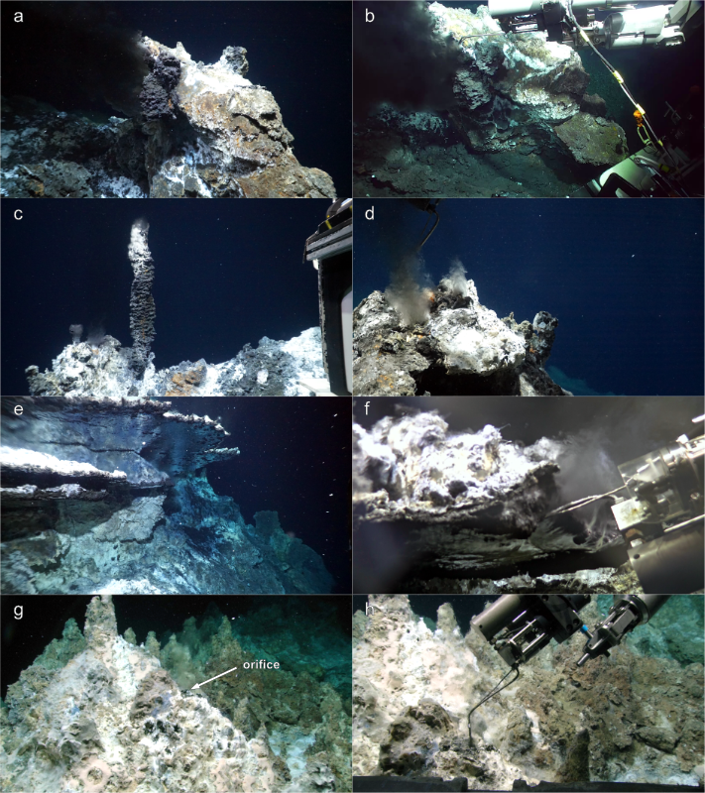
Supplementary Figure S2. Photographs of the four sampling sites at the Jøtul hydrothermal field. a–b: Sampling of 314°C black-smoker vent fluid at the hottest-most Fenris vent, which was formerly called “black smoker”². c–d: Vent orifice and sampling at Gyme. e–f: Mirror phenomenon at a flange structure of Yggdrasil and sample intake of the flange fluid. g–h: Orifice releasing shimmering fluids at Nidhogg vent and sampling of 214 °C clear fluids. Typical mineral paragenesis at high-temperature vents in the Jøtul hydrothermal field are: chalcopyrite + cubanite + sphalerite + anhydrite ± pyrrhotite². Low temperature outflows typically mineralize amorphous silica + barite + dolomite + calcite ± chalcopyrite². Seafloor photographs were taken by ROV MARUM Quest (©MARUM, University of Bremen).
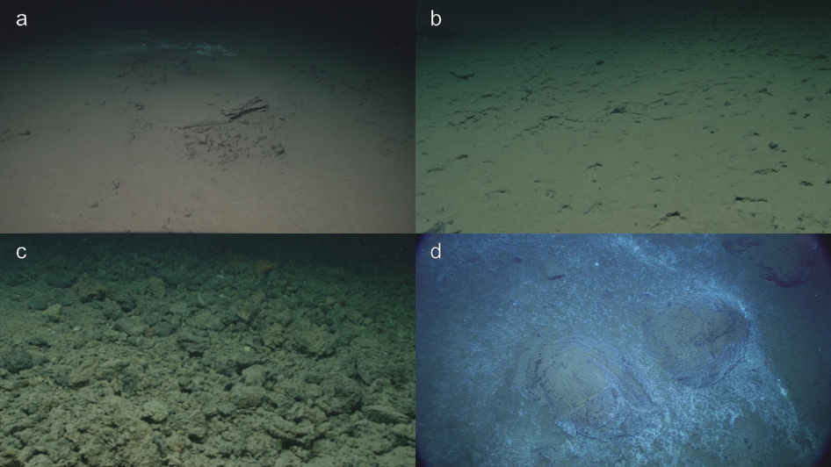
Supplementary Figure S3. Geology around the Jøtul hydrothermal field. a–b: Undisturbed sediment is the typical-most seafloor feature around the vent sites. c: Sulfide debris at the foot of the sulfide mound hosting Gyme indicates prolongued venting activity and processes of mass wasting. d: Sporadic outcrops of pillow basalts (here between Gyme and Fenris) point to either syn-sedimentary volcanic activity or locally thin sediment cover. Seafloor photographs were taken by ROV MARUM Quest (©MARUM, University of Bremen).

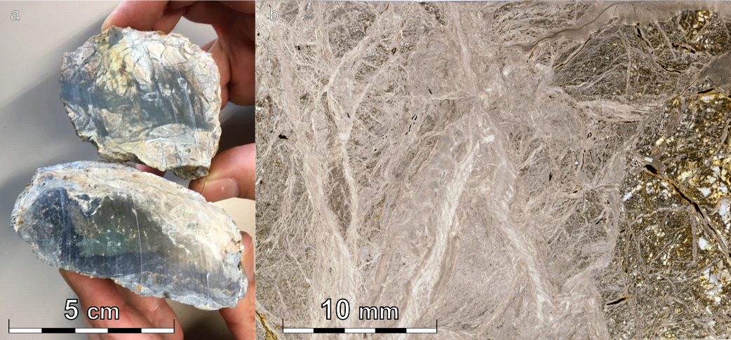
Supplementary Figure S4. Rock sample from the slope east of Yggdrasil. a: Soapstone (GeoB25026-2) recovered during cruise MSM109. b: Mesh texture in the rock sample as typically developed during silica-metasomatism of ultramafic-rocks.

Supplementary Table S5. Bulk-rock compositions of soapstone samples GeoB 25026-2 and GeoB25026-3 (former is shown in S4). The bulk compositions are close to the ideal composition of talc. The composition was determined by XRF analysis (see online methods). LOI: Loss On Ignition.
GeoB# | SiO₂ | TiO₂ | Al₂O₃ | FeO(t) | MnO | MgO | CaO | Na₂O | K₂O | P₂O₅ | Sum | LOI | Co | Cr | Ni
 | wt.% | wt.% | wt.% | wt.% | wt.% | wt.% | wt.% | wt.% | wt.% | wt.% | wt.% | wt.% | ppm | ppm | ppm
25026-2 | 58.5 | 0.007 | 0.35 | 3.17 | 0.031 | 30.3 | 0.10 | 0.11 | 0.01 | 0.014 | 93.2 | 6.8 | 39 | 1796 | 467
25026-3 | 57.5 | 0.009 | 0.36 | 3.43 | 0.034 | 30.1 | 0.04 | 0.19 | 0.02 | 0.011 | 92.5 | 7.5 | 41 | 1508 | 519

Supplementary Table S6. Vent fluid composition of individual IGT samples from the Jøtul field and composition of background seawater used to prime the sampler.
GeoB# | Vent-ID | T_{avg} | T_{max} | pH | Alk | Eh | Cond | B | Ba | Ca | Fe | K | Li | Mg | Mn
 |  | °C | °C |  | mM | mV | mS∙cm⁻¹ | mM | µM | mM | µM | mM | mM | mM | mM
26224-5 | seawater | - | - | n.m. | n.m | n.m. | n.m. | 0.41 | b.d.l. | 10.2 | b.d.l. | 10.1 | b.d.l. | 52.8 | b.d.l.
26252-3 | Gyme | 293  ± 1 | 298 | 5.76 | 4.5 | -297.6 | 49.5 | 2.42 | 37 | 34.9 | 33 | 22.2 | 1.48 | 1.9 | 0.18
26269-2 | Nidhogg | 213  ± 3 | 214 | 5.77 | 3.5 | -270.3 | 50.9 | 2.37 | 18 | 34.0 | 12 | 21.3 | 1.4 | 2.5 | 0.18
26269-4 | Fenris | 299  ± 15 | 314 | 5.82 | 4.2 | -299.8 | 50.1 | 2.42 | 5 | 34.9 | 28 | 21.8 | 1.42 | 4.1 | 0.21
26235-3 | Yggdrasil | 289  ± 0.3 | 289 | 5.66 | 4.5 | n.m. | 49.3 | 2.42 | 19 | 35.2 | 29 | 21.7 | 1.45 | 1.8 | 0.19
26280-2 | Yggdrasil | 272  ± 4 | 280 | 5.88 | 4.6 | -285.2 | 48.9 | 2.25 | 10 | 32.9 | 18 | 20.2 | 1.32 | 4.0 | 0.18
S6. continued
GeoB# | Vent-ID | Na | NH₄ | Si | Sr | Br | Cl | SO₄ | PO₄ | NO₃ | CO₂ | CH₄ | H₂ | H₂S
 |  | mM | mM | mM | µM | µM | mM | mM | µM | µM | mm | mM | mM | mM
26224-5 | seawater | 462 | n.m. | b.d.l. | 87 | 840 | 545 | 27.2 | n.m | n.m. | n.m. | n.m. | n.m. | n.m.
26252-3 | Gyme | 377 | 5.3 | 13.1 | 154 | 799 | 486 | 1.9 | 1.2  ± 0.1 | 6.1  ± 0.6 | 40.5  ± 0.5 | 64.7  ± 1.4 | 16.7  ± 0.1 | 1.4
26269-2 | Nidhogg | 372 | 1.7 | 10.6 | 152 | 785 | 482 | 2.1 | 0.8  ± 0.1 | 4.4  ± 0.6 | 36.0  ± 0.2 | 66.3  ± 0.5 | 16.9  ± 0.2 | 2.5
26269-4 | Fenris | 386 | 2.8 | 14.0 | 151 | 824 | 499 | 2.8 | 0.8  ± 0.1 | 5.1  ± 0.5 | 41.6  ± 0.8 | 61.0  ± 1.6 | 17.6  ± 0.5 | 1.1
26235-3 | Yggdrasil | 373 | 2.8 | 12.6 | 153 | 795 | 486 | 2.1 | 2.1  ± 0.1 | 5.8  ± 0.6 | 39.1  ± 0.4 | 49.7  ± 1.7 | 14.3  ± 0.5 | 0.9
26280-2 | Yggdrasil | 360 | 2.6 | 12.0 | 142 | 768 | 471 | 2.9 | 1.9  ± 0.1 | 6.5  ± 0.6 | 39.4  ± 0.4 | 57.1  ± 2.2 | 15.1  ± 0.6 | 1.4
mM: mmol∙l⁻¹;µM: mmol∙l⁻¹;mm: mmol∙kg⁻¹; n.m.: not measured; b.d.l.: below detection limit. T_{avg} represents the average temperature during sample intake. T_{max} represents the maximum measured temperature during the entire sampling process. CH₄ and H₂ concentrations were determined in triplicates from individual aliquots (± represents 1sde).
Supplementary Table S7. Compositions of light hydrocarbons and carbon, oxygen and hydrogen isotope ratios of CO₂, CH₄, H₂ and H₂O in the Jøtul vent fluids.
GeoB# | Vent-ID | C₁/(C₂-C₃) | δ¹³C-CO₂ | δ¹³C-CH₄ | δ²H-CH₄ | δ²H-H₂ | δ¹⁸O-H₂O | δ²H-H₂O
 |  |  | [‰ V-PDB] | [‰ V-PDB] | [‰ V-SMOW] | [‰ V-SMOW] | [‰ V-SMOW] | [‰ V-SMOW]
26252-3 | Gyme | 107.7 | -11.0 | -32.2 | -104.2 | -378.3 | 2.5 | 3.0
26269-2 | Nidhogg | 107.7 | -10.9 | -32.0 | -108.0 | -425.2 | 2.2 | 3.7
26269-4 | Fenris | 109.5 | -10.8 | -32.3 | -103.0 | -372.9 | 1.9 | 3.3
26235-3 | Yggdrasil | 107.8 | -11.7 | -31.9 | -103.3 | -378.4 | 2.3 | 4.0
26280-2 | Yggdrasil | 108.7 | -10.7 | -32.2 | -106.2 | -381.6 | 1.9 | 3.8

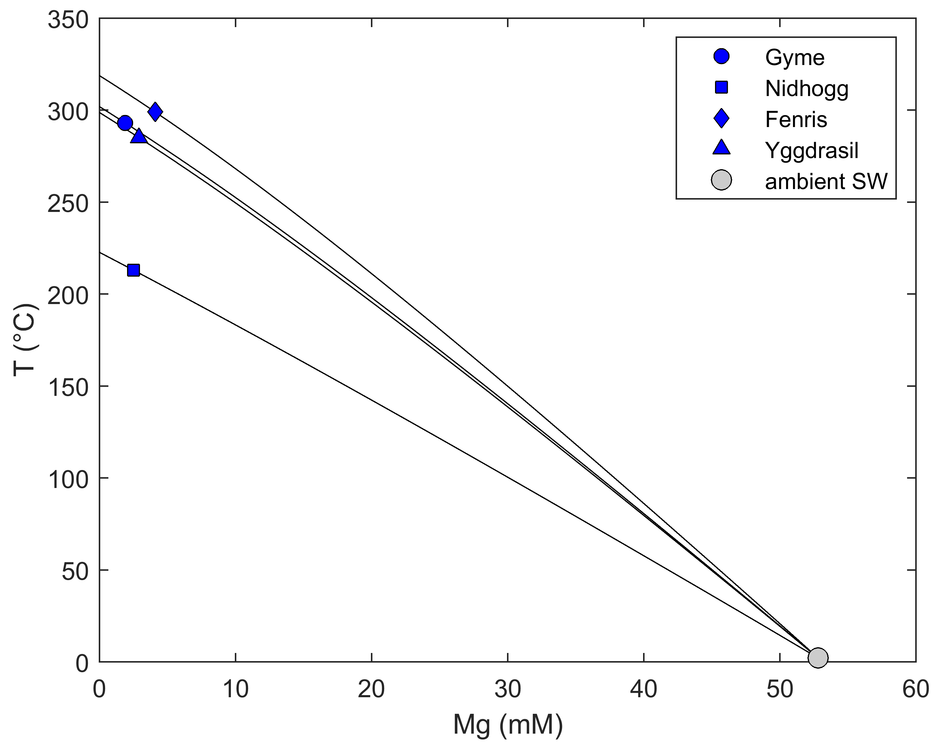
Supplementary Figure S8. Mixing paths of isenthalpic-isobaric mixing models between hydrothermal endmember fluids and ambient seawater. Endmember temperatures are the intercept of the mxing path at Mg=0. For Yggdrasil temperatures and Mg concentrations of the two samples (GeoB26235-3 & GeoB26280-2) were averaged.

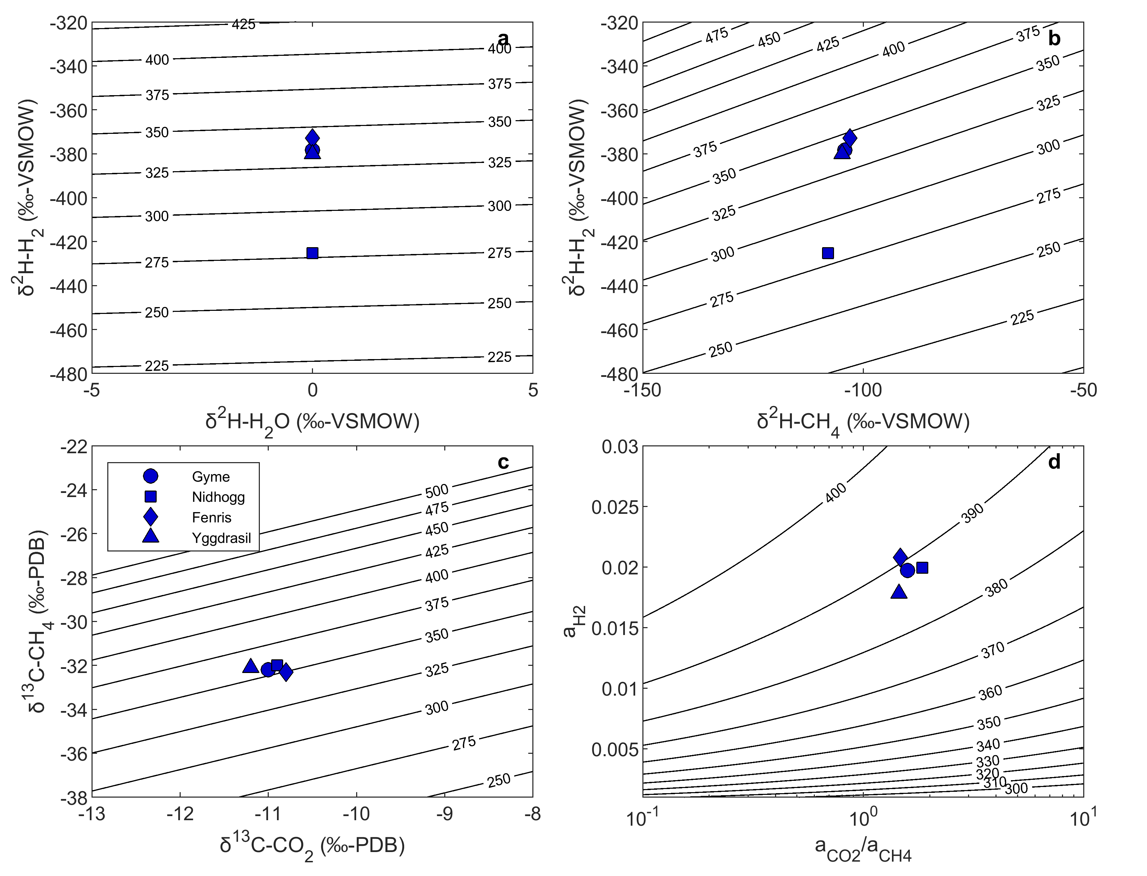
Supplementary Figure S9. Chemical and isotopic equilibrium temperatures for the Jøtul vent fluids. a: Isotope equilibrium temperatures for water vapor and di-hydrogen based on δ²H ratios. b: Isotope equilibrium temperature of Reaction 1 (see main text) based on δ²H ratios in CH₄ and H₂. c: Isotope equilibrium temperatures for Reaction 1 based on δ¹³C ratios in CH₄ and CO₂. d: Chemical equilibrium temperature of Reaction 1 based on H₂, CH₄ and CO₂ concentrations. Activity coefficients of unity were used for CO₂ and CH₄, while an activity coefficient of 1.18 was used for H₂. For the vent site Yggdrasil isotope ratios of the two samples (GeoB26235-3 & GeoB26280-2) were averaged.

Supplementary Table S10. Setup for reaction path models. Dissolved species concentrations are given in mM. Mineral composition is given in (wt.%).
 | #1 | 2# | #3
 | SW | SW heated | RxnZone  Fluid (W/R=1)
Br | 0.84 | 0.84 | 0.84
Ca | 10.2 | 23.6 | 32.7
Cl | 545 | 545 | 545
Fe | 3.00E-06 | 5.84E-05 | 0.21
pH | 7.8 | 6.3 | 5.35
C | 2.33 | 1.68 | 104.9
P | 2.58E-03 | 2.10E-06 | 1.00E-07
Mg | 52.8 | 1.06 | 0.048
K | 10.1 | 19.2 | 19.6
Mn | 2.10E-06 | 2.10E-06 | 2.10E-06
Na | 462 | 485 | 460
SO4 | 27.2 | 2.6 | 4.20E-11
Si | 0.129 | 4.2 | 15.9
H2 | 4.00E-07 | 0.17 | 18.8
Ni | 1.00E-06 | 1.00E-06 | 1.00E-06
Al | 3.10E-05 | 9.62E-03 | 0.085
N | 1.00E-04 | 1.00E-04 | 14
Albite | 24 | 24
Anorthite | 24 | 24
K-Feldspar | 12 | 12
Quartz | 20 | 19.78
Kaolinite | 10 | 10
Smectite-highFe-Mg | 10 | 10
Alanine | - | 0.11
Propane | - | 0.09
Cyseine | - | 0.02
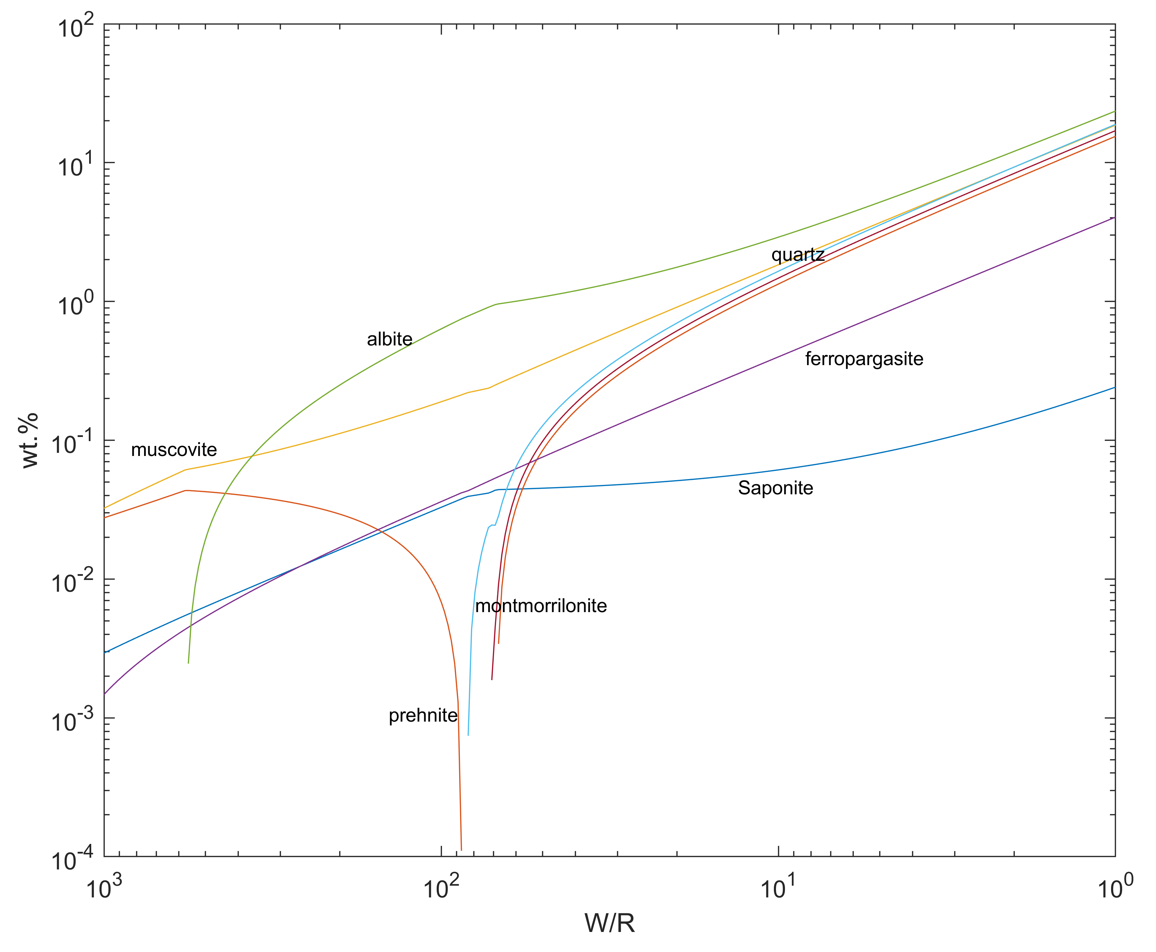
Supplementary Figure S11. Predicted alteration mineral assemblages during the reaction path modeling presented in Figure 5. W/R denotes the water to rock ratio and the y-axis shows the relative abundances of the minerals in weight percent (wt. %).

Supplementary references
1 Seewald, J. S., Doherty, K. W., Hammar, T. R. & Liberatore, S. P. A new gas-tight isobaric sampler for hydrothermal fluids. Deep Sea Research Part I: Oceanographic Research Papers 49, 189-196 (2002). https://doi.org/10.1016/s0967-0637(01)00046-2
2 Bohrmann, G. et al. Discovery of the first hydrothermal field along the 500-km-long Knipovich Ridge offshore Svalbard (the Jotul field). Scientific Reports 14, 10168 (2024). https://doi.org/10.1038/s41598-024-60802-3

