Supplementary Information

Composition, interactions and resulting inhalation risk of micro- and nano-plastics in urban air
Ankush Kaushik¹, Anju Elizbath Peter¹, Manuela van Pinxteren¹, Barbara M. Scholz-Böttcher² and Hartmut Herrmann¹*
¹Atmospheric Chemistry Department (ACD), Leibniz Institute for Tropospheric Research (TROPOS), Permoserstraße 15, Leipzig, 04318, Germany
² Institute for Chemistry and Biology of the Marine Environment (ICBM), Carl von Ossietzky University of Oldenburg, P.O. Box 5634, D-26046 Oldenburg, Germany
*Corresponding Author: Prof. Dr. Hartmut Herrmann (herrmann@tropos.de)
ORCID: https://orcid.org/0000-0001-7044-2101

Supplementary Table 1: List of quantified polymers with key pyrolysis markers, associated ions (m/z), masses for Single ion monitoring (SIM) measurements are given in bold, calibration linear equations, coefficients of determination (R²), limits of detection (LOD), and limits of quantification (LOQ) in absolute mass (µg) for the identified polymers.
Polymer | Cluster associated  compounds | Marker Pyrolyzate | Ions (m/z) | Linear Equation | R² | LOD  (µg) | LOQ  (µg)
C-PS | PS, PS-containing copolymers (e.g., ABS, SAN),  PS- or acryl styrene binders, varnish | 2,4,6-triphenyl-1-hexene  (Styrene trimer) | 91,117, 194, 207, 312 [M] | y = 0.7545x + 0.0039 | 0.99 | 0.01 | 0.03
C-PVC* | PVC (hard and plasticized),  chlorinated PE, chlorinated rubber; cluster is interfered by polymers related to soot/black carbon | Naphthalene | 51, 64, 102,128 [M] | y = 0.0602x + 0.0386 | 0.97 | 0.04 | 0.14
C-PET | PET, polybutylene terephthalate | Dimethyl terephthalate | 103,135, 163,194 [M] | y = 0.7474x - 0.0281 | 0.99 | 0.27 | 0.91
C-PMMA | PMMA, polyalkylated methacrylate,  acryl-containing binder | Methyl methacrylate | 69, 85 99, 100 [M] | y = 0.6761x + 0.0464 | 0.98 | 0.02 | 0.08
C-PC | PC, epoxide resin | 2,2-Bis(4’-methoxyphenyl) propane | 77, 133, 149, 241, 256 [M] | y = 7.6117x - 0.1245 | 0.98 | 0.02 | 0.06
C-PE | HDPE, LDPE, PE-containing copolymers and rubbers,  ethylene-vinyl acetate (EVA), EPDM rubber | Avg Alkadienes from C16 to C26 | e.g: C₁₇: 55, 67, 82, 95, 109, 236 [M] | One-point calibration | - | 0.1 | 0.3
C-PP | PP, EPDM rubber | 2,4, Dimethyl-1-heptene | 70, 83, 126 [M] | One-point calibration | - | 0.1 | 0.5
MDI-PUR | MDI-PUR,  MDI-PUR-based formulations | 4,4’-Methylenbis(N,Ndimethylaniline) | 134, 210, 253, 254 [M] | NA | - | - | -
C-PA6 | PA6 | ɛ-Caprolactam | 55, 84, 85, 113[M] | NA | - | - | -
C-PA6 | PA6 | N-methyl caprolactam | 55, 127[M] | NA | - | - | -
CTT |  | Cyclohexenylbenzene | 104,115, 129, 158 [M] | y = 0.0014x + 0.0016 | 0.99 | 0.12 | 0.39
TTT |  | 2,4-Dimethyl-4-vinylcyclohexene | 68, 93, 121, 136 [M] | y = 0.0092x - 0.0039 | 0.99 | 0.13 | 0.42
d₈-PS (IS) |  | d₈-PS Trimer | 98,126, 208, 222, 336[M] | - | - | - | -
NA: Not Available; IS: Internal Standard
Supplementary Table 2: Concentrations of airborne micro- and nano-plastics (MNPs) measured in the current study, categorized by polymer type and particle size. Polymers include Polymethyl Methacrylate (C-PMMA), Polyvinyl Chloride (C-PVC*), Polyethylene Terephthalate (C-PET), Polycarbonate (C-PC), Polystyrene (C-PS), car tire tread (CTT), truck tire tread (TTT), tire wear particles (TWPs), and Polypropylene (C-PP). Particle size classifications are PM₁₀MNPs (micro- and nano-plastic particles with aerodynamic diameters ≤10 µm), FMPs (fine microplastics; aerodynamic diameter ≤2.5 µm), and CMPs (coarse microplastics; aerodynamic diameter 2.5-10 µm). For each polymer and size category, the table presents minimum, maximum, average, and standard deviation (SD) concentrations (in nanograms per cubic meter, ng/m³). Ratios of FMPs/PM₁₀MNPs and CMPs/PM₁₀MNPs are also included to illustrate the relative distribution of particle sizes within each polymer type. Carbonaceous parameters reported include organic carbon (OC), elemental carbon (EC), total carbon (TC), primary organic carbon (POC), secondary organic carbon (SOC), and particulate organic matter (POM).
Polymers | PM Size | Concentration |  |  |  | FMPs/PM₁₀MNPs |  |  |  | CMPs/PM₁₀MNPs
 |  | Min | Max | Avg | SD | Min | Max | Avg | SD | Min | Max | Avg | SD
 |  | ng/m³ |  |  |  | Ratio
C-PMMA | PM₁₀MNPs | 4.9 | 23.4 | 14.3 | 6.1 | 0.3 | 1 | 0.6 | 0.2 | 0 | 0.7 | 0.4 | 0.2
C-PMMA | FMPs | 1.4 | 15.4 | 8.9 | 4.9
C-PMMA | CMPs | 0.4 | 8.4 | 5.4 | 2.7
C-PVC* | PM₁₀MNPs | 36.9 | 108.2 | 74.3 | 27 | 0.2 | 0.9 | 0.6 | 0.3 | 0.1 | 0.8 | 0.4 | 0.3
C-PVC* | FMPs | 10.5 | 102.5 | 42.8 | 26.1
C-PVC* | CMPs | 4.5 | 86.1 | 31.5 | 25.9
C-PET | PM₁₀MNPs | 7.4 | 56.5 | 29.6 | 15.8 | 0.1 | 1 | 0.6 | 0.3 | 0 | 0.9 | 0.4 | 0.3
C-PET | FMPs | 3 | 27.1 | 13.8 | 8.8
C-PET | CMPs | 0.2 | 50.7 | 15.8 | 17
C-PC | PM₁₀MNPs | 1.5 | 1.6 | 1.5 | 0 | 0.9 | 1 | 1 | 0 | 0 | 0.1 | 0 | 0
C-PC | FMPs | 1.4 | 1.6 | 1.4 | 0
C-PC | CMPs | 0 | 0.2 | 0.1 | 0
C-PS | PM₁₀MNPs | 0.5 | 2.4 | 1.1 | 0.5 | 0.1 | 0.7 | 0.3 | 0.2 | 0.3 | 0.9 | 0.7 | 0.2
C-PS | FMPs | 0 | 0.8 | 0.3 | 0.3
C-PS | CMPs | 0.3 | 2.1 | 0.8 | 0.5
CTT | PM₁₀MNPs | 160.1 | 632.4 | 362.4 | 146.6 | 0.2 | 1 | 0.5 | 0.2 | 0 | 0.8 | 0.5 | 0.2
CTT | FMPs | 39 | 336.6 | 185.6 | 73.3
CTT | CMPs | 2.7 | 487.2 | 176.8 | 126.7
TTT | PM₁₀MNPs | 9.9 | 46.8 | 24.2 | 12.2 | 0.2 | 0.9 | 0.6 | 0.2 | 0.1 | 0.8 | 0.4 | 0.2
TTT | FMPs | 2.5 | 25.7 | 14.7 | 7
TTT | CMPs | 1.2 | 32.4 | 9.5 | 9.2
TWPs | PM₁₀MNPs | 0.2 | 0.7 | 0.4 | 0.2 | 0.2 | 1 | 0.5 | 0.2 | 0 | 0.8 | 0.5 | 0.2
TWPs | FMPs | 0 | 0.4 | 0.2 | 0.1
TWPs | CMPs | 0 | 0.5 | 0.2 | 0.1
C-PP | PM₁₀MNPs | 0.9 | 6.1 | 2.5 | 1.6 | 0.1 | 0.9 | 0.3 | 0.2 | 0.1 | 0.9 | 0.7 | 0.2
C-PP | FMPs | 0.1 | 1.5 | 0.7 | 0.4
C-PP | CMPs | 0.2 | 5.8 | 2.1 | 1.9
C-PE | PM₁₀MNPs | 44.2 | 100.7 | 73.3 | 16 | 0.2 | 0.8 | 0.4 | 0.1 | 0.2 | 0.8 | 0.6 | 0.1
C-PE | FMPs | 16.2 | 52.9 | 32.8 | 11.8
C-PE | CMPs | 10.4 | 57.8 | 40.5 | 13.2
∑MNPs | ∑PM₁₀MNPs | 364.3 | 878.1 | 583 | 158.7 | 0.3 | 0.8 | 0.5 | 0.2 | 0.2 | 0.7 | 0.5 | 0.2
∑MNPs | ∑FMPs | 103.5 | 485.9 | 301.1 | 100.9
∑MNPs | ∑CMPs | 88.2 | 620.6 | 281.9 | 136.5
OC | PM₁₀ | 1980.6 | 3943.7 | 2949.2 | 717.4 | 0.6 | 0.8 | 0.7 | 0.1 | 0.0 | 0.4 | 0.3 | 0.1
OC | PM_{2.5} | 1272.4 | 3221.6 | 2113 | 741.5
OC | PM_{10-2.5} | 574.1 | 1279.9 | 832.2 | 191.7
EC | PM₁₀ | 286.5 | 488.2 | 393.2 | 65 | 0.8 | 1.1 | 0.9 | 0.1 | 0.0 | 0.2 | 0.1 | 0.1
EC | PM_{2.5} | 228.6 | 464.2 | 362.6 | 59.7
EC | PM_{10-2.5} | 0 | 100.4 | 31.5 | 42.8
POC | PM₁₀ | 1297.6 | 2627.6 | 2072.9 | 410.2 | 0.0 | 1.1 | 0.6 | 0.2 | 0.0 | 0.5 | 0.3 | 0.2
POC | PM_{2.5} | 838.9 | 1703.4 | 1330.7 | 219
POC | PM_{10-2.5} | 433.5 | 1204.4 | 817.1 | 225.1
SOC | PM₁₀ | 0 | 1787.8 | 876.4 | 498.5 | 0.0 | 1.4 | 0.7 | 0.5 | 0.0 | 1.0 | 0.2 | 0.3
SOC | PM_{2.5} | 0 | 1815.6 | 782.2 | 669.1
SOC | PM_{10-2.5} | 0 | 974.4 | 236.5 | 301.3
POM | PM₁₀ | 3169 | 6309.9 | 4718.8 | 1147.8 | 0.0 | 0.8 | 0.7 | 0.2 | 0.0 | 0.4 | 0.3 | 0.1
POM | PM_{2.5} | 2035.8 | 5154.5 | 3380.7 | 1186.4
POM | PM_{10-2.5} | 918.5 | 2047.8 | 1331.4 | 306.8

Supplementary Table 3: Summary of Micro- and nano-plastics (MNPs) concentrations from different global studies, including study location, sampling type, instrumentation, detected polymers, and reported concentrations.
Location | Type | Sample type | Instrumentation | Analysed polymers | Concentration | Study
Leipzig (Germany) | Urban | PM₁₀, PM_{2.5}, PM_{10-2.5} | Py-GC-MS | C-PMMA, C-PS, C-PP, C-PE, C-PVC*, C-PET, CTT, TTT | PM₁₀MNPs = 0.6±0.2 µg/m³  FMPs= 0.3±0.1 µg/m³  CMPs = 0.3±0.1 µg/m3 | This Study
Kaohsiung  Pingtung  Taichung  Tainan  Taipei  (Taiwan) | Urban | PM_{2.5} | TD/Py-GC-MS | PVC, PE, PP, PS | Kaohsiung = 68.97 ng/m³  Pingtung = 71.03 ng/m³  Taichung = 70.26 ng/m³  Tainan = 71.74 ng/m³  Taipei = 76.86 ng/m³ | ¹
Heihe Grand Canyon (China) | Remote | PM_{<100} | LDIR | PET, PS, PP, PE, PVC, PU, Nylon | 126 ng/m³ | ²
Southern New Zealand | Remote | TSP | Py-GC-MS | PET, PS, PP, PE, PVC, PMMA, Nylon | 65 ng/m³ | ³
Shanghai (China) | Urban | PM_{2.5} | Py-GC-MS | PS and PVC, PE | 5.6 µg/m³ | ⁴
Kyoto (Japan) | Urban | PM_{11-0.43} | Py-GC-MS | PE, PP, PS, PET, PA66, PA6, PMMA, ABS, SBR | 1.20 µg/m³ | ⁵
Sonblick obsevatory (Austria) | Remote high alpine | PM₁₀ and PM₁ | TD-PTR-MS | PE, PET, PP, PS, PVC, TWP | PM₁₀ = 35 ng/m³  PM₁ = 21 ng/m³ | ⁶
North-South Atlantic Ocean | Open Ocean | PM₁₀ | Py-GC-MS | PE, PP, PI, PS | 0.01 to 51.74 ng/m³ | ⁷
Beijing (China) | Urban | PM₁ | Py-GC-MS | PS | 23-149 pg/m³ | ⁸
Zhengzhou, Taiyuan, Guanzhou (China) | Urban | PM_{2.5} | Py-GC-MS/MS | PE | Zhengzhou= 5.0 pg/m³,  Taiyuan = 10.2 pg/m³,  Guangzhou = 5.2 pg/m³ | ⁹
Cartagena (Spain) | Urban | PM₁₀ and PM_{2.5} | Py-GC-MS | PS | PM₁₀ = 2.09 ng/m³  PM_{2.5} = 1.81 ng/m³ | ¹⁰
Graz Don Bosco (Austria) | Urban | PM_{2.5} | TD-PTR-MS | PE, PP, PET | PM_{2.5} = 238 ng/m³ | ¹¹
North Atlantic Ocean | Open Ocean | >PM₁₀ and PM₅₋₁₀ | Py-GC-MS | C-PP, C-PS, C-PET, C-PMMA, TWP, C-PE, C-MDI-PUR, C-PC, C-PA-6 | >PM₁₀=0.23 to 37.5 ng/m³;  PM₅₋₁₀ = LOQ to 1.82 ng/m³ | ¹²
Gothenburg (Sweden) | Urban and industrial Fjords | PM_{2.8} | Py-GC-MS | C-PP, C-PS, C-PET, C-PMMA, TWP, C-PE, C-MDI-PUR, C-PC, C-PA-6 | Average total of all Fjords = 100.71 ng/m³ | ¹³
Tokushima (Japan) | Urban | >PM₁₀, PM_{2.5-10}, PM_{2.5} | Py-GC-MS | PP, PS, SBR | >PM₁₀ = 4.47 ng/m³  PM_{2.5-10} = 1.57 ng/m³  PM_{2.5} = 2.13 ng/m³ | ¹⁴
Cartagena (Spain) | Urban | PM₁₀ | TGA-MS | PS | 36 ng/m³ | ¹⁵
Los Angeles (USA); London (UK); Greater Tokyo (Japan) | Urban | PM₁₀,  PM_{2.5} | Py-GC-MS | Tire Tread | PM₁₀:  London (UK): 0.62 µg/m³  Greater Tokyo (Japan): 0.15 µg/m³  PM_{2.5}:  Los Angeles (USA): 0.006 µg/m³  London (UK): 0.021 µg/m³  Greater Tokyo (Japan): 0.011 µg/m³ | ¹⁶
Seine (France), Chesapeake (USA), Yodo (Japan) | Urban | PM₁₀ | Py-GC-MS | Tire Tread | Seine (France): 0.135 µg/m³; Chesapeake (USA): 0.075 µg/m³;  Yodo (Japan): 0.055 µg/m³ | ¹⁷

Supplementary Table 4: Pairwise comparisons of polymer abundances between fine microplastics (FMPs) and coarse microplastics (CMPs) over 14 days. Differences were evaluated using the Wilcoxon signed-rank test (two-sided, n = 14). Significant differences (p < 0.05) are indicated, while consistent directional trends (FMPs > CMPs or CMPs > FMPs) are reported for non-significant results. These comparisons support the observed divergence in polymer composition between the two size fractions.
Polymer | n (pairs) | Median FMPs | Median CMPs | Median Difference  (FMPs-CMPs) | Wilcoxon  (W) | p-value | Direction
C-PC | 14 | 1.43 | 0.06 | 1.37 | 0 | 0.00098 | FMPs > CMPs
C-PMMA | 14 | 7.88 | 6.01 | 2.29 | 19 | 0.035 | FMPs > CMPs
C-PVC* | 14 | 40.74 | 25.78 | 16.41 | 35 | 0.272 | FMPs > CMPs (trend)
TTT | 14 | 15.28 | 6.65 | 10.22 | 25 | 0.084 | FMPs > CMPs (trend)
CTT | 14 | 194.6 | 148.37 | 12.71 | 43 | 0.551 | FMPs > CMPs (trend)
C-PP | 14 | 0.58 | 1.04 | −0.72 | 20 | 0.041 | CMPs > FMPs
C-PS | 14 | 0.25 | 0.67 | −0.51 | 13 | 0.013 | CMPs > FMPs
C-PE | 14 | 32.78 | 39.02 | −6.95 | 30 | 0.158 | CMPs > FMPs (trend)
C-PET | 14 | 10.73 | 10.97 | 1.61 | 48 | 0.778 | CMPs > FMPs (trend)

Supplementary Table 5: Pearson’s correlation coefficient (R) matrices among identified polymers - Polymethyl Methacrylate (C-PMMA), Polyvinyl Chloride (C-PVC*), Polyethylene Terephthalate (C-PET), Polycarbonate (C-PC), Polystyrene (C-PS), car tire tread (CTT), truck tire tread (TTT), tire wear particles (TWPs), Polypropylene (C-PP), Polyethylene (C-PE), and the sum of all quantified micro- and nano-plastics (∑MNPs) and carbonaceous species: organic carbon (OC), elemental carbon (EC), total carbon (TC), primary organic carbon (POC), secondary organic carbon (SOC), and particulate organic matter (POM). Results are presented for: a) PM₁₀MNPs (micro- and nano-plastic particles with aerodynamic diameters ≤10 µm), b) FMPs (fine microplastics; aerodynamic diameter ≤2.5 µm), and c) CMPs (coarse microplastics; aerodynamic diameter 2.5-10 µm). In the matrices, red boxes indicate correlation coefficients R < 0.5, and green boxes indicate R > 0.5 with a p-value < 0.05.
- PM₁₀MNPs:
 | C-PMMA | C-PVC* | C-PET | C-PC | C-PS | CTT | TTT | TWPs | C-PP | C-PE | ∑MNPs | OC | EC | TC | POC | SOC | POM
C-PMMA | 1.00
C-PVC* | 0.48 | 1.00
C-PET | 0.38 | 0.34 | 1.00
C-PC | 0.00 | 0.21 | -0.08 | 1.00
C-PS | 0.26 | 0.47 | 0.13 | 0.54 | 1.00
CTT | -0.15 | 0.03 | -0.33 | 0.64 | 0.58 | 1.00
TTT | 0.02 | 0.04 | -0.42 | 0.50 | 0.43 | 0.89 | 1.00
TWPs | -0.14 | 0.03 | -0.34 | 0.63 | 0.57 | 1.00 | 0.90 | 1.00
C-PP | 0.23 | -0.07 | 0.13 | 0.09 | -0.04 | -0.06 | 0.22 | -0.03 | 1.00
C-PE | 0.64 | 0.81 | 0.17 | 0.02 | 0.33 | -0.15 | -0.03 | -0.14 | -0.07 | 1.00
∑MNPs | 0.09 | 0.34 | -0.15 | 0.66 | 0.71 | 0.94 | 0.86 | 0.95 | -0.02 | 0.14 | 1.00
OC | 0.94 | 0.62 | 0.40 | 0.06 | 0.29 | -0.15 | -0.07 | -0.14 | -0.01 | 0.77 | 0.12 | 1.00
EC | 0.72 | 0.66 | 0.42 | 0.12 | 0.42 | 0.07 | 0.07 | 0.07 | 0.06 | 0.76 | 0.33 | 0.81 | 1.00
TC | 0.94 | 0.63 | 0.41 | 0.06 | 0.31 | -0.13 | -0.06 | -0.13 | 0.00 | 0.78 | 0.14 | 1.00 | 0.84 | 1.00
POC | 0.72 | 0.66 | 0.42 | 0.12 | 0.42 | 0.07 | 0.07 | 0.07 | 0.06 | 0.76 | 0.33 | 0.81 | 1.00 | 0.84 | 1.00
SOC | 0.93 | 0.53 | 0.34 | 0.02 | 0.20 | -0.22 | -0.13 | -0.22 | -0.04 | 0.68 | 0.01 | 0.97 | 0.63 | 0.95 | 0.63 | 1.00
POM | 0.94 | 0.62 | 0.40 | 0.06 | 0.29 | -0.15 | -0.07 | -0.14 | -0.01 | 0.77 | 0.12 | 1.00 | 0.81 | 1.00 | 0.81 | 0.97 | 1.00

b) FMPs:
 | C-PMMA | C-PVC* | C-PET | C-PC | C-PS | CTT | TTT | TWPs | C-PP | C-PE | ∑FMPs | OC | EC | TC | POC | SOC | POM
C-PMMA | 1.00
C-PVC* | 0.32 | 1.00
C-PET | 0.78 | 0.14 | 1.00
C-PC | 0.42 | 0.11 | 0.11 | 1.00
C-PS | 0.57 | 0.11 | 0.55 | 0.10 | 1.00
CTT | 0.36 | 0.29 | 0.42 | 0.34 | 0.17 | 1.00
TTT | 0.61 | 0.28 | 0.34 | 0.49 | 0.31 | 0.55 | 1.00
TWPs | 0.40 | 0.30 | 0.42 | 0.37 | 0.19 | 1.00 | 0.61 | 1.00
C-PP | 0.56 | 0.60 | 0.17 | 0.60 | 0.16 | -0.01 | 0.42 | 0.02 | 1.00
C-PE | 0.76 | 0.46 | 0.55 | 0.22 | 0.37 | 0.22 | 0.45 | 0.25 | 0.61 | 1.00
∑FMPs | 0.59 | 0.57 | 0.55 | 0.37 | 0.30 | 0.92 | 0.66 | 0.93 | 0.29 | 0.52 | 1.00
OC | 0.84 | 0.45 | 0.75 | 0.35 | 0.52 | 0.44 | 0.52 | 0.47 | 0.51 | 0.71 | 0.67 | 1.00
EC | 0.53 | 0.39 | 0.44 | 0.59 | 0.22 | 0.77 | 0.68 | 0.79 | 0.34 | 0.26 | 0.80 | 0.72 | 1.00
TC | 0.83 | 0.45 | 0.73 | 0.39 | 0.50 | 0.49 | 0.55 | 0.52 | 0.51 | 0.68 | 0.70 | 1.00 | 0.77 | 1.00
POC | 0.53 | 0.39 | 0.44 | 0.59 | 0.22 | 0.77 | 0.68 | 0.79 | 0.34 | 0.26 | 0.80 | 0.72 | 1.00 | 0.77 | 1.00
SOC | 0.80 | 0.36 | 0.74 | 0.11 | 0.56 | 0.12 | 0.28 | 0.14 | 0.47 | 0.80 | 0.40 | 0.91 | 0.36 | 0.87 | 0.36 | 1.00
POM | 0.84 | 0.45 | 0.75 | 0.35 | 0.52 | 0.44 | 0.52 | 0.47 | 0.51 | 0.71 | 0.67 | 1.00 | 0.72 | 1.00 | 0.72 | 0.91 | 1.00

c) CMPs:
 | C-PMMA | C-PVC* | C-PET | C-PC | C-PS | CTT | TTT | TWPs | C-PP | C-PE | ∑CMPs | OC | EC | TC | POC | SOC | POM
C-PMMA | 1.00
C-PVC* | 0.00 | 1.00
C-PET | 0.25 | -0.05 | 1.00
C-PC | 0.29 | -0.25 | 0.12 | 1.00
C-PS | -0.08 | -0.08 | 0.25 | 0.08 | 1.00
CTT | -0.48 | 0.07 | -0.29 | 0.16 | 0.60 | 1.00
TTT | -0.37 | 0.04 | -0.37 | 0.31 | 0.38 | 0.83 | 1.00
TWPs | -0.48 | 0.07 | -0.30 | 0.17 | 0.59 | 1.00 | 0.85 | 1.00
C-PP | 0.23 | -0.02 | -0.18 | 0.37 | -0.20 | 0.12 | 0.38 | 0.14 | 1.00
C-PE | 0.10 | 0.32 | 0.02 | 0.23 | 0.28 | 0.08 | 0.21 | 0.09 | 0.22 | 1.00
∑CMPs | -0.41 | 0.28 | -0.17 | 0.17 | 0.62 | 0.96 | 0.82 | 0.96 | 0.15 | 0.25 | 1.00
OC | -0.30 | 0.27 | 0.00 | 0.17 | 0.61 | 0.41 | 0.27 | 0.40 | -0.10 | 0.52 | 0.47 | 1.00
EC | 0.60 | -0.39 | -0.08 | 0.04 | -0.24 | -0.59 | -0.33 | -0.58 | 0.08 | 0.37 | -0.59 | -0.30 | 1.00
TC | -0.18 | 0.19 | -0.02 | 0.19 | 0.58 | 0.29 | 0.21 | 0.28 | -0.08 | 0.62 | 0.36 | 0.97 | -0.08 | 1.00
POC | 0.60 | -0.39 | -0.08 | 0.04 | -0.24 | -0.59 | -0.33 | -0.58 | 0.08 | 0.37 | -0.59 | -0.30 | 1.00 | -0.08 | 1.00
SOC | -0.54 | 0.40 | 0.05 | 0.10 | 0.55 | 0.61 | 0.37 | 0.60 | -0.11 | 0.15 | 0.65 | 0.85 | -0.76 | 0.71 | -0.76 | 1.00
POM | -0.30 | 0.27 | 0.00 | 0.17 | 0.61 | 0.41 | 0.27 | 0.40 | -0.10 | 0.52 | 0.47 | 1.00 | -0.30 | 0.97 | -0.30 | 0.85 | 1.00

Supplementary Table 6: Estimated Relative Risk (RR) and Attributable Fraction (AF) for cardiopulmonary and lung cancer mortality due to inhalation of airborne MNPs was calculated using^{1,18,19}.
 | Relative Risk (RR) |  | Attributable Fraction (AF)
 | Cardiopulmonary  mortality | Lung cancer  mortality | Cardiopulmonary mortality | Lung cancer mortality
Min | 1.06 | 1.09 | 0.05 (5%) | 0.08 (8%)
Max | 1.10 | 1.15 | 0.09 (9%) | 0.13 (13%)
Avg | 1.08 | 1.12 | 0.07 (7%) | 0.11 (11%)
SD | 0.01 | 0.02 | 0.01 (1%) | 0.01 (1%)

Supplementary Table 7: Polymer Hazard Index (PHI) values for identified polymers, including hazard categories based on physicochemical and toxicological properties.
Polymer | % Contribution in PM₁₀MNPs (P_{n}) | Hazard Score (S_{n}) | Polymer Hazard Index (PHI) | Hazard Category | Associated Chemicals | Health Impacts | Reference
C-PMMA | 2.6 | 1021 | 2613 | V | Methyl methacrylate | Respiratory irritation, skin sensitization | ²⁰
C-PVC* | 13.2 | 10551 | 139323 | V | Vinyl chloride | Carcinogenicity and mutagenicity | ²⁰
C-PET | 5.4 | 4 | 22 | III | Ethylene glycol, Terephthalic acid | Respiratory, fetal development and hepatic function issues | ^{21–23}
C-PC | 0.3 | 1177 | 325 | IV | Bisphenol A | Tissue damage, redox homeostasis in the ²⁴liver | ²⁴
C-PS | 0.2 | 30 | 6 | II | Styrene | Reproductive toxicity, disrupts cellular integrity | ²⁵
CTT** | 60.6 | 20001 | 1212661 | V | Benzothiazoles, 6-PPDQ | Acute toxicity, oxidative stress, chronic respiratory and cardiovascular issues | ^{26,27}
TTT** | 4.0 | 20001 | 80170 | V | Benzothiazoles, 6-PPDQ | Acute toxicity, oxidative stress, chronic respiratory and cardiovascular issues | ^{26,27}
C-PP | 0.4 | 1 | 0.4 | I | Propylene | Endocrine disruption | ²⁸
C-PE | 13.3 | 11 | 146 | IV | Ethylene | Neurotoxic effect and neurodegenerative disease | ^{29,30}
**Hazard Score of 1,3-butadiene was considered to calculate the PHI for CTT and TTT. All the Hazard Scores were taken from Lithner et al.,²⁰
Supplementary Table 8: List of polymer standards used in the study, including their acronyms, additional characteristics, and suppliers.
Polymer standard | Acronym | Additional  information | Supplier | Solvent used to dissolve
Polyamide 6 (K891), Alkulon®  K222-D | C-PA6 | Low viscosity | Ter Hell, GmbH, Hamburg,  Germany | Dichloromethane
Polycarbonate, Markoplon 2558 | C-PC |  | Bayer Material, Science | Dichloromethane
Polyethylene, Lupolen 4261 AG  UV | C-PE | High density | LyondellBasell
Polyethylene terephthalate,  NEOPET 80 | C-PET |  | Neogroup | Hexafluoro isopropanol
Polymethyl methacrylate,  PLEXIGLAS® 7N | C-PMMA |  | Plexiglas® | Acetone
Polypropylene, HL508FB | C-PP |  | Borealis
Polystyrene, TOTAL C-PS  impact 7240 | C-PS | High-impact C-PS for  extrusion industry | Ter Hell, GmbH, Hamburg,  Germany | Dichloromethane
Polystyrene, Styrolution C-PS 158N/L | C-PS | Raw material | IINEOS Styrosolution | Dichloromethane
Deuterated poly(styrene-d8)  P41212-dPS | d₈-PS |  | Polymer Source ^{TM}, Inc.  Canada | Dichloromethane
Polyurethane | MDI-PUR | MDI-PUR | GEBA GmbH
Polyvinylchloride, Vinnolit S3268 | C-PVC | Hard C-PVC, raw  material | Vinnolit | Tetrahydrofuran and Dichloromethane
All-season truck tire tread | TTT |  | Goodyear Tire & Rubber  Company
All-season car tire tread | CTT |  | Semperit (Continental AG)
Adapted from Goßmann et al.,³¹
Supplementary Table 9: Summary of operating conditions for the pyrolysis-GC-MS system, including details of the micro furnace pyrolyzer, gas chromatograph, and mass spectrometer settings.
Micro furnace pyrolyzer (EGA/PY-3030D, FrontierLabs)
Carrier gas | Helium
Temperature | 590°C
Pyrolysis time | 1 min
Transfer line temperature | 320°C
Gas chromatograph (6890 N (Agilent)
Injector | Split/split less
Mode | SIM; Split 1:12.5
Temperature | 300°C
Pre-Column | Trajan P/N 064062; 3 m x 250 µm/363 µm VSPD  Tubing
Column | DB5 (J&W); 30 m x 0.25 mm ID, film thickness  0.25 µm
Flow (constant) | 1.2 mL/min
Temperature program | 35°C (2 min) 310°C (30 min) at 4°C/min  hold 60 min
Transfer line temperature | 280°C
Mass spectrometer (MSD 5973, Agilent)
Ionization energy | 70 eV
Scan rate | 2.91 scans/s
Scan range | m/z 50 - 550
EI-source temperature | 230°C
Quadrupole temperature | 150°C

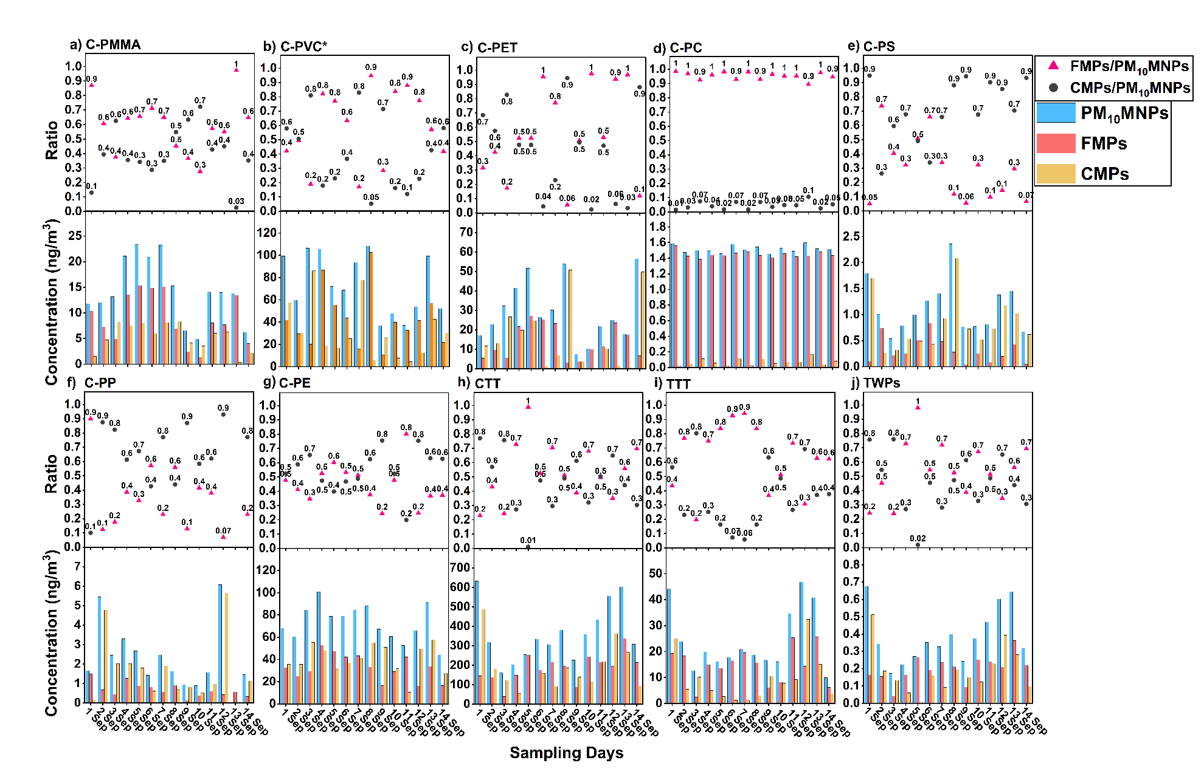
Supplementary Figure 1: Temporal and size-fractional polymer trends of micro- and nano-plastics (MNPs) over the sampling period in airborne samples.
Top panels (a-j) show relative contributions of fine microplastics (FMPs) and coarse microplastics (CMPs) to PM₁₀MNPs, expressed as FMPs/PM10MNPs (red triangle) and CMPs/PM₁₀MNPs (black circles) ratios, respectively. Bottom panels show daily mass concentrations (ng/m³) of polymers in PM₁₀MNPs (blue bar), FMPs (orange bar), and CMPs (yellow bar) for: (a) Polymethyl methacrylate (C-PMMA), (b) Polyvinyl chloride (C-PVC*), (c) Polyethylene terephthalate (C-PET), (d) Polycarbonate (C-PC), (e) Polystyrene (C-PS), (f) Polypropylene (C-PP), (g) Polyethylene (C-PE), (h) Car tire tread (CTT), (i) Truck tire tread (TTT), and (j) Tire wear particles (TWPs = CTT+TTT).

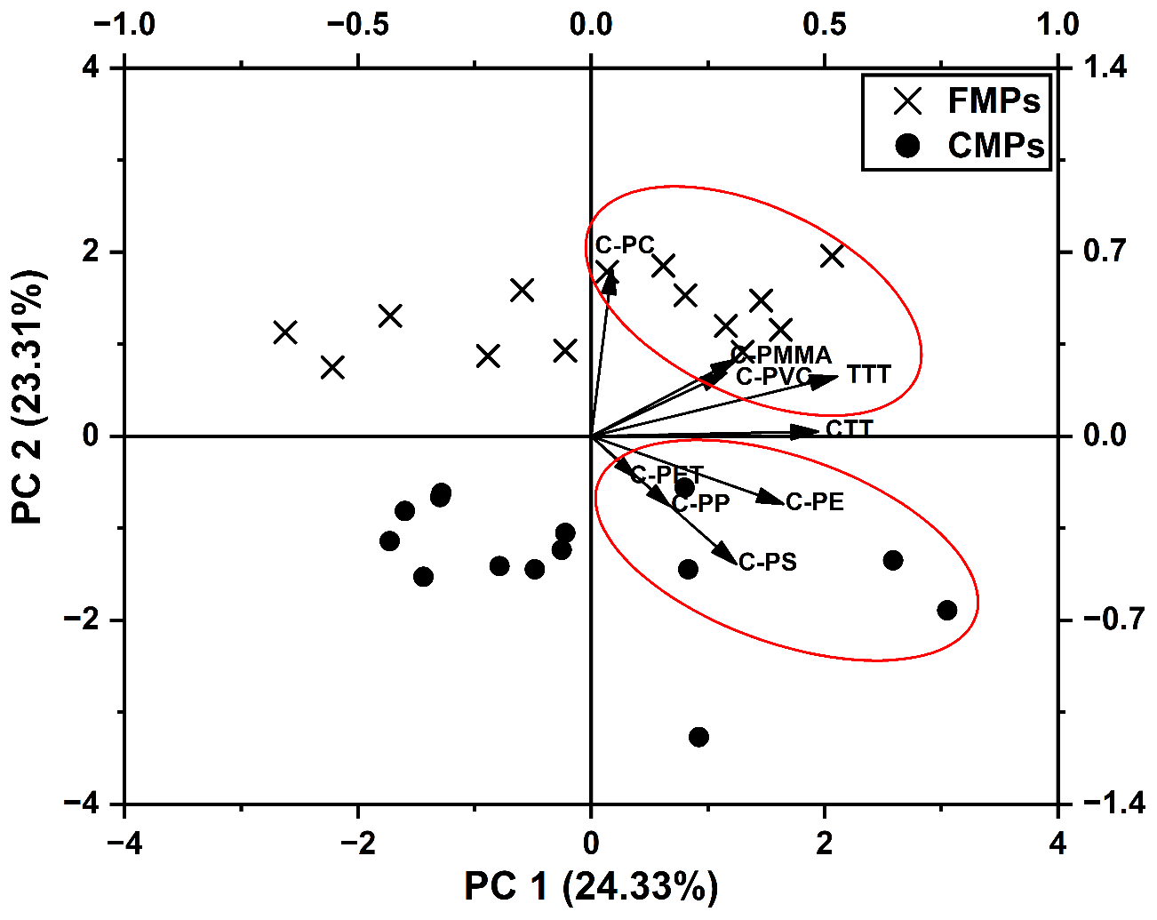
Supplementary Figure 2: Principal Component Analysis (PCA) of polymer abundances in fine (FMPs) and coarse (CMPs) microplastics. The first two components explain ~48% of the variance and reveal distinct clustering of the two size fractions. FMPs are associated with polycarbonate (C-PC), polymethyl methacrylate (C-PMMA), polyvinyl chloride (C-PVC*), and truck tire tread (TTT), whereas CMPs cluster with polyethylene (C-PE), polypropylene (C-PP), polyethylene terephthalate (C-PET), and polystyrene (C-PS). Red ellipses represent 95% confidence intervals for each fraction. This multivariate analysis highlights the polymer groups driving compositional divergence between size classes.

Supplementary Section S1

Meteorology and MNPs
As discussed in section 2.1, meteorology significantly impacts MNPs concentration and distribution. Meteorological data were procured from the Leipzig Institute for Meteorology-LIM (University of Leipzig).

Influence of Rainfall:
Over the two weeks campaign, it has been observed that there were three major rain events on the 8-9th and 14th of September 2022 (Supplementary Figure 6a). These events distinctly reduced PM₁₀ and CMP concentrations, signifying that rainfall acts as a natural scavenger of MNPs via wet deposition^{32–34}. FMPs concentrations showed a gradual decrease compared to CMPs and PM₁₀ MNPs, indicating less impact of rain events on fine particles³⁵. Although rain effectively reduces atmospheric MNPs, concentration may rise again in a few days (September 10 to September 13, 2022; Supplementary Figure 6a), likely attributed to the surface resuspension. This highlights that rain events provide only temporary reductions in MNPs concentrations, particularly in urban areas with continuous particle emissions.

Influence of relative humidity:
Higher relative humidity (RH) is generally associated with lower MNPs concentrations, likely due to enhanced particle hygroscopicity and deposition rates ³⁶. This trend is evident in CMPs, particularly during September 3-5, 9-11, and 13-14, when concentrations reduced as particles absorb moisture, increased in mass and were removed via gravitational settling (Supplementary Figure 6b). However, Hasnatul et al.³³ did not observe an increased abundance in MNPs with elevated RH, corroborating with the present study’s findings that FMPs are less affected by RH compared to PM₁₀ MNPs. Hong et al.³⁷ observed that the influence of humidity on PM_{2.5} varies with chemical composition; some fine particles may exhibit hygroscopic growth yet remain airborne, while others aggregate and settle more readily.

Influence of temperature and solar flux:
The temperature and solar flux are interrelated factors which influence suspended PM (Supplementary Figure 6c and d). The present study observed a direct relationship of temperature and solar flux with FMPs but an inverse relationship with CMPs, particularly during September 1-5, 2022, when both parameters are high as compared to the other sampling days (Supplementary Figure 6c and d). The interaction of temperature and UV rays can degrade plastics via oxidative reactions^{38,39}. The elevated temperature can accelerate the ageing of microplastics⁴⁰ and enhance their resuspension into the atmosphere from surfaces⁴¹.

Role of speed and direction of winds:
The amount of MNPs in the atmosphere is correlated with urban density and anthropogenic activity and is influenced by wind speed and direction⁴². Wind dynamics play a critical role in the dispersion and transport of microplastics in urban environments, influencing their distribution and potential health impacts⁴³. Supplementary Figure 7 illustrates the relationship between wind patterns and concentrations of MNPs at the roadside sampling site. The current study site experienced relatively low wind speed (1.0 to 2.1 m/s) due to the complex urban environment with building geometries that affect airflow patterns. Hence, the study site is influenced by local wind flow. Interestingly, the distribution of microplastics did not strictly align with wind patterns, suggesting a significant influence of local traffic emissions and resuspension processes. This observation, particularly for CMPs, aligns with the findings by Chen et al.⁴⁴, who reported that larger particles are prone to wind-induced resuspension and are more primarily linked to local sources than long-range transport. The proximity of the sampling site to a heavily trafficked road and near a few plastic processing industries likely contributed to the MNPs during the campaign. The existence of MNPs (especially FMPs) in urban outdoor environments suggests their potential for long-range atmospheric transport influenced by wind speed and direction⁴⁵.
The meteorological parameters interact in complex ways to influence atmospheric MNP concentrations. The distribution of MNPs in various particle sizes is crucial in analysing their transport and deposition dynamics. This underscores the need for integrated, long-term studies to understand atmospheric MNPs across diverse geographical and climatic settings.
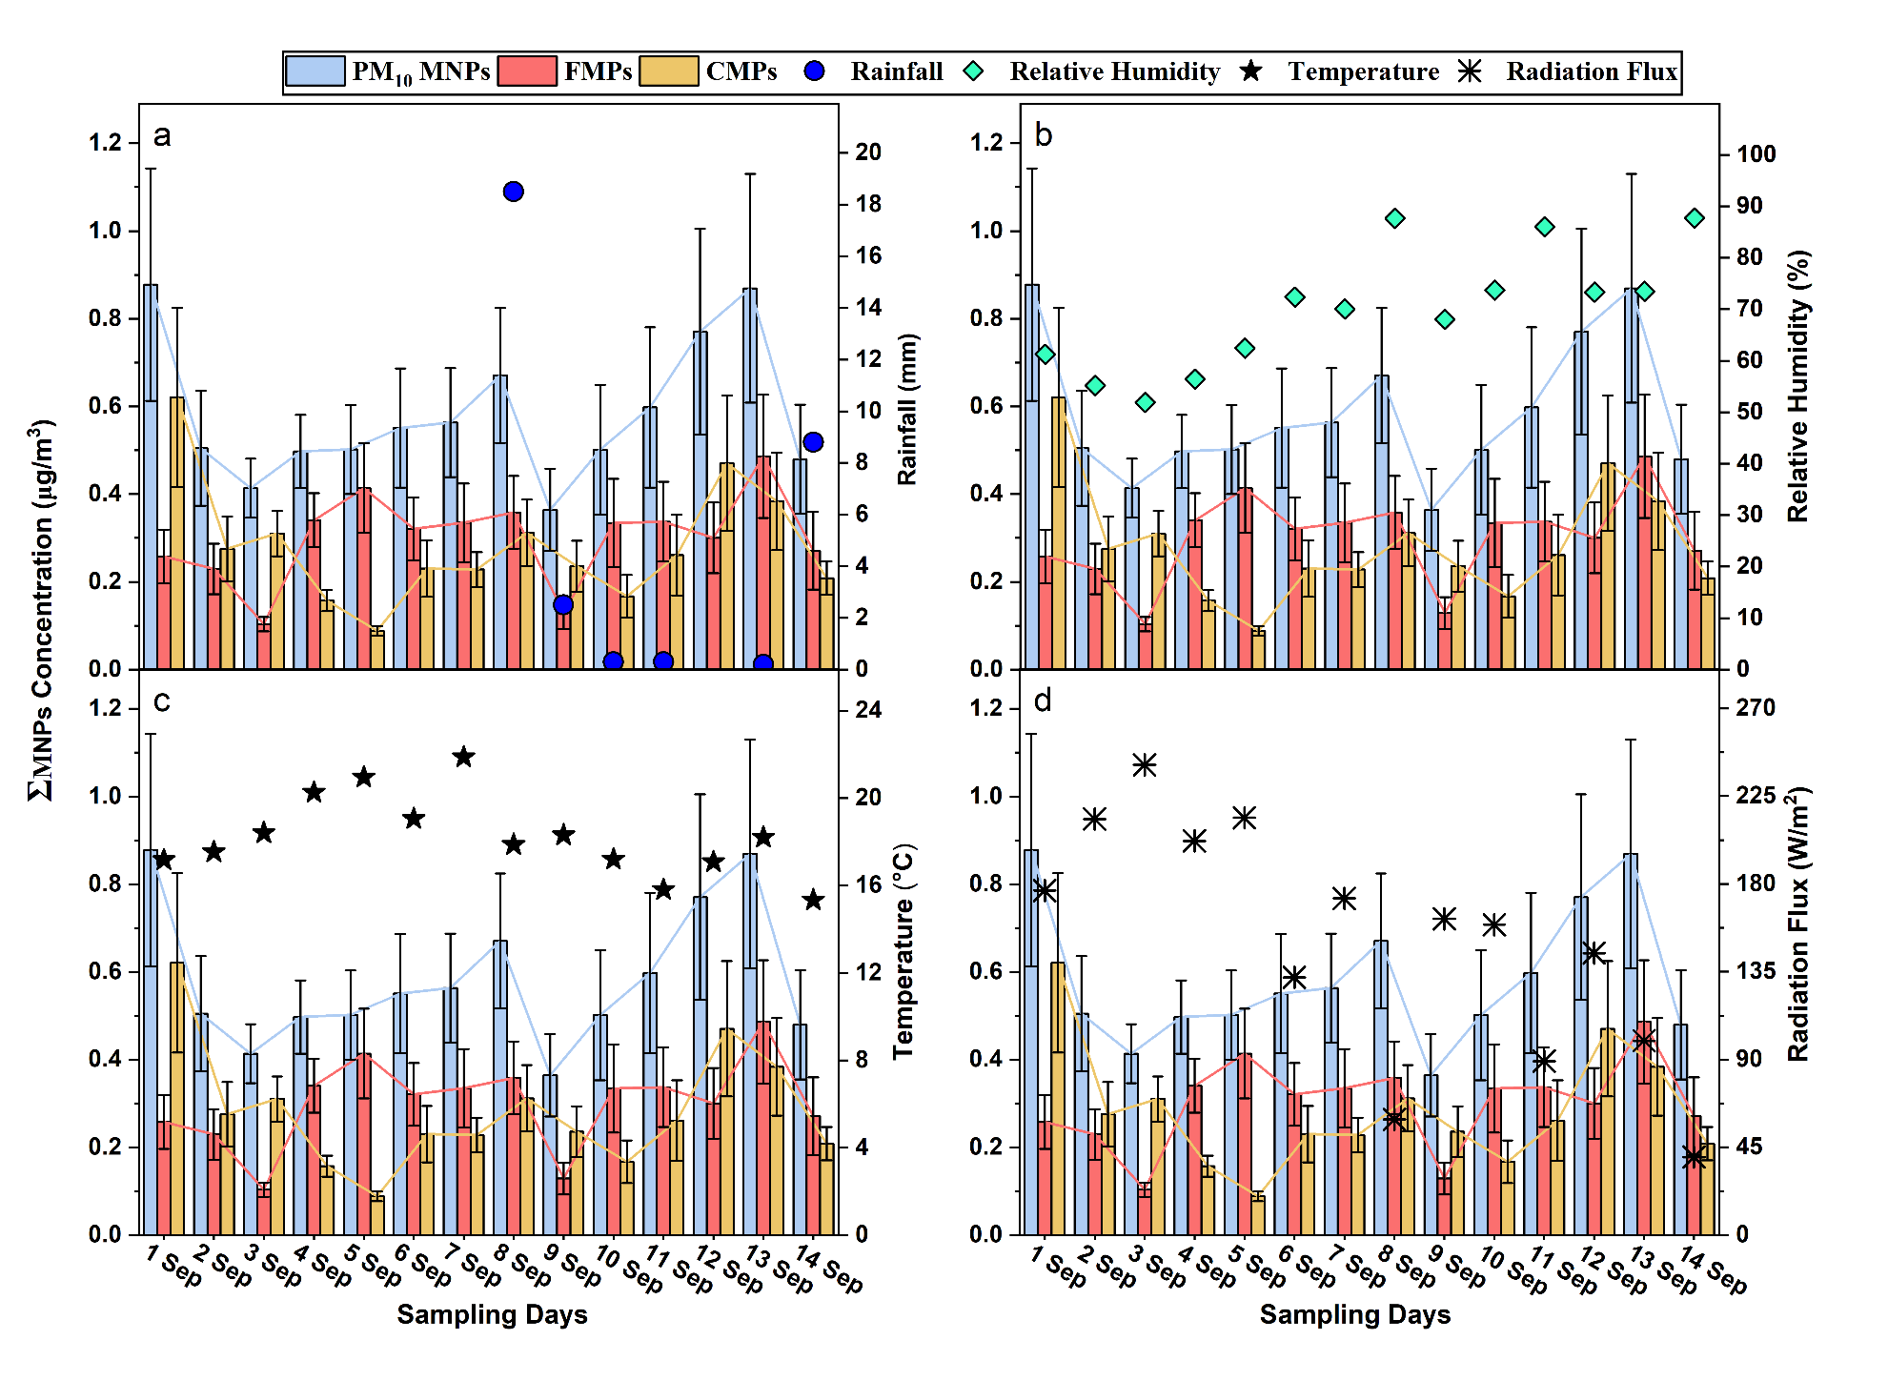
Supplementary Figure 3: Temporal variation of micro- and nano-plastics (MNPs) and meteorological parameters.
Daily concentrations of total MNPs (ΣMNPs) in PM₁₀ (blue bar), fine microplastics (FMPs; orange bars), and coarse microplastics (CMPs; yellow bars) compared with meteorological variables during the study period. a) ΣMNPs concentrations with daily rainfall (blue circles). b) ΣMNPs concentrations with relative humidity (green diamonds). c) ΣMNPs concentrations with temperature (black stars). d) ΣMNPs concentrations with radiation flux (black asterisks). Error bars represent standard deviations.
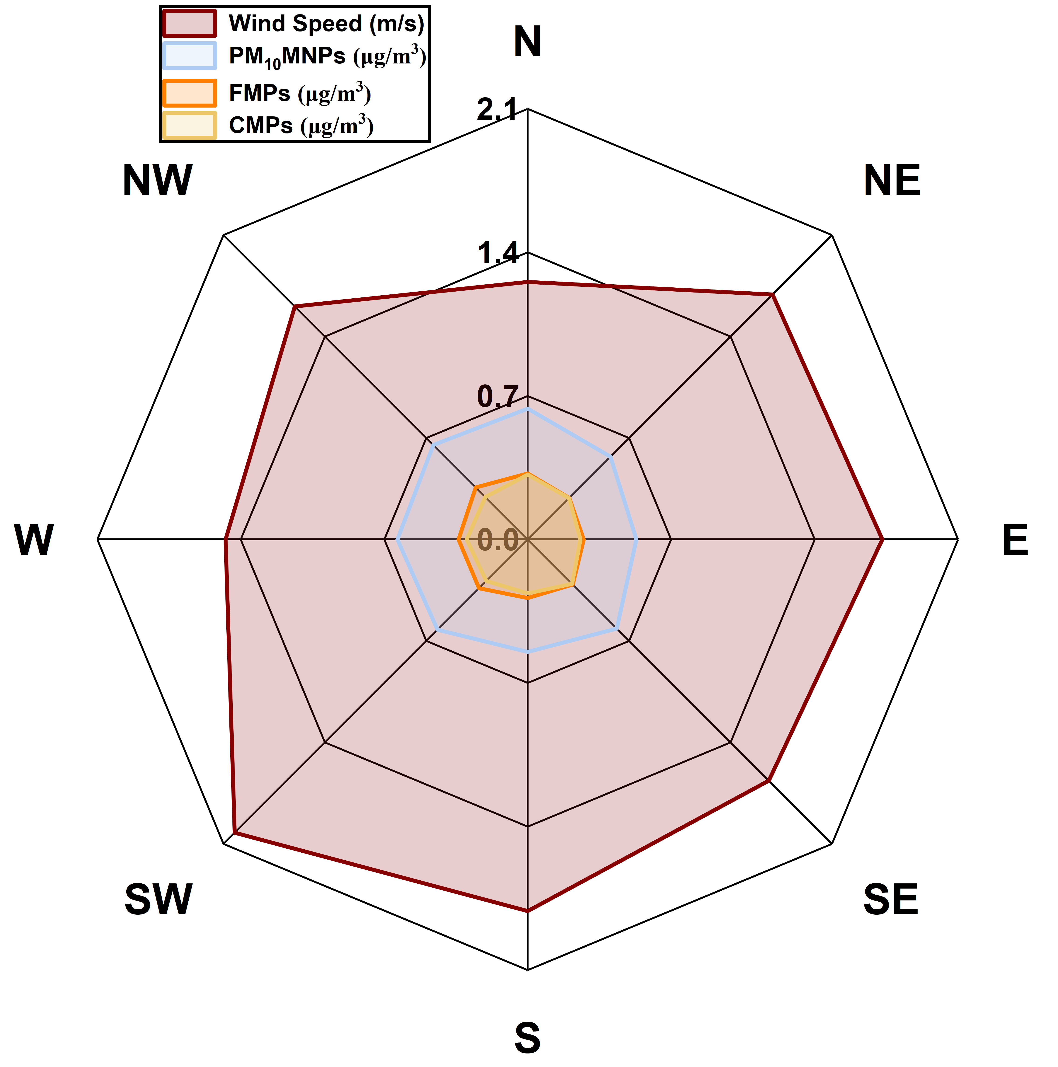
Supplementary Figure 4: Directional distribution of wind speed and micro- and nano- plastics (MNPs) concentrations.
Radar plot showing the relationship between wind speed (red) and concentrations of total MNPs (PM₁₀MNPs, blue), fine microplastics (FMPs; orange), and coarse microplastics (CMPs; yellow) across different wind directions during the study period.
Supplementary Figure 5: Calibration plots for quantification of polymer standards via Py-GC-MS.
Calibration plots for different polymer standards used in the study: (a) Polystyrene (C-PS), (b) Polycarbonate (C-PC), (c) Polyethylene terephthalate (C-PET), (d) Polymethyl methacrylate (C-PMMA), (e) Polyvinyl chloride (C-PVC*), (f) Car tire tread (CTT), and (g) Truck tire tread (TTT). The plots display the linear relationship between polymer amount (µg) and pyrolysis product peak area ratio (PAR) with the internal standard (IS), with 95% confidence (dark) and prediction (light) bands. High coefficients of determination (R² > 0.97) indicate strong correlations for all polymers.
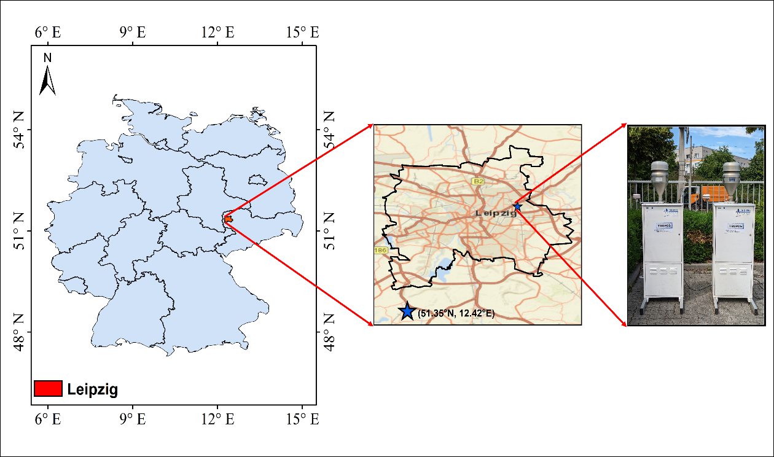
Supplementary Figure 6: Sampling location map for airborne micro- and nano- plastics (MNPs) collection.
This is a geographical map (created by QGIS software) of Leipzig (red color), Germany (blue map), showing the urban sampling site (blue star) at Torgauer Straße with traffic and local emission context.

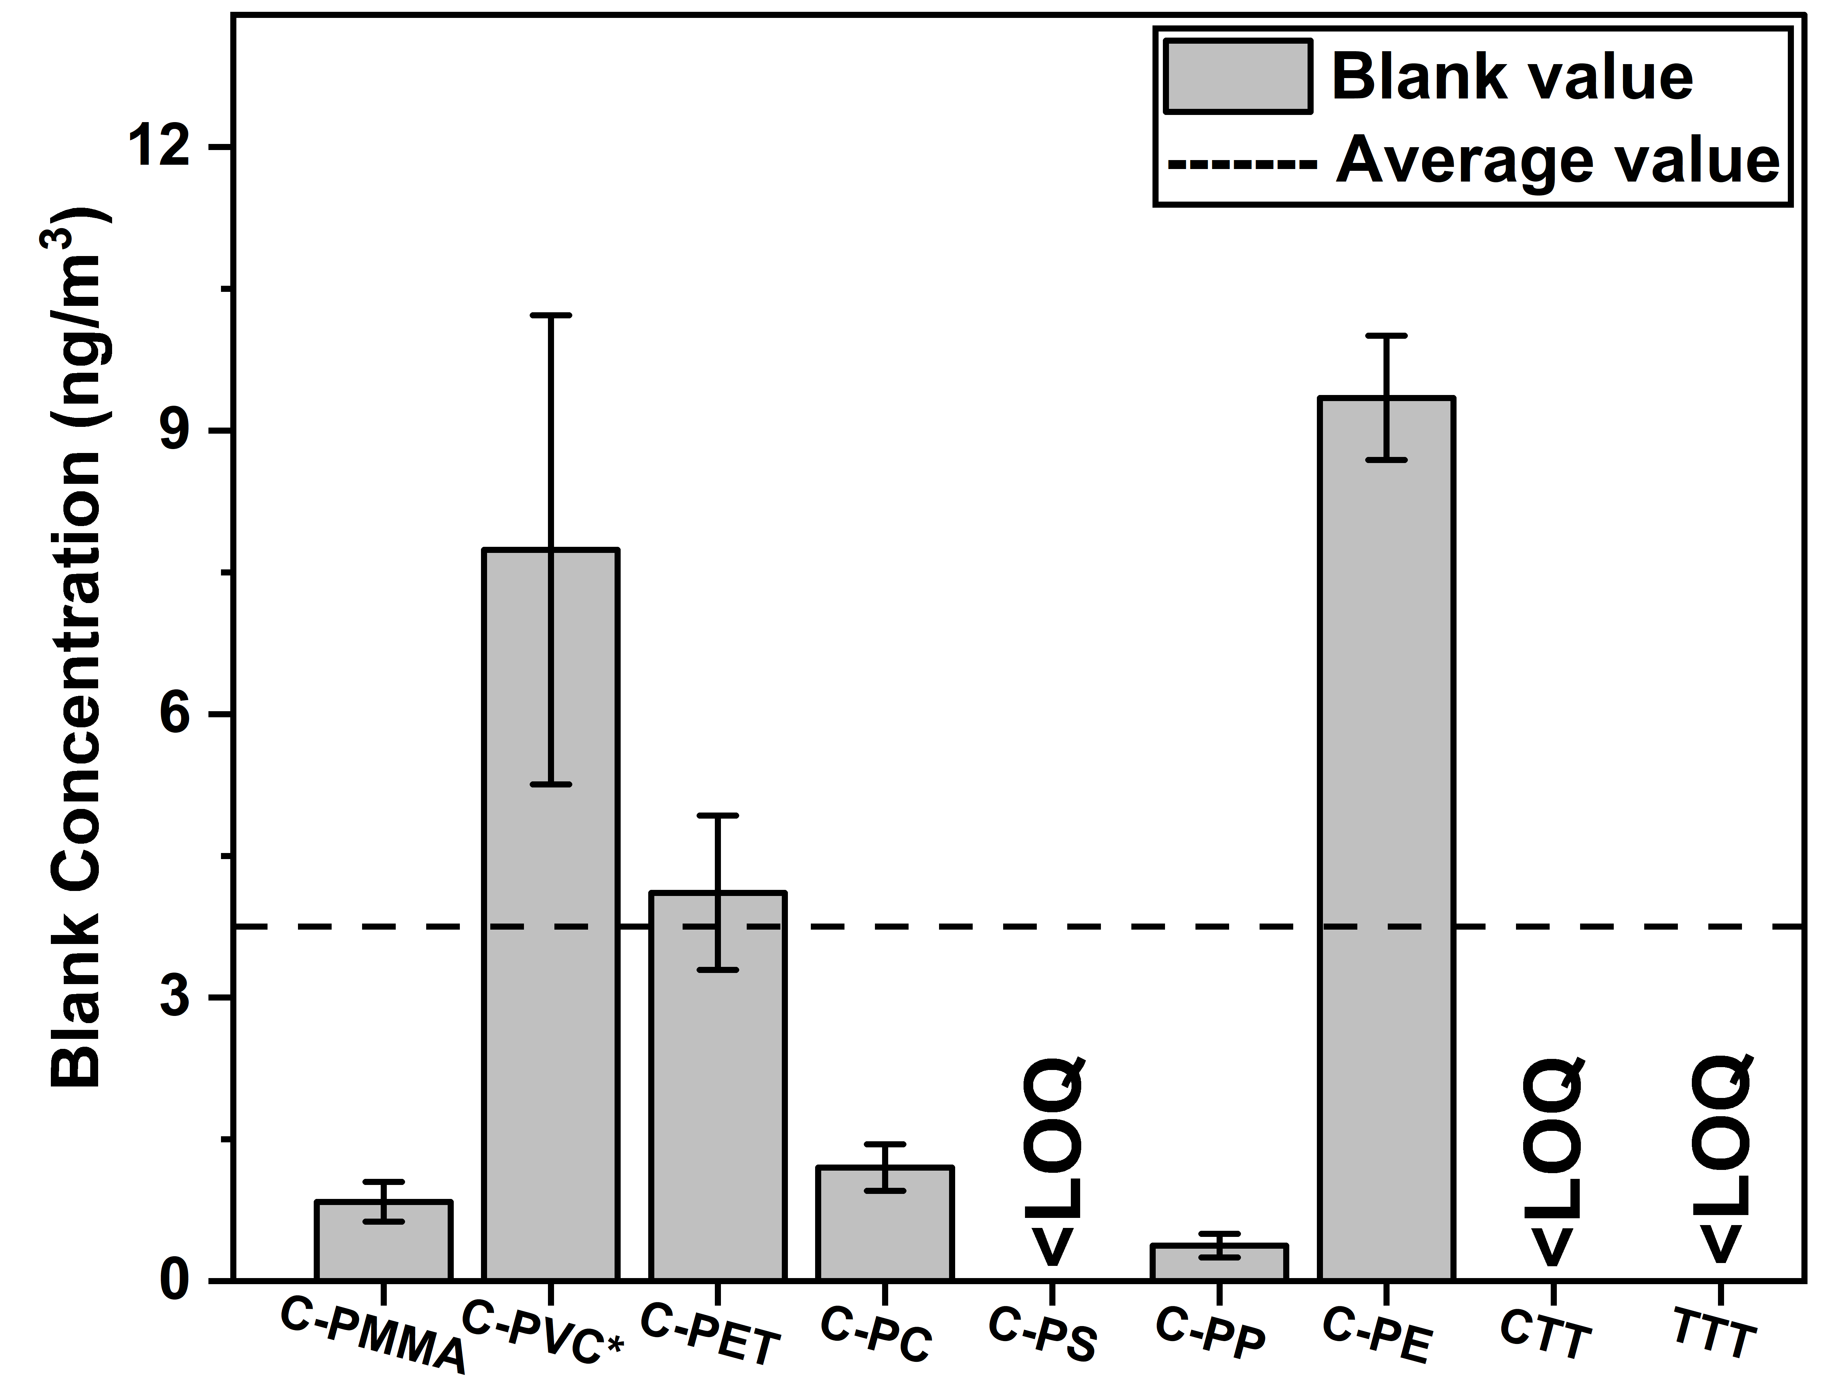

Supplementary Figure 7: Blank concentrations of target polymers.
Blank concentrations (ng/m³) for individual polymers with error bars representing standard deviations. The dashed line indicates the average blank value across all polymers. Concentrations below the limit of quantification (LOQ) are marked as <LOQ. Polymers: polymethyl methacrylate (C-PMMA), polyvinyl chloride (C-PVC*), polyethylene terephthalate (C-PET), polycarbonate (C-PC), polystyrene (C-PS), polypropylene (C-PP), polyethylene (C-PE), car tire tread (CTT), and truck tire tread (TTT).

Supplementary References:
1. Wu, C.-H. et al. Evaluation of PM2.5 bound microplastics and plastic additives in several cities in Taiwan: Spatial distribution and human health risk. Science of The Total Environment 959, 178213 (2025).
2. Luo, X. et al. Atmospheric emissions of microplastics entrained with dust from potential source regions. Journal of Hazardous Materials 488, 137509 (2025).
3. Rindelaub, J. D. et al. Aerosol mass concentrations and dry/wet deposition of atmospheric microplastics at a remote coastal location in New Zealand. Environmental Pollution 372, 126034 (2025).
4. Chen, Y. et al. Quantification and Characterization of Fine Plastic Particles as Considerable Components in Atmospheric Fine Particles. Environ. Sci. Technol. acs.est.3c06832 (2024) doi:10.1021/acs.est.3c06832.
5. Morioka, T., Tanaka, S., Kohama-Inoue, A. & Watanabe, A. The quantification of the airborne plastic particles of 0.43–11 μm: Procedure development and application to atmospheric environment. Chemosphere 351, 141131 (2024).
6. Kau, D. et al. Fine micro- and nanoplastics concentrations in particulate matter samples from the high alpine site Sonnblick, Austria. Chemosphere 352, 141410 (2024).
7. Caracci, E. et al. Micro(nano)plastics in the atmosphere of the Atlantic Ocean. Journal of Hazardous Materials 450, 131036 (2023).
8. Sheng, X. et al. Quantitation of Atmospheric Suspended Polystyrene Nanoplastics by Active Sampling Prior to Pyrolysis–Gas Chromatography–Mass Spectrometry. Environ. Sci. Technol. acs.est.3c02299 (2023) doi:10.1021/acs.est.3c02299.
9. Luo, P. et al. A Novel Strategy to Directly Quantify Polyethylene Microplastics in PM _{2.5} Based on Pyrolysis-Gas Chromatography–Tandem Mass Spectrometry. Anal. Chem. 95, 3556–3562 (2023).
10. Costa-Gómez, I. et al. A novel application of thermogravimetry-mass spectrometry for polystyrene quantification in the PM10 and PM2.5 fractions of airborne microplastics. Science of The Total Environment 856, 159041 (2023).
11. Kirchsteiger, B., Materić, D., Happenhofer, F., Holzinger, R. & Kasper-Giebl, A. Fine micro- and nanoplastics particles (PM2.5) in urban air and their relation to polycyclic aromatic hydrocarbons. Atmospheric Environment 301, 119670 (2023).
12. Goßmann, I. et al. Occurrence and backtracking of microplastic mass loads including tire wear particles in northern Atlantic air. Nat Commun 14, 3707 (2023).
13. Goßmann, I. et al. Unraveling the Marine Microplastic Cycle: The First Simultaneous Data Set for Air, Sea Surface Microlayer, and Underlying Water. Environ. Sci. Technol. 57, 16541–16551 (2023).
14. Mizuguchi, H. et al. Direct analysis of airborne microplastics collected on quartz filters by pyrolysis-gas chromatography/mass spectrometry. Journal of Analytical and Applied Pyrolysis 171, 105946 (2023).
15. Peñalver, R. et al. Assessing the level of airborne polystyrene microplastics using thermogravimetry-mass spectrometry: Results for an agricultural area. Science of The Total Environment 787, 147656 (2021).
16. Panko, J., Hitchcock, K., Fuller, G. & Green, D. Evaluation of Tire Wear Contribution to PM2.5 in Urban Environments. Atmosphere 10, 99 (2019).
17. Panko, J. M., Chu, J., Kreider, M. L. & Unice, K. M. Measurement of airborne concentrations of tire and road wear particles in urban and rural areas of France, Japan, and the United States. Atmospheric Environment 72, 192–199 (2013).
18. Ostro, B. Assessing the environmental burden of disease at national and local levels. https://iris.who.int/bitstream/handle/10665/42909/9241591463.pdf?sequence=1 (2004).
19. WHO. WHO Global Air Quality Guidelines: Particulate Matter (PM2.5 and PM10), Ozone, Nitrogen Dioxide, Sulfur Dioxide and Carbon Monoxide. (2021).
20. Lithner, D., Larsson, Å. & Dave, G. Environmental and health hazard ranking and assessment of plastic polymers based on chemical composition. Science of The Total Environment 409, 3309–3324 (2011).
21. Ragusa, A. et al. Raman Microspectroscopy Detection and Characterisation of Microplastics in Human Breastmilk. Polymers 14, 2700 (2022).
22. Horvatits, T. et al. Microplastics detected in cirrhotic liver tissue. eBioMedicine 82, 104147 (2022).
23. Jenner, L. C. et al. Detection of microplastics in human lung tissue using μFTIR spectroscopy. Science of The Total Environment 831, 154907 (2022).
24. Li, J., Li, J., Zhai, L. & Lu, K. Co-exposure of polycarbonate microplastics aggravated the toxic effects of imidacloprid on the liver and gut microbiota in mice. Environmental Toxicology and Pharmacology 101, 104194 (2023).
25. Zurub, R. E., Cariaco, Y., Wade, M. G. & Bainbridge, S. A. Microplastics exposure: implications for human fertility, pregnancy and child health. Front. Endocrinol. 14, 1330396 (2024).
26. Prokić, M. D., Radovanović, T. B., Gavrić, J. P. & Faggio, C. Ecotoxicological effects of microplastics: Examination of biomarkers, current state and future perspectives. TrAC Trends in Analytical Chemistry 111, 37–46 (2019).
27. Kuntz, V., Zahn, D. & Reemtsma, T. Quantification and occurrence of 39 tire-related chemicals in urban and rural aerosol from Saxony, Germany. Environment International 194, 109189 (2024).
28. Abad López, A. P., Trilleras, J., Arana, V. A., Garcia-Alzate, L. S. & Grande-Tovar, C. D. Atmospheric microplastics: exposure, toxicity, and detrimental health effects. RSC Adv. 13, 7468–7489 (2023).
29. Leslie, H. A. et al. Discovery and quantification of plastic particle pollution in human blood. Environment International 163, 107199 (2022).
30. Nihart, A. J. et al. Bioaccumulation of microplastics in decedent human brains. Nat Med https://doi.org/10.1038/s41591-024-03453-1 (2025) doi:10.1038/s41591-024-03453-1.
31. Goßmann, I., Süßmuth, R. & Scholz-Böttcher, B. M. Plastic in the air?! - Spider webs as spatial and temporal mirror for microplastics including tire wear particles in urban air. Science of The Total Environment 832, 155008 (2022).
32. Abbasi, S. Microplastics washout from the atmosphere during a monsoon rain event. Journal of Hazardous Materials Advances 4, 100035 (2021).
33. Hasnatul, A. H., Azman, N. F., NorRuwaida, J., Dewika, M. & Sara, Y. Y. Relationship of Suspended Atmospheric Microplastics and Meteorological Parameters in Universiti Teknologi Malaysia, Kuala Lumpur. IOP Conf. Ser.: Earth Environ. Sci. 1135, 012042 (2023).
34. Ochoa, L., Chan, J., Auguste, C., Arbuckle-Keil, G. & Fahrenfeld, N. L. Stormwater runoff microplastics: Polymer types, particle size, and factors controlling loading rates. Science of The Total Environment 929, 172485 (2024).
35. Chen, Y. et al. Wet Deposition of Globally Transportable Microplastics (<25 μm) Hovering over the Megacity of Beijing. Environ. Sci. Technol. 57, 11152–11162 (2023).
36. Szewc, K., Graca, B. & Dołęga, A. Atmospheric deposition of microplastics in the coastal zone: Characteristics and relationship with meteorological factors. Science of The Total Environment 761, 143272 (2021).
37. Hong, J. et al. Mixing state and particle hygroscopicity of organic-dominated aerosols over the Pearl River Delta region in China. Atmos. Chem. Phys. 18, 14079–14094 (2018).
38. Haque, F. & Fan, C. Fate of microplastics under the influence of climate change. iScience 26, 107649 (2023).
39. Zhang, K. et al. Understanding plastic degradation and microplastic formation in the environment: A review. Environmental Pollution 274, 116554 (2021).
40. Ding, L., Mao, R., Ma, S., Guo, X. & Zhu, L. High temperature depended on the ageing mechanism of microplastics under different environmental conditions and its effect on the distribution of organic pollutants. Water Research 174, 115634 (2020).
41. Khodabakhshloo, N., Abbasi, S. & Turner, A. Resuspension of microplastics and microrubbers in a semi-arid urban environment (Shiraz, Iran). Environmental Pollution 316, 120575 (2023).
42. Muthuvairavasamy, R. Microplastics in the Atmosphere. in Microplastics: Footprints On The Earth and Their Environmental Management (ed. Muthuvairavasamy, R.) 37–39 (Springer International Publishing, Cham, 2022). doi:10.1007/978-3-031-10729-0_6.
43. Zhang, B., Zhu, R. & Wang, Y. A Review of the Sources, Environmental Behaviours and Human Health of Atmospheric Microplastics: Focusing on indoor and outdoor microplastic pollution. Johnson Matthey Technology Review 68, 232–246 (2024).
44. Chen, Y.-C. et al. Impact of seasonal changes and environmental conditions on suspended and inhalable microplastics in urban air. Environmental Pollution 362, 124994 (2024).
45. Klein, M., Bechtel, B., Brecht, T. & Fischer, E. K. Spatial distribution of atmospheric microplastics in bulk-deposition of urban and rural environments – A one-year follow-up study in northern Germany. Science of The Total Environment 901, 165923 (2023).

