Phylogenetically and metabolically diverse autotrophs in the world's deepest blue hole
Xing Chen¹⁺, Jiwen Liu^{1,2,3+}, Xiao-Yu Zhu¹, Chun-Xu Xue¹, Peng Yao^{2,4}, Liang Fu⁵, Zuosheng Yang⁶, Kai Sun¹, Min Yu^{1,2,3}, Xiaolei Wang¹, Xiao-Hua Zhang^{1,2,3*}

¹ Frontiers Science Center for Deep Ocean Multispheres and Earth System, and College of Marine Life Sciences, Ocean University of China, Qingdao 266003, China
²Laboratory for Marine Ecology and Environmental Science, Laoshan Laboratory, Qingdao 266237, China
³Institute of Evolution & Marine Biodiversity, Ocean University of China, Qingdao 266003, China
⁴Key Laboratory of Marine Chemistry Theory and Technology, Ministry of Education, Ocean University of China, Qingdao 266100, China
⁵Sansha Track Ocean Coral Reef Conservation Research Institute, Sansha 573199, China
⁶College of Marine Geosciences, Ocean University of China, Qingdao 266100, China

*Author for correspondence:
Xiao-Hua Zhang, College of Marine Life Sciences, Ocean University of China, 5 Yushan Road, Qingdao 266003, PR China, Tel/Fax: +86-532-82032767, Email: xhzhang@ouc.edu.cn
Supplementary figures
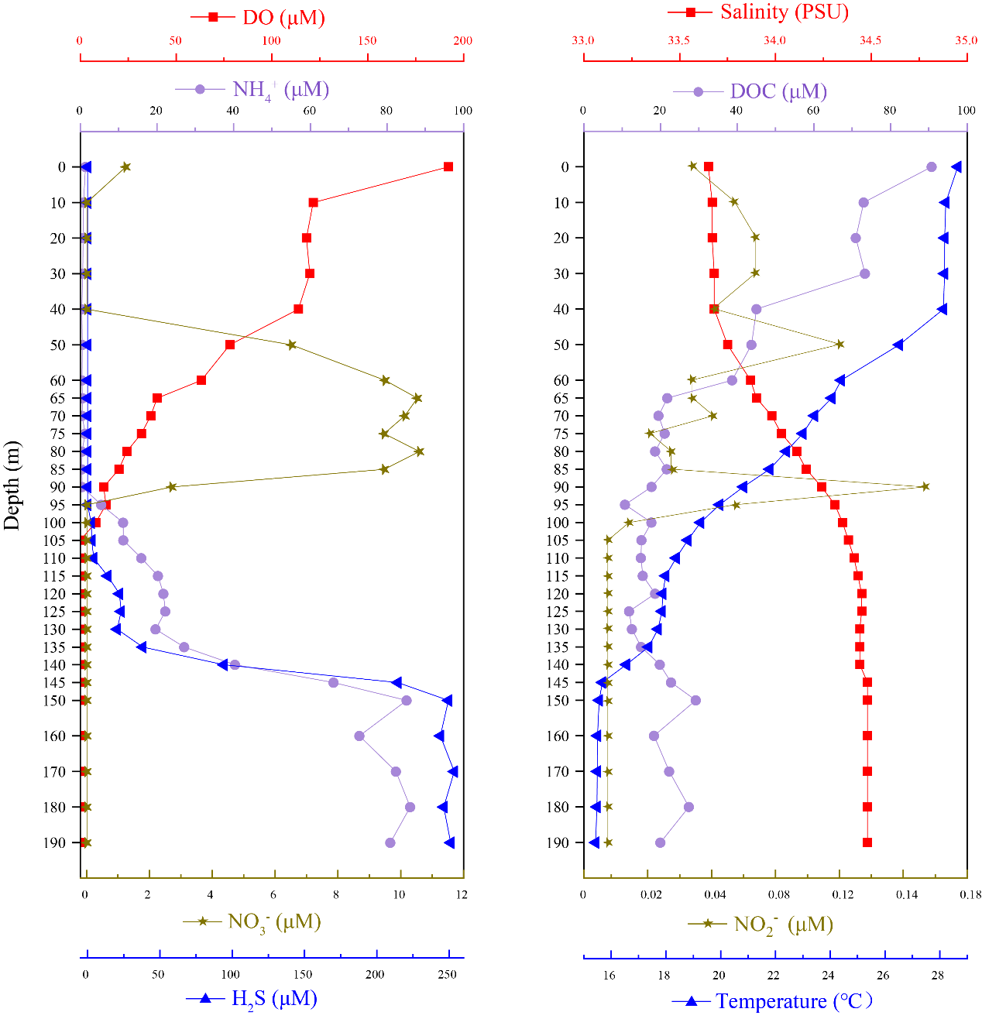
Figure S1: The Yongle blue hole water column in October 2019 was highly stratified with physicochemical differences.
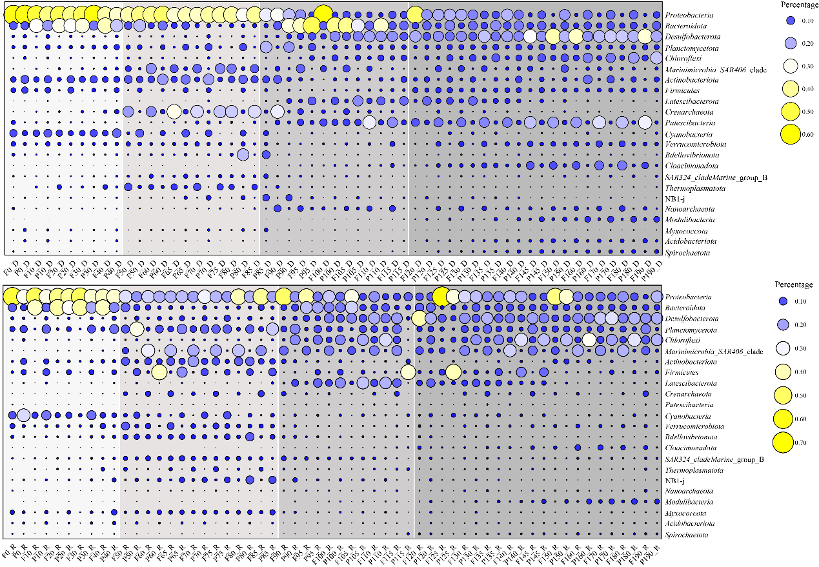
Figure S2: The relative abundance of microbial community present across the YBH at phylum level by DNA and RNA sequencing.

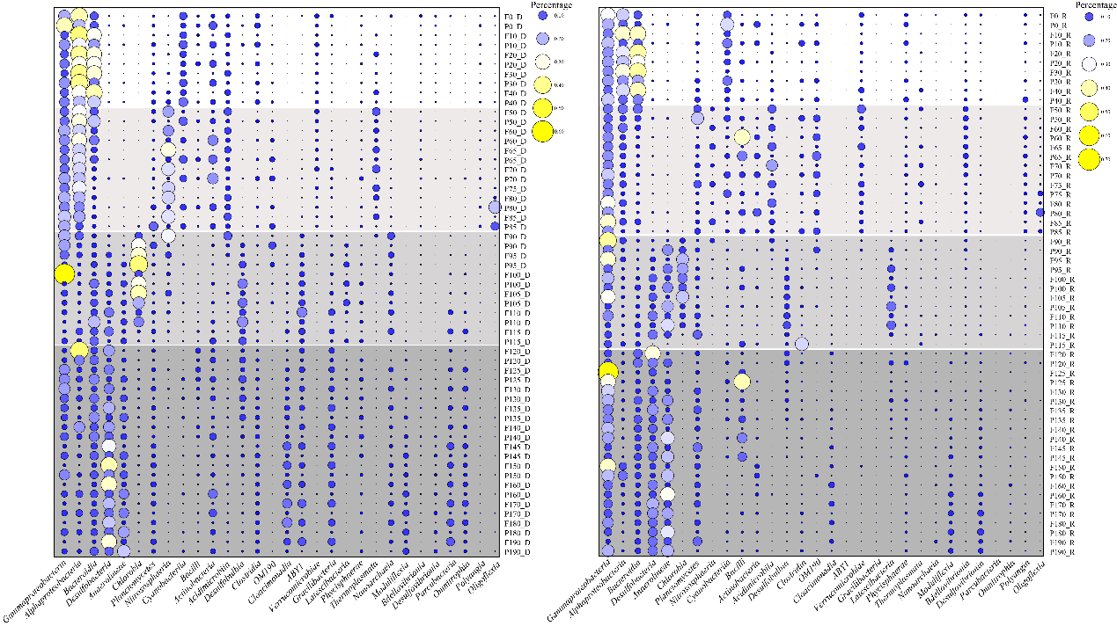
Figure S3: The relative abundance of the microbial community present across the YBH at the class level as defined by DNA and RNA sequencing.
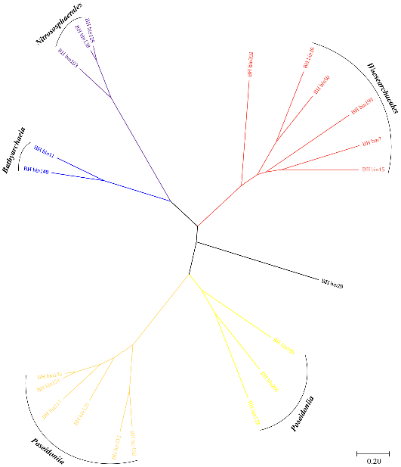
Figure S4: Phylogenetic analysis of 22 archaeal MAGs based on 122 single-copy protein-coding marker genes. MAGs were assigned to clusters represented by different branch colors. The scale bar represents 0.2 substitutions per site.
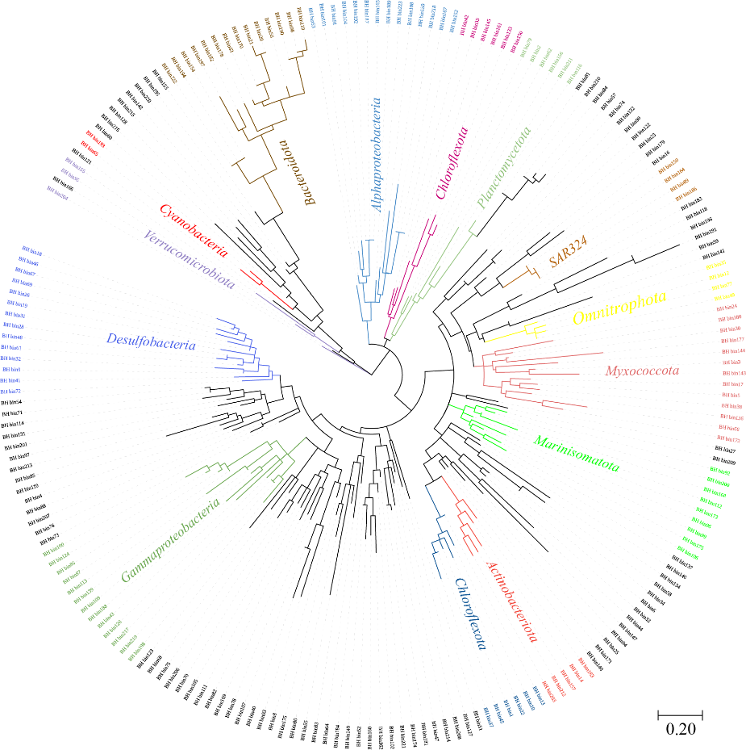
Figure S5: Phylogenetic analysis of 222 bacterial MAGs based on 120 single-copy protein-coding marker genes.
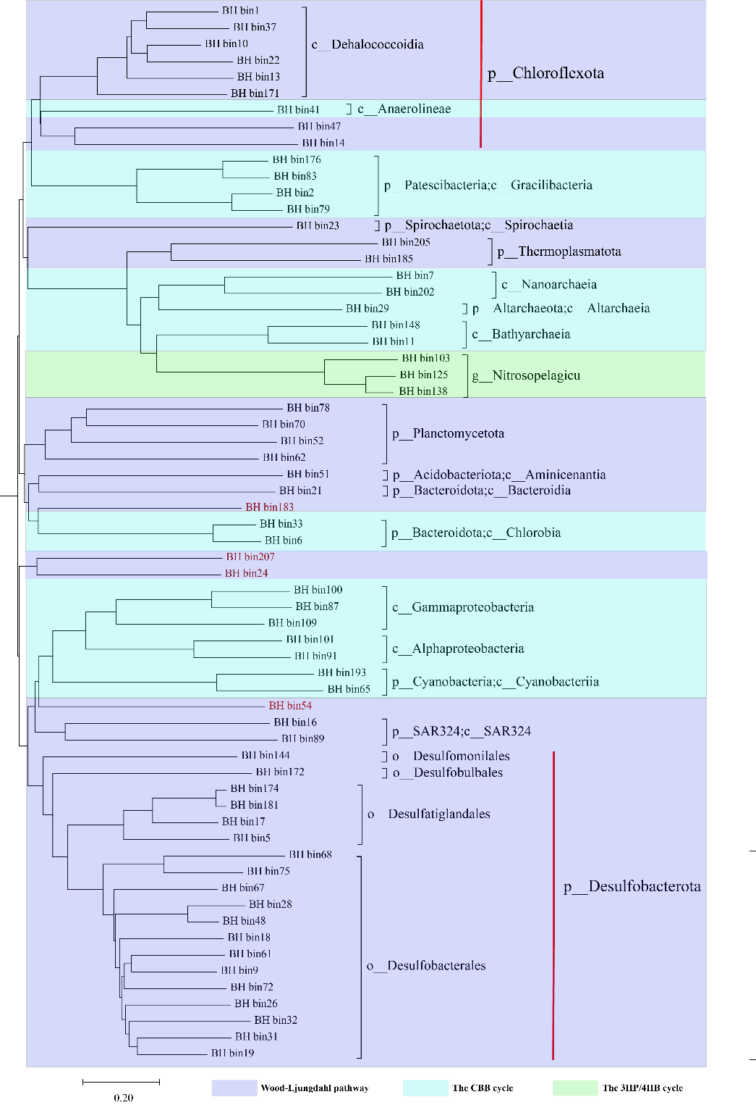
Figure S6: Phylogenetic analysis of 64 carbon fixation MAGs based on 16S rRNA sequences. Bootstrap calculated by maximum likelihood in IQ-Tree under the test option (100 replicates). MAGs were assigned to different pathways clusters. The scale bar represents 0.2 substitutions per site.

