Supplementary Information
Methods

Seed germination and soil
Z. mays spp. parviglumis is an ancestral maize lineage commonly known as teosinte whereas Z. mays genotype B73 is an early maize hybrid. Seeds were surface sterilized using 2% TWEEN (polysorbate) solution for 90 seconds followed by priming incubation in aerated sterile 1 mM calcium chloride solution for 24 hours. The seeds were germinated in sterile petriplates lined with autoclaved Kimwipes soaked in 1 mM calcium chloride solution in a dark growth chamber at 25° C [1]. Once seeds germinated, they were transplanted into the experimental soil matrix.
Soil was collected from the top 30 cm of a native tallgrass prarie, Nile Mile Prairie, sieved (2 mm mesh), homogenized, and mixed with autoclaved sandy agricultural soil also collected from the top 30 cm from the UNL Agricultural Research and Development Center (ARDC) in Mead, Nebraska (41°09'31.3"N 96°24'47.4" W), sieved (2 mm mesh), and homogenized. The agricultural sandy soil was autoclaved for two dry cycles of 121°C and 110 kPa for 100 minutes and was kept covered in autoclaved sterile aluminum containers (< 45 Kg per container) to avoid environmental contaminants until mixed with live prarie soil. The soil mixutre was allowed to equilibrate in sterile sealed aluminum containers for a week prior to potting.

Below ground plant phenotype data collection

Root phenotype parameters were collected using WinRhizo root scanning software within one week of plant harvesting. In the event any soil remianed on the root surface, soil was gently removed and roots were untangled using forceps to avoid overlap of the root hairs without breaking the roots. Roots were stained in Toluidine blue (0.05% in pH 4.4) and positioned in the WinRhizo Epson Perfection scanning tray immersed in double distilled water with minimum overlaps and illuminated from the top and bottom sides to scan the roots. The scanned root images were used to evaluate root phenotype parameters such as length, diameter, and volume using Winrhizo image analysis software (Regent Instruments, version 2008a). To differentiate the allocation traits precisely, roots were categorized into coarse (> 1 mm) and fine ($≤$ 1 mm) roots in the WinRhizo root analysis program. For the roots, based on the root category, coarse and fine roots fresh weight (g), total below ground fresh and dry weight (g), root dry matter content coarse and fine roots (g/g), coarse and fine root length (cm), total root length (cm), the surface area of coarse and fine roots (cm²), total root surface area (cm²), coarse and fine root volume (cm³), total root volume (cm³), total biomass in dry weight (g) was collected.
Intrinsic root traits such as specific root length for coarse and fine roots (cm/g), coarse and fine root density (g/cm³), total root density (g/cm³), average coarse and fine root diameter (cm) were calculated as previously described [2]. Plant growth rate data comprise growth coarse and fine root growth rate (cm/day), and total root length growth rate (cm/day). Allocation traits such as coarse and fine root length ratio (cm/g), root mass ratio (g/g), total length ratio (coarse and fine roots), below-ground plant ratio (g/g), below-ground mass ratio (g/g) was calculated.

Cell and virus enumeration
Cell and virus enumeration from biological replicates of parviglumis (n = 5) and B73 (n=6) were collected. One of the parviglumis biological replicates was discarded as a result of an error occurring during sample collection. Following sample collection, all cell and virus samples were enumerated within one week. Cell samples were collected on an Isopore 0.2 µm black polycarbonate filters (product# GTBP02500), while viruses were collected on 0.02 µm Anodisc™ filters (product# 6809-6002) for enumeration with Whatman 0.45 µm cellulose nitrate membrane filters (product# 7184-002) as a supported filter to ensure uniform distribution of cells and viruses. Samples were passed through each filter by using Gast high-capacity vacuum pump (model# DOA-P704-A4) maintaining a constant pressure of less than -0.2 bar to avoid cell lysis. SYBR Green I was used to stain the filters for 15 minutes followed by drying [3]. The filters were mounted on slides with an anti-fade solution (50% glycerol, 50% PBS, 0.1 p-phenylenediamine). At least 200 particles in 10 field views were enumerated per filter [4] and averaged to estimate the cells and viruses in the rhizobiome. The enumeration data was analyzed against rhizosphere mass and other root parameters. All experimental data is reported on the Experimental Data S1, S2, S3, and S4.

16S rRNA gene amplicon and shotgun metagenomic sequence library preparation
All the glassware used to extract rhizobiome (rhizosphere and rhizoplane collectively) was treated with 0.1% diethylpyrocarbonate (DEPC) whereas spatulas, needles, and other equipment such as sonicator horn dip were sterilized by treating them with bleach (10% v/v), ethanol (70% v/v), distilled water (x3), RNase AWAY™ surface decontaminant (product#7002), and finally with 0.1% DEPC treated water (x3) rinse.
$DNA per gram of rhizobiome \left(\frac{ng}{g}\right)=Total DNA extract \left(uL\right)×DNA concentration \left(\frac{ng}{uL}\right)÷ Rhizbiome mass \left(g\right) used for DNA extraction$
Bioinformatic analyses: 16S rRNA gene amplicon sequences
The 16S rRNA gene amplicon sequence data was analyzed using the DADA2 package [5] with parameters (truncLen=c(240,160), maxN=0, maxEE=c(2,2), truncQ=2, rm.phix=TRUE) to obtain amplicon sequence variants (ASVs). ZymoBiomics microbial community standard (product # D6300) with known microbial community and abundance served as a positive control for 16S rRNA gene amplicon sequencing. The mentioned parameters for the 16S rRNA amplicon sequencing processing pipeline were validated using a positive control to detect contamination and remove spurious sequences (ASV abundance < 0.05 %). The diversity and evenness were measured using Shannon’s diversity index and Pielou’s evenness, respectively, and observed richness was the total number of ASVs. Broad SILVA v138 (Silva 138 SSURef Nr99) [6] was used to assign taxonomic identification to the ASVs. Experimental data sequence summary S5 summarizes 16S rRNA gene amplicon sequence data.

Bioinformatic analyses: Shotgun metagenome sequences
The metagenomic raw reads were quality checked to exploit FastQC and Trimmomatic v0.39 [7] was used to remove Illumina adapter sequences and quality trim with parameters (LEADING:2 TRAILING:2 SLIDINGWINDOW:4:20 MINLEN:25 ILLUMINACLIP:NexteraPE-PE.fa:2:40:15) and PhiX sequences were removed using BBDuk v38.84 [8]. To ensure the quality of the clean reads FastQC check was performed again. The clean reads were used for three biological replicates of the parviglumis and B73 utilizing MEGAHIT v1.2 [9], using a contig minimum size threshold of 1500bp. Bowtie2 v2.4 [10] was used to map the reads back to the assembly and indexed using SamTools v1.9. [11]. The final set of MAGs were categorized based on Minimum Information about a Metagenome Assembled Genome (MIMAG) quality parameters [12]. The relative abundance of the reconstructed MAGs was estimated by normalizing the mean coverage depth of metagenome reads against the total reads of the samples [13-15]. Taxonomic identification of reconstructed MAGs was performed using 22 single copy core genes coding for ribosomal proteins using Genome Taxonomy Database (GTDB) [16-19]. Experimental data sequence summary S6 and S7 summarizes processing results of metagenome assembled genomes.

Viral contig and vOTU detection and identification
To identify the viral contigs VirSorter 2 (v2.1) was used (--high-confidence-only --hallmark-required --prep-for-dramv) [20]. To retrieve only the genuine viruses output of VirSorter2 was facilitated as input of DeepVirFinder which identifies viruses based on reference-free and alignment-free machine learning methods [21]. The viral contigs identified by DeepVirFinder comprising p- value <0.05 were retained. SortmeRNA [22] was used to detect the 16S rRNA fragment contamination in the viral contigs. The final set of viral contigs was mapped using Bowtie2 v2.4 [10] and resulting alignments were sorted and indexed using SamTools v1.9. [11]. BamM ‘parse’ coverage [23] with ‘tpmean’ coverage mode was used to generate abundances of the MAGs. The putative viral contigs Kaiju (v1.8) [24] and BLASTN (e-value $≤$ 10⁻⁵, bit score ≥ 50) against NCBI-viral RefSeq was used to taxonomically identify viral contigs. Putative viral contig sequences queried against the NCBI ref database with BLAST [25] with threshold e-value < 10⁻⁵ was also used to remove any bacterial contamination. Experimental data sequence summary S8 and S10 summarizes processing results of viral contigs and vOTUs.

Virus-host linkage
To validate the viral infection of a host from sequence identified in MAGs, sequences were detected in the MAGs utilizing CRISPRCasFinder [26]. The retrieved spacers were matched against all viral contigs using BLASTN and matches with 0 mismatches and e-value $≤$ 10⁻⁵ hit were scored as a positive match. For the spacer with the positive hit, the direct repeat sequences were compared to the MAGs via BLASTN threshold e-value 10⁻¹⁰ and 100% nucleotide identity to link between the CRISPR region and the host [27]. The BLASTN (e-value 10⁻⁵, bit score ≥ 50) was used to link viral contigs to the hosts, based on their shared genomic contents such as AMGs and/or tRNAs [28, 29]. Normalized virus-host relative abundance was calculated by dividing viral contig relative abundance by viral-linked host abundance at the family level (or at order/class/phylum level if the family was not informative) [15, 27]. Experimental data sequence summary S11 and S15 summarizes processing results of virus and host relationships.

Metabolic potential of microorganisms and viruses
Experimental data sequence summary S16 and S18 summarizes processing results of metabolic potential characterization of sequence data.

Supplementary Figures
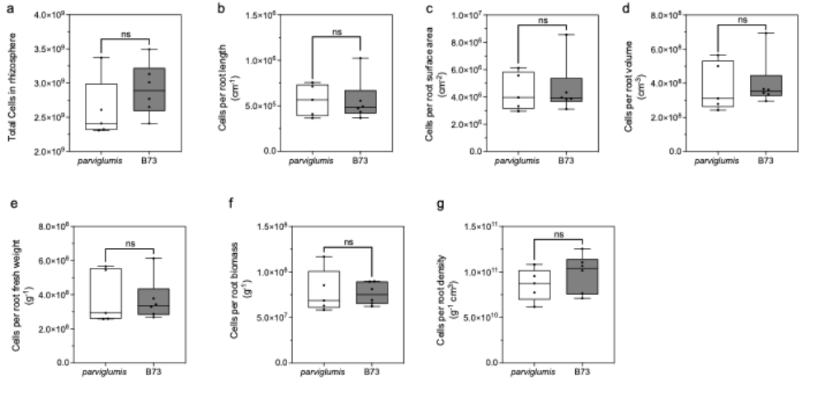

Fig. S1 Cell enumeration data against other root parameters. Statistical differences were quantified in the cell abundance of biological replicates of parviglumis (n=5) (transparent) and B73 (n=6) (gray) enumerated using epifluorescence microscopy with SYBR Green I dye. The (a) represents the total cells collected in rhizosphere and cell enumeration against (b) root length, (c) root surface area, (d) root volume, (e) root fresh weight, (f) root biomass, and (g) root density. The non-parametric unpaired t-test with Welch’s correction was conducted assuming unequal variances did not show any significant difference between the parviglumis and B73 cell count data against any of the analyzed root parameters. The boxes represent the interquartile range, the center represents the median, and the whiskers indicate ± 1.5 times the interquartile range.

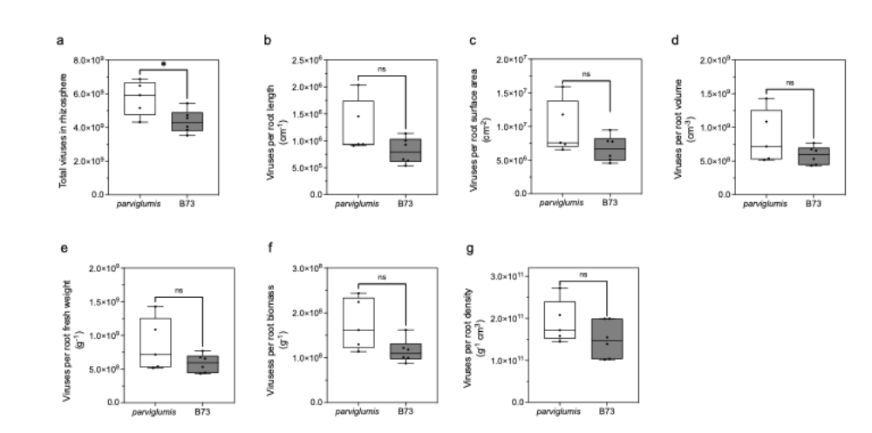

Fig. S2 Virus enumeration data against other root parameters. Statistical differences were quantified in virus abundance of biological replicates of parviglumis (n=5) (transparent) and B73 (n=6) (gray) enumerated using epifluorescence microscopy with SYBR Green I dye. The (a) represents the total viruses collected in rhizosphere and virus enumeration against (b) root length, (c) root surface area, (d) root volume, (e) root fresh weight, (f) root biomass, and (g) root density The non-parametric unpaired t-test with Welch’s correction was conducted assuming unequal variances showed significant variation (p = 0.0376) while viruses against other root parameters did not show any significant difference between the parviglumis and B73 cell count data against any of the analyzed root parameters. The boxes represent the interquartile range, the center represents the median, and the whiskers indicate ± 1.5 times the interquartile range.

Supplementary Information References Cited
[1] Rehman Ur H, Iqbal H, Basra SM, Afzal I, Farooq M, Wakeel A et al. Seed priming improves early seedling vigor, growth and productivity of spring maize. J Integr Agr 2015;14: 1745-1754.

[2] Quattrone A, Lopez-Guerrero M, Yadav P, Meier MA, Russo SE, Weber KA. Interactions between Root Hairs and the Soil Microbial Community Affect the Growth of Maize Seedlings. in press.

[3] Noble RT, Fuhrman JA. Use of SYBR Green I for rapid epifluorescence counts of marine viruses and bacteria. Aquat Microb Ecol. 1998;14: 113-118.

[4] Patel A, Noble RT, Steele JA, Schwalbach MS, Hewson I, Fuhrman JA. Virus and prokaryote enumeration from planktonic aquatic environments by epifluorescence microscopy with SYBR Green I. Nat Protoc. 2007;2: 269-276.

[5] Callahan BJ, McMurdie PJ, Rosen MJ, Han AW, Johnson AJA, Holmes SP. DADA2: High-resolution sample inference from Illumina amplicon data. Nat Methods. 2016;13: 581-583.

[6] Quast C, Pruesse E, Yilmaz P, Gerken J, Schweer T, Yarza P et al. The SILVA ribosomal RNA gene database project: improved data processing and web-based tools. Nucleic Acids R. 2012;41: D590-D596.

[7] Bolger AM, Lohse M, Usadel B. Trimmomatic: a flexible trimmer for Illumina sequence data. Bioinformatics. 2014;30: 2114-2120.

[8] Bushnell B (2014). BBTools software package.

[9] Li D, Liu C-M, Luo R, Sadakane K, Lam T-W. MEGAHIT: an ultra-fast single-node solution for large and complex metagenomics assembly via succinct de Bruijn graph. Bioinformatics. 2015;31: 1674-1676.

[10] Langdon WB. Performance of genetic programming optimised Bowtie2 on genome comparison and analytic testing (GCAT) benchmarks. BioData Min 2015;8: 1-7.

[11] Li H, Handsaker B, Wysoker A, Fennell T, Ruan J, Homer N et al. The sequence alignment/map format and SAMtools. Bioinformatics. 2009;25: 2078-2079.

[12] Bowers RM, Kyrpides NC, Stepanauskas R, Harmon-Smith M, Doud D, Reddy T et al. Minimum information about a single amplified genome (MISAG) and a metagenome-assembled genome (MIMAG) of bacteria and archaea. Nature Biotechnol 2017;35: 725-731.

[13] Starr EP, Shi S, Blazewicz SJ, Probst AJ, Herman DJ, Firestone MK et al. Stable isotope informed genome-resolved metagenomics reveals that Saccharibacteria utilize microbially-processed plant-derived carbon. Microbiome. 2018;6: 1-12.

[14] Emerson JB, Roux S, Brum JR, Bolduc B, Woodcroft BJ, Jang HB et al. Host-linked soil viral ecology along a permafrost thaw gradient. Nat Microbiol 2018;3: 870-880.

[15] Jarett JK, Džunková M, Schulz F, Roux S, Paez-Espino D, Eloe-Fadrosh E et al. Insights into the dynamics between viruses and their hosts in a hot spring microbial mat. ISME J. 2020;14: 2527-2541.

[16] Starr EP, Shi S, Blazewicz SJ, Probst AJ, Herman DJ, Firestone MK et al. Stable isotope informed genome-resolved metagenomics reveals that Saccharibacteria utilize microbially-processed plant-derived carbon.

[17] Probst AJ, Ladd B, Jarett JK, Geller-McGrath DE, Sieber CMK, Emerson JB et al. Differential depth distribution of microbial function and putative symbionts through sediment-hosted aquifers in the deep terrestrial subsurface. Nat Microbiol. 2018;3: 328–336.

[18] Sharon I, Battchikova N, Aro EM, Giglione C, Meinnel T, Glaser F et al. Comparative metagenomics of microbial traits within oceanic viral communities. ISME J. 2011;5: 1178-1190.

[19] Parks DH, Chuvochina M, Rinke C, Mussig AJ, Chaumeil P-A, Hugenholtz P. GTDB: an ongoing census of bacterial and archaeal diversity through a phylogenetically consistent, rank normalized and complete genome-based taxonomy. Nucleic Acids R. 2022;50: D785-D794.

[20] Guo J, Bolduc B, Zayed AA, Varsani A, Dominguez-Huerta G, Delmont TO et al. VirSorter2: a multi-classifier, expert-guided approach to detect diverse DNA and RNA viruses. Microbiome. 2021;9: 1-13.

[21] Ren J, Song K, Deng C, Ahlgren NA, Fuhrman JA, Li Y et al. Identifying viruses from metagenomic data using deep learning. Quant Biol. 2020;8: 64-77.

[22] Kopylova E, Noé L, Touzet H. SortMeRNA: fast and accurate filtering of ribosomal RNAs in metatranscriptomic data. Bioinformatics. 2012;28: 3211-3217.

[23] Quinlan AR, Hall IM. BEDTools: a flexible suite of utilities for comparing genomic features. Bioinformatics. 2010;26: 841-842.

[24] Menzel P, Ng KL, Krogh A. Fast and sensitive taxonomic classification for metagenomics with Kaiju. Nat Commun. 2016;7: 1-9.

[25] Altschul SF, Gish W, Miller W, Myers EW, Lipman DJ. Basic local alignment search tool. J Mol Biol. 1990;215: 403-410.

[26] Couvin D, Bernheim A, Toffano-Nioche C, Touchon M, Michalik J, Néron B et al. CRISPRCasFinder, an update of CRISRFinder, includes a portable version, enhanced performance and integrates search for Cas proteins. Nucleic Acids R. 2018;46: W246-W251.

[27] Emerson JB, Roux S, Brum JR, Bolduc B, Woodcroft BJ, Jang HB et al. Host-linked soil viral ecology along a permafrost thaw gradient. Nat Microbiol. 2018;3: 870-880.

[28] Roux S, Brum JR, Dutilh BE, Sunagawa S, Duhaime MB, Loy A et al. Ecogenomics and potential biogeochemical impacts of globally abundant ocean viruses. Nature. 2016;537: 689-693.

[29] Paez-Espino D, Eloe-Fadrosh EA, Pavlopoulos GA, Thomas AD, Huntemann M, Mikhailova N et al. Uncovering Earth’s virome. Nature. 2016;536: 425-430.

