Supplementary table 1: Haematological indices of the study participants across age groupings and sites
 | WBC | RBC | HGB | MCV | MCH | MCHC | PLT | HbF | F cells | HbF per F cells
Persons <18 years n [Median (Interquartile range)
Tanzania | 53 [14.7 (12.3, 17)] | 53 [2.7 (2.4, 3.3)] | 53[7.5 (6.9, 8.1)] | 53[78.5 (70.7, 85.6)] | 53[27  (24.4, 30.2)] | 53[34.6 (33.6, 35.4)] | 53[469 (338, 549)] | 53 [4.9 (3.3, 7.2)] | 53 [22.4 (16.6, 32.6)] | 53[4.7 (3.8, 6.3)]
Ghana | 88 [12.8 (10.6, 15)] | 88 [2.8 (2.5, 3.5)] | 88[7.9 (7, 8.8)] | 88[77.2 (72, 82.5)] | 88[27.9 (25.6, 29.6)] | 88[35.6 (34.7, 37.1)] | 88[382.5 (256, 494)] | 76 [8 (5, 14.4)] | 51 [15.4 (5.2, 24.2)] | 41[2.4 (0.6, 3.3)]
Nigeria | 25 [12 (9, 17.2)] | 19 [2.4 (2, 2.8)] | 31[6.9 (6, 7.7)] | 20[84.6 (78.3, 89)] | 19[27.2  (24, 29.9)] | 20[32.2 (30.5, 33.6)] | 34[338.5 (200, 462)] | 35 [5.1 (3.3, 8.1)] | 28 [21.1 (6.2, 40.6)] | 26[5.3 (1.1, 6.4)]
Total | 166 [13.1 (10.6, 15.7)] | 160 [2.7 (2.4, 3.3)] | 172[7.6 (6.8, 8.5)] | 161[78.5 (72.5, 84.2)] | 160[27.7 (25.3, 29.9)] | 161[35 (33.6, 36)] | 175[402 (269, 508)] | 164 [6.1 (3.7, 9.9)] | 132 [19.1 (11, 32.5)] | 120[4.1 (2.1, 5.7)]
p-value* | 0.027 | 0.023 | 0.0002 | 0.025 | 0.485 | 0.0001 | 0.004 | 0.0003 | 0.007 | 0.0001
Persons >=18 years n [Median (Interquartile range)
Tanzania | 39 [11.2 (9.6, 15.1)] | 39 [3 (2.7, 4)] | 39[8.5 (6.7, 9.6)] | 39[77.6 (67.9, 85.2)] | 39[27.6 (23.5, 30.1)] | 39[35.2 (34.7, 35.7)] | 39[388 (273, 521)] | 39 [3.7 (2.1, 6.6)] | 39 [20 (11.9, 27.2)] | 39[5.3 (3.7, 6.4)]
Ghana | 6 [8.4 (7.4, 10.6)] | 6 [2.6 (1.9, 3.3)] | 6[7.9 (6.5, 9)] | 6[85.6 (83, 87.5)] | 6[29.4 (28.6, 31.2)] | 6[34.8 (33.6, 36.6)] | 6[264 (230, 422)] | 7 [14.8 (9.3, 15.2)] | 1 [0.7 (0.7, 0.7)] | 1[0.1 (0.1, 0.1)]
Nigeria | 48 [9.6 (7.4, 12.7)] | 25 [2.5 (2.3, 3)] | 49[7.8 (7, 9)] | 29[83.8 (80.2, 89.7)] | 23[28.4 (26.9, 30.9)] | 30[33.7 (32.6, 34.8)] | 47[389 (238, 486)] | 41 [4.3 (2.5, 6.6)] | 32 [21.6 (13.4, 39.6)] | 27[4.9 (4, 10)]
Total | 93 [10.2 (8.4, 13.4)] | 70 [2.8 (2.4, 3.4)] | 94[8.1 (7, 9.2)] | 74[82.3 (74.7, 87)] | 68[28.3 (26.2, 30.3)] | 75[34.8 (33.3, 35.5)] | 92[383 (245, 489)] | 87 [4.3 (2.3, 7.6)] | 72 [19.8 (12, 32.5)] | 67[5 (3.7, 7.1)]
p-value* | 0.011 | 0.02 | 0.703 | 0.006 | 0.123 | 0.0001 | 0.358 | 0.021 | 0.164 | 0.186
Bold font-statistically significant

Supplementary table 2: Association of HbF, F-cells and HbF per F-cells with the clinical events across countries
 |  | Tanzania* [OR (p-value)] | Ghana* [OR (p-value)] |  |  | Nigeria* [OR (p-value)] |  |  | Total** [OR (p-value)]
Outcomes as predicted by HbF
Blood Transfusion |  | 0.84 (0.006) | 0.98 (0.451) |  |  | 0.87 (0.09) |  |  | 0.95 (0.017)
Dactylitis |  | 1.02 (0.623) | 1 (0.901) |  |  | 0.92 (0.316) |  |  | 1.01 (0.824)
Pain crises |  | 0.99 (0.948) | 0.97 (0.268) |  |  | 1.02 (0.868) |  |  | 0.98 (0.307)
Acute Chest Syndrome |  | 1.04 (0.367) | 0.98 (0.619) |  |  | 0.99 (0.907) |  |  | 1 (0.966)
Fits |  | 1.05 (0.305) | 1.01 (0.853) |  |  | 1.01 (0.96) |  |  | 1.03 (0.445)
Neurological defect |  | 1.02 (0.692) | ^ |  |  | 0.86 (0.592) |  |  | 1.01 (0.795)
Leg Ulcer |  | 1.02 (0.706) | 0.94 (0.536) |  |  | 0.9 (0.315) |  |  | 0.97 (0.553)
Fever |  | ^ | 1.07 (0.043) |  |  | 1.01 (0.91) |  |  | 1.03 (0.206)
Splenomegaly |  | 0.95 (0.705) | ^ |  |  | 0.13 (0.29) |  |  | 0.88 (0.42)
Priapism |  | 1.02 (0.766) | 0.89 (0.404) |  |  | 0.83 (0.562) |  |  | 0.97 (0.603)
Admission in 12 months |  | 1.03 (0.482) | 0.99 (0.544) |  |  | 1.08 (0.276) |  |  | 1 (0.945)
Outcomes as predicted by F-cells
Blood Transfusion |  | 0.96 (0.015) |  | 1.01 (0.553) |  |  | 0.97 (0.067) |  |  | 0.95 (0.017)
Dactylitis |  | 1.02 (0.209) |  | 1.02 (0.549) |  |  | 0.96 (0.014) |  |  | 1.01 (0.824)
Pain crises |  | 1.02 (0.667) |  | 1.01 (0.715) |  |  | 1 (0.9) |  |  | 0.98 (0.307)
Acute Chest Syndrome |  | 1.02 (0.224) |  | 1.02 (0.304) |  |  | 1 (0.93) |  |  | 1 (0.966)
Fits |  | 1.03 (0.253) |  | 0.88 (0.469) |  |  | 0.98 (0.577) |  |  | 1.03 (0.445)
Neurological defect |  | 1.01 (0.793) |  | 0 (0) |  |  | 0.98 (0.696) |  |  | 1.01 (0.795)
Leg Ulcer |  | 1.01 (0.569) |  | 1.03 (0.713) |  |  | 1.03 (0.151) |  |  | 0.97 (0.553)
Fever |  | 0.75 (0.411) |  | 1.03 (0.174) |  |  | 1 (0.96) |  |  | 1.03 (0.206)
Splenomegaly |  | 1 (0.958) |  | 0 (0) |  |  | 0.9 (0.443) |  |  | 0.88 (0.42)
Priapism |  | 1.01 (0.634) |  | 0 (0) |  |  | 1.02 (0.688) |  |  | 0.97 (0.603)
Admission in 12 months |  | 1.01 (0.699) |  | 0.97 (0.099) |  |  | 1.01 (0.364) |  |  | 1 (0.945)
Outcomes as predicted by HbF per F-cell
Blood Transfusion | 1.24 (0.13) |  |  |  | 1.87 (0.013) |  |  | 0.97 (0.666) |  |  | 1.17 (0.022)
Dactylitis | 1.03 (0.523) |  |  |  | 0.82 (0.451) |  |  | 0.83 (0.071) |  |  | 0.99 (0.754)
Pain crises | 1.44 (0.333) |  |  |  | 1.17 (0.33) |  |  | 1.07 (0.715) |  |  | 1.39 (0.005)
Acute Chest Syndrome | 0.78 (0.186) |  |  |  | 1.19 (0.304) |  |  | 1.04 (0.586) |  |  | 0.98 (0.689)
Fits | 0.81 (0.412) |  |  |  | 1.73 (0.186) |  |  | 1.06 (0.457) |  |  | 1.05 (0.24)
Neurological defect | 0.84 (0.485) |  |  |  | ^ |  |  | 0.95 (0.774) |  |  | 0.97 (0.734)
Leg Ulcer | 0.76 (0.303) |  |  |  | 1.11 (0.787) |  |  | 1.06 (0.368) |  |  | 1.03 (0.467)
Fever | ^ |  |  |  | 0.84 (0.273) |  |  | 0.93 (0.258) |  |  | 1.02 (0.66)
Splenomegaly | 0.98 (0.874) |  |  |  | ^ |  |  | 0.9 (0.73) |  |  | 1.02 (0.835)
Priapism | 0.87 (0.601) |  |  |  | ^ |  |  | 0.58 (0.26) |  |  | 0.99 (0.741)
Admission in 12 months | 0.98 (0.647) |  |  |  | 0.88 (0.379) |  |  | 1.08 (0.223) |  |  | 0.91 (0.444)
*Age-adjusted; **Age and Country adjusted ^ Outcome does not vary; Bold font-statistically significant
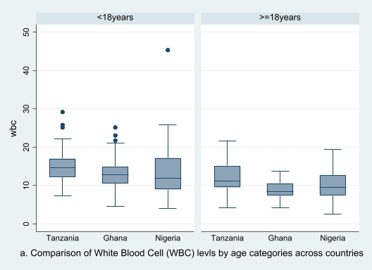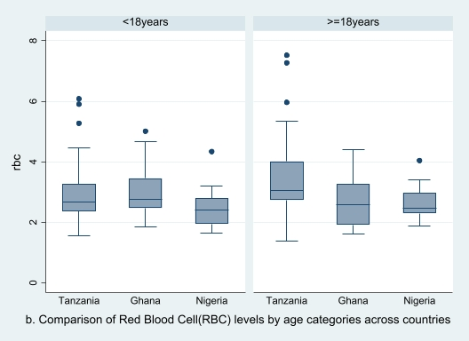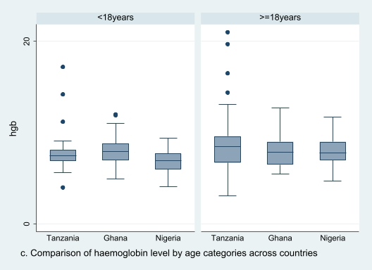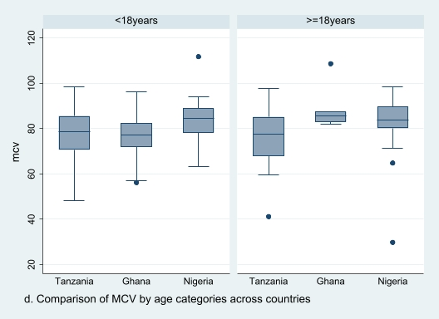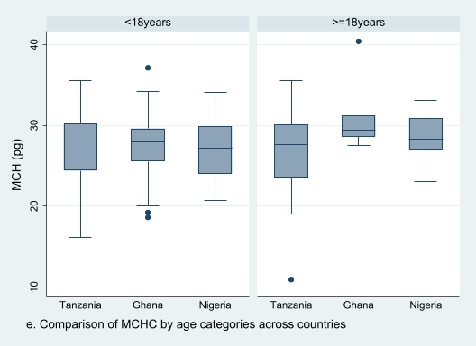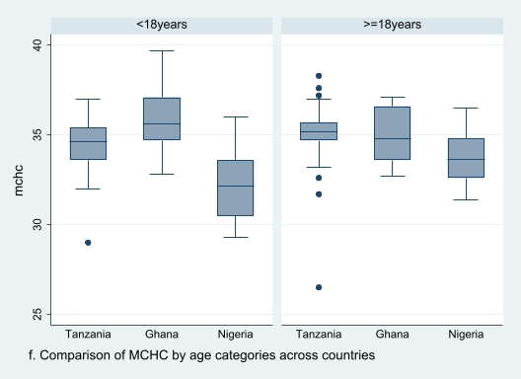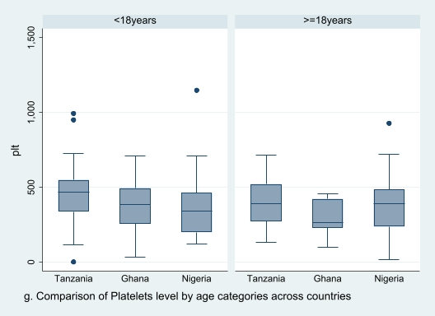Supplementary Figure 1: Comparison of haematological indices in age categories across countries
Supplementary Figure 1 Legend
- Boxplot comparison of White Blood Cell (WBC) levels by age categorization (less than 18 year and 18 years and over) across participating countries
- Boxplot comparison of Red Blood Cell (RBC) levels by age categorization (less than 18 year and 18 years and over) across participating countries
- Boxplot comparison of haemoglobin levels by age categorization (less than 18 year and 18 years and over) across participating countries
- Boxplot comparison of Mean Corpuscular Volume (MCV) levels by age categorization (less than 18 year and 18 years and over) across participating countries
- Boxplot comparison of Mean Corpuscular Haemoglobin (MCH) levels by age categorization (less than 18 year and 18 years and over) across participating countries
- Boxplot comparison of Mean Corpuscular Haemoglobin Concentration (MCHC) levels by age categorization (less than 18 year and 18 years and over) across participating countries
- Boxplot comparison of platelets levels by age categorization (less than 18 year and 18 years and over) across participating countries

