Supplementary Information

Digital health technology use in clinical trials of rare diseases: A systematic review

Xiangyun Mao*, Dian Zeng*, Xiaocong Wang, David A Pearce, Gareth Baynam, Niels H. Chavannes, Wendy K. Chung, Honghan Wu, Yih-Chung Tham, Shuyang Zhang#, Guanqiao Li#, Tienyin Wong#

*These authors contributed equally to this work.
#Correspondence: shuyangzhang103@nrdrs.org (S.Z.), guanqiaoli@tsinghua.edu.cn (G.L.), ophwty@nus.edu.sg (T.W.)

Content:
Supplementary Tables 1
Supplementary Figures 1, 2, 3

Supplementary Table 1: Simplified protocol for systematic review
Databases:
1. Clinicaltrials.gov 2. The World Health Organization (WHO) International Clinical Trials Registry Platform (ICTRP) (https://trialsearch.who.int/) 3. Cochrane Central Register of Controlled Trials (https://www.cochranelibrary.com) 4. PubMed 5. Web of Science
Disease settings:
Given the vast volume of rare diseases, we identified the top 10 rare diseases globally with the most research development as our focus, based on a recently published article (Nat Rev Drug Discov. 2024;23(3):168-169). These diseases include Amyotrophic Lateral Sclerosis (ALS), Pulmonary Fibrosis (PF), Acute Respiratory Distress Syndrome (ARDS), Duchenne Muscular Dystrophy (DMD), Cystic Fibrosis (CF), Huntington’s Disease (HD), Pulmonary Hypertension (PH), Cytokine Release Syndrome (CRS), Frontotemporal Dementia (FTD), and Graft-versus-Host Disease (GVHD).
Search Keywords: (digital health OR artificial intelligence OR AI OR deep learning OR machine learning OR neural network OR big data OR mobile health OR mHealth OR internet of things OR IoT OR telehealth OR telemedicine OR teleconsultation OR telesupport OR telemonitoring OR monitoring OR digital platforms OR distributed database OR blockchain OR smartphone OR smart phone OR mobile app OR mobile device OR study app OR digital therapeutic OR digital therapy OR digital therapies OR digital intervention OR mobile platform OR digital treatment OR android OR app OR digital tablet OR ios OR iphone OR smart watch OR smartwatch OR virtual reality OR video game OR mobile video OR software intervention OR software treatment OR wearable devices OR online recruitment OR remote recruitment OR mobile recruitment OR virtual recruitment OR social media recruitment OR web-based recruitment OR app-based recruitment OR patient portals OR digital recruitment)
AND
(Amyotrophic Lateral Sclerosis OR ALS OR Lou Gehrig's disease OR Motor Neuron Disease OR MND OR Pulmonary Fibrosis OR PF OR Idiopathic Pulmonary Fibrosis OR IPF OR Acute Respiratory Distress Syndrome OR ARDS OR Adult Respiratory Distress Syndrome OR Acute Lung Injury OR ALI OR Duchenne Muscular Dystrophy OR DMD OR Duchenne's Disease OR Cystic Fibrosis OR CF OR Huntington's Disease OR HD OR Huntington's Chorea OR Pulmonary Hypertension OR PH OR Pulmonary Arterial Hypertension OR PAH OR Cytokine Release Syndrome OR CRS OR Cytokine Storm OR Frontotemporal Dementia OR FTD OR Frontotemporal Lobar Degeneration OR FTLD OR Graft versus Host Disease OR GvHD)
Study type
• Inclusion criteria: Interventional studies
• Exclusion criteria: Observational studies, patient registries, and expanded access reports.
Population:
-Inclusion criteria: All individuals (including patients with rare diseases, staff working in a health-care setting, members of parents and relatives) enrolled in the selected clinical trials.
-Exclusion criteria: Those not meeting the inclusion criteria.
Language
• Inclusion criteria: no restriction
• Exclusion criteria: none

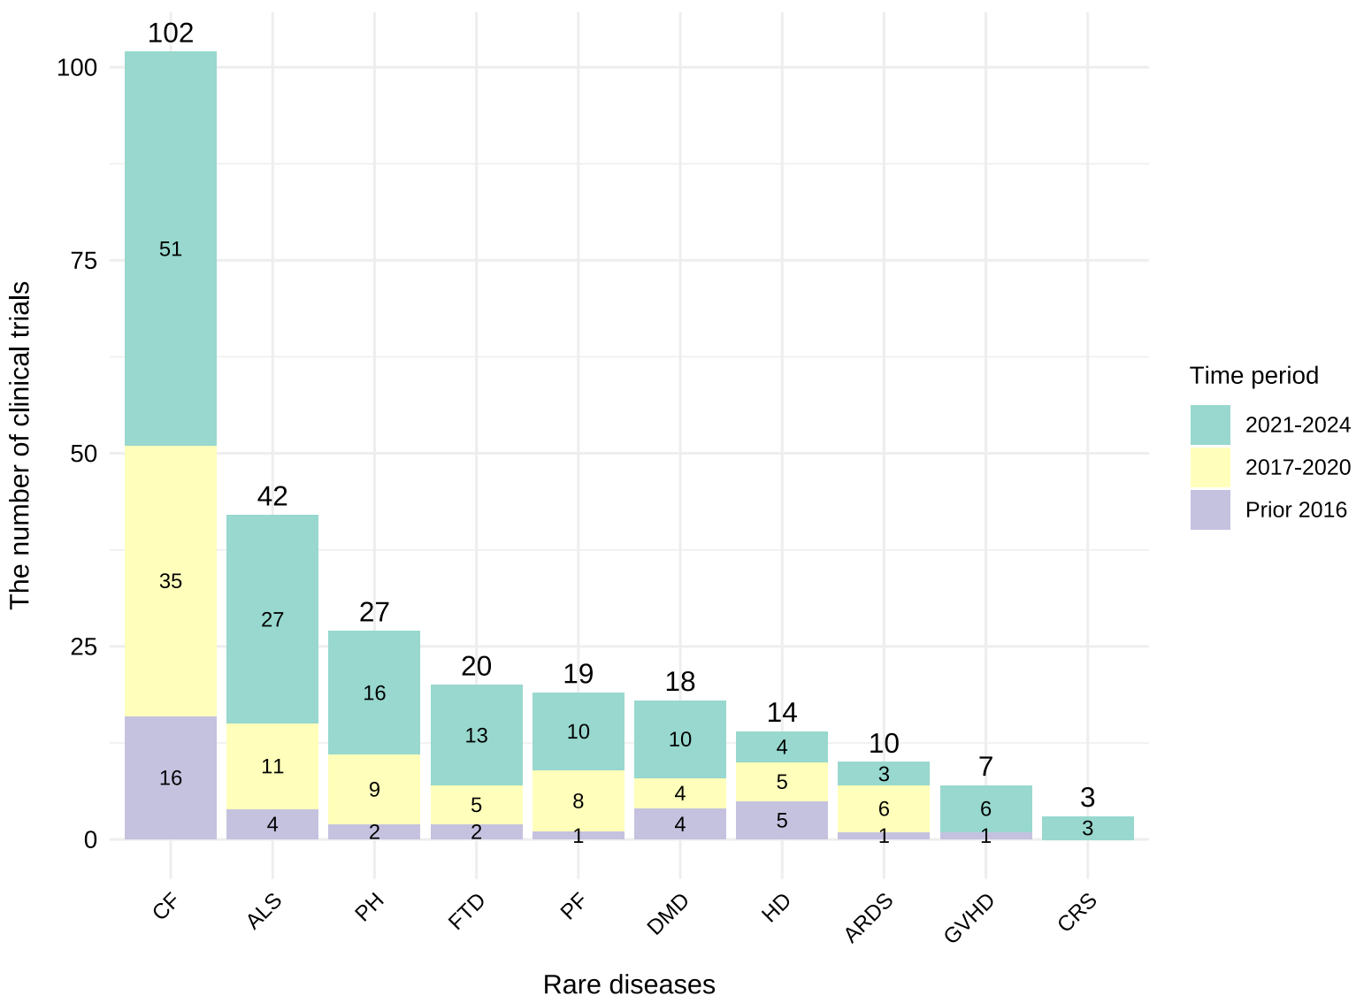
Supplementary Fig. 1: The number of clinical trials for different rare diseases
This stacked bar chart illustrates the total number of clinical trials for ten rare diseases, grouped by study initiation period: prior to 2016, 2017–2020, and 2021–2024. Cystic fibrosis (CF) and amyotrophic lateral sclerosis (ALS) had the highest number of trials, with a noticeable increase in trials initiated after 2020.
Note: ALS: Amyotrophic Lateral Sclerosis, PF: Pulmonary Fibrosis, ARDS: Acute Respiratory Distress Syndrome, DMD: Duchenne Muscular Dystrophy, CF: Cystic Fibrosis, HD: Huntington’s Disease, PH: Pulmonary Hypertension, CRS: Cytokine Release Syndrome, FTD: Frontotemporal Dementia, GVHD: Graft-Versus-Host Disease

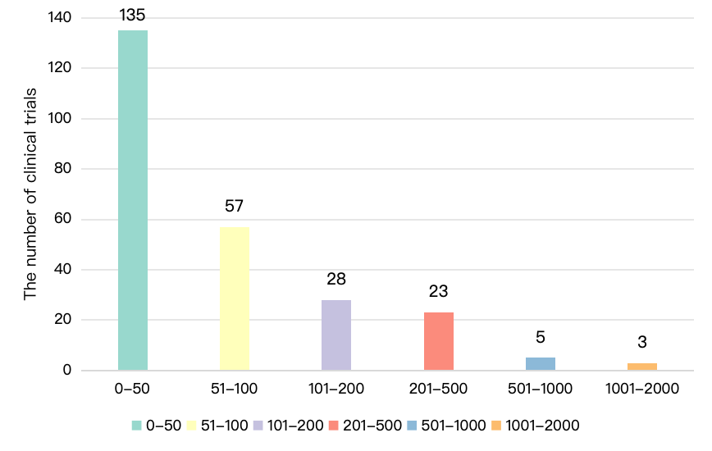
Supplementary Fig. 2: Enrollment distribution
The bar chart displays the number of participants enrolled in each trial, with the majority of trials enrolled fewer than 100 participants.

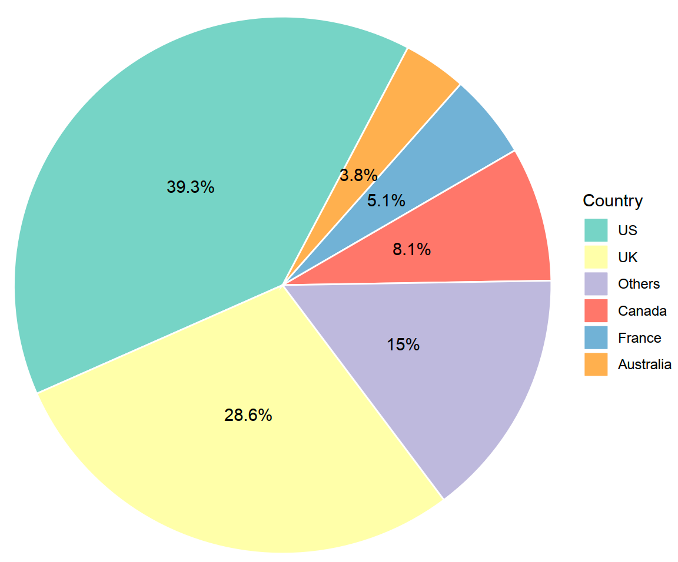
Supplementary Fig. 3: Geographical distribution
The pie chart illustrates the proportion of trials conducted in each country, with the United States (US) contributing the largest share (39.3%), followed by the United Kingdom (UK) (28.6%), and other countries including Canada, France, and Australia.

