Supplementary Methods 1: Functional ANOVA
For univariate summaries of the peripheral haemodynamic signals, group means were compared using functional ANOVA. Briefly, for each of the haemodynamic signals considered the participants’ response curves are represented by $X_{hj}\left(t\right)$, where $t=1, …,151$ are the timepoints at which data is captured for each individual (once per second); $h=1, …,n_{l}$ indexes over the number of groups being compared (i.e. $l=3$ in the case of cause specific mortality); $j=1, …,n_{h}$ indexes over individuals in group $i$. The functional ANOVA tests the null hypothesis that group means $μ_{h}$ are equal at each timepoint $t$ versus the alternative that at least one group mean is different.
$$H_{o}: μ_{1}\left(t\right)=…=μ_{l}(t)$$
To ensure that results and conclusions drawn are not dependent on the underlying assumptions regarding any one version of the functional ANOVA test, multiple versions of this test all with varying assumptions were performed and the results for each reported (Tables S1,S2). The conclusions of the analysis were not affected by varying test assumptions.
Supplementary Methods 2: Functional Principal Components Analysis (FPCA)
FPCA is an extension of the well-known dimensionality reduction technique principal components analysis (PCA) for functional data (in this case haemodynamic responses as a function of time). In standard PCA an eigen decomposition is performed on the covariance matrix of multivariate data which results in eigenvalues and their accompanying eigenvectors commonly referred to as principal components. Eigenvalues represent the proportion of variation explained by each of the principal components. The principal components or eigenvectors themselves describe the direction of variation in the data. FPCA is a very similar except instead of eigenvectors associated with each eigenvalue; there are eigenfunctions associated with each eigenvalue which explain the orientation and scale of the variation in the data respectively. In a similar vein, as with PC scores in standard PCA where observations are projected onto the PC sub-space and their coordinates extracted; FPC scores can also be extracted for each individual and each component in FPCA as follows:
$$c_{ik}=∫ϕ_{k}(t)[X_{i}(t)-μ(t)]$$
Here $c_{ik}$are the component scores, $ϕ_{k}$ refers to the $k_{ }^{th}$ eigenfunction and $X_{i}(t)$ refers to the response curve for observation $i$ at time $t$. These scores can then be input as coefficients into other standard multivariable models (58-60).
Supplementary Methods 3: Elastic Net Regression
To model incident CVD an elastic net logistic regression was implemented. As high class-imbalance was present for incident CVD (9.6% of participants had incident CVD); the model was trained across 1,000 balanced bootstrap samples to ensure that the associations discovered were not due to bias in selecting the control cases. Over each of the 1,000 permutated datasets we employed an elastic net penalised regression which is a common method for variable selection. The optimal $λ$ was chosen using 10-fold cross validation on the training data and $α=0.5$. The variables which had non-zero coefficients in more than 50% of the permutations were considered consistently associated with CVD and presented in the results. Again, all performance metrics were calculated based on the 20% test set which was not used in any part of the model building.

Supplementary Tables:
Supplementary Table 1: Results for the full list of ANOVA tests performed for each of the haemodynamic signals on survival status for All-Cause mortality.
Test Type | Heart Rate p-value | Systolic Blood Pressure p-value | Diastolic Blood Pressure p-value | Stroke Volume Index p-value
FP Test: Permutation test based on a basis function representation | 0.023 | <0.001 | <0.001 | <0.001
CH Test: L2-norm-based parametric bootstrap test for homoscedastic samples | 0.026 | <0.001 | <0.001 | <0.001
CS Test: L2-norm-based parametric bootstrap test for heteroscedastic samples | 0.050 | <0.001 | <0.001 | <0.001
L2-norm-based test with naïve method of estimation | 0.025 | <0.001 | <0.001 | <0.001
L2-norm-based test with bias-reduced method of estimation | 0.025 | <0.001 | <0.001 | <0.001
L2 norm based on bootstrap test | 0.052 | <0.001 | <0.001 | <0.001
F-type test with naïve method of estimation | 0.025 | <0.001 | <0.001 | <0.001
F-type test with bias-reduced method of estimation | 0.025 | <0.001 | <0.001 | <0.001
F-type bootstrap test | 0.044 | <0.001 | <0.001 | <0.001
Globalizing Pointwise F-test | 0.027 | <0.001 | <0.001 | <0.001
Fmax bootstrap test | <0.001 | <0.001 | <0.001 | <0.001

Supplementary Table 2: Results for the full list of ANOVA tests performed for each of the haemodynamic signals on cause-specific mortality.
Test Type | Heart Rate p-value | Systolic Blood Pressure p-value | Diastolic Blood Pressure p-value | Stroke Volume Index p-value | Cardiac Index p-value
FP Test: Permutation test based on a basis function representation | 0.01 | 0.607 | 0.194 | 0.001 | 0.001
CH Test: L2-norm-based parametric bootstrap test for homoscedastic samples | 0.010 | 0.608 | 0.213 | 0.006 | 0.003
CS Test: L2-norm-based parametric bootstrap test for heteroscedastic samples | 0.007 | 0.624 | 0.204 | 0.006 | 0.002
L2-norm-based test with naïve method of estimation | 0.005 | 0.626 | 0.207 | <0.001 | <0.001
L2-norm-based test with bias-reduced method of estimation | 0.005 | 0.626 | 0.206 | <0.001 | <0.001
L2 norm based bootstrap test | 0.007 | 0.639 | 0.199 | 0.003 | <0.001
F-type test with naïve method of estimation | 0.006 | 0.626 | 0.208 | 0.001 | <0.001
F-type test with bias-reduced method of estimation | 0.006 | 0.627 | 0.208 | 0.001 | <0.001
F-type bootstrap test | 0.007 | 0.634 | 0.193 | 0.003 | <0.001
Globalizing Pointwise F-test | 0.006 | 0.687 | 0.263 | 0.001 | <0.001
Fmax bootstrap test | 0.006 | 0.931 | 0.233 | 0.009 | 0.003

Supplementary Table 3 P-values resulting from a pairwise comparison of mortality cause.
Pairwise Comparison | p-value
Heart Rate
Cancer Vs Circulatory | 0.222
Cancer Vs Other | 0.022
Circulatory Vs Other | 0.002
Systolic Blood Pressure
Cancer Vs Circulatory | 0.564
Cancer Vs Other | 0.536
Circulatory Vs Other | 0.445
Diastolic Blood Pressure
Cancer Vs Circulatory | 0.131
Cancer Vs Other | 0.122
Circulatory Vs Other | 0.971
Stroke Volume Index
Cancer Vs Circulatory | 0.008
Cancer Vs Other | 0.004
Circulatory Vs Other | 0.545

Supplementary Table 4 Hazard Ratio, 95% CI and p-value for variables included in the final model of all-cause mortality after applying step-wise variable selection
 | Hazard Ratio | LCI | UCI | p-value
Age | 0.90 | 0.88 | 0.92 | <0.001
Female | 0.64 | 0.51 | 0.80 | <0.001
Education Secondary | 0.86 | 0.67 | 1.10 | 0.238
Education Third | 0.68 | 0.51 | 0.90 | 0.007
Depression/Anxiety/Psychosis | 1.34 | 1.01 | 1.76 | 0.040
Former Smoker | 1.44 | 1.13 | 1.84 | 0.004
Current Smoker | 2.76 | 2.02 | 3.79 | <0.001
Pre-Frail | 1.19 | 0.83 | 1.54 | 0.171
Frail | 2.08 | 1.54 | 2.81 | <0.001
FPC HR 1 | 1.08 | 0.98 | 1.20 | 0.109
FPC SBP 5 | 1.14 | 1.04 | 1.26 | 0.007

Supplementary Table 5: Coefficients included in the final model for cause specific mortality using competing risks analysis and stepwise variable selection:
Model | HR | HR LCI | HR UCI | p-value
Circulatory System
Age | 0.96 | 0.94 | 0.98 | <0.001
Sex Female | 0.65 | 0.44 | 0.98 | 0.038
Education
Secondary | 0.65 | 0.40 | 1.03 | 0.069
Third | 0.58 | 0.34 | 0.97 | 0.039
Hypertension | 2.00 | 1.10 | 3.62 | 0.023
Frailty Index
Pre-Frail | 1.02 | 0.61 | 1.72 | 0.931
Frail | 2.44 | 1.46 | 4.07 | <0.001
FPC HR2 | 0.78 | 0.65 | 0.95 | 0.013
FPC SBP5 | 1.15 | 0.98 | 1.35 | 0.084
Cancer
Age | 0.96 | 0.94 | 0.97 | <0.001
Depression/Anxiety/Psychosis | 1.49 | 1.03 | 2.18 | 0.037
Smoking Status
Former Smoker | 1.54 | 1.08 | 2.20 | 0.037
Current Smoker | 2.75 | 1.77 | 4.27 | <0.001
FPC HR2 | 1.19 | 1.01 | 1.40 | 0.037
FPC SV1 | 1.19 | 1.02 | 1.39 | 0.025
FPC SV2 | 0.86 | 0.71 | 1.04 | 0.112
Other
Depression/Anxiety/Psychosis | 1.56 | 0.95 | 2.56 | 0.080
Smoking Status
Former Smoker | 2.06 | 1.26 | 3.36 | 0.004
Current Smoker | 2.71 | 1.41 | 5.23 | 0.003
FPC HR1 | 1.48 | 1.22 | 1.80 | <0.001
FPC SBP5 | 1.28 | 1.07 | 1.53 | 0.007
FPC SVI1 | 0.68 | 0.55 | 0.85 | <0.001

Supplementary Table 6: Association between orthostatic hypotension at 10 second intervals post-stand and mortality.
Model | HR | HR LCI | HR UCI | p-value
All-Cause Mortality
Baseline absolute HR | 1.00 | 1.00 | 1.00 | 0.463
Baseline absolute SBP | 1.00 | 1.00 | 1.01 | 0.088
OH 10 | 1.06 | 0.77 | 1.46 | 0.713
OH 20 | 1.05 | 0.84 | 1.31 | 0.678
OH 30 | 1.23 | 0.97 | 1.57 | 0.087
OH 40 | 1.36 | 1.06 | 1.75 | 0.016
OH 50 | 1.14 | 0.87 | 1.49 | 0.330
OH 60 | 1.19 | 0.90 | 1.57 | 0.232
Circulatory System
Baseline absolute HR | 1.00 | 0.99 | 1.00 | 0.003
Baseline absolute SBP | 1.00 | 1.00 | 1.014 | 0.280
OH 10 | 1.00 | 0.56 | 1.79 | 0.990
OH 20 | 1.02 | 0.68 | 1.53 | 0.940
OH 30 | 1.31 | 0.83 | 2.08 | 0.250
OH 40 | 1.40 | 0.88 | 2.24 | 0.160
OH 50 | 1.05 | 0.63 | 1.73 | 0.870
OH 60 | 0.90 | 0.51 | 1.56 | 0.700
Cancer
Baseline absolute HR | 1.01 | 1.00 | 1.02 | 0.250
Baseline absolute SBP | 1.00 | 1.00 | 1.01 | 0.630
OH 10 | 0.88 | 0.57 | 1.37 | 0.570
OH 20 | 1.00 | 0.72 | 1.39 | 0.990
OH 30 | 0.99 | 0.69 | 1.42 | 0.940
OH 40 | 1.04 | 0.71 | 1.54 | 0.840
OH 50 | 0.98 | 0.65 | 1.49 | 0.930
OH 60 | 1.28 | 0.85 | 1.93 | 0.230
Other
Baseline absolute HR | 1.00 | 0.99 | 1.01 | 0.94
Baseline absolute SBP | 1.00 | 0.99 | 1.02 | 0.470
OH 10 | 1.59 | 0.77 | 3.29 | 0.210
OH 20 | 1.10 | 0.70 | 1.73 | 0.680
OH 30 | 1.42 | 0.88 | 2.27 | 0.140
OH 40 | 1.49 | 0.90 | 2.45 | 0.120
OH 50 | 1.34 | 0.82 | 2.19 | 0.250
OH 60 | 1.24 | 0.72 | 2.13 | 0.440

Supplementary Table 7 Results for the full list of ANOVA tests performed for each of the haemodynamic signals on incident CVD.

Test Type | Heart Rate p-value | Systolic Blood Pressure p-value | Diastolic Blood Pressure p-value | Stroke Volume Index p-value
FP Test: Permutation test based on a basis function representation | 0.038 | 0.310 | 0.001 | <0.001
CH Test: L2-norm-based parametric bootstrap test for homoscedastic samples | 0.046 | 0.268 | <0.001 | <0.001
CS Test: L2-norm-based parametric bootstrap test for heteroscedastic samples | 0.057 | 0.341 | 0.003 | <0.001
L2-norm-based test with naïve method of estimation | 0.047 | 0.310 | <0.001 | <0.001
L2-norm-based test with bias-reduced method of estimation | 0.047 | 0.310 | <0.001 | <0.001
L2 norm based bootstrap test | 0.060 | 0.331 | <0.002 | <0.001
F-type test with naïve method of estimation | 0.047 | 0.311 | <0.001 | <0.001
F-type test with bias-reduced method of estimation | 0.047 | 0.311 | <0.001 | <0.001
F-type bootstrap test | 0.056 | 0.344 | 0.002 | <0.001
Globalizing Pointwise F-test | 0.050 | 0.469 | <0.001 | <0.001
Fmax bootstrap test | 0.003 | 0.070 | <0.001 | <0.001
Supplementary Table 8 Mean Coefficients (Odds Ratio) along with their 2.5 and 97.5 percentiles from elastic net model of incident CVD. Variables with non-zero coefficients in at least 50% of the 1,000 bootstrap samples and whose association was consistent (2.5 and 97.5 percentile intervals did not overlap 1) were considered associated with the outcome and shown below. Note: covariates with zero coefficients over more than 50% of the bootstrap samples included: education, high cholesterol, depression/anxiety/psychosis, FPC HR1, FPC HR2, FPCs SV3-4 and FPCs DBP1-6.

Coefficient | OR (95% CI)
FPC SV1 | 0.88 (0.71, 0.995)
FPC HR1 | 0.89 (0.71, 0.997)
Age | 1.37 (1.11, 1.73)
Sex (Female) | 0.75 (0.48, 0.98)
Hypertension | 1.61 (1.08, 2.51)
Pre-Frail | 1.32 (1.01, 2.04)
Frail | 1.52 (1.01, 3.39)

Supplementary Figures:
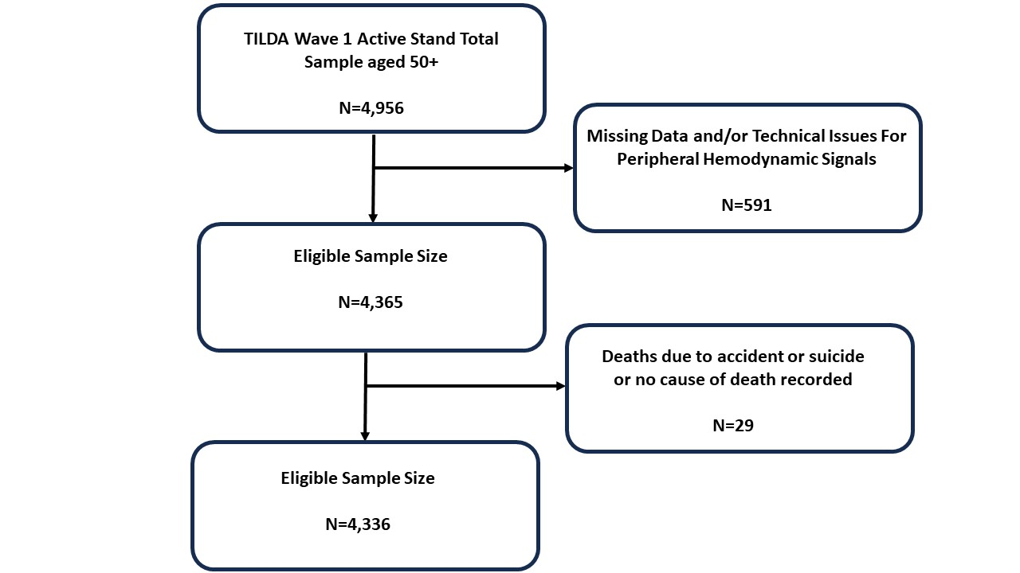
Supplementary Figure 1 Flow chart depicting exclusion criteria and eligible sample size included in final analysis.
Figure Title Flow Chart

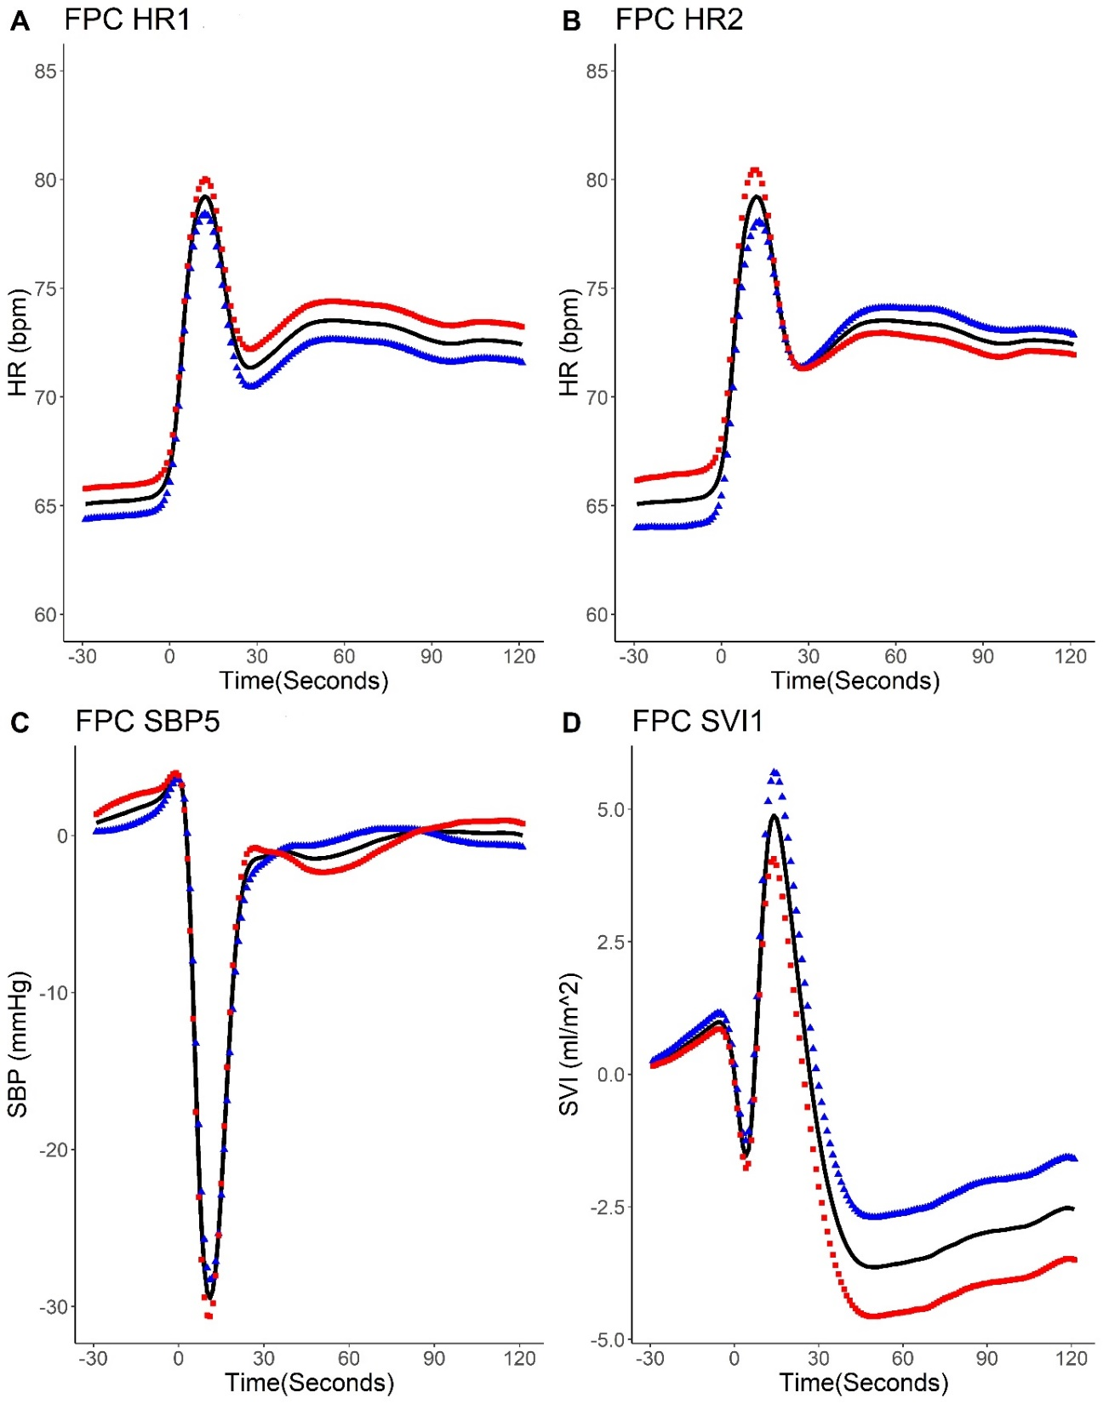
Supplementary Figure 2: How positive vs negative scores on the principal components associated with cause specific mortality impact the mean curve (Figure 2A relates to FPC HR1; Figure 2B to FPC HR2; Figure 2C to FPC SBP5 and Figure 2D to FPC SV1)). Red squares in each case represent how high (positive) scores on the indicated component affect the mean, blue triangles represent how low (negative) scores on the component affect the mean.
Figure Title: Associations with Cause-Specific Mortality

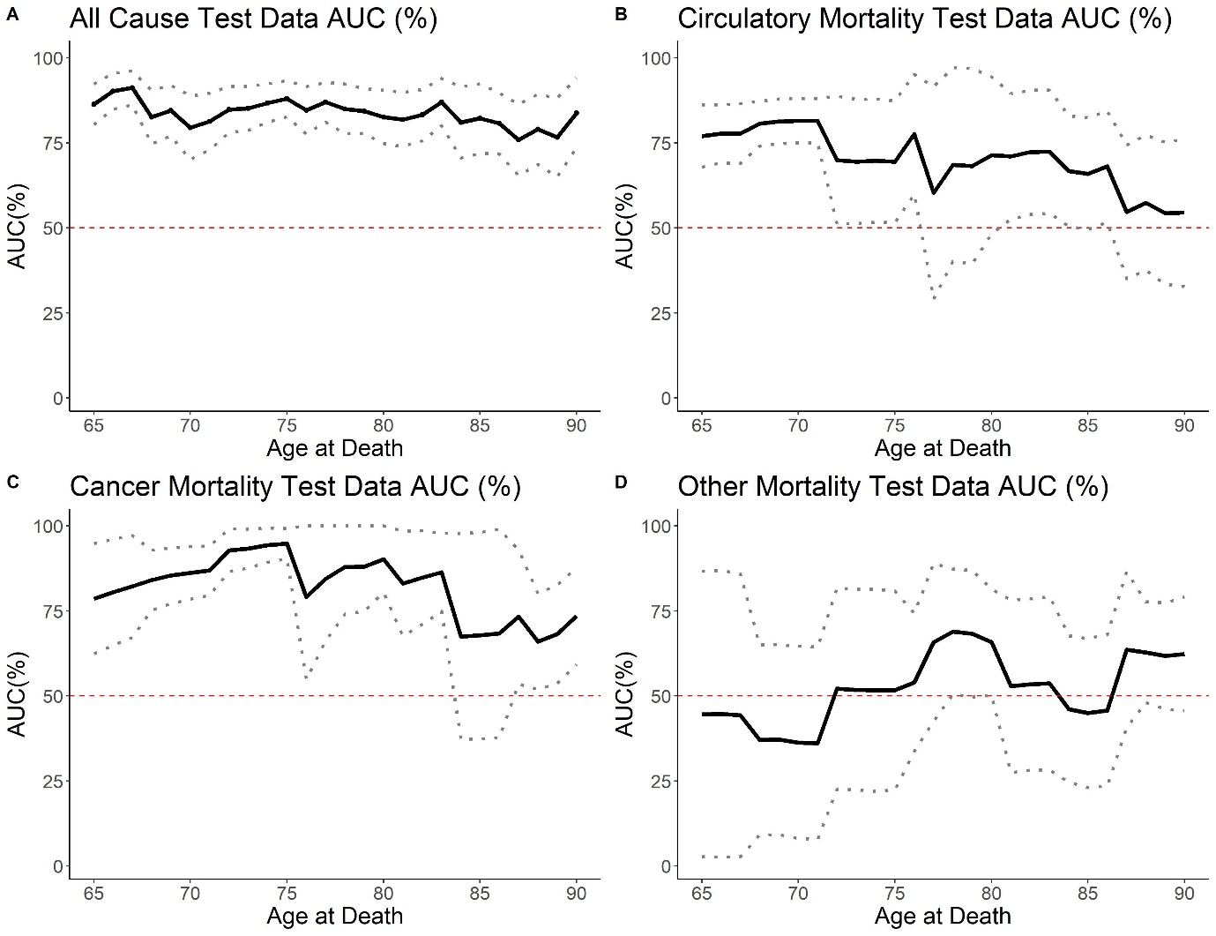
Supplementary Figure 3: Estimated time-dependent AUC and 95% CI according to age at death on 20% hold-out test data (A) All-Cause Mortality, (B) Circulatory Mortality, (C) Cancer Mortality and (D) Other Mortality.
Figure Title: Accuracy of Mortality Models

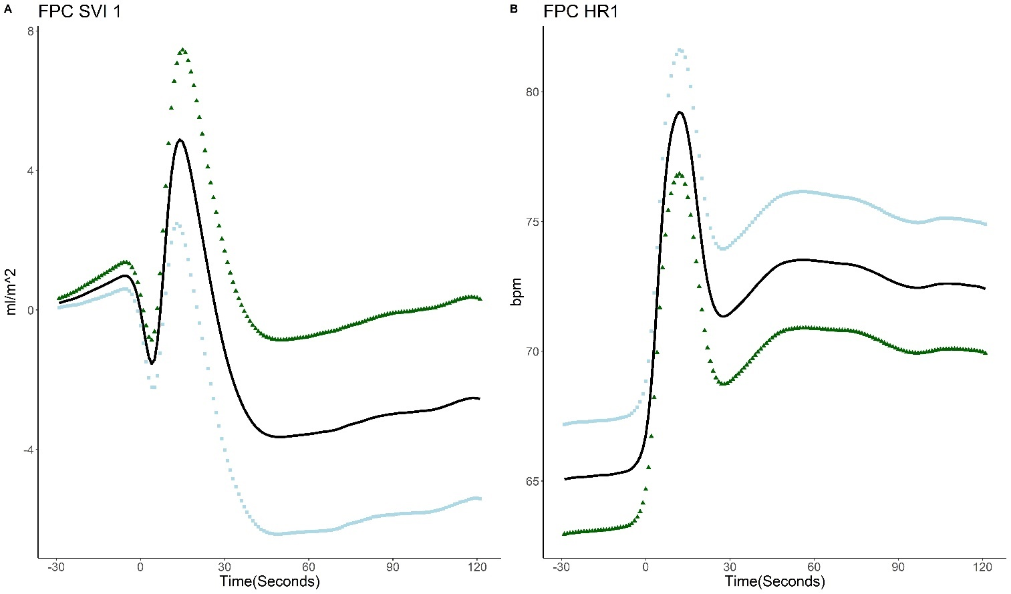
Supplementary Figure 4 (A) Mean trace (black) with FPCs added and subtracted from the mean for FPC SVI 1. (B) Mean trace (black) with FPCs added and subtracted from the mean for FPC HR 1. The direction of the principal component scores associated with incident CVD is represented by green triangles in each case.
Figure Title: Association with 12-year incident CVD

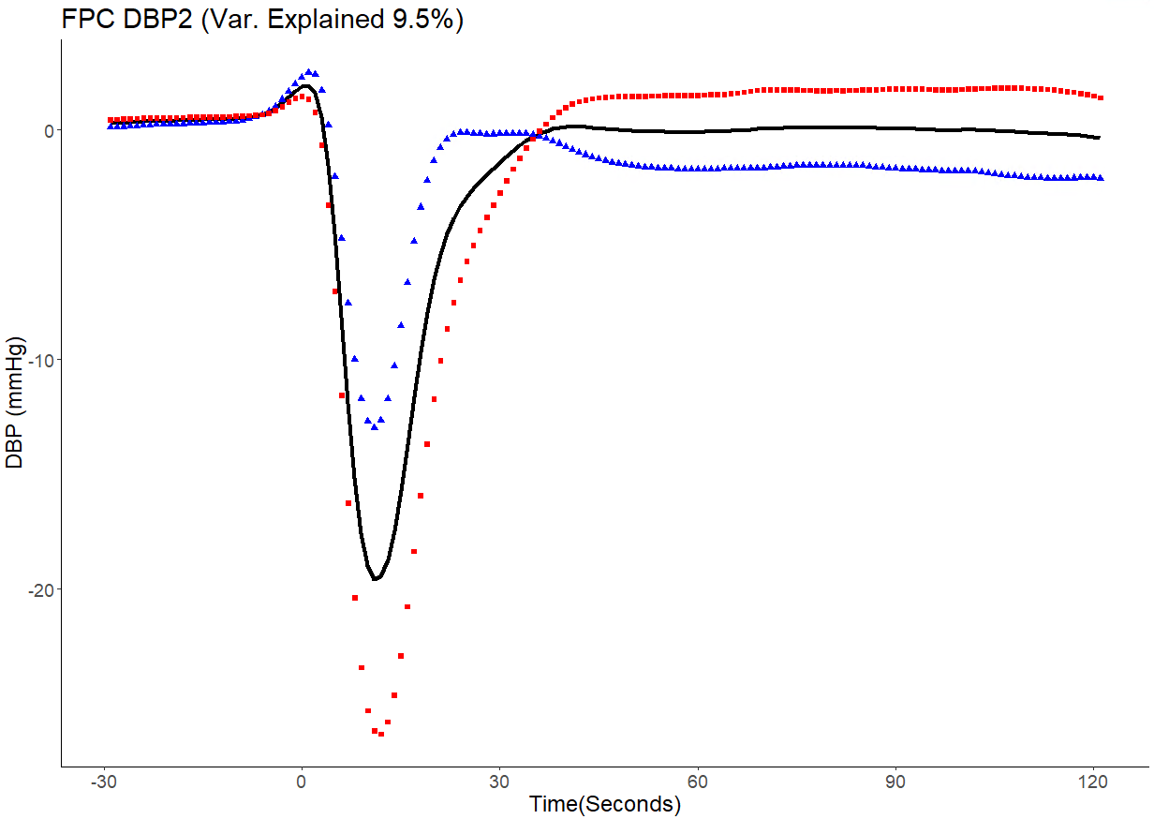
Supplementary Figure 5: How positive (red squares) and negative (blue triangles) FPC scores on the second principal component for DBP perturb the mean curve (black solid line) on a validation clinical cohort.
Figure Title: How FPC DBP2 impacts on the Mean DBP curve

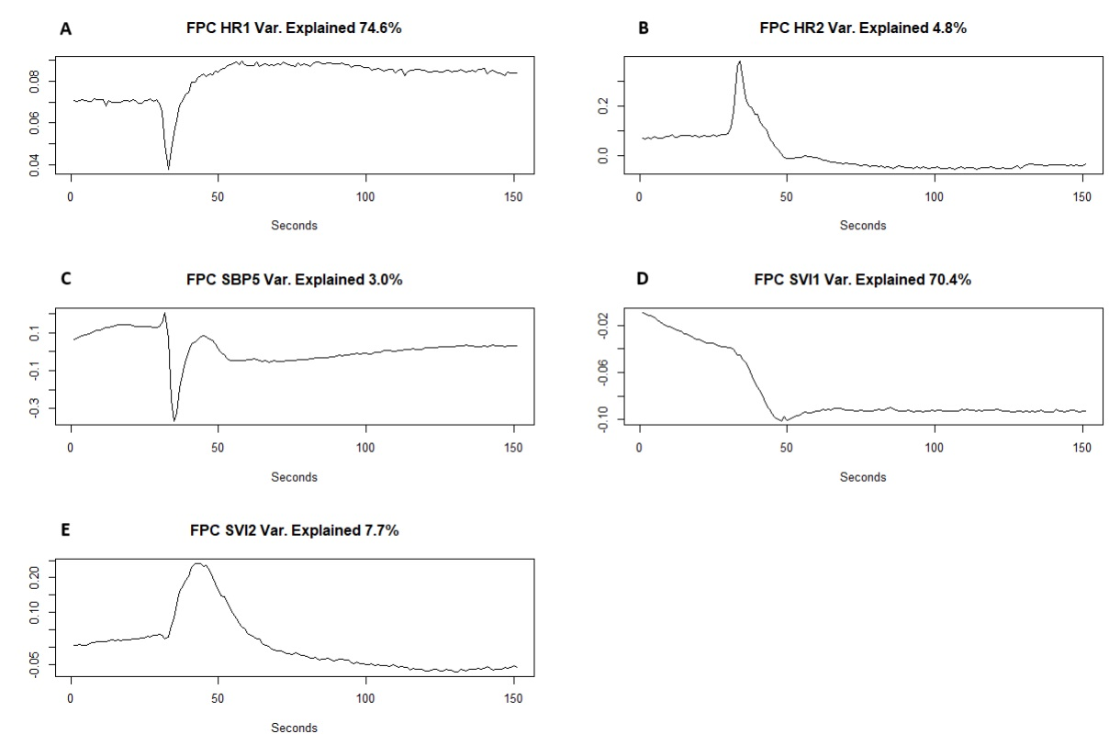
Supplementary Figure 6 Eigenfunctions associated with all-cause mortality, cause specific mortality and incident CVD. Figure 6 A Eigenfunction for FPC HR1 associated with all-cause mortality, other mortality and incident CVD.
Figure 6 B Eigenfunction for FPC HR2 associated with circulatory system mortality (positive association) and cancer mortality (negative association)
Figure 6 C Eigenfunction for FPC SBP5 associated with all-cause mortality and other mortality.
Figure 6 D Eigenfunction for FPC SVI1 associated with incident CVD and other mortality
Figure 6 E Eigenfunction for FPC SVI2 associated with cancer mortality.
Figure Title: Eigenfunctions associated with all-cause mortality, cause specific mortality and incident CVD

