Supplementary Information
Cell-specific proteome profiling reveals altered peripheral immune cell communication in early multiple sclerosis

Hengameh Shams†1, Gabriela Grigorean2, Stacy J Caillier1, Qin Ma1, Adam Santaniello1, Adam Renschen1, Rachael R Denbrock3, Jonathan J Carver3, Taylor C Roberson3, Chaitrali Saha1, University of California San Francisco MS-EPIC Team*, Refujia Gomez1, Bruce AC Cree1, Stephen L Hauser1, Jorge R Oksenberg1, Alessandro Didonna†3

†Correspondence to:
Hengameh Shams, PhD — hengameh.shams@gmail.com
Alessandro Didonna, PhD — didonnaal21@ecu.edu

1Weill Institute for Neurosciences, Department of Neurology, University of California San Francisco, San Francisco, CA 94158, USA
2Genome & Biomedical Sciences Facility, University of California, Davis, CA 95616, USA
3Department of Anatomy and Cell Biology, Brody School of Medicine, East Carolina University, Greenville, NC 27834, USA

*A list of authors and their affiliations appear at the end of the paper.

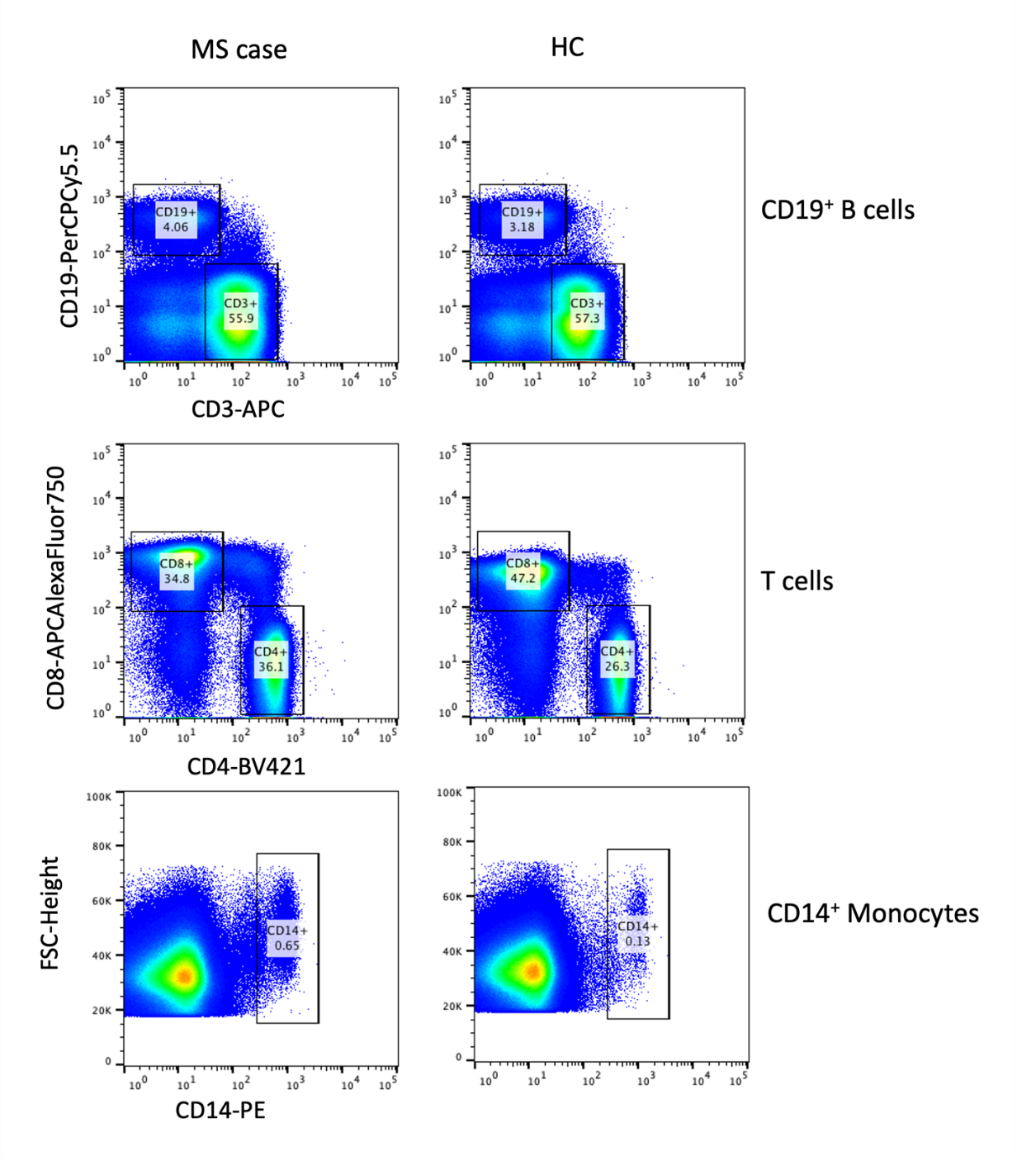
Figure S1. Flow cytometric sorting of peripheral immune cell populations from MS patients and healthy controls. Flow cytometric sorting (FACS) of CD4⁺ and CD8⁺ T cells, CD14⁺ monocytes, and CD19⁺ B cells from MS patients and healthy controls. Representative flow cytometry plots from MS and healthy control (HC) subjects are shown.

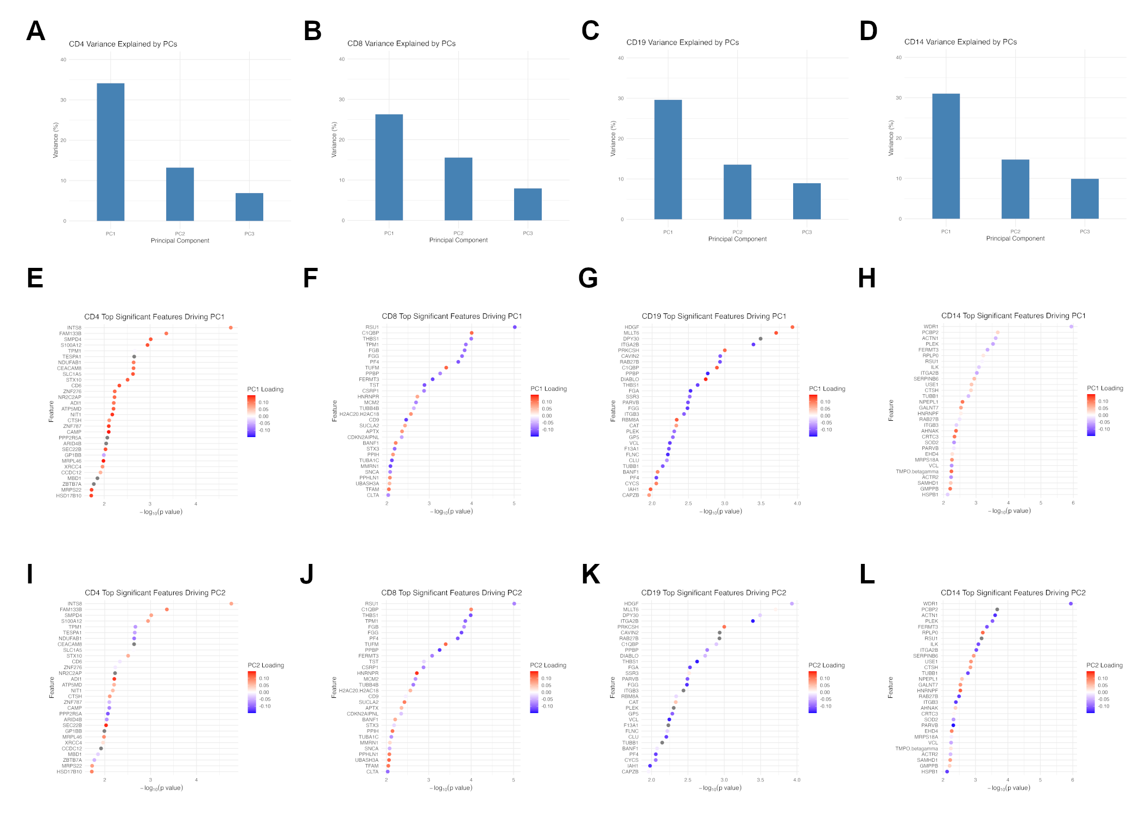
Figure S2. Explained variance and drivers of the PCA across cell subtypes. Bar plots showing the percentage of variance explained by the top three principal components (PC1–PC3) for (A) CD4⁺ T cells, (B) CD8⁺ T cells, (C) CD19⁺ B cells, and (D) CD14⁺ monocytes, respectively. PC1 and PC2 explained the largest proportion of variance in all cell types and were selected for further analysis. Dot plots displaying the top significantly differentially expressed proteins (FDR < 0.05) driving separation along (E-H) PC1 and (I-L) PC2 axes. The x-axis represents –log₁₀(p-value) from a two-group comparison between case and control samples, and the color gradient indicates the PCA loading value for each protein along PC1 (center panels) or PC2 (bottom panels). Only the top 30 features ranked by significance are shown for each principal component.
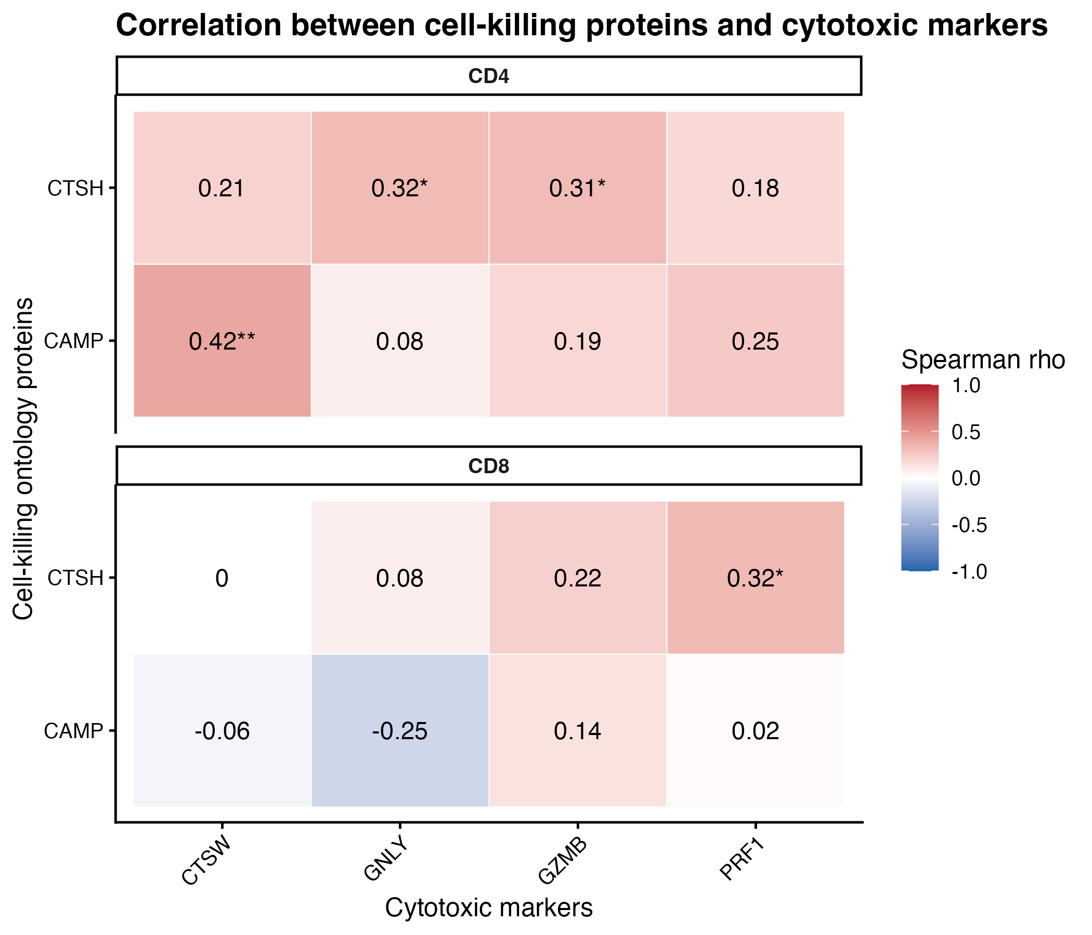

Figure S3. Correlation analysis between proteins contributing to the ‘cell killing’ enrichment signature and canonical cytotoxic effector markers in CD4⁺ and CD8⁺ T cells. Spearman correlation coefficients were calculated between CAMP and CTSH and the cytotoxic proteins CTSW, GNLY, GZMB, and PRF1 across samples. Positive correlations were observed between CTSH and multiple cytotoxic markers in both CD4⁺ and CD8⁺ T-cell populations, while CAMP showed a more selective association, including correlation with CTSW in CD4⁺ T cells. These findings support an association between the ‘cell killing’ enrichment program and cytotoxic/effector-associated immune features.

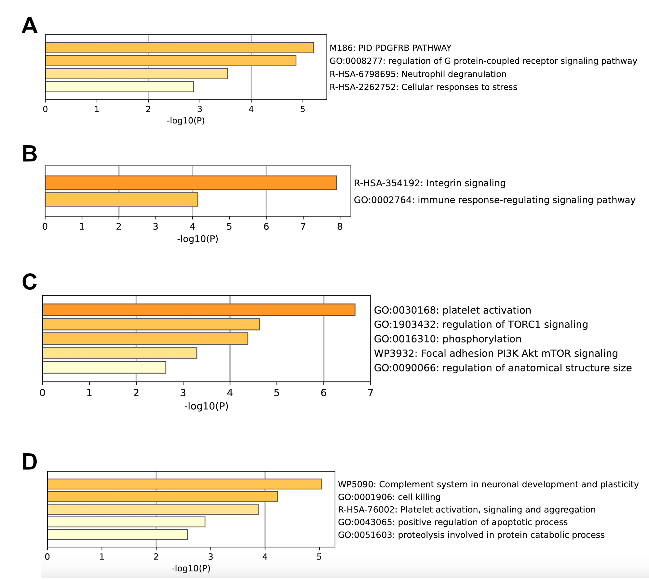
Figure S4. Pathway enrichment analysis of overlap between differentially expressed genes and MS genetic risk gene sets. Pathway enrichment results for CD14⁺ monocytes (A) and CD19⁺ B cells (B) based on the overlap between DEGs and a set of 551 prioritized multiple sclerosis (MS) risk genes. Enrichment results for CD14⁺ monocytes (C) and CD19⁺ B cells (D) based on the overlap between DEGs and MS-associated genes identified by Hi-C coupled MAGMA (H-MAGMA).

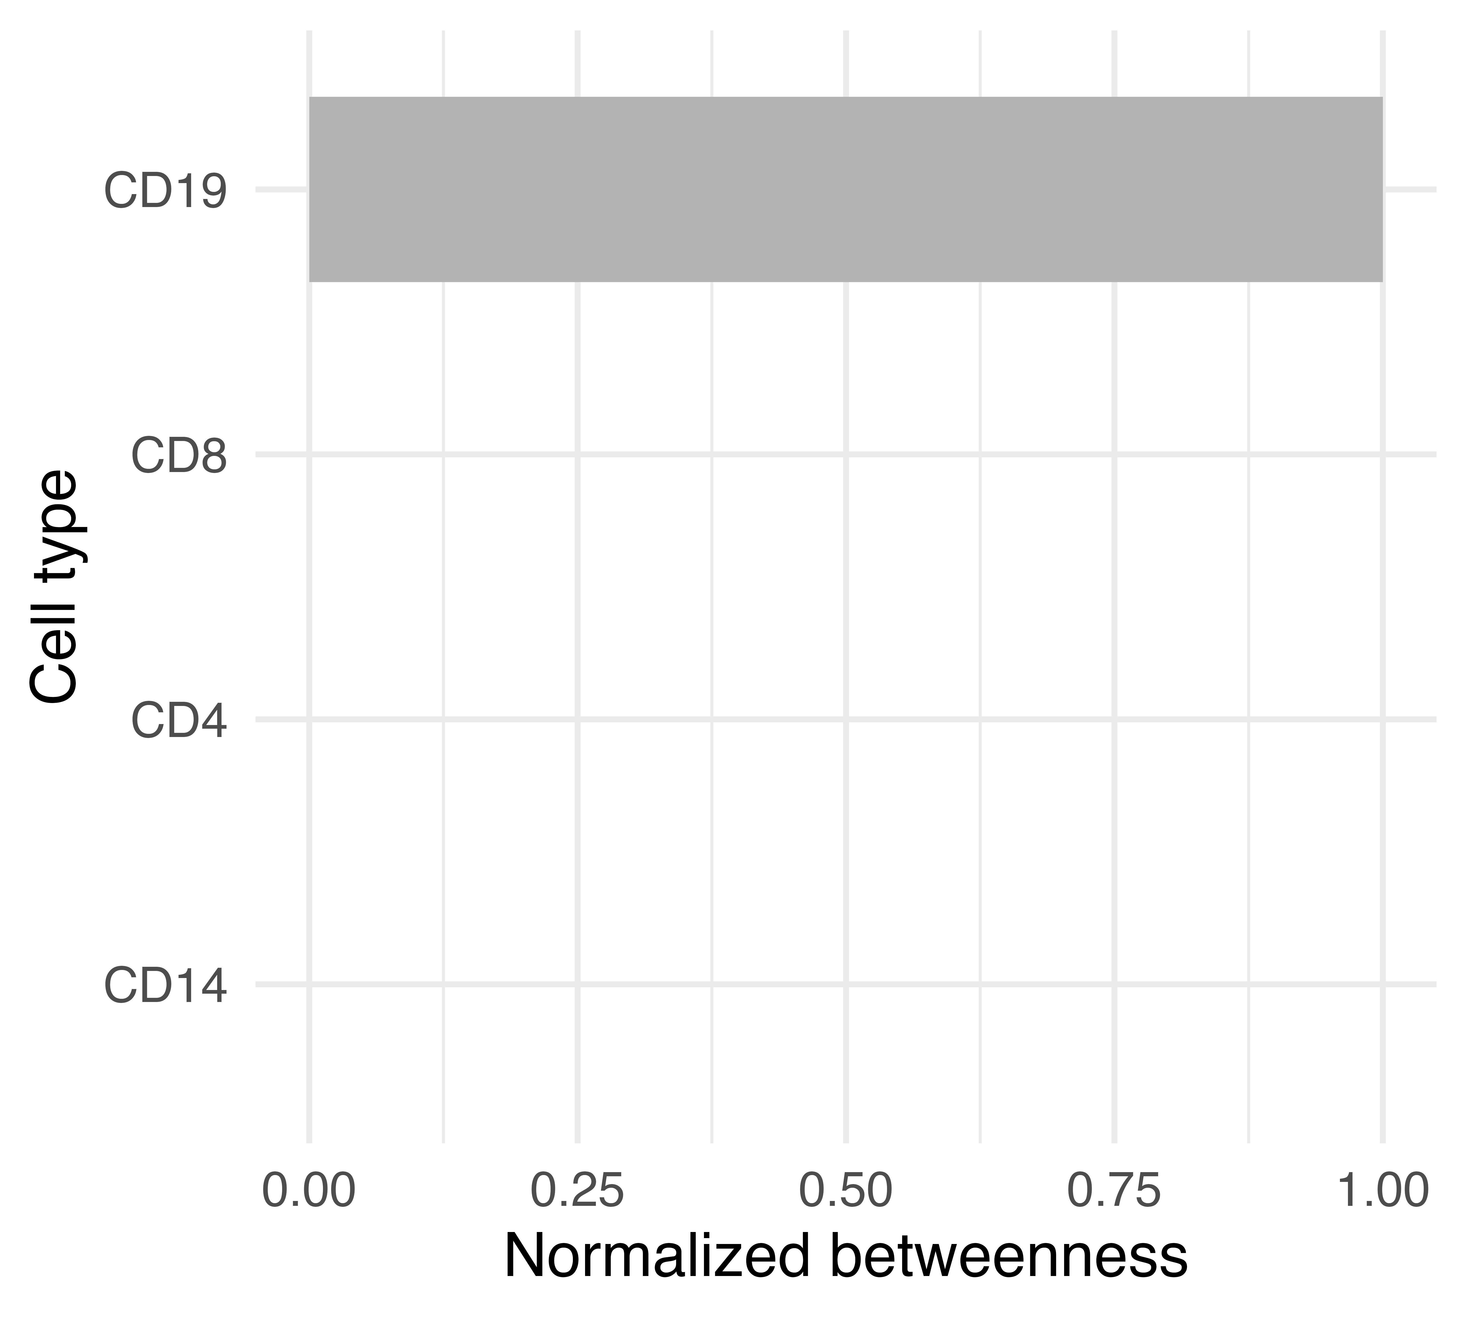
Figure S5. Betweenness centrality of immune cell populations in the LR-rewiring network. Weighted betweenness centrality values for each immune cell population computed from the ligand–receptor rewiring graph using disease-weighted edges. The plot shows a strong concentration of betweenness in CD19⁺ B cells, with all other cell types exhibiting values near zero, indicating minimal contribution to weighted shortest paths between sender and receiver nodes.
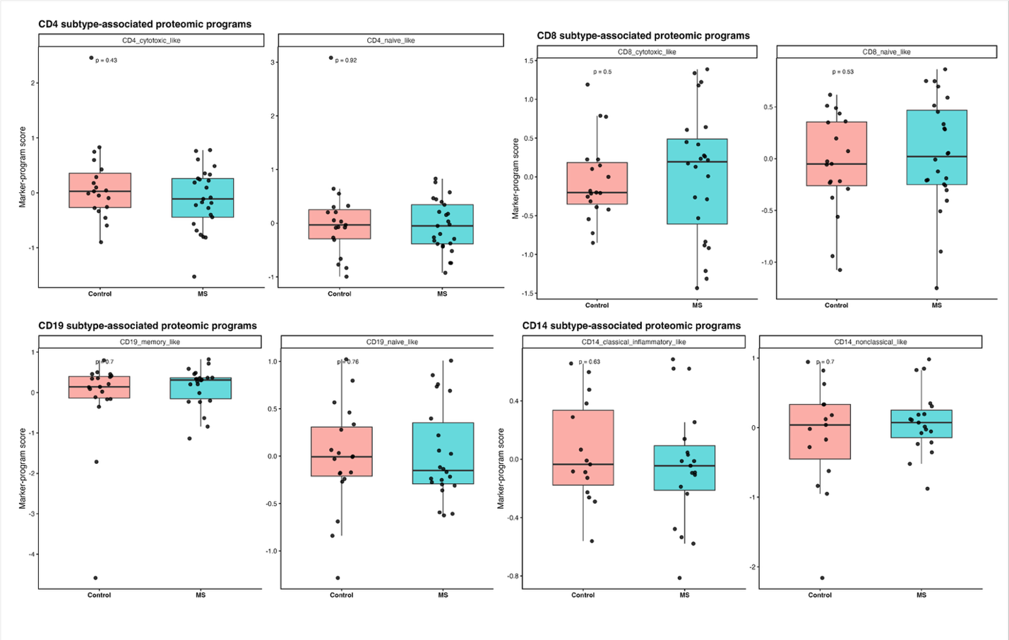
Figure S6. Subtype-associated proteomic programs across bulk-sorted peripheral immune populations. Subtype-associated proteomic program scores across major immune populations in MS patients and healthy controls. Marker-based subtype program analysis was performed using established immune subtype-associated protein signatures within bulk-sorted CD4⁺ and CD8⁺ T cells, CD19⁺ B cells, and CD14⁺ monocytes. Boxplots show relative enrichment scores for cytotoxic-like and naïve-like T-cell programs, memory-like and naïve-like B-cell programs, and classical inflammatory-like and nonclassical-like monocyte programs. No significant differences were observed between MS and control groups across the evaluated subtype-associated programs
Table S1. Antibodies used for flow cytometry staining and cell sorting
Name | Clone | Lot No. | Catalog No. | Vendor | Dilution
CD3-APC | UCHT1 | 200063 | IM2467U | Beckman Coulter | 1:5
CD4-BV421 | OKT4 | B263661 | 317434 | BioLegend | 1:10
CD8-APC-A750 | B9.11 | 200048 | A94686 | Beckman Coulter | 1:5
CD19-PC5.5 | J3-119 | 200061 | A66328 | Beckman Coulter | 1:5
CD14-PE | 61D3 | 2022015 | 12014942 | eBioscience | 1:10

Table S1. Antibodies used for flow cytometry staining and cell sorting. Antibody panel, clones, vendors, catalog numbers, and dilutions used for flow. cytometric identification and sorting of major peripheral immune cell populations.

Table S2. Subcellular localization of differentially
expressed proteins in CD4+ T cells
Compartment | P-value | FDR
Mitochondrion | 4.45E-05 | 0.0006
Cytoplasm | 0.000153 | 0.0020
Ribosome | 0.000354 | 0.0043
Lysosome | 0.001920 | 0.0211
Vacuole | 0.004341 | 0.0434
Nucleus | 0.009776 | 0.0880
Intracellular vesicle | 0.011521 | 0.0922
Golgi apparatus | 0.165165 | 1
Cytoskeleton | 0.564852 | 1
Plasma membrane | 0.779511 | 1
Endoplasmic reticulum | 0.148273 | 1
Endosome | 0.345418 | 1
Extracellular region | 0.251266 | 1
Peroxisome | 0.429284 | 1

Table S2. Subcellular localization of differentially expressed proteins in CD4+ T cells. Subcellular compartment enrichment analysis of differentially expressed proteins identified in CD4⁺ T cells using the SubcellulaRVis web tool. Significantly enriched compartments are shown together with enrichment statistics and associated proteins.

Table S3. Subcellular localization of differentially expressed proteins in CD8+ T cells
Compartment | P-value | FDR
Cytoplasm | 9.57E-08 | 1.34E-06
Extracellular region | 7.12E-05 | 0.000925
Vacuole | 0.001195 | 0.014005
Lysosome | 0.001167 | 0.014005
Intracellular vesicle | 0.001466 | 0.014661
Mitochondrion | 0.003136 | 0.028222
Endoplasmic reticulum | 0.003273 | 0.028222
Golgi apparatus | 0.020118 | 0.140826
Nucleus | 0.053090 | 0.318542
Cytoskeleton | 0.098943 | 0.494717
Plasma membrane | 0.804113 | 1
Ribosome | 0.484138 | 1
Endosome | 0.352743 | 1
Peroxisome | 0.620708 | 1

Table S3. Subcellular localization of differentially expressed proteins in CD8+ T cells. Subcellular compartment enrichment analysis of differentially expressed proteins identified in CD8⁺ T cells. Enrichment statistics and associated proteins are shown.

Table S4. Subcellular localization of differentially
expressed proteins in CD19+ B cells
Compartment | P-value | FDR
Cytoplasm | 3.67E-11 | 5.14E-10
Extracellular region | 5.52E-09 | 7.17E-08
Intracellular vesicle | 9.00E-08 | 1.08E-06
Endoplasmic reticulum | 0.000256 | 0.002818
Mitochondrion | 0.002075 | 0.020753
Ribosome | 0.012013 | 0.108113
Endosome | 0.054765 | 0.419448
Lysosome | 0.052431 | 0.419448
Vacuole | 0.091573 | 0.549441
Golgi apparatus | 0.114471 | 0.572356
Nucleus | 0.372567 | 0.635727
Cytoskeleton | 0.241325 | 0.635727
Plasma membrane | 0.158932 | 0.635727
Peroxisome | 0.194237 | 0.635727

Table S4. Subcellular localization of differentially expressed proteins in CD19+ T cells. Subcellular compartment enrichment analysis of differentially expressed proteins identified in CD19⁺ T cells. Enrichment statistics and associated proteins are shown.

Table S5. Subcellular localization of differentially expressed proteins in CD14+ monocytes
Compartment | P-value | FDR
Cytoplasm | 8.51E-18 | 1.19E-16
Intracellular vesicle | 8.57E-11 | 1.11E-09
Extracellular region | 5.89E-07 | 7.07E-06
Lysosome | 8.20E-07 | 9.02E-06
Endoplasmic reticulum | 3.52E-06 | 3.52E-05
Vacuole | 5.99E-06 | 5.39E-05
Ribosome | 1.46E-05 | 0.0001171
Cytoskeleton | 5.85E-05 | 0.0004096
Endosome | 8.14E-04 | 0.0048835
Mitochondrion | 1.05E-03 | 0.0052253
Golgi apparatus | 1.09E-02 | 0.0434362
Nucleus | 8.06E-02 | 0.2419187
Plasma membrane | 8.48E-02 | 0.2419187
Peroxisome | 1.45E-01 | 0.2419187

Table S5. Subcellular localization of differentially expressed proteins in CD14+ T cells. Subcellular compartment enrichment analysis of differentially expressed proteins identified in CD14⁺ T cells. Enrichment statistics and associated proteins are shown.

Table S6. Overlap between cell type–specific DEPs and MS genetic risk genes
Cell type | DEG  count | Overlap  count | Overlapping genes | P-value | Jaccard  index | Odds  ratio
CD4+  T cells | 75 | 4 | INTS8, CD6, CTSH, TNFAIP3 | 0.0492 | 0.0157 | 3.05
CD8+  T cells | 131 | 7 | CDKN2AIPNL, TNFAIP8, PIP4K2C, MFN2, BANF1, STAT3, MAPK1 | 0.0105 | 0.0227 | 3.09
CD19+  B cells | 110 | 6 | ITGB3, PLEK, CTSH, BANF1, GRB2, PTPN1 | 0.0158 | 0.0208 | 3.15
CD14+  monocytes | 177 | 9 | SHC1, RAB5C, ITGB3, PLEK, CTSH, CRTC3, ASF1A, ACTR2, CISD2 | 0.00539 | 0.0256 | 2.95

Table S6. Overlap between cell type–specific DEPs and MS genetic risk genes. Enrichment of multiple sclerosis susceptibility genes among cell type–specific differentially expressed proteins. Differentially expressed proteins from CD4⁺ T cells, CD8⁺ T cells, CD19⁺ B cells, and CD14⁺ monocytes were compared with established multiple sclerosis risk genes, and overlap statistics are shown.

Table S7. Enrichment of cell-type-specific DEPs among HMAGMA-predicted MS risk genes
Cell  type | DEP  count | Reference count | Overlap count | DEP-HMAGMA Overlapping genes | P-value | Jaccard index | Odds ratio
CD19+  B cells | 110 | 1247 | 12 | BANF1, C4A, CTSH, DIABLO, GRB2, ITGB3, LSM2, PEA15, PLEK, PM20D2, PSMD9, UBE4A | 0.0047 | 0.0214 | 2.57
CD14+ monocytes | 177 | 1148 | 16 | CISD2, CTSH, DGKQ, FERMT3, GALK1, ITGB3, LAMTOR5, PFKFB3, PLEK, PUM1, RAB5C, RPS6KB1, SMC4, SOD2, STX11, WDR46 | 0.0039 | 0.0271 | 2.26

Table S7. Enrichment of cell-type-specific DEPs among HMAGMA-predicted MS risk genes. Differentially expressed proteins identified in each immune cell population were compared with genes prioritized through HMAGMA analysis of multiple sclerosis genetic risk loci. The table reports DEP counts, reference gene set sizes, overlap counts, overlapping genes, enrichment p-values, Jaccard indices, and odds ratios.

Table S8. Enrichment of DEPs with ClinVar 2019 disease associations
Cell Type | Top Enriched Disorders | Representative Genes | P-value Range
CD4⁺ T Cells | Combined oxidative phosphorylation deficiency, Galloway-Mowat syndrome, Severe congenital neutropenia, Primary familial hypertrophic cardiomyopathy, Familial dilated cardiomyopathy, Congenital disorder of glycosylation, Cardiomyopathies | C1QBP, MRPS22, TPRKB, ELANE, TPM1, DPM3 | 0.009 – 0.167
CD8⁺ T Cells | Combined oxidative phosphorylation deficiency, Familial adenomatous polyposis, Acute lymphoid leukemia, Lynch syndrome, Mitochondrial DNA deletion syndromes, Hyperlipoproteinemia, Alzheimer’s disease, Disorder of fatty acid metabolism, Age-related macular degeneration, Familial colorectal cancer | C1QBP, TUFM, MLH1, BCR, SUCLA2, APOE, ACADM | 0.025 – 0.082
CD19⁺ B Cells | Myocardial infarction 1, Primary familial hypertrophic cardiomyopathy, Familial dilated cardiomyopathy, Hereditary hearing loss and deafness, Pyruvate dehydrogenase complex deficiency, Cardiomyopathies, Myofibrillar myopathy, Venous thrombosis, Alzheimer’s disease | ITGB3, F13A1, TPM1, VCL, TIMM8A, KARS1, DIABLO, DLAT, FLNC, A2M | 0.004 – 0.069
CD14⁺ Monocytes | Disorders of fatty acid metabolism, Aicardi-Goutières syndrome, Chronic granulomatous disease, Severe congenital neutropenia, Cardiomyopathies, Microvascular complications of diabetes, Distal hereditary motor neuronopathy, Ashkenazi Jewish disorders | ETFA, ETFB, SAMHD1, CYBA, ELANE, VCL, TMPO, GMPPB, SOD2, HSPB1, HEXA | 0.002 – 0.044

Table S8. Enrichment of DEPs with ClinVar 2019 disease associations. Disease-association enrichment analysis of cell type–specific differentially expressed proteins using the ClinVar 2019 database. The top enriched disease terms identified for each immune cell population are shown together with representative overlapping genes and enrichment p-value ranges.

