SUPPLEMENTARY:
Further details on study selection:
Studies included were not restricted based on whether the study was successful or its endpoints were met, but we did not include participants from studies who were taking experimental drugs which were later not approved by regulatory agencies and therefore not available on the market. In general, if a multi-arm study included participants in one or more arms who matched our intended use population (IUP), we included participants from those arms but not from the arms that did not match the IUP.
With respect to sample size, sample size was deemed to be sufficient given similar results to previous, smaller studies.
Further information on naive and conservative testing:
Our first “naïve” experiment aims at estimating the performance of the model if it was applied to a hypothetical “new” clinical population. To create a test set we used the 875 subjects from the test dataset. To get a probability of remission, we pass each subject in the held-out sample, paired with 10 drugs separately, through the final model, once for each possible drug in the dataset. The output of the forward pass is the probability of remission for that subject for that given drug. For each of the 875 subjects we take the drug with the highest probability of remission and obtain the mean remission rate of those subjects. Finally, we take the difference between the mean remission rate of the entire dataset and our mean remission rate for the test subjects. We estimate the remission probability when using our neural network to assign patients to drugs when compared with the baseline study drug assignment. In this naïve version of the analysis, we look at hypothetical cases in which we do not necessarily know the outcome of giving a certain patient a drug. We also assess the mean difference between the best and worst predicted remission rate for each patient, to provide a sense of the spread between treatment remission probabilities as this was often noted by clinicians as being important (e.g. an accurate model that only finds a 5% difference between the best and worst drug was not seen as being clinically useful by some clinicians consulted¹⁴).
Our second “conservative” analysis is derived from the method established by Kapelner et. al. ⁴⁶ and only considers the non-hypothetical cases in which we know the outcome of giving a specific treatment option to a patient^{7,18}. This analysis answers the question: does our deep learning neural network personalization model outperform chance allocation? We used 100 independent and identically distributed bootstrap samples. In creating these new samples, we resample from the original dataset with replacement, train a model several times using 10-fold cross validation, and compute an “improvement score” that compares the chance remission rate with the improved remission rate found using the personalized assignations from our DNN model. To exclude hypothetical cases, we compare improvement scores between patients who actually received (by chance) the drug our model predicted they should have received to the rest of the study population. This allows us to generate a distribution, over the bootstrapped samples, of remission rates for subjects receiving model-optimized treatment versus those who do not. This, in turn, lets us compare these two populations to determine if their mean predicted remission rates are statistically significantly different from each other, and if the actual population remission rates are higher for those obtaining model-coherent treatment. Taken together, the results of the naïve and conservative analyses act to help define a range of potential effect sizes which the model could be expected to produce in clinic⁷.
For conservative testing, note that on average, roughly 713.75 (SD = 80.2, max = 933, min = 554) patients were predicted as having optimal treatment in the bootstrap folds, resulting in a ~9% rate of optimal treatment by chance, in line with expectations. As the total number of patients receiving escitalopram in the bootstrap dataset should be roughly 494, this indicates that in most versions of the model, escitalopram was not the sole optimal treatment selected. As such, with more and different data, as expected in the future, more variability in the number one optimal treatment would be expected.
Model merging:
Due to contractual obligations, data from pharmaceutical companies needed to be kept separate from data from other sources during training. As such, models were trained and their performance was optimized using the validation datasets within each data source separately. The best performing architectures were selected and then merged to produce a final model. This final merged model was then run on the test set, which was comprised of data from both data sources. This test set was not used in any way during model training. The results of one of these models, the model trained on data provided through data requests made to pharmaceutical companies, are published in Perlman et al., 2024. A previous version of the model trained on data provided by the NIMH is available in Mehltretter et. al 2019.
Supp. Table 1: Final n per drug:
 | n
Citalopram | 2311
Paroxetine | 1502
Duloxetine | 1428
Venlafaxine | 988
Fluoxetine | 662
Bupropion | 628
Sertraline | 606
Escitalopram | 544
Venlafaxine-XR + Mirtazapine | 188
Escitalopram+Bupropion | 185

Further Early Stopping Details:
Within a training iteration, we make use of Early Stopping which is responsible for checkpointing model states and preserving optimal generalizability of the proposed model by tracking the validation accuracy within a training interval. If after 3 full training iterations (e.g. a patience of 3 epochs) the model is seen to have a steady drop in validation accuracy while the training accuracy continues to improve, this indicates that the model is beginning to overfit the data. Through preliminary experiments with Bayesian Optimization where the number of epochs is an attribute of variation from one experiment to another, then we can localize a range of training epochs that leads to model convergence. This range can then inform the max epochs allowed for an individual training experiment (within that class of model) and the Early Stopping procedure will fine tune the viable trainable epoch range to maximize the models exposure to the data while still preserving generalizability. Our range for an individual model to converge was set between 150-300 epochs.
Further details on model usage during inference:

As the model is an integral component of the encompassing application used to mediate the interaction between patient, physician, and model, the following are the steps taken to take a single patient profile and get the results.

With each request of the model, the JSON objects are first directed to the preprocessing function, where the first step is equipercentile equating, where several of the questions answered are transformed using a pre-defined dictionary into values that match our equipercentile equating process (i.e., the transformation of question response values into one standard for each “group” of similar questions).

We then one-hot encode categorical questions into the values that are expected by the model (e.g. Such as the mapping of Gender where Female (1) and Male (0)). Then the values are standardized and add an imputation constant for those variables that went through the imputation process. The process of imputation led to some of the feature values to be zero which made the training process unstable, thus, we added in a constant uniformly to all the imputed features such to avoid a large amount of zeros in the training set which led to better model training stability. A constant was added to imputed values during training to ensure no value was at 0 to aid the learning process. This was followed by completing forward passes of the model and then presenting the results to the clinician as discussed in the main paper.

No missing data is allowed to be passed to the model using inference due to the manner in which the interface is set up.

Further information on calibration:
Since our data doesn’t allow our models to extend their prediction certainties into the outer bounds of confidence (close to 0 or 100%), we limited our calibration evaluation towards less extreme boundaries of remission likelihood.
Information on Prespecified metrics:
We included 2 pre-specified metrics of model performance which were required to be met for a model to be selected as the final model after testing on the held-out test set. The first was a minimum AUC of 0.65 on the held-out test set. This number was chosen with the following reasoning. Previous models we and others have produced had AUCs close to or near 0.7 ^{6,7}, and these models had previously been predicted to potentially improve treatment outcomes. The current dataset, while larger in terms of total number of subjects and available treatments than any model we have previously produced, also had fewer available high-quality features going into feature selection than our earlier models. This was a result of the need to use the common available features across disparate studies, and we were aware that certain metrics, such as education and income, which we had previously shown to be predictive of outcome ⁶ were no longer available. As such, we expected that there might be a reduction in AUC below previous results; however, results lower than 0.65 would not be likely to be clinically useful. Therefore, 0.65 was selected as a realistic estimate that would still provide benefit over chance allocation. The second pre-specified metric was that in the bias testing we would not tolerate more than a 5% underprediction of remission for any age, sex, or race/ethnicity subgroup, in order to ensure that the model did not learn to amplify harmful biases for any sociodemographic subgroup⁸.
Further notes on Bias Testing:
In some cases, if the sample sizes in the test or validation set of a particular drug are small, sampling effects may lead to lower or higher than expected remission rates for a given drug. In these situations, to minimize the potential bias effects, we were satisfied if the model’s performance approximated the mean predicted remission rate, since it has been shown that most drugs should perform roughly equally well at the population level (within margins of error) ¹².
Testing for Study Level Variables:
As the studies varied, for example with respect to their design and their inclusion/exclusion criteria, study level variables were assessed to determine whether they were more predictive of remission than individual patient-level variables. It is important to note that for each study included there we many (sometimes over a dozen or more) sites; as such, an analysis of site effects is impossible, especially as there was no way to link sites between studies. We found that the majority of explained variance was derived from individual patient-level variables.
In order to determine that the study design elements (e.g. randomization, design, study location, etc…) do not act as confounders, we conducted hierarchical regression tests. We first created a regression model with all candidate variables for our machine learning model – those at an individual patient level, and then examined the difference between models when we additionally added for each patient the relevant study design element variables. The process used for this was to use SPSS’s logistic regression function (In SPSS, Analyze>Regression>Binary Logistic; Bootstrap was set to ‘on’ with 1000 samples; all other options left as standard. This was performed once for the individual level patient data, and once for the individual level data plus the study level data added for each participant. This resulted in nested models which could be compared to determine if the larger model produced meaningful changes in performance). The null model produced a classification accuracy of 56.8%. The model with patient level variables only produced a classification accuracy of 62.7% and a Naegelkerke pseudo r2 of 0.1. The model with patient level variables and the study level variables produced a classification accuracy of 64.6% and a Naegelkerke pseudo r2 of 0.14. As such we found a very small percentage improvement in the accuracy and pseudo r2 of the second model, much smaller than the effect of the individual patient variables model compared to a null model (predict the majority class). As such, study level variables have a small but likely not clinically significant impact on our results. We can further review the study level variables which were significant to determine if there were confounds which make their true nature as study level variables rather than drug-or-patient specific variables less certain, further weakening the influence of study level variables. A study being conducted in Western Europe had a beta –6.7 and a p value of 0.012 (note this would not be significant at an alpha of 0.01 which may be more conservative given the large number of features used). Upon further review, the 541 patients in the dataset from Western Europe were from two studies, one of which had 51% of its patients assigned to bupropion, and the other had 42% of their subjects assigned to bupropion; given that bupropion was one of the least performing drugs in terms of remission rate, this may provide a partial explanation of the lower remission rate for Western Europe. Blinding had a positive beta (4.4) and a p value of 0.003; this is likely explained by the fact that the largest unblinded study was STAR*D, which had one of the antidepressants of middle efficacy as per metanalyses (citalopram) and more patients with chronic or recurrent depression than other studies. As such, this variable likely was picking up on patient population and drug differences, which are accounted for patient variable model, rather than being truly about study design. Whether a study had a placebo lead-out did have a beta of 1.1 and p value of 0.005; the studies with placebo lead out did have an overrepresentation of one of the higher performing medications (duloxetine 62%) compared to studies without placebo lead out (where adding together venlafaxine, duloxetine, escitalopram, venlafaxine-mirtazapine, escitalopram-bupropion and sertraline, the highest performing drugs, we get 41%). This over-representation of a more effective drug may be a confound which at least partially explains the placebo lead-out advantage. Finally, years since study start has a beta of –0.6, with a p value of 0.03. This result is likely explained by the fact that older antidepressants in the SSRI/SNRI/NDRI categories (such as paroxetine and fluoxetine) are less effective than newer ones (such as escitalopram for example) as per guidelines and some metanalyses and this was certainly true in our data; as such this variable is likely capturing drug effectiveness at the group level, and drug is accounted for in the individual patient data model. As such, only placebo lead out and blinding would survive quasi-robust correction of p-values and also represents a study level variable, and in all cases the details about the drugs used in the studies seems to be a confounding variable which may explain part of the effect. While whether or not treatment resistant patients were allowed in the study was not a variable selected by the regression model (likely as it co-varied with other study characteristics), including it in model by force did not appreciably change the results.
Supplementary Figure 1: Train Set AUC Plots

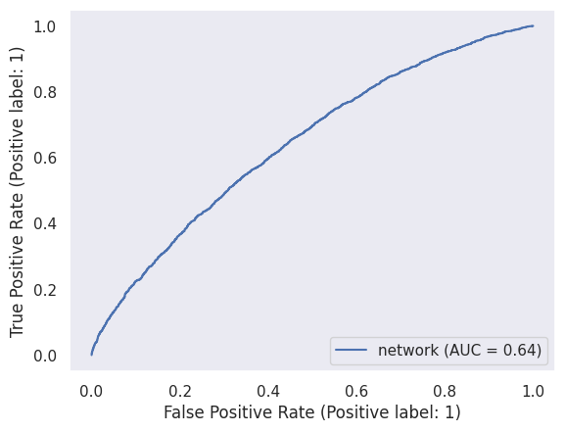
Supp. Fig. 2 Test Set AUC Plot

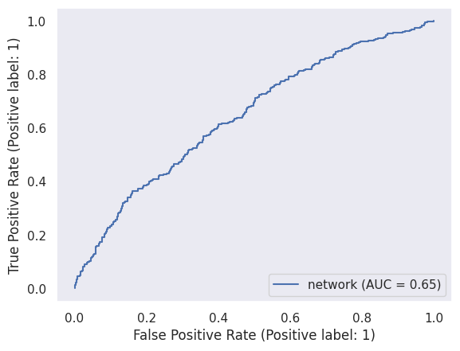

Supp. Fig 3. Validation Set AUC Plots
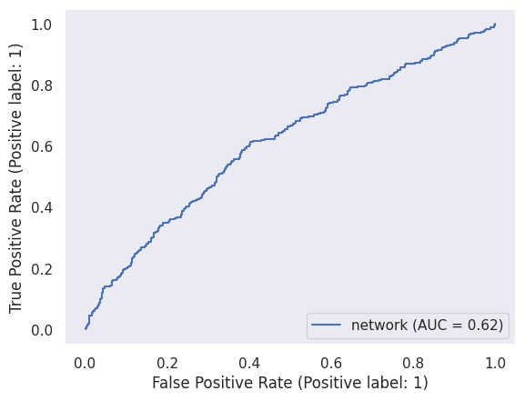
Model Accuracy Results by Treatment Subgroup:
Note: limited sample size was available for several treatments; future updates of this model with more data for treatments with limited n is expected to improve treatment subgroup performance. We note that in the training set AUC’s of 0.6 or more were achieved for all drugs except sertraline, where the AUC was close to 0.6. Results in the test and validation set were more variable; we note that there were low sample sizes for some of the tested drugs in these sets.
Supp. Table 2: Model Accuracy Results by Treatment Subgroup, Train Set
 | Accuracy | Sensitivity | Specificity | PPV | NPV | F1 | AUC
Bupropion (516) | 0.6335 | 0.132 | 0.932 | 0.5 | 0.68 | 0.21 | 0.644
Escitalopram + Bupropion (147) | 0.61 | 0.485 | 0.727 | 0.62 | 0.61 | 0.54 | 0.66
Duloxetine (1160) | 0.558 | 0.789 | 0.308 | 0.552 | 0.575 | 0.65 | 0.603
Escitalopram (446) | 0.581 | 0.827 | 0.269 | 0.588 | 0.552 | 0.687 | 0.627
Fluoxetine (535) | 0.671 | 0.355 | 0.813 | 0.461 | 0.737 | 0.401 | 0.647
Venlafaxine-XR + Mirtazapine (152) | 0.585 | 0.492 | 0.655 | 0.516 | 0.633 | 0.503 | 0.602
Citalopram (1873) | 0.594 | 0.508 | 0.664 | 0.551 | 0.624 | 0.529 | 0.627
Paroxetine (1217) | 0.653 | 0.444 | 0.779 | 0.549 | 0.698 | 0.491 | 0.66
Venlafaxine (812) | 0.551 | 0.7 | 0.424 | 0.509 | 0.624 | 0.59 | 0.611
Sertraline (492) | 0.581 | 0.44 | 0.657 | 0.413 | 0.683 | 0.427 | 0.586

Supp. Table 3: Model Accuracy Results by Treatment Subgroup, Test Set
 | Accuracy | Sensitivity | Specificity | PPV | NPV | F1 | AUC
Bupropion (60) | 0.633 | 0.157 | 0.853 | 0.333 | 0.686 | 0.214 | 0.49
Escitalopram + Bupropion (18) | 0.5 | 0.222 | 0.777 | 0.5 | 0.5 | 0.307 | 0.703
Duloxetine (149) | 0.69 | 0.847 | 0.48 | 0.685 | 0.704 | 0.757 | 0.703
Escitalopram (50) | 0.58 | 0.851 | 0.26 | 0.575 | 0.6 | 0.686 | 0.63
Fluoxetine (67) | 0.686 | 0.381 | 0.826 | 0.5 | 0.745 | 0.432 | 0.687
Venlafaxine-XR + Mirtazapine (18) | 0.44 | 0 | 0.727 | 0 | 0.53 | 0 | 0.53
Citalopram (212) | 0.561 | 0.26 | 0.81 | 0.532 | 0.569 | 0.349 | 0.591
Paroxetine (154) | 0.655 | 0.41 | 0.795 | 0.534 | 0.702 | 0.464 | 0.65
Venlafaxine (93) | 0.505 | 0.536 | 0.481 | 0.448 | 0.568 | 0.488 | 0.541
Sertraline (54) | 0.537 | 0.211 | 0.714 | 0.286 | 0.625 | 0.24 | 0.58

Supp. Table 4: Model Accuracy Results by Treatment Subgroup, Validation Set
 | Accuracy | Sensitivity | Specificity | PPV | NPV | F1 | AUC
Bupropion (52) | 0.615 | 0.181 | 0.933 | 0.666 | 0.608 | 0.285 | 0.454
Escitalopram + Bupropion (20) | 0.55 | 0.333 | 0.727 | 0.5 | 0.57 | 0.4 | 0.565
Duloxetine (119) | 0.672 | 0.841 | 0.482 | 0.646 | 0.729 | 0.731 | 0.687
Escitalopram (48) | 0.562 | 0.884 | 0.181 | 0.561 | 0.571 | 0.686 | 0.634
Fluoxetine (60) | 0.65 | 0.263 | 0.829 | 0.416 | 0.708 | 0.322 | 0.612
Venlafaxine-XR + Mirtazapine (18) | 0.55 | 0.625 | 0.5 | 0.5 | 0.625 | 0.555 | 0.487
Citalopram (226) | 0.601 | 0.561 | 0.632 | 0.539 | 0.653 | 0.549 | 0.641
Paroxetine (131) | 0.603 | 0.34 | 0.75 | 0.432 | 0.67 | 0.38 | 0.568
Venlafaxine (83) | 0.506 | 0.722 | 0.34 | 0.456 | 0.615 | 0.559 | 0.53
Sertraline (60) | 0.55 | 0.333 | 0.666 | 0.35 | 0.649 | 0.341 | 0.515

Supp. Figure 4: Train Set Calibration Plots
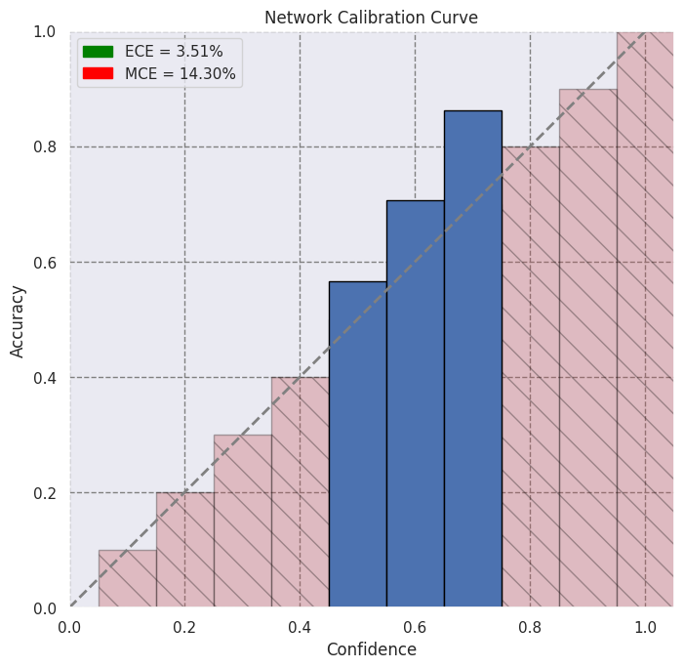
Supp Figure 5: Validation Set Calibration Plots
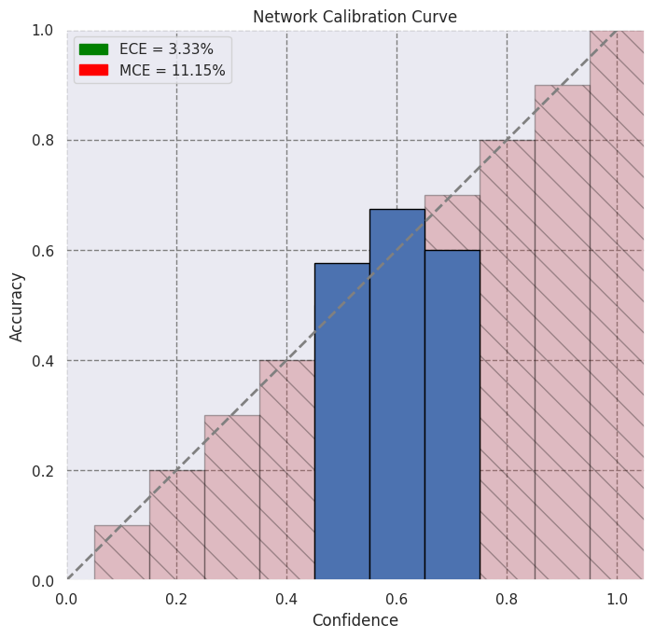
Supp. Figure 6: Train Set Sensitivity Plots
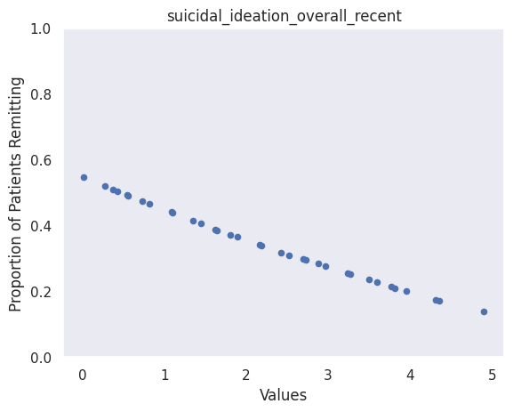
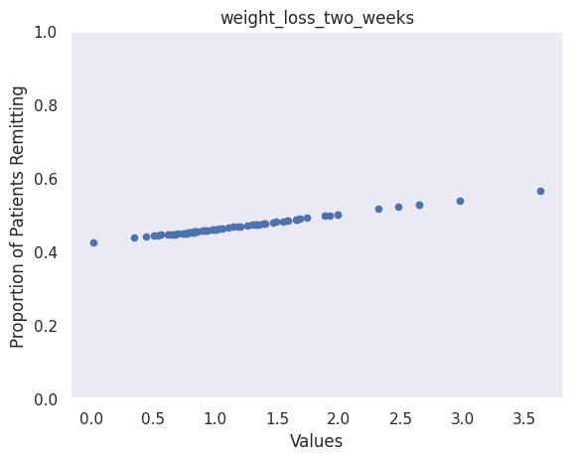

Supp. Figure 7: Validation Set Sensitivity Plot
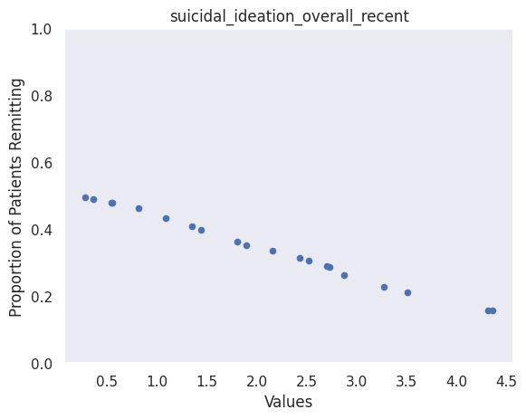

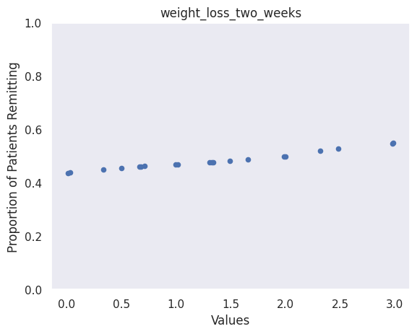
Differential treatment rankings
Supp. Table 5: Differential Treatment Ranking on Test Set

 | Rank 1 | Rank 2 | Rank 3 | Rank 4 | Rank 5 | Rank 6 | Rank 7 | Rank 8 | Rank 9 | Rank 10
Bupropion | 0 | 0 | 0 | 0 | 0 | 2 | 5 | 61 | 142 | 665
Citalopram | 0 | 46 | 144 | 138 | 185 | 305 | 56 | 1 | 0 | 0
Escitalopram | 860 | 13 | 2 | 0 | 0 | 0 | 0 | 0 | 0 | 0
Escitalopram + Bupropion | 2 | 15 | 63 | 157 | 230 | 206 | 181 | 17 | 4 | 0
Sertraline | 0 | 7 | 27 | 64 | 86 | 129 | 460 | 79 | 17 | 6
Venlafaxine | 5 | 368 | 206 | 135 | 108 | 37 | 15 | 1 | 0 | 0
Venlafaxine-XR + Mirtazapine | 7 | 184 | 194 | 168 | 138 | 129 | 46 | 9 | 0 | 0
Duloxetine | 1 | 242 | 239 | 213 | 122 | 55 | 2 | 1 | 0 | 0
Fluoxetine | 0 | 0 | 0 | 0 | 4 | 10 | 69 | 485 | 196 | 111
Paroxetine | 0 | 0 | 0 | 0 | 2 | 2 | 41 | 221 | 516 | 93
Supp Table 6: Differential Treatment Ranking on Validation Set
 | Rank 1 | Rank 2 | Rank 3 | Rank 4 | Rank 5 | Rank 6 | Rank 7 | Rank 8 | Rank 9 | Rank 10
Bupropion | 0 | 0 | 0 | 0 | 1 | 1 | 5 | 59 | 134 | 617
Citalopram | 0 | 67 | 115 | 149 | 146 | 293 | 44 | 3 | 0 | 0
Escitalopram | 790 | 20 | 6 | 0 | 1 | 0 | 0 | 0 | 0 | 0
Escitalopram + Bupropion | 0 | 16 | 76 | 142 | 251 | 180 | 144 | 7 | 1 | 0
Sertraline | 0 | 5 | 11 | 46 | 78 | 112 | 431 | 102 | 27 | 5
Venlafaxine | 1 | 319 | 219 | 153 | 72 | 41 | 12 | 0 | 0 | 0
Venlafaxine-XR + Mirtazapine | 25 | 189 | 210 | 123 | 112 | 118 | 32 | 8 | 0 | 0
Duloxetine | 1 | 201 | 180 | 203 | 156 | 68 | 8 | 0 | 0 | 0
Fluoxetine | 0 | 0 | 0 | 0 | 0 | 3 | 92 | 419 | 189 | 114
Paroxetine | 0 | 0 | 0 | 1 | 0 | 1 | 49 | 219 | 466 | 81
Comparison to null model
We explored accuracy p-values compared to a null model (i.e., a model predicting the majority class which, for all our datasets, resulted in a comparison to a null model accuracy that would only predict no remission, compared using a one-sided binomial test). We found that our model outperformed a null model on the training set (p = 1.2e-09); did not outperform the null, but was approaching significance, in the validation set (p = 0.08); and outperformed the null in the test set (p = 0.01).

Software package details:
The following is a list of the open-source Python packages used throughout the model building, testing, and deployment phases of the project. These packages are integral to various aspects of the machine learning pipeline, including data manipulation, model training, evaluation, and visualization.:

Core Data Manipulation and Computation
  - numpy>=1.21.1: Essential for numerical operations and array manipulation.
  - pandas>=1.5.0: Used for data manipulation and analysis, particularly with structured data.
  - scipy>=1.7.1: Extends numpy with additional mathematical and scientific functionality.
  - pydash>=5.0.2: Utility library for working with collections, strings, and numbers.

Machine Learning and Model Building
  - scikit-learn>=1.0: Provides tools for classical machine learning algorithms (e.g., regression, classification, clustering).
  - torch>=1.9.0: Core library for deep learning, providing tools to build and train neural networks.
  - torchvision>=0.10.0: Extends PyTorch with vision-specific functionalities (image transformations, pre-trained models).
  - ax-platform>=0.2.8: Optimization framework for hyperparameter tuning, typically used for model optimization.

Model Interpretation and Testing
  - skater==1.0.4: Model interpretation tool, providing explainability for complex models like deep learning.
  - pytest>=6.2.4: Testing framework to ensure correctness and quality of code and models.

Visualization
  - matplotlib>=3.4.2: Core library for creating static visualizations and plots.
  - seaborn>=0.12: Built on top of matplotlib, it simplifies statistical visualizations with enhanced aesthetics.

Package Management and Documentation
  - setuptools>=57.4.0: Manages packaging and distribution of Python code.
  - sphinx>=4.1.2: Documentation generator for Python projects, making it easier to create readable project docs.

Data Preprocessing and Imputation
  - optbinning==0.12.1: For optimal binning of data, useful for feature engineering and preprocessing.
  - autoimpute==0.13.0: Handles missing data imputation with advanced techniques like matrix completion.

Utilities and Development Tools
  - ipython>=7.26.0: Enhanced interactive Python shell for easier debugging and exploration.
  - tqdm>=4.62.0: Progress bar library for tracking task progress, useful during long-running processes.
These technologies and packages combine to form a robust infrastructure that ensures the ML model is built, trained, tested, and deployed in a scalable, efficient, and reproducible manner. Each tool and library plays a role in the overall machine learning pipeline, from model design to deployment in production.
Final Model Accuracy Results. Columns 4-8 results are based on classifying remission if the predicted remission probability is 50% or greater.
Data Source | Accuracy | AUC | F1-Score | Sensitivity | Specificity | NPV | PPV
Train Set | 0.60 | 0.64 | 0.55 | 0.57 | 0.63 | 0.66 | 0.54
Validation Set | 0.60 | 0.62 | 0.55 | 0.56 | 0.62 | 0.65 | 0.53
Held-Out Test Set | 0.60 | 0.65 | 0.51 | 0.47 | 0.70 | 0.55 | 0.64

