Suplementary Files

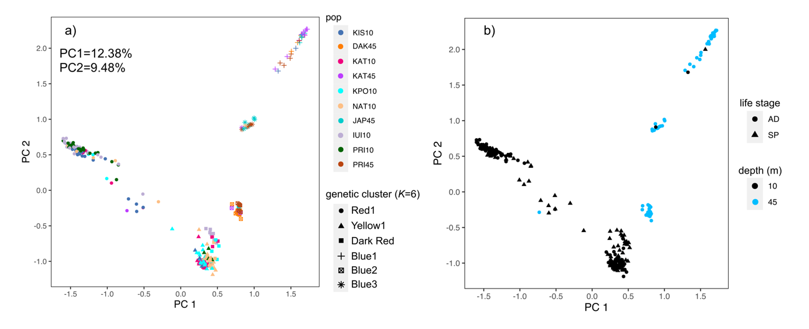
Supplementary Figure S1. Principal Component Analysis (PCA) from the whole dataset. Principal Component Analysis (PCA) of Stylophora pistillata performed with the R package adegenet based on a reduced dataset of SNPs separated by at least 2,500 bp containing 281 individuals and 7,185 SNPs. Samples are colored by a) sampled site (pop) and genetic cluster (K=6) and b) life stage and sampling depth (m). KIS=Kissosky; DAK=Dakel; KAT=Katza; KPO=Katza polluted; NAT=Natural Reserve; JAP= Japanese gardens; IUI=IUI; PRI=Princess. Numbers 10 and 45 indicates samples collected from 7 to 10 (showed in black in the right panel) and at 45 meters depth (showed in blue in the right panel), respectively. Life stage indicates adults (circles, AD) and recruits (triangles, SP).

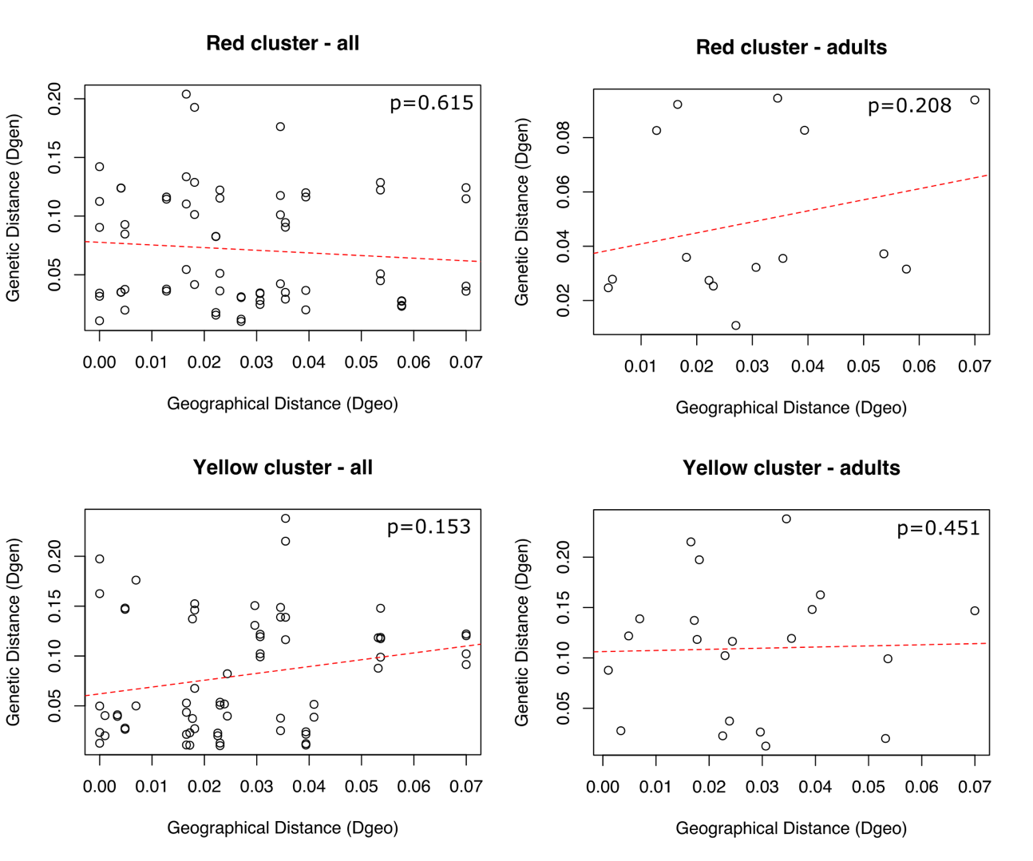
Supplementary Figure S2. Isolation by distance for the Red and Yellow clusters. Results from Mantel’s test for isolation-by-distance for all individuals and only adults of Stylophora pistillata from the two major lineages, Red1 and Yellow1.

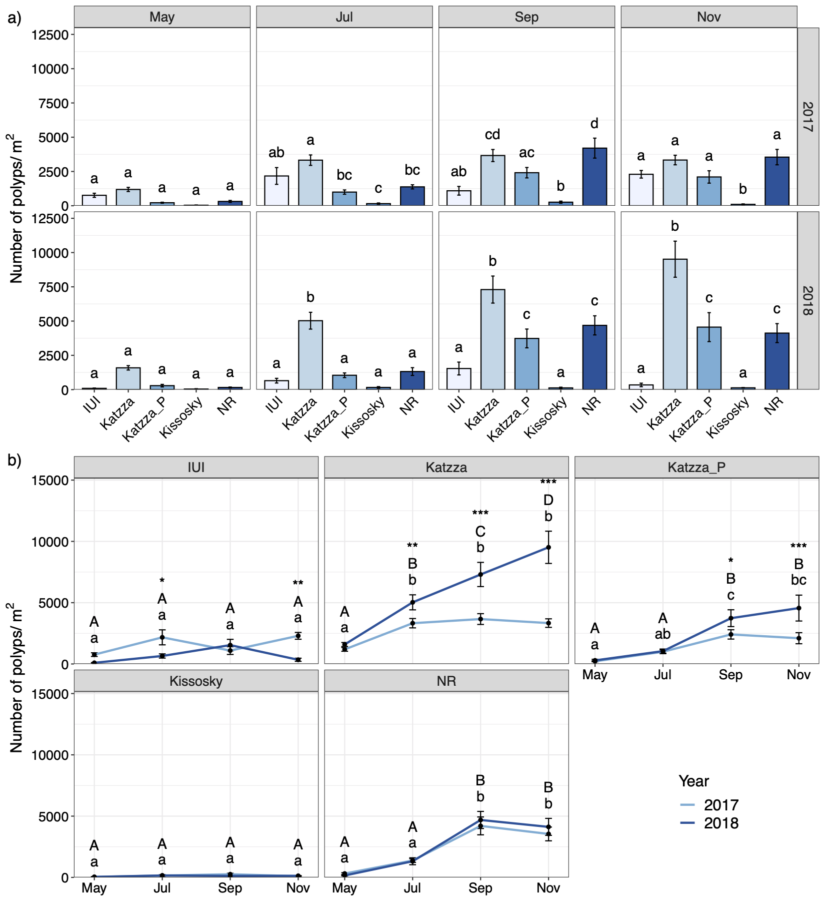
Supplementary Figure S3. Polyp counts per m² at different locations and periods. Polyp counts expressed as mean ± SEM (Standard Error of the Mean) (n = 4-12) per location and sampling period. A) Comparison between locations. Different lowercase letters indicate significantly different mean values between location for each period (p < 0.05). B) Comparison between periods. Different lowercase/ uppercase letters indicate significantly different mean values between months in 2017 and 2018 respectively (p < 0.05). Asterisks indicate significantly different mean values between measurements in 2017 and 2018 for each month (* p < 0.05, ** p < 0.01, *** p < 0.001). Statistical significance was determined by a three-way ANOVA, followed by pairwise comparisons with FDR correction.

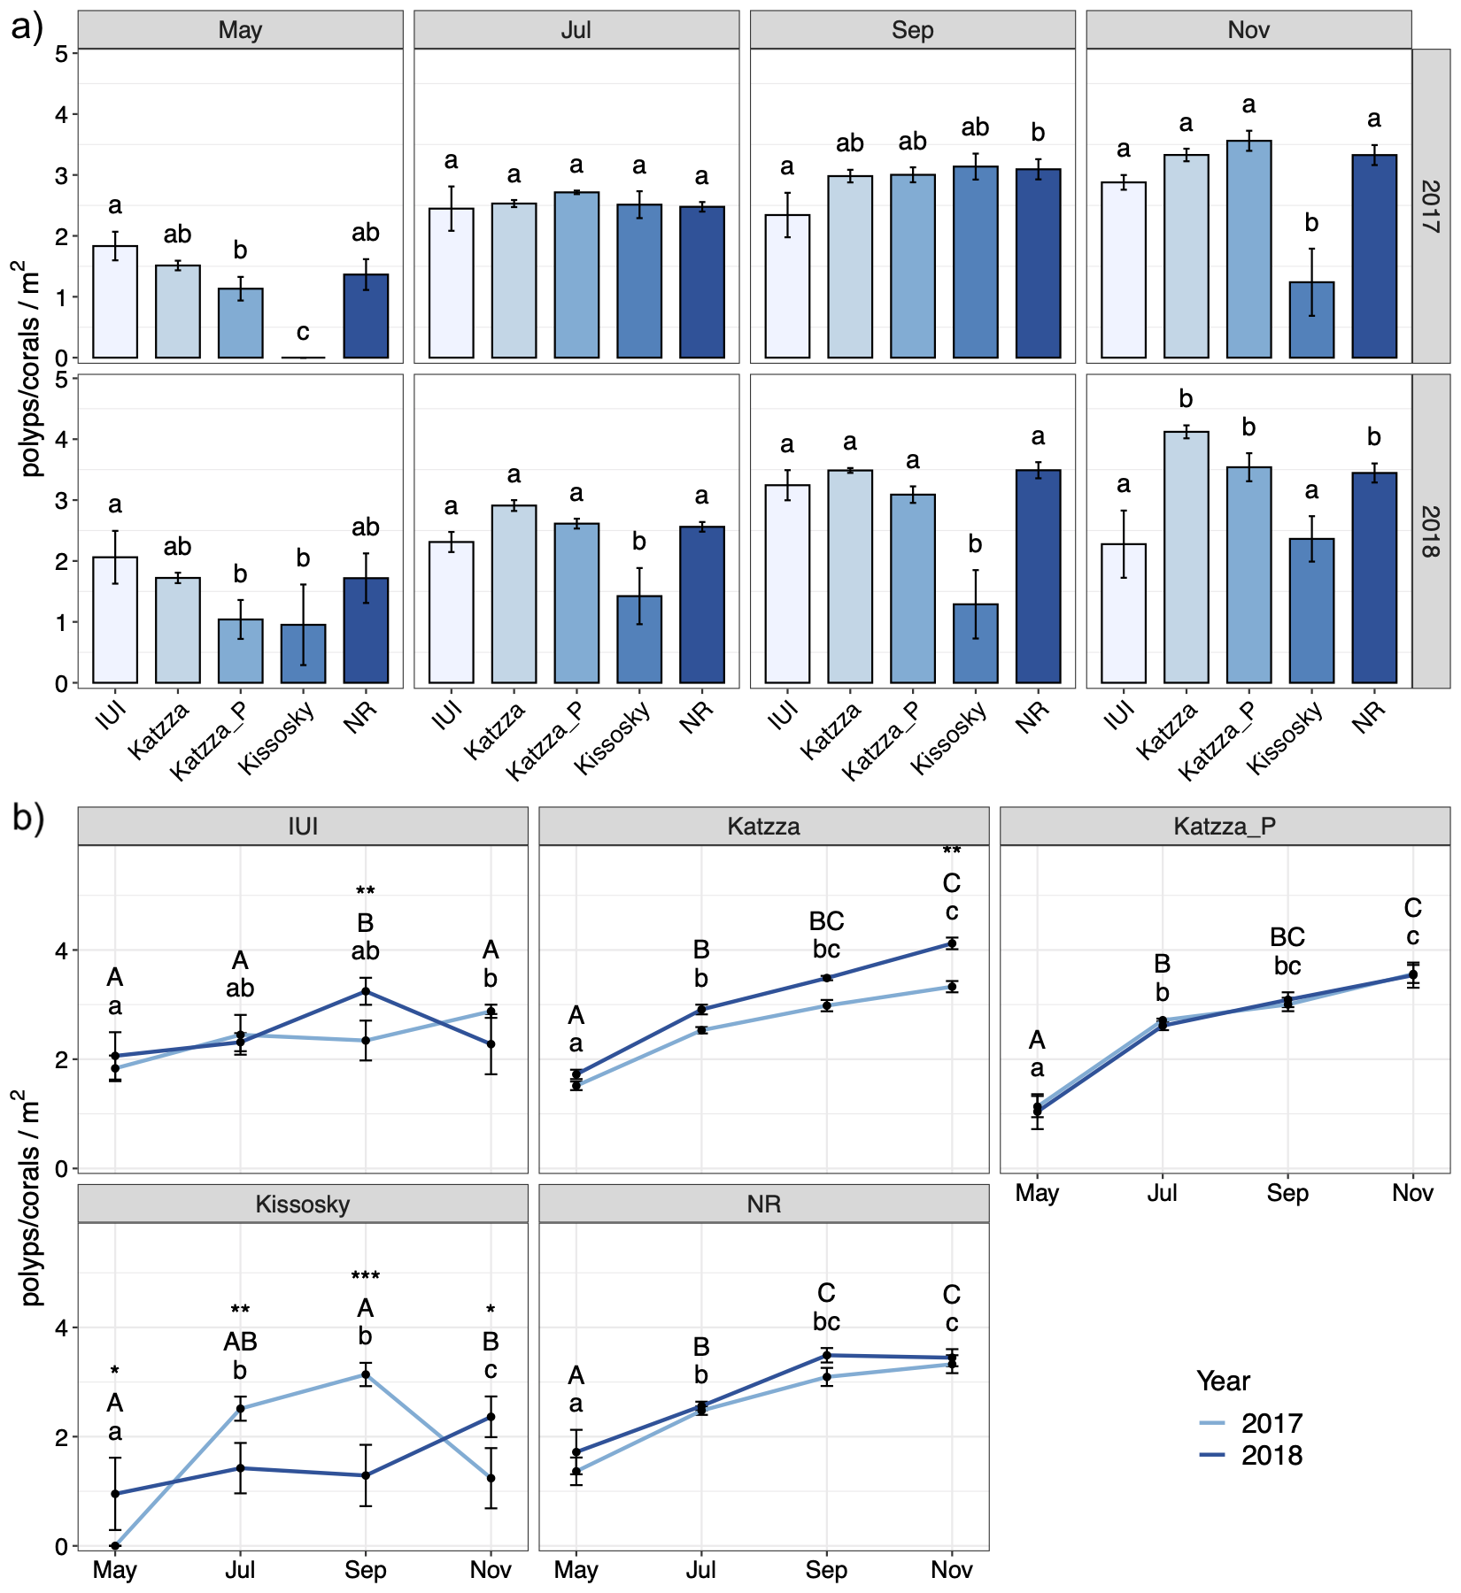
Supplementary Figure S4. Polyp to spat count (per m²⁾ ratio at different locations and periods. Polyp to spat count are expressed as mean ± SEM (Standard Error of the Mean) (n = 4-12) per location and sampling period. A) Comparison between locations. Different lowercase letters indicate significantly different mean values between location for each period (p < 0.05). B) Comparison between periods. Different lowercase/ uppercase letters indicate significantly different mean values between months in 2017 and 2018 respectively (p < 0.05). Asterisks indicate significantly different mean values between measurements in 2017 and 2018 for each month (* p < 0.05, ** p < 0.01, *** p < 0.001). Statistical significance was determined by a three-way ANOVA, followed by pairwise comparisons with FDR correction.

