Supplementary Table S1. Bacteria strains and plasmids used in this study
Strain/Plasmid | Description | Source
Bacteria
Escherichia coli
DH5α | cloning strain | Lab collection
BL21(DE3) | protein expression host strain | Novagen, USA
NCTC12923 | ATCC 8739, KCTC 2571 | KCTC, Korea
A004 | UTI clinical isolate harboring fosA¹ | Lab collection
Staphylococcus aureus
USA300 | wild-type epidemic community-associated methicillin-resistant isolate FPR3757 LAC strain | NARSA²
COL | MRSA isolate containing fosB ³ | Lab collection
Plasmid
pACKK-P_{gapA}-MCS | synthetic MCS with P_{gapA} promoter cloned at EagI-BamH1 sites | ⁴
pACKK-P_{gapA}::mCherry | mCherry protein expressing under P_{gapA} promoter; Amp^{r} and Cm^{r} | ⁴
pACKK-PuhpT::mCherry | mCherry expressing under PuhpT promoter; Amp^{r} and Cm^{r} | This study
pACKK-P_{uhpT-SUB}::mCherry | mCherry expressing under site-directed mutation of P_{uhpT-SUB} promoter; Amp^{r} and Cm^{r} | This study
pET21b-HptA | carrying a native gene that encodes HptA in fusion with a C-terminal 6×His tag; Amp^{r} | This study

Supplementary Table S2. Primers used for the construction of reporter system and primers used in qRT-PCR analyses.
Name | Sequence (5’ → 3’)
P_{uhpT_}fwd | ctagccgccggcggtttaagcgtgatgcatctcacc
P_{uhpT}_rev | ccttgctcaccatctcgagtacggcatgcattgtaaaaatc
P_{uhpT-SUB}_fwd | gctatctcccatgggatttgctgctgatttttac
P_{uhpT-SUB}_rev | gtccaggaaaaacctgga
EC_gyrA_fwd | gaactgttgcgtattcttgg
EC_gyrA_rev | gatacttaacgtagccctgg
EC_uhpA_fwd | gccggatattgccattaaac
EC_uhpA_rev | agctctacgtcgttactgac
EC_uhpB_fwd | attaccgttattgcctgctt
EC_uhpB_rev | ttagccagtaaatcagcagc
EC_uhpC_fwd | gtatatctggctgctttcgt
EC_uhpC_rev | tgccgttaaacaatttgtcc
EC_uhpT_fwd | caaattacctgttcgatggc
EC_uhpT_rev | gccacttggtcatatcggta
uhpT-flanking-PCR_fwd | taaccagtcaggggctatttgatggcg
uhpA-flanking-PCR_rev | gcattctttgtctgccgattcaggac
uhpT-Seq-1_fwd | ttcaaacagcgtaaagccctg
uhpT Seq-2_fwd | gtgatggagaaacccagg
uhpC-Seq-3_fwd | atggtgaagaagcaggttg
uhpC-Seq-4_fwd | cggtacgtgaataccagg
uhpB_Seq-5_fwd | atcgattcgccattcgagatg
uhpB_Seq-6_fwd | acaccagacatatcgggg
uhpA-Seq-7_fwd | tatccggcgtcagataacag
murA-flanking-PCR_fwd | atcgacagaacgcagttgatgcg
murA-flanking-PCR_rev | cgatcaaagcgtatacccctgc
murA_Seq-1_rev | cgcagccagatactctcgac
murA_Seq-2_fwd | ttcgatgacgatacgatcgg
glpT-flanking-PCR_fwd | tatccactggcaccgcgatgggcg
glpT-flanking-PCR_rev | aataatgtgtgcggcaattcac
glpT-Seq-1_fwd | aaggaagtaggcccaggagg
glpT-Seq-2_fwd | acaaacatcaccgcaatgctc

Supplementary Table S3. Mutational frequencies of E. coli DH5α following 7-day serial passage with fosfomycin ± adjuvants.
Condition | 16 x MIC (mean ± SD) | 32 x MIC (mean ± SD)
Growth control (GC) | 6.69 × 10⁻¹² ± 5.85 × 10⁻¹² | 1.32 × 10⁻¹⁵ ± 9.46 × 10⁻¹⁶
8 x MIC fos | 2.57 × 10⁻¹ ± 2.53 × 10⁻¹ | 7.99 × 10⁻² ± 7.82 × 10⁻²
2 x MIC fos | 3.78 × 10⁻² ± 3.31 × 10⁻² | 2.32 × 10⁻² ± 3.40 × 10⁻²
0.25 MIC fos | 1.29 × 10⁻⁶ ± 7.07 × 10⁻⁷ | 2.50 × 10⁻⁸ ± 2.97 × 10⁻⁸
8 x MIC fos + 50 µM G6P | 1.71 × 10⁻¹ ± 2.27 × 10⁻¹ | 2.46 × 10⁻² ± 2.70 × 10⁻²
2 x MIC fos + 50 µM G6P | 3.29 × 10⁻³ ± 4.35 × 10⁻³ | 2.16 × 10⁻³ ± 3.26 × 10⁻³
0.25 MIC fos + 50 µM G6P | 6.44 × 10⁻⁶ ± 5.49 × 10⁻⁶ | 1.66 × 10⁻⁵ ± 2.41 × 10⁻⁵
8 x MIC fos + 50 µM 3FG6P | 3.93 × 10⁻⁴ ± 3.07 × 10⁻⁴ | 6.61 × 10⁻⁴ ± 5.68 × 10⁻⁴
2 x MIC fos + 50 µM 3FG6P | 1.94 × 10⁻⁵ ± 1.77 × 10⁻⁵ | 7.41 × 10⁻⁵ ± 8.42 × 10⁻⁵
0.25 MIC fos + 50 µM 3FG6P | 5.01 × 10⁻⁸ ± 4.67 × 10⁻⁸ | 1.51 × 10⁻⁹ ± 1.20 × 10⁻⁹

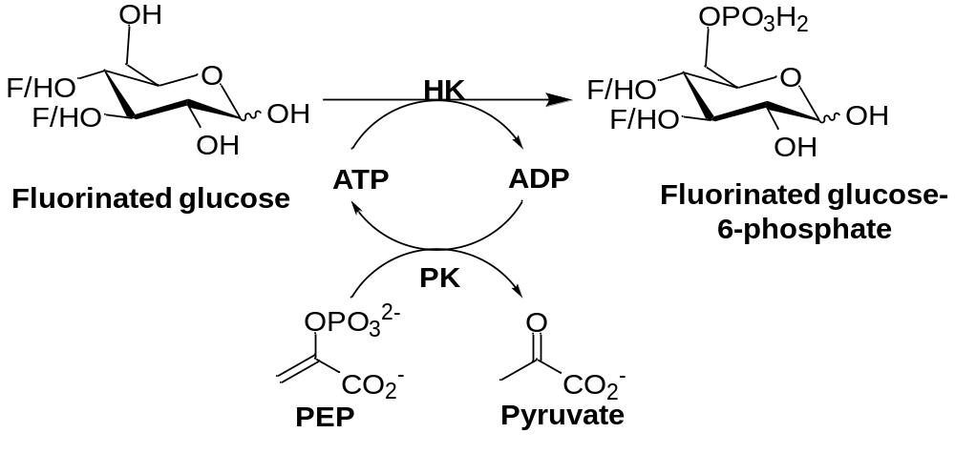

Supplementary Figure S1. Schematic diagram showing the synthesis of fluorinated glucose 6-phosphate from fluorinated glucose using ATP-dependent coupled reaction of hexokinase (HK) and pyruvate kinase (PK). HK utilized the ATP to convert fluorinated glucose to fluorinated glucose 6-phosphate and ADP. The high-energy phosphate group from phosphoenolpyruvate (PEP) is transferred to ADP to generate one molecule of ATP and pyruvate.

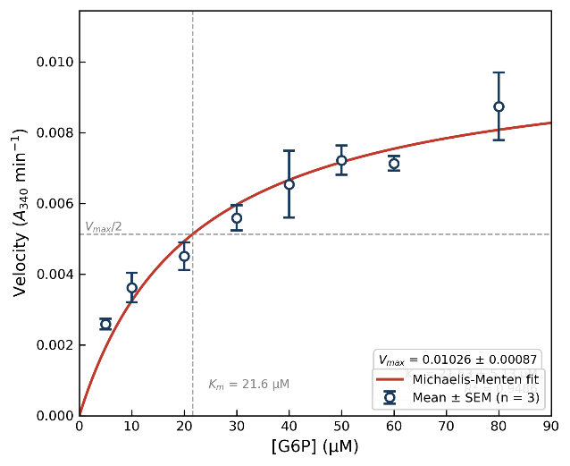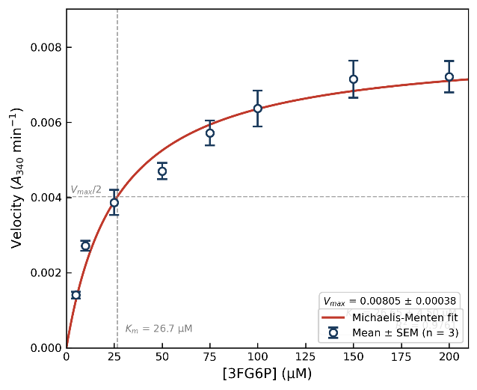
B
A
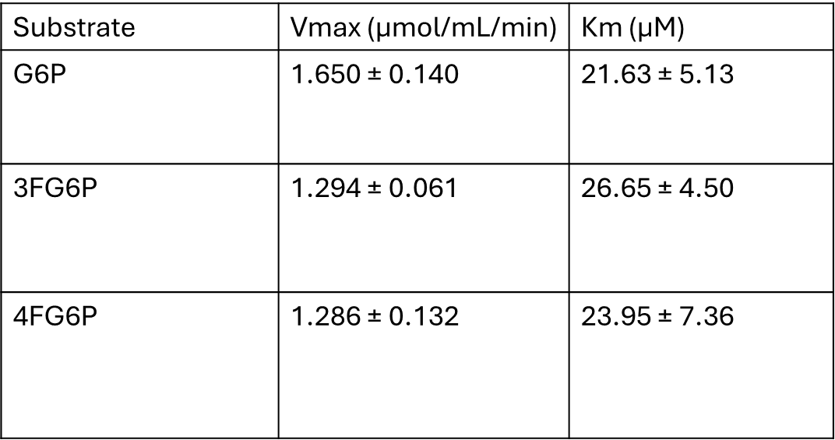
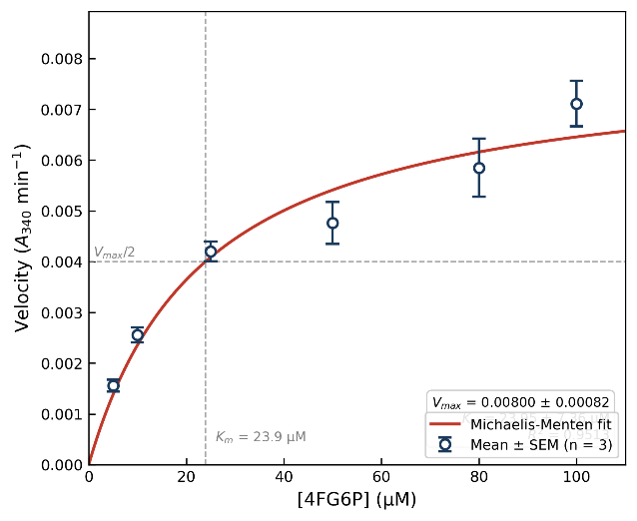
D
C

Supplementary Figure S2. Enzyme kinetics of glucose-6-phosphate dehydrogenase
with native and fluorinated substrates. Data points represent mean ± SD of three technical replicates. Lines represent best-fit to Michaelis-Menten equation. (A) glucose-6-phosphate (G6P), (B) 3-fluoro-glucose-6-phosphate (3FG6P), (C) 4-fluoro-glucose-6-phosphate (4FG6P) (D) Summary of kinetic parameters. Values represent mean ± SD from three independent experiments.

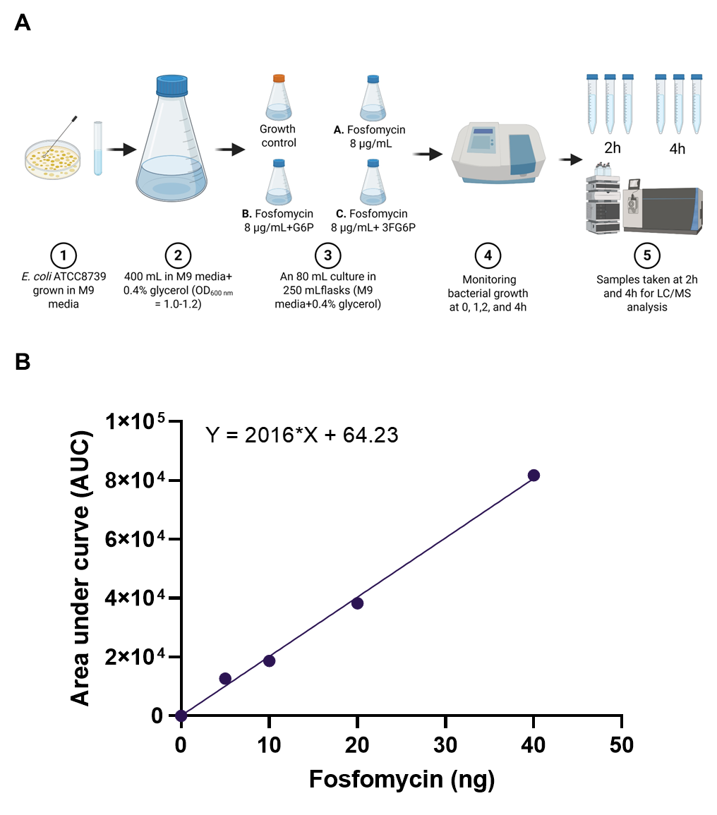

Supplementary Figure S3. Cell-suspension assay for fosfomycin antibiotic uptake wherein various steps showing the cell-suspension assay of fosfomycin. (A) Schematic diagram showing the steps of cell suspension assay to estimate the intracellular concentration of fosfomycin in E. coli ATCC8739 (E. coli NCTC12923). (1) The overnight grown culture was washed with 0.9% saline once and resuspended into 5 mL M9 medium supplemented with 0.4% glycerol. (2) A 400 mL of M9 medium supplemented with 0.4% glycerol was inoculated at 1:100 dilution and allowed to grow until OD₆₀₀ of 1.0–1.2. (3) An 80 mL culture was prepared in 250 mL flasks containing M9 medium with 0.4% glycerol and divided into four conditions: growth control, (A) fosfomycin only (8 µg/mL), (B) fosfomycin (8 µg/mL) plus G6P (50 µM), and (C) fosfomycin (8 µg/mL) plus 3FG6P (50 µM). (4) Bacterial growth was measured at each time-points (0‒4h) to normalize the fosfomycin from each sample. (5) Bacterial samples (10 mL) were taken 2, and 4 hours’ time points for LC–MS analysis to measure the intracellular content of fosfomycin. Image created in BioRender. (B) Calibration curve of fosfomycin showing the relationship between area under curve (AUC) and fosfomycin.

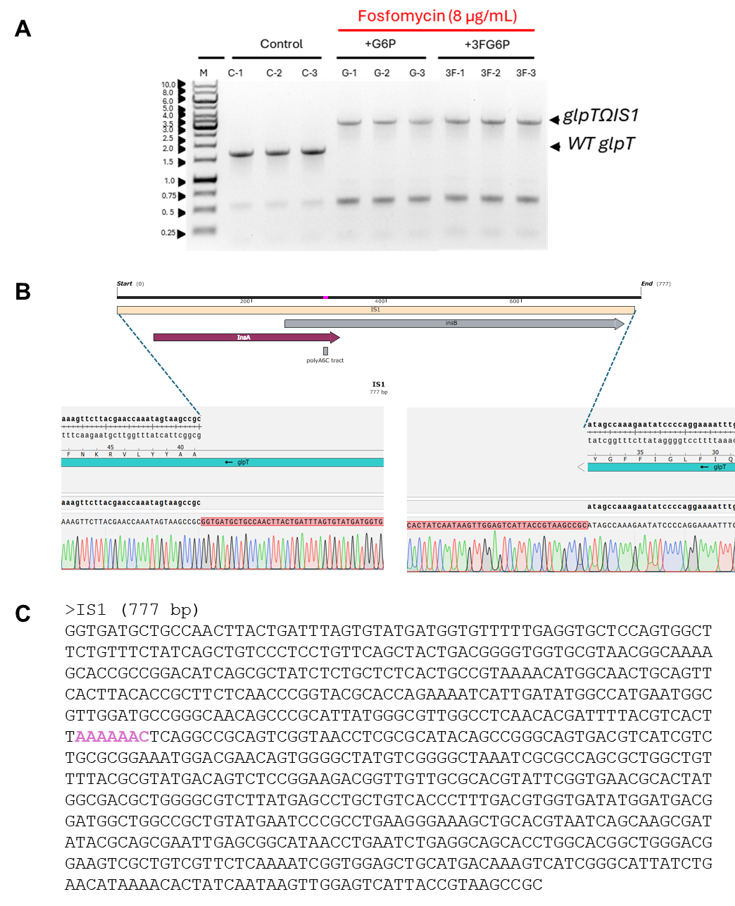

Supplementary Figure S4. Disruption of glpT gene due to insertion of IS1 element (768 bp). (A) Isolates exposed to fosfomycin showed an increase in the glpT gene as compared to the glpT from the E. coli DH5α transferred continuously without fosfomycin during adaptive laboratory evolution. (B) Site of insertion of IS1 in glpT gene, and (C) nucleotide sequence of inserted IS1 harboring InsA and InsB orfs with (A)₆C tract.
Supplementary Figure S5. Quantitative reverse-transcription polymerase chain reaction (qRT–PCR) analysis to evaluate the expression of uhpA, uhpB, uhpC, and uhpT in E. coli NCTC12923 in the presence of compound (glucose, G6P and 3FG6P). (A) The treatment of 3FG6P led to marked upregulation of all four genes, with fold changes of 4.2 (uhpA), 6.0 (uhpB), 6.9 (uhpC), and 46.4 (uhpT) relative to untreated controls in M9 minimal medium supplemented with glycerol (M9-Gly). Notably, the greatest induction was observed for uhpT, consistent with its role as the primary fosfomycin transporter. (B)
In M9 medium supplemented with both glycerol and glucose, a similar transcriptional profile was observed, with 3FG6P inducing uhpA, uhpB, uhpC, and uhpT by 49.0-, 54.2-, 1.9-, and 22.2-fold, respectively; wherein the expression levels of uhpA, uhpB, and uhpT in response to 3FG6P were significantly elevated compared to G6P.

Supplementary Figure S6. Optimization Infection parameters by inoculating larvae with varying colony-forming units (CFUs). (a) E. coli NCTC12923; (b) S. aureus USA300, by monitoring survival over 72 hours.

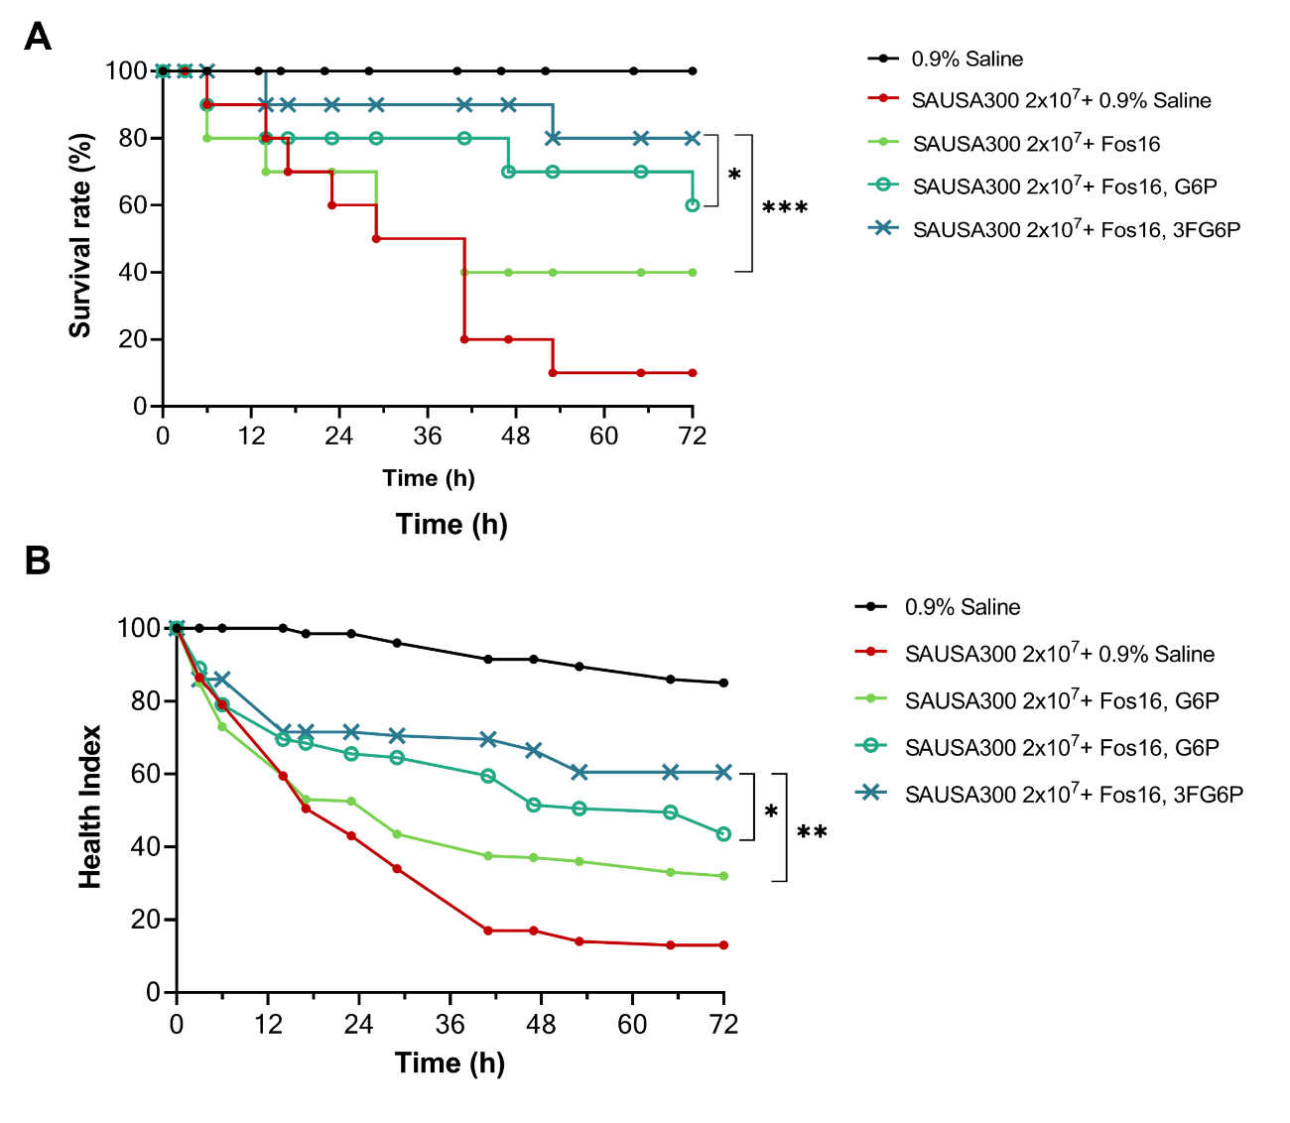

Supplementary Figure S7. Comparative analysis of 3FG6P as a potentiator in S. aureus USA300. Based on survival (A) and health-index (B) analyses, it protects ~80% larvae but at higher concentration (16 µg/mL) of fosfomycin, which presumably shows species-specificity. Data is presented as the means ± s.d. of the means. Statistical comparisons among groups were conducted using one-way ANOVA followed by a post-hoc Tukey's test. Differences were considered statistically significant for p values < 0.05 and labeled in the graph as follows: ns, nonsignificant; *, p ≥ 0.05; and **, p ≤ 0.01, and ***, P < 0.001.

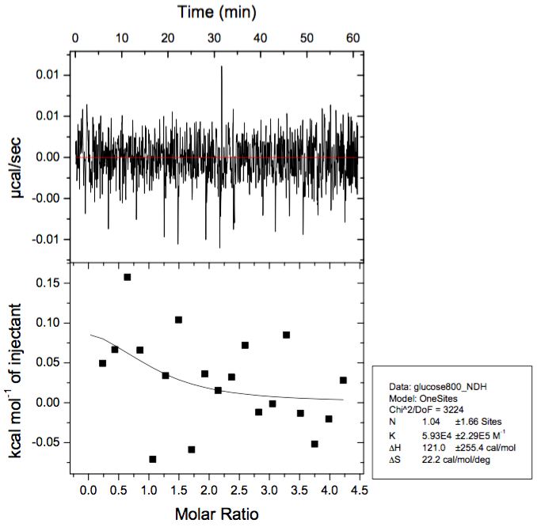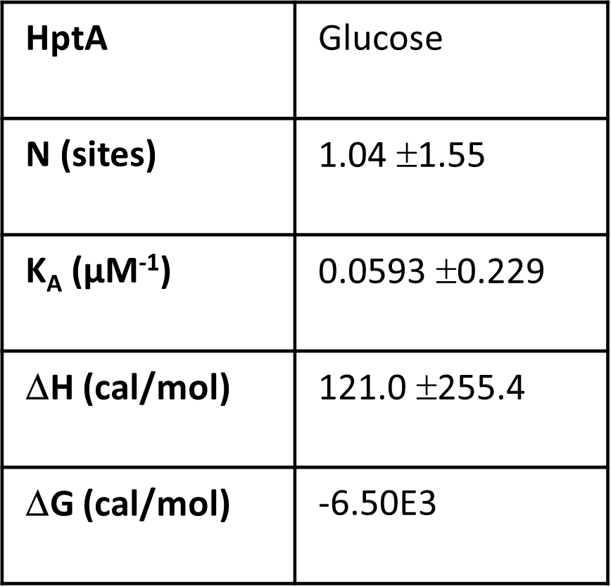
B
A
a
b
Supplementary Figure S8. Glucose was kept as negative control in isothermal titration calorimetry (ITC) experiments to show the preferred binding of 4-fluoro-glucose-6-phosphate (4FG6P) and glucose-6-phosphate (G6P) with staphylococcal HptA. (a) Representative ITC thermograms and binding isotherms for the interaction of HptA with glucose, and (b) While the dissociation constant (K_{D}) for 4FG6P was determined to be 0.36 μM, compared to 2.70 μM for G6P, indicating a strong preference for phosphorylated hexoses, glucose showed negligible interaction and binding with staphylococcal HptA.

REFERENCES
1 Seok, H. et al. Fosfomycin resistance in Escherichia coli isolates from South Korea and in vitro activity of fosfomycin alone and in combination with other antibiotics. Antibiotics 9, 112 (2020). https://doi.org/10.3390/antibiotics9030112
2 Fey, P. D. et al. A genetic resource for rapid and comprehensive phenotype screening of nonessential Staphylococcus aureus genes. mBio 4, e00537-00512 (2013). https://doi.org/10.1128/mBio.00537-12
3 Gill Steven, R. et al. Insights on evolution of virulence and resistance from the complete genome analysis of an early Methicillin-Resistant Staphylococcus aureus strain and a biofilm-producing Methicillin-Resistant Staphylococcus epidermidis strain. J Bacteriol 187, 2426-2438 (2005). https://doi.org/10.1128/jb.187.7.2426-2438.2005
4 Sultan, M. et al. Targeting the G-quadruplex as a novel strategy for developing antibiotics against hypervirulent drug-resistant Staphylococcus aureus. J Biomed Sci 32, 15 (2025). https://doi.org/10.1186/s12929-024-01109-3

