Compound Hazard Mapping for Tropical Cyclone induced Concurrent Wind and Rainfall Extremes over India

Ravi Ranjan¹, *Subhankar Karmakar^{1,2,3}
- ¹Environmental Science and Engineering Department, Indian Institute of Technology Bombay, Mumbai 400076, India
- ²Interdisciplinary Programme in Climate Studies, Indian Institute of Technology Bombay, Mumbai 400076, India
- ³Centre for Urban Science and Engineering, Indian Institute of Technology Bombay, Mumbai 400076, India
* Corresponding Author, e-mail: subhankar.karmakar@gmail.com, skarmakar@iitb.ac.in

Supplementary materials
- Kernel Density Estimator (KDE)
- Supplementary Figures
- Seasonal Variation for Premonsoon and Post-monsoon Tropical Cyclones

Kernel Density Estimator
A kernel distribution is a nonparametric representation of the probability density function (PDF) of a random variable. A kernel distribution can be used when a parametric distribution cannot properly describe the data, or to avoid making assumptions about the distribution of the data. A kernel distribution is defined by a smoothing function and a bandwidth value, which control the smoothness of the resulting density curve.
The kernel density estimator is the estimated pdf of a random variable. For any real values of x, the kernel density estimator's formula is given by
$${\hat{f}}_{h}\left(x\right)=\frac{1}{nh}\sum_{1=1}^{n}{K\left(\frac{x-x_{i}}{h}\right)} ,$$
where x₁, x₂, …, x_{n} are random samples from an unknown distribution, n is the sample size, K(·) is the kernel smoothing function, and h is the bandwidth^{1,2}.
The kernel estimator for the cumulative distribution function (CDF), for any real values of x, is given by
$${\hat{F}}_{h}\left(x\right)=\int_{-∞}^{x}{{\hat{f}}_{h}\left(t\right)dt}=\frac{1}{n}\sum_{1=1}^{n}{G\left(\frac{x-x_{i}}{h}\right)} ,$$
where $G\left(x\right)=\int_{-∞}^{x}{K\left(t\right)dt} .$
The choice of the bandwidth h is an important issue in estimating the probability density function because the kernel estimator is highly sensitive to bandwidth¹. Nevertheless, for an asymptotically optimal choice for h, an overall measure of the effectiveness of $\hat{f}$ is provided by the mean integrated squared error (MISE), which is given in the equation below³:
$$MISE=E\left[\int{{\left\{\hat{f}\left(x\right)-f(x)\right\}}^{2} dx}\right]≈ \frac{1}{4}h^{4}α_{k}^{4}\int{f^{''}{\left(x\right)}^{2}}dx + \frac{1}{nh}α$$
where $α=∫K^{2}\left(x\right)ⅆx$ and $α_{k}^{2}$ denotes the variance of the kernel function $∫x^{2} K\left(x\right)ⅆx$. Furthermore, the bandwidth is estimated such that the MISE is minimized. Additionally, Bowman and Azzalini (1997) provided the general form of optimal bandwidth for different kernels:
$$h_{opt , i }={\left[\frac{4}{n\left(p+2\right)}\right]}^{\frac{1}{p+4}}α_{i}$$
where n is the number of observations, p is the number of variables (for univariate p = 1) and $α_{i}$ is the standard deviation of the variable in the i direction.
References:
1. Adamowski, K., Liang, G.-C. & Patry, G. G. Annual maxima and partial duration flood series analysis by parametric and non-parametric methods. Hydrol. Process. 12, 1685–1699 (1998).
2. Silverman, B. W. Density Estimation for Statistics and Data Analysis. (CRC Press, 1986).
3. Bowman, A. W. & Azzalini, A. Applied smoothing techniques for data analysis: the kernel approach with S-Plus illustrations. vol. 18 (OUP Oxford, 1997).

Supplementary Figures
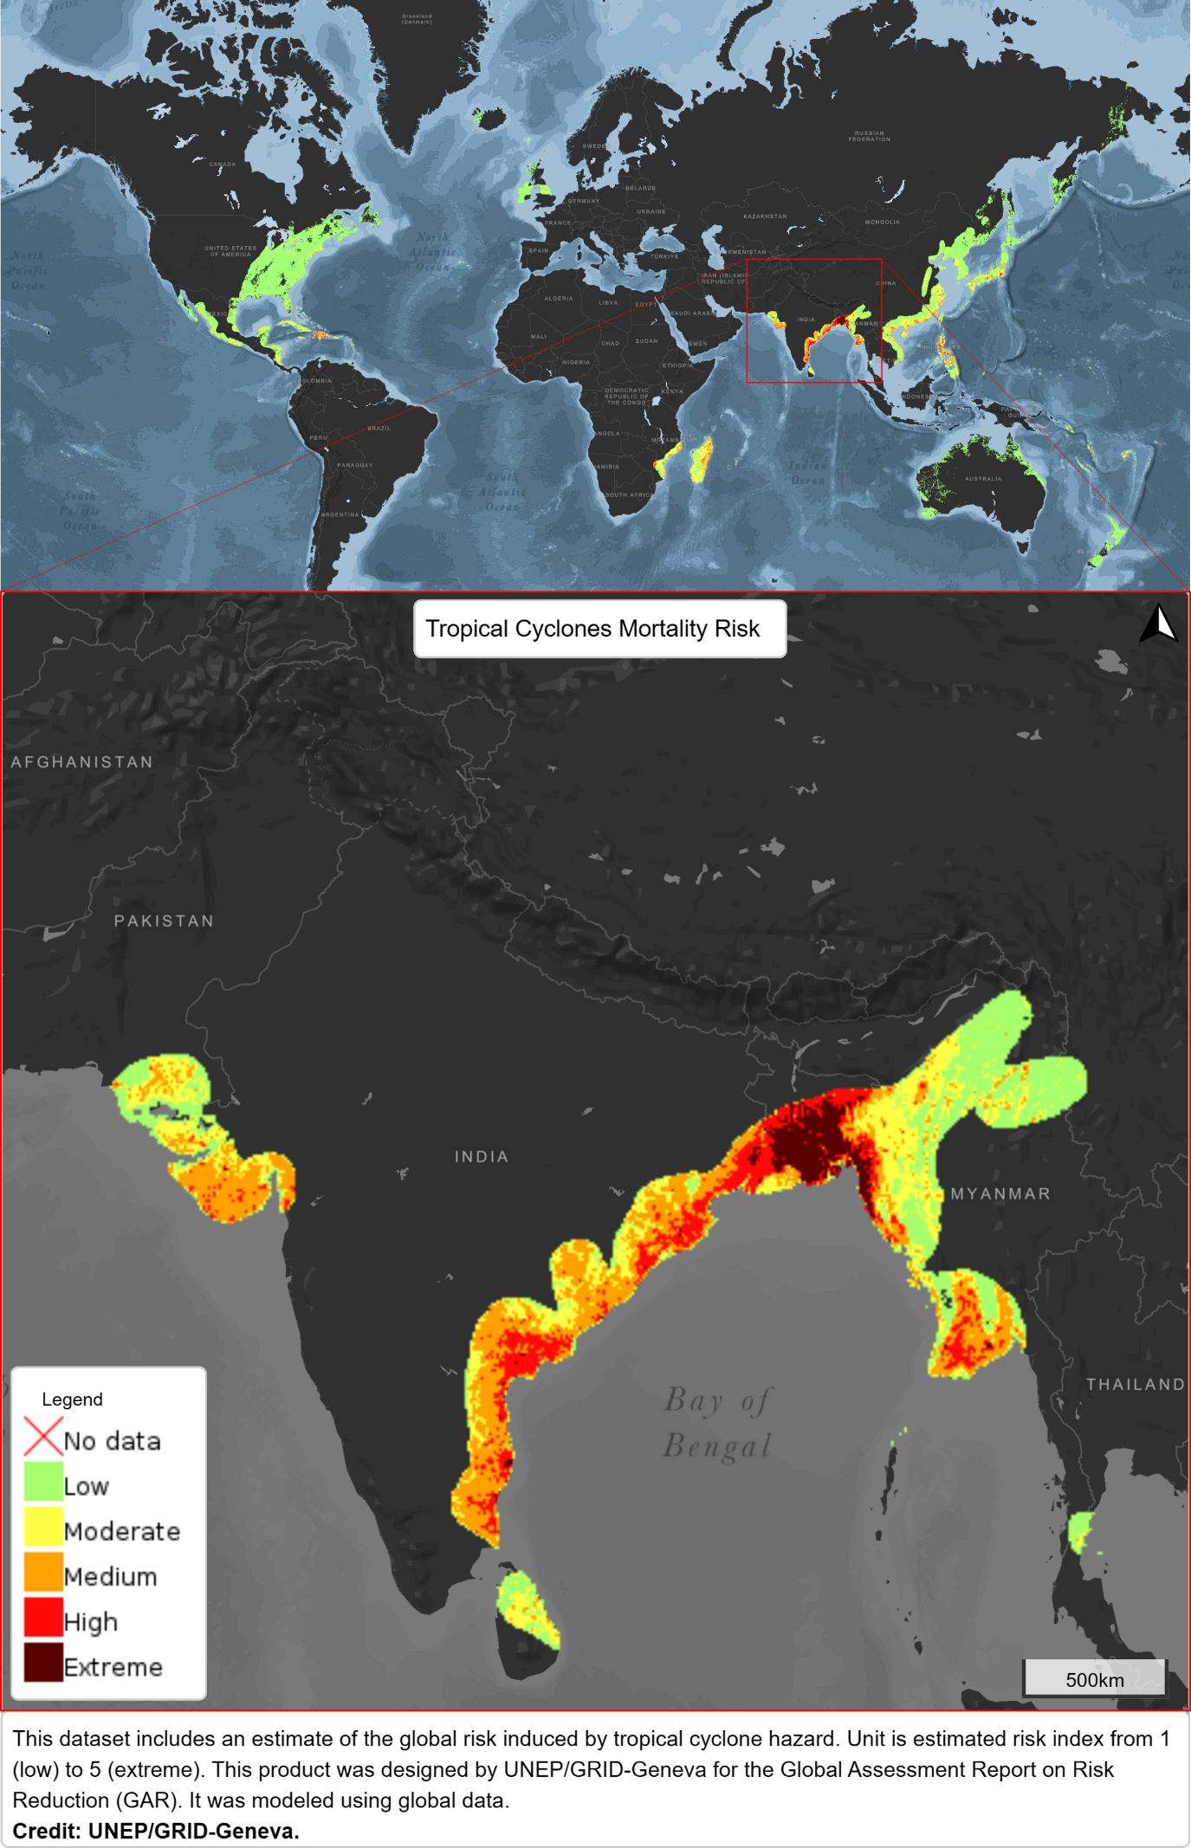
(b).
(a).
Fig. S1 Tropical cyclone mortality risk for (a) world and (b) India. (UNEP/GRID-Geneva GAR2015) (Map adapted from Global Risk Platform, UNEP)
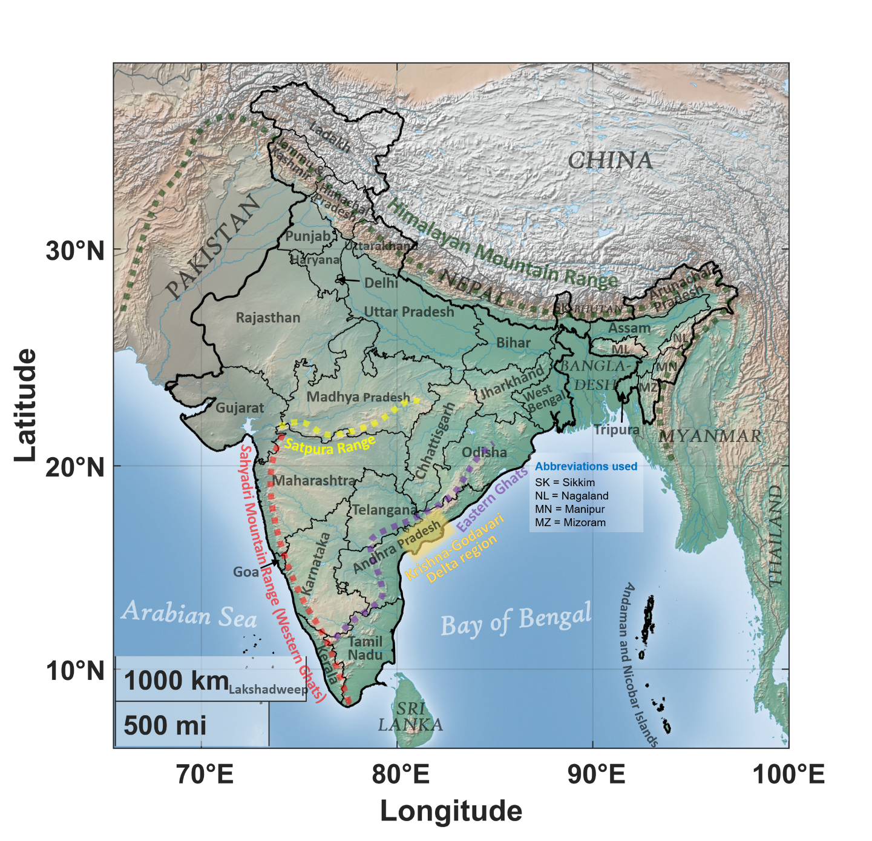
Fig. S2 Physical map of India (study area) with its administrative state boundaries. [Background shows colorterrain map (source: MATLAB 2022b); thick black line shows country boundary for India; thin black line shows state boundaries; very thick coloured dotted lines show major mountain ranges]
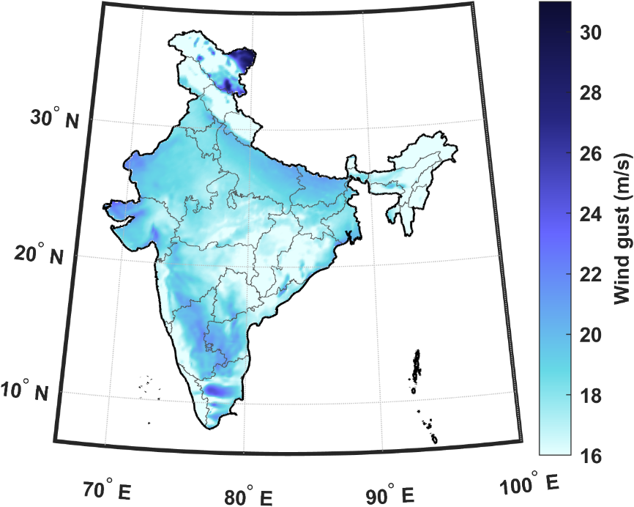
Fig. S3 Threshold for gust windspeed over India

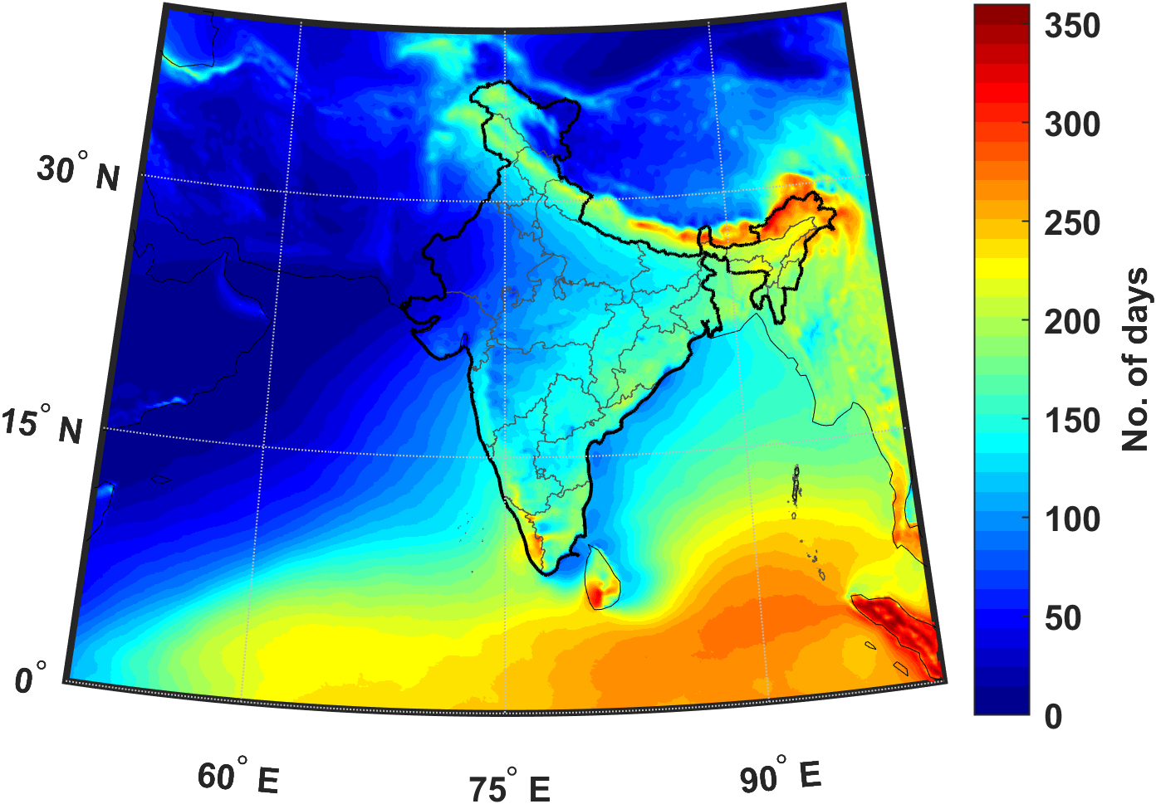
Fig. S4 Average number of rainy days per year during 1979-2020 over study area

Duration of tropical cyclone induced wind extremes for various return period level

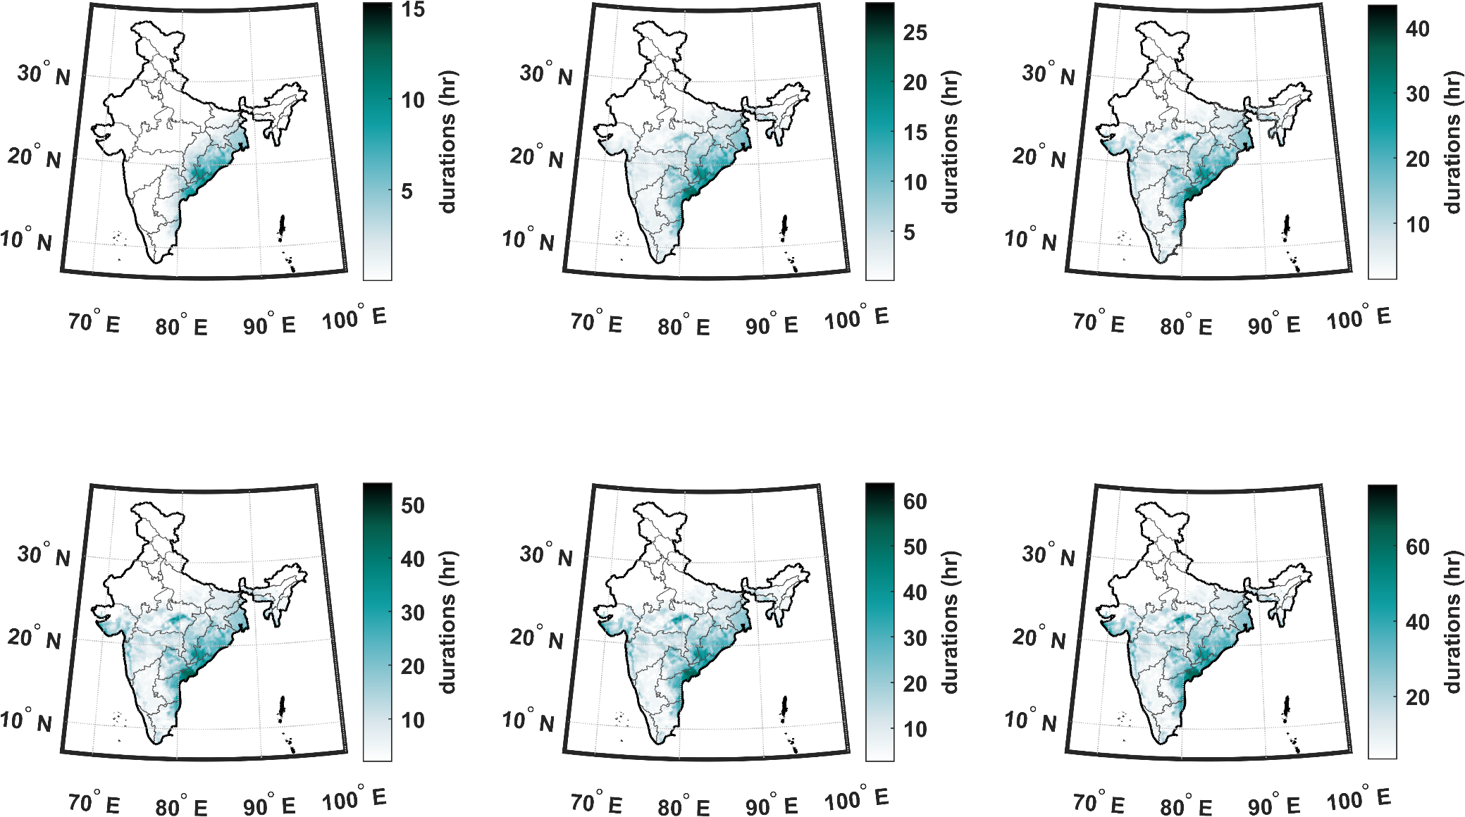
(a)
(b)
(d)
(e)
(c)
(f)
Fig. S5 Duration of tropical cyclone induced wind extremes for various return period level (a) 1 year, (b) 2 years, (c) 5 years, (d) 10 years, (e) 20 years, and (f) 50 years.

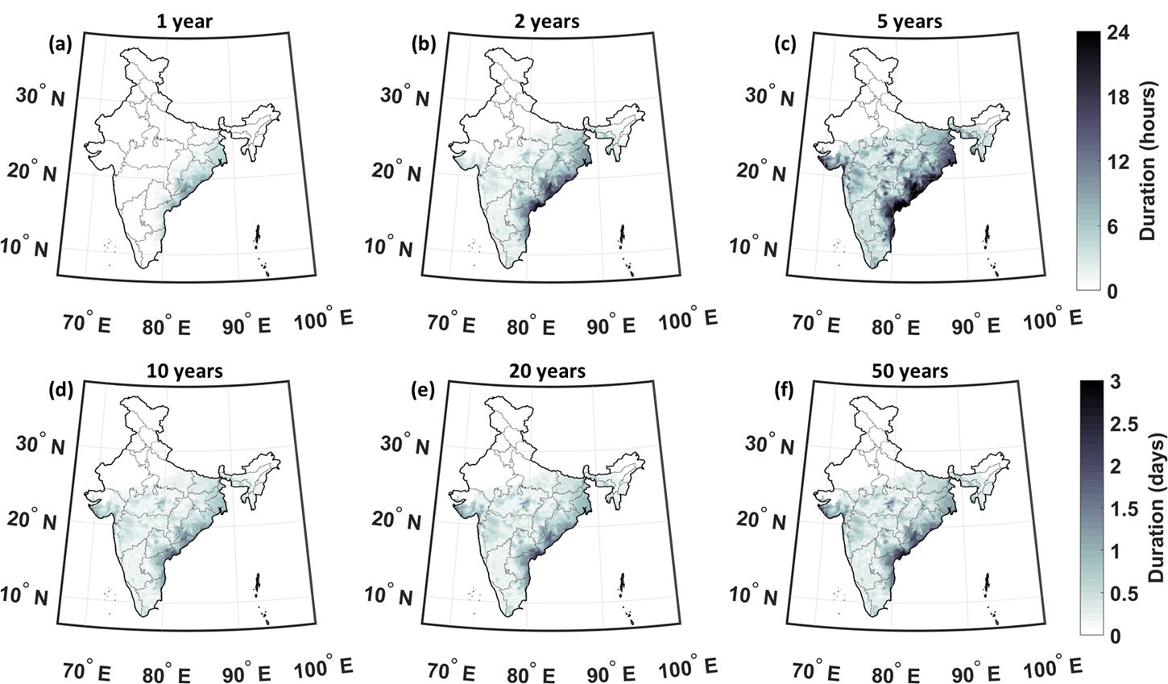
Fig. S6 Duration of tropical cyclone induced concurrent wind-rainfall extremes. Duration of tropical cyclone induced concurrent wind-rainfall extremes for various return period level (a) 1 year, (b) 2 years, (c) 5 years, (d) 10 years, (e) 20 years, and (f) 50 years.
Duration of tropical cyclone induced rainfall extremes for various return period level

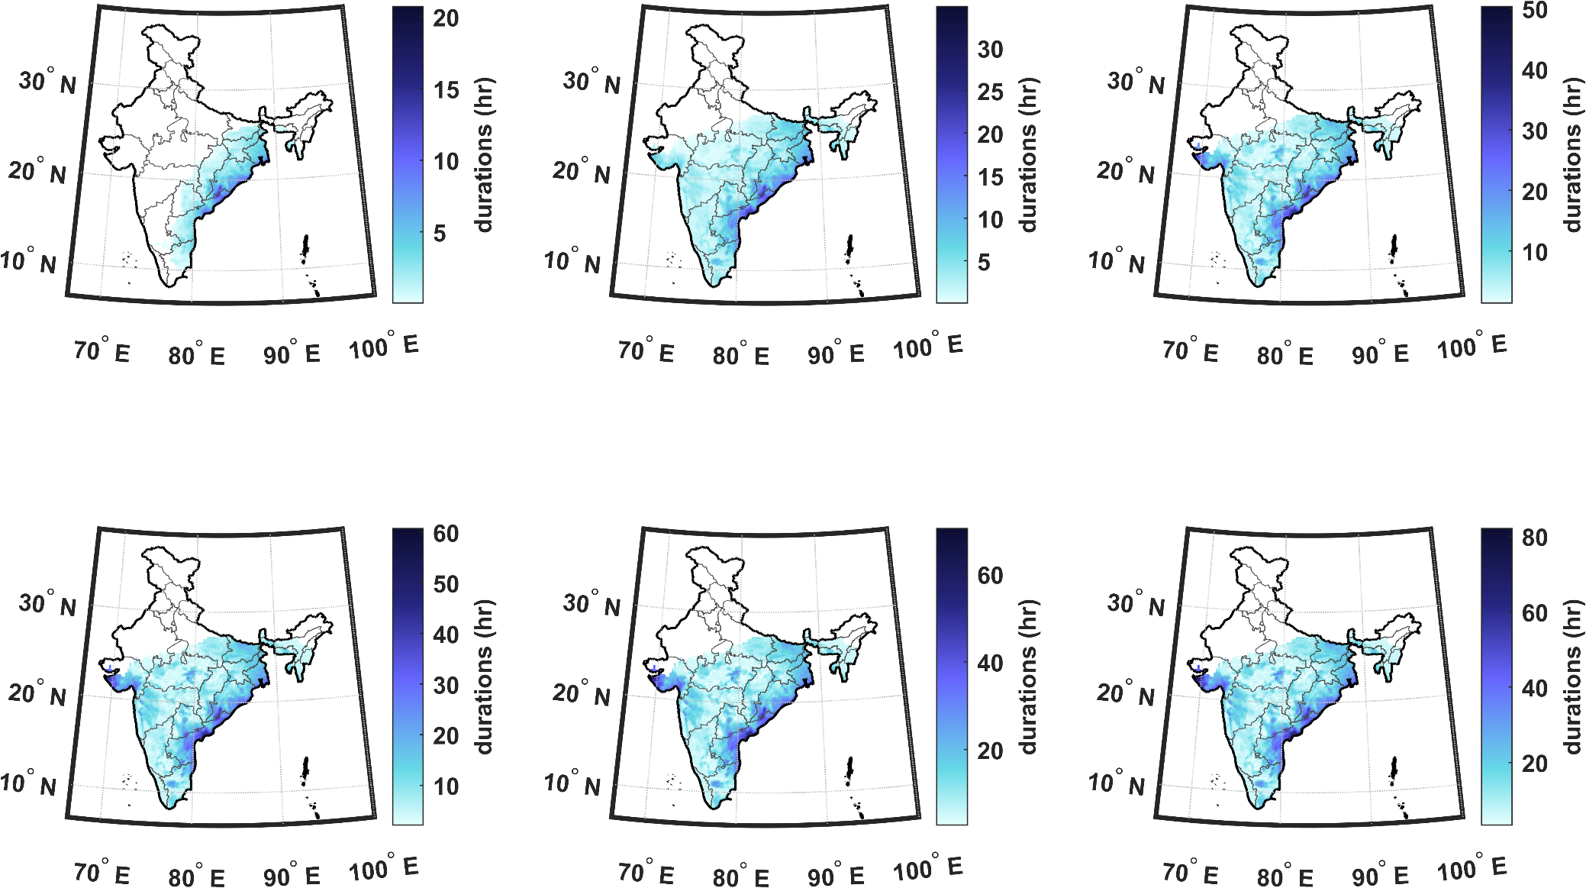
(a)
(b)
(d)
(e)
(c)
(f)
Fig. S7 Duration of tropical cyclone induced rainfall extremes for various return period level (a) 1 year, (b) 2 years, (c) 5 years, (d) 10 years, (e) 20 years, and (f) 50 years.

Return period of TC induced wind extremes for various duration level
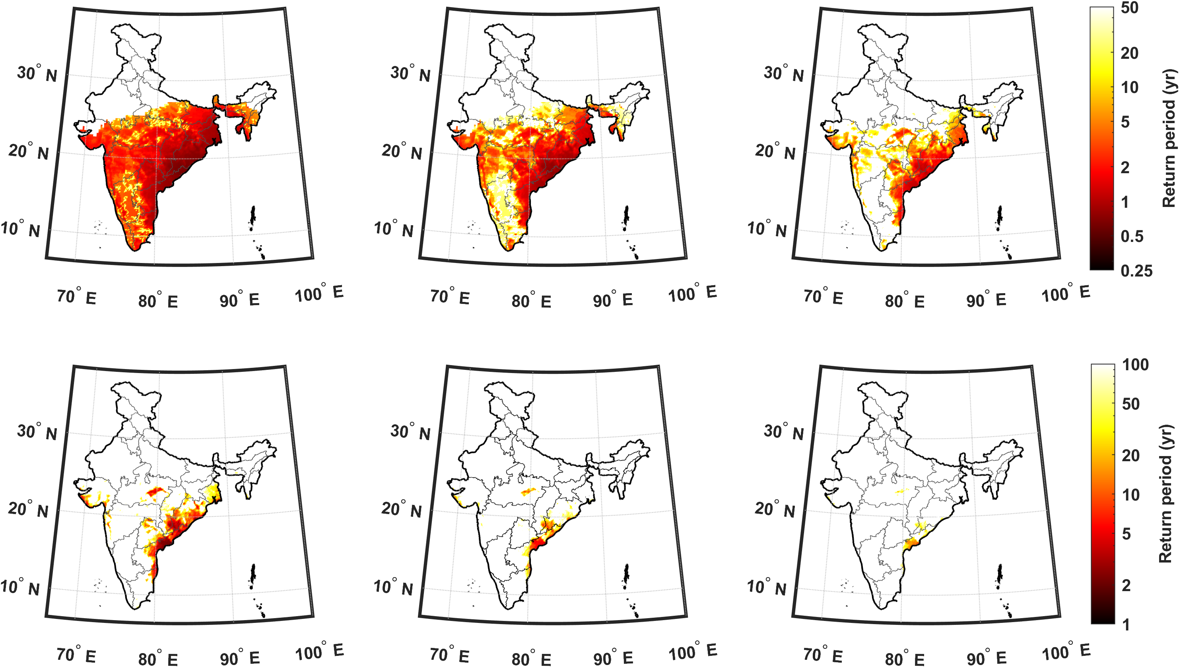
(a)
(b)
(d)
(e)
(c)
(f)
Fig. S8 Return period of tropical cyclone induced wind extremes for various durations of event (a) 3 hr, (b) 6 hr, (c) 12 hr, (d) 1 day, (e) 1.5 days, and (f) 2 days.

Return period of TC induced rainfall extremes for various duration level
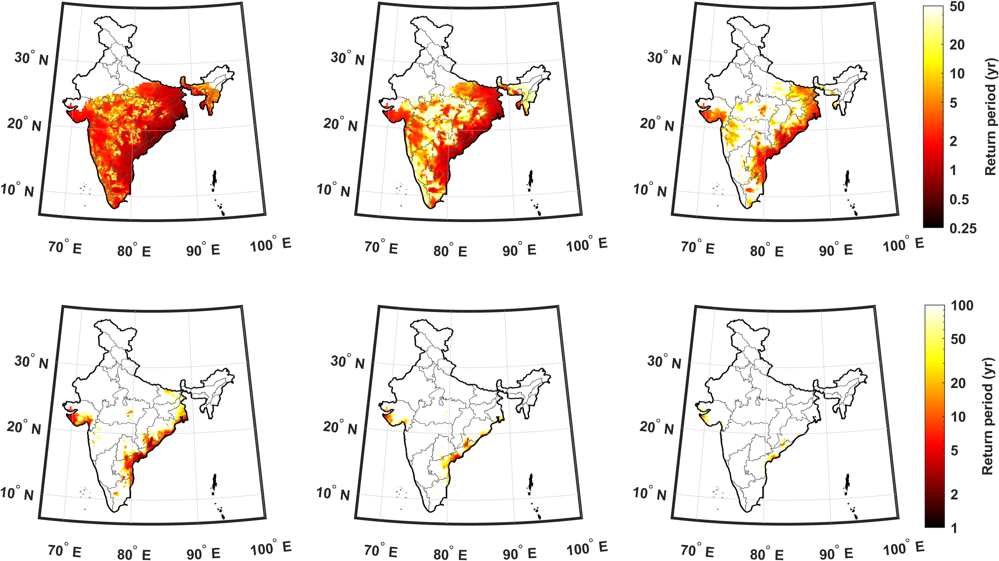
(a)
(b)
(d)
(e)
(c)
(f)
Fig. S9 Return period of tropical cyclone induced rainfall extremes for various durations of event (a) 3 hr, (b) 6 hr, (c) 12 hr, (d) 1 day, (e) 1.5 days, and (f) 2 days.

Wind and rainfall extremes for more than 6 hours
(a)
(b)
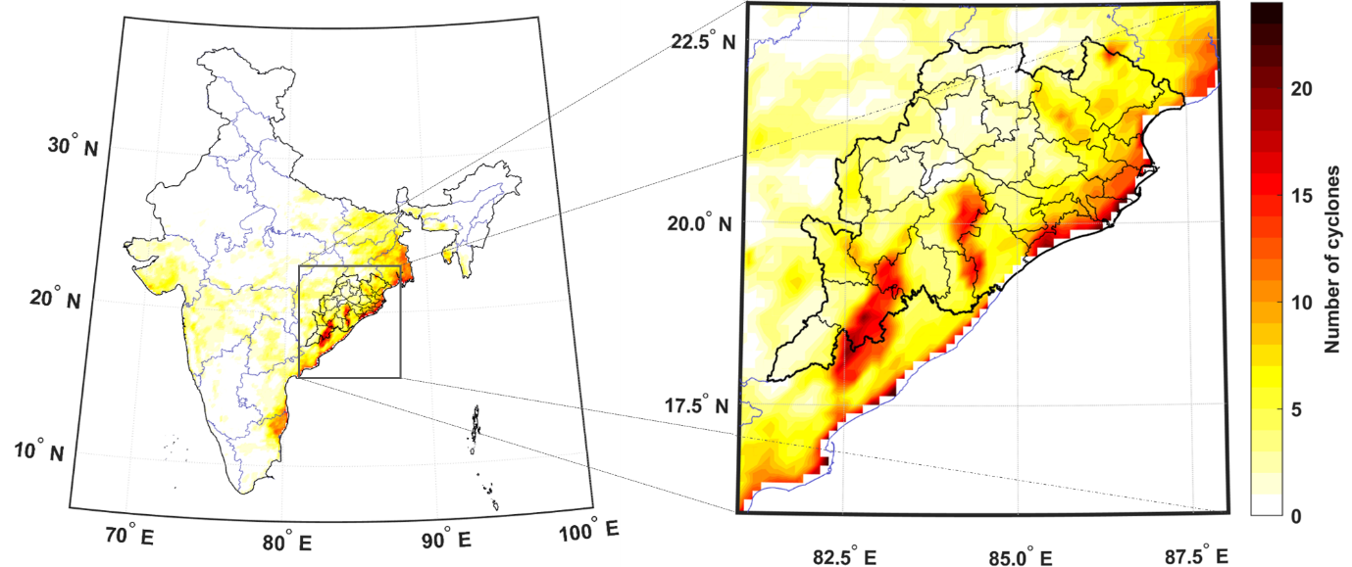
Fig. S10 Number of cyclonic events causing both wind and rainfall extreme more than 6hr over (a) India and (b) Odisha

Seasonal Variation for Premonsoon and Post-monsoon Tropical Cyclones
The number of premonsoon and post monsoon cyclones that affected any location is shown in Figure S9 for entire India. There is a clear shift in spatial distribution of cyclone prone region. Most of the cyclones in pre-monsoon is concentrated to Odisha and West Bengal. However, cyclones in post monsoon season affects Andhra Pradesh most. Post monsoon cyclones on-average affects eastern coastal states including Telangana, Chhattisgarh, Jharkhand, and Bihar more than twice each year.
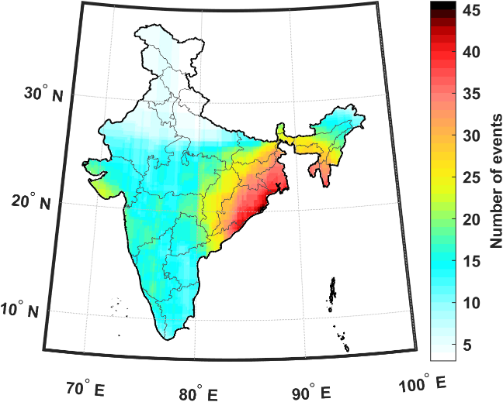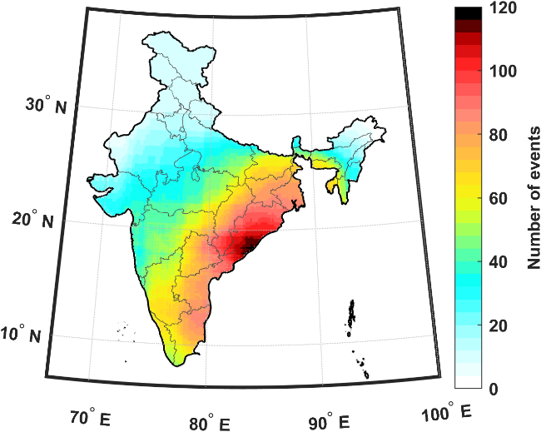
(a)
(b)
Fig. S11 Number of (a) premonsoon and (b) post monsoon TCs affecting the location.

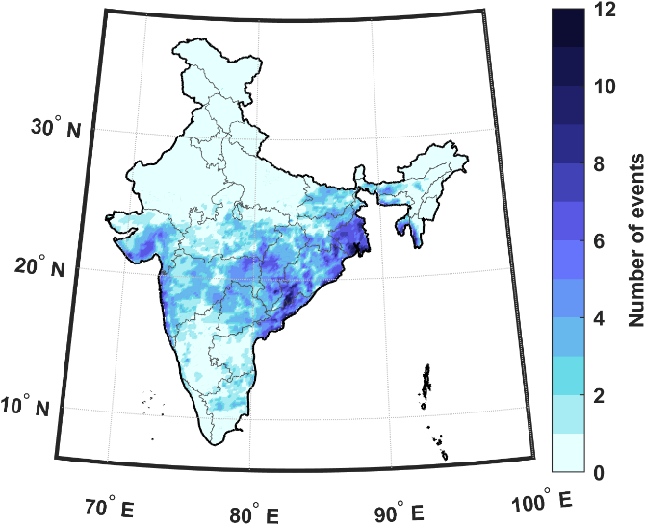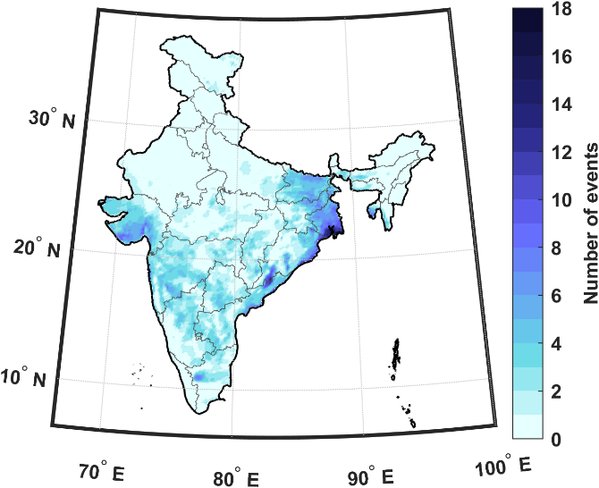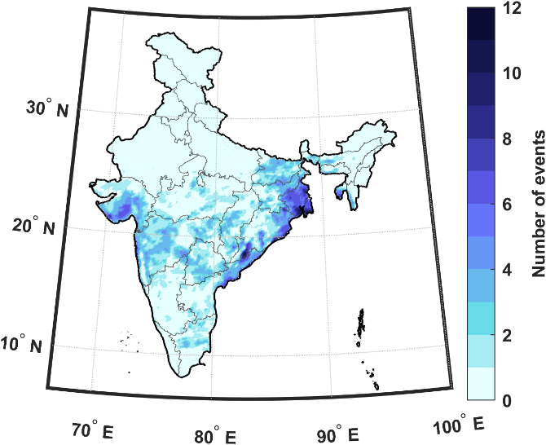
(a)
(b)
(d)
(e)
(c)
(f)
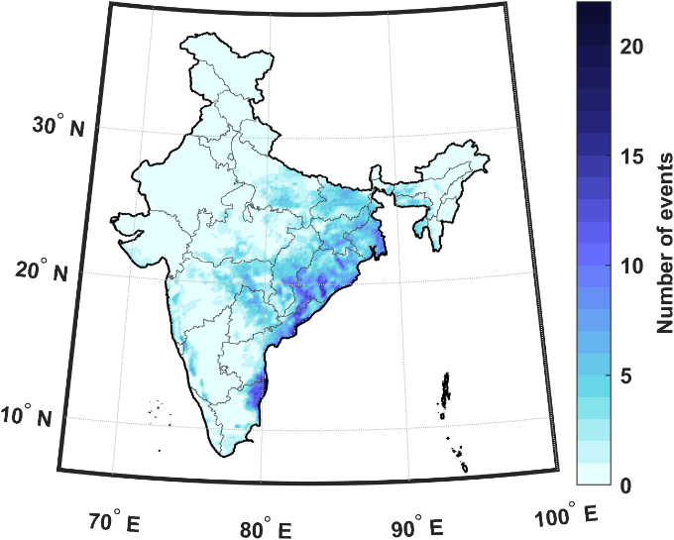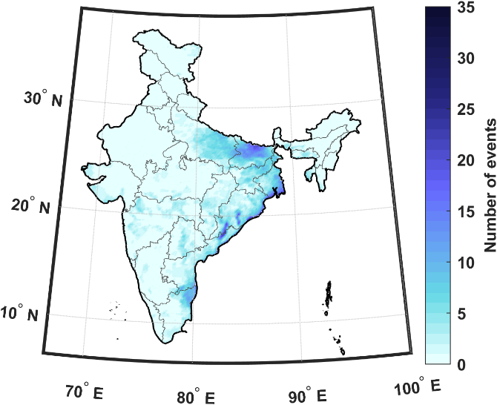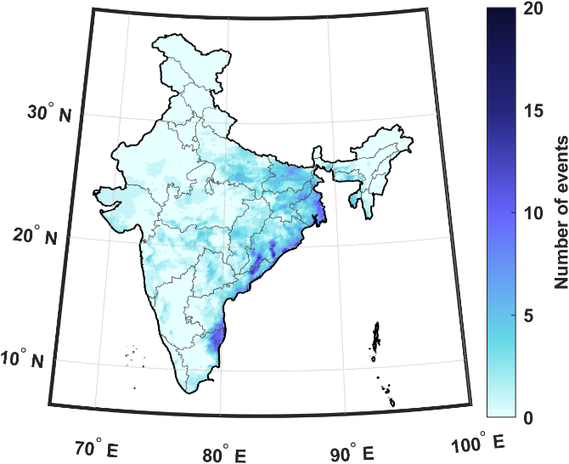
Fig. S12 Number of premonsoon TCs causing (a) wind, (b) rainfall, (c) concurrent wind-rainfall extremes and number of post-monsoon TCs causing (d) wind, (e) rainfall, (f) concurrent wind-rainfall extremes during 1979-2020.

