Appendix
Energy landscape steering mediates dynamic coupling in ATP-driven protein translocation

Joel A. Crossley^{1,2,3}, William J. Allen⁴, Daniel W. Watkins^{4,‡}, Tara Sabir³, Sheena E. Radford¹, Roman Tuma^{1,2} Ian Collinson⁴* and Tomas Fessl²*
¹Astbury Centre for Structural Molecular Biology, School of Molecular and Cellular Biology, Faculty of Biological Sciences, University of Leeds, Leeds, LS2 9JT, United Kingdom
²Faculty of Science, University of South Bohemia, České Budějovice, 370 05, Czech Republic
³School of Clinical and Applied Sciences, Leeds Beckett University, Leeds, LS1 3HE, United Kingdom
⁴School of Biochemistry, University of Bristol, Bristol, BS8 1QU, United Kingdom

*Correspondence: fessl@prf.jcu.cz and ian.collinson@bristol.ac.uk
‡, present address: CytoSeek, Science Creates Old Market, Midland Road, Bristol, BS2 0JZ, United Kingdom.

Table of Contents
Appendix Materials and Methods 3
Protein expression, purification, labelling and reconstitution 3
ATPase assays 6
Transport assays 7
Single-molecule data acquisition 8
Burst selection 9
mpH²MM analysis 9
Model selection 9
Viterbi analysis 10
Dwell time error analysis 10
Burst variance analysis 10
Correction for the presence of apo SecYEG 11
Simulation of transition rates 11
Mixing simulated rates with apo dynamics 13
Extracting the corrected rates 13
Calculation of simplified potential energy surface 14
Appendix Figures 15
Appendix Figure S1 - The structure of the SecYE:A complex 15
Appendix Figure S2 - Mechanisms for protein translocation through the SecYEG:A complex illustrated by a free energy diagram across the mechanical reaction coordinate. 16
Appendix Figure S3 - The structure of SecY showing the amino acid substation associated with PrlA4 17
Appendix Figure S4 - Apo correction pipeline. 18
Appendix Figure S5 – Single-molecule data for one of five repeats of SecYEG apo. 21
Appendix Figure S6 - Single-molecule data for one of five repeats of SecYEG + signal sequence (SecYEG+SS). 23
Appendix Figure S7 - Single-molecule data for one of five repeats of SecYEG + SecA (SecYEG:A). 25
Appendix Figure S8 - Single-molecule data for one of five repeats of SecYEG + SecA + ATPγS (SecYEG:A:ATPγS). 27
Appendix Figure S9 - Single-molecule data for one of five repeats of SecYEG + SecA + ADP·AlF_{x} (SecYEG:A:ADP·AlF_{x}). 29
Appendix Figure S10 - Single-molecule data for one of five repeats of SecYEG + SecA + ADP (SecYEG:A:ADP). 31
Appendix Figure S11 - Single-molecule data for one of five repeats of SecYEG + SecA + ATP (SecYEG:A:ATP). 33
Appendix Figure S12 - Single-molecule data for one of five repeats of SecYEG + SecA + ATP + proSpy (SecYEG:A:proSpy:ATP). 35
Appendix Figure S13 – SecYEG channel dwell time plot for SecYEG:A:ATPγS vs. SecYEG:A:AMP-PNP. 36
Appendix Figure S14 - Single-molecule data for one of five repeats of SecYEG + SecA + AMP-PNP (SecYEG:A:AMP-PNP). 38
Appendix Figure S15 - Single-molecule data for one of five repeats of SecYEG-PrlA4 apo. 40
Appendix Figure S16 - Single-molecule data for one of five repeats of SecYEG-PrlA4 + signal sequence (SecYEG-PrlA4:SS). 42
Appendix Figure S17 - Single-molecule data for one of five repeats of SecYEG-PrlA4 + SecA (SecYEG-PrlA4:A). 44
Appendix Figure S18 - Single-molecule data for one of five repeats of SecYEG-PrlA4 + proSpy + ATP (SecYEG-PrlA4:A:ATP+proSpy). 46
Appendix Figure S19 - Five technical repeats show the variability of SecYEG channel opening and closure rates (s⁻¹) for wild-type SecYEG apo. 47
Appendix Tables 48
Appendix Table S1 – SecYEG wild-type corrected dwell times in each FRET state. 48
Appendix Table S2 – SecYEG wild-type percent open. 49
Appendix Table S3 – The SecA ATPase rate ± proSpy in the presence of SecYEG proteoliposomes (wild-type and prlA4) and ATP. 50
Appendix Table S4 – proSpy_{4x} transport assay lag times using the NanoLuc split-luciferase assay. 51
Appendix Table S5 - Fitting statistics for Nanoluc assay lag times of proSpy_{4x.} 52
Appendix Table S6 – SecYEG-PrlA4 corrected dwell times in each FRET state. 53
Appendix Table S7 – SecYEG-PrlA4 percent open. 54

Appendix Materials and Methods

Protein expression, purification, labelling and reconstitution
All SecYEG variants, cloned in pBAD/myc-His C and with an N-terminal 6His tag on SecE, were taken from our laboratory collection. Plasmids were transformed into competent E. coli C43 cells. A 100 ml pre-culture of 2xYT broth containing 100 μg.ml⁻¹ ampicillin was inoculated and incubated overnight at 200 RPM and 37°C. The following morning, Flasks containing 2xYT with 100 µg.ml⁻¹ Ampicillin were inoculated with pre-culture (15 ml per 2 L, in 5 L flasks) and incubated at 200 RPM and 37°C. On reaching an A₆₀₀ of 0.8, expression was induced by addition of arabinose to 0.2 % (w/v). After 3 hours, cells were harvested by centrifugation (5000 g, 15 mins) and resuspended in 50 ml 20 mM Tris pH 8, 300 mM NaCl, 10 % glycerol (TSG300). The cells were passed twice through a cell disruptor (Constant Systems Ltd.) at 25 kPSI and membranes clarified by centrifugation (160,000 g, 45 mins, 4°C). The membrane pellets were then washed gently in TSG300 and stored at -20˚C until purification.

For purification, membrane pellets were resuspended to 42.5 ml in TSG and homogenised with a potter. A 10 % n-Dodecyl β-D-maltoside (DDM, Glycon) stock was added to 1 % final, and membranes were incubated gently rotating at 4°C for 30 mins. Insoluble material was removed by centrifugation (160,000 g, 45 mins, 4°C). A 25 ml bed volume nickel immobilised metal affinity chromatography column linked to an Akta FPLC (GE Healthcare) was equilibrated in TSG300 + 0.1 % DDM. The solubilised membranes were loaded onto the column, which was subsequently washed with TSG300 + 0.1 % DDM + 30 mM imidazole until the A280 stabilised. On completion, bound material was eluted with TSG300 + 0.1 % DDM + 330 mM imidazole. The eluate was subsequently loaded onto a HiLoad 26/600 Superdex 200 pg size exclusion column with a 25 ml bed volume Q sepharose fast flow (GE healthcare) column connected in tandem, pre-equilibrated in TSG130 (as TSG300, but with only 130 mM NaCl) + 0.02 % DDM. Purified SecYEG was concentrated to approximately 200 μM in a 50 kDa cut-off centrifugal concentrator (Sartorius Stedim) and stored at -80°C for future use.

Before labelling, SecY_{A103C-V353C}EG was treated with 100 mM DTT for 30 mins to fully reduce all cysteines. The sample was then passed over a 20 ml Superdex 200 10/300 GL size exclusion column equilibrated in TSG130 + 0.02 % DDM (to remove excess DTT), and the protein peak concentrated to ~100 µM, then immediately labelled with 200 µM ATTO 565 maleimide and 200 µM ATTO 655-maleimide, in the dark at 4˚C for 2 h. The reaction was quenched by addition of 10 mM DTT, and excess probe removed by size exclusion exactly as for the DTT. The resulting protein was concentrated and stored at -80˚C. Fluorescently labelled SecY_{A103C-V353C}EG was subsequently reconstituted into proteoliposomes before smFRET measurements (see main text Methods section ‘Single-molecule Sample Preparation’).

We employed exactly the same translocation substrate constructs as in Allen et al. (Allen et al, 2020): the soluble periplasmic chaperone proSpy followed by three tandem repeats of the Spy mature domain, with each Spy sequence followed by pep86 (to allow detection by NanoLuc; pSpy_{4x}). For each substrate, three copies of pep86 were scrambled such that they have the same amino acid composition but no longer interact with 11S, leaving only one functional pep86 sequence. The resulting proteins are identical except for the number of amino acids that must be transported before the functional pep86 reaches the vesicle lumen and interacts with 11S. Expression plasmids for these constructs (in pBAD/myc-His C) were transformed into E. coli MM52 cells. A 250 ml 2xYT preculture containing 100 μg/ml ampicillin was grown overnight at 30°C and 200 RPM in a 2L flask. 1 L 2xYT containing 100 μg/ml ampicillin, prewarmed to 39°C, was added to the overnight culture before incubation at 39°C and 200 RPM. After 45 minutes, expression was induced with addition of arabinose to 0.2%. 3 hours later cells were harvested, resuspended and lysed as for SecYEG (described above), but with 50 ml resuspension buffer of 50 mM Tris-HCl pH 8.0 and 500 mM NaCl (TS500 buffer). The sample was clarified by centrifugation (20,000 g, 30 minutes, 4°C) and the soluble fraction taken. Nickel affinity purification was conducted as for SecYEG, but columns were washed in TS500 containing 30 (wash) or 330 mM (elution) imidazole. The eluate was passed over a Q-sepharose column to remove any remaining contaminants, and the flowthrough exchanged into 20 mM Tris pH 8 and 6 M urea and concentrated to ~200 μl final volume with a 10 kDa centrifugal concentrator and stored at -80°C for future use.

_{His6}SecA cloned in pTrc99a from our laboratory collection was transformed into competent E. coli BL21(DE3), used to inoculate a 100 ml culture of LB broth containing 50 μg.ml⁻¹ kanamycin and incubated overnight at 200 RPM and 37°C. The following morning LB supplemented with 50 µg.ml⁻¹ kanamycin was inoculated with pre-culture (15 ml per 2 L, in 5 L flasks), left to incubate at 200 RPM and 37°C until the A₆₀₀ reached 0.6, then expression was induced with 1 mM IPTG for 1.5 hours. Cells were harvested by centrifugation (5000 g, 15 mins), resuspended in 100 ml TKM (20 mM Tris pH 8, 50 mM KCl, 2 mM MgCl₂), lysed as described for SecYEG and clarified by centrifugation (20,000 g, 60 minutes, 4°C). SecA was purified from the soluble fraction as described for SecYEG but using TKM buffer with 30 (wash) or 300 mM (elution) imidazole. The eluate was further purified on a 25 ml bed volume column containing Q Sepharose fast flow resin equilibrated in TKM. After sample loading, a linear gradient of 50-1000 mM KCl was applied with SecA eluting at approximately 450 mM NaCl. SecA was subsequently purified with a HiLoad 26/600 Superdex 200 pg size exclusion column equilibrated in TKM, concentrated to approximately 500 μl with a 50 kDa centrifugal concentrator and stored at -80°C for future use.

GST-dark in pGEX-1 from our lab stock was transformed into BL21(DE3) cells and expressed as for SecYEG, using 1 mM IPTG for induction. Cells were resuspended in TK buffer (20 mM Tris-HCl pH 8.0 + 50 mM KCl), then cracked and centrifuged as for SecA. The supernatent was then loaded onto a GSTrap 4B column, washed with TK buffer, and eluted with 10 µM reduced glutathione in TK. Eluted protein was concentrated and stored at -80 ˚C.

11S in pBAD/myc-His C was transformed into BL21(DE3) and expressed in the same way as SecYEG, then resuspended in TKG (20 mM Tris pH 7.5, 50 mM KCl, 10 % glycerol) and cracked open and centrifuged as for SecA. Protein was purified by Ni²⁺ affinity chromatography as above, using 50 mM imidazole for the wash step and 330 mM imidazole for the elution (in TKG). The imidazole was then exchanged away in a spin concentrator, and the pure protein concentrated and frozen at -80˚ C for later use.

ATPase assays
ATPase activity was followed by coupling ADP production to NADH oxidation using pyruvate kinase and lactate dehydrogenase (PK/LDH, Merck) in the presence of excess phophoenolpyruvate (PEP), then measuring reduction in NADH from its absorbance at 340 nm. Master mixes were assembled in TKM to give a final volume of 84 µl per well, with 1 µl PK/LDH, 5 µl PLs, and SecA, PEP and NADH to give final concentrations of 50 nM, 2 mM and 0.2 mM, respectively, when diluted to 100 µl. 84 µl master mix was added to clear, flat-bottomed 96-well plates (CoStar), and a baseline signal at 340 nm measured for 5 mins in a BioTek Synergy Neo2 plate reader. Next, 1 µl 100 mM ATP was added manually, using a multichannel pipette, followed by 5 second double orbital shaking (559 cpm), and 20 min measurement of ATPase consumption in the absence of pre-protein. Finally, 15 µl pre-protein at 6.67 µM (to give 1 µM final) was added manually, followed by further shaking and measurement (stimulated activity). Slopes were determined by linear regression to the straight part of the line, then converted to ATP consumption by:

$rate = \frac{-slope}{ε×[SecA]×l}$ Eq.1

where ε is the extinction coefficient for NADH at 340 nm (6,220 M⁻¹.cm⁻¹), [SecA] is the concentration of SecA (50 nM), and l is the path length (0.28 cm). Note that because the wells are cylindrical, the slightly higher [SecA] before pre-protein addition is precisely cancelled out by the shorter l. Eight simultaneous reactions were recorded per plate, and the identical repeats (4 per condition) averaged to produce a single value.

Transport assays
Transport assays were performed using the published Nanoluc system (Allen et al, 2020; Pereira et al, 2018), wherein the large fragment of split NanoLuc (11S) is encapsulated within PLs with SecYEG in the membrane, and the small fragment (pep86) is incorporated into the pre-protein substrate. Upon transport of pre-protein into the vesicle, 11S and pep86 rapidly combine to form NanoLuc, which – when 11S is in excess and the substrate furimazine is provided – produces a luminescent signal proportional to the amount of pep86 imported.

NanoLuc measurements were performed on a BioTek Synergy Neo2 plate reader. Reaction master mixes were assembled at 25 ˚C to give a volume of 99 µl per well in TKM, such that when diluted to 125 µl each well contained: 0.625 µl furimazine, 0.1 % prionex, 0.1 mg.ml⁻¹ creatine kinase, 5 mM creatine phosphate, 20 µM GST-dark, 0.828 µl PLs and 500 µM SecA. Immediately prior to measurement, 1 µl pre-protein at 250 µM was added to each measurement well in a white 96-well plate (Nunc), pre-warmed to 25 ˚C, followed by 99 µl master mix. After a 5 second double orbital shake (559 cpm), measurements were performed in kinetic mode (i.e. measuring absolute time from the start): 8 min luminescence measurement (to obtain background signal from unencapsulated 11S), injection of 25 µl ATP at 5 mM (in TKM), 5 second double orbital shake (559 cpm), and finally luminescence signal measurement (up to 50 minutes, but usually terminated early once all luminescence signals had plateaued).

Data processing was performed in pro Fit 7 (Quantumsoft), using the method established in Allen et al. (Allen et al, 2020). First, the first 8 minutes were fitted to a single exponential + lag model, where t_{app} = t - lag:
if (t_{app}<0) $y = c$ Eq.2
if (t_{app}≥0) $y = A(1-e^{-t_{app}×k}) + c$ Eq.3
The resulting fit was extrapolated to cover the complete experiment time, tabulated, and subtracted from the data. Finally, the signal part of the corrected data was fitted to the same equation (with t=0 set to the injection time). Transport time is taken as lag from this fit, i.e. the minimum time for pep86 to reach the PL lumen.

Single-molecule data acquisition
Single-molecule Förster resonance energy transfer (smFRET) experiments were performed on a custom-built confocal epi-illuminated microscope (Fessl et al, 2020) in a standard inverted-stage configuration. Molecules were excited in a pulsed interleaved excitation (PIE) regime using pulsed 560 nm (LDH-P-FA-560, Picoquant) and 640 nm (LDH-D-C-640, Picoquant) diode lasers which were alternatively pulsed at a combined frequency of 40 MHz by a Multichannel Picosecond Diode Laser Driver (Sepia PDL 828, Picoquant). The lasers were first combined using a dichroic mirror (86-394, Edmund Optics) before being coupled to an optical fiber (PAF2A-11A, ThorLabs). Laser emission from the fiber was collimated (60FC-4-A11-01, Schäfter + Kirchhoff) before being reflected from a polychroic beam splitter (Di03-R405/488/561/635-t1-25x36m Semrock) into a 60x 1.2 NA water-immersion objective (UPLSAPO60XW, Olympus). Average powers for the donor and acceptor lasers at the objective were 75 μW and 35 μW respectively. Excitation light from the objective was focused 10 μm above the surface of the cover glass.
Light emitted from the sample was then collected by the same objective lens before being transmitted through the polychroic beam splitter. The emitted light was focused onto a 100 μM pinhole (P100D, ThorLabs) using an achromatic doublet lens with a focal length of 50 mm (AC254-050-A, ThorLabs). The pinhole spatially filtered photons outside of the desired observation volume. Light was then collimated using another achromatic lens of the same specifications before being separated by wavelength into the donor and acceptor emission channels by a long-pass dichroic mirror (Di02-R635, Semrock). Bandpass filters removed residual excitation wavelength light in each channel (Donor: FF01-607/36-25, Semrock. Acceptor: FF01-670/30-25, Semrock) before it was focused by an achromatic doublet lens with a focal length of 50 mm (AC254-050-A, ThorLabs) onto single-photon avalanche diodes (SPCM-AQRH-14, Excelitas) with high timing resolution and low dark counts. Signals from the detectors are sent to a TCSPC data acquisition unit (Multiharp 150P, Picoquant).

Burst selection
We performed burst search and selection using the FRETBursts analysis software (Ingargiola et al, 2016). The background was assessed per each 60 s of acquisition, and bursts were identified as time periods during which the instantaneous photon count rate within a sliding window of 10 consecutive photons is at least 6 times higher than the background rate. Detected bursts which overlapped were fused. Bursts were selected if they include a minimum of 30 and a maximum of 1000 photons in total between all streams. The maximum photon threshold was included to filter out sparse aggregates of labelled SecYEG, which were significantly brighter than single-molecules.

mpH²MM analysis
Bursts identified by FRETBursts were then converted into a format readable by the H2MM_C software (Harris et al, 2022). All mpH²MM calculations were performed within the Jupyter notebooks, available in supplementary dataset (Harris, 2021), using the Python package by Paul David Harris (Harris). We used the mpH²MM algorithm to test how well different state models describe the data.

Model selection
The modified Bayes Information Criterion (BIC’) (Harris et al, 2022) was used for determining the number of states in the HMM model. The number of states for which BIC′ drops under 0.005 is generally considered reliable to describe the data with minimum parameters and this criterion was used throughout this study. Viterbi algorithm was used to find the most likely path between states based on the posterior probability. All data were best described by four states representing: i) dark donor, ii) dark acceptor, iii) low FRET (open state of SecYEG) and iv) high FRET (closed state of SecYEG) (see Main text Fig 3).

Viterbi analysis
From the state path, photons were separated into dwells, each of which was assigned a duration, a mean E_{raw}, and a mean S_{raw}. This also allowed bursts to be classified by which and how many states they encompassed. As a measure of error, we used the weighted standard deviation and the weighted standard error of the E_{raw} and S_{raw} as a proxy for the standard error of the mpH²MM model.

Dwell time error analysis
Analysis of the variability of subsets is a well-established method to assess the error of parameters. We repeated each experiment five times with freshly prepared proteoliposomes (see Appendix Tables S1, S2, S6 and S7) and calculated the average values together with a t-test to get the 90% confidence interval (90%CI). An example of the variability of the raw data is shown in Appendix Fig S19.

Burst variance analysis
As a qualitative test for FRET dynamics occurring within bursts, we used burst variance analysis (BVA) (Torella et al, 2011), which compares the expected variance in E_{raw} based on shot noise (the static FRET semi-circle) against the actual variance in E_{raw} in each individual burst. We performed BVA in the FRETbursts environment. To calculate the experimental burst wide standard deviation, we segmented each burst into consecutive (and nonoverlapping) windows of 5 photons each, and calculated the standard deviation of all windows within the burst. To further increase the statistical power of BVA, we segmented the E_{raw} axis into bins, each centred on a given value of E_{raw} and bearing an E_{raw} bin width = 0.05.

Correction for the presence of apo SecYEG
During proteoliposome preparation, SecYEG complexes incorporate into the liposomes in a random fashion. This renders roughly 50% of molecules inaccessible (Deville et al, 2011), i.e. with the cytoplasmic loops facing inside the proteoliposome. These molecules cannot bind SecA and therefore remain in an ‘apo state’. To correct measured kinetics for the apo contribution, we simulated a mixture of transition rates of apo state with one unknown dynamic state represented by the pair of transition rates that were varied of physically reasonable range until a good agreement with measured data was found. The correction process pipeline was:
- Simulate transition events of dynamic states with rates systematically varied over a 2D grid within a physically reasonable range.
- Simulate transition events with apo rates
- Mix the simulated transitions (from stage 1) with apo (from stage 2) in a 1:1 ratio and determine the resulting apparent parameters (dwell times in the two states)
- Find the best agreement between the simulated apparent and measured dwell times to extract the corrected dwell times and convert them into rates (i.e. transition rates before being “polluted” with apo event).

Simulation of transition rates
Stochastic conformational dynamics is often mathematically described using the “continuous-time Markov process”, where the changes of state (conformation) of the system are called transitions. The probabilities associated with various state changes are called transition probabilities (P). The process is then characterised by a state space (S), a transition matrix (Q) describing the rates of particular transitions (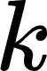), and an initial state (or initial distribution) across the state space (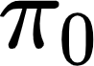). Based on these parameters, we can determine a probability vector (π), which identifies the probability of the system being in a given state.

In our system, the state space consisted of two states, S={0, 1}. Here we used 0 to represent the open state of the LG and 1 for the closed state. We defined the rate of LG closing as 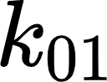 as and the rate of LG opening as 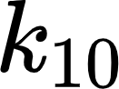.
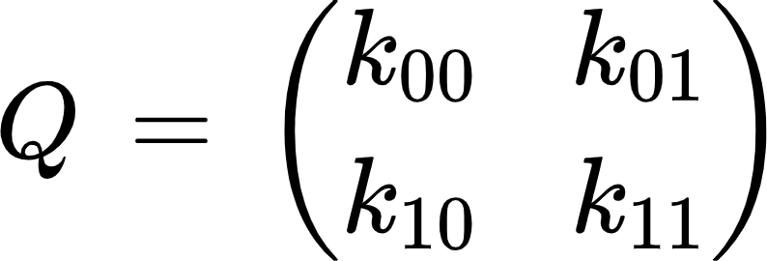 Eq.4
 and 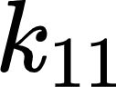 have no physical meaning, we can use them to justify a condition that a sum of each row of Q has to equal to zero, which means that 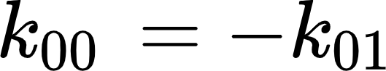 and 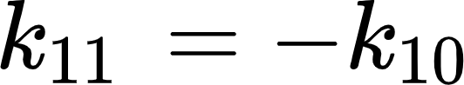. This condition is later needed to solve Eq.6. What we want to find is a probability vector π, which identifies the probability of the system being in a given state. In our example, π = (1, 0) would imply that the system stays all the time in state 0. On the other side, π = (0.5, 0.5) would imply an equal chance of being in both states. The relationship between Q and π is given by the following differential equation:
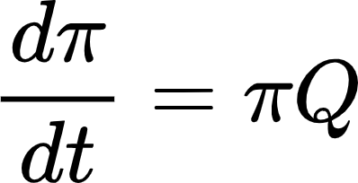 Eq.5
What specifically is of interest for us is the steady state of a continuous Markov chain, in other words a state for which the derivative is 0:
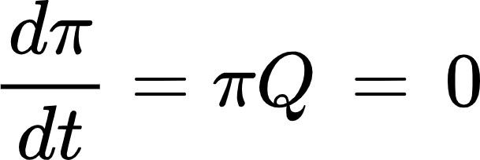 Eq.6
We can quickly solve our differential equation analytically, using the matrix exponential:
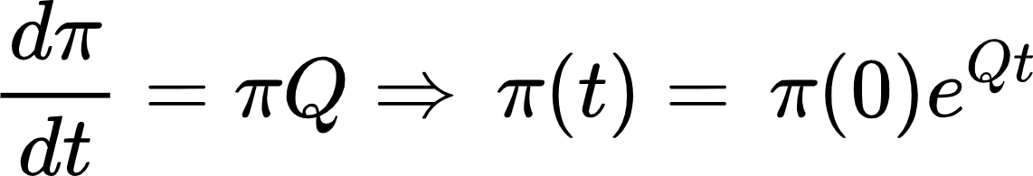 Eq.7
where the matrix exponential was computed using the python package scipy's linalg.expm function which implements an algorithm from Al-Mohy et al. (Al-Mohy & Higham, 2010). Now, since we determined the probability vector π and we know the range of rates, we simulated all rates over a fine grid of opening and closing rates.

Mixing simulated rates with apo dynamics
In the next step, we mixed the simulated values with apo kinetics using weighted arithmetic average approach. Since opening and closing rates are independent, we mix the rates separately resulting in  and 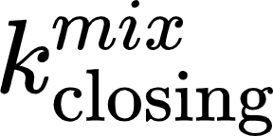.
Eq.8
where
 Eq.9
and
 Eq.10
 and  were determined experimentally.  was calculated for each simulated rate  using the above-mentioned approach. Mixed closing rates were calculated the same way. Dwell times of each state are then defined as reciprocal values of a given rate. The Python script used for the generation of the correction matrix is attached under name “APO_correction.py”.

Extracting the corrected rates
In the last step we recovered corrected rates by finding a minimum of the following expression:
Eq.11
where 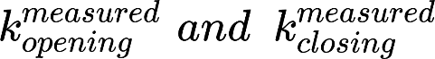 are the experimentally determined values. Calculated minima, showing the “apo-corrected” rates, for one repeat per technical repeat are depicted in Appendix Figs S6f-12f and S14f for SecYEG wild-type and Appendix Fig S16f-18f for SecYEG-PrlA4.

Calculation of simplified potential energy surface
Using the transition rates derived from the mpH²MM analysis and subsequent apo correction process the potential energy surface was estimated from transition state theory using the Kramers rate equation:
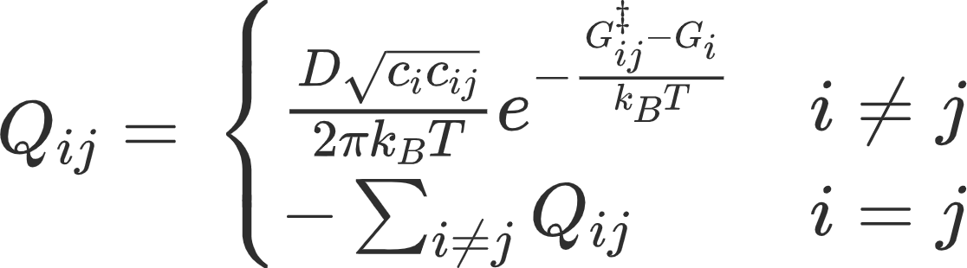 Eq.12
where Q_{ij} is the rate matrix, D is the diffusion constant over an energy barrier; c_{i} and c_{ij} are the curvatures of the continuous free energy landscape at the energy minimum G_{i} and the energy barrier G‡_{ij} corresponding to the stable state i and the transition state from state i to state j, respectively. The minima and maxima of the energy landscape were interpreted as the free energy of the stable states and the transition states, respectively. Solving for the barrier heights we get:
Eq.13
We note that using Eq.13, we can only learn the exact energy of the barrier, G‡_{ij}, if we know D, c_{i} and c_{ij}. However, D, c_{i} and c_{ij} are internal parameters of the system which are not easy to deduce. Moreover, the curvatures corresponding to different stable states are typically not equal. For example, proteins in folded states tend to be more rigid than in their unfolded states, leading to greater curvatures of the potential wells for the folded states than for the unfolded states. Nevertheless, in our system transitions occur between two well defined states and therefore we assume they do not significantly differ. We assume these parameters remain constant for all biochemical conditions in our experiments, therefore we can ignore the D, c_{i} and c_{ij}.

Appendix Figures
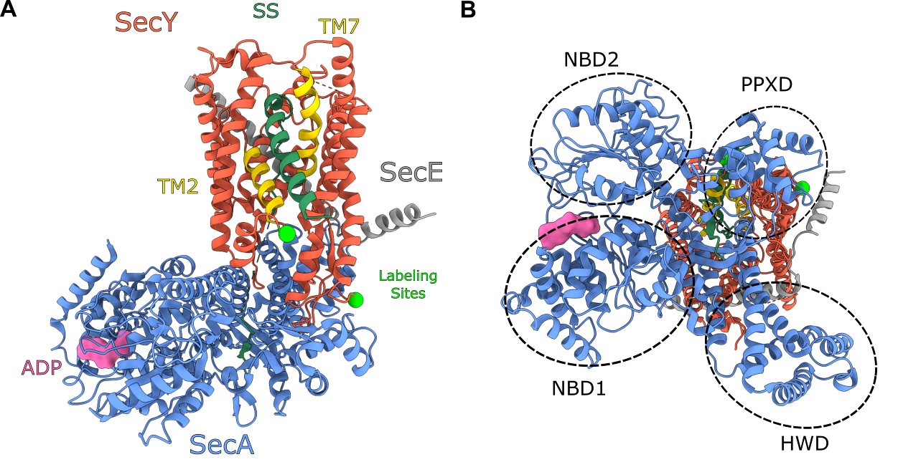

Appendix Figure S1 - The structure of the SecYE:A complex
A The side profile membrane view of the SecYE:A complex, PDB: 6ITC (Ma et al, 2019) (structure determined in the absence of SecG).
B The cytoplasmic view of the structure shown in panel A highlighting the nucleotide binding domains (NBD1+2), the pre-protein cross-linking domain (PPXD) and the helical wing domain (HWD).
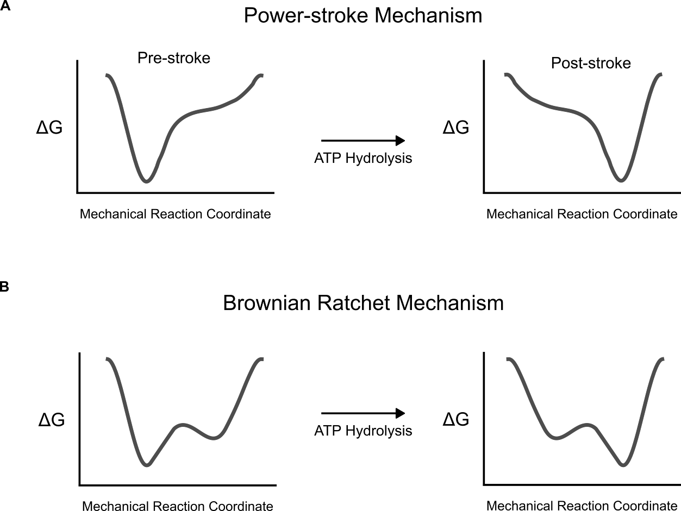

Appendix Figure S2 - Mechanisms for protein translocation through the SecYEG:A complex illustrated by a free energy diagram across the mechanical reaction coordinate.
A Power-stroke mechanism: deep minima at either the pre-stroke or post-stroke position which directly correspond to the nucleotide state of the ATPase.
B Brownian ratchet mechanism: the nucleotide hydrolysis cycle biases a shallow energy profile towards certain conformations, which in turn undergo rapid interconversion between the available states due to thermal fluctuations.

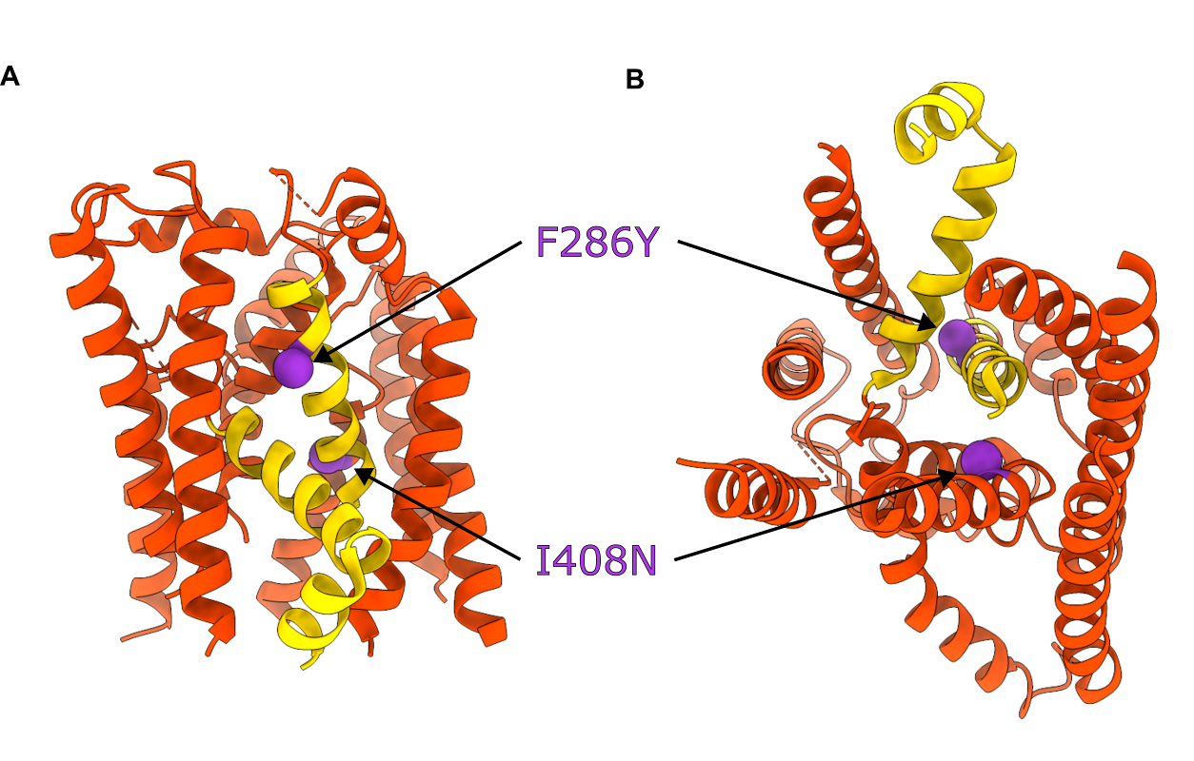

Appendix Figure S3 - The structure of SecY showing the amino acid substation associated with PrlA4
A The side profile membrane view of SecY. SecY is shown in red. The two prlA4 mutations F286Y and I408N are shown as purple space filled spheres. The two helices that comprise the lateral gate are shown in yellow (transmembrane helices 2 and 7). SecE, SecG and the cytoplasmic loops have been removed for clarity.PDB: 1RHZ (Van den Berg et al, 2004).
B The cytoplasmic view of the structure in panel A.

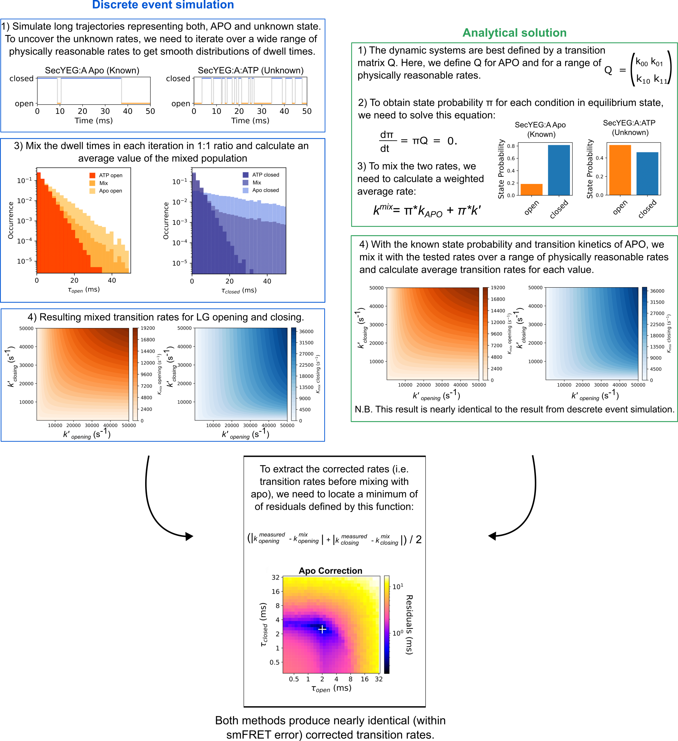

Appendix Figure S4 - Apo correction pipeline.
We used two different methods to extract Apo corrected rates, shown side-by-side to facilitate understanding of the process. The methods are analogous, the first is using the discrete event simulation (blue boxes, left) while the second uses an analytical solution (green boxes, right). Both are based on simulating continuous time Markov chains that represented opening and closing events from an equimolar mixture of apo (with known fixed opening and closing rates) and the SecA:nucleotide-bound SecYEG state of interest. The opening and closing rates for the latter were systematically varied within physically meaningful range and the resulting apparent dwell time distributions, which represent the mixture, were compared with the experimentally measured apparent dwell times. The closest match and corresponding confidence intervals were found from the 2D plots of residual (bottom panel). Both methods yield results which are identical within the margin of error given by our single-molecule fluorescence techniques. Discrete event simulation is considerably slower to calculate, for this reason, we used the analytical method to correct the experimental data.

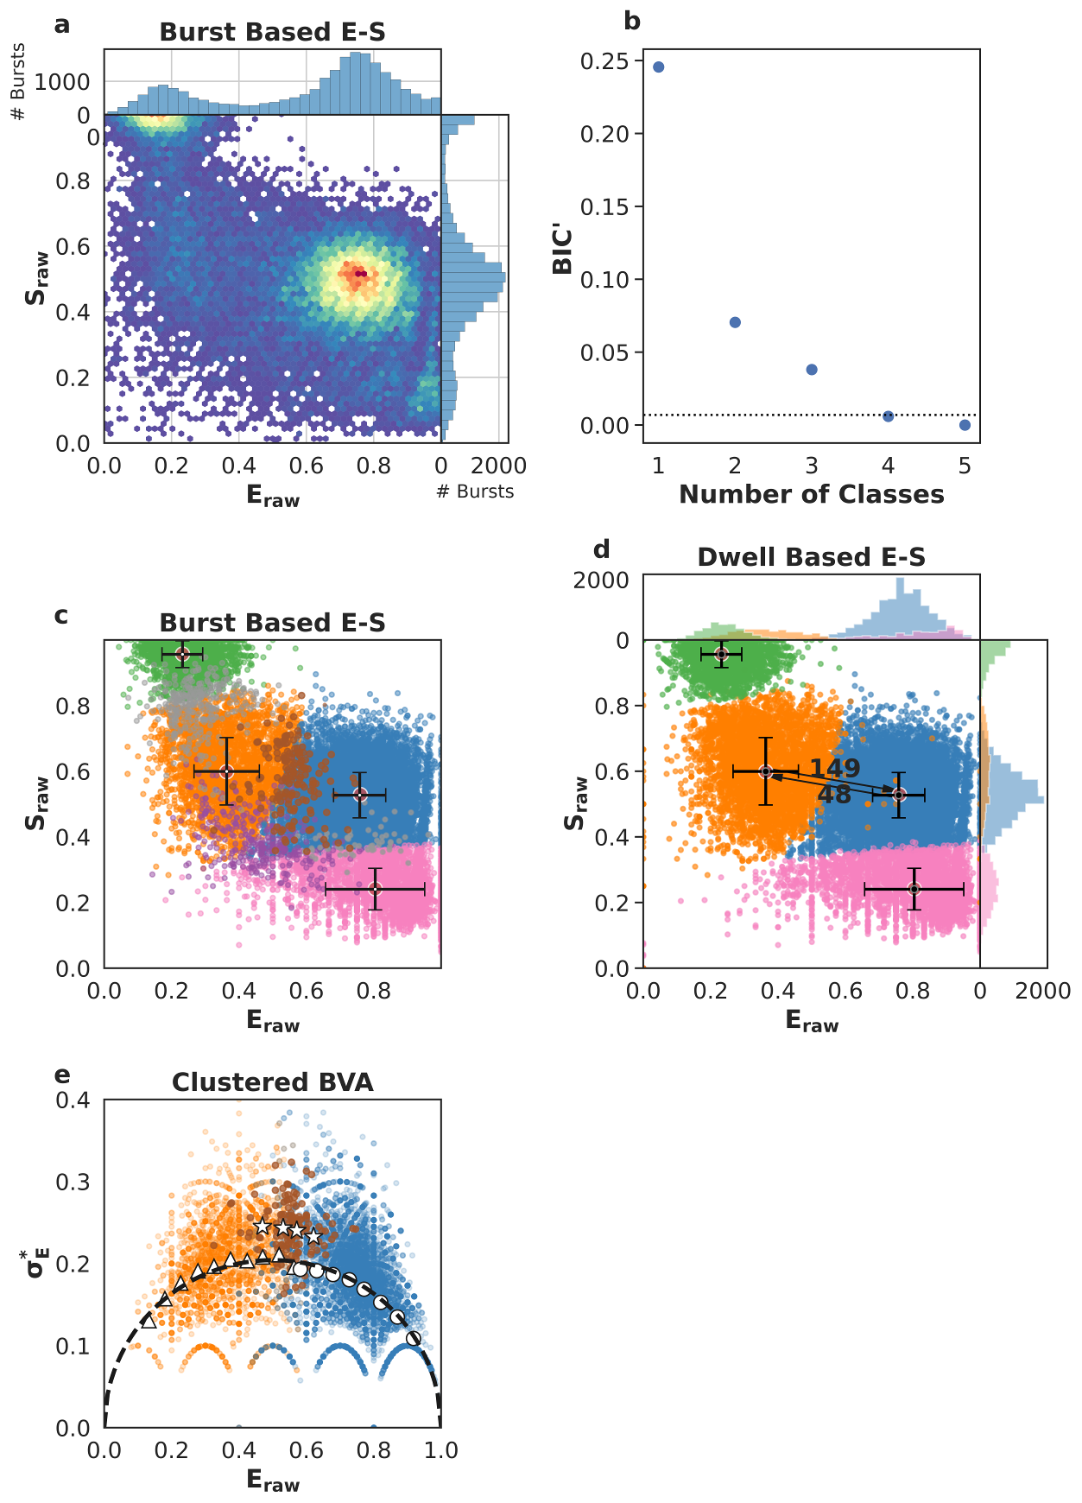

Appendix Figure S5 – Single-molecule data for one of five repeats of SecYEG apo.
First column of data in Appendix Tables 1 and 2.
a Burst data plotting FRET efficiency (E_{raw}) against stoichiometry (S_{raw}).
b Modified Bayes Information Criterion (BIC’) of different state-models indicated that four classes best describe the data (most likely state model BIC’<0.005).
c Using a burst based E_{raw} S_{raw} plot we interpreted the classes as the open state (orange, low E_{raw}), closed state (blue, high E_{raw}), dark acceptor (green, high S_{raw}), dark donor (pink, low S_{raw}), in this step, we also identified bursts representing transitions between conformational states (brown), transitions and photophysics (purple) and pure photophysics (grey).
d Dwell based E_{raw} S_{raw} plot showing the rate of interconversion (s⁻¹) between the open and closed states.
e Burst Variance Analysis (BVA) provided a qualitative confirmation of dynamic exchange between states and transition detection within bursts. Binned values representing bursts assigned to either the open (triangles) or the closed (circles) state, respectively, coincide with the static line (black), exhibiting no exchange on a millisecond time scale. On the other hand, bursts which mpH₂MM identified to capture dynamic interconversion (stars) were indeed found well above the static line, implying dynamics.
Data information: Crosses in panel c and d identify the average E_{raw} and S_{raw} position for each state and the standard deviations.

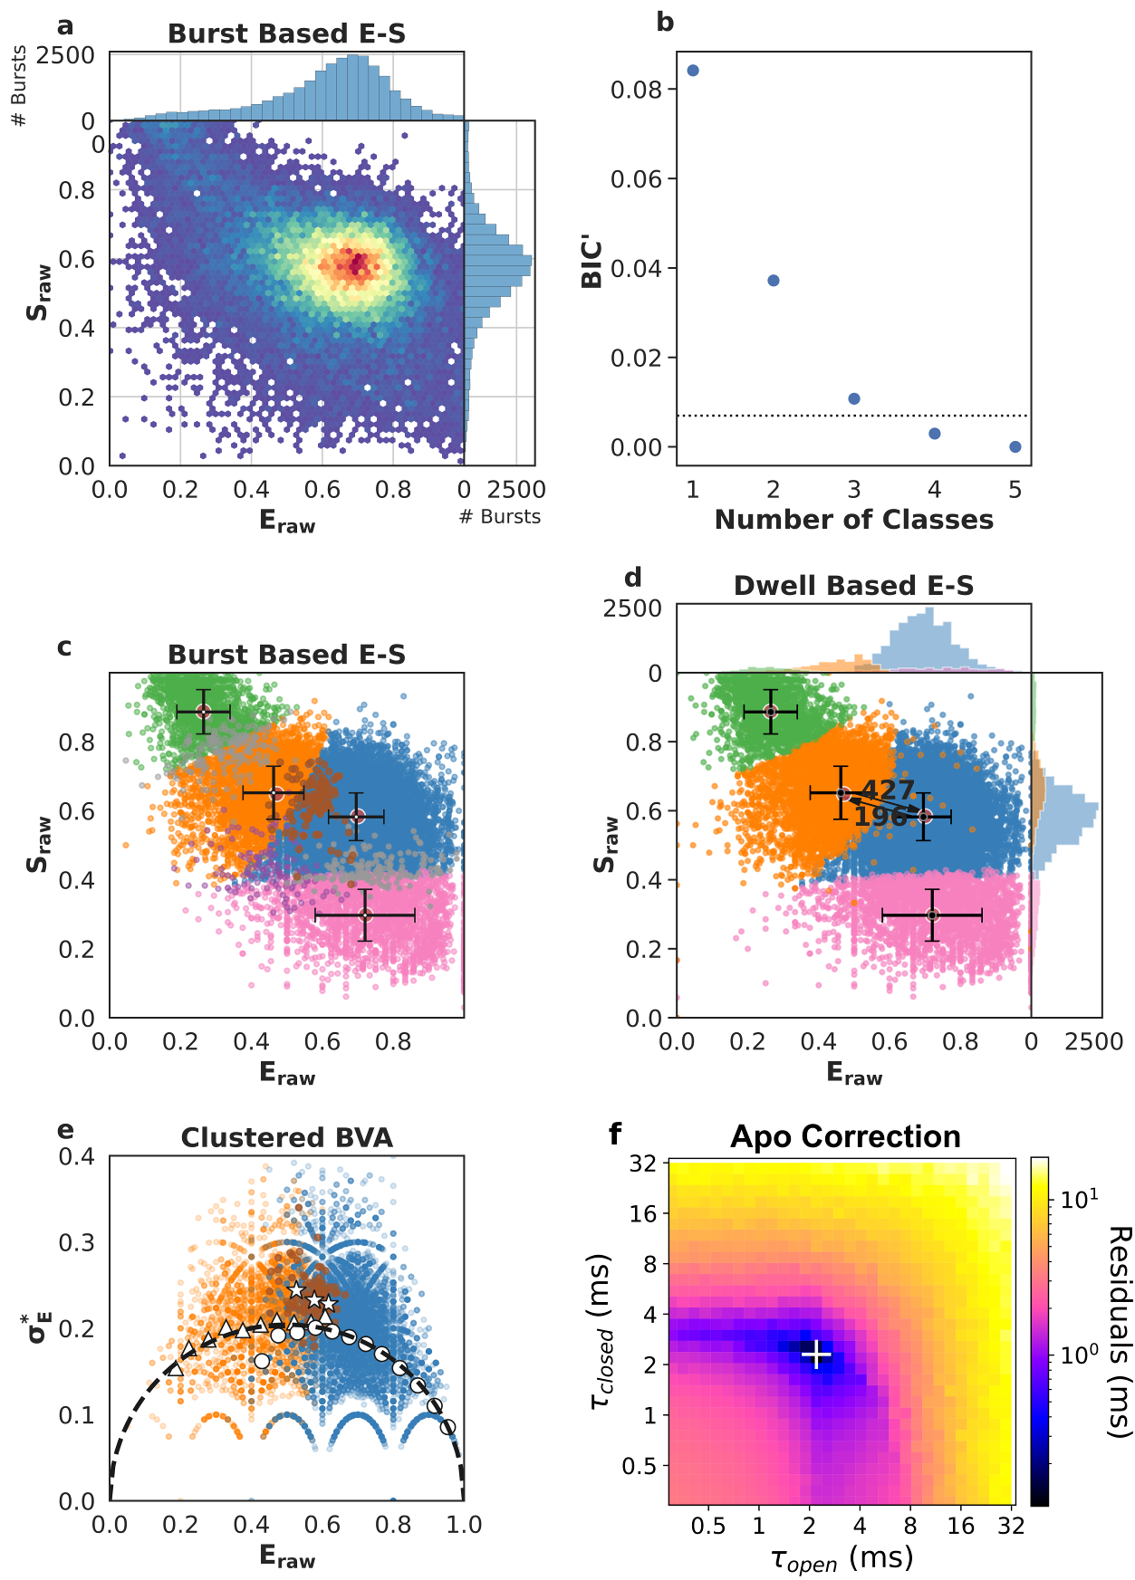

Appendix Figure S6 - Single-molecule data for one of five repeats of SecYEG + signal sequence (SecYEG+SS).
First column of data in Appendix Tables S1 and S2.
a Burst data plotting FRET efficiency (E_{raw}) against stoichiometry (S_{raw}).
b Modified Bayes Information Criterion (BIC’) of different state-models indicated that four classes best describe the data (most likely state model BIC’<0.005).
c Using a burst based E_{raw} S_{raw} plot we interpreted the classes as the open state (orange, low E_{raw}), closed state (blue, high E_{raw}), dark acceptor (green, high S_{raw}), dark donor (pink, low S_{raw}), in this step, we also identified bursts representing transitions between conformational states (brown), transitions and photophysics (purple) and pure photophysics (grey).
d Dwell based E_{raw} S_{raw} plot showing the rate of interconversion (s⁻¹) between the open and closed states.
e Burst Variance Analysis (BVA) provided a qualitative confirmation of dynamic exchange between states and transition detection within bursts. Binned values representing bursts assigned to either the open (triangles) or the closed (circles) state, respectively, coincide with the static line (black), exhibiting no exchange on a millisecond time scale. On the other hand, bursts which mpH₂MM identified to capture dynamic interconversion (stars) were indeed found well above the static line, implying dynamics.
f apo correction of extracted rates. The apo contribution is corrected for by finding the minimum difference between measured rates (panel d) and the numerical mixing of apo values with a range of opening and closing rates. The white '+' marks the recovered dwell times, i.e. the position of the lowest residuals.
Data information: Crosses in panel c and d identify the average E_{raw} and S_{raw} position for each state and the standard deviations.
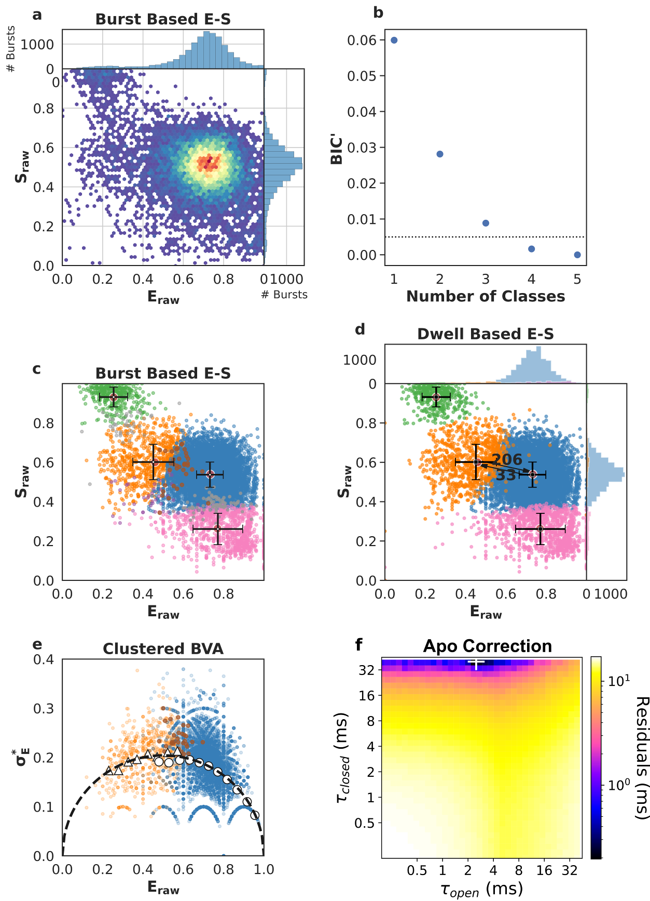

Appendix Figure S7 - Single-molecule data for one of five repeats of SecYEG + SecA (SecYEG:A).
First column of data in Appendix Tables S1 and S2.
a Burst data plotting FRET efficiency (E_{raw}) against stoichiometry (S_{raw}).
b Modified Bayes Information Criterion (BIC’) of different state-models indicated that four classes best describe the data (most likely state model BIC’<0.005).
c Using a burst based E_{raw} S_{raw} plot we interpreted the classes as the open state (orange, low E_{raw}), closed state (blue, high E_{raw}), dark acceptor (green, high S_{raw}), dark donor (pink, low S_{raw}), in this step, we also identified bursts representing transitions between conformational states (brown), transitions and photophysics (purple) and pure photophysics (grey).
d Dwell based E_{raw} S_{raw} plot showing the rate of interconversion (s⁻¹) between the open and closed states.
e Burst Variance Analysis (BVA) provided a qualitative confirmation of dynamic exchange between states and transition detection within bursts. Binned values representing bursts assigned to either the open (triangles) or the closed (circles) state, respectively, coincide with the static line (black), exhibiting no exchange on a millisecond time scale. On the other hand, bursts which mpH₂MM identified to capture dynamic interconversion (stars) were indeed found well above the static line, implying dynamics.
f apo correction of extracted rates. The apo contribution is corrected for by finding the minimum difference between measured rates (panel d) and the numerical mixing of apo values with a range of opening and closing rates. The white '+' marks the recovered dwell times, i.e. the position of the lowest residuals.
Data information: Crosses in panel c and d identify the average E_{raw} and S_{raw} position for each state and the standard deviations.
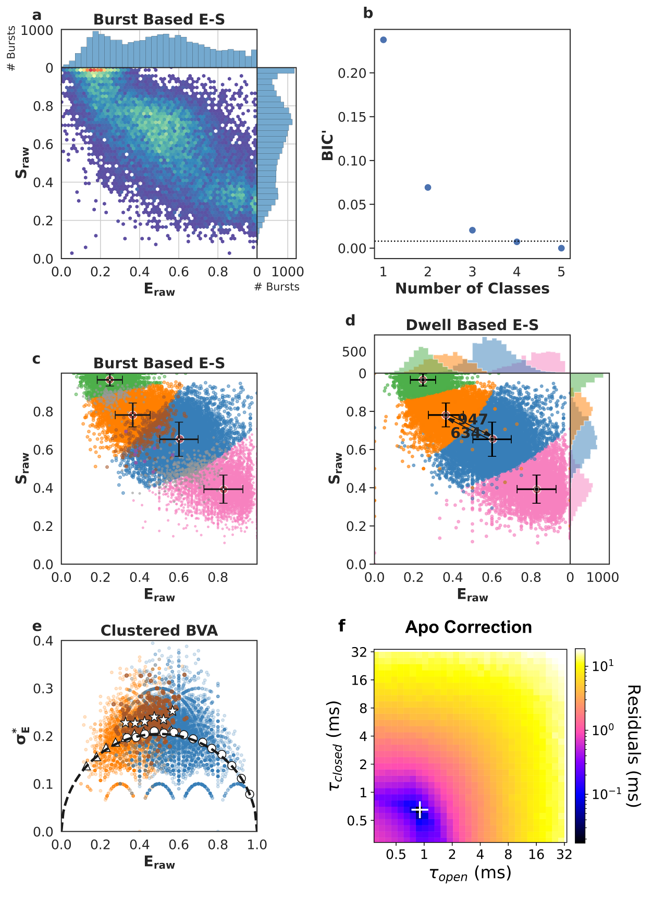

Appendix Figure S8 - Single-molecule data for one of five repeats of SecYEG + SecA + ATPγS (SecYEG:A:ATPγS).
First column of data in Appendix Tables S1 and S2.
a Burst data plotting FRET efficiency (E_{raw}) against stoichiometry (S_{raw}).
b Modified Bayes Information Criterion (BIC’) of different state-models indicated that four classes best describe the data (most likely state model BIC’<0.005).
c Using a burst based E_{raw} S_{raw} plot we interpreted the classes as the open state (orange, low E_{raw}), closed state (blue, high E_{raw}), dark acceptor (green, high S_{raw}), dark donor (pink, low S_{raw}), in this step, we also identified bursts representing transitions between conformational states (brown), transitions and photophysics (purple) and pure photophysics (grey).
d Dwell based E_{raw} S_{raw} plot showing the rate of interconversion (s⁻¹) between the open and closed states.
e Burst Variance Analysis (BVA) provided a qualitative confirmation of dynamic exchange between states and transition detection within bursts. Binned values representing bursts assigned to either the open (triangles) or the closed (circles) state, respectively, coincide with the static line (black), exhibiting no exchange on a millisecond time scale. On the other hand, bursts which mpH₂MM identified to capture dynamic interconversion (stars) were indeed found well above the static line, implying dynamics.
f apo correction of extracted rates. The apo contribution is corrected for by finding the minimum difference between measured rates (panel d) and the numerical mixing of apo values with a range of opening and closing rates. The white '+' marks the recovered dwell times, i.e. the position of the lowest residuals.
Data information: Crosses in panel c and d identify the average E_{raw} and S_{raw} position for each state and the standard deviations.

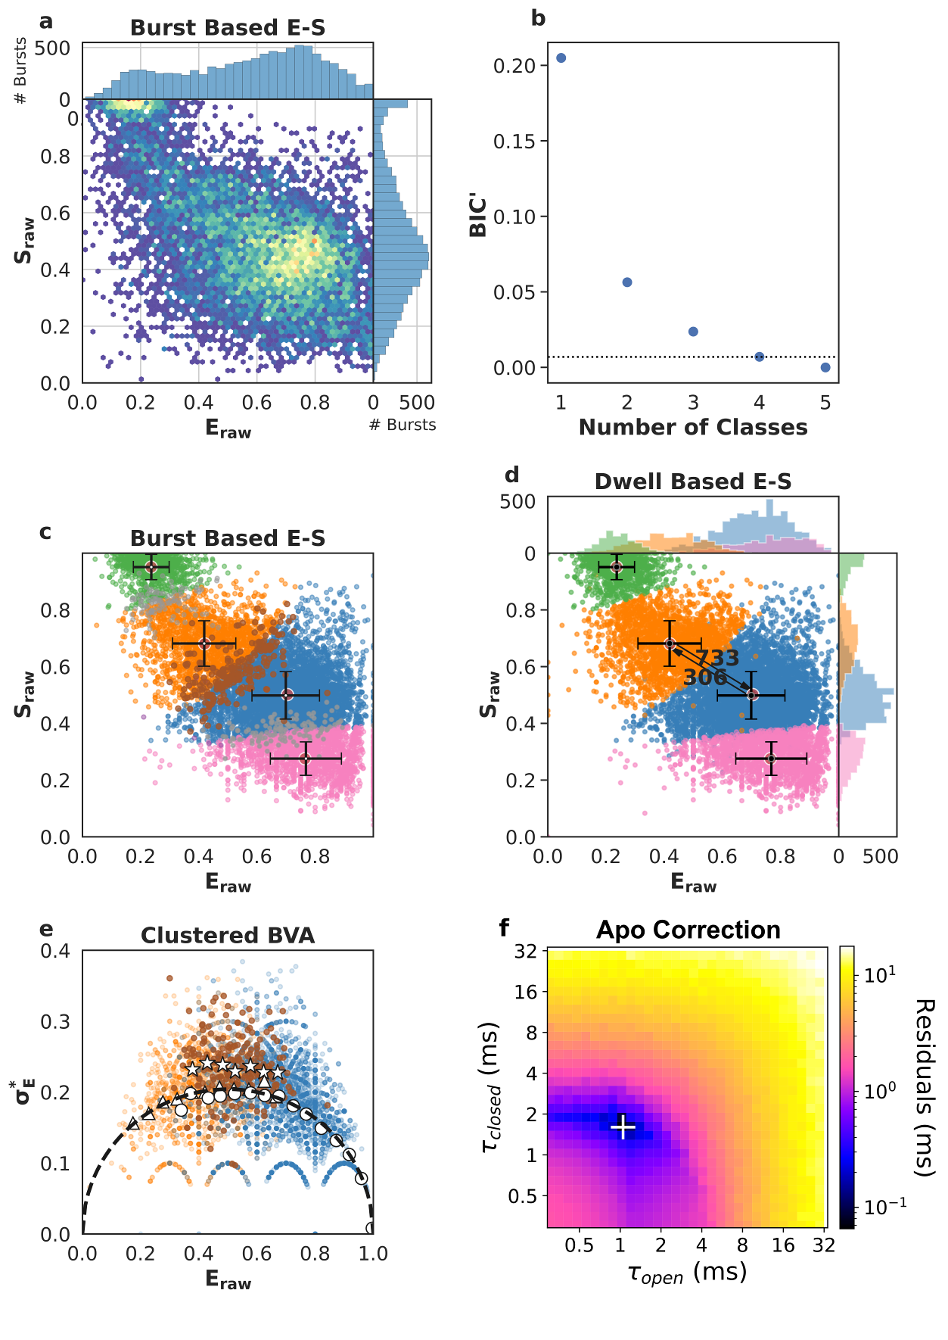

Appendix Figure S9 - Single-molecule data for one of five repeats of SecYEG + SecA + ADP·AlF_{x} (SecYEG:A:ADP·AlF_{x}).
First column of data in Appendix Tables S1 and S2.
a Burst data plotting FRET efficiency (E_{raw}) against stoichiometry (S_{raw}).
b Modified Bayes Information Criterion (BIC’) of different state-models indicated that four classes best describe the data (most likely state model BIC’<0.005).
c Using a burst based E_{raw} S_{raw} plot we interpreted the classes as the open state (orange, low E_{raw}), closed state (blue, high E_{raw}), dark acceptor (green, high S_{raw}), dark donor (pink, low S_{raw}), in this step, we also identified bursts representing transitions between conformational states (brown), transitions and photophysics (purple) and pure photophysics (grey).
d Dwell based E_{raw} S_{raw} plot showing the rate of interconversion (s⁻¹) between the open and closed states.
e Burst Variance Analysis (BVA) provided a qualitative confirmation of dynamic exchange between states and transition detection within bursts. Binned values representing bursts assigned to either the open (triangles) or the closed (circles) state, respectively, coincide with the static line (black), exhibiting no exchange on a millisecond time scale. On the other hand, bursts which mpH₂MM identified to capture dynamic interconversion (stars) were indeed found well above the static line, implying dynamics.
f apo correction of extracted rates. The apo contribution is corrected for by finding the minimum difference between measured rates (panel d) and the numerical mixing of apo values with a range of opening and closing rates. The white '+' marks the recovered dwell times, i.e. the position of the lowest residuals.
Data information: Crosses in panel c and d identify the average E_{raw} and S_{raw} position for each state and the standard deviations.
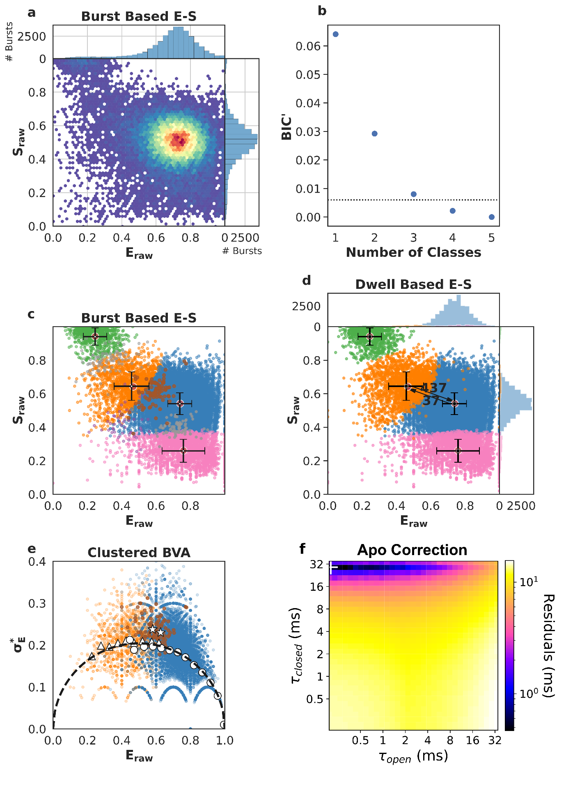

Appendix Figure S10 - Single-molecule data for one of five repeats of SecYEG + SecA + ADP (SecYEG:A:ADP).
First column of data in Appendix Tables S1 and S2.
a Burst data plotting FRET efficiency (E_{raw}) against stoichiometry (S_{raw}).
b Modified Bayes Information Criterion (BIC’) of different state-models indicated that four classes best describe the data (most likely state model BIC’<0.005).
c Using a burst based E_{raw} S_{raw} plot we interpreted the classes as the open state (orange, low E_{raw}), closed state (blue, high E_{raw}), dark acceptor (green, high S_{raw}), dark donor (pink, low S_{raw}), in this step, we also identified bursts representing transitions between conformational states (brown), transitions and photophysics (purple) and pure photophysics (grey).
d Dwell based E_{raw} S_{raw} plot showing the rate of interconversion (s⁻¹) between the open and closed states.
e Burst Variance Analysis (BVA) provided a qualitative confirmation of dynamic exchange between states and transition detection within bursts. Binned values representing bursts assigned to either the open (triangles) or the closed (circles) state, respectively, coincide with the static line (black), exhibiting no exchange on a millisecond time scale. On the other hand, bursts which mpH₂MM identified to capture dynamic interconversion (stars) were indeed found well above the static line, implying dynamics.
f apo correction of extracted rates. The apo contribution is corrected for by finding the minimum difference between measured rates (panel d) and the numerical mixing of apo values with a range of opening and closing rates. The white '+' marks the recovered dwell times, i.e. the position of the lowest residuals.
Data information: Crosses in panel c and d identify the average E_{raw} and S_{raw} position for each state and the standard deviations.
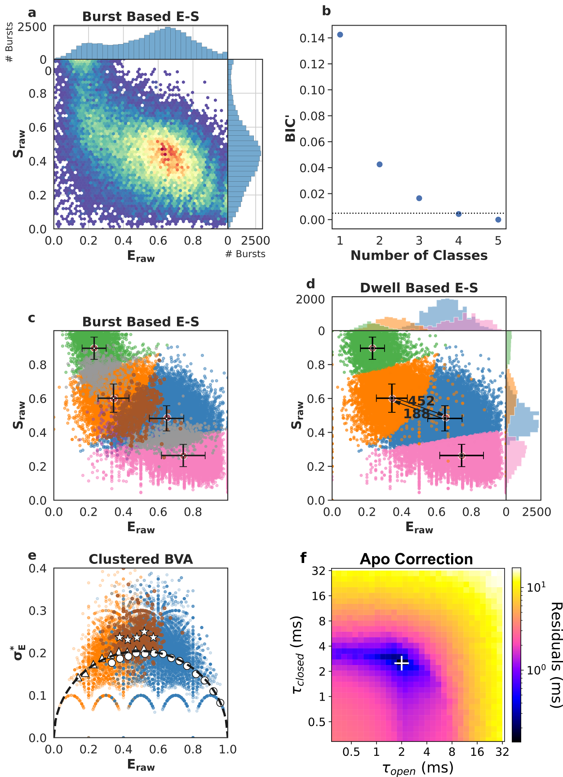

Appendix Figure S11 - Single-molecule data for one of five repeats of SecYEG + SecA + ATP (SecYEG:A:ATP).
First column of data in Appendix Tables S1 and S2.
a Burst data plotting FRET efficiency (E_{raw}) against stoichiometry (S_{raw}).
b Modified Bayes Information Criterion (BIC’) of different state-models indicated that four classes best describe the data (most likely state model BIC’<0.005).
c Using a burst based E_{raw} S_{raw} plot we interpreted the classes as the open state (orange, low E_{raw}), closed state (blue, high E_{raw}), dark acceptor (green, high S_{raw}), dark donor (pink, low S_{raw}), in this step, we also identified bursts representing transitions between conformational states (brown), transitions and photophysics (purple) and pure photophysics (grey).
d Dwell based E_{raw} S_{raw} plot showing the rate of interconversion (s⁻¹) between the open and closed states.
e Burst Variance Analysis (BVA) provided a qualitative confirmation of dynamic exchange between states and transition detection within bursts. Binned values representing bursts assigned to either the open (triangles) or the closed (circles) state, respectively, coincide with the static line (black), exhibiting no exchange on a millisecond time scale. On the other hand, bursts which mpH₂MM identified to capture dynamic interconversion (stars) were indeed found well above the static line, implying dynamics.
f apo correction of extracted rates. The apo contribution is corrected for by finding the minimum difference between measured rates (panel d) and the numerical mixing of apo values with a range of opening and closing rates. The white '+' marks the recovered dwell times, i.e. the position of the lowest residuals.
Data information: Crosses in panel c and d identify the average E_{raw} and S_{raw} position for each state and the standard deviations.
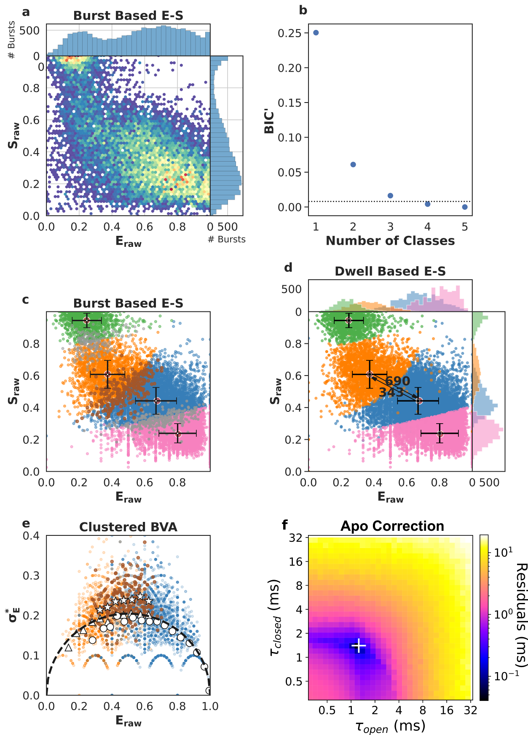

Appendix Figure S12 - Single-molecule data for one of five repeats of SecYEG + SecA + ATP + proSpy (SecYEG:A:proSpy:ATP).
First column of data in Appendix Tables S1 and S2.
a Burst data plotting FRET efficiency (E_{raw}) against stoichiometry (S_{raw}).
b Modified Bayes Information Criterion (BIC’) of different state-models indicated that four classes best describe the data (most likely state model BIC’<0.005).
c Using a burst based E_{raw} S_{raw} plot we interpreted the classes as the open state (orange, low E_{raw}), closed state (blue, high E_{raw}), dark acceptor (green, high S_{raw}), dark donor (pink, low S_{raw}), in this step, we also identified bursts representing transitions between conformational states (brown), transitions and photophysics (purple) and pure photophysics (grey).
d Dwell based E_{raw} S_{raw} plot showing the rate of interconversion (s⁻¹) between the open and closed states.
e Burst Variance Analysis (BVA) provided a qualitative confirmation of dynamic exchange between states and transition detection within bursts. Binned values representing bursts assigned to either the open (triangles) or the closed (circles) state, respectively, coincide with the static line (black), exhibiting no exchange on a millisecond time scale. On the other hand, bursts which mpH₂MM identified to capture dynamic interconversion (stars) were indeed found well above the static line, implying dynamics.
f apo correction of extracted rates. The apo contribution is corrected for by finding the minimum difference between measured rates (panel d) and the numerical mixing of apo values with a range of opening and closing rates. The white '+' marks the recovered dwell times, i.e. the position of the lowest residuals.
Data information: Crosses in panel c and d identify the average E_{raw} and S_{raw} position for each state and the standard deviations.
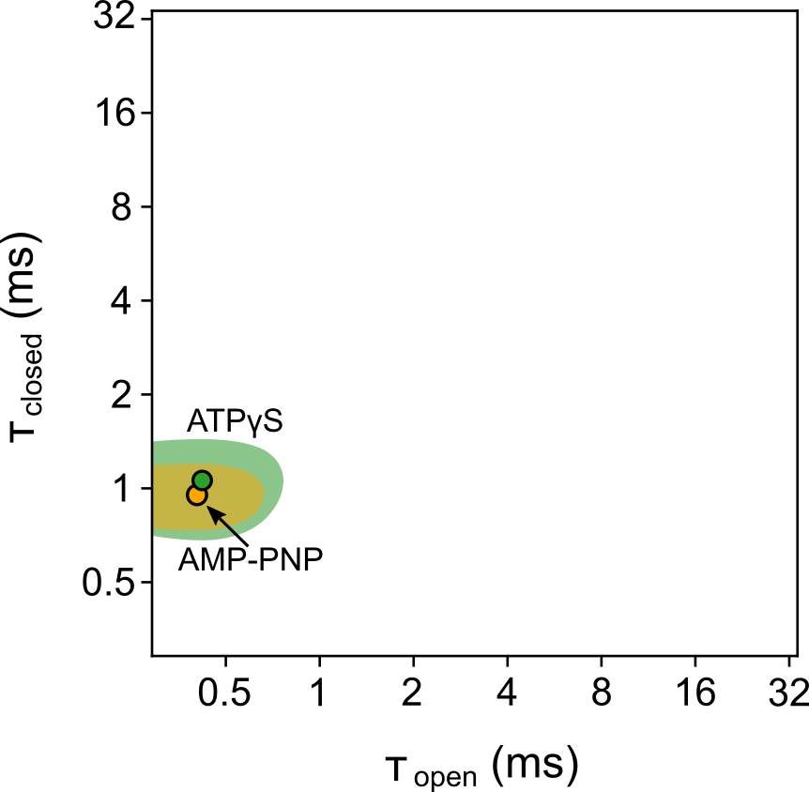

Appendix Figure S13 – SecYEG channel dwell time plot for SecYEG:A:ATPγS vs. SecYEG:A:AMP-PNP.
SecYEG channel dwell times in the open (𝜏_{open}) and closed (𝜏_{closed}) states for SecYEG:A with the addition of ATPγS (green) or AMP-PNP (orange). The 90% confidence areas are shaded with the average dwell times shown as points with black outline.
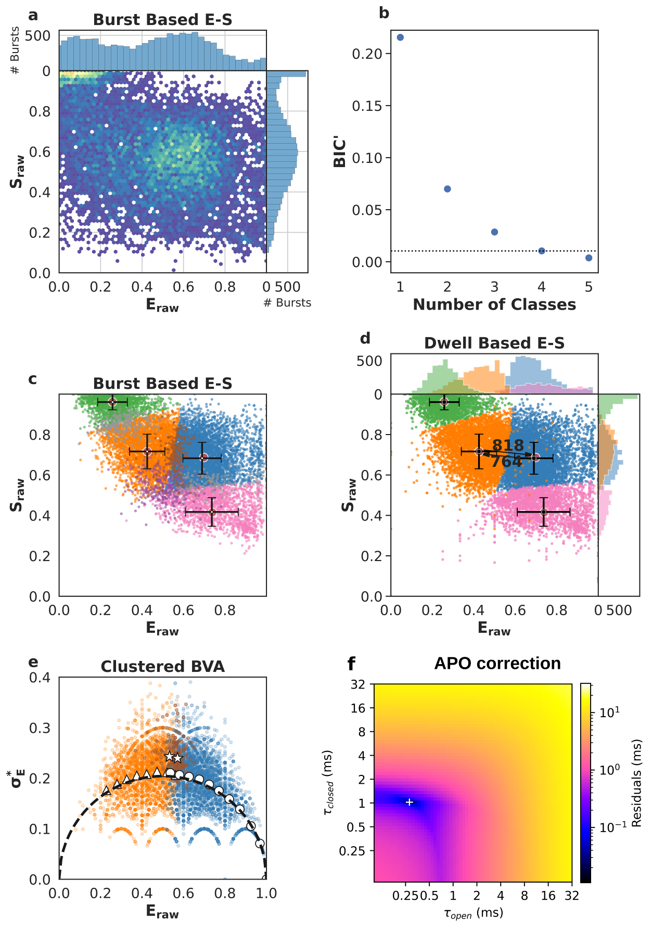

Appendix Figure S14 - Single-molecule data for one of five repeats of SecYEG + SecA + AMP-PNP (SecYEG:A:AMP-PNP).
First column of data in Appendix Table S1.
a Burst data plotting FRET efficiency (E_{raw}) against stoichiometry (S_{raw}).
b Modified Bayes Information Criterion (BIC’) of different state-models indicated that four classes best describe the data (most likely state model BIC’<0.005).
c Using a burst based E_{raw} S_{raw} plot we interpreted the classes as the open state (orange, low E_{raw}), closed state (blue, high E_{raw}), dark acceptor (green, high S_{raw}), dark donor (pink, low S_{raw}), in this step, we also identified bursts representing transitions between conformational states (brown), transitions and photophysics (purple) and pure photophysics (grey).
d Dwell based E_{raw} S_{raw} plot showing the rate of interconversion (s⁻¹) between the open and closed states.
e Burst Variance Analysis (BVA) provided a qualitative confirmation of dynamic exchange between states and transition detection within bursts. Binned values representing bursts assigned to either the open (triangles) or the closed (circles) state, respectively, coincide with the static line (black), exhibiting no exchange on a millisecond time scale. On the other hand, bursts which mpH₂MM identified to capture dynamic interconversion (stars) were indeed found well above the static line, implying dynamics.
f Apo correction of extracted rates. The apo contribution is corrected for by finding the minimum difference between measured rates (panel d) and the numerical mixing of apo values with a range of opening and closing rates. The white '+' marks the recovered dwell times, i.e. the position of the lowest residuals.
Data information: Crosses in panel c and d identify the average E_{raw} and S_{raw} position for each state and the standard deviations.
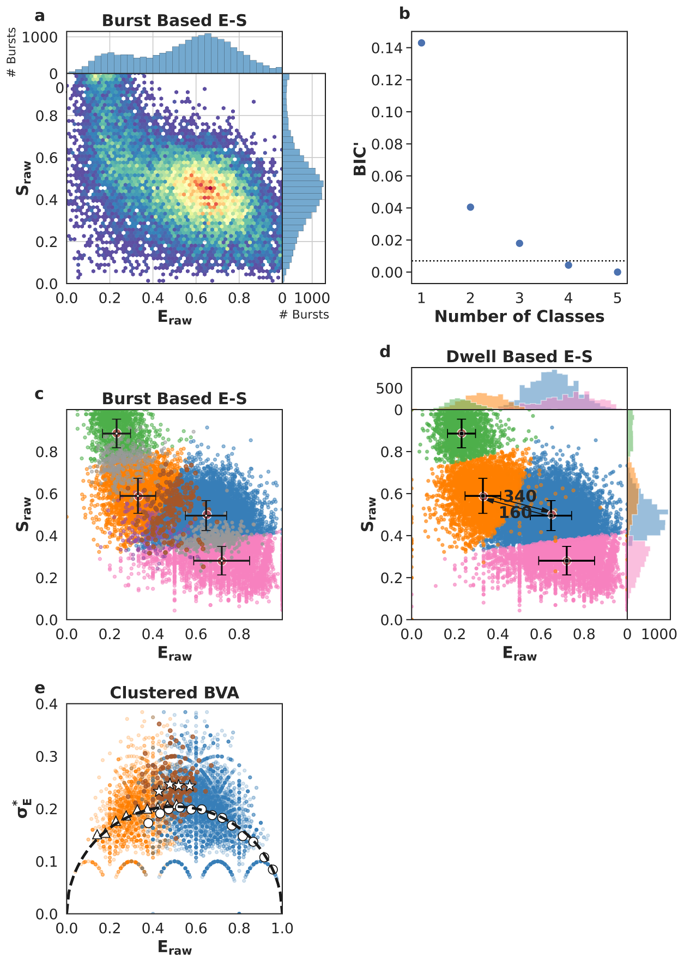

Appendix Figure S15 - Single-molecule data for one of five repeats of SecYEG-PrlA4 apo.
First column of data in Appendix Tables S6 and S7.
a Burst data plotting FRET efficiency (E_{raw}) against stoichiometry (S_{raw}).
b Modified Bayes Information Criterion (BIC’) of different state-models indicated that four classes best describe the data (most likely state model BIC’<0.005).
c Using a burst based E_{raw} S_{raw} plot we interpreted the classes as the open state (orange, low E_{raw}), closed state (blue, high E_{raw}), dark acceptor (green, high S_{raw}), dark donor (pink, low S_{raw}), in this step, we also identified bursts representing transitions between conformational states (brown), transitions and photophysics (purple) and pure photophysics (grey).
d Dwell based E_{raw} S_{raw} plot showing the rate of interconversion (s⁻¹) between the open and closed states.
e Burst Variance Analysis (BVA) provided a qualitative confirmation of dynamic exchange between states and transition detection within bursts. Binned values representing bursts assigned to either the open (triangles) or the closed (circles) state, respectively, coincide with the static line (black), exhibiting no exchange on a millisecond time scale. On the other hand, bursts which mpH₂MM identified to capture dynamic interconversion (stars) were indeed found well above the static line, implying dynamics.
Data information: Crosses in panel c and d identify the average E_{raw} and S_{raw} position for each state and the standard deviations.
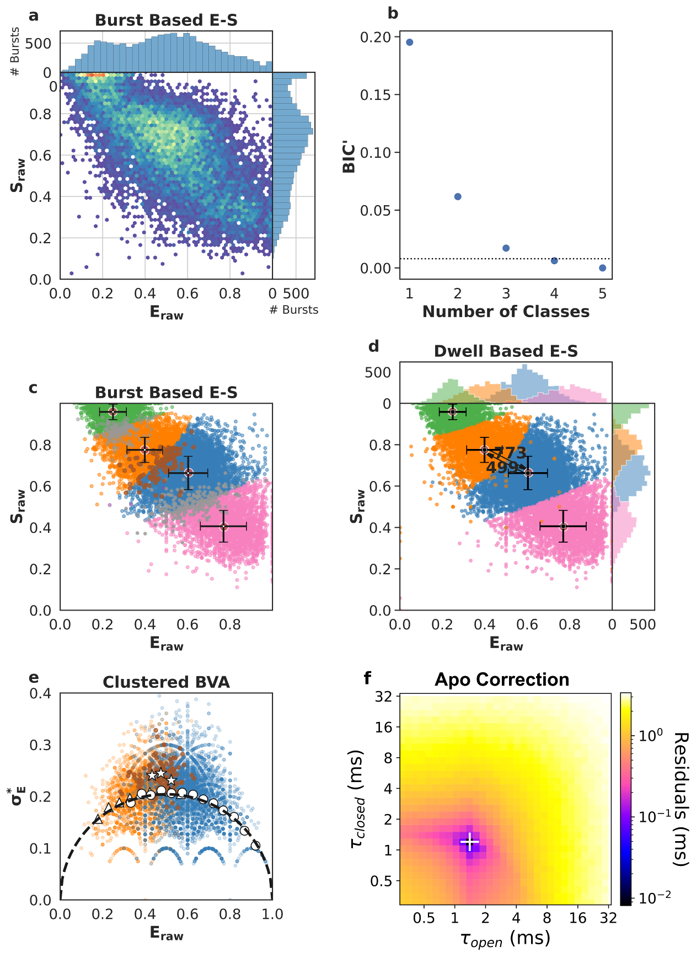

Appendix Figure S16 - Single-molecule data for one of five repeats of SecYEG-PrlA4 + signal sequence (SecYEG-PrlA4:SS).
First column of data in Appendix Tables S6 and S7.
a Burst data plotting FRET efficiency (E_{raw}) against stoichiometry (S_{raw}).
b Modified Bayes Information Criterion (BIC’) of different state-models indicated that four classes best describe the data (most likely state model BIC’<0.005).
c Using a burst based E_{raw} S_{raw} plot we interpreted the classes as the open state (orange, low E_{raw}), closed state (blue, high E_{raw}), dark acceptor (green, high S_{raw}), dark donor (pink, low S_{raw}), in this step, we also identified bursts representing transitions between conformational states (brown), transitions and photophysics (purple) and pure photophysics (grey).
d Dwell based E_{raw} S_{raw} plot showing the rate of interconversion (s⁻¹) between the open and closed states.
e Burst Variance Analysis (BVA) provided a qualitative confirmation of dynamic exchange between states and transition detection within bursts. Binned values representing bursts assigned to either the open (triangles) or the closed (circles) state, respectively, coincide with the static line (black), exhibiting no exchange on a millisecond time scale. On the other hand, bursts which mpH₂MM identified to capture dynamic interconversion (stars) were indeed found well above the static line, implying dynamics.
f Apo correction of extracted rates. The apo contribution is corrected for by finding the minimum difference between measured rates (panel d) and the numerical mixing of apo values with a range of opening and closing rates. The white '+' marks the recovered dwell times, i.e. the position of the lowest residuals.
Data information: Crosses in panel c and d identify the average E_{raw} and S_{raw} position for each state and the standard deviations.
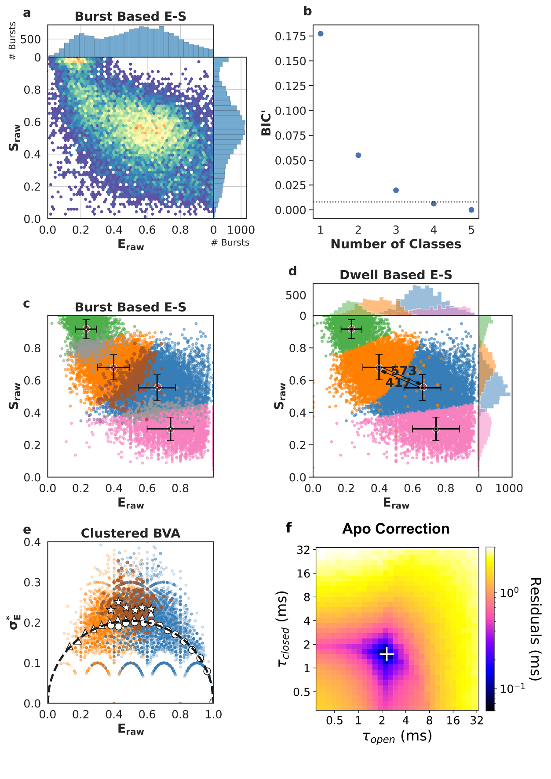

Appendix Figure S17 - Single-molecule data for one of five repeats of SecYEG-PrlA4 + SecA (SecYEG-PrlA4:A).
First column of data in Appendix Tables S6 and S7.
a Burst data plotting FRET efficiency (E_{raw}) against stoichiometry (S_{raw}).
b Modified Bayes Information Criterion (BIC’) of different state-models indicated that four classes best describe the data (most likely state model BIC’<0.005).
c Using a burst based E_{raw} S_{raw} plot we interpreted the classes as the open state (orange, low E_{raw}), closed state (blue, high E_{raw}), dark acceptor (green, high S_{raw}), dark donor (pink, low S_{raw}), in this step, we also identified bursts representing transitions between conformational states (brown), transitions and photophysics (purple) and pure photophysics (grey).
d Dwell based E_{raw} S_{raw} plot showing the rate of interconversion (s⁻¹) between the open and closed states.
e Burst Variance Analysis (BVA) provided a qualitative confirmation of dynamic exchange between states and transition detection within bursts. Binned values representing bursts assigned to either the open (triangles) or the closed (circles) state, respectively, coincide with the static line (black), exhibiting no exchange on a millisecond time scale. On the other hand, bursts which mpH₂MM identified to capture dynamic interconversion (stars) were indeed found well above the static line, implying dynamics.
f Apo correction of extracted rates. The apo contribution is corrected for by finding the minimum difference between measured rates (panel d) and the numerical mixing of apo values with a range of opening and closing rates. The white '+' marks the recovered dwell times, i.e. the position of the lowest residuals.
Data information: Crosses in panel c and d identify the average E_{raw} and S_{raw} position for each state and the standard deviations.
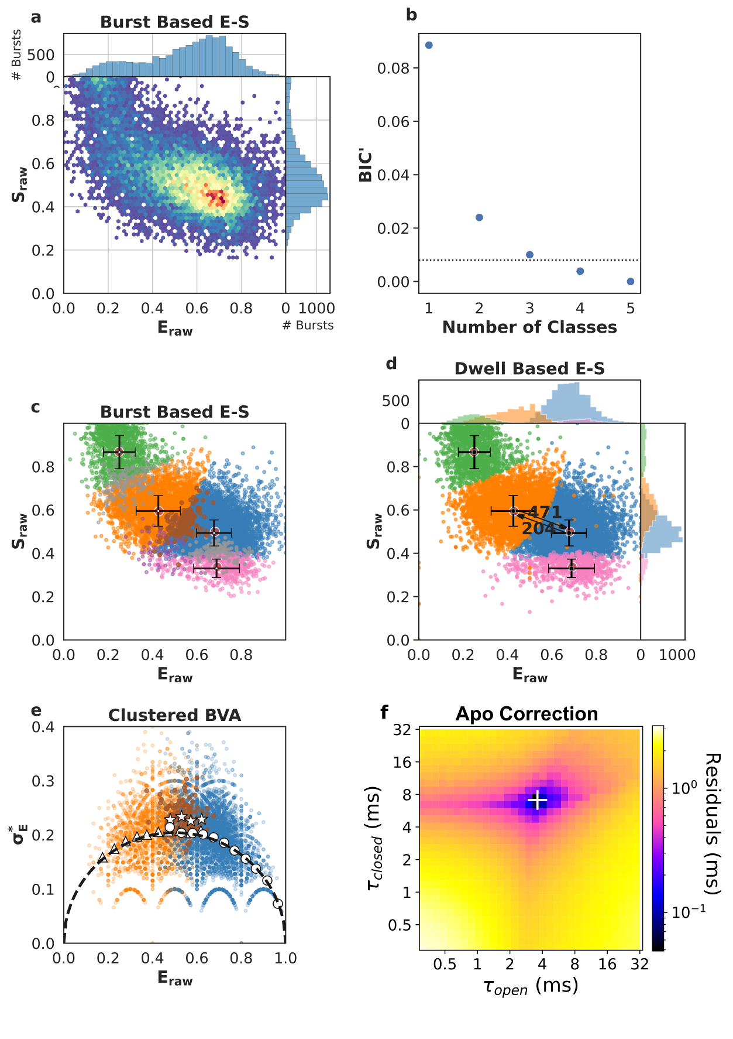

Appendix Figure S18 - Single-molecule data for one of five repeats of SecYEG-PrlA4 + proSpy + ATP (SecYEG-PrlA4:A:ATP+proSpy).
First column of data in Appendix Tables S6 and S7.
a Burst data plotting FRET efficiency (E_{raw}) against stoichiometry (S_{raw}).
b Modified Bayes Information Criterion (BIC’) of different state-models indicated that four classes best describe the data (most likely state model BIC’<0.005).
c Using a burst based E_{raw} S_{raw} plot we interpreted the classes as the open state (orange, low E_{raw}), closed state (blue, high E_{raw}), dark acceptor (green, high S_{raw}), dark donor (pink, low S_{raw}), in this step, we also identified bursts representing transitions between conformational states (brown), transitions and photophysics (purple) and pure photophysics (grey).
d Dwell based E_{raw} S_{raw} plot showing the rate of interconversion (s⁻¹) between the open and closed states.
e Burst Variance Analysis (BVA) provided a qualitative confirmation of dynamic exchange between states and transition detection within bursts. Binned values representing bursts assigned to either the open (triangles) or the closed (circles) state, respectively, coincide with the static line (black), exhibiting no exchange on a millisecond time scale. On the other hand, bursts which mpH₂MM identified to capture dynamic interconversion (stars) were indeed found well above the static line, implying dynamics.
f Apo correction of extracted rates. The apo contribution is corrected for by finding the minimum difference between measured rates (panel d) and the numerical mixing of apo values with a range of opening and closing rates. The white '+' marks the recovered dwell times, i.e. the position of the lowest residuals.
Data information: Crosses in panel c and d identify the average E_{raw} and S_{raw} position for each state and the standard deviations.
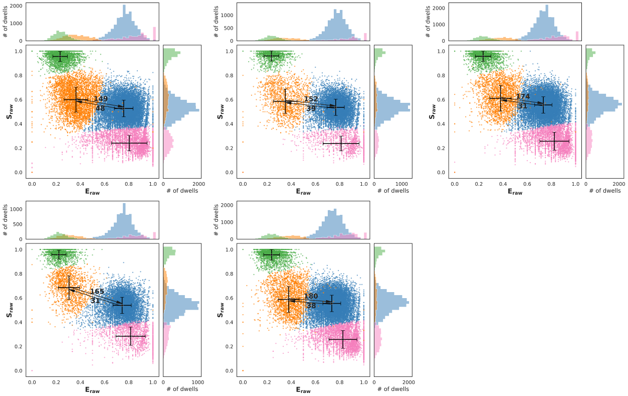

Appendix Figure S19 - Five technical repeats show the variability of SecYEG channel opening and closure rates (s⁻¹) for wild-type SecYEG apo.
The data for the SecYEG complex are obtained from a single protein purification, but proteoliposomes were prepared fresh before each measurement.
Data information: Crosses in each panel identify the average E_{raw} and S_{raw} position for each state and the standard deviations.

Appendix Tables
Condition | FRET State | Dwell Time (ms) |  |  |  |  | Mean Dwell Time (ms)  ± 90%CI
SecYEG  (apo) | Open | 6.7 | 6.6 | 5.7 | 6.1 | 5.6 | 6.1 ± 0.5
SecYEG  (apo) | Closed | 20.8 | 25.6 | 32.3 | 32.3 | 26.3 | 27.5 ± 4.6
SecYEG+SS  (SS) | Open | 2.1 | 6.5 | 3.9 | 10.2 | 4.4 | 5.4 ± 2.9
SecYEG+SS  (SS) | Closed | 2.2 | 1.1 | 1.6 | 1.0 | 0.6 | 1.3 ± 0.6
SecYEG:A  (SecA) | Open | 2.5 | 1.9 | 4.2 | 1.3 | 2.6 | 2.5 ± 1.0
SecYEG:A  (SecA) | Closed | 40.0 | 32.1 | 19.5 | 34.5 | 15.3 | 28.3 ± 10
SecYEG:A:ATPγS  (ATPγS) | Open | 0.9 | 0.3 | 0.4 | 0.3 | 0.2 | 0.4 ± 0.3
SecYEG:A:ATPγS  (ATPγS) | Closed | 0.7 | 1.0 | 0.9 | 1.2 | 1.5 | 1.1 ± 0.3
SecYEG:A:AMP-PNP  (AMP-PNP) | Open | 0.5 | 0.3 | 0.1 | 0.4 | 0.6 | 0.4 ± 0.2
SecYEG:A:AMP-PNP  (AMP-PNP) | Closed | 0.9 | 1.0 | 0.9 | 1.2 | 0.9 | 1.0 ± 0.2
SecYEG:A:ADP·AlFx  (ADP·AlFx) | Open | 1.0 | 3.7 | 4.5 | 4.3 | 4.0 | 3.5 ± 1.3
SecYEG:A:ADP·AlFx  (ADP·AlFx) | Closed | 1.6 | 2.0 | 1.9 | 2.1 | 1.9 | 1.9 ± 0.2
SecYEG:A:ADP  (ADP) | Open | 0.2 | 0.6 | 1.0 | 0.4 | 0.5 | 0.5 ± 0.3
SecYEG:A:ADP  (ADP) | Closed | 29.0 | 20.0 | 10.0 | 8.3 | 5.0 | 14.5 ± 9.4
SecYEG:A:ATP  (ATP) | Open | 2.0 | 2.3 | 1.3 | 3.9 | 4.5 | 2.8 ± 1.3
SecYEG:A:ATP  (ATP) | Closed | 2.5 | 2.2 | 3.0 | 2.0 | 2.4 | 2.4 ± 0.4
SecYEG:A:ATP+proSpy  (ATP+proSpy) | Open | 1.2 | 1.1 | 1.2 | 2.5 | 1.1 | 1.4 ± 0.6
SecYEG:A:ATP+proSpy  (ATP+proSpy) | Closed | 1.2 | 1.1 | 1.2 | 2.5 | 1.1 | 1.4 ± 0.5

Appendix Table S1 – SecYEG wild-type corrected dwell times in each FRET state.
Open = low FRET, closed = high FRET.
Data information: Each experimental condition was repeated five times with fresh proteoliposomes. Error is given as the 90% confidence interval (± 90%CI).

Condition | Percent Open |  |  |  |  | Mean Percent Open ± 90%CI
SecYEG  (apo) | 24 | 20 | 15 | 16 | 17 | 19 ± 4
SecYEG+SS  (SS) | 49 | 86 | 71 | 91 | 88 | 77 ± 17
SecYEG:A  (SecA) | 6 | 6 | 18 | 4 | 15 | 9 ± 6
SecYEG:A:ATPγS  (ATPγS) | 56 | 23 | 31 | 20 | 12 | 29 ± 16
SecYEG:A:ADP·AlFx  (ADP·AlFx) | 40 | 65 | 70 | 67 | 68 | 62 ± 12
SecYEG:A:ADP  (ADP) | 1 | 3 | 9 | 5 | 9 | 5 ± 4
SecYEG:A:ATP  (ATP) | 44 | 51 | 30 | 66 | 65 | 51 ± 14
SecYEG:A:ATP+proSpy  (ATP+proSpy) | 47 | 46 | 44 | 64 | 37 | 48 ± 9

Appendix Table S2 – SecYEG wild-type percent open.
Data information: Percent open calculated with (𝜏_{open}/(𝜏_{open}+𝜏_{closed})x100 (data from Appendix Table S1). Each experimental condition was repeated five times with fresh proteoliposomes. Error is given as the 90% confidence interval (± 90%CI).

SecYEG | proSpy | SecA ATPase Rate  (k_{cat}) (s⁻¹) |  |  |  | Mean SecA ATPase Rate (k_{cat}) (s⁻¹) ± 95%CI
Wild-type | + | 6.12 | 6.46 | 7.22 | 6.27 | 6.52 ± 0.42
Wild-type | - | 0.20 | 0.12 | 0.12 | 0.15 | 0.15 ± 0.02
PrlA4 | + | 6.46 | 7.61 | 7.26 | 6.86 | 7.05 ± 0.43
PrlA4 | - | 0.19 | 0.20 | 0.15 | 0.17 | 0.18 ± 0.01

Appendix Table S3 – The SecA ATPase rate ± proSpy in the presence of SecYEG proteoliposomes (wild-type and prlA4) and ATP.
Data information: Each condition was performed with 4 technical repeats. Error is given as the 95% confidence interval (± 95%CI).

SecYEG | Pep86 Position | Amino Acids | Lag Time (s)
Wild-type | 1 | 146 | 41.2 | 41.4 | 42.3
Wild-type | 2 | 292 | 91.2 | 90.7 | 93.9
Wild-type | 3 | 438 | 131.8 | 131.6 | 137.4
Wild-type | 4 | 584 | 196.3 | 189.0 | 209.7
PrlA4 | 1 | 146 | 10.4 | 11.3 | 15.3
PrlA4 | 2 | 292 | 25.0 | 26.8 | 31.7
PrlA4 | 3 | 438 | 36.8 | 37.0 | 40.4
PrlA4 | 4 | 584 | 53.6 | 55.4 | 68.1

Appendix Table S4 – proSpy_{4x} transport assay lag times using the NanoLuc split-luciferase assay.
Data for wild-type and PrlA4 SecYEG (for further details on the NanoLuc split-luciferase assay see Appendix Materials and Methods).
Data information: Each condition was performed with 4 technical repeats.

SecYEG | Slope (± SE) | Intercept (± SE) | Coefficient of determination (R²) | Transport Rate (aa.s⁻¹) (± SE)
Wild-type | 0.35 ± 0.01 | -11.59 ± 5.28 | 0.99 | 2.85 ± 0.03
PrlA4 | 0.10 ± 0.01 | -3.30 ± 3.41 | 0.94 | 9.70 ± 0.02

Appendix Table S5 - Fitting statistics for Nanoluc assay lag times of proSpy_{4x.}
Linear least-squares regression fits in Fig 5a, data in Appendix Table S4 and the derived transport rates (1/Slope) for wild-type and PrlA4 SecYEG.
Data information: Error is given as standard error (± SE).

Condition | FRET State | Dwell Time (ms) |  |  |  |  | Mean Dwell Time (ms) ± 90%CI
SecYEG-PrlA4  (apo) | Open | 1.5 | 1.3 | 2.0 | 1.2 | 1.6 | 1.5 ± 0.3
SecYEG-PrlA4  (apo) | Closed | 4.2 | 3.6 | 7.5 | 2.4 | 4.9 | 4.5 ± 1.8
SecYEG-PrlA4+SS  (SS) | Open | 1.3 | 2.5 | 2.9 | 2.8 | 2.4 | 2.4 ± 0.6
SecYEG-PrlA4+SS  (SS) | Closed | 1.2 | 1.7 | 1.5 | 1.7 | 1.7 | 1.6 ± 0.2
SecYEG-PrlA4:A  (SecA) | Open | 2.3 | 3.0 | 2.8 | 3.3 | 2.4 | 2.8 ± 0.4
SecYEG-PrlA4:A  (SecA) | Closed | 1.5 | 1.4 | 1.7 | 1.5 | 1.4 | 1.5 ± 0.1
SecYEG-PrlA4:A:ATP+proSpy  (ATP+proSpy) | Open | 3.9 | 6.1 | 5.9 | 2.4 | 4.3 | 4.5 ± 1.5
SecYEG-PrlA4:A:ATP+proSpy  (ATP+proSpy) | Closed | 7.9 | 5.1 | 14.2 | 6.6 | 7.7 | 8.3 ± 3.3

Appendix Table S6 – SecYEG-PrlA4 corrected dwell times in each FRET state.
Open = low FRET, Closed = high FRET.
Data information: Each experimental condition was repeated five times with fresh proteoliposomes. Error is given as the 90% confidence interval (± 90%CI).

Condition | Percent Open |  |  |  |  | Percent Open ± 90%CI
SecYEG-PrlA4  (apo) | 26 | 26 | 21 | 34 | 25 | 26 ± 4
SecYEG-PrlA4+SS  (SS) | 52 | 60 | 66 | 62 | 59 | 60 ± 6
SecYEG-PrlA4:A  (SecA) | 61 | 68 | 62 | 69 | 63 | 65 ± 4
SecYEG-PrlA4:A:ATP+proSpy  (ATP+proSpy) | 33 | 54 | 29 | 27 | 36 | 36 ± 10

Appendix Table S7 – SecYEG-PrlA4 percent open.
Data information: Percent open calculated with (𝜏_{open}/(𝜏_{open}+𝜏_{closed})x100 (data from Appendix Table S6). Each experimental condition was repeated five times with freshly prepared proteoliposomes. Error is given as the 90% confidence interval (± 90%CI).

References
Allen WJ, Watkins DW, Dillingham MS & Collinson I (2020) Refined measurement of SecA-driven protein secretion reveals that translocation is indirectly coupled to ATP turnover. Proceedings of the National Academy of Sciences 117: 31808–31816
Al-Mohy AH & Higham NJ (2010) A New Scaling and Squaring Algorithm for the Matrix Exponential. SIAM J Matrix Anal Appl 31: 970–989
Deville K, Gold VAM, Robson A, Whitehouse S, Sessions RB, Baldwin SA, Radford SE & Collinson I (2011) The oligomeric state and arrangement of the active bacterial translocon. J Biol Chem 286: 4659–4669
Fessl T, Crossley JA, Watkins D, Scholz M, Watson MA, Sabir T, Radford SE, Collinson I & Tuma R (2020) Dynamics of Membrane Proteins Monitored by Single-Molecule Fluorescence Across Multiple Timescales. Methods Mol Biol 2168: 273–297
Harris PD (2021) Multi-parameter photon-by-photon hidden Markov modeling dataset. https://zenodo.org/record/5902313/export/hx
Harris PD H2MMpythonlib. https://github.com/harripd/h2mmpythonlib
Harris PD, Narducci A, Gebhardt C, Cordes T, Weiss S & Lerner E (2022) Multi-parameter photon-by-photon hidden Markov modeling. Nat Commun 13: 1000
Ingargiola A, Lerner E, Chung SY, Weiss S & Michalet X (2016) FRETBursts: An open source toolkit for analysis of freely-diffusing Single-molecule FRET. PLoS One 11: e0160716
Ma C, Wu X, Sun D, Park E, Catipovic MA, Rapoport TA, Gao N & Li L (2019) Structure of the substrate-engaged SecA-SecY protein translocation machine. Nat Commun 10: 2872
Pereira GC, Allen WJ, Watkins DW, Buddrus L, Noone D, Liu X, Richardson AP, Chacinska A & Collinson I (2018) A High-Resolution Luminescent Assay for Rapid and Continuous Monitoring of Protein Translocation across Biological Membranes. J Mol Biol 431: 1689–1699
Torella JP, Holden SJ, Santoso Y, Hohlbein J & Kapanidis AN (2011) Identifying molecular dynamics in single-molecule fret experiments with burst variance analysis. Biophys J 100: 1568–1577
Van den Berg B, Clemons WM Jr, Collinson I, Modis Y, Hartmann E, Harrison SC & Rapoport TA (2004) X-ray structure of a protein-conducting channel. Nature 427: 36–44

