An extrinsic motor directs cohesin chromatin loop formation and expansion
Thomas M Guérin, Christopher Barrington, Georgii Pobegalov, Maxim I Molodtsov &
Frank Uhlmann

Appendix

Table of content:

Appendix Table S1. Yeast strains used in this study. 2

Appendix Table S2. micro-C library sequencing read count statistics. 4

Appendix Figure S1. Supporting analyses: evidence for unwound DNA as possible cohesin target for loop capture. 7

Appendix Figure S2. Supporting analyses: TAD formation without cohesin. 8

Appendix Figure S3. Reproducibility between micro-C experiments. 9

Appendix Table S1 – Yeast strains used in this study.
All strains were derivative of the W303 background (strain 141), unless otherwise stated.
Figure 1:
141 | MATa leu2-3,112 trp1-1 can1-100 ura3-1 ade2-1 his3-115
5226 | MATa can1-100, pep4∆::HIS3 wpl1∆::LEU2 eco1∆::KAN^{MX6} pRSII402-pGAL1/10-GAL4+SMC1-Pk₃::ADE2 YIplac204-pGAL1/10-SMC3+SCC1-3C-2PROTA::TRP1 YIplac211-pGAL1/10-SCC3-MYC1::URA3
6853 | MATa can1-100 pep4∆::HIS3 wpl1∆::LEU2 eco1∆::KAN^{MX6} SCC3^{K423E, K520E, K669E}-myc::NAT^{R} pRSII402-pGAL1/10-GAL4+SMC1-Pk₃::ADE2 YIplac204-pGAL1/10-SMC3+SCC1-3C-2PROTA::TRP1 YIplac211-pGAL-SCC3^{K423E, K520E, K669E}-myc::URA3
6854 | MATa can1-100, pep4∆::HIS3 wpl1∆::LEU2 eco1∆::KAN^{MX6} SMC1^{R53E, R58E, N60E, K63E}-Pk₃::NAT^{R} pRSII402-pGAL1/10-GAL4+SMC1^{R53E, R58E, N60E, K63E}-Pk₃::ADE2 YIplac204-pGAL1/10-SMC3+SCC1-3C-2PROTA::TRP1 YIplac211-pGAL1/10-SCC3-MYC1::URA3
6918 | MATa SCC3-myc::URA3
6920 | MATa SCC3^{K423E,K510E,K669E}-myc::URA3
5278 | MATa can1-100 pep4Δ::HIS3 pGAL1/10-SCC2-3C-2PROTA::ADE2 pGAL1/10-SCC4-HA3::TRP1
6855 | MATa SCC3-myc::URA3 SMC3-Pk₃::HPH^{R}
6856 | MATa SCC3^{K423E, K520E, K669E}-myc::URA3 SMC3-Pk₃::HPH^{R}
6857 | MATa SMC1-Pk₃::ADE2
6858 | MATa tor1-1 fpr1∆::NAT^{R} SMC3-Pk₃::HPH^{R} pGAL1/10-SIC1^{V5,V33 A76}-HA::ADE2 RPL13A-2xFKBP12::TRP1 rpb1-GFP-FRB::HIS3^{MX} rpb3-FRB::HIS3^{MX}
6795 | MATa SMC1^{R53E, R58E, N60E, K63E}-Pk₃::ADE2
6862 | Candida glabrata, (NCYC 388 background) CAGL0H02805g-Pk₃::HPH^{R}

Figure 2:
2271 | FY23 background MATa leu2Δ1 ura3−52 trp1Δ63 SCC1-Pk₉::TRP1
2272 | FY23 background MATa rat1-1 leu2Δ1 ura3−52 trp1Δ63 SCC1-Pk₉::TRP1
6859 | MATa rat1-1::LEU2 URA3::pMET3-scc2-aid::KAN^{MX} pADH1-OsTIR1-myc₉::ADE2 SMC3-Pk₃::HIS3^{MX}

Figure 3:
6858 | As above, Figure 1
6312 | MATa tor1-1 fpr1∆::NAT^{R} SMC3-Pk₃::HPH^{R} pGAL1/10-SIC1^{V5,V33 A76}-HA::URA3 RPL13A-2xFKBP12::TRP1 rpb3-FRB::HIS3^{MX}
6236 | MATa tor1-1 fpr1∆::NAT^{R} SMC3-Pk₃::HPH^{R} pGAL1/10-SIC1^{V5 V33,A76}-HA::URA3 RPL13A-2xFKBP12::TRP1 rpb1-GFP-FRB::HIS3MX
6217 | MATa scc1-aid::KAN^{R} pGPD1-OsTIR1::LEU2 SMC3-Pk₃::HIS3^{MX}

Figure 4:
6900 | MATa/a top2-4 top1∆::KlTRP1
6901 | MATa/a top2-4 top1∆::KlTRP1 pGPD-TopA::LEU2
6863 | MATa sub1Δ::KlTRP1
6750 | MATa pGAL1-10-SIC1^{V5,V33 A76}::TRP1
6875 | MATa pGAL1-10- SIC1^{V5,V33 A76}::ADE2 chl1Δ::KlTRP1

Figure 5:
6217, 6858 | As above, Figure 3

Figure EV2:
193 | MATa ura3::3XURA3-tetO112 his3::HIS3-tetR-GFP
6825 | MATa ura3::3XURA3-tetO112 his3::HIS3-tetR-GFP SCC3^{K423E, K520E, K669E}-myc::NAT^{R}
6860 | MATa ura3::3XURA3-tetO112 his3::HIS3-tetR-GFP SMC1^{R53E, R58E, N60E, K63E}-Pk₃::ADE2
4169 | MATa ura3::3XURA3-tetO112 his3::HIS3-tetR-GFP chl1Δ::LEU2
2316 | MATa rad52Δ::LEU2
6929 | MATa/a SMC1-Pk₃::ADE2/ SMC1-Pk₃::ADE2
6928 | MATa/a SCC3^{K423E, K520E, K669E}-myc::URA3/ SCC3^{K423E, K520E, K669E}-myc::URA3
6930 | MATa/a SMC1^{R53E, R58E, N60E, K63E}-Pk₃::ADE2/ SMC1^{R53E, R58E, N60E, K63E}-Pk₃::ADE2

Figure EV3:
6885 | MATa pADH1-OsTIR1-myc₉::ADE2 scc3-aid ::KlLEU2
6891 | MATa pADH1-OsTIR1-myc₉::ADE2 HIS3::pMET3 -scc3-aid ::KlLEU2

Appendix Table S2. micro-C library sequencing read count statistics.

 | dataset | nofilter | mapq30 | mapq30_cis150
Figure 1
control_G2 * | control_G2 * | 120,947,404 | 118,680,029 | 114,505,836
GUE3552A29 | control_G2_N1 | 34,516,587 | 33,835,088 | 32,417,515
GUE3552A31 | control_G2_N2 | 86,430,817 | 84,844,941 | 82,088,321
Scc3-3E * | Scc3-Patch3 * | 108,528,282 | 106,414,468 | 102,279,975
GUE3552A75 | Scc3-Patch3_N1 | 56,227,606 | 55,142,240 | 53,023,039
GUE3552A76 | Scc3-Patch3_N2 | 52,300,676 | 51,272,228 | 49,256,936
Smc1-4E * | Smc1-4E * | 102,038,149 | 100,025,185 | 95,766,673
GUE3552A77 | Smc1-4E_N1 | 51,981,280 | 50,951,338 | 48,841,365
GUE3552A78 | Smc1-4E_N2 | 50,056,869 | 49,073,847 | 46,925,308
Figure 2
wt_37C_G2 * | wt_37C_G2 * | 75,510,911 | 74,000,781 | 71,112,317
GUE3552A18 | wt_37C_G2_N1 | 42,849,578 | 42,028,642 | 40,485,936
GUE3552A34 | wt_37C_G2_N2 | 32,661,333 | 31,972,139 | 30,626,381
rat1_37C_G2 * | rat1_37C_G2 * | 102,335,992 | 100,285,709 | 96,636,249
GUE3552A19 | rat1_37C_G2_N1 | 66,849,150 | 65,523,313 | 63,235,547
GUE3552A33 | rat1_37C_G2_N2 | 35,486,842 | 34,762,396 | 33,400,702
rat1_25C_G2 * | 2272_HS * | 73,253,286 | 71,859,782 | 68,823,043
GUE3552A53 | 2272_HS_N1 | 32,995,252 | 32,354,899 | 30,967,951
GUE3552A58 | 2272_HS_N2 | 40,258,034 | 39,504,883 | 37,855,092
rat1_37C_G2 * | 2272_No_HS * | 94,162,912 | 92,483,299 | 89,012,298
GUE3552A52 | 2272_No_HS_N1 | 52,074,757 | 51,138,752 | 49,296,089
GUE3552A57 | 2272_No_HS_N2 | 42,088,155 | 41,344,547 | 39,716,209
rat1_depleted_G1 * | TG75_Scc2_G1Depl * | 76,457,158 | 75,058,764 | 71,718,303
GUE3552A51 | TG75_Scc2_G1Depl_N1 | 37,642,151 | 36,934,138 | 35,282,496
GUE3552A56 | TG75_Scc2_G1Depl_N2 | 38,815,007 | 38,124,626 | 36,435,807
rat1_depleted_G2_25 * | TG75_Scc2_G2Depl_25 * | 132,185,432 | 129,665,114 | 124,035,198
GUE3552A97 | TG75_Scc2_G2Depl_25_N1 | 74,171,507 | 72,773,493 | 69,630,595
GUE3552A99 | TG75_Scc2_G2Depl_25_N2 | 58,013,925 | 56,891,621 | 54,404,603
rat1_depleted_G2_35 * | TG75_Scc2_G2Depl_35 * | 135,307,182 | 132,877,535 | 125,986,105
GUE3552A98 | TG75_Scc2_G2Depl_35_N1 | 69,617,289 | 68,382,279 | 64,882,462
GUE3552A100 | TG75_Scc2_G2Depl_35_N2 | 65,689,893 | 64,495,256 | 61,103,643

 | dataset | nofilter | mapq30 | mapq30_cis150
Figure 3
rapamycin_G2 * | rapamycin_G2 * | 58,140,938 | 56,827,439 | 54,321,534
GUE3552A30 | rapamycin_G2_N1 | 29,920,007 | 29,254,395 | 28,026,870
GUE3552A32 | rapamycin_G2_N2 | 28,220,931 | 27,573,044 | 26,294,664
control_G1 * | control_G1 * | 76,143,016 | 74,636,686 | 71,150,706
GUE3552A12 | control_G1_N1 | 38,463,623 | 37,664,098 | 35,968,935
GUE3552A15 | control_G1_N2 | 37,679,393 | 36,972,588 | 35,181,771
rapamycin_G1 * | rapamycin_G1 * | 76,006,404 | 74,215,951 | 70,358,452
GUE3552A13 | rapamycin_G1_N1 | 43,347,065 | 42,376,984 | 40,049,813
GUE3552A16 | rapamycin_G1_N2 | 32,659,339 | 31,838,967 | 30,308,639
6217_G2_auxin * | 6217_G2_auxin * | 104,678,620 | 102,601,741 | 97,432,051
GUE3552A26 | 6217_G2_auxin_N1 | 65,750,249 | 64,483,372 | 61,253,069
GUE3552A28 | 6217_G2_auxin_N2 | 38,928,371 | 38,118,369 | 36,178,982

Figure 4
6900_top2-4_top1 * | 6900_top2-4_top1 * | 70,094,547 | 68,281,835 | 64,066,203
GUE3552A131 | 6900_top2-4_top1_N1 | 26,775,548 | 26,067,655 | 24,521,252
GUE3552A132 | 6900_top2-4_top1_N2 | 26,287,511 | 25,583,421 | 24,008,772
GUE3552A133 | 6900_top2-4_top1_N3 | 17,031,488 | 16,630,759 | 15,536,179
6901_top2-4_top1_topA * | 6901_top2-4_top1_topA * | 97,146,176 | 95,015,090 | 92,926,972
GUE3552A134 | 6901_top2-4_top1_topA_N1 | 38,129,431 | 37,343,240 | 36,621,010
GUE3552A135 | 6901_top2-4_top1_topA_N2 | 37,799,253 | 36,990,630 | 36,264,148
GUE3552A136 | 6901_top2-4_top1_topA_N3 | 21,217,492 | 20,681,220 | 20,041,814
141_WT_chl1sub1 * | 141_WT_chl1sub1 * | 59,034,400 | 57,931,084 | 55,937,050
GUE3552A104 | 141_WT_chl1sub1_N1 | 59,034,400 | 57,931,084 | 55,937,050
6863_sub1 * | 6863_sub1 * | 68,505,150 | 67,183,067 | 64,721,634
GUE3552A106 | 6863_sub1_N1 | 68,505,150 | 67,183,067 | 64,721,634
6750_WT_G1 * | 6750_WT_G1 * | 77,155,055 | 75,603,330 | 71,423,271
GUE3552A126 | 6750_WT_G1_N1 | 41,741,388 | 40,863,325 | 38,647,227
GUE3552A137 | 6750_WT_G1_N2 | 35,413,667 | 34,740,005 | 32,776,044
6875_chl1_G1 * | 6875_chl1_G1 * | 76,620,044 | 75,113,791 | 70,931,136
GUE3552A127 | 6875_chl1_G1_N1 | 39,634,321 | 38,839,985 | 36,674,665
GUE3552A138 | 6875_chl1_G1_N2 | 36,985,723 | 36,273,806 | 34,256,471

 | dataset | nofilter | mapq30 | mapq30_cis150
Figure 5
6217_IAA_Raffinose * | 6217_IAA_Raffinose * | 77,117,929 | 75,344,015 | 70,442,004
GUE3552A93 | 6217_IAA_Raffinose_N1 | 35,502,295 | 34,667,630 | 32,404,750
GUE3552A94 | 6217_IAA_Raffinose_N2 | 41,615,634 | 40,676,385 | 38,037,254
6217_IAA_Galactose * | 6217_IAA_Galactose * | 78,071,149 | 76,187,755 | 71,368,878
GUE3552A95 | 6217_IAA_Galactose_N1 | 43,147,697 | 42,076,318 | 39,478,535
GUE3552A96 | 6217_IAA_Galactose_N2 | 34,923,452 | 34,111,437 | 31,890,343

Figure EV3
6885_Scc3-AID_Untreated * | 6885_Scc3-AID_Untreated * | 63,464,011 | 62,134,795 | 59,415,256
GUE3552A116 | 6885_Scc3-AID_Untreated_N1 | 29,249,952 | 28,636,560 | 27,334,454
GUE3552A117 | 6885_Scc3-AID_Untreated_N2 | 34,214,059 | 33,498,235 | 32,080,802
6891_Scc3-AID_Treated * | 6891_Scc3-AID_Treated * | 74,913,795 | 73,381,245 | 69,999,279
GUE3552A118 | 6891_Scc3-AID_Treated_N1 | 34,906,726 | 34,176,181 | 32,581,153
GUE3552A119 | 6891_Scc3-AID_Treated_N2 | 40,007,069 | 39,205,064 | 37,418,126

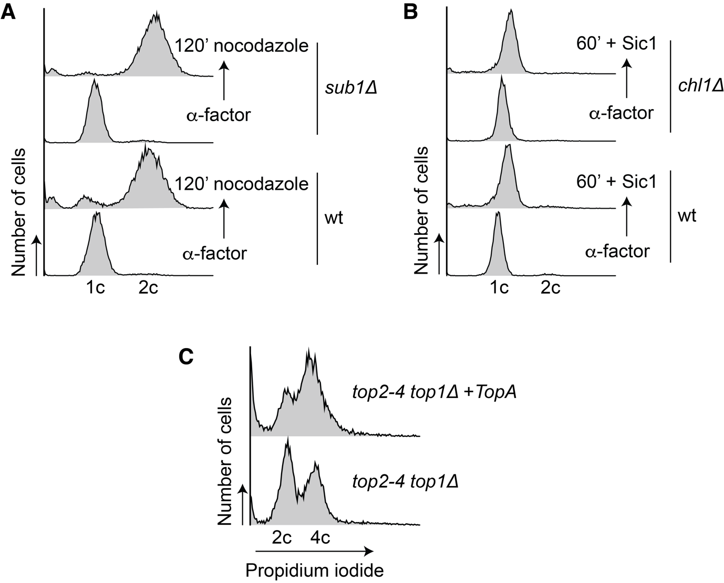

Appendix Figure S1. Supporting analyses: evidence for unwound DNA as possible cohesin target for loop capture.
(A) - (C) FACS analyses of DNA content and experimental outlines of the three experiments shown in Figure 4. (A) wild type (wt) and sub1Δ cells were synchronised in G1 by α-factor treatment and released into nocodazole containing medium for arrest in G2/M, when micro-C samples were taken. (B) wild type and chl1Δ cells were released from synchronisation by α-factor treatment into a late G1 arrest due to Sic1 overexpression. The previously reported drop of chromosomal cohesin levels in chl1Δ cells during DNA replication (Samora et al, 2016), would have confounded a comparison in G2/M. (C) We reproduced previously established experimental conditions (Joshi et al, 2010), employing asynchronous cultures during exponential growth phase, shifted to 35°C for two hours to achieve top2-4 inactivation. The FACS analysis revealed a relative shift of top1Δ top2-4 +TopA cells to G2 DNA content during this treatment, a cell cycle phase in which cohesin chromatin loops are expected to be more stable. In contrast to this expectation, top1Δ top2-4 +TopA cells show reduced looping. Note that top1Δ top2-4 cells grow as diploids.

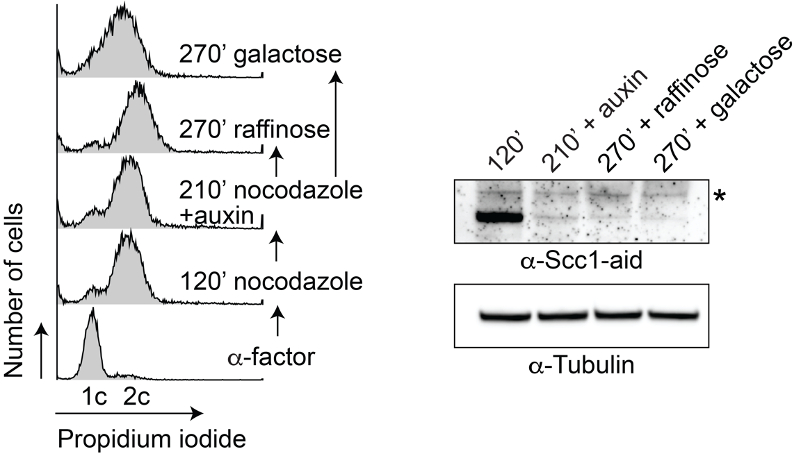

Appendix Figure S2. Supporting analyses: TAD formation without cohesin.
FACS analysis of DNA content of the cells in the experiment shown in Fig. 5, as well as an experimental outline. Western blot analysis confirmed Scc1-aid depletion by its auxin-inducible degron, following auxin addition to a G2/M arrested culture. The asterisk marks a background band recognised by the α-aid-tag antibody. Tubulin served as a loading control.

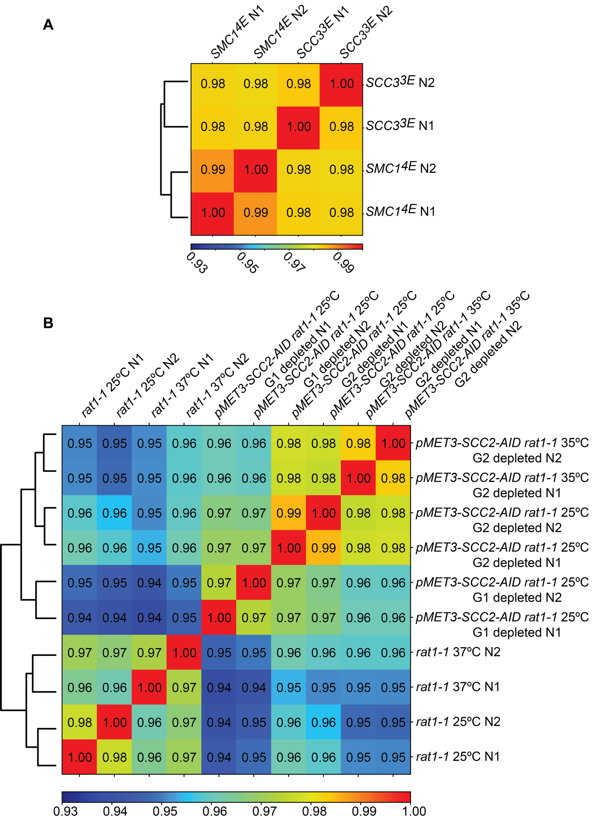
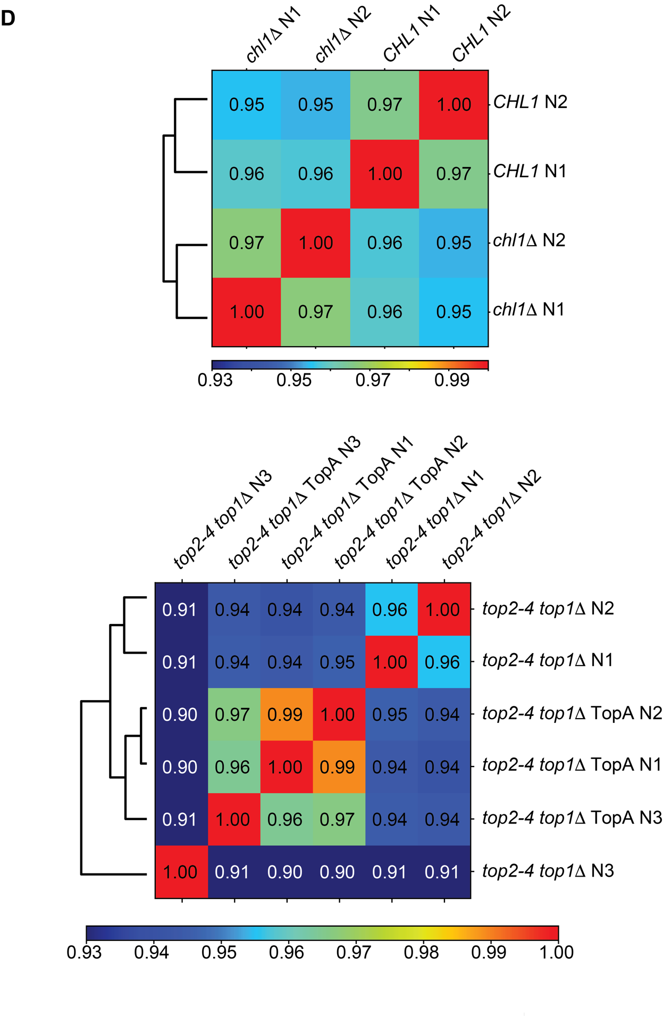

Appendix Figure S3. Reproducibility between micro-C experiments.
Spearman correlation plots were used to check data reproducibility between independent micro-C repeat experiments, used to prepare the indicated Figures. Note that cohesin-dependent chromatin loops are a relatively small feature in the context of a genome-wide chromatin interaction map. While repeat experiments typically show very close correlation, substantial similarities also exist between maps obtained from different genetic strain backgrounds and experimental conditions. The correlation plots relate to the experiments shown in (A) Figure 1, (B) Figure 2, (C) Figure 3, (D) Figure 4, and (E) Figure EV3.

