Supplementary Information

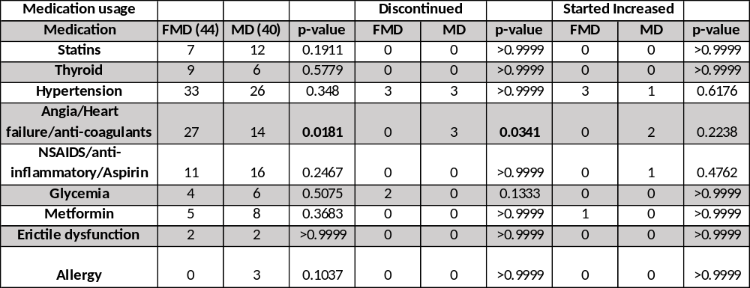
Supplementary Table 1. Medication usage
All subjects enrolled in each arm were included. Intention-to-treat analysis.
Significance was calculated using Fisher's exact test: p < 0.05.
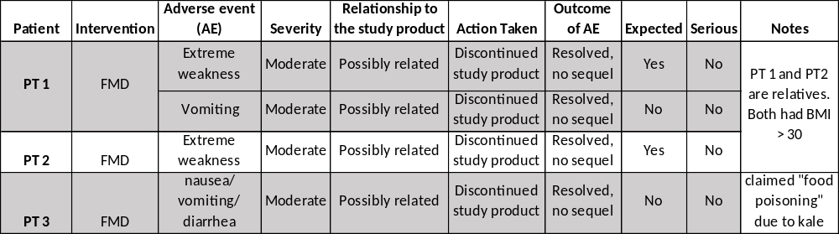

Supplementary Table 2. Adverse Events
Detailed description of the adverse events.

 | FMD (n=38) (number of times) |  | MD (n=39) (number of times) |  | nonparametric Mann-Whitney test
 | mean | SD | mean | SD | p-value
Red meat (weekly) | 2.211 | 1.298 | 2.282 | 1.503 | 0.9314
Processed meat (weekly) | 1.421 | 1.328 | 1.436 | 1.334 | 0.9812
Fried Food (weekly) | 1.474 | 1.179 | 2.103 | 1.252 | 0.0199
Pastries (weekly) | 1.632 | 1.731 | 1.282 | 1.572 | 0.3443
Fish (weekly) | 1.789 | 1.094 | 1.667 | 1.06 | 0.6387
Vegetables (weekly) | 4.949 | 1.754 | 5.513 | 1.745 | 0.1419
Fruits (weekly) | 3.553 | 2.127 | 4.436 | 2.036 | 0.0754
Milk products (weekly) | 2.974 | 2.52 | 3.718 | 2.316 | 0.1633
no. of meals (daily) | 2.789 | 0.8107 | 2.692 | 0.6551 | 0.7670

Supplementary Table 3. Participants’ self-reported dietary information collected during intake survey.
Participants were asked to fill up a questionnaire asking how many times per week they consume red meat, processed meat, fried food, pastries, fish, vegetables, fruits, milk products as well as the daily number of meals. Participants in both groups reported similar weekly consumption of red meat, processed meat, pastries, fish, vegetables, fruits, milk products, and daily number of meals. MD group reported higher consumption of fried food as determined by the nonparametric Mann-Whitney test (non-normally distributed data). The average number of daily meals was <3 for both groups and fruits and vegetables were consumed at a higher frequency than red meat and processed meat.

Mediterranean diet guidelines handout -page 1
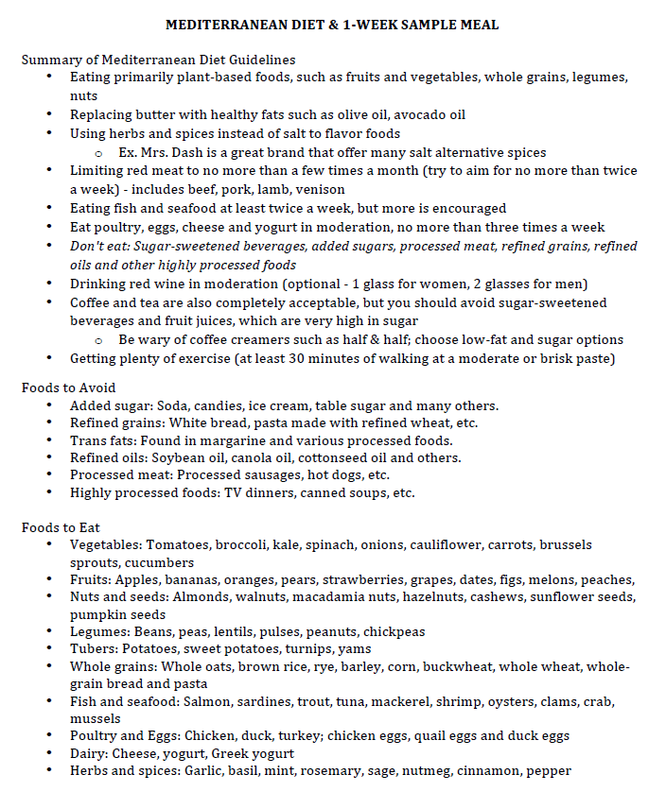

Mediterranean diet guidelines handout -page 2
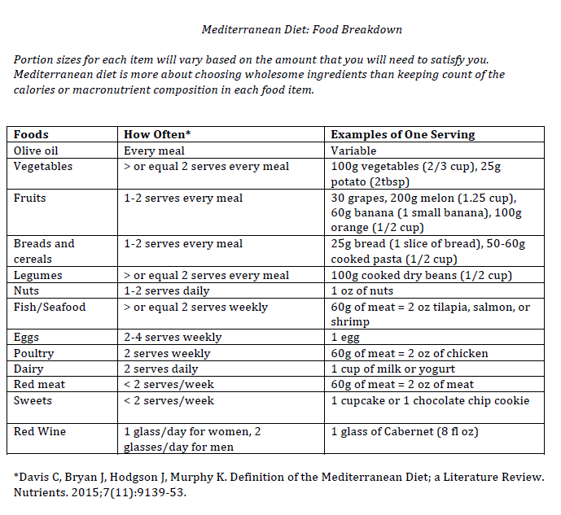

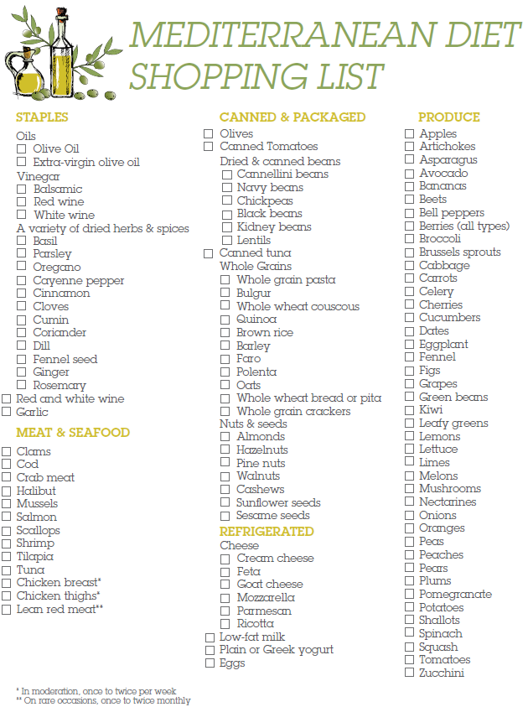
Mediterranean diet guidelines handout -page 3

