Supporting information

Probing the Transmembrane Structure and Topology of Microsomal Cytochrome-P450 by Solid-State NMR on Temperature-Resistant Bicelles
Kazutoshi Yamamoto,¹ Melissa Gildenberg,¹ Shivani Ahuja,¹ Sang-Choul Im,² Paige Pearcy,¹ Lucy Waskell,² and Ayyalusamy Ramamoorthy¹*
¹Biophysics and Department of Chemistry, University of Michigan, Ann Arbor, MI 48109-1055
²Department of Anesthesiology, University of Michigan, and VA Medical Center, Ann Arbor, MI

*To whom all correspondence should be addressed
Email: ramamoor@umich.edu

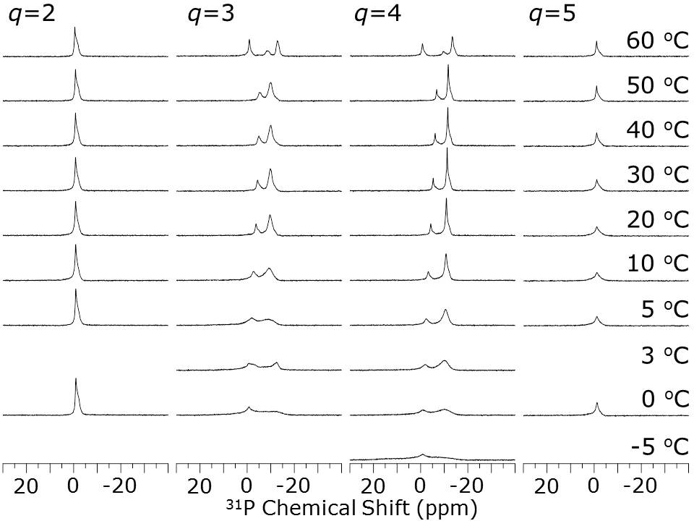

Figure S1. Proton-decoupled ³¹P NMR spectra of magnetically-aligned DLPC/DHPC bicelles examined with various q ratios and temperatures. Peaks around 12 (DLPC), and 4 (DHPC) ppm can be observed in the magnetically-alligned phase. Magnetic alignments are observed between 0 and 54 ºC (q=4). Isotropic ³¹P chemical shift peaks ~0 ppm are observed due to the isotropic phase of DLPC/DHPC bicelles (q=2, and 5). All spectra were obtained from a 400 MHz Varian NMR spectrometer using a 4 mm double resonance MAS probe. 50 mM HEPES buffer, pH 7.0 was used.

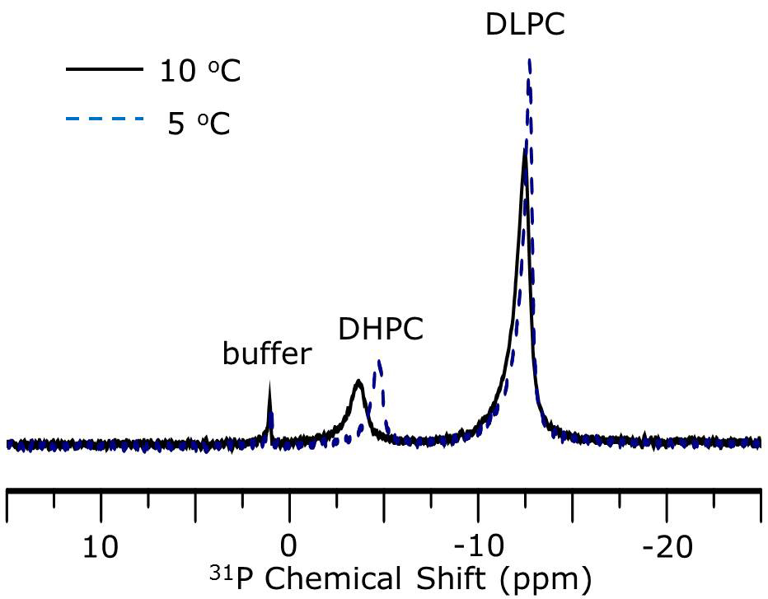

Figure S2. Proton-decoupled ³¹P NMR spectra of magnetically-aligned q=4 DLPC/DHPC bicelles containing cytochrome b₅. ³¹P NMR spectra indicate that the alignment of bicelles at 5 ºC (black solid line) is not as homogenous as it is at 10ºC (dashed navy line). 50 mM phosphate buffer pH 7.5 is used. Other experimental conditions are as described in Figure S1.

Amino acid sequence of the full-length rabbit cytochrome P450 2B4 is given below with the N-terminal transmembrane domain and other hydrophobic regions are underlined.

MEFSLLLLLA FLAGLLLLLF RGHPKAHGRL PPGPSPLPVL GNLLQMDRKG LLRSFLRLRE 60

KYGDVFTVYL GSRPVVVLCG TDAIREALVD QAEAFSGRGK IAVVDPIFQG YGVIFANGER 120

WRALRRFSLA TMRDFGMGKR SVEERIQEEA RCLVEELRKS KGALLDNTLL FHSITSNIIC 180

SIVFGKRFDY KDPVFLRLLD LFFQSFSLIS SFSSQVFELF PGFLKHFPGT HRQIYRNLQE 240

INTFIGQSVE KHRATLDPSN PRDFIDVYLL RMEKDKSDPS SEFHHQNLIL TVLSLFFAGT 300

ETTSTTLRYG FLLMLKYPHV TERVQKEIEQ VIGSHRPPAL DDRAKMPYTD AVIHEIQRLG 360

DLIPFGVPHT VTKDTQFRGY VIPKNTEVFP VLSSALHDPR YFETPNTFNP GHFLDANGAL 420

KRNEGFMPFS LGKRICLGEG IARTELFLFF TTILQNFSIA SPVPPEDIDL TPRESGVGNV 480

PPSYQIRFLA R

