Endogenous Antibodies for Tumor Detection
Supplemental Information
Barrie S. Rich, Joshua N. Honeyman, David G. Darcy, Peter T. Smith, Andrew R. Williams, Irene Isabel P. Lim, Linda K. Johnson, Mithat Gönen, Joel S. Simon, Michael P. LaQuaglia and Sanford M. Simon

Supplemental Figure 1: (a) Tumor tissue from Alb/c-myc, MMTV-neu, 4T1, Pb-Myc, and PTEN tumor models stained with fluorescent goat anti-rabbit IgG and counterstained with DAPI. (b) Tissue from the same tumor models was processed without secondary antibody and then imaged in the same manner.

Supplemental Figure 2: (a) Transgenic mouse liver from Alb/c-myc model (top) and matched WT liver (bottom) stained with fluorescent anti-mouse IgM. (b) Transgenic and WT liver from the same mouse stained with anti-mouse IgA.
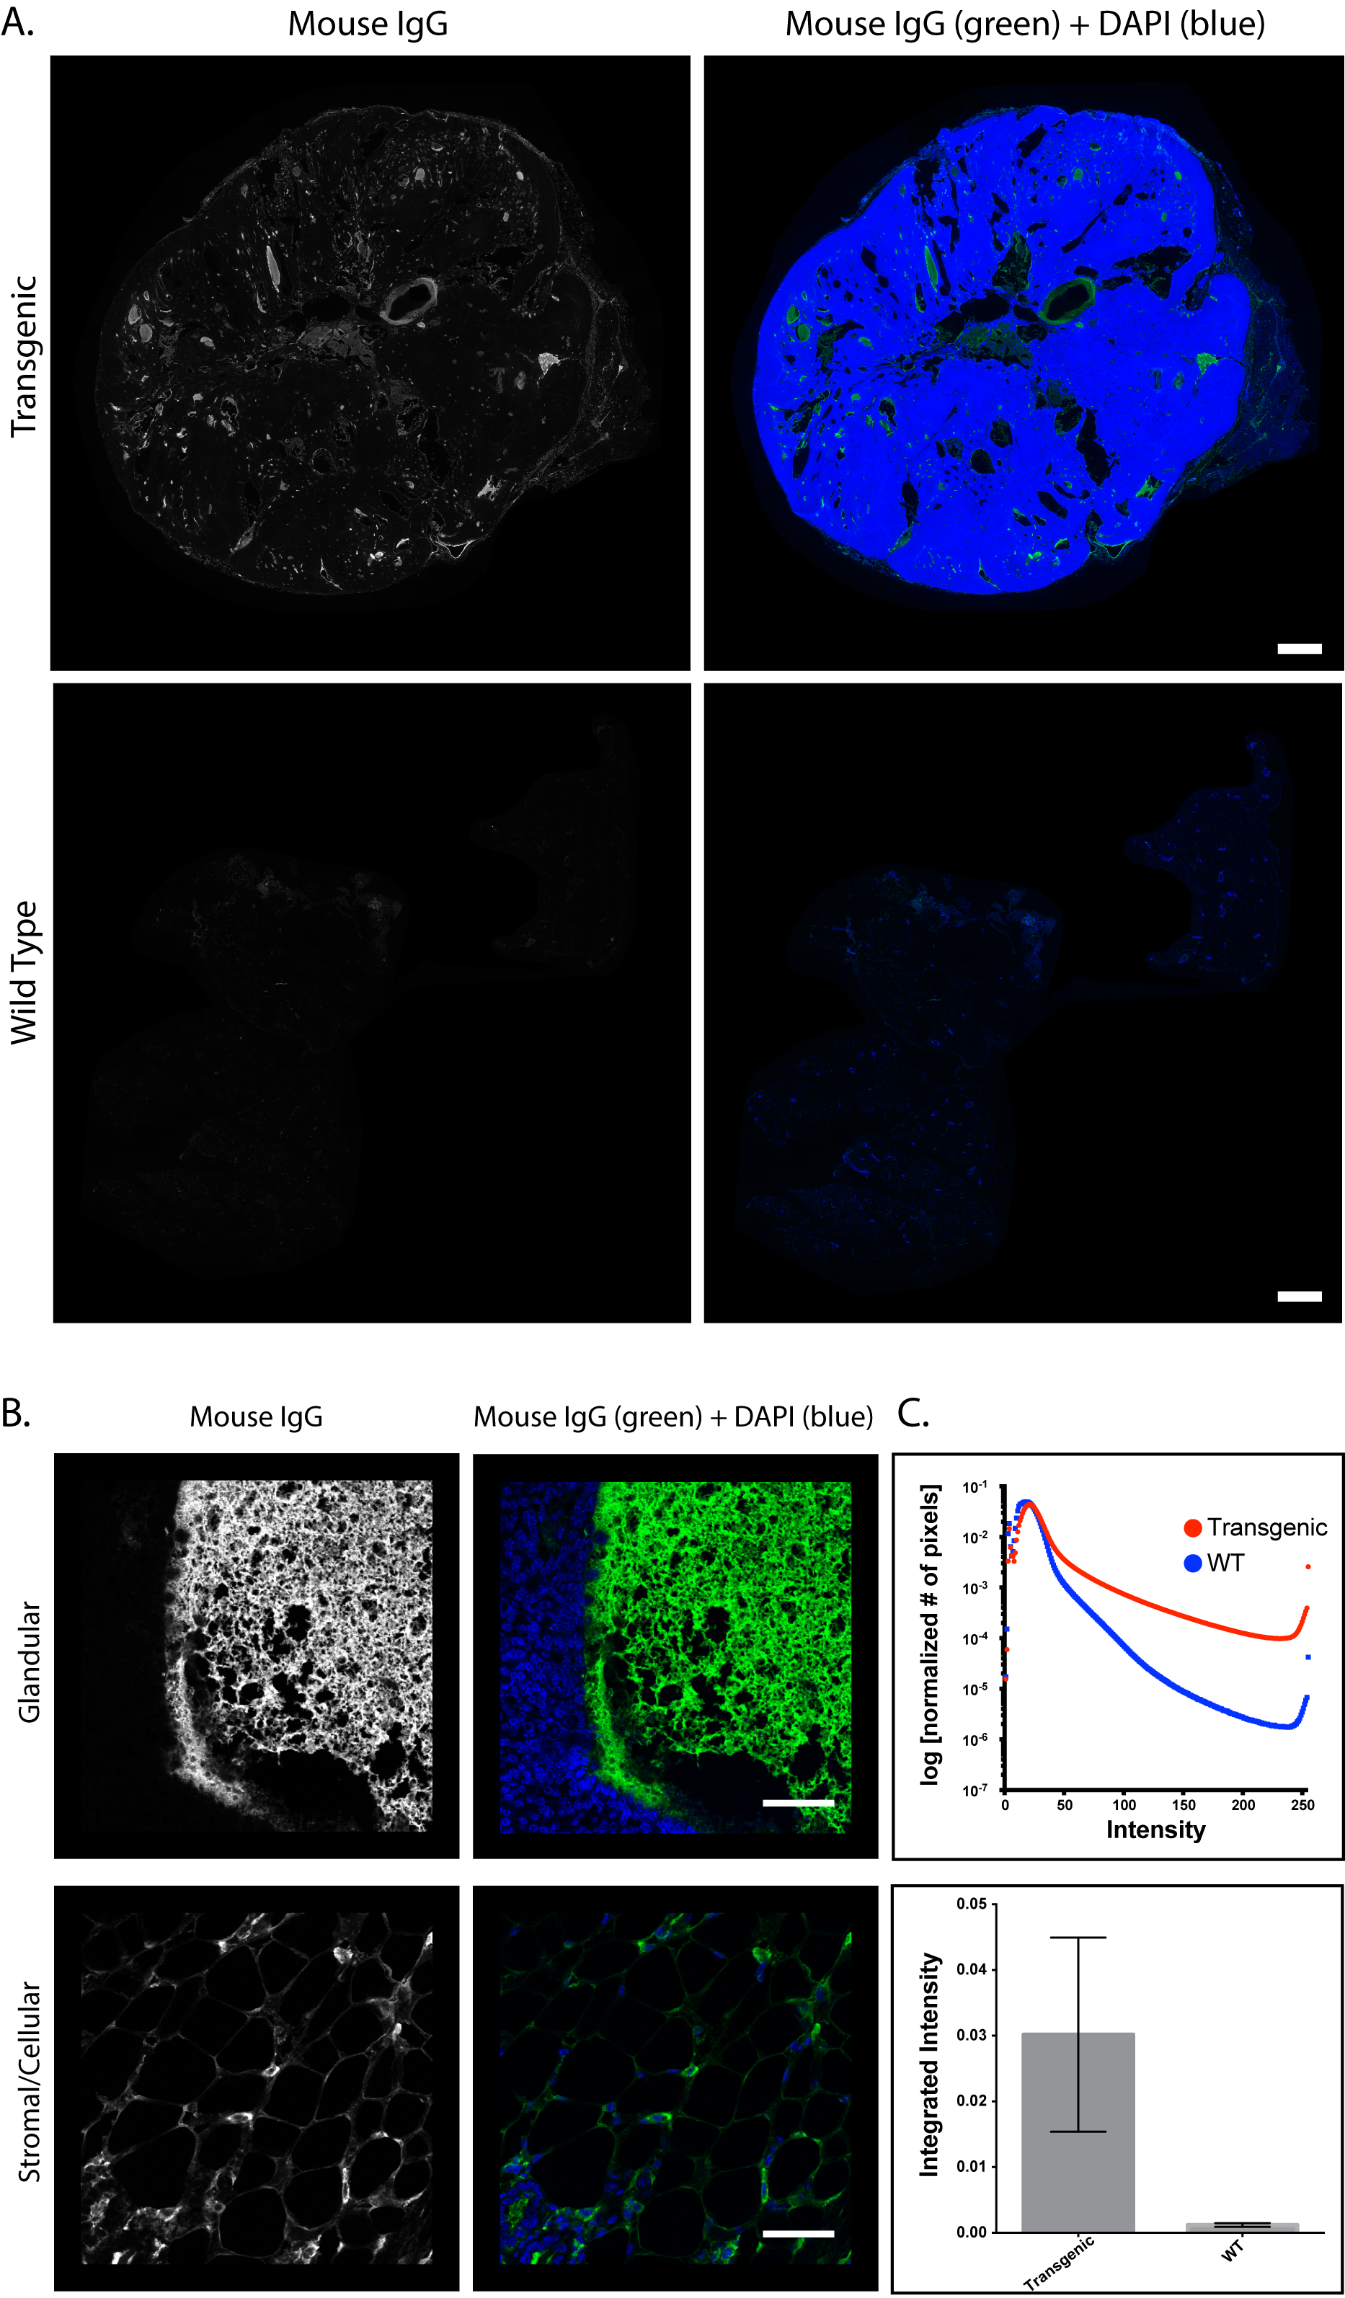
Supplemental Figure 3: Spleen and liver from alb/c-myc mice and liver from C57 WT mice were probed with a pan anti-B cell antibody, anti-CD45R. The spleen served as a positive control and demonstrated diffuse staining of B cells. However, in liver from both the transgenic and WT mice which was processed in parallel and on the same slide, we observed very sparse isolated signal that did not localize with small round cells that looked like B cells. This probe did not localize with our anti IgG fluorescence. Scale bar = 100um.
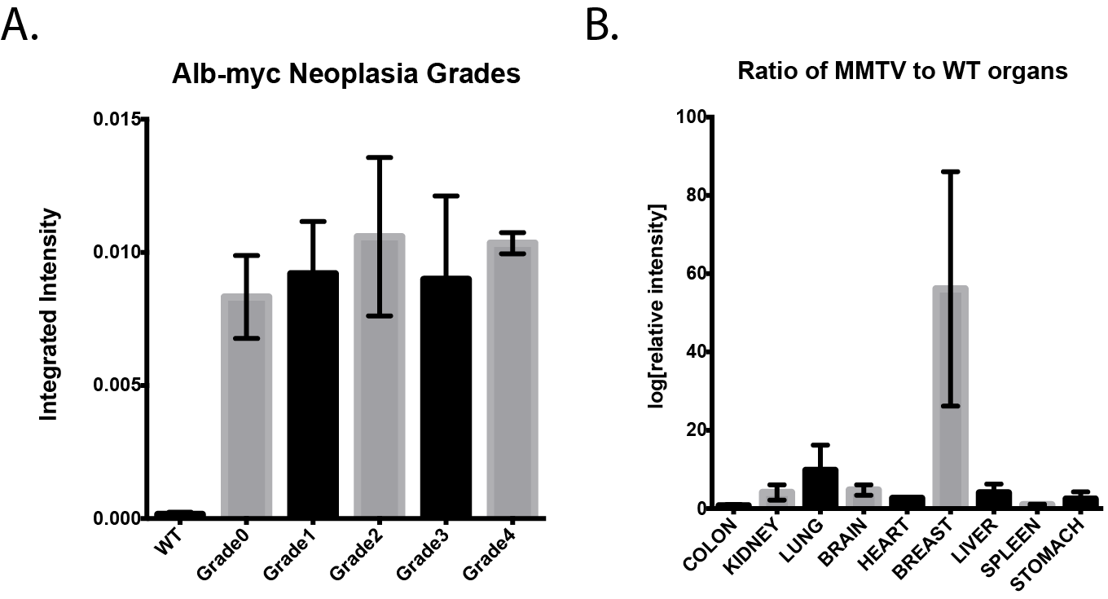
Supplemental Figure 4: 4T1 xenograft from an immune competent Balb/c mouse stained with fluorescent anti-mouse IgG (a) demonstrates fluorescent signal throughout the tumor and adjacent stroma. The signal is evident at both low and high magnification. In a xenograft from a mouse that does not express IgG(b), there is no fluorescent signal when the tissue is stained with fluorescent anti-mouse IgG.