SUPPORTING INFORMATION

for

A graphene-based physiometer array for the analysis of single biological cells

Geraldine L.C. Paulus *, Justin T. Nelson*, Katherine Y. Lee, Qing Hua Wang, Nigel F. Reuel, Brittany R. Grassbaugh, Sebastian Kruss, Markita P. Landry, Jeon Woong Kang, Emma Vander Ende, Jingqing Zhang, Bin Mu, Ramachandra R. Dasari, Cary F. Opel, K. Dane Wittrup, and Michael S. Strano

* These authors contributed equally.

I. Discussion of spread in Raman data

II. Substrate effect on graphene pH response

III. Reversibility of the graphene Raman response

IV. Cell line generation and cell passaging

V. FFT analysis of Raman data maps

VI. Additional Raman footprints of different cells

VII. Statistics

VIII. Statistical analysis of I_{2D}/I_{G} and G_{FWHM} for different types of cells

IX. Relationship between pH and metabolic rate
X. Effect of IgG on graphene Raman signal

XI. Dopamine detection
I. Discussion of spread in Raman data

There is a significant spread in the values of G_{POS} and 2D_{POS} of graphene exposed to 1M HCl (purple crosses in Fig. 2(a) of the main text). Allowing the water to evaporate from the solution over the course of the experiment (~50 min using the Horiba Labram Raman setup) increases the concentration of aqueous H⁺ beyond the starting pH, causing the graphene to become more strongly p-doped over time. Indeed, in a plot of the G peak and 2D peak position data as a function of the time at which they are collected, a linear trend arises (purple crosses in Fig. S1(a) and (b)). Logically we would expect a similar spread in the peak positions of graphene exposed to extremely alkaline solutions (e.g. blue squares in Fig. 2(a)). At first glance this is not the case; however plotting the peak positions vs. collection time (Fig. S1(a) and (b)) suggests otherwise. During the first half of the experiment G_{POS} and 2D_{POS} decrease, reaching minimum values of ~1580 cm⁻¹ and 2639cm⁻¹ respectively. This represents the point where the hydroxide ions have fully compensated the initial p-doping in graphene. As time progresses, and more water evaporates from the solution, G_{POS} and 2D_{POS} increase again (i.e. the data disperse upward along the doping trajectory) and graphene has a net excess of negative carriers. This transient behavior and evaporation was not observed in similar experiments performed on a higher-sensitivity Raman system (see Methods for details), which allowed the total scan time to be reduced to 1 minute. Rather, G_{POS} was observed to remain constant over the course of the experiment (see Fig. S1(c)).
There is some inherent spread in all Raman data. Small differences in graphene quality and homogeneity will give rise to differences in G and 2D peak positions, G FWHM, and 2D/G ratio. Similarly spatial inhomogeneities in the substrate, temporal and temperature fluctuations can cause some variation. This is unavoidable and the reason why it is important to collect a statistically significant amount of data for comparing different datasets.
We acknowledge there is some overlap in the Raman data of graphene exposed to PBS (pH=7.4) and 10mM NaOH (pH 12) in Figure 2. This is likely a result of using separate graphene samples for each exposure to pH. This was mainly done to avoid having residual ions present on graphene before exposing it to a solution of different pH. To minimize variation, we did ensure all graphene samples (~1cm²) in Figure 2 originated from the same batch (1 CVD-grown 2”x3” piece). Furthermore the sensitivity of graphene to the pH of its environment depends on the initial doping condition of the sample in air (determined by e.g. growth and substrate conditions). As seen in the work by Das et al. ¹ and in our pH model discussed in the main text the Raman response of graphene to dopants is highly non-linear. The overlap in the alkaline (n-doping) regime can be avoided by using graphene which is more highly p-doped to begin with (see Fig. S1(d)). Four different graphene samples, initially very p-doped, were exposed to solutions of varying pH. Virtually no overlap is observed in the pH range of 4.5 to 14. This highly p-doped graphene is naturally less sensitive to more p-doping solutions (such 1M HCl), since the graphene becomes saturated with protons. For the data in Figure 2, we chose to start with a graphene sample that allowed a decent Raman response to both acidic and alkaline solutions (i.e. starting off moderately doped).
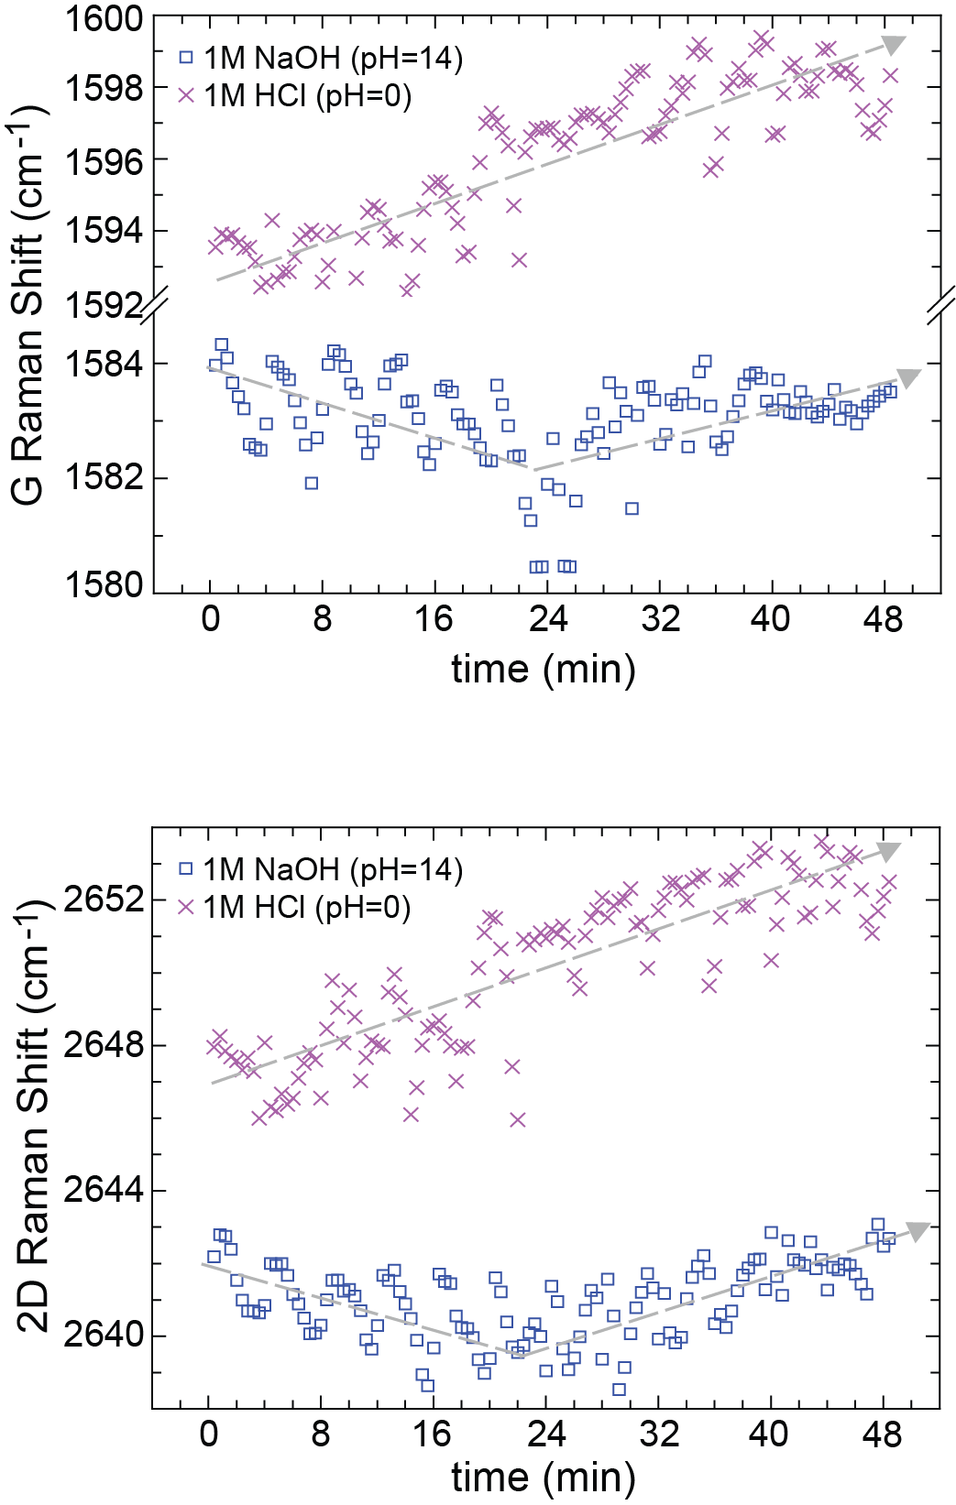

(b)
(a)
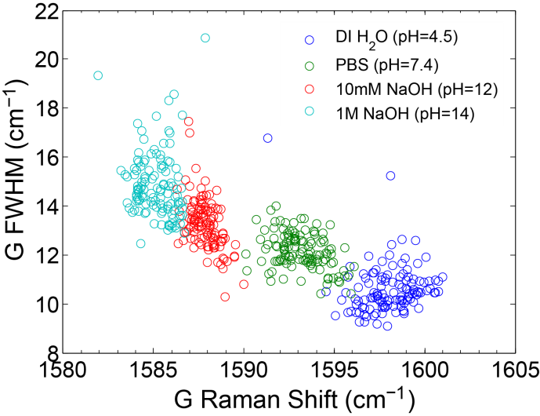
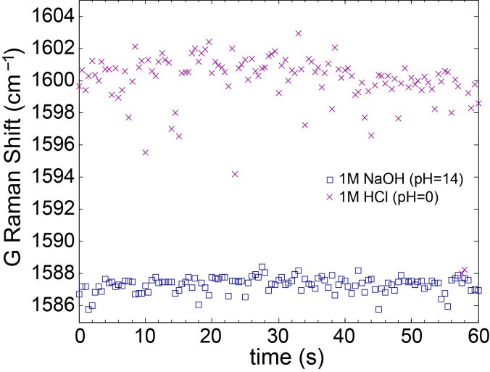

(c)
(d)
Figure S1. Analysis of spread in the Raman data. Temporal evolution of G peak position (a) and 2D peak position (b) of graphene samples exposed to 1M HCl (purple crosses) and 1M NaOH (blue squares), querried with the Horiba Labram Raman setup. Trendlines are linear regressions that serve as a guide to the eye. (c) Graphene exposed to 1M HCl (purple crosses) and 1M NaOH (blue squares), interrogated with the higher-sensitivity home-built Raman setup described in the Methods Section. Scan time is drastically reduced, avoiding evaporation. (d) G_{FWHM} – G_{POS} doping trajectory for graphene starting out more p-doped, probed with the higher-sensitivity Raman setup. No overlap is detected.

Finally, despite all the variation between different samples, it should be noted that quantitative pH changes can be determined by considering relative shifts within a sample, as shown in Fig. 4. We demonstrate significant differences in G and 2D peak positions for graphene exposed to well-adhered IgG producing cells and graphene exposed to medium.

II. Substrate effect on graphene pH response

In the main text we hypothesize that part of pH response of the overall charge-neutral graphene is due to the presence of charged puddles in graphene, which are in turn caused by charged impurities in the substrates. Shielding the graphene from these charged impurities (e.g. by placing a self-assembled monolayer between graphene and SiO₂, or by transferring graphene onto boron nitride instead of SiO₂) would decrease this puddle landscape ^{2,3} and hence decrease the pH response of graphene. We tested this hypothesis by transferring a monolayer of graphene on either a SiO₂ substrate (300nm thick, on top of a silicon wafer) or onto a SAM of octadecyltrichlorosilane (OTS, Sigma Aldrich 90%) on 300nm of SiO₂. The SAM was formed by exposing a plasma-cleaned SiO₂ substrate overnight to the OTS solution (10mM OTS in toluene) in a closed vial. The next day the SAM-coated SiO₂ was rinsed in fresh toluene and blown dry with nitrogen.
The average G peak position of graphene directly on top of SiO₂ rises by ~ 4.5cm⁻¹ when changing the environment from a 10mM NaOH solution to a 10mM HCl solution (Fig. S2(a)). This difference is decreased to <1cm⁻¹ when graphene is transferred onto the OTS SAM (Fig. S2(b)).
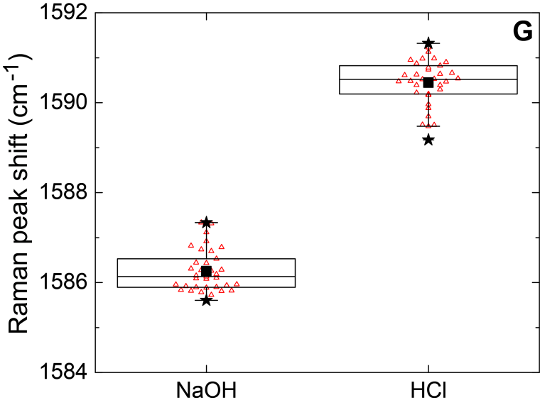
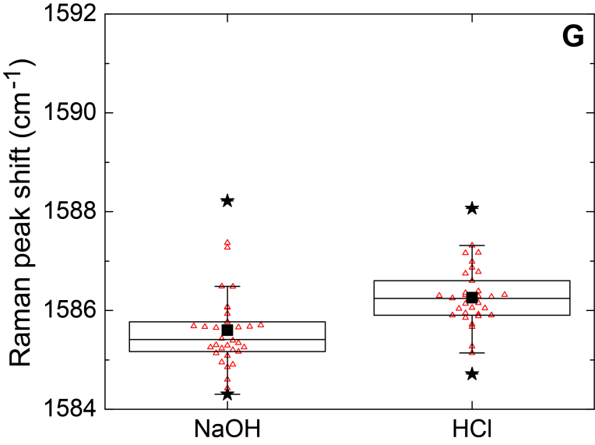

(b)
(a)

Figure S2. pH response of graphene is determined by the underlying substrate. (a) G peak positions of graphene transferred directly on SiO₂, exposed to 10mM NaOH and 10 mM HCl respectively. (b) G peak positions of graphene transferred onto an OTS SAM on top of SiO₂, exposed to 10mM NaOH and 10 mM HCl respectively.

III. Reversibility of the graphene Raman response

The graphene Raman response is expected to be fully reversible as long as charges only physisorb onto the graphene lattice.
We exposed graphene to solutions of 10mM NaOH and 10mM HCl and switched back between those conditions three consecutive times (Figure S3). No significant hysteresis was recorded, indicating the observed Raman changes are mostly caused by charges physisorbing onto the lattice (corresponding to the low pKa value of graphene).
It should be noted that exposing graphene to medium shifts the graphene G peak position to values similar to those measured when graphene is exposed to extremely alkaline solutions. However, it is important to realize that the medium does not cause defects in graphene. Additionally, changing the solution from pH =7 (neutral) to pH=2 (10mM HCl) adds > 2x10¹² dopants/cm² graphene to the lattice (based on Figure 2d). The most metabolically active cells used in this work introduced on average 1.28x10¹² dopants/cm² graphene (see section IX of the Supporting Information), indicating this change is situated well within the reversible regime.
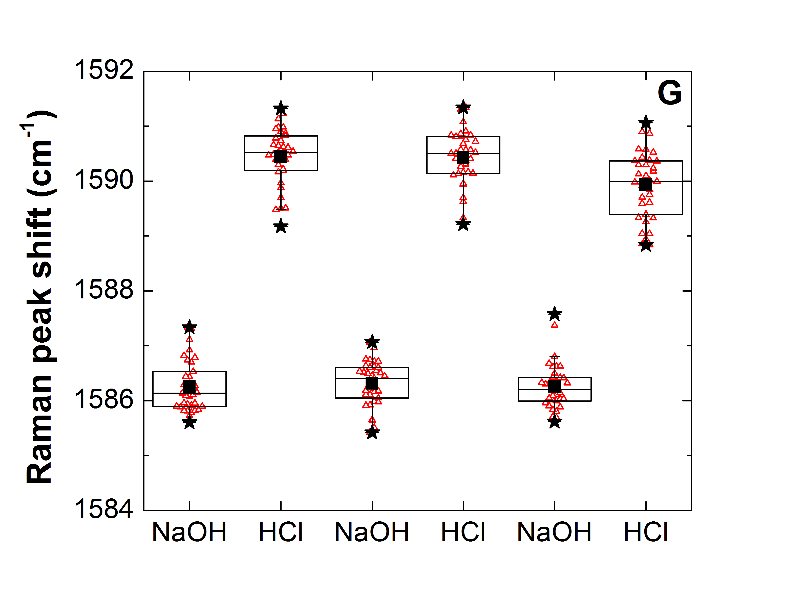

Figure S3. Reversibility of the Raman peak shifts in response to pH. A monolayer of graphene on top SiO₂ was rinsed 3 times with 10mM NaOH after which 35 spatially distinct Raman data points were collected. Next the NaOH solution was removed and graphene was rinsed 3 times with 10mM HCl after which the graphene Raman signal was recorded in the same 35 locations. This was repeated 2 more times. No significant hysteresis was recorded.

IV. Cell line generation and cell passaging

A stable cell line expressing a murine IgG2a (TA99) ⁴ and green fluorescent protein (GFP) was established using a modified lentiviral transduction process previously described ⁵. Briefly, pLB2-CMV-GFP-TA99, a polycistronic expression vector using 2A skip peptides was cloned by overlap extension PCR ⁶. This resulted in a promoter/expression cassette of CMV-GFP-F2A-TA99 Light Chain-T2A-TA99 Heavy Chain in the lentiviral expression vector pLB2 ⁷. Lentiviral particles were generated by transfecting HEK-293F cells (Invitrogen) with the plasmids pLB2-CMV-GFP-TA99, pCMV-dR8.91 ⁸, and pCMV-VSV-G ⁹ at a mass ratio of 2:1:1 using PEI. Fresh media was exchanged after 24 hours. Lentivirus containing supernatant was harvested 48 hours later and supplemented with protamine sulfate at 5 μg/mL. HEK-293F cells (Invitrogen) were transduced by resuspension in freshly harvested viral supernatant. 24 hours later, the HEK-293F cells were transduced a second time. GFP positive, and therefore IgG expressing, cells were purified using flow fluorescence activated cell sorting at the Koch Institute Flow Cytometry Core. The genetically modified HEK-293F cells secrete IgG into to the medium due to the presence of a signal peptide at the N-terminus of the IgG protein. Each cell excretes on average 1pg IgG2a per day. Confluent cells growing in 6ml media in a 10cm dish for 3 days result in an IgG concentration in the medium of ~3μg/ml. GFP on the other hand, is not excreted by the cells and thus does not have an active doping effect on graphene. Untransduced HEK-293F cells were used as non-expressing controls.

The cells are typically passaged after 2 days of growth in a petri dish in the incubator. The spent medium is removed from the dish, after which the dish is rinsed with sterile phosphate buffered saline (PBS), which is then removed again. Subsequently, we diluted as received trypsin (cellgro #25-053-CI) by 5X to a final trypsin concentration of 0.05wt% in PBS. 1ml of this solution is added to the petri dish to loosen the cells. After ~ 30s 9ml medium is added to dilute and deactivate the trypsin and the entire contents of the petri dish are pipetted into a falcon tube and centrifuged at 1000 rpm for 5 minutes. Afterwards, the supernatant (medium + trypsin) is removed and the cells are resuspended in 5 ml fresh medium. Because of our extended Raman mappings the cells spend several hours outside of the incubator. In order to prolong the lifetime of the cells outside of the incubator, we chose to use L-15 medium (with pH buffer pair KH₂PO₄/Na₂HPO₄) because it does not require CO₂ to maintain a stable pH, as does Dulbecco’s DMEM medium (with buffer pair H₂CO₃/NaHCO₃).

V. FFT Analysis of Raman data maps

Background noise in the raw Raman data (e.g. Figure S4(b)) can originate from imperfect graphene, impurities in the substrate, and slight temperature and calibration fluctuations. In order to reduce the background signal, a forward FFT was performed to transform the raw Raman data (Figure S4(b), corresponding to the cell shown in Figure S4(a) from the spatial into the frequency domain. Then, a power spectrum was calculated (Figure S4(c)) and a threshold was determined the filter out the noise (threshold set at -8.7). Next a mask was applied to the FFT-transformed image removing all the noise. Finally an inverse Fast Fourier Transformation was applied to transform the image back into the spatial domain. The result is shown in Figure S4(d).

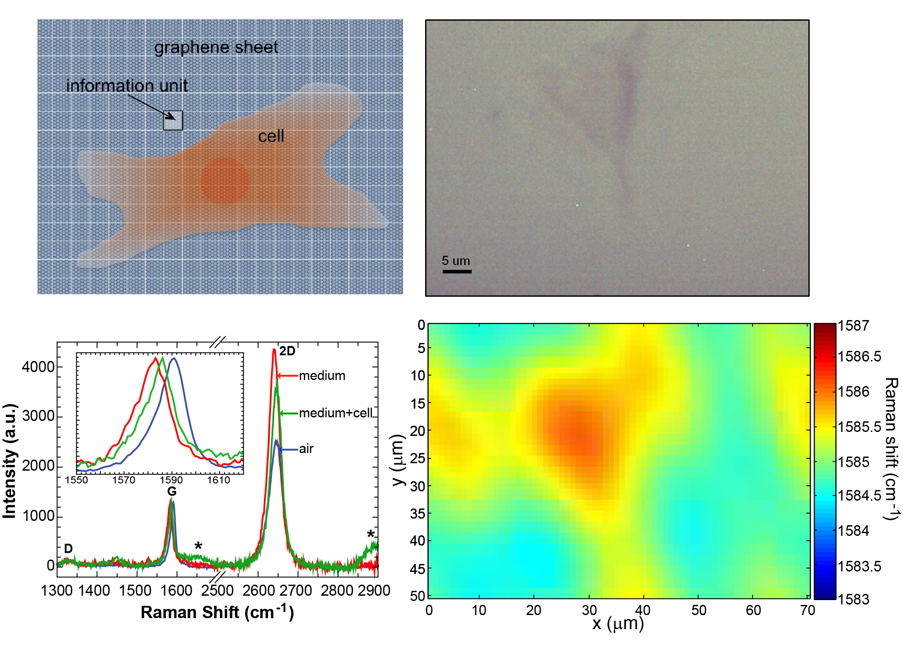
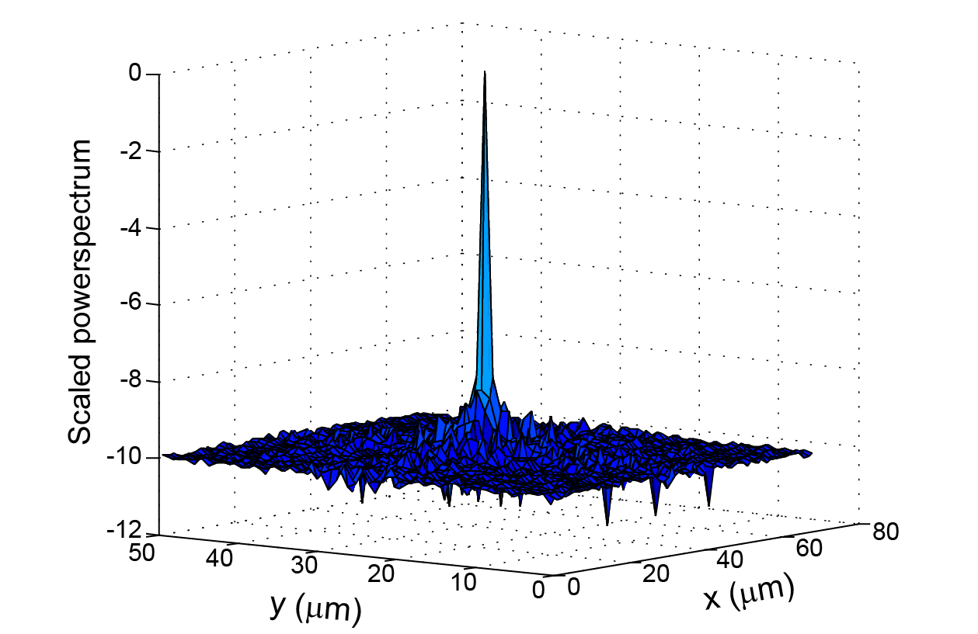
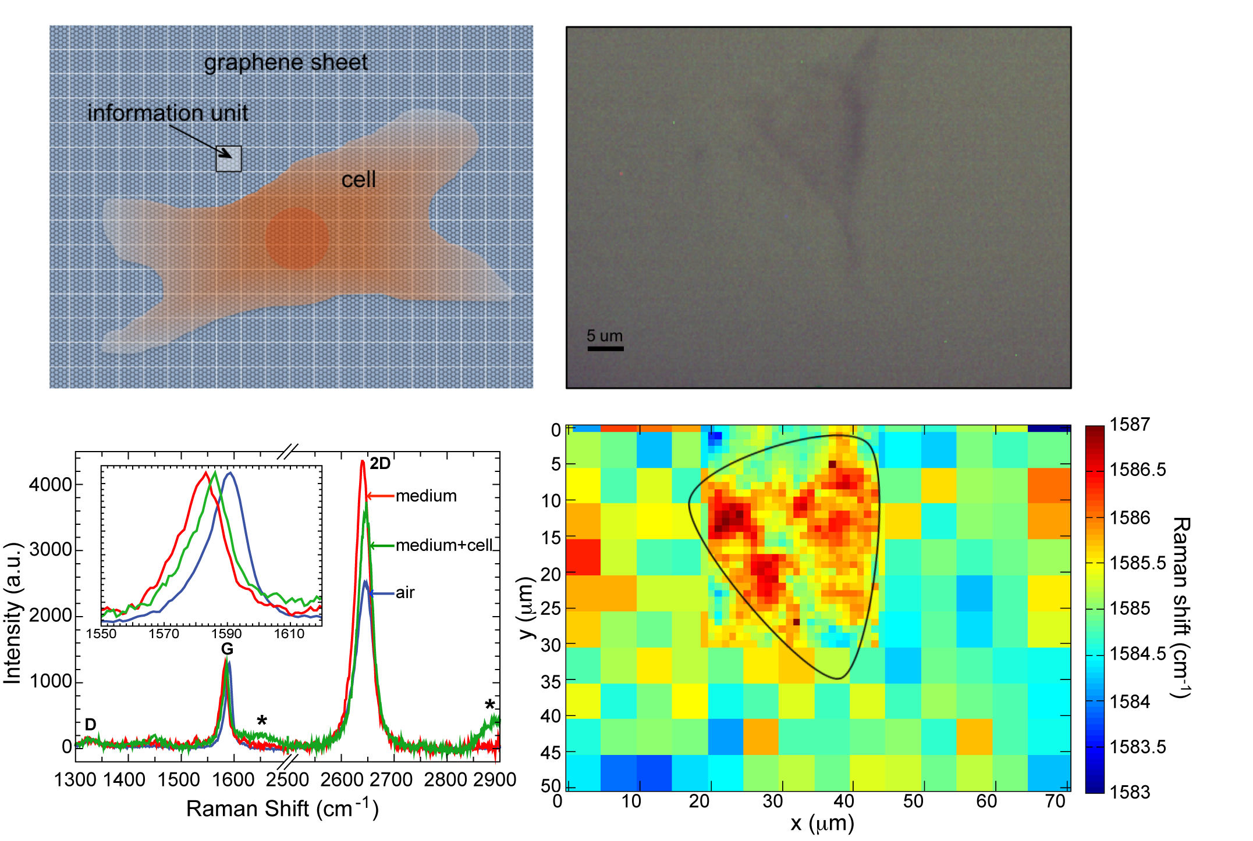
(d)
(a)
(b)
(c)

Figure S4. Reducing the background signal in Raman data maps. (a) Optical micrograph of an IgG-producing HEK-293F cell well-adhered to graphene. (b) Spatial Raman footprint of the cell shown optically in (a), by probing the graphene G peak position. (c) Surface plot of the scaled power spectrum of the fourier-transformed image of (b); noise cutoff value set at -8.7 (d) Smoothed Raman data map obtained by masking the FFT image and applying an inverse FFT to shift it back into the spatial domain.

VI. Additional Raman footprints of different cells

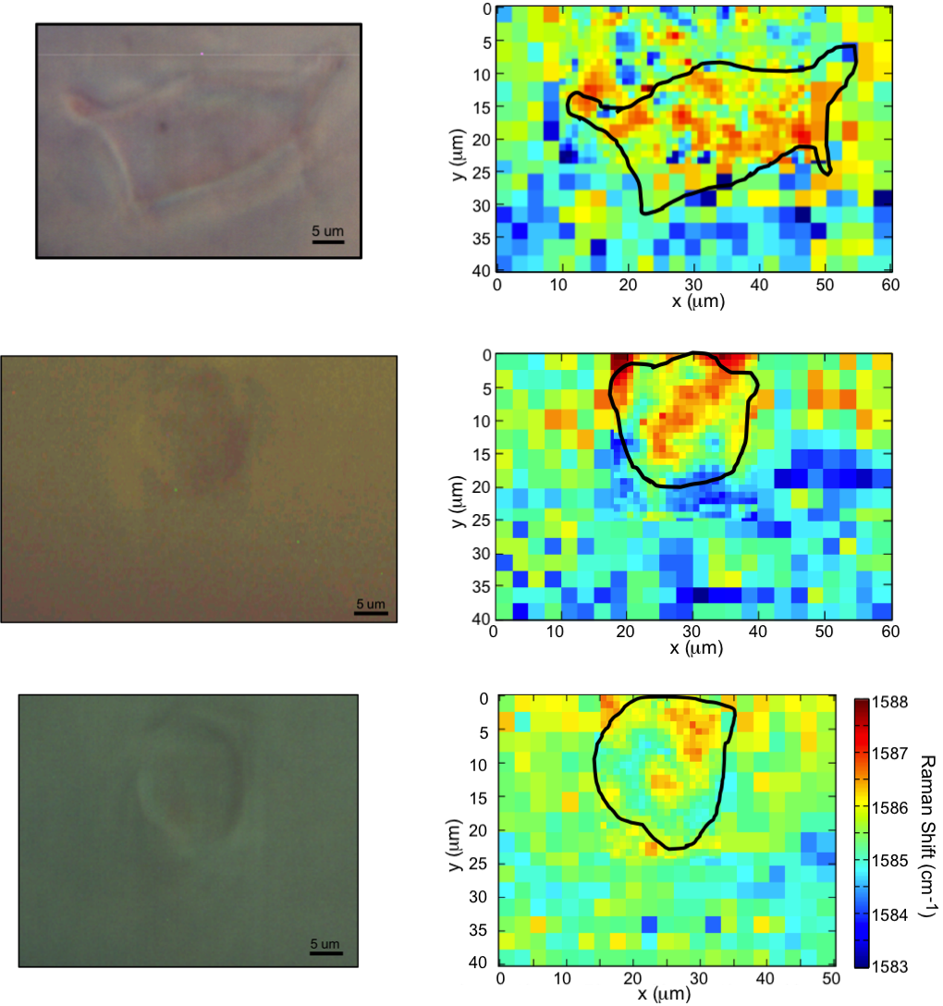
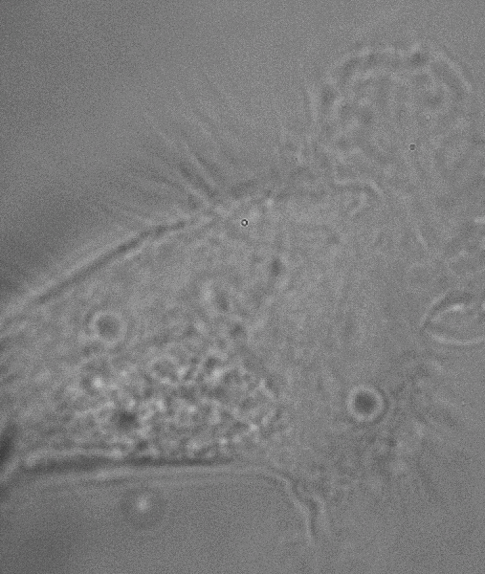
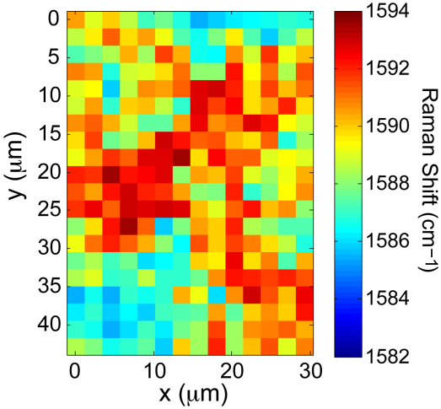
5 um

Figure S5. Additional examples of Raman footprints for different cells. Left panels show optical images of the cell, right panels the corresponding spatial map of the G peak position (scale is identical for the first three and shown next to the third map). The top panel shows a control cell that was allowed to adhere to graphene for 3 hours in the incubator prior to data collection. A control cell is a non-IgG producing HEK-293F cell (see Methods). The second panel shows an IgG-producing cell that is less adhered (spent 30 minutes in the incubator prior to data collection). The third panel shows a less-adhered control cell. The bottom panel is a well-adhered IgG producing HEK-293F cell, mapped using the higher-sensitivity Raman system described in the Methods section. An exposure time of 100ms reduced the total scan time was reduced to 2.5 minutes, and the cellular footprint is still easily seen.

VII. Statistics

For each two distributions compared in this work, we tested whether they are statistically significantly different from one another. First, for each dataset a Shapiro-Wilks test was performed, with the null hypothesis being that the data is normally distributed. The significance level was set at 0.05. For p-values less than 0.05 the null hypothesis was rejected, and vice versa. If two distributions being compared are both normal, an independent two-sample t-test was performed where the null-hypothesis states that the data in both datasets comes from normal distributions with equal means but unknown variances. If on the other hand, one or both of the distributions compared are not normally distributed, a two-sample Kolmogorov-Smirnov test was performed; the null hypothesis is that both datasets come from the same continuous distribution.
For either test, the null hypothesis was rejected for p-values <0.01, in which case the difference between both datasets was declared statistically significant. Where appropriated, the p-value of either the t-test or the Kolmogorov-Smirnov test was reported in the figure caption.

VIII. Statistical analysis of I_{2D}/I_{G} and G_{FWHM} for different types of cells

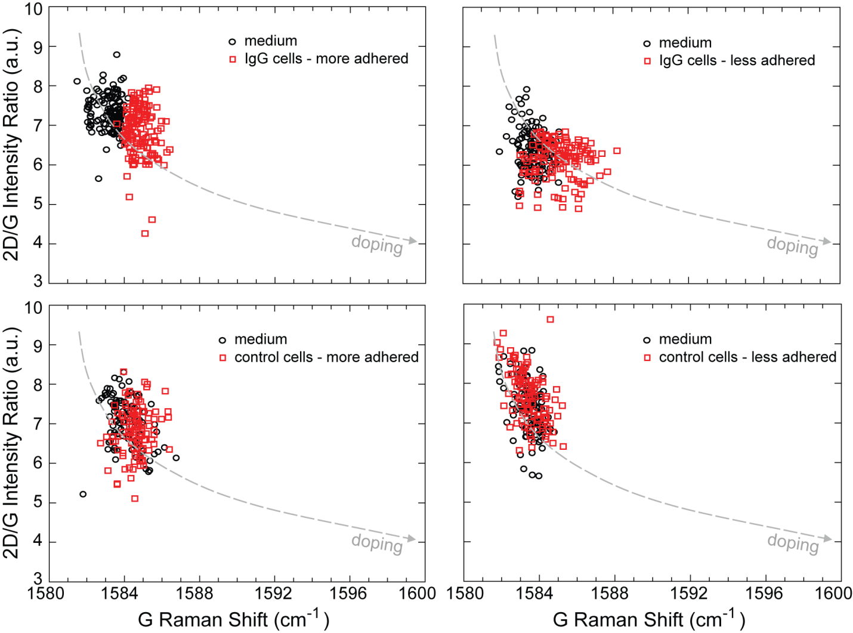

Figure S6. Scatter plots of 2D peak position vs. G peak position of graphene covered in growth medium (black dots) and cells (red squares) for IgG-producing cells (top panels) and non-IgG-producing control cells (bottom panels). Left panels show data for well-adhered cells (3 hrs of incubation prior to data collection); right panels represent data for less-adhered cells (30 min of incubation prior to data collection). Dashed lines represent trend lines adapted from ref.¹ The trend lines are shifted downwards to account for the dependence of the 2D peak position on the excitation wavelength (a 532nm laser was used in ref.¹, as opposed to a 633nm laser in this work). Scales are identical for all panels.
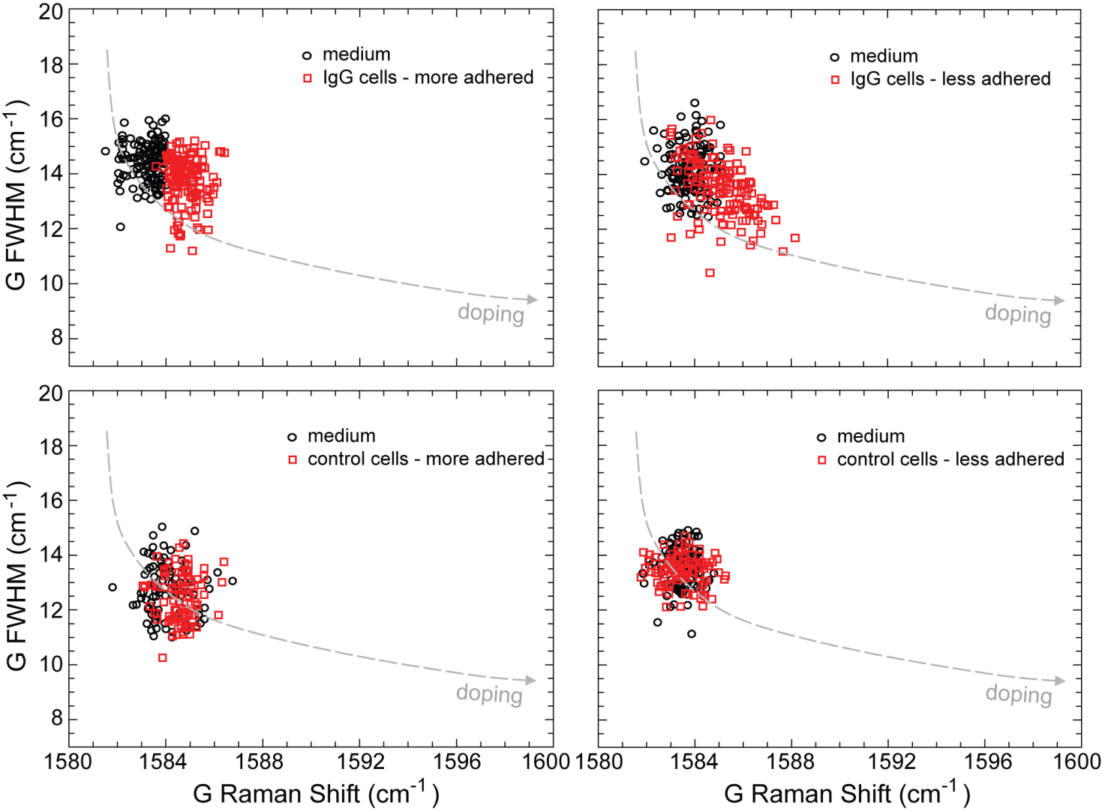

Figure S7. Scatter plots of 2D peak position vs. G peak position of graphene covered in growth medium (black dots) and cells (red squares) for IgG-producing cells (top panels) and non-IgG-producing control cells (bottom panels). Left panels show data for well-adhered cells (3 hrs of incubation prior to data collection); right panels represent data for less-adhered cells (30 min of incubation prior to data collection). Dashed lines represent trend lines adapted from ref.¹ The trend lines are shifted downwards to account for the dependence of the 2D peak position on the excitation wavelength (a 532nm laser was used in ref.¹, as opposed to a 633nm laser in this work). Scales are identical for all panels.

IX. Relationship between pH and metabolic rate

This is a steady-state (SS) problem involving spherical symmetry. The appropriate equation could be derived from the general vector equation, but we can instead use a simpler approach, based on Fick’s law of diffusion (for SS):
$J=-D\frac{δC}{δr}$ (S1)

In the steady state, we assume that a constant rate of generated protons is diffusing out of the cell. Therefore, for any radius, r:

$J=\frac{Q}{4π r^{2}}$ (S2)
Thus:
$\frac{Q}{4π r^{2}}=-D\frac{δC}{δr}$ (S3)
Or
$Q=-4π r^{2}D\frac{δC}{δr}=constant$ (S4)

Rearranging and integrating this expression with semi-infinite boundary conditions:

$\int_{C}^{C_{med}}{dC=\frac{-Q}{4πD}\int_{r}^{∞}{\frac{1}{r^{2}}}}dr$ (S5)

$C_{med}-C=\frac{Q}{4πD}{\left[\frac{1}{r}\right]}_{r}^{∞}=\frac{Q}{4πD}\left(\frac{1}{∞}-\frac{1}{r}\right)=-\frac{Q}{4πDr}$ (S6)
So
$C=C_{med}+\frac{Q}{4πDr}$ (S7)

At cell radius r₀ (assume ~ 10 um) C= C_{cell}

$C_{cell}=C_{med}+\frac{Q}{4πDr_{0}}$ (S8)
Thus:

$Q=4πDr_{0}{(C}_{cell}-C_{med})$ (S9)

Units: Q: #/s (per cell); D: cm²/s; r: cm; C:#/cm³.

The proton measurements described in the main manuscript are surface concentrations, not bulk concentrations. These can be linked by an adsorption constant.

At equilibrium we can state that

$K=\frac{k_{on}}{k_{off}}=\frac{Γ}{(Γ_{max}-Γ)C_{bulk}}$ (S10),

where K is the equilibrium adsorption constant, k_{on} is the adsorption rate constant and k_{off} the desorption rate constant, $Γ$ is the surface concentration (in #/cm²), $Γ_{max}$ is the maximum proton surface concentration and $C_{bulk}$ is the proton bulk concentration (in #/cm³).

Rearranging this leads to

$Γ=\frac{KC_{bulk}Γ_{max}}{(1+KC_{bulk})}$ (S11)

In our case $Γ$ << $Γ_{max}$, as the largest obtained proton surface concentration (at pH=0) equals 9.15x10¹²cm⁻² , whereas the maximal proton surface concentration equals 3.8x10¹⁵cm⁻² , i.e., the total carbon atom density of graphene. Thus equation (10) becomes:

$K=\frac{Γ}{Γ_{max}C_{bulk}}$ (S12)

And eqn. (11) becomes

$Γ=KC_{bulk}Γ_{max}$ (S13)

Combining equation (9) with (13) relates the cellular proton production rate Q (related to its metabolic activity) to the proton surface concentration $Γ$:

$Q=\frac{4πDr_{0}}{KΓ_{max}}{(Γ}_{cell}-Γ_{med})$ (S14),

where $\frac{4πDr_{0}}{KΓ_{max}}$ is a constant.

This implies that Q is linearly proportional to the difference in proton surface concentration under the cell and in the medium. We have indirectly measured these quantities as the G peak position can translated into a surface hole concentration¹:

For IgG producing, well-adhered, based on the statistical analysis of the 100 cells:
|${ Γ}_{cell}-Γ_{med}$| = 1.28 x 10¹² cm⁻²

For non-IgG producing, well-adhered, based on the statistical analysis of the 100 cells:
|$Γ_{cell}-Γ_{med}$| = 0.32 x 10¹² cm⁻².

Compared to adhered control cells, the IgG producing more-adhered cells have a proton production rate (and thus metabolism) that is 4 times higher.

X. Effect of IgG on graphene Raman signal

In order to investigate the effect that IgG has on graphene, IgG secreted by the cells, was collected and up-concentrated to 1.5 mg/ml in PBS. As we have shown that PBS has a significant effect on the Raman spectrum of graphene (Fig.2) we exchanged the PBS for medium by centrifuge filtration. The filter tubes (Amicon, Millipore) had a membrane with a MWCO (molecular weight cut off) value of 3000 Da. The IgG is ~150kDa, and will thus definitely be retained by the membrane. We added 800 μl of L-15 growth medium to 200 μl of PBS containing 0.3mg IgG. This solution is centrifuged 5 consecutive times for 15 minutes at 4000 rpm. After each of the first four centrifugations the filtrate (~400 μl) is removed and an equivalent volume of new L-15 medium is added to the residue. In order to get a high enough concentration of IgG in the final product, we added only 100 μl of fresh growth medium prior to the fifth centrifugation, which resulted in a final residue of 300 μl.
Most proteins absorb strongly at 280nm ¹⁰; comparison of UV-VIS absorbance of pure medium (blue curve in Fig. S8) and the medium+IgG solution after filtration (green curve in Fig. S8) shows a clear increase in absorbance at 280 nm. In order to determine whether this increase is caused by the presence of IgG or by an up-concentration of proteins in the growth medium after 5 centrifuge filtration cycles we performed a control experiment in which L-15 growth medium was centrifuge-filtered under the exact same conditions described above.
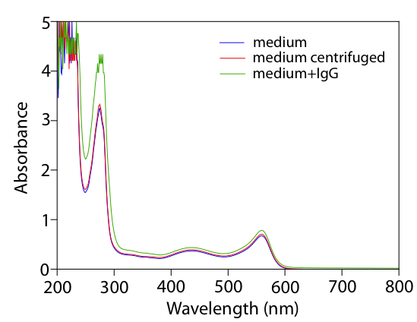
Figure S8. Absorption spectra of growth medium (blue), growth medium that has been centrifuged (red), and medium+IgG (green)

UV-VIS spectroscopy of this sample shows almost no increase of absorbance at 280 nm (red curve in Fig. S8) compared to the absorbance of pure medium (blue curve in Fig. S8), indicating the increase in absorbance for the medium+IgG case is predominantly caused by IgG. IgG has a protein extinction coefficient of 14 (i.e. , where is the absorbance at 280 nm for a 1% (1g/100ml) solution measured in a 1cm path length)¹¹; therefore . The increase in absorbance at 280 nm between the centrifuged medium (red curve in Fig. S8) and the medium+IgG solution was 1.386, implying the total concentration of IgG in medium was 0.99 mg/ml (=1.386/1.4), indicating we have recuperated ~ 0.297mg of IgG (i.e. it was a 99% successful buffer exchange).
UV-VIS spectroscopy was performed on a Shimadzu UV-3101PC UV-VIS-NIR Scanning Spectrophotometer system using a deuterium arc lamp as the excitation source from 190-360 nm and a tungsten excitation source from 360-2500 nm. The photodetector is a visible photomultiplier tube in the considered wavelength range (200-800 nm).

Raman maps (consisting of 121 spatially distinct points) were collected for graphene in air, graphene exposed to growth medium and graphene exposed to the IgG in growth medium (Fig. S9). All 3 datasets were collected in the same 20x20μm area on the same sample of graphene. Exposure of the graphene to medium decreases the amount of excess charge carriers in graphene (red squares) compared to when graphene is exposed to air (blue dots), with the data points shifting towards the undoped end of the doping trajectories. The L-15 growth medium contains n-doping amino acids that can counteract the initial p-doping in graphene, rendering it overall more undoped. Moreover it is likely that medium partially shields the graphene from the p-doping oxygen in the air. Interestingly the average G-peak position of graphene exposed to medium (~1587 cm⁻¹) is significantly higher than that measured in the earlier experiments (~1584 cm⁻¹ e.g. in Fig. 4). The main difference between both sets of measurements is that the graphene exposed to growth medium in Fig. 4 had spent 3 hours in the incubator prior to Raman mapping. This observation triggered us to investigate the effect of placing graphene in the incubator (Forma Series II, Thermo Scientific), thereby exposing to a 5% CO₂ environment, at 37 °C. We collected the same dataset as shown in Figure S8 after placing the graphene+medium and graphene+medium+IgG in the incubator for 3 hours. The results are shown in Figure S10. After exposure to the incubator atmosphere we retrieve similar values of the G peak position) ~1585 cm⁻¹ as in the earlier cell experiments (e.g. Fig. 4). This implies that it is not the decreased pH that dominates (otherwise higher G peak position values would have been obtained as shown in Fig. 2). Rather we hypothesize that due to the replacement of O₂ by dissolved CO₂ (H₂CO₃) the p-doping effect of oxygen is eliminated, resulting in a lower G-peak position. Finally we can also note that the difference between graphene exposed to medium and graphene exposed to medium+IgG is stronger after incubation (compare inset of Fig. S9 and Fig. S10).
Adding IgG to the growth medium (green diamonds in Fig. S9 and S10) decreases the average doping in graphene, likely due to the presence of n-doping moieties in the protein that make the originally p-doped graphene even more neutral. The doping effects these chemical environments have on graphene are added to Table 1 of the main text. Specifically the effect of ~1mg/ml secreted IgG into the medium introduces ~10¹² electrons/cm² (or -10¹² holes/cm²) of graphene. This implies that the IgG secretion slightly offsets the proton secretion and the change in metabolic activity between the IgG and control cells is a lower limit, i.e. the IgG producing cells are at least four times as metabolically active as the non-IgG producing control cells.

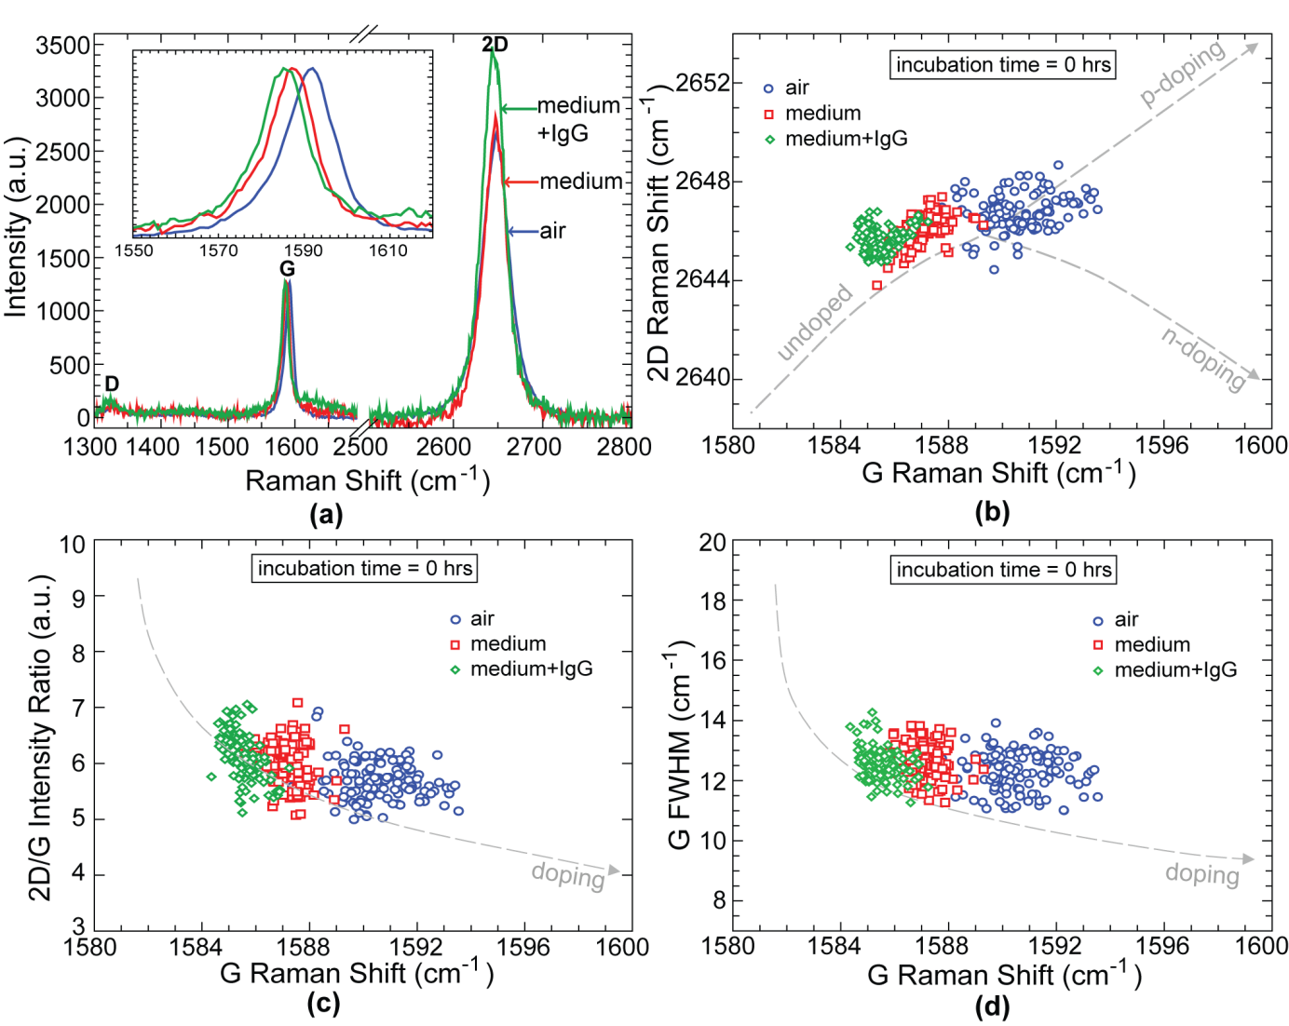
Figure S9. Raman data of graphene exposed to air (blue), growth medium (red) and both growth medium and IgG (green), without incubation. (a) Characteristic Raman spectra showing the D, G and 2D peaks of graphene; inset zooms in on the G peak. (b) 2D_{POS}-G_{POS} doping trajectory. (c) I_{2D/G}-G_{POS} doping trajectory. (d) G_{FWHM}-G_{POS} doping trajectory. Dashed lines are a guide to the eye adapted from ref.¹ The trend lines in (a) are shifted downwards to account for the dependence of the 2D peak position on the excitation wavelength (a 532nm laser was used in ref.¹ , as opposed to a 633nm laser in this work). p_{G-position} <0.01 (see Supporting Information Section VII for more details).

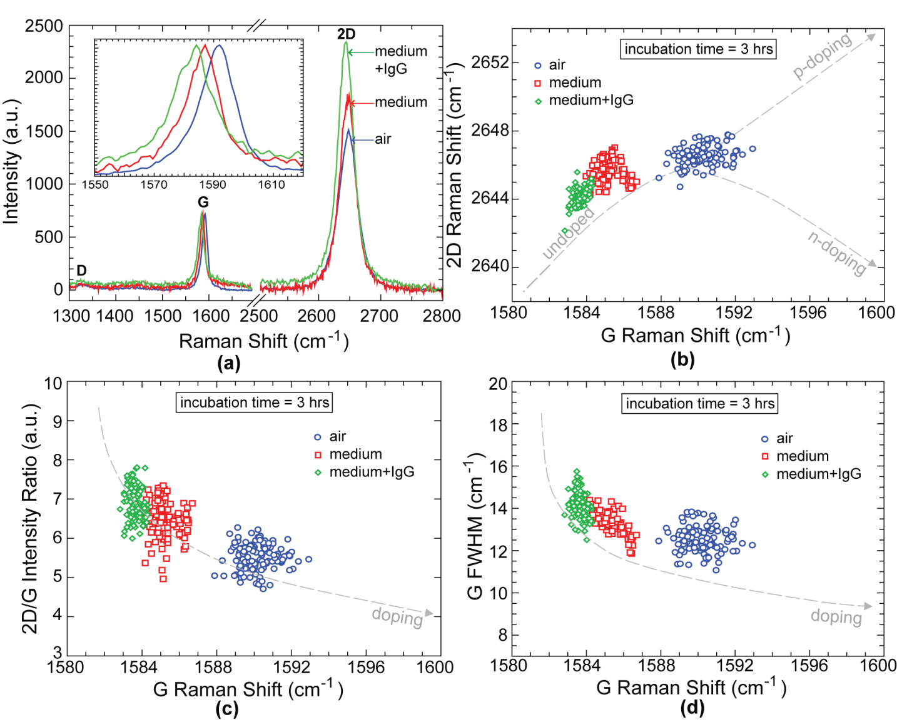
Figure S10. Raman data of graphene exposed to air (blue), growth medium (red) and both growth medium and IgG (green), after incubation. (a) Characteristic Raman spectra showing the D, G and 2D peaks of graphene; inset zooms in on the G peak. (b) 2D_{POS}-G_{POS} doping trajectory. (c) 2D/G doping trajectory. (d) G_{FWHM}-G_{POS} doping trajectory. For all distributions compared in this figure: p_{G-position} <0.01 (see Supporting Information, Section VII for more details).

XI. Dopamine detection

We aim to explore the detection of different analytes, such as catecholamines, an important group of neutrotransmitters and neuromodulators, of which the most important examples are epinephrine, norepinephrine and dopamine. A lot of research efforts focus on spatially and temporally detecting exocytosis of these molecules across the membrane of single cells ¹²⁻¹⁸. Ultimately, we wish to study dopamine uptake and release in networks of fully differentiated healthy mammalian neural cells.

Preliminary work is done using neuroendocrine, dopaminergic rat pheochromocytoma (PC12) cells, a clone cell line that shares a lot of properties of sympathetic ganglion neurons and is often used to study properties of the latter, since the primary mammalian neurons stop proliferation once matured, making them hard to work with in a laboratory setting ¹³. Like sympathetic ganglion neurons, the catecholamines in PC12 cells contain mostly dopamine, a small amount of norepinephrine, and no detectable level of epinephrine ¹³. When these cells are exposed to a solution with a high concentration of K⁺, the latter depolarizes the cell membrane and allows a Ca²⁺ influx, which in turn causes the exocytosis of vesicles of catecholamines ^{12,13,16,18}. Current methods for detecting exocytosed dopamine include amperometric detection with a carbon fiber electrode ¹³, cyclic voltammetry ¹⁹, patch clamp ²⁰, capillary electrophoresis ²¹, electrochemical cytometry ¹², and field effect transistors ¹⁶. Currently, the spatial and resolutions for chemical measurements are ~ 100 μm; this is where our Raman sensing technique displays a clear advantage. Moreover, in order to decrease data collection time, we used the higher-sensitivity confocal Raman setup described in the Methods section. The only downside to using this instrument is that the spectral range of this Raman spectrometer is limited to 1840 cm⁻¹, which means only the graphene Raman D and G peaks can be monitored.

Passaging the PC12 cells happens following the procedure described in Section IV of the Supporting Information, with two exceptions. Firstly, the PC12 neural progenitor cells are much less prone to adhere to a substrate than the HEK-293F tissue cells, alleviating the need to use trypsin when passaging them. Secondly, RPMI-1640 medium with 10% horse serum and 5% bovine serum is used to culture the cells (standard for this cell line ²²), instead of L-15 or Dulbecco medium.
Figure S11 shows that non-stimulated PC12 cells do not leave a significant Raman footprint on the graphene it covers. Note that since neural progenitor cells are typically less adherent than tissue cells, they tend to cluster together more (due to a stronger affinity for one another than for a substrate) and have a relatively round shape. In many ways the cells behave like the less-adhered control cells shown in Figure 4 of the main manuscript; it is thus not surprising the cells do not display a metabolic footprint in the graphene Raman signal (see also Figure 4f).

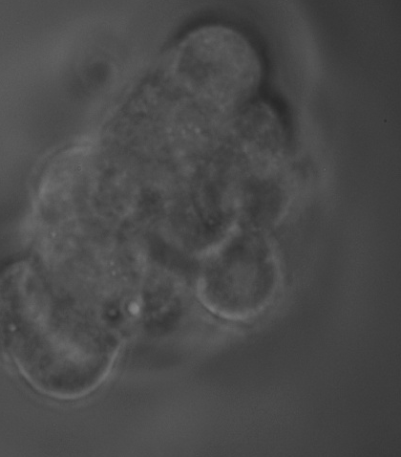

(a)

(b)

(c)

(d)

(e)

(f)
Figure S11. Effect of non-stimulated neural progenitor cells on the graphene Raman signal. (a) Optical micrograph of a cluster of PC12 cells on graphene (45μm x 45μm). (b) Rayleigh scattering (i.e. confocal reflectance) map of the area shown in (a), in the central focal plane of the cell cluster. (c) Rayleigh scattering map of the area shown in (a), in the graphene focal plane, showing the part of the cell cluster that is well-adhered to the graphene. (d-f) Spatial map of Raman G peak position (d), G peak FWHM (e), and D to G intensity ratio (f) of the graphene shown in (a); 500ms exposure.

Figure 5 of the main text shows the effect of a potassium-evoked calcium-dependent dopamine secretion on the graphene Raman signal. 50μl of 120 mM aqueous KCl solution was added to the already present 150 μl of medium containing cells on the graphene surface. Figure 5a-b show the outline of the cell cluster in the cluster’s focal plane, and Figure 5c is a confocal reflectance map of the cell cluster collected in the graphene focal plane. Comparing Figure 5c to 5b shows only the bottom part of the cell cluster is well adhered to the graphene surface. Upon stimulation, the Raman signal of the graphene that is in close contact with the cells displays a lower G peak position (Fig. 5d), an increased G peak width (Fig. 5e) and an increased D to G intensity ratio (Fig. 5f). The decrease in G peak position and increase in its width is indicative of neutralization of the pre-hole doped graphene (similarly observed for exposure of graphene to IgG – see Fig. S9 and S10 and to -OH groups – see Fig. 2). This is expected given the electron-rich aromatic ring, the -OH groups and the amine group that make up the dopamine molecule. The G peak width increase is very significant; it can also signify an increased concentration of lattice defects ²³, which is consistent with the observation of the increased D to G intensity ratio ²³ (which does not occur for graphene exposed to IgG).
Overall, Figure 5 indicates that dopamine not only changes the charge density of graphene by doping it but also covalently interacts with it. This is not surprising given the knowledge that dopamine is an extremely reactive molecule that can oxidize to form free radicals and reactive quinones ²⁴. It should be noted that the Raman data in Figure 5 were collected about one minute after cellular stimulation. Collecting the dataset took ~7 minutes. A second dataset was collected 10 minutes after stimulation and the results were quasi identical, indicating that (1) the effect of dopamine on the graphene is irreversible and/or (2), the dopamine released by the cell is ‘trapped’ between the cell and the graphene and can not diffuse out of this small pocket. Likely a combination of both effects explains the data. Covalent modification of the lattice (resulting in the increased D to G intensity ratio and increased G peak width) is typically irreversible, while physisorption (resulting in the decreased G peak position) can be reversible.
From Figure 5 it is clear that adhesion once more plays an important role: only the part of the graphene to which the cells are closely adhered displays a significant change in its Raman signal upon stimulation. Likely the dopamine released from the other cells in the cluster diffuses quickly in the medium, and is thereby significantly diluted to such an extent that it barely affects the graphene Raman signal. Increased adhesion could be achieved by coating the graphene with poly-L-lysine prior to depositing cells on it ²⁵. Moreover, using fully differentiated neurons (with dendrites and axons) rather than the round progenitor cells will likely also eliminate the adhesion issue. Future efforts will explore these options.
To verify that the observed effects in Figure 5 are caused by dopamine, graphene control samples were exposed to different concentrations of dopamine. For each scenario, 900 Raman spectra were collected in a 45μm x 45μm area. The main results are incorporated in Figure S12. The left (right) panels show the effect on the graphene Raman signal of adding 100 (10) mM dopamine to the medium. Similarly to what was observed for the graphene covered by stimulated cells, the G peak position decreases, the G peak width increases and the D to G intensity ratio increases.
When graphene is exposed to 100mM of dopamine the average G peak position decreases by ~4.5 cm⁻¹, the peak width increases by ~3.1 cm⁻¹ and the D to G intensity ratio increases from ~0.7 to 0.95. For graphene exposed to 10mM of dopamine the dopamine the average G peak position decreases by ~2.6 cm⁻¹, the peak width increases by ~2.3 cm⁻¹ and the D to G intensity ratio increases from ~0.6 to 0.85. The observed Raman changes for graphene covered by a stimulated cell (Figure 5d-f) fall in this 10-100mM range. Amperometric measurements of stimulated PC12 cells have revealed that ~190 zmol catecholamines (i.e. 114.300 molecules) are released per vesicle, which yields an average vesicular transmitter concentration of 0.11M ¹³, supporting our findings.

(b)

(a)

(c)

(d)

(e)

(f)

Figure S12. Raman data of graphene exposed to medium vs. medium containing dopamine. (a-b) Effect of dopamine on the graphene G peak position. (c-d) Effect of dopamine on the graphene G peak width. (e-f) Effect of dopamine on the graphene D to G intensity ratio. The lower and higher end of the boxplots represent the 25 and 75 percentile mark respectively; whereas the middle line is the median value of the distribution. Minimum and maximum values are represented by black stars, and the average is the black square. The red triangles represent the complete dataset, superimposed on the boxplots. Panels (a),(c) and (e) show the Raman effect of 100mM dopamine, whereas panels (b),(d) and (f) reveal the effect of 10mM dopamine. For all distributions compared in this figure: p <0.01 (see also Supporting Section IV for more details).

We also investigated the transient response of the graphene Raman signal to dopamine. A single position of a graphene sample, exposed to PBS, was monitored as a 1mM dopamine solution (in PBS) was added. The trace in Fig. S13 shows the reduction of the G peak position upon dopamine addition. Like the NaOH trace shown in Fig. 1(c), the graphene G peak position shifts within seconds.

Figure S13. Transient response of the G peak position to dopamine. A graphene sample is originally exposed to PBS- upon addition of 1mM dopamine in PBS, the G peak position is reduced.

REFERENCES

1 Das, A. et al. Monitoring dopants by Raman scattering in an electrochemically top-gated graphene transistor. Nature Nanotechnology 3, 210-215 (2008).
2 Zhang, Y., Brar, V. W., Girit, C., Zettl, A. & Crommie, M. F. Origin of spatial charge inhomogeneity in graphene. Nature Physics 5, 722-726 (2009).
3 Martin, J. et al. Observation of electron-hole puddles in graphene using a scanning single-electron transistor. Nature Physics 4, 144-148 (2007).
4 Thomson, T. M., Mattes, M. J., Roux, L., Old, L. J. & Lloyd, K. O. Pigmentation-associated glycoprotein of human melanomas and melanocytes: definition with a mouse monoclonal antibody. Journal of investigative dermatology 85, 169-174 (1985).
5 Kuroda, H., Kutner, R. H., Bazan, N. G. & Reiser, J. Simplified lentivirus vector production in protein-free media using polyethylenimine-mediated transfection. Journal of virological methods 157, 113-121 (2009).
6 Hu, T., Fu, Q., Chen, P., Zhang, K. & Guo, D. Generation of a stable mammalian cell line for simultaneous expression of multiple genes by using 2A peptide-based lentiviral vector. Biotechnology letters 31, 353-359 (2009).
7 Stern, P. et al. A system for Cre-regulated RNA interference in vivo. Proceedings of the National Academy of Sciences 105, 13895-13900 (2008).
8 Zufferey, R., Nagy, D., Mandel, R. J., Naldini, L. & Trono, D. Multiply attenuated lentiviral vector achieves efficient gene delivery in vivo. Nature biotechnology 15, 871-875 (1997).
9 Dull, T. et al. A third-generation lentivirus vector with a conditional packaging system. Journal of virology 72, 8463-8471 (1998).
10 Scopes, R. K. Protein purification: principles and practice. (Springer, 1993).
11 Ross, D. & Jirgensons, B. The far ultraviolet optical rotatory dispersion, circular dichroism, and absorption spectra of a myeloma immunoglobulin, immunoglobulin G. Journal of Biological Chemistry 243, 2829-2836 (1968).
12 Mellander, L., Cans, A. Ä. & Ewing, A. G. Electrochemical probes for detection and analysis of exocytosis and vesicles. ChemPhysChem 11, 2756-2763 (2010).
13 Chen, T. K., Luo, G. & Ewing, A. G. Amperometric monitoring of stimulated catecholamine release from rat pheochromocytoma (PC12) cells at the zeptomole level. Analytical chemistry 66, 3031-3035 (1994).
14 Heien, M. L. et al. Real-time measurement of dopamine fluctuations after cocaine in the brain of behaving rats. Proceedings of the National Academy of Sciences of the United States of America 102, 10023-10028 (2005).
15 Phillips, P. E., Stuber, G. D., Heien, M. L., Wightman, R. M. & Carelli, R. M. Subsecond dopamine release promotes cocaine seeking. Nature 422, 614-618 (2003).
16 He, Q. et al. Centimeter-long and large-scale micropatterns of reduced graphene oxide films: fabrication and sensing applications. ACS nano 4, 3201-3208 (2010).
17 Alivisatos, A. P. et al. Nanotools for Neuroscience and Brain Activity Mapping. ACS nano (2013).
18 Koike, T. & Takashima, A. Cell Cycle-Dependent Modulation of Biosynthesis and Stimulus-Evoked Release of Catecholamines in PC12 Pheochromocytoma Cells. Journal of neurochemistry 46, 1493-1500 (1986).
19 Livett, B., Boksa, P., Dean, D., Mizobe, F. & Lindenbaum, M. Use of isolated chromaffin cells to study basic release mechanisms. Journal of the autonomic nervous system 7, 59-86 (1983).
20 Staal, R. G., Mosharov, E. V. & Sulzer, D. Dopamine neurons release transmitter via a flickering fusion pore. Nature neuroscience 7, 341-346 (2004).
21 Chen, G., Gavin, P. F., Luo, G. & Ewing, A. G. Observation and quantitation of exocytosis from the cell body of a fully developed neuron in Planorbis corneus. The Journal of neuroscience 15, 7747-7755 (1995).
22 Li, R., Kong, Y. & Ladisch, S. Nerve growth factor-induced neurite formation in PC12 cells is independent of endogenous cellular gangliosides. Glycobiology 8, 597-603 (1998).
23 Cançado, L. G. et al. Quantifying defects in graphene via Raman spectroscopy at different excitation energies. Nano letters 11, 3190-3196 (2011).
24 Cadet, J. L. & Brannock, C. Invited Review Free radicals and the pathobiology of brain dopamine systems. Neurochemistry international 32, 117-131 (1997).
25 Li, N. et al. The promotion of neurite sprouting and outgrowth of mouse hippocampal cells in culture by graphene substrates. Biomaterials 32, 9374-9382 (2011).

