Supplementary Information for:

Early crocodylomorph increases top predator diversity during rise of dinosaurs

Lindsay E. Zanno^{1,2*}, Susan Drymala^{1,2*}, Sterling J. Nesbitt³, & Vincent P. Schneider¹
¹Research & Collections, North Carolina Museum of Natural Sciences, Raleigh, NC 27601, USA
²Department of Biological Sciences, North Carolina State University, Raleigh, NC 27607, USA
³Department of Geosciences, Virginia Polytechnic Institute and State University, Blacksburg, VA 24061, USA

CONTENTS

I. Stratigraphic Information
II. Character codes for Carnufex & Redondavenator
III. References #59-#61

Figure S1: 3D PDF of right premaxilla*
Figure S2: 3D PDF of left maxilla*
Figure S3: 3D PDF of left lacrimal*
Figure S4: 3D PDF of left jugal*
Figure S5: 3D PDF of right angular (reversed)*
Figure S6: 3D PDF of left articular*
Figure S7: 3D PDF of cervical neural arch*
Figure S8: 3D PDF of dorsal neural arch*
Figure S9: Photographic figure of NCSM 21623
Figure S10: Strict consensus tree with support values
Figure S11: OLS linear regression of humeral length against femur length in Loricata
Figure S12: OLS linear regression of skull length against femur length in Loricata
Figure S13: OLS linear regression of skull length against humeral length in Loricata

Table S1: Taxonomic dataset for scaling equations
Table S2: Femur length of carnivorous pseudosuchians used in bivariate plots
of body mass and geologic time (Fig. 2B,C)
Table S3: Select measurements of Carnufex carolinensis

*3-dimentional PDFs of individual elements included as separate files.
I. Stratigraphic Information

The Deep River Basin of North and South Carolina represents the southernmost exposure of Upper Triassic sequences deposited on the east coast of North America during the rifting of Pangea⁵⁹. The basin is further divided along a northeast/southwest transect into the Wadesboro, Sanford, and Durham nominal subbasins. The Pekin Formation is the oldest strata in the Chatham Group, overlain by the Cumnock and Sanford formations respectively⁶⁰. Carnufex carolinensis was recovered from an active brick quarry in the mid-upper Pekin Formation, northern Sanford Basin (detailed locality data on file at NCMNS, locality NCPALEO 1902). The specimen was discovered in a boulder field out of stratigraphic context. Its exact stratigraphic position within Pekin Fm. has not yet been determined; however, the lithology of these boulders is consistent with a channel and/or alluvial fan deposit located near the base of the quarry⁶⁰. Paleomagnetic data indicates that the Pekin Formation was deposited 2°S of the Triassic paleoequator at ~231 Ma¹². The overlying Cumnock Formation, from which Postosuchus alisonae and Dromicosuchus grallator were recovered, was deposited at the equator between 226-224 Myr¹².

In dating to 231 Ma, Carnufex is older than or penecontemporaneous with oldest confirmed crocodylomorph Trialestes romeri, which stems from lower to middle strata of the Ischigualasto Formation (231-227 Myr⁶¹). At least two specimens of Trialestes are known. Although the holotype derives from the Cancha de Bochas Member (lower third of the formation [231-228 Myr⁶¹) a specimen referred to Trialestes romeri was recovered near Cerro Las Lajas^{10,62}, which may preserve younger deposits (227 Ma)¹⁰, although these beds have not been dated as other part of the Ischigualasto Formation. Based on this association, a reasonable estimate for Trialestes would be closer to 228 Ma¹⁰; however, it is not yet clear if the two specimens represent the same taxon.

The Pekin Formation preserves an entirely new window on equatorial Pangean assemblages. Although the vertebrate fauna remains mostly undescribed, a diversity of specimens have been recovered, almost all of which represent novel taxa. These include: a new aetosaur²⁶; two new crocodylomorphs (Carnufex and a small bodied taxon²⁷; a traversodont cynodont formerly assigned to Boreogomphodon²⁵; and a new dicynodont²⁴.

II. Character codes for Carnufex & Redondovenator

Carnufex carolinensis
?00?0300001?0010000?0000022?11???????01?????????????????????????0?00113?000????????????????????????????????????????????????????????????12100?1?????????????11?1??0?1??01000001????????????0??????00?00???????????????????????????????0???000????????????????????????????????????????????????????????????????????????????????????????????????????????????????????????????????????????????????????????????????????????????????0

Redondovenator quayensis
010?0200001001???000?0?00??????2??0???????????????????????????????????????????????????????????????????????????????????????????????????????00??????????????????????????01000001????????????????????????????????????????????0??11??????????????????????????????????????????????????????????????????????????????????????????????????????????????????????????????????????????????????????????????????????????????????????????????

- References #59-62

59. Olsen, P. E. & Huber, P. The oldest Late Triassic footprint assemblage from North America (Pekin Formation, Deep River basin, North Carolina, USA). Southeastern Geol. 38, 77–90 (1998).

60. Heckert, A. B., Schneider, V. P., Fraser, N. C., Webb, R. A. A new aetosaur (Archosauria, Suchia) from the Upper Triassic Pekin Formation, Deep River Basin, North Carolina, U.S.A. and its implications for early aetosaur evolution. J. Vertebr. Paleontol. (in press).

61. Martinez, R. N. et al. A basal dinosaur from the dawn of the dinosaur era in south-western Pangea. Science 331, 206–210 (2011).

62. Bonaparte, J. F. El Mesozoico de Americá del Sur y sus tetrapodos. Opera Lilloana, 26, 1–596 (1978).

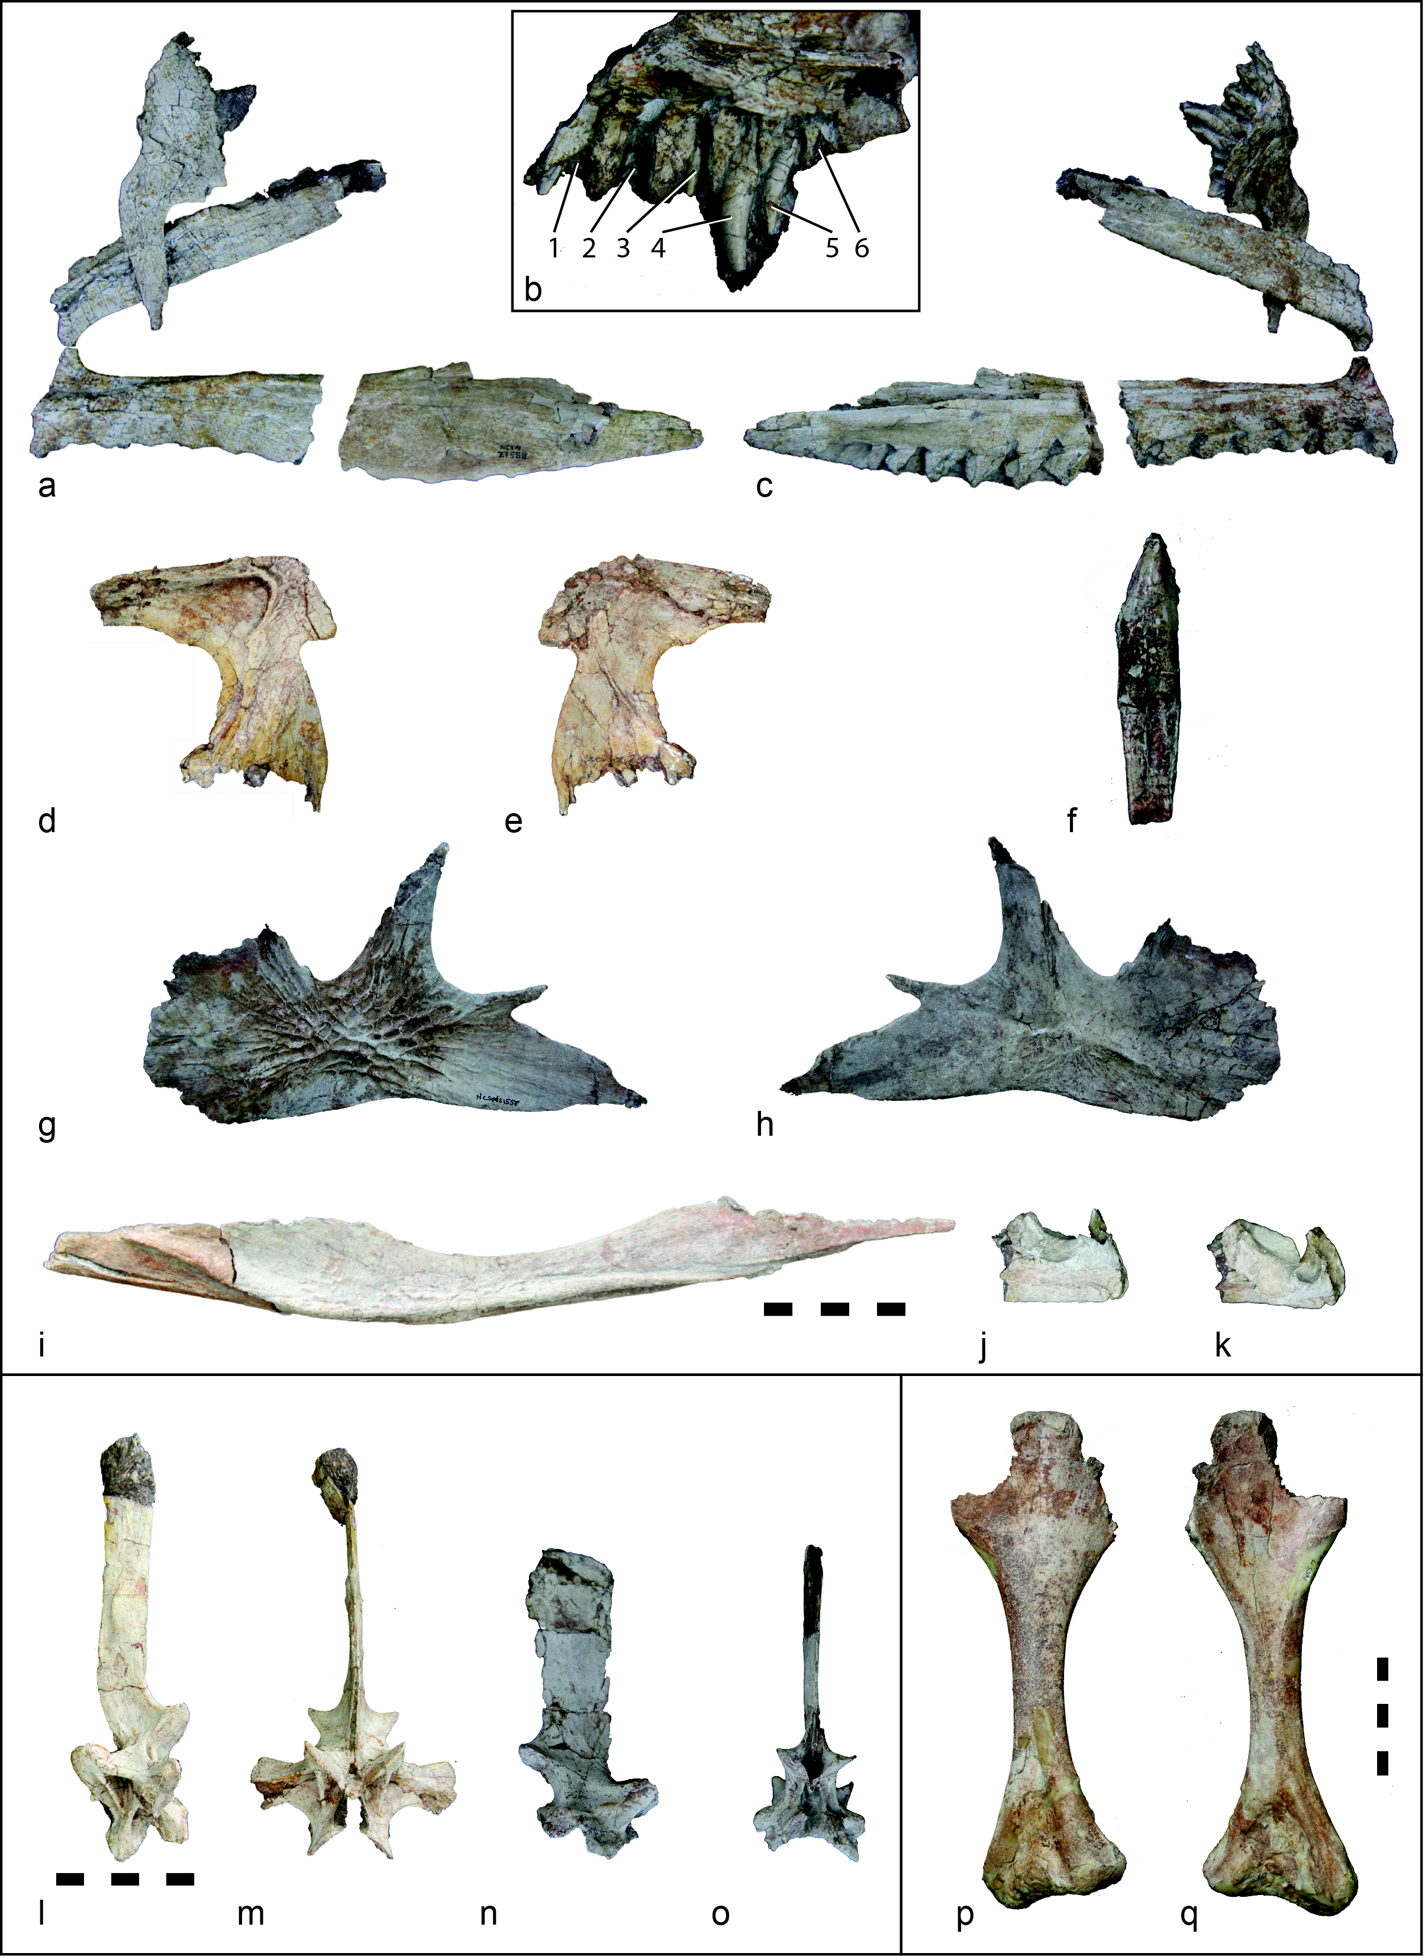
Figure S9. Photographic figure of NCSM 21623). right premaxilla and maxilla in lateral (a) and medial (c) views; (b) right premaxilla detail of teeth and alveoli (not to scale); left lacrimal, lateral (d) and medial (e) views; (f) isolated maxillary tooth with root; left jugal in lateral (g) and medial (h) views; (i) right angular, lateral view; left articular in lateral (j) and medial (k) views; cervical neural arch in left lateral (l) and cranial (m) views; dorsal neural arch in right lateral (n) and caudal (o) views; right humerus in caudal (p) and cranial (q) views. Scale bar corresponds to all elements in boxes: 5 cm.

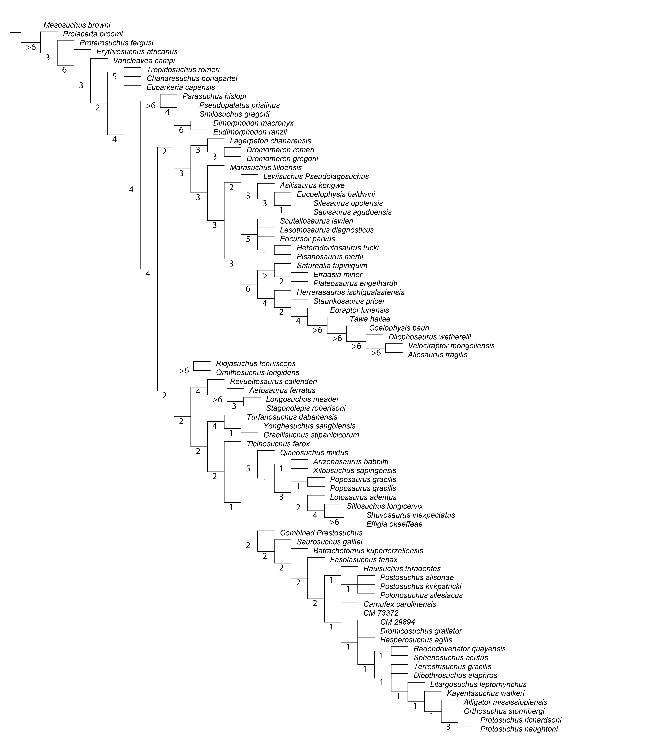
Figure S10. Strict consensus tree with Bremer values.

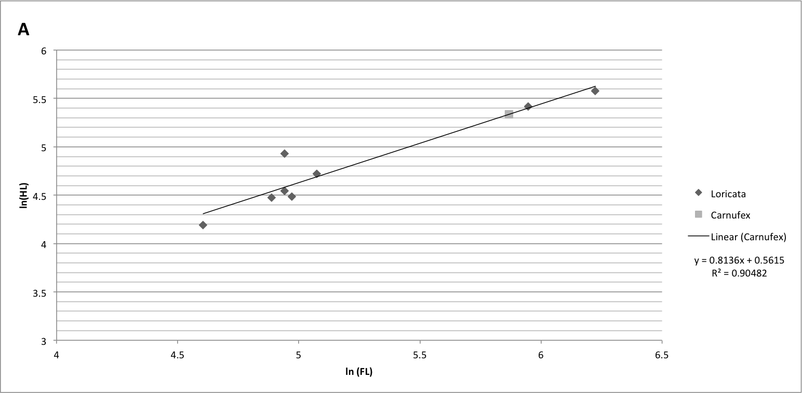
Figure S11. OLS linear regression of humeral length against femur length in Loricata. Calculated values of Carnufex plotted for reference.

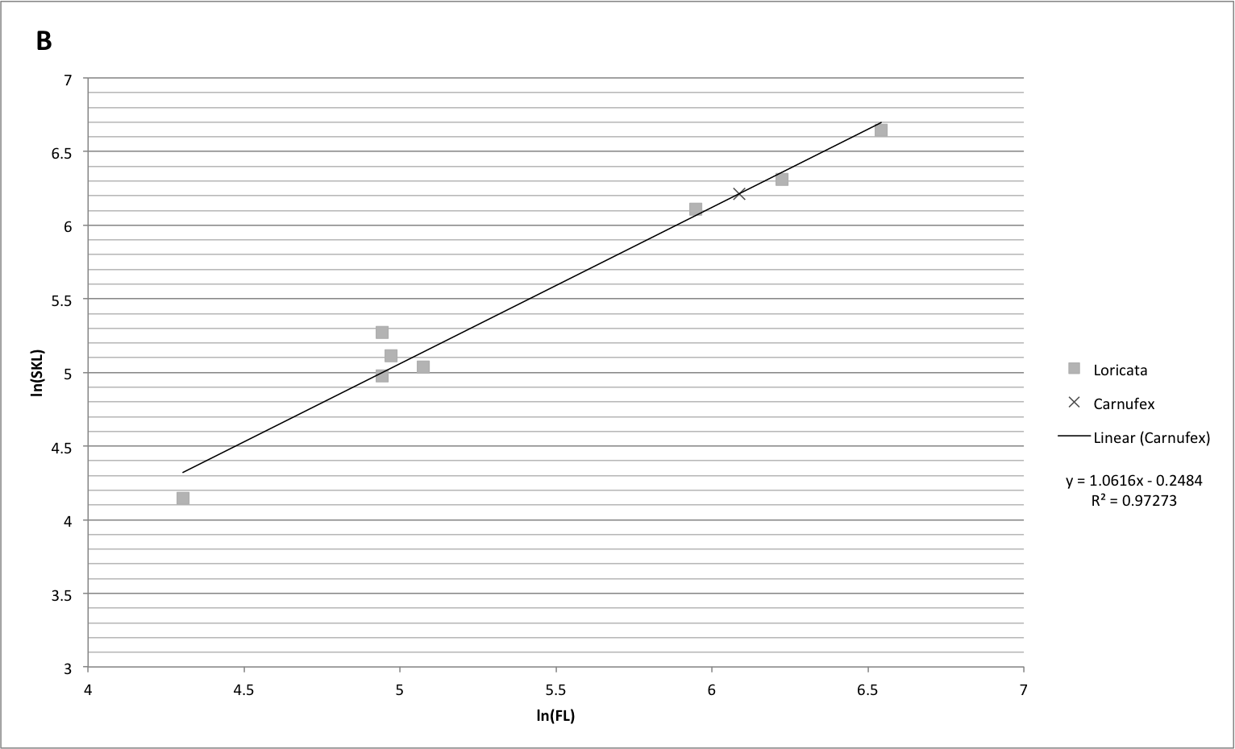
Figure S12. OLS linear regression of skull length against femur length in Loricata. Calculated values of Carnufex plotted for reference.

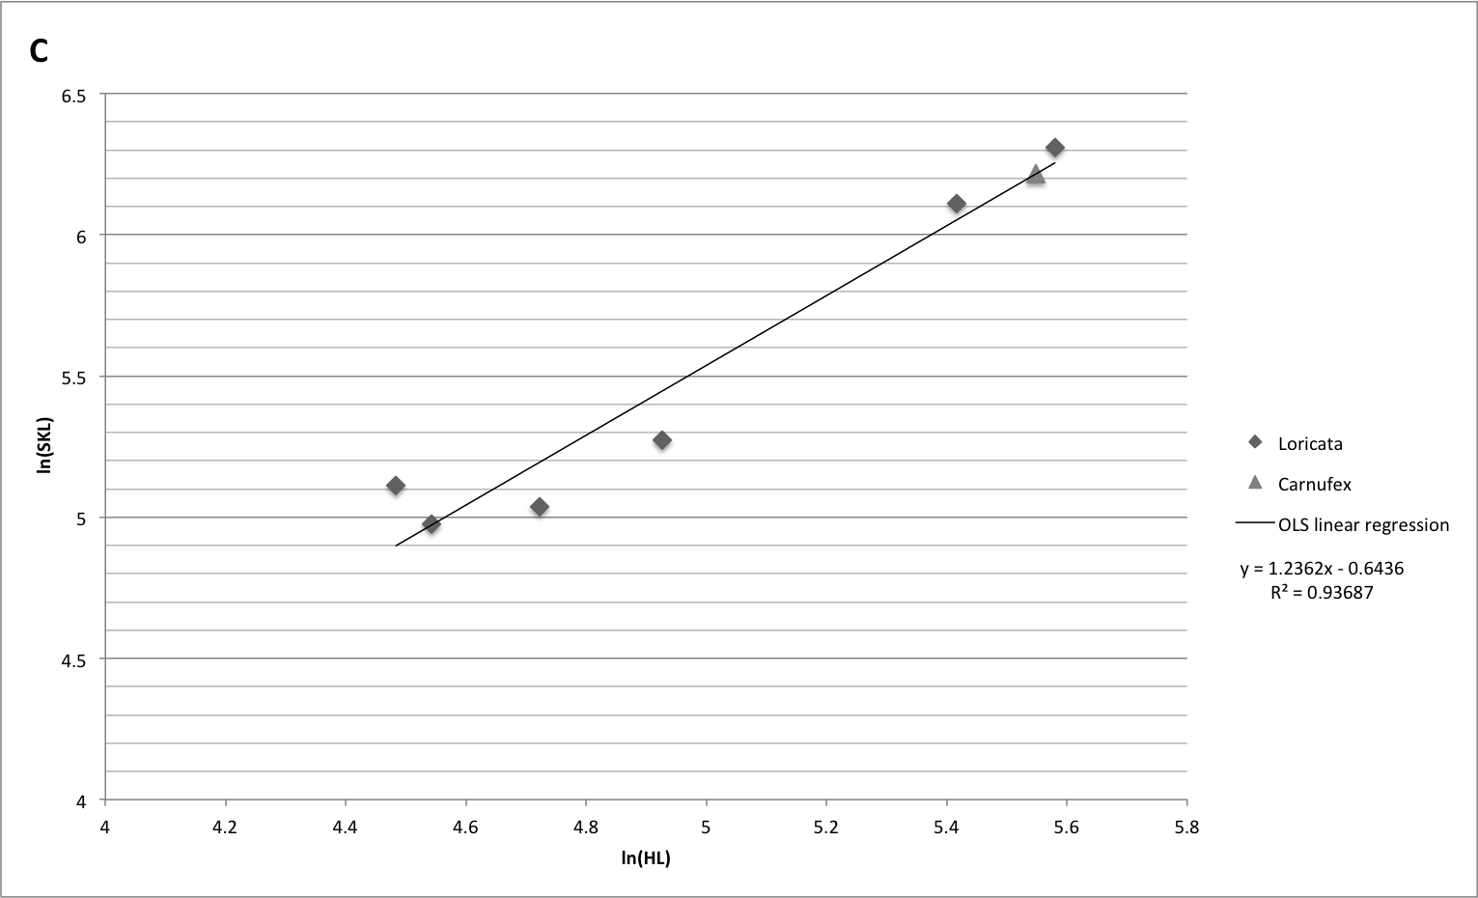
Figure S13. OLS linear regression of skull length against humeral length in Loricata. Calculated values of Carnufex plotted for reference.

Table S1. Taxonomic dataset for scaling equations. Measurements in mm.
Taxon | FL | ln(FL) | HL | ln(HL) | SKL | ln(SKL) | Reference
Saurosuchus galilei | 694 | 6.542 |  |  | 670 | 6.507 | Sill 1974
Postosuchus kirkpatricki | 505 | 6.225 | 265 | 5.580 | 550 | 6.310 | Chatterjee 1985
Postosuchus kirkpatricki | 383 | 5.948 | 225 | 5.416 | 450 | 6.109 | Chatterjee 1985
Hesperosuchus agilis | 140 | 4.942 | 94 | 4.543 | 145 | 4.977 | Colbert 1952
CM 29894 | 140 | 4.942 | 138 | 4.927 | 195 | 5.273 | Clark et al. 2000
Dromicosuchus grallator | 144.3 | 4.972 | 88.6 | 4.484 | 166.3 | 5.114 | NCSM 13733 (UNC 15574)
Dibothrosuchus elaphros | 160 | 5.075 | 112.5 | 4.723 | 154 | 5.037 | Wu & Chattergee 1993
Litargosuchus leptorhynchus | 74 | 4.304 |  |  | 63 | 4.143 | Clark & Sues 2002
Protosuchus haughtoni | 90 | 4.500 |  |  |  |  | Turner & Nesbitt 2013
Protosuchus richardsoni | 100 | 4.605 | 66 | 4.190 |  |  | Colbert & Mook 1951
NCSM 21722 | 132.5 | 4.887 | 87.6 | 4.472 |  |  | NCSM 21722

Table S2. Femur length of carnivorous pseudosuchians used in bivariate plots of body mass and geologic time (Fig. 2B,C). Data sources listed. Measurements in mm.
Symbol (Fig. 2) | Taxon | FL | Reference | Age
CROCODYLOMORPHA
a | Carnufex carolinensis | 353*-440* | NCSM 21558 | 231 Ma, Carnian, Late Triassic
b | Dromicosuchus grallator | 144 | Turner & Nesbitt 2013 | 226 Ma, early Norian, Late Triassic
c | CM 73372 | 290 | Turner & Nesbitt 2013 | Rhaetian, Late Triassic
d | Redondavenator quayensis | 523* | this paper | Rhaetian, Late Triassic
e | CM 29894 | 140 | Turner & Nesbitt 2013 | Rhaetian, Late Triassic
f | Hesperosuchus agilis | 140 | Colbert 1952 | early Norian, Late Triassic
g | Terrestrisuchus gracilis | 80 | Crush 1984 | Rhaetian, Late Triassic
h | Saltoposuchus connectens | 111 | Turner & Nesbitt 2013 | 215–212 Ma, Norian, Late Triassic
i | NCSM 21722 | 133 | NCSM 21722 | 231 Ma, Carnian, Late Triassic
j | Trialestes romeri | 203* | Reig 1962 | 229–231 Ma, Carnian, Late Triassic
k | Pseudhesperosuchus jachaleri | 159 | Turner & Nesbitt 2013 | 227–213 Ma, Norian, Late Triassic
l | Kayentasuchus walker | 129 | Turner & Nesbitt 2013 | Sinemurian, Early Jurassic
m | Sphenosuchus acutus | 140 | Turner & Nesbitt 2013 | Hettangian, Early Jurassic
n | Litargosuchus leptorhynchus | 74 | Turner & Nesbitt 2013 | Hettangian, Early Jurassic
o | Pedeticosaurus leviseuri | 113* | Walker 1970 | Sinemurian, Early Jurassic
p | Dibrothosuchus elaphros | 154*-167* | Wu and Chatterjee 1993 | Sinemurian, Early Jurassic
q | Phyllodontosuchus lufengensis | 71* | Harris et al. 2000 | Sinemurian, Early Jurassic
RAUISUCHIDAE
A | Rauisuchus tiradentes | 338 | Turner & Nesbitt 2013 | Carnian, Late Triassic
B | Polonosuchus silesiacus | 355 | Turner & Nesbitt 2013 | Carnian, Late Triassic
C | Postosuchus kirkpatricki | 528 | Long & Murry 1995 | early Norian, Late Triassic
D | Postosuchus alisonae | 558 | Turner & Nesbitt 2013 | 226 Ma, early Norian, Late Triassic
BASAL LORICATA
E | Fasolasuchus tenax | 750 | Turner & Nesbitt 2013 | late Norian, Late Triassic
F | Batrachotomus kupferzellensis | 420 | Turner & Nesbitt 2013 | Ladinian, Middle Triassic
G | Saurosuchus galilei | 694 | Turner & Nesbitt 2013 | Carnian, Late Triassic
H | Prestosuchus chiniquensis | 538 | Turner & Nesbitt 2013 | Ladinian, Middle Triassic
POPOSAUROIDEA
I | Ticinosuchus ferox | 240 | Krebs 1965 | Anisian, Middle Triassic
J | Qianosuchus mixtus | 491 | Li et al. 2006 | Anisian, Middle Triassic
K | Arizonasaurus babbitti | 490 | Turner & Nesbitt 2013 | Anisian, Middle Triassic
L | Xilousuchus sapingensis | 302 | Turner & Nesbitt 2013 | Olenekian, Early Triassic
M | Poposaurus gracilis | 353 | Long & Murry 1995 | Carnian–early Norian, Late Triassic
N | Lotosaurus adentus | 266 | Turner & Nesbitt 2013 | Anisian, Middle Triassic
O | Sillosuchus longicervix | 540 | Turner & Nesbitt 2013 | 229–231 Ma, Carnian, Late Triassic
P | Shuvosaurus inexpectatus | 255 | Turner & Nesbitt 2013 | early Norian, Late Triassic
Q | Effigia okeeffeae | 301 | Nesbitt 2007 | Rhaetian, Late Triassic
GRACILISUCHIDAE
R | Gracilisuchus stipanicicorum | 79.93 | Lecuona and Desojo, 2011 | Ladinian, Middle Triassic
S | Yonghesuchus sangbiensis | 146* | Butler et al. 2014 | 235–239 Ma, Ladinian, Middle Triassic
T | Turfanosuchus dabanensis | 135 | Wu and Russell 2001 | Ladinian, Middle Triassic
ORNITHOSUCHIDAE
U | Riojasuchus tenuisceps | 171 | Turner & Nesbitt 2013 | 227–213 Ma, Norian, Late Triassic
V | Ornithosuchus longidens | 87 | Colbert 1952 | Carnian–early Norian, Late Triassic
W | Venaticosuchus rusconii | 171* | Baczko & Ezcurra 2013 | 232–225 Ma, late Carnian-early Nornian
DINOSAURIA
1 | Staurikosaurus pricei | 220 | Carrano 2006 | Carnian, Late Triassic
2 | Chindesaurus bryansmalli | 265 | Long & Murry 1995 | 212 Ma, late Norian, Late Triassic
3 | Herrerasaurus ischigualastensis | 482 | Carrano 2006 | 229–231 Ma, Carnian, Late Triassic
4 | Eoraptor lunensis | 154 | Carrano 2006 | 229–231 Ma, Carnian, Late Triassic
5 | Guaibasaurus bandelariensis | 214 | Carrano 2006 | early Norian Late Triassic
6 | Tawa hallae | 174 | Irmis 2011 | 212 Ma, late Norian, Late Triassic
7 | Liliensternus liliensterni | 424 | Carrano 2006 | late Norian, Late Triassic
8 | Procompognathus triassicus | 92.5 | Fraas 1913 | 215–212 Ma, Norian, Late Triassic
9 | Coelophysis bauri | 233 | Turner & Nesbitt 2013 | Rhaetian, Late Triassic
10 | Sanjuansaurus gordilloi | 395 | Alcober & Martinez 2010 | 231 Ma, Carnian, Late Triassic
11 | Eodromaeus murphi | 150.2 | Martinez et al. 2011 | 229–231 Ma, Carnian, Late Triassic
12 | Coelophysis rhodesiensis | 203 | Carrano 2006 | Hettangian, Early Jurassic
13 | Cryolophosaurus ellioti | 769 | Smith et al 2007 | Sinemurian-Pliensbachian, Early Jurassic
14 | Dilophosaurus wetherilli | 552 | Carrano 2006 | Sinemurian, Early Jurassic
15 | “Dilophosaurus” sinensis | 587 | Carrano 2006 | Hettangian, Early Jurassic
16 | “Syntarsus” kayentakatae (MNA V2623) | 272 | Carrano 2006 | Sinemurian-Pliensbachian, Early-Middle Jurassic
17 | Daemonosaurus chauliodus | 175* | Sues et al. 2011 | Rhaetian, Late Triassic
18 | Zupaysaurus rougieri | 770* | Arcucci & Coria 2003 | Norian, Late Triassic

Table S3. Select measurements of Carnufex carolinensis (NCSM 21623).
Element | Measurement (mm)
Premaxilla | alveolar margin length | 53
 | posterior process length | 56
 | total length | 90
External Naris | length (min) | 20
Maxilla | length (min) | 207
 | height (min) | 108
Antorbital Fenestra | length (min) | 154
 | height (min) | 68
Lacrimal | length | 84
 | height | 89
Jugal | length | 179
 | height | 94
Orbit | height (min) | 68
 | width (min) | 50
Angular | length | 328
Mandibular Fenestra | length | 100
Articular | length | 45
Humerus | length | 210
 | shaft width (long axis) | 22
 | proximal end width | 71
 | distal end width | 65
Vertebrae |  | Cervical | Dorsal
 | centrum length (min) | 30 | 37
 | neural spine height | 104 | 75
 | total height | 146 | 103

