Supplementary
Directionality of substrate translocation of the hemolysin Type I secretion system
Michael H. H. Lenders¹, Stefanie Weidtkamp-Peters², Diana Kleinschrodt³, Karl-Erich Jaeger^{4,5}, Sander H. J. Smits¹ and Lutz Schmitt^{1,5}*

¹Institute of Biochemistry, Heinrich-Heine-Universitaet, 40225 Duesseldorf, Germany
²Center for Advanced Imaging (CAi), Heinrich-Heine-Universitaet, 40225 Duesseldorf, Germany

³Protein Production Facility, Heinrich-Heine-Universitaet, 40225 Duesseldorf, Germany
⁴Institute for Molecular Enzyme Technology (IMET), Forschungszentrum Jülich, 52426 Jülich, Germany
⁵Center of Excellence on Plant Sciences (CEPLAS), Heinrich-Heine-Universitaet, 40225 Duesseldorf, Germany

*To whom correspondence should be addressed:
Lutz.Schmitt@hhu.de
Tel. +49 211 81-10773
Fax +49 211 81-15310
Universitaetsstraße 1
40225 Duesseldorf
Germany
Figures legends
Supplementary Fig. 1
Domain organization of different T1SS substrates. Boxes on the left highlight the ABC transporter families involved in the T1SS. “CLD” describes a T1SS with an ABC transporter with an N-terminal CLD extension, contributing defective peptidase, “C39” describes a T1SS with an ABC transporter having an active N-terminal C39 peptidase domain and “no” describes an ABC transporter without additional domains. Proteins are abbreviated as follows and listed with their corresponding UniProtKB entries: HlyA, hemolysin A; LktA, leukotoxin; RtxA, RtxA; CyaA, bifunctional hemolysin/adenylate cyclase; PaxA, exotoxin PaxA; CvaC, colicin V protein; ComC, competence-stimulating peptide type 1; HasA, hemophore HasA; EprA, metalloprotease EprA. Domains of the substrates are labeled as follows: AC, adenylate cyclase domain; RTX, RTX domain; GG, GG repeats; SEC, secretion signal; L, N-terminal leader peptide; MP, metalloprotease domain.

Supplementary Fig. 2
Plasmid map pK184-HlyBD. The map was created using the PlasMapper web server ¹.

Supplementary Fig. 3
Plasmid map pSOI-eGFP-HlyAc^{BAD} / HlyAc^{lac}. The map was created using the PlasMapper web server ¹.

Supplementary Fig. 4
Plasmid map pSOI-eGFP-HlyAc-Δss^{BAD} / HlyAc^{lac}. The map was created using the PlasMapper web server ¹.
Supplementary Fig. 5
Plasmid map pSOI-eGFP-HlyAc. The map was created using the PlasMapper web server ¹.

Supplementary Fig. 6
Western blot analysis of supernatants and total cells content of CLSM analyzed cells. eGFP-HlyAc respectively eGFP-HlyAc-Δss, HlyB and HlyD are only present if the corresponding promotors were induced.

Supplementary Fig. 7
Western blot analysis of supernatants and total cells content of CLSM analyzed cells. eGFP-HlyA respectively eGFP-HlyA-Δss, HlyB and HlyD are only present if the corresponding promotors were induced.

Figures

Supplementary Figure 1

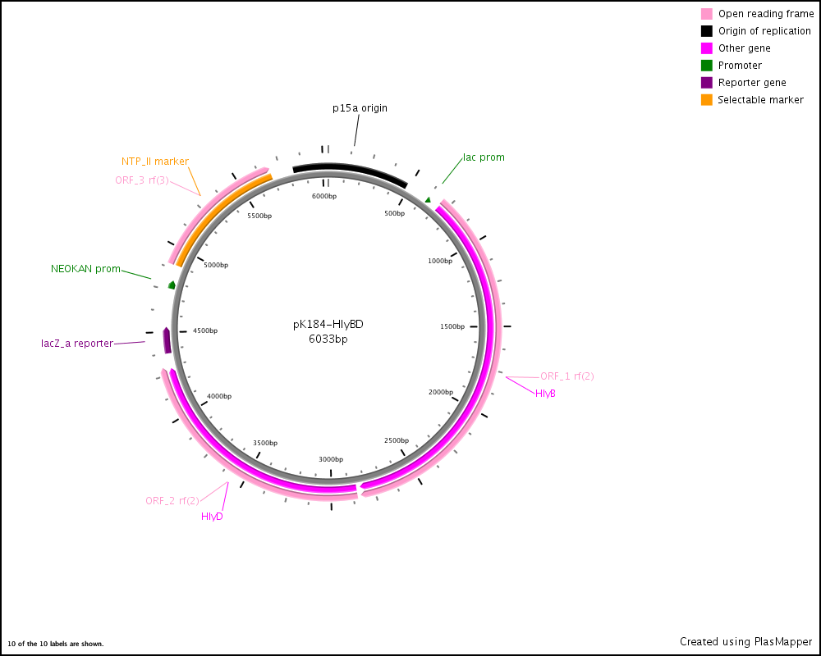
Supplementary Figure 2
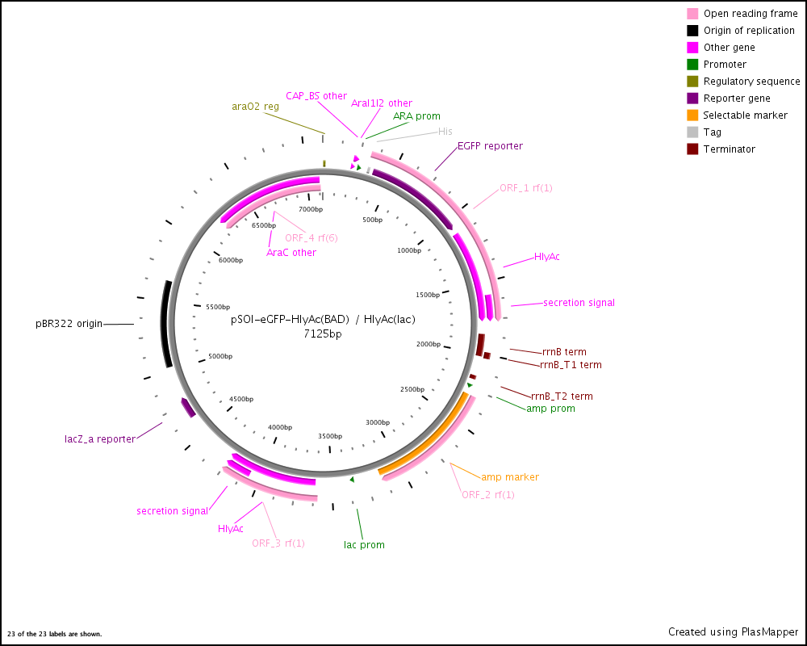
Supplementary Figure 3
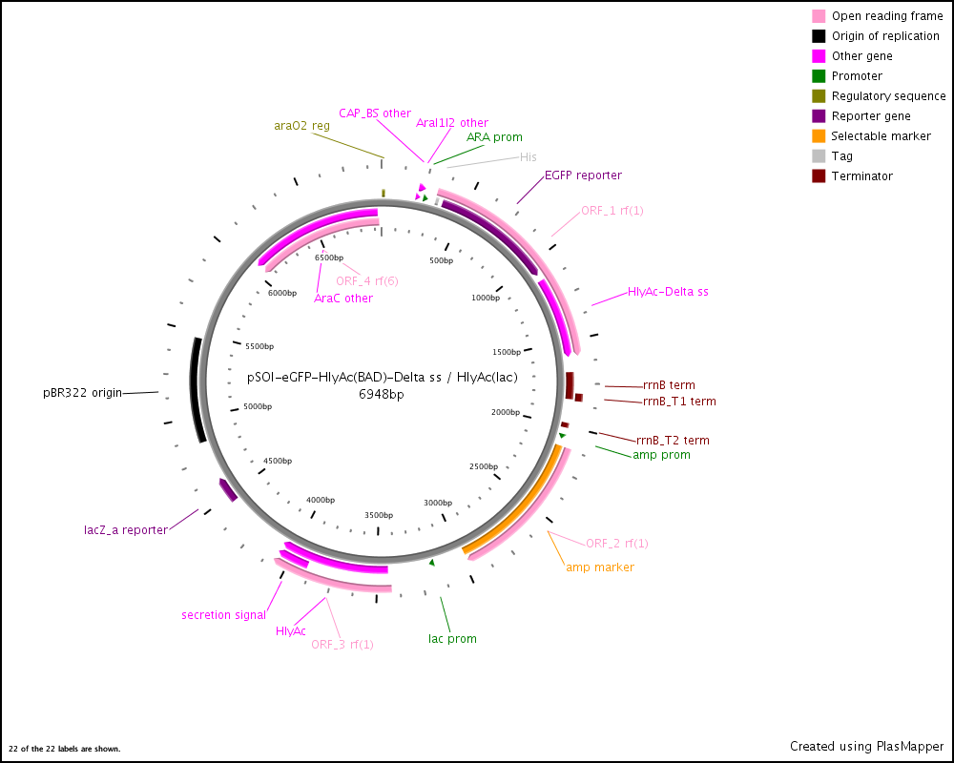
Supplementary Figure 4
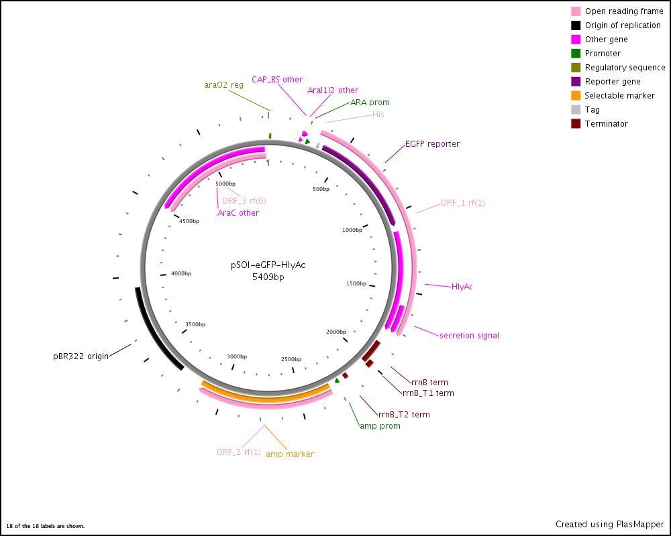
Supplementary Figure 5

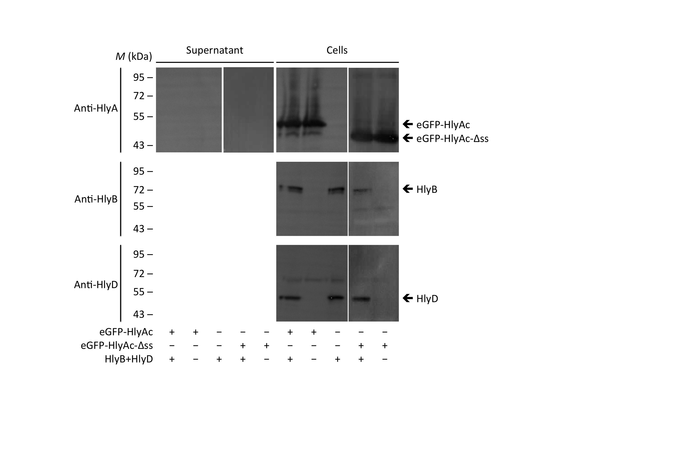
Supplementary Figure 6

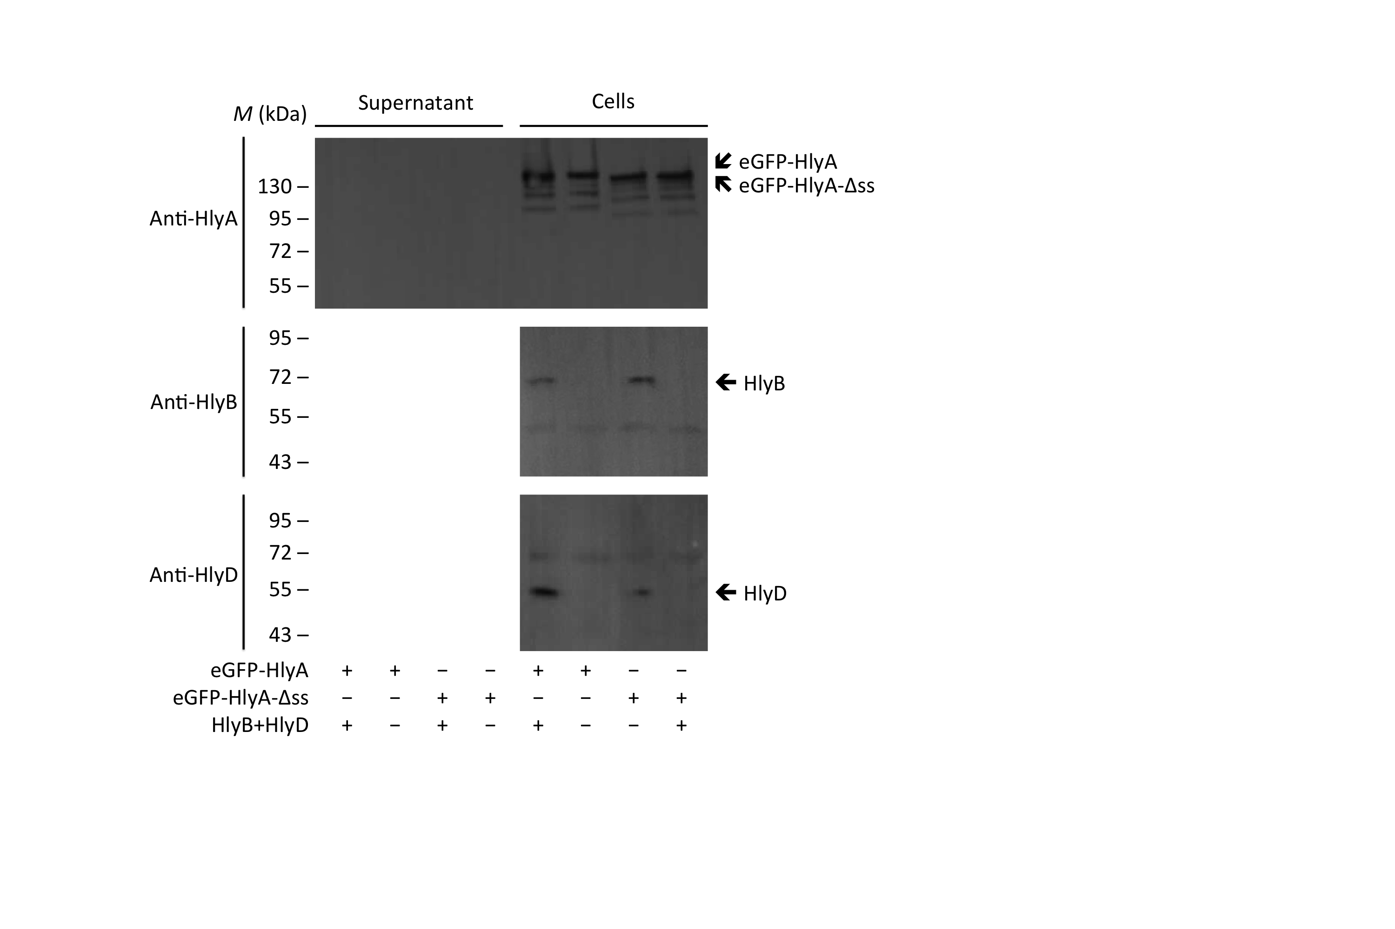
Supplementary Figure 7

Tables

Supplementary Table 1
Primers used in this study
Name | Sequence
HlyAcΔ-ss-for | 5’-GGACATGATGCATGAACTTATGGGAG-3’
HlyAcΔ-ss-rev | 5’-CTCCCATAAGTTCATGCATCATGTCC-3’
pSOI-ColE1-for | 5’-CATTTTTAATTTAAAAGGATCTAGGTGAAG-3’
pSOI-AMP-rev | 5’-AGTTTTAAATCAATCTAAAGTATATATGAGTAAAC-3’
Inf-pSOI-HlyA-F | 5’-GATTGATTTAAAACTGCCAATACGCAAACCGCCTCTC-3’
Inf-pSOI-HlyA-R | 5’-TTTAAATTAAAAATGTAGGGGTTCCGCGCACATTTCC-3’
RF_pSOI_eGFP_for | 5’-CCATCATGGTGAGAATTTATATTTTCAAGGTGTGAGCAAGGGCGAGG-3’
RF_pSOI_eGFP_rev | 5’-TGGAAGGGTGGGATTTACCGGACTTGTACAGCTCGTCCATGC-3’
RF_pSOI_HlyA_for | 5’-CCCTTCCAGCATCGAAGGCCGCATGACAACAATAACCACTGCAC-3’
RF_pSOI_HlyA_rev | 5’-TCCGCCAAAACAGCCAAGCTTATGCTGATGTGGTCAGGGT-3’
HlyAΔss_for | 5’-GGGAATGATGCATAAGCCTATGGAAG-3’
HlyAΔss_rev | 5’-CTTCCATAGGCTTATGCATCATTCCC-3’
Deletion-HlyAc-for | 5’-TAAGCTTGGCTGTTTTGGCGGATG-3’
Deletion-HlyAc-rev | 5’-TCATGCATCATGTCCATACACATAACTTACCTT-3’

Supplementary Table 2
Plasmids used in this study
Name | Description | Reference
pK184-HlyB  pSU-hlyA  pSOI-eGFP-HlyAc  pSOI-eGFP-HlyAc-Δss  pSOI-eGFP-HlyAc^{BAD} / HlyAc^{lac}  pSOI-eGFP-HlyAc-Δss ^{BAD} / HlyAc^{lac}  pSOI-eGFP-HlyA  pSOI-eGFP-HlyA-Δss | Plasmid encoding hlyB and hlyD  Plasmid hlyA  eGFP inserted in pSOI-HlyAc ² via restriction free cloning  Plasmid pSOI-eGFP-HlyAc with a stop codon in front of the HlyAc secretion signal via site-directed mutagenesis  HlyAc with lac promoter inserted in pSOI-eGFP-HlyAc via In-Fusion® Advantage PCR Cloning Kit (Clontech)  Plasmid pSOI-eGFP-HlyAc^{BAD} / HlyAc^{lac}  without the base pairs coding for the last 60 C-terminal amino acids (HlyAc secretion signal)  HlyAc is exchanged for HlyA from pSU-hlyA in plasmid pSOI-eGFP-HlyAc  Plasmid pSOI-eGFP-HlyA with a stop codon in front of the HlyA secretion signal via site-directed mutagenesis | ²  ³  This study  This study  This study  This study  This study  This study

1 Dong, X., Stothard, P., Forsythe, I. J. & Wishart, D. S. PlasMapper: a web server for drawing and auto-annotating plasmid maps. Nucleic acids research 32, W660-664, doi:10.1093/nar/gkh410 (2004).
2 Bakkes, P. J., Jenewein, S., Smits, S. H., Holland, I. B. & Schmitt, L. The rate of folding dictates substrate secretion by the Escherichia coli hemolysin type 1 secretion system. The Journal of biological chemistry 285, 40573-40580, doi:10.1074/jbc.M110.173658 (2010).
3 Thomas, S., Smits, S. H. & Schmitt, L. A simple in vitro acylation assay based on optimized HlyA and HlyC purification. Analytical biochemistry, doi:10.1016/j.ab.2014.07.001 (2014).

