Neonicotinoids target distinct nicotinic acetylcholine receptors and neurons, leading to differential risks to bumblebees

Christopher Moffat¹, Stephen T. Buckland², Andrew J. Samson¹, Robin McArthur, Victor Chamosa Pino¹, Karen A. Bollan¹, Jeffrey T. -J. Huang³ & Christopher N. Connolly^{1*}.

Affiliations:
¹Centre for Environmental Change and Human Resilience, University of Dundee, Dundee, DD1 9SY.
²Centre for Research into Ecological and Environmental Modelling, University of St.Andrews, KY16 9LZ.
³ Biomarker and Drug Analysis Core Facility, School of Medicine, University of Dundee, Dundee, DD1 9SY.

*Correspondence to: c.n.connolly@dundee.ac.uk

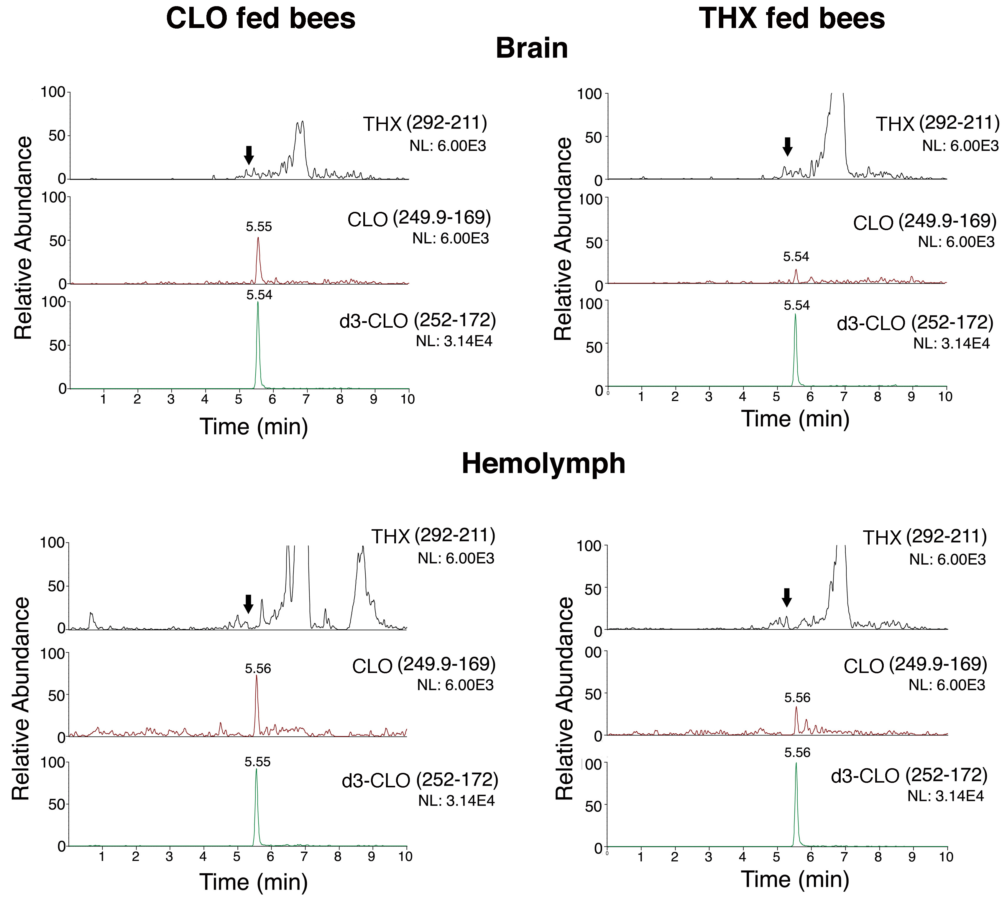
Figure S1. Representative LC-MS/MS chromatograms of CLO and THX signals. Bees were fed CLO or THX (2.5 ppb) for 3 days prior to removal of the brains and collection of the hemolymph. The signal from THX is shown in black, CLO is shown in red and d3-CLO (internal standard) in green. THX and CLO were eluted at 5.1min (indicated with arrows) and 5.5min, respectively. Note that the signals from THX were below limit of quantification.

 | % Females
 | UT | CLO | THX | IMD
 | 7.7 | 14.6 | 4.8 | 8.6
 | 16.7 | 20.0 | 7.5 | 10.0 (n=10)
 | 27.1 | 30.0 | 8.3 | 14.3
 | 47.4 (n=19) | 32.4 | 13.5 | 24.2
 | 47.7 | 32.5 | 17.8 | 33.3
 | 48.6 | 41.2 | 19.4 | 37.1
 | 51.3 | 44.2 | 28.0 | 46.2
 | 51.4 | 47.2 | 28.6 | 50.0
 | 51.4 | 48.9 | 28.6 | 57.5
 | 56.7 | 51.4 | 32.3 | 62.9
 | 57.1 | 55.6 | 32.5 | 65.9
 | 60.7 | 65.7 | 37.1 | 68.7 (n=16)
 | 65.0 | 69.4 | 37.1 | 71.4
 | 80.0 (n=20) | 84.6 | 40.0 | 71.4
 | 80.0 |  | 48.3 | 94.3
 | 84.4 |  | 52.6 (n=19) | 100
 | 85.7 |  | 57.1 (n=14)
 | 93.5 |  | 83.3 (n=18)
Average (%) | 56.2 | 45.6 | 32.0 | 51.0
STDEV | 23.4 | 19.3 | 19.9 | 28.2
% colonies with  female preference | 66.7 | 35.7 | 16.7 | 53.3
Table S2. Bee sexing. Samples of bee heads were collected from nests at the end of the experiment and the number of antennal segments counted to distinguish females (12 segments) from males (13 segments). Where fewer than 25 bees were counted the numbers are shown in brackets. Figures above and below 50% are colour coded to indicate a preference for females (red) or males (blue). Finally, the % of colonies with a preference (>50%) for females is indicated.

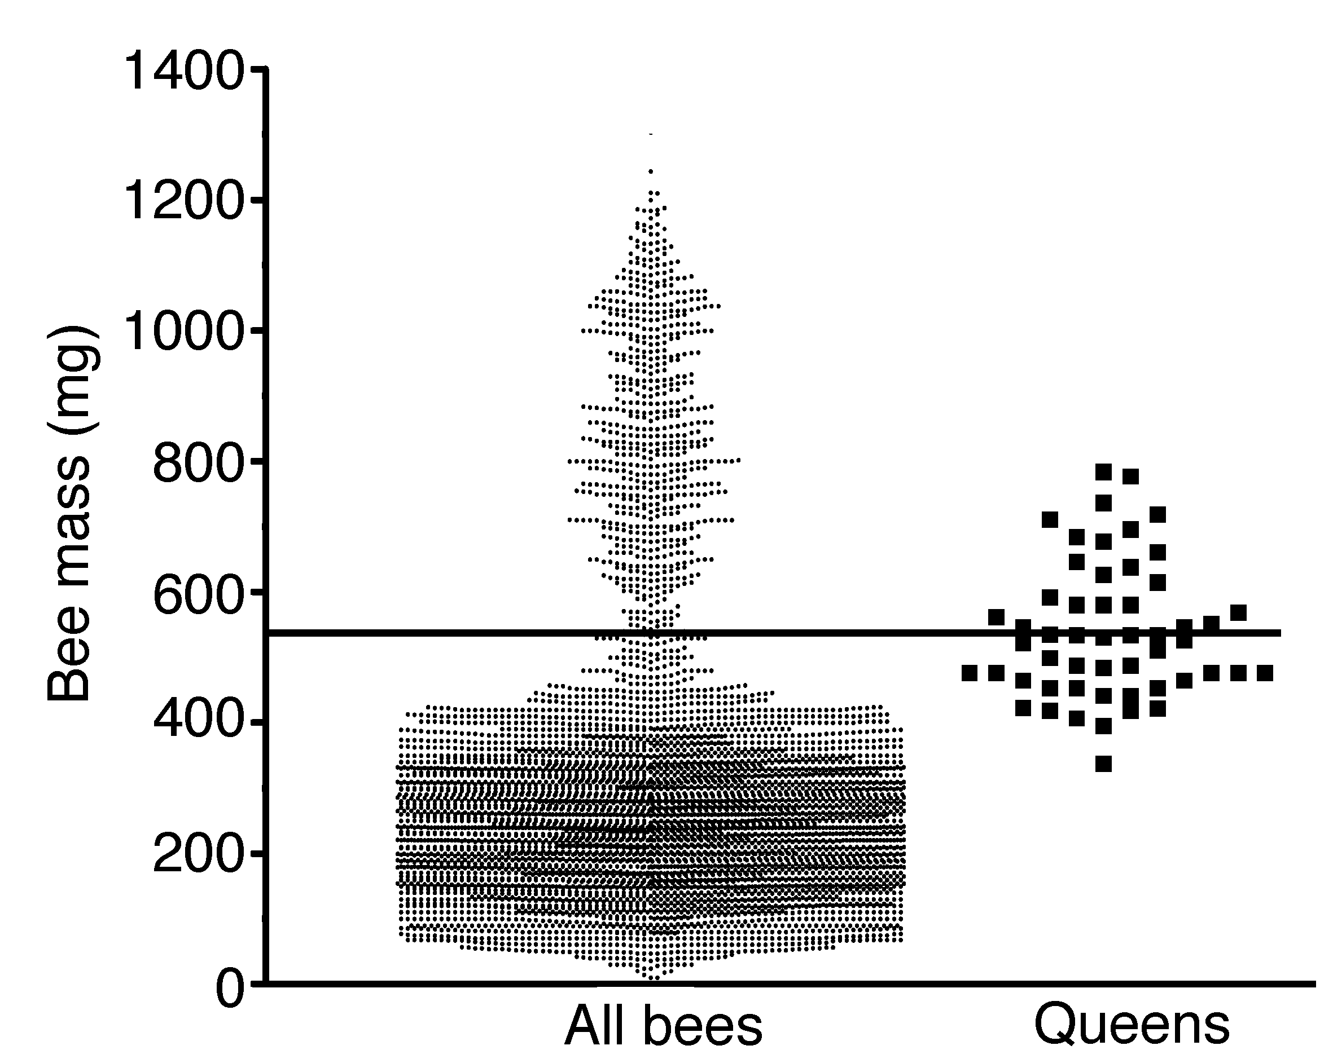
Figure S3. Queen determination. Queens were determined by a direct comparison to thorax width (> 7 mm) and their mass recorded (Queens) and also compared to the average colony mass distribution (All bees) to ensure that large workers were excluded.

Supplementary data. GLM summaries appear below:
Appendix: R output
> m1 <- glm(nlive~site+period+treat,family=quasipoisson)
> summary(m1)

Call:
glm(formula = nlive ~ site + period + treat, family = quasipoisson)

Deviance Residuals:
Min 1Q Median 3Q Max
-10.615 -3.190 -1.087 1.661 16.105

Coefficients:
Estimate Std. Error t value Pr(>|t|)
(Intercept) 4.1672 0.2373 17.562 < 2e-16 ***
siteB 0.4090 0.2600 1.573 0.12061
siteF 0.5545 0.2522 2.198 0.03150 *
siteK 0.7731 0.2848 2.715 0.00848 **
siteP -0.4745 0.4466 -1.062 0.29194
periodlate -0.1643 0.1735 -0.947 0.34698
treatCLO 0.1463 0.1793 0.816 0.41744
treatIMD -0.2318 0.2109 -1.099 0.27576
treatTHX -0.4722 0.2271 -2.079 0.04157 *
---
Signif. codes: 0 ‘***’ 0.001 ‘**’ 0.01 ‘*’ 0.05 ‘.’ 0.1 ‘ ’ 1

(Dispersion parameter for quasipoisson family taken to be 30.24137)

Null deviance: 2941.3 on 73 degrees of freedom
Residual deviance: 1813.7 on 65 degrees of freedom
AIC: NA

Number of Fisher Scoring iterations: 5

> m2 <- glm(nbrood~site+period+treat,family=quasipoisson)
> summary(m2)

Call:
glm(formula = nbrood ~ site + period + treat, family = quasipoisson)

Deviance Residuals:
Min 1Q Median 3Q Max
-12.3801 -3.9837 -0.1787 3.0980 10.0945

Coefficients:
Estimate Std. Error t value Pr(>|t|)
(Intercept) 4.33903 0.22981 18.881 < 2e-16 ***
siteB 0.19002 0.26866 0.707 0.48191
siteF 0.18218 0.26574 0.686 0.49543
siteK 0.06139 0.32856 0.187 0.85237
siteP -0.07156 0.35181 -0.203 0.83947
periodlate 0.44043 0.17725 2.485 0.01555 *
treatCLO -0.18806 0.17848 -1.054 0.29594
treatIMD -0.62497 0.19720 -3.169 0.00233 **
treatTHX -1.19552 0.24230 -4.934 5.89e-06 ***
---
Signif. codes: 0 ‘***’ 0.001 ‘**’ 0.01 ‘*’ 0.05 ‘.’ 0.1 ‘ ’ 1

(Dispersion parameter for quasipoisson family taken to be 27.26192)

Null deviance: 3129.5 on 73 degrees of freedom
Residual deviance: 1945.8 on 65 degrees of freedom
AIC: NA

Number of Fisher Scoring iterations: 5

> m3 <- glm(nqueen~site+period+treat,family=quasipoisson)
> summary(m3)

Call:
glm(formula = nqueen ~ site + period + treat, family = quasipoisson)

Deviance Residuals:
Min 1Q Median 3Q Max
-8.2616 -2.7760 -1.2352 0.7421 10.2060

Coefficients:
Estimate Std. Error t value Pr(>|t|)
(Intercept) 0.51297 0.82269 0.624 0.53512
siteB 1.30112 0.81668 1.593 0.11597
siteF 1.22419 0.81182 1.508 0.13641
siteK 0.85628 0.94174 0.909 0.36658
siteP -0.01145 1.20004 -0.010 0.99242
periodlate 0.54589 0.36197 1.508 0.13638
treatCLO 1.29805 0.44523 2.915 0.00487 **
treatIMD 0.32811 0.51927 0.632 0.52969
treatTHX -0.62479 0.67659 -0.923 0.35920
---
Signif. codes: 0 ‘***’ 0.001 ‘**’ 0.01 ‘*’ 0.05 ‘.’ 0.1 ‘ ’ 1

(Dispersion parameter for quasipoisson family taken to be 18.06707)

Null deviance: 1579.0 on 73 degrees of freedom
Residual deviance: 996.8 on 65 degrees of freedom
AIC: NA

Number of Fisher Scoring iterations: 6

> #m4 <- glm(nestmass2~site+period+treat,family=Gamma(link="log"))
> #summary(m4)
> m4 <- glm(nestmassnorm~site+period+treat,family=Gamma(link="log"))
> summary(m4)

Call:
glm(formula = nestmassnorm ~ site + period + treat, family = Gamma(link = "log"))

Deviance Residuals:
Min 1Q Median 3Q Max
-0.34448 -0.09198 -0.01992 0.08245 0.30035

Coefficients:
Estimate Std. Error t value Pr(>|t|)
(Intercept) -0.024500 0.052923 -0.463 0.6450
siteB 0.101897 0.058808 1.733 0.0879 .
siteF 0.081512 0.058042 1.404 0.1650
siteK 0.006933 0.078126 0.089 0.9296
siteP 0.153333 0.081187 1.889 0.0634 .
periodlate -0.117913 0.044311 -2.661 0.0098 **
treatCLO 0.036032 0.050197 0.718 0.4754
treatIMD -0.074802 0.049691 -1.505 0.1371
treatTHX -0.108420 0.049691 -2.182 0.0327 *
---
Signif. codes: 0 ‘***’ 0.001 ‘**’ 0.01 ‘*’ 0.05 ‘.’ 0.1 ‘ ’ 1

(Dispersion parameter for Gamma family taken to be 0.02302417)

Null deviance: 1.8750 on 73 degrees of freedom
Residual deviance: 1.4948 on 65 degrees of freedom
AIC: -65.334

Number of Fisher Scoring iterations: 5

> m5 <- glm(formula=counts ~ treat+site+period,family=quasibinomial)
> summary(m5)

Call:
glm(formula = counts ~ treat + site + period, family = quasibinomial)

Deviance Residuals:
Min 1Q Median 3Q Max
-5.7692 -1.8201 0.2525 1.6790 7.1444

Coefficients:
Estimate Std. Error t value Pr(>|t|)
(Intercept) 0.29946 0.33230 0.901 0.37122
treatCLO -0.34977 0.32752 -1.068 0.28996
treatIMD -0.06556 0.32482 -0.202 0.84076
treatTHX -1.15241 0.33771 -3.412 0.00118 **
siteB -0.34047 0.37336 -0.912 0.36558
siteF -0.28827 0.36257 -0.795 0.42981
siteP 0.01402 0.56630 0.025 0.98033
period3 0.23335 0.27989 0.834 0.40785
---
Signif. codes: 0 ‘***’ 0.001 ‘**’ 0.01 ‘*’ 0.05 ‘.’ 0.1 ‘ ’ 1

(Dispersion parameter for quasibinomial family taken to be 7.380214)

Null deviance: 603.03 on 65 degrees of freedom
Residual deviance: 481.76 on 58 degrees of freedom
AIC: NA

Number of Fisher Scoring iterations: 4

