Three-dimensional bulk electronic structure of the Kondo lattice CeIn₃ revealed by photoemission
Yun Zhang^{1,2*}, Haiyan Lu¹, Xiegang Zhu¹, Shiyong Tan¹, Qin Liu¹, Qiuyun Chen¹, Wei Feng¹,
Donghua Xie¹, Lizhu Luo¹, Yu Liu^{4,5}, Haifeng Song^{4,5}, Zhengjun Zhang³, Xinchun Lai^{1*}
¹Science and Technology on Surface Physics and Chemistry Laboratory, Mianyang 621907, China
²Department of Engineering Physics, Tsinghua University, Beijing 100084, China
³School of Materials Science and Engineering, Advanced Materials Laboratory, Tsinghua University, Beijing 100084, China
⁴Laboratory of Computational Physics, Institute of Applied Physics and Computational Mathematics, Beijing 100088, China
⁵CAEP Software Center for High Performance Numerical Simulation, Beijing 100088, China

Supplementary Information
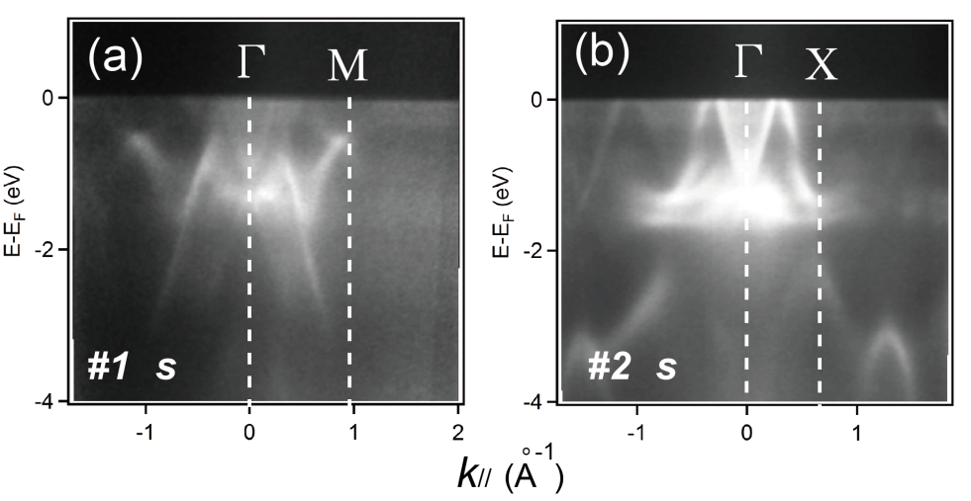
Figure S1. Valence band structure of CeIn₃. (a) and (b) Photoemission intensity plots taken using 542 eV s-polarised light along the Γ-M and Γ-X directions, respectively.
Figure S1 shows the ARPES spectra along the Γ-M and Γ-X directions. Two nearly non-dispersive f bands are observed around E_{F}. If we change the relative intersection angle between the surface of the sample and the light source, the two flat f bands seem constant over all angles and over different photon energies. Namely, the two flat bands are apparently momentum and photon-energy independent. In fact, if hybridization between f electrons and conduction electrons occurs, then the f bands should not be visible in some of the momentum space around E_{F}. The region where hybridization occurs should have an energy gap, and the f band should only be partially observed, as is shown in Fig. 4(c) in the main text. We propose that the f electrons in CeIn₃ primarily remain nearly localized at ambient pressure and low temperature.

