In situ Scanning Electron Microscopy of Silicon Anode Reactions in Lithium-Ion Batteries during Charge/Discharge Processes

Chih-Yao Chen,¹ Teruki Sano,¹ Tetsuya Tsuda,¹ Koichi Ui,² Yoshifumi Oshima,³ Masaki Yamagata,⁴ Masashi Ishikawa,⁴ Masakazu Haruta,⁵ Takayuki Doi,⁵ Minoru Inaba⁵ & Susumu Kuwabata¹

¹Department of Applied Chemistry, Graduate School of Engineering, Osaka University, 2-1 Yamada-oka, Suita, Osaka 565-0871, Japan
²Department of Frontier Materials and Function Engineering, Graduate School of Engineering, Iwate University, 4-3-5 Ueda, Morioka, Iwate 020-8551, Japan
³School of Materials Science, Japan Advanced Institute of Science and Technology, 1-1 Asahidai, Nomi, Ishikawa 923-1292, Japan
⁴Department of Chemistry and Materials Engineering, Kansai University, 3-3-35 Yamate-cho, Suita, Osaka 564-8680, Japan
⁵Department of Molecular Chemistry and Biochemistry, Doshisha University, 1-3 Tatara Miyakodani, Kyotanabe, Kyoto 610-0321, Japan

Correspondence and requests for materials should be addressed to T.T. (e-mail: ttsuda@chem.eng.osaka-u.ac.jp) or S.K. (e-mail: kuwabata@chem.eng.osaka-u.ac.jp)

Supplementary Information

Movie legends p. 2
Supplementary Figures 1–4 p. 4

Movie legends
Movie 1 | In situ SEM images of a Si microparticle anode during the 2nd charge process. The charge process was conducted in constant current and constant voltage (CC/CV) mode with cut-off voltages ranging between –3.88 V and –2.40 V (vs. LiCoO₂). The CC rates for charge and discharge were 0.12 C. The video clip plays at 640 × speed.

Movie 2 | In situ SEM images of a Si microparticle anode during the 2nd discharge process. The discharge process was conducted in constant current and constant voltage (CC/CV) mode with cut-off voltages ranging between –3.88 V and –2.40 V (vs. LiCoO₂). The CC rates for charge and discharge were 0.12 C. The video clip plays at 640 × speed.

Movie 3 | In situ SEM images of a Si thin flake anode during the 3rd charge process. The charge process was conducted in constant current and constant voltage (CC/CV) mode with cut-off voltages ranging between –3.88 V and –2.40 V (vs. LiCoO₂). The CC rates for charge and discharge were 0.50 C. The video clip plays at 640 × speed.

Movie 4 | In situ SEM images of a Si thin flake anode during the 3rd discharge process. The discharge process was conducted in constant current and constant voltage (CC/CV) mode with cut-off voltages ranging between –3.88 V and –2.40 V (vs. LiCoO₂). The CC rates for charge and discharge were 0.50 C. The video clip plays at 640 × speed.

Movie 5 | In situ SEM and BSE images of a Si thin flake anode during the 2nd discharge process. The charge process was conducted in constant current and constant voltage (CC/CV) mode with cut-off voltages ranging between –3.88 V and –2.40 V (vs. LiCoO₂). The CC rates for charge and discharge were 0.50 C. The video clip plays at 640 × speed.

Movie 6 | In situ SEM and BSE images of a Si thin flake anode during the 3rd charge process. The discharge process was conducted in constant current and constant voltage (CC/CV) mode with cut-off voltages ranging between –3.88 V and –2.40 V (vs. LiCoO₂). The CC rates for charge and discharge were 0.50 C. The video clip plays at 640 × speed.

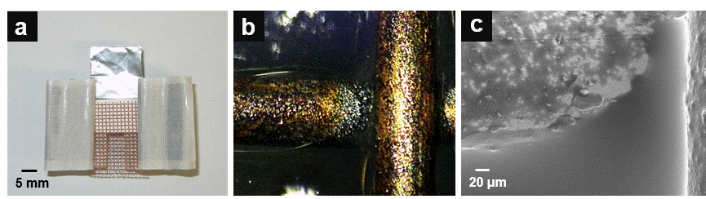

Supplementary Figure 1 | A typical LIB cell used for in situ SEM. a, A photograph of the LIB cell. b, A digital microscope image of a Si microparticle electrode. c, A SEM image recorded in the same area shown in Supplementary Fig. 1b.

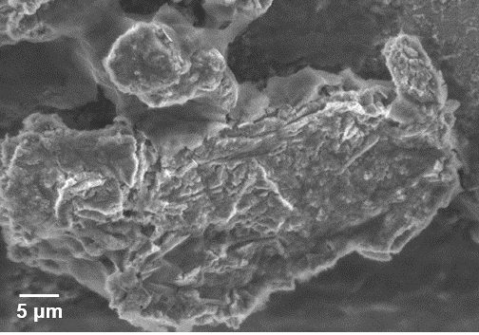

Supplementary Figure 2 | An ex situ SEM image of the Si particle shown in Fig. 2g after rinsing with DEC.

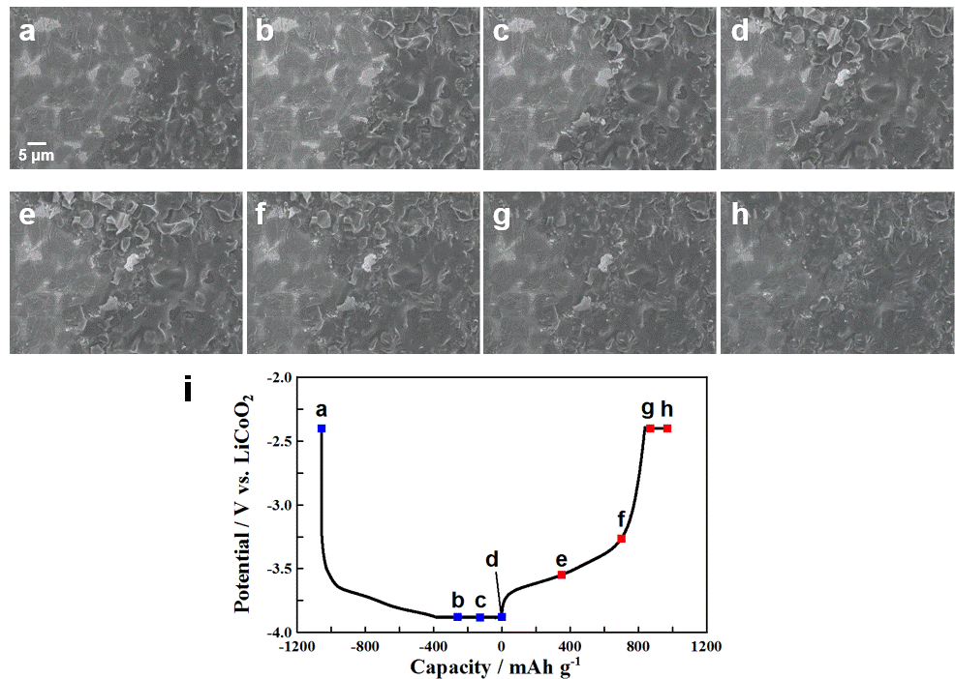

Supplementary Figure 3 | In situ SEM images of the morphology variation of Si thin flakes during charging and discharging in the 3rd cycle. The charge/discharge curve of a Si thin flake anode measured in constant current and constant voltage (CC/CV) mode with cut-off voltages ranging between –3.88 V and –2.40 V (vs. LiCoO₂). The CC rates for charge and discharge were 0.50 C. These images were captured at the points indicated by a-h in Supplementary Fig. 3i. i, The charge/discharge curve during the in situ SEM observation.

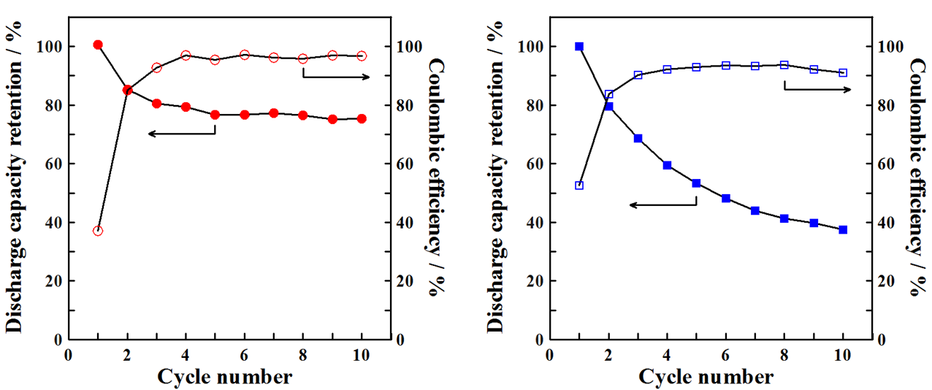

Supplementary Figure 4 | Discharge capacity retention and coulombic efficiency of LIB cells used for in situ SEM. Si thin flake and Si nanoparticle aggregate electrodes are shown as red circles and blue squares, respectively.

