Supplementary Material A: fsQCA ‘Robustness’ Checks
We start with the analysis of necessary conditions, following the standards of good practice brought forward by Schneider and Wagemann (2012). We first look at the consistency score telling us how well and consistently a configuration is supported by empirical evidence. Necessary conditions should always be present with a positive outcome and therefore have a very high consistency score of above 0.9 (Schneider and Wagemann 2012: 278). We checked the necessity consistency for the presence (> 0.5) and absence (< 0.5) of all conditions included (outcome > 0.5). Given that there is no condition with a consistency score of above 0.9 (see Table A1), we conclude that there is no condition that is necessary for the outcome to occur across countries. Still, a higher budget seems to be very close given the consistency score of 0.87 (Schneider and Wagemann 2012).
Table A1: Analysis of Necessity Consistency for Presence of the Outcome
 | Consistency | Coverage
BUDGET | 0,8687 | 0.641239
Budget | 0,3666 | 0.588359
VOLUNTEER | 0,552 | 0.575974
Volunteer | 0,6806 | 0.667603
STATUS | 0,8016 | 0.595917
Status | 0,3774 | 0.596444
SCOPE | 0,6766 | 0.676092
Scope | 0,6906 | 0.706832
COUNTRY | 0,3838 | 0.421854
Country | 0,6162 | 0.576948
Note: UPPERCASE= Presence; lowercase = absence of condition; scores calculated only for presence of the outcome.
For the analysis of sufficiency, we look at the truth table in which all possible configurations are reported; empirically observed configurations are reported along with the consistency score of the configuration (outcome consistency, see Table A2). To calculate a final solution term, then, requires us to set a consistency threshold below which cases are excluded from the calculation. An often used threshold in QCA analyses is 0.7. However, a threshold should always be defined in relation to the qualities of the sample and the research interests (Schneider and Wagemann 2009, 2012). In our dataset, we can identify an empirical threshold since the data shows consistency scores of above 0.8 for all positive outcomes; we therefore opted for a higher consistency threshold of 0.8. Given the focus of this analysis on the presence of the outcome, i.e. more activities reported by CSOs, we also separate our truthtable rows by if cases included in this configurations show a positive or negative outcome (outcome >0.5).
Table A2: Truth Table
Budget | volunteer | Status | scope | country | outcome  consist. | Outcome | freq. | Case ID
0 | 0 | 1 | 1 | 0 | 0,9927 | 1 | 3 | GR24, GR25, GR26
0 | 0 | 1 | 0 | 0 | 0,99 | 1 | 1 | GR27
1 | 1 | 1 | 1 | 0 | 0,9718 | 1 | 1 | GR1
1 | 0 | 1 | 1 | 0 | 0,9619 | 1 | 4 | GR6, GR7, GR8, GR9
1 | 1 | 1 | 1 | 1 | 0,9603 | 1 | 2 | DE1, DE2
1 | 1 | 0 | 0 | 0 | 0,9386 | 1 | 3 | GR3, GR4, GR5
1 | 1 | 1 | 0 | 1 | 0,9356 | 1 | 3 | DE3, DE4, DE5
1 | 0 | 1 | 0 | 0 | 0,9331 | 1 | 4 | GR10, GR11, GR12, GR13
1 | 0 | 0 | 0 | 0 | 0,9195 | 1 | 2 | GR16, GR17
1 | 1 | 0 | 1 | 1 | 0,8868 | 1 | 1 | DE6
1 | 0 | 1 | 0 | 1 | 0,8404 | 1 | 2 | DE15, DE16
1 | 1 | 0 | 0 | 1 | 0,6935 | 0 | 2 | DE7, DE8
1 | 0 | 1 | 1 | 1 | 0,5349 | 0 | 6 | DE9, DE10, DE11, DE12, DE13, DE14
1 | 1 | 1 | 0 | 0 | 0,856 | 0 | 1 | GR2
0 | 1 | 1 | 0 | 0 | 0,8441 | 0 | 1 | GR20
0 | 1 | 1 | 1 | 0 | 0,7843 | 0 | 2 | GR18, GR19
0 | 0 | 1 | 0 | 1 | 0,7692 | 0 | 1 | DE23
1 | 0 | 0 | 1 | 0 | 0,7287 | 0 | 2 | GR14, GR15
0 | 1 | 1 | 0 | 1 | 0,6233 | 0 | 4 | DE17, DE18, DE19, DE20
0 | 1 | 0 | 0 | 1 | 0,6092 | 0 | 2 | DE21, DE22
0 | 1 | 0 | 1 | 0 | 0,5924 | 0 | 3 | GR21, GR22, GR23
0 | 0 | 0 | 0 | 1 |  | 0 | 0
0 | 0 | 0 | 0 | 0 |  | 0 | 0
0 | 0 | 0 | 1 | 1 |  | 0 | 0
0 | 0 | 0 | 1 | 0 |  | 0 | 0
0 | 0 | 1 | 1 | 1 |  | 0 | 0
0 | 1 | 0 | 0 | 0 |  | 0 | 0
0 | 1 | 1 | 1 | 1 |  | 0 | 0
0 | 1 | 0 | 1 | 1 |  | 0 | 0
1 | 0 | 0 | 0 | 1 |  |  | 0
1 | 1 | 0 | 1 | 0 |  |  | 0
1 | 0 | 0 | 1 | 1 |  |  | 0
Note: lower rows in italics = logical remainders (non-observed configurations); in country condition: 0=Greece, 1=Germany.
An often-occurring problem with QCA is the phenomenon of so-called logical remainders: Configurations of conditions that are logically possible but not observed in the dataset. In our case, possible configurations are 32, but only 21 are observed in our sample. The preferred way of dealing with such remainders is to include those that can be predicted based on counterfactual analysis, thus ‘[a]ssumptions … that are in line with directional expectations and that contribute to parsimony’ (Schneider and Wagemann 2012: 326; emphasis in the original). In the following, thus, we explain the reasons behind including some, but not all of these ‘empty’ cases.
Looking at 11 logical remainders, we have, for example, analysed necessary conditions before. While the budget condition was close to the threshold but failed the necessity test, we see its presence in all German cases showing a positive outcome, regardless of the configuration’s consistency score. We also see its absence in all observed German cases in which budget is not present. Thus, we may derive from these observations that in the German case, the budget condition is necessary for the outcome to occur. To increase parsimony of the solution term, thus, we add logical remainders for the German case and assign them a negative outcome when budget is not present.
In addition, it is, from a theoretical point of view, unlikely that with none of the included conditions present, CSOs would reach an activity score of above 0.5 (OUTCOME). The respective configurations are therefore included with a negative outcome for both countries. Moreover, from the analysis of necessity as well as the truthtable itself is becomes apparent that the budget and the status conditions are the most important for the Greek case since they can either alone or in combination with other conditions lead to the outcome. It seems therefore unlikely that a configuration in which only the volunteer condition or the scope condition would be present would lead to a positive outcome. These configurations are therefore included for the Greek case with a negative outcome.

Supplementary Material B: Visualization of all Solution Sets individually: XY Plots
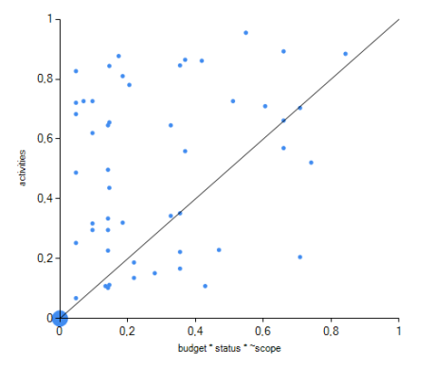 | 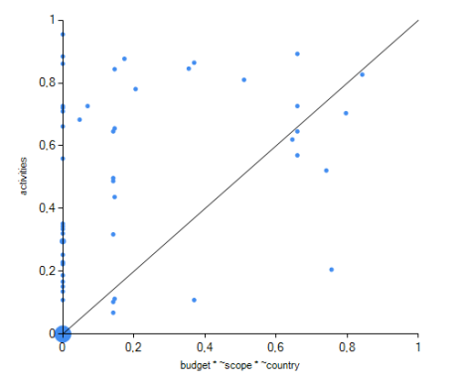 | 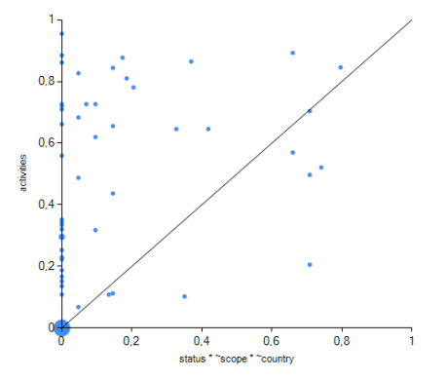
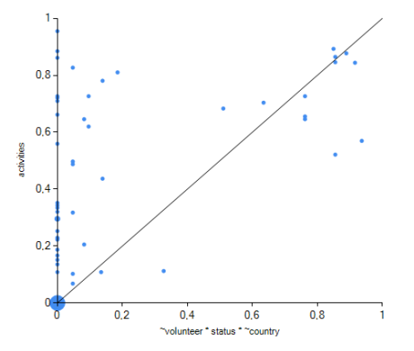 | 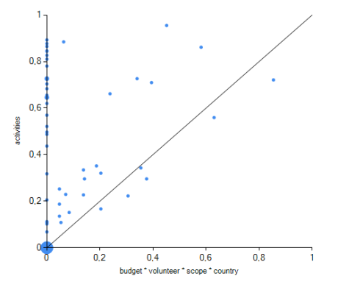 | 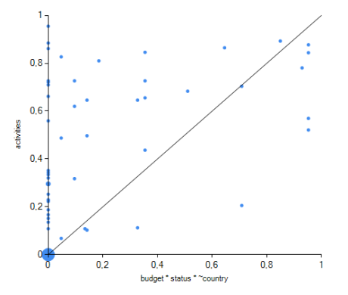
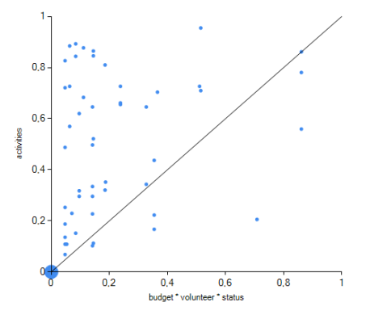
Note: Cases above the diagonal are generally defined as consistent in terms of sufficiency while cases below the diagonal are not. The part of the upper right quadrant (x&y >0.5) above the diagonal displays the cases well explained by the solution term in question; such cases are called ‘onliers’ (Schneider and Rohlfing 2013). As we can see, cases in this area are generally quite few which again highlights the heterogeneity of the sample, also expressed in relatively low coverage of each solution set individually.

Supplementary Material C: Translation of conditions into fuzzy sets
Fuzzy set QCA requires that the conditions included are measured on a scale ranging from 0-1. Therefore, all variables included needed to be rescaled, or ‘fuzzified’, to range from 0-1 to fit the fsQCA set logic. This was done in Stata, using the direct transformation method brought forward by Ragin (2008; Schneider and Wagemann 2012). During this transformation of variables, we defined a point of no membership (0), the turnover point (0,5), and the full membership score (1). For defining the turnover point, we assessed cases individually and looked at the distribution of cases, taking into account that our fsQCA scores are based on a standardized questionnaire.
Condition | Turnover point | Justification
Budget | 2.5 (Having a budget of up to 200,000€ = condition present) | The budget condition turned out to be very dominant, given also a heavy bias in the sample towards CSOs with a budget above 500,000€, especially in the German case. Defining a relatively low turnover point therefore helps to accommodate the heterogeneity in the sample, also given the aim to compare two very different countries with very different financial situations when it comes to civil society structures.
Volunteer | 51 (Relying on volunteers from 51% upwards = condition present) | The mean of this condition is at 49.34, indicating that the sample is quite balanced in this respect. Using 51% as a turnover point, then, was necessary since some cases reported a reliance on volunteers of 50%. Such cases would have dropped out of the analysis if 50% had been the turnover point. We therefore decided to go with a slightly higher threshold.
Status | 7.9 (Index of ties to other CSOs and pol. institutions more than 7.9 = condition present) | The status variable was more difficult to define due to the great variance in the sample. The mean here was at 19.1, however with a standard deviation of almost 18 indicating vast differences between CSOs. However, 35% of CSOs have a value that is below 8, indicating a strong bias again towards higher values, i.e., more contacts and more involvement in political institutions. We therefore opted for a lower threshold to accommodate the great variance in the sample.
Scope | 7.8 (Index of cross-sectional activities and operating level higher than 7.7 = condition present) | The highest reported number here was 15 with a mean of 7.8. Given that the score is based on a standardized questionnaire, we decided to define the mean as turnover point; no value of the index was at 7.8 which is why we could use this turnover point without risking to decrease our number of cases.

This assumption is underscored by a separate analysis of necessity consistency for the German case in which budget reaches a score of above 0.95 (see appendix for details) and it is also confirmed by the literature we have discussed earlier.
All included logical remainders are assigned a negative outcome in Table 5 whereas non-included remainders are left blank in the outcome column.

