Appendix
Table A1: Items of the IMPIC immigration policy data
 |  | Policy areas
 |  | Family reunification | Labor migration | Asylum and refugees
External | Eligibility | Residence requirements  Family members  Age limits  Quotas family reunification | Targeting  Quotas labor  Age limits  Young age beneficial | Existence of subsidiary/ humanitarian protection  Nationality  Quotas asylum  Safe third country  Safe countries of origin  Resettlement agreements
External | Conditions | Financial requirements  Accommodation requirements  Language skills  Application fees | Specific income per month  Specific financial funds  Language skills  Application fee  Job offer  Equal work conditions  List of occupations  Labor market tests | Place of application
Internal | Security of status | Residence permit validity  Autonomous residence permit | Work permit validity  Renewal of permit  Transition temporary permanent  Loss of employment | Permit validity  Permit renewal  Permanent permit  Right to appeal  Status when crisis resolved
Internal | Rights associated | (Self)employment | Flexibility of permit | Free movement  (Self)employment  Form of benefits
Note. In addition to differentiating between different areas of immigration policy, the Immigration Policy in Comparison Index also allows to distinguish between policies that regulate immigration either at the border or within the country (i.e., external and internal regulations, respectively). Whereas external regulations cover the conditions and entry criteria, internal regulations determine the length of time immigrants are allowed to stay and the rights they are granted on the basis of their permit.
For more details and codebook see Bjerre, Liv; Helbling, Marc; Römer, Friederike; Zobel, Malisa (2016): The Immigration Policies in Comparison (IMPIC) Dataset: Technical Report. WZB Berlin Social Science Center (Discussion paper).

Figure A1: Distribution of immigration policy variable
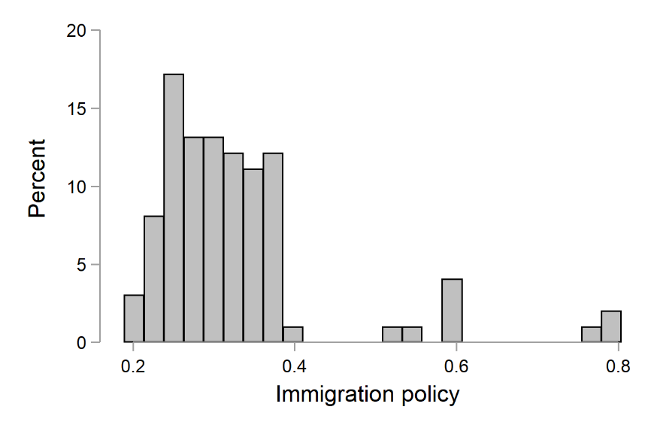
Note: Figure shows the distribution of the immigration policy indicator at country-level, lower numbers indicating more liberal policies, and higher numbers more restrictive policies.

Table A2: Question wordings of main dependent and independent variables (continues on next page)

Variable names | Question wordings | Answers
Political trust | Using this card, please tell me on a score of 0-10 how much you personally trust each of the institutions I read out. 0 means you do not trust an institution at all, and 10 means you have complete trust:  … [country]’s parliament?  … politicians? | No trust at all (0) to complete trust (10)
Immigration attitudes | Now, using this card, to what extent do you think [country] should allow people of the same race or ethnic group as most [country]’s people to come and live here?  How about people of a different race or ethnic group from most [country] people? Still use this card.  How about people from the poorer countries outside Europe? Use the same card.  Would you say it is generally bad or good for [country]’s economy that people come to live here from other countries? Please use this card.  And, using this card, would you say that [country]’s cultural life is generally undermined or enriched by people coming to live here from other countries?  Is [country] made a worse or a better place to live by people coming to live here from other countries? Please use this card. | Allow many to come and live here (1) Allow some (2) Allow a few (3) Allow none (4)  Allow many to come and live here (1) Allow some (2) Allow a few (3) Allow none (4)  Allow many to come and live here (1) Allow some (2) Allow a few (3) Allow none (4)  Bad for the economy (0) to good for the economy (10)  Cultural life undermined (0) to cultural life enriched (10)  Worse place to live (0) to better place to live (10)
Political interest | How interested would you say you are in politics – are you… | Very interested (1), quite interested (2), hardly interested (3), not at all interested (4)
TV watching, news/politics/current affairs on average weekday | And on an average weekday how much of your time watching television is generally spent watching news or programmes about politics and current affairs? | No time at all (0), Less than 0,5 hour (1), 0,5 hour to 1 hour (2), More than 1 hour, up to 1,5 hours (3), More than 1,5 hours, up to 2 hours (4), More than 2 hours, up to 2,5 hours (5), More than 2,5 hours, up to 3 hours (6), More than 3 hours (7)
Radio listening, news/politics/current affairs on average weekday | And again on an average weekday, how much of your time listening to the radio is generally spent listening to news or programmes about politics and current affairs? | No time at all (0), Less than 0,5 hour (1), 0,5 hour to 1 hour (2), More than 1 hour, up to 1,5 hours (3), More than 1,5 hours, up to 2 hours (4), More than 2 hours, up to 2,5 hours (5), More than 2,5 hours, up to 3 hours (6), More than 3 hours (7)
Newspaper reading, politics/current affairs on average weekday | And how much of this time is spent reading about politics and current affairs? | No time at all (0), Less than 0,5 hour (1), 0,5 hour to 1 hour (2), More than 1 hour, up to 1,5 hours (3), More than 1,5 hours, up to 2 hours (4), More than 2 hours, up to 2,5 hours (5), More than 2,5 hours, up to 3 hours (6), More than 3 hours (7)

Table A3: Summary statistics of individual-level independent variables (dummies)
Variable | Freq. | Percent | Cum.
Gender
0 Male | 84,919 | 46.64 | 46.64
1 Female | 97,163 | 53.36 | 100.00
 | 182,082 | 100.00
Total
Living area
0 Small/middle town | 79,846 | 43.93 | 43.93
1 Rural area or village | 68,820 | 37.86 | 81.79
2 Large town | 33,109 | 18.21 | 100.00
Total | 181,775 | 100.00
Unemployed
0 Employed | 171,978 | 94.35 | 94.35
1 Unemployed | 10,298 | 5.65 | 100.00
Total | 182,276 | 100.00
Migration status
0 Native born with native background | 161,269 | 88.94 | 88.94
1 Second-generation immigrants | 11,653 | 6.43 | 95.36
2 First-generation immigrants | 8,406 | 4.64 | 100.00
Total | 181,328 | 100.00

Table A4: Summary statistics of individual-level independent variables (numerical)
Variable | Obs | Mean | Std. Dev. | Min | Max
Immigration attitudes | 162,415 | 0.4875936 | 0.209717 | 0 | 1
Age | 181,405 | 47.77948 | 18.53984 | 14 | 123
Years of education | 180,241 | 12.07683 | 4.112003 | 0 | 56
Political ideology | 160,985 | 5.101742 | 2.11678 | 0 | 10
Political interest | 181,864 | 2.385981 | 0.8974997 | 1 | 4
Political news exposure | 108,160 | 1.653122 | 0.8727531 | 0 | 7

Table A5: Summary statistics of individual-level independent variables (categorical) (continued on next page)
Variables | Freq. | Percent | Cum.
TV watching, news/politics/current affairs on average weekday
0 No time at all | 11,463 | 6.50 | 6.50
1 Less than 0,5 hour | 56,296 | 31.92 | 38.42
2 0,5 hour to 1 hour | 67,925 | 38.52 | 76.94
3 More than 1 hour, up to 1,5 hours | 22,806 | 12.93 | 89.87
4 More than 1,5 hours, up to 2 hours | 9,782 | 5.55 | 95.42
5 More than 2 hours, up to 2,5 hours | 3,811 | 2.16 | 97.58
6 More than 2,5 hours, up to 3 hours | 2,025 | 1.15 | 98.73
7 More than 3 hours | 2,246 | 1.27 | 100.00
Total | 176,354 | 100.00
Radio listening, news/politics/current affairs on average weekday
0 No time at all | 24,763 | 17.16 | 17.16
1 Less than 0,5 hour | 62,622 | 43.39 | 60.55
2 0,5 hour to 1 hour | 32,641 | 22.62 | 83.16
3 More than 1 hour, up to 1,5 hours | 10,549 | 7.31 | 90.47
4 More than 1,5 hours, up to 2 hours | 5,400 | 3.74 | 94.21
5 More than 2 hours, up to 2,5 hours | 2,576 | 1.78 | 96.00
6 More than 2,5 hours, up to 3 hours | 1,782 | 1.23 | 97.23
7 More than 3 hours | 3,992 | 2.77 | 100.00
Total | 144,325 | 100.00
Newspaper reading, politics/current affairs on average weekday
0 No time at all | 17,754 | 13.33 | 13.33
1 Less than 0,5 hour | 81,327 | 61.07 | 74.41
2 0,5 hour to 1 hour | 26,244 | 19.71 | 94.11
3 More than 1 hour, up to 1,5 hours | 4,980 | 3.74 | 97.85
4 More than 1,5 hours, up to 2 hours | 1,626 | 1.22 | 99.07
5 More than 2 hours, up to 2,5 hours | 570 | 0.43 | 99.50
6 More than 2,5 hours, up to 3 hours | 298 | 0.22 | 99.73
7 More than 3 hours | 365 | 0.27 | 100.00
Total | 133,164 | 100.00
Feeling household income
1 Living comfortably on present income | 54,407 | 30.73 | 30.73
2 Coping on present income | 81,950 | 46.28 | 77.01
3 Difficult on present income | 30,544 | 17.25 | 94.26
4 Very difficult on present income | 10,170 | 5.74 | 100.00
Total | 177,071 | 100.00
Political interest
1 Very interested | 18,896 | 10.39 | 10.39
2 Quite interested | 65,203 | 35.85 | 46.24
3 Hardly interested | 64,966 | 35.72 | 81.97
4 Not at all interested | 32,799 | 18.03 | 100.00
Total | 181,864 | 100.00

Table A6: Summary statistics of country-level independent variables (numerical)
Variable | Obs | Mean | Std. Dev. | Min | Max
GDP per capita | 99 (country-years) | 35307.74 | 18985.15 | 5196.933 | 96880.51
Percentage unemployment | 99 (country-years) | 7.66 | 3.8 | 2.5 | 19.9
Percentage foreignborn | 99 (country-years) | 10.48 | 6.26 | 2 | 35.013
Immigration policy | 99 (country-years) | 0.33 | 0.12 | 0.19 | 0.80
External immigration policy | 99 (country-years) | 0.31 | 0.12 | 0.14 | 0.79
Internal immigration policy | 99 (country-years) | 0.35 | 0.13 | 0.15 | 0.82
Family reunification policy | 99 (country-years) | 0.28 | 0.24 | 0.02 | 1
Labor migration policy | 99 (country-years) | 0.41 | 0.13 | 0.21 | 1
Asylum policy | 99 (country-years) | 0.3 | 0.08 | 0.14 | 0.48

Table A7: Sources of country-level variables
Variable name | Source(s) | Comments
Percentage foreignborn | OECD live data: https://data.oecd.org/migration/foreign-born-population.htm | Missing data was replaced with data from succeeding years and, if these were not available, from previous years.
GDP per capita | Retrieved from Quality of Government (QoG) OECD time-series dataset Jan 2018: https://qog.pol.gu.se/data/datadownloads/qogoecddata | -
Percentage unemployment | Retrieved from Quality of Government (QoG) OECD time-series dataset Jan 2018: https://qog.pol.gu.se/data/datadownloads/qogoecddata | -
Immigration policy, external immigration policy, internal immigration policy, family reunification policy, labor migration policy, asylum policy, control policy | Retrieved from the Immigration Policies in Comparison (IMPIC) dataset http://www.impic-project.eu/data/ | -

Table A8: Main regression models: Immigration policy indicator only, and 2-way interaction (continued on next page)
 | DV: Political trust
 | M1 | M2
Respondent level
Constant | 3.813***  (0.355) | 3.848***  (0.356)
Immigration attitudes | -2.286***  (0.104) | -2.844***  (0.249)
Age | 0.00420***  (0.000301) | 0.00420***  (0.000301)
Education | 0.0112***  (0.00147) | 0.0112***  (0.00147)
Political ideology | 0.0872***  (0.00250) | 0.0873***  (0.00250)
Gender | -0.0377***  (0.0102) | -0.0378***  (0.0102)
Living area (ref. Small/middle town)
Rural area or village | 0.0243*  (0.0115) | 0.0244*  (0.0115)
Large town | 0.0394**  (0.0146) | 0.0395**  (0.0146)
Unemployed | -0.175***  (0.0231) | -0.175***  (0.0231)
Feeling household income | -0.288***  (0.00718) | -0.288***  (0.00718)
Migration status (ref. Nat. born with nat. backgr.)
2nd generation immigrants | -0.150***  (0.0210) | -0.150***  (0.0210)
1st generation immigrants | 0.0899***  (0.0249) | 0.0900***  (0.0249)
Country-year level
Immigr. policy t-1 | 0.0112  (0.0710) | -0.00321  (0.0713)
GDP per capita | 0.0000179**  (0.00000553) | 0.0000180**  (0.00000553)
% unemployment | -0.0444**  (0.0164) | -0.0445**  (0.0164)
% foreign born t-1 | 0.00966  (0.0155) | 0.00961  (0.0155)
Immigr. policy t-1 X Immigration attitudes |  | 0.223*  (0.0911)
Variance components
var(Year) | 0.0957**  (0.0400) | 0.0960**  (0.0401)
var(Country) | 0.209***  (0.0377) | 0.210***  (0.0377)
var(Country-year) | 0.121***  (0.0119) | 0.120***  (0.0117)
var(Individual) | 3.551***  (0.00674) | 3.551***  (0.00674)
N (country) | 23 | 23
N (country-year) | 97 | 97
N (respondents) | 139070 | 139070
Standard errors in parentheses
* p < 0.05, ** p < 0.01, *** p < 0.001

Table A9: Main regression models: 3-way interactions of immigration policy indicator with immigration attitudes and political information seeking indicators (continued on next page)
 | DV: Political trust
 | M3: Political interest | M4: Political news exposure
Respondent level
Constant | 2.772***  (0.348) | 3.872***  (0.352)
Immigration attitudes | -2.741***  (0.304) | -2.717***  (0.313)
Age | 0.000910**  (0.000304) | 0.00273***  (0.000399)
Education | -0.00576***  (0.00148) | 0.0132***  (0.00185)
Political ideology | 0.0850***  (0.00248) | 0.0821***  (0.00312)
Gender | 0.0369***  (0.0101) | -0.0462***  (0.0125)
Living area (ref. Small/middle town)
Rural area or village | 0.0377***  (0.0114) | 0.00534  (0.0141)
Large town | 0.0259  (0.0144) | 0.0372*  (0.0182)
Unemployed | -0.165***  (0.0228) | -0.156***  (0.0307)
Feeling household income | -0.265***  (0.00712) | -0.282***  (0.00929)
Migration status (ref. Nat. born with nat. backgr.)
2nd generation immigrants | -0.156***  (0.0208) | -0.163***  (0.0264)
1st generation immigrants | 0.0942***  (0.0246) | 0.0687*  (0.0315)
Political interest | 0.429***  (0.0321)
Political news exposure |  | 0.00396  (0.0254)
Political news exposure (w/o radio)
Country-year level
Immigr. policy t-1 | 0.0543  (0.0729) | -0.0549  (0.0712)
GDP per capita | 0.0000176***  (0.00000535) | 0.0000186***  (0.00000537)
% unemployment | -0.0417*  (0.0162) | -0.0387*  (0.0157)
% foreign born t-1 | 0.00873  (0.0149) | 0.00866  (0.0152)
Immigr. policy t-1 X Immigration attitudes | 0.148  (0.110) | 0.155  (0.113)
Immigr. policy t-1 X Political interest | -0.0252*  (0.0117)
Immigration attitudes X Political interest | 0.104  (0.0719)
Immigr. policy t-1 X Immigration attitudes X Political interest | 0.0146  (0.0255)
Immigr. policy t-1 X Political news exposure |  | 0.0324***  (0.00910)
Immigration attitudes X Political news exposure |  | -0.0635  (0.0929)
Immigr. policy t-1 X Immigration attitudes X Political news exposure |  | 0.0465  (0.0319)
Immigr. policy t-1 X Political news exposure (w/o radio)
Immigration attitudes X Political news exposure (w/o radio)
Immigr. policy t-1 X Immigration attitudes X Political news exposure (w/o radio)
Variance components
var(Year) | 0.0800**  (0.0341) | 0.106**  (0.0428)
var(Country) | 0.186***  (0.0341) | 0.209***  (0.0374)
var(Country-year) | 0.155***  (0.0167) | 0.128***  (0.0141)
var(Individual) | 3.460***  (0.00657) | 3.352***  (0.00804)
N (country) | 23 | 23
N (country-year) | 97 | 97
N (respondents) | 138938 | 87179
Standard errors in parentheses
* p < 0.05, ** p < 0.01, *** p < 0.001

Figure A2. Illustration of the conditional effect of immigration attitudes & degree of political interest on political trust (3-way interaction)
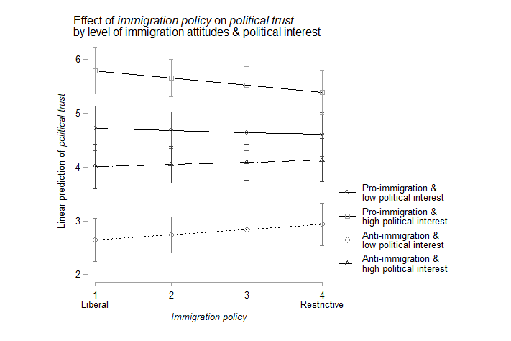
Note. Shows the predicted effect of immigration policy on political trust at pro-immigration attitudes & low/high levels of political information seeking, and at anti-immigration attitudes & low/high levels of political interest, with 95% confidence intervals. Predictions are based on Model 3 in Table A9. Immigration policy restrictiveness on x-axis divided into four quartiles, with quartile 1 representing the most liberal immigration policy values and quartile 4 the most restrictive immigration policy values. Pro- and anti-immigration attitudes fixed at 2SDs below and above the mean, respectively. Low level of political interest to 1 and high level of political interest to 4 of the 1-4 scale.

Figure A3. Illustration of the conditional effect of immigration attitudes & degree of political news exposure on political trust (3-way interaction) – level of political news exposure set to 0 and 3
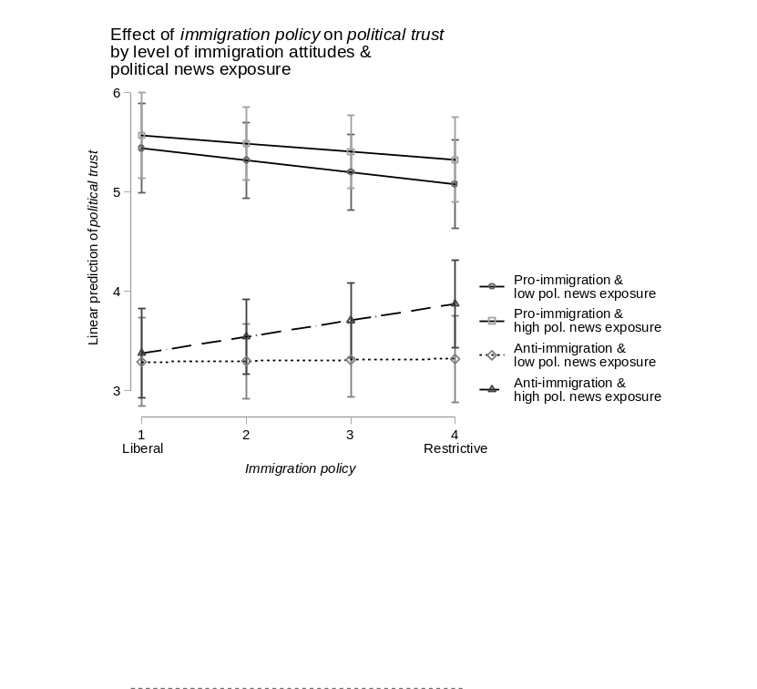
Note. Shows the predicted effect of immigration policy on political trust at pro-immigration attitudes & low/high levels of political news exposure, and at anti-immigration attitudes & low/high levels of political news exposure, with 95% confidence intervals. Predictions are based on Model 4 in Table A9. Immigration policy restrictiveness on x-axis divided into four quartiles, with quartile 1 representing the most liberal immigration policy values and quartile 4 the most restrictive immigration policy values. Pro- and anti-immigration attitudes fixed at 2SDs below and above the mean, respectively. Low level of political news exposure to 0 and high level of political information seeking to 3 of the 0-7 scale.

Robustness tests – 2-way interactions
Table A10: Using alternative immigration policy indicators (external immigration policy, internal immigration policy, family reunification policy, labor migration policy, asylum policy) (continued on next page) – 2-way interactions
 | DV: Political trust
 | M5: External immigration policy | M6: Internal immigration policy | M7: Family reunification policy | M8: Labor migration policy | M9: Asylum policy
Respondent level
Constant | 3.829***  (0.334) | 3.817***  (0.344) | 3.772***  (0.329) | 3.785***  (0.368) | 3.738***  (0.336)
Immigration attitudes | -2.374***  (0.253) | -3.103***  (0.241) | -2.695***  (0.248) | -2.680***  (0.254) | -2.591***  (0.251)
Age | 0.00420***  (0.000301) | 0.00420***  (0.000301) | 0.00421***  (0.000301) | 0.00420***  (0.000301) | 0.00420***  (0.000301)
Education | 0.0112***  (0.00147) | 0.0112***  (0.00147) | 0.0112***  (0.00147) | 0.0112***  (0.00147) | 0.0112***  (0.00147)
Political ideology | 0.0872***  (0.00250) | 0.0873***  (0.00250) | 0.0873***  (0.00250) | 0.0873***  (0.00250) | 0.0873***  (0.00250)
Gender | -0.0377***  (0.0102) | -0.0377***  (0.0102) | -0.0378***  (0.0102) | -0.0378***  (0.0102) | -0.0378***  (0.0102)
Living area (ref. Small/middle town)
Rural area or village | 0.0243*  (0.0115) | 0.0243*  (0.0115) | 0.0243*  (0.0115) | 0.0243*  (0.0115) | 0.0243*  (0.0115)
Large town | 0.0395**  (0.0146) | 0.0396**  (0.0146) | 0.0395**  (0.0146) | 0.0395**  (0.0146) | 0.0395**  (0.0146)
Unemployed | -0.175***  (0.0231) | -0.175***  (0.0231) | -0.175***  (0.0231) | -0.175***  (0.0231) | -0.175***  (0.0231)
Feeling household income | -0.288***  (0.00718) | -0.288***  (0.00718) | -0.288***  (0.00718) | -0.288***  (0.00718) | -0.288***  (0.00718)
Migration status (ref. Nat. born with nat. backgr.)
2nd generation immigrants | -0.150***  (0.0210) | -0.150***  (0.0210) | -0.150***  (0.0210) | -0.150***  (0.0210) | -0.150***  (0.0210)
1st generation immigrants | 0.0899***  (0.0249) | 0.0898***  (0.0249) | 0.0900***  (0.0249) | 0.0899***  (0.0249) | 0.0899***  (0.0249)
Country-year level
External immigration policy t-1 | 0.00635  (0.0657)
Internal immigration policy t-1 |  | 0.0162  (0.0684)
Family reunification policy t-1 |  |  | 0.0389  (0.0622)
Labor migration policy t-1 |  |  |  | 0.0136  (0.0599)
Asylum policy t-1 |  |  |  |  | 0.0488  (0.0637)
GDP per capita | 0.0000177**  (0.00000563) | 0.0000177**  (0.00000548) | 0.0000170**  (0.00000559) | 0.0000183***  (0.00000555) | 0.0000174**  (0.00000555)
% unemployment | -0.0443**  (0.0164) | -0.0459**  (0.0165) | -0.0450**  (0.0162) | -0.0430**  (0.0165) | -0.0469**  (0.0164)
% foreign born t-1 | 0.0100  (0.0158) | 0.00987  (0.0155) | 0.0106  (0.0157) | 0.00953  (0.0153) | 0.0114  (0.0158)
External immigration policy t-1 X Immigration attitudes | 0.0354  (0.0929)
Internal immigration policy t-1 X Immigration attitudes |  | 0.325***  (0.0879)
Family reunification policy t-1 X Immigration attitudes |  |  | 0.166  (0.0914)
Labor migration policy t-1 X Immigration attitudes |  |  |  | 0.157  (0.0924)
Asylum policy t-1 X Immigration attitudes |  |  |  |  | 0.122  (0.0916)
Variance components
var(Year) | 0.0960**  (0.0401) | 0.0900**  (0.0383) | 0.0922**  (0.0388) | 0.0951**  (0.0397) | 0.0928**  (0.0390)
var(Country) | 0.210***  (0.0383) | 0.207***  (0.0373) | 0.218***  (0.0398) | 0.200***  (0.0368) | 0.224***  (0.0414)
var(Country-year) | 0.121***  (0.0119) | 0.121***  (0.0120) | 0.119***  (0.0119) | 0.122***  (0.0119) | 0.118***  (0.0118)
var(Individual) | 3.551***  (0.00674) | 3.551***  (0.00674) | 3.551***  (0.00674) | 3.551***  (0.00674) | 3.551***  (0.00674)
N (country) | 23 | 23 | 23 | 23 | 23
N (country-years) | 97 | 97 | 97 | 97 | 97
N (respondents) | 139070 | 139070 | 139070 | 139070 | 139070
Standard errors in parentheses
* p < 0.05, ** p < 0.01, *** p < 0.001

Table A11: All legal citizens included – 2-way interactions (continued on next page)
 | DV: Political trust
 | M10: All citizens
Respondent level
Constant | 3.849***  (0.355)
Immigration attitudes | -2.840***  (0.249)
Age | 0.00433***  (0.000300)
Education | 0.0114***  (0.00146)
Political ideology | 0.0875***  (0.00250)
Gender | -0.0361***  (0.0102)
Living area (ref. Small/middle town)
Rural area or village | 0.0264*  (0.0115)
Large town | 0.0405**  (0.0146)
Unemployed | -0.174***  (0.0231)
Feeling household income | -0.289***  (0.00716)
Country-year level
Immigration policy t-1 | -0.00490  (0.0711)
GDP per capita | 0.0000180**  (0.00000552)
% unemployment | -0.0444**  (0.0164)
% foreign born t-1 | 0.00897  (0.0155)
Immigration policy t-1 X Immigration attitudes | 0.221*  (0.0908)
Variance components
var(Year) | 0.0956**  (0.0399)
var(Country) | 0.208***  (0.0376)
var(Country-year) | 0.120***  (0.0116)
var(Individual) | 3.556***  (0.00673)
Observations | 139628
Standard errors in parentheses
* p < 0.05, ** p < 0.01, *** p < 0.001

Table A12: Sensitivity analyses – 2-way interactions (continued on next page)
 | DV: Political trust
 | M11 | M12 | M13 | M14
Respondent level
Constant | 4.474***  (0.258) | 4.104***  (0.315) | 3.424***  (0.340) | 3.848***  (0.356)
Immigration attitudes | -2.844***  (0.250) | -2.844***  (0.250) | -2.843***  (0.249) | -2.844***  (0.249)
Age | 0.00420***  (0.000301) | 0.00420***  (0.000301) | 0.00420***  (0.000301) | 0.00420***  (0.000301)
Education | 0.0112***  (0.00147) | 0.0112***  (0.00147) | 0.0112***  (0.00147) | 0.0112***  (0.00147)
Political ideology | 0.0873***  (0.00250) | 0.0873***  (0.00250) | 0.0873***  (0.00250) | 0.0873***  (0.00250)
Gender | -0.0378***  (0.0102) | -0.0378***  (0.0102) | -0.0378***  (0.0102) | -0.0378***  (0.0102)
Living area (ref. Small/middle town)
Rural area or village | 0.0244*  (0.0115) | 0.0243*  (0.0115) | 0.0243*  (0.0115) | 0.0244*  (0.0115)
Large town | 0.0394**  (0.0146) | 0.0394**  (0.0146) | 0.0396**  (0.0146) | 0.0395**  (0.0146)
Unemployed | -0.175***  (0.0231) | -0.175***  (0.0231) | -0.175***  (0.0231) | -0.175***  (0.0231)
Feeling household income | -0.289***  (0.00718) | -0.289***  (0.00718) | -0.289***  (0.00718) | -0.288***  (0.00718)
Migration status (ref. Nat. born with nat. backgr.)
2nd generation immigrants | -0.150***  (0.0210) | -0.150***  (0.0210) | -0.150***  (0.0210) | -0.150***  (0.0210)
1st generation immigrants | 0.0903***  (0.0249) | 0.0901***  (0.0249) | 0.0900***  (0.0249) | 0.0900***  (0.0249)
Country-year level
Immigr. policy t-1 | -0.0827  (0.0832) | -0.0733  (0.0810) | -0.0260  (0.0719) | -0.00321  (0.0713)
% foreign born t-1 |  | 0.0325*  (0.0164) | 0.00628  (0.0157) | 0.00961  (0.0155)
GDP per capita |  |  | 0.0000230***  (0.00000544) | 0.0000180**  (0.00000553)
% unemployment |  |  |  | -0.0445**  (0.0164)
Immigr. policy t-1 X Immigration attitudes | 0.222*  (0.0911) | 0.222*  (0.0911) | 0.222*  (0.0911) | 0.223*  (0.0911)
Variance components
var(Year) | 0.0199***  (0.0102) | 0.0298***  (0.0139) | 0.128**  (0.0511) | 0.0960**  (0.0401)
var(Country) | 0.369**  (0.0640) | 0.325**  (0.0582) | 0.211***  (0.0381) | 0.210***  (0.0377)
var(Country-year) | 0.164***  (0.0189) | 0.157***  (0.0179) | 0.127***  (0.0119) | 0.120***  (0.0117)
var(Individual) | 3.551***  (0.00674) | 3.551***  (0.00674) | 3.551***  (0.00674) | 3.551***  (0.00674)
N (country) | 23 | 23 | 23 | 23
N (country-years) | 97 | 97 | 97 | 97
N (respondents) | 139070 | 139070 | 139070 | 139070
Standard errors in parentheses
* p < 0.05, ** p < 0.01, *** p < 0.001

Robustness tests – 3-way interactions
Table A13: Political news exposure (w/o radio news exposure)
 | DV: Political trust
 | M15
Respondent level
Constant | 3.631***  (0.355)
Immigration attitudes | -2.840***  (0.297)
Age | 0.00179***  (0.000369)
Education | 0.0133***  (0.00170)
Political ideology | 0.0841***  (0.00287)
Gender | -0.0437***  (0.0116)
Living area (ref. Small/middle town)
Rural area or village | 0.0207  (0.0132)
Large town | 0.0238  (0.0168)
Unemployed | -0.166***  (0.0278)
Feeling household income | -0.285***  (0.00851)
Migration status (ref. Nat. born with nat. backgr.)
2nd generation immigrants | -0.175***  (0.0243)
1st generation immigrants | 0.0712*  (0.0286)
Political news exposure (w/o radio) | 0.0729**  (0.0260)
Country-year level
Immigration policy t-1 | -0.0143  (0.0708)
GDP per capita | 0.0000203***  (0.00000544)
% unemployment | -0.0388*  (0.0158)
% foreign born t-1 | 0.00870  (0.0154)
Immigration policy t-1 X Immigration attitudes | 0.202  (0.107)
Immigration policy t-1 X political news exposure (w/o radio) | 0.0157  (0.00930)
Immigration attitudes X political news exposure (w/o radio) | 0.0141  (0.0878)
Immigration policy t-1 X Immigration attitudes X political news exposure (w/o radio) | 0.0201  (0.0300)
Variance components
var(Year) | 0.113**  (0.0452)
var(Country) | 0.216***  (0.0388)
var(Country-year) | 0.113***  (0.0120)
var(Individual) | 3.427***  (0.00755)
N (country) | 23
N (country-year) | 97
N (respondents) | 103320
Standard errors in parentheses
* p < 0.05, ** p < 0.01, *** p < 0.001

Figure A4. Illustration of the conditional effect of immigration attitudes & degree of political information seeking (w/o radio listening) on political trust (3-way interaction)
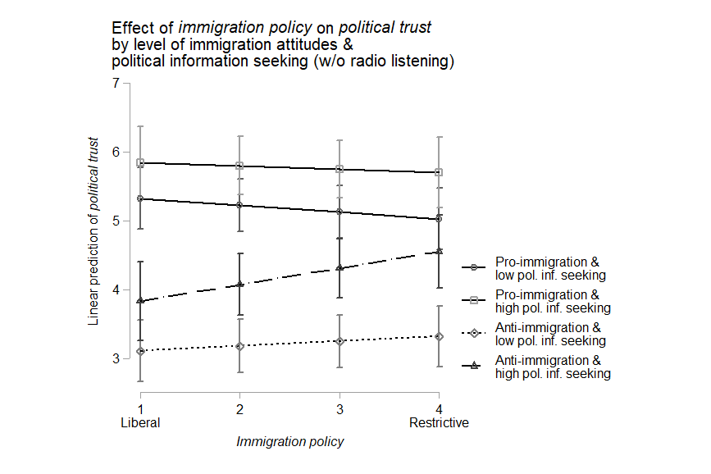
Note. Shows the predicted effect of immigration policy on political trust at pro-immigration attitudes & low/high levels of political information seeking, and at anti-immigration attitudes & low/high levels of political information seeking (w/o radio listening), with 95% confidence intervals. Predictions are based on Model 15 in Table A13. Immigration policy restrictiveness on x-axis divided into four quartiles, with quartile 1 representing the most liberal immigration policy values and quartile 4 the most restrictive immigration policy values. Pro- and anti-immigration attitudes fixed at 2SDs below and above the mean, respectively. Low level of political information seeking (w/o radio listening) to 0 and high level of political information seeking (w/o radio listening) to 7 of the 0-7 scale.

Table A14: Using alternative immigration policy indicators (external immigration policy, internal immigration policy) (continued on next page) – 3-way interactions
 | DV: Political trust
 | Political interest |  |  |  |  |  | Political news exposure
 | M16: External immigration policy | M17: Internal immigration policy | M18: Family reunification policy | M19: Labor migration policy | M20: Asylum policy |  | M21: External immigration policy | M22: Internal immigration policy | M23: Family reunification policy | M24: Labor migration policy | M25: Asylum policy
Respondent level
Constant | 2.844***  (0.327) | 2.786***  (0.337) | 2.852***  (0.323) | 2.885***  (0.362) | 2.644***  (0.328) |  | 3.832***  (0.331) | 3.828***  (0.343) | 3.711***  (0.327) | 3.776***  (0.363) | 3.767***  (0.334)
Immigration attitudes | -2.311***  (0.303) | -3.055***  (0.298) | -2.682***  (0.301) | -2.674***  (0.303) | -2.587***  (0.305) |  | -2.575***  (0.317) | -3.046***  (0.304) | -2.950***  (0.313) | -2.615***  (0.312) | -2.393***  (0.312)
Age | 0.000910**  (0.000304) | 0.000908**  (0.000304) | 0.000908**  (0.000304) | 0.000905**  (0.000304) | 0.000914**  (0.000304) |  | 0.00274***  (0.000399) | 0.00273***  (0.000399) | 0.00274***  (0.000399) | 0.00273***  (0.000399) | 0.00273***  (0.000399)
Education | -0.00574***  (0.00148) | -0.00576***  (0.00148) | -0.00573***  (0.00148) | -0.00574***  (0.00148) | -0.00576***  (0.00148) |  | 0.0133***  (0.00185) | 0.0133***  (0.00185) | 0.0133***  (0.00185) | 0.0132***  (0.00185) | 0.0132***  (0.00185)
Political ideology | 0.0850***  (0.00248) | 0.0851***  (0.00248) | 0.0850***  (0.00248) | 0.0850***  (0.00248) | 0.0850***  (0.00248) |  | 0.0821***  (0.00312) | 0.0822***  (0.00312) | 0.0821***  (0.00312) | 0.0821***  (0.00312) | 0.0821***  (0.00312)
Gender | 0.0369***  (0.0101) | 0.0370***  (0.0101) | 0.0369***  (0.0101) | 0.0369***  (0.0101) | 0.0368***  (0.0101) |  | -0.0463***  (0.0125) | -0.0462***  (0.0125) | -0.0464***  (0.0125) | -0.0463***  (0.0125) | -0.0462***  (0.0125)
Living area (ref. Small/middle town)
Rural area or village | 0.0376***  (0.0114) | 0.0376***  (0.0114) | 0.0376***  (0.0114) | 0.0375**  (0.0114) | 0.0377***  (0.0114) |  | 0.00551  (0.0141) | 0.00562  (0.0141) | 0.00577  (0.0141) | 0.00568  (0.0141) | 0.00554  (0.0141)
Large town | 0.0259  (0.0144) | 0.0260  (0.0144) | 0.0259  (0.0144) | 0.0259  (0.0144) | 0.0259  (0.0144) |  | 0.0364*  (0.0182) | 0.0369*  (0.0182) | 0.0363*  (0.0182) | 0.0367*  (0.0182) | 0.0373*  (0.0182)
Unemployed | -0.165***  (0.0228) | -0.165***  (0.0228) | -0.165***  (0.0228) | -0.165***  (0.0228) | -0.165***  (0.0228) |  | -0.156***  (0.0307) | -0.156***  (0.0307) | -0.155***  (0.0307) | -0.156***  (0.0307) | -0.156***  (0.0307)
Feeling household income | -0.265***  (0.00712) | -0.265***  (0.00712) | -0.265***  (0.00712) | -0.265***  (0.00712) | -0.265***  (0.00712) |  | -0.281***  (0.00929) | -0.282***  (0.00929) | -0.281***  (0.00929) | -0.282***  (0.00929) | -0.282***  (0.00929)
Migration status (ref. Nat. born with nat. backgr.)
2nd generation immigrants | -0.156***  (0.0208) | -0.156***  (0.0208) | -0.156***  (0.0208) | -0.156***  (0.0208) | -0.156***  (0.0208) |  | -0.162***  (0.0264) | -0.162***  (0.0264) | -0.162***  (0.0264) | -0.162***  (0.0264) | -0.163***  (0.0264)
1st generation immigrants | 0.0942***  (0.0246) | 0.0942***  (0.0246) | 0.0944***  (0.0246) | 0.0942***  (0.0246) | 0.0943***  (0.0246) |  | 0.0683*  (0.0315) | 0.0685*  (0.0315) | 0.0681*  (0.0315) | 0.0681*  (0.0315) | 0.0687*  (0.0315)
Political interest | 0.401***  (0.0320) | 0.412***  (0.0326) | 0.363***  (0.0323) | 0.368***  (0.0329) | 0.450***  (0.0310)
Political information seeking |  |  |  |  |  |  | 0.0410  (0.0263) | 0.0319  (0.0261) | 0.0694*  (0.0275) | 0.0426  (0.0265) | 0.00614  (0.0259)
Country-year level
External immigration policy t-1 | 0.0269  (0.0680) |  |  |  |  |  | -0.0393  (0.0659)
Internal immigration policy t-1 |  | 0.0560  (0.0701) |  |  |  |  |  | -0.0394  (0.0688)
Family reunification policy t-1 |  |  | 0.0344  (0.0647) |  |  |  |  |  | 0.0126  (0.0630)
Labor migration policy t-1 |  |  |  | 0.00449  (0.0631) |  |  |  |  |  | -0.0219  (0.0607)
Asylum policy t-1 |  |  |  |  | 0.113  (0.0659) |  |  |  |  |  | -0.00514  (0.0641)
GDP per capita | 0.0000174**  (0.00000543) | 0.0000172**  (0.00000528) | 0.0000166**  (0.00000538) | 0.0000177**  (0.00000538) | 0.0000170**  (0.00000536) |  | 0.0000184***  (0.00000547) | 0.0000186***  (0.00000534) | 0.0000179***  (0.00000543) | 0.0000187***  (0.00000538) | 0.0000178***  (0.00000538)
% unemployment | -0.0410*  (0.0162) | -0.0431**  (0.0163) | -0.0420**  (0.0160) | -0.0404*  (0.0163) | -0.0438**  (0.0162) |  | -0.0383*  (0.0156) | -0.0384*  (0.0158) | -0.0386*  (0.0155) | -0.0376*  (0.0157) | -0.0407**  (0.0156)
% foreign born t-1 | 0.00866  (0.0151) | 0.00900  (0.0148) | 0.00949  (0.0151) | 0.00860  (0.0148) | 0.0104  (0.0152) |  | 0.00883  (0.0155) | 0.00857  (0.0152) | 0.00948  (0.0153) | 0.00869  (0.0150) | 0.0107  (0.0155)
External immigration policy t-1 X Immigration attitudes | -0.0214  (0.110) |  |  |  |  |  | 0.0863  (0.115)
External immigration policy t-1 X Political interest | -0.0141  (0.0117)
Immigration attitudes X Political interest | 0.108  (0.0712) | 0.115  (0.0718) | 0.101  (0.0714) | 0.122  (0.0696) | 0.145*  (0.0715)
External immigration policy t-1 X Immigration attitudes X Political interest | 0.0117  (0.0251)
Internal immigration policy t-1 X Immigration attitudes |  | 0.273*  (0.108) |  |  |  |  |  | 0.279*  (0.110)
Internal immigration policy t-1 X Political interest |  | -0.0182  (0.0119)
Internal immigration policy t-1 X Immigration attitudes X Political interest |  | 0.0102  (0.0262)
Family reunification policy t-1 X Immigration attitudes |  |  | 0.131  (0.109) |  |  |  |  |  | 0.234*  (0.114)
Family reunification policy t-1 X Political interest |  |  | 0.00145  (0.0119)
Family reunification policy t-1 X Immigration attitudes X Political interest |  |  | 0.0140  (0.0249)
Labor migration policy t-1 X Immigration attitudes |  |  |  | 0.123  (0.112) |  |  |  |  |  | 0.105  (0.114)
Labor migration policy t-1 X Political interest |  |  |  | -0.000677  (0.0120)
Labor migration policy t-1 X Immigration attitudes X Political interest |  |  |  | 0.00598  (0.0262)
Asylum policy t-1 X Immigration attitudes |  |  |  |  | 0.0862  (0.110) |  |  |  |  |  | 0.0272  (0.113)
Asylum policy t-1 X Political interest |  |  |  |  | -0.0334**  (0.0113)
Asylum policy t-1 X Immigration attitudes X Political interest |  |  |  |  | -0.00179  (0.0253)
External immigration policy t-1 X Political information seeking |  |  |  |  |  |  | 0.0183  (0.00938)
Immigration attitudes X Political information seeking |  |  |  |  |  |  | 0.144  (0.0957) | -0.00881  (0.0909) | 0.217*  (0.0955) | -0.0540  (0.0887) | -0.151  (0.0950)
External immigration policy t-1 X Immigration attitudes X Political information seeking |  |  |  |  |  |  | -0.0282  (0.0325)
Internal immigration policy t-1 X Political information seeking |  |  |  |  |  |  |  | 0.0218*  (0.00943)
Internal immigration policy t-1 X Immigration attitudes X Political information seeking |  |  |  |  |  |  |  | 0.0284  (0.0320)
Family reunification policy t-1 X Political information seeking |  |  |  |  |  |  |  |  | 0.00794  (0.00988)
Family reunification policy t-1 X Immigration attitudes X Political information seeking |  |  |  |  |  |  |  |  | -0.0559  (0.0327)
Labor migration policy t-1 X Political information seeking |  |  |  |  |  |  |  |  |  | 0.0176  (0.00956)
Labor migration policy t-1 X Immigration attitudes X Political information seeking |  |  |  |  |  |  |  |  |  | 0.0475  (0.0320)
Asylum policy t-1 X Political information seeking |  |  |  |  |  |  |  |  |  |  | 0.0316***  (0.00928)
Asylum policy t-1 X Immigration attitudes X Political information seeking |  |  |  |  |  |  |  |  |  |  | 0.0811*  (0.0330)
Variance components
var(Year) | 0.0797**  (0.0340) | 0.0731**  (0.0320) | 0.0768**  (0.0330) | 0.0794**  (0.0338) | 0.0766**  (0.0329) |  | 0.105**  (0.0423) | 0.106**  (0.0430) | 0.103**  (0.0417) | 0.105**  (0.0422) | 0.104**  (0.0418)
var(Country) | 0.184***  (0.0345) | 0.180***  (0.0333) | 0.192***  (0.0357) | 0.179***  (0.0334) | 0.197***  (0.0369) |  | 0.207***  (0.0377) | 0.207***  (0.0371) | 0.214***  (0.0393) | 0.201***  (0.0368) | 0.222***  (0.0407)
var(Country-year) | 0.157***  (0.0168) | 0.157***  (0.0169) | 0.157***  (0.0167) | 0.159***  (0.0169) | 0.149***  (0.0160) |  | 0.132***  (0.0150) | 0.133***  (0.0148) | 0.135***  (0.0154) | 0.136***  (0.0154) | 0.130***  (0.0145)
Var(Individual) | 3.460***  (0.00657) | 3.460***  (0.00657) | 3.460***  (0.00657) | 3.460***  (0.00657) | 3.460***  (0.00657) |  | 3.352***  (0.00804) | 3.352***  (0.00804) | 3.352***  (0.00804) | 3.352***  (0.00804) | 3.352***  (0.00804)
N (country) | 23 | 23 | 23 | 23 | 23 |  | 23 | 23 | 23 | 23 | 23
N (country-year) | 97 | 97 | 97 | 97 | 97 |  | 97 | 97 | 97 | 97 | 97
N (respondents) | 138938 | 138938 | 138938 | 138938 | 138938 |  | 87179 | 87179 | 87179 | 87179 | 87179
Standard errors in parentheses
* p < 0.05, ** p < 0.01, *** p < 0.001

Table A15: All legal citizens included – 3-way interactions (continued on next page)
 | DV: Political trust
 | M26: Political interest | M27: Political news exposure
Respondent level
Constant | 2.773***  (0.347) | 3.870***  (0.351)
Immigration attitudes | -2.711***  (0.303) | -2.709***  (0.312)
Age | 0.00104***  (0.000303) | 0.00285***  (0.000398)
Education | -0.00552***  (0.00148) | 0.0132***  (0.00185)
Political ideology | 0.0852***  (0.00248) | 0.0822***  (0.00312)
Gender | 0.0385***  (0.0101) | -0.0447***  (0.0125)
Living area (ref. Small/middle town)
Rural area or village | 0.0397***  (0.0114) | 0.00752  (0.0141)
Large town | 0.0268  (0.0144) | 0.0376*  (0.0182)
Unemployed | -0.164***  (0.0228) | -0.153***  (0.0306)
Feeling household income | -0.265***  (0.00709) | -0.282***  (0.00926)
Political interest | 0.428***  (0.0324)
Political news exposure |  | 0.00585  (0.0254)
Country-year level
Immigration policy t-1 | 0.0516  (0.0726) | -0.0555  (0.0710)
GDP per capita | 0.0000177***  (0.00000533) | 0.0000186***  (0.00000535)
% unemployment | -0.0415*  (0.0162) | -0.0385*  (0.0156)
% foreign born t-1 | 0.00813  (0.0149) | 0.00797  (0.0152)
Immigration policy t-1 X Immigration attitudes | 0.136  (0.109) | 0.152  (0.112)
Immigration policy t-1 X Political interest | -0.0249*  (0.0118)
Immigration attitudes X Political interest | 0.0929  (0.0717)
Immigration policy t-1 X Immigration attitudes X Political interest | 0.0189  (0.0254)
Immigration policy t-1 X Political news exposure |  | 0.0317***  (0.00906)
Immigration attitudes X Political news exposure |  | -0.0671  (0.0928)
Immigration policy t-1 X Immigration attitudes X Political news exposure |  | 0.0472  (0.0319)
Variance components
var(Year) | 0.0796**  (0.0333) | 0.105**  (0.0423)
var(Country) | 0.184***  (0.0337) | 0.208***  (0.0373)
Var(Country-year) | 0.154***  (0.0144) | 0.128***  (0.0141)
Var(Individual) | 3.465***  (0.00657) | 3.358***  (0.00804)
N (country) | 23 | 23
N (country-year) | 97 | 97
N (respondents) | 139496 | 87494
Standard errors in parentheses
* p < 0.05, ** p < 0.01, *** p < 0.001

Table A16: Sensitivity analyses – 3-way interactions
 | DV: Political trust
 | Political interest |  |  |  |  | Political news exposure
 | M26 | M27 | m30 | m31 |  | m32 | m33 | m34 | m35
Respondent level
Constant | 3.375***  (0.258) | 3.025***  (0.308) | 2.362***  (0.327) | 2.772***  (0.348) |  | 4.522***  (0.260) | 4.158***  (0.318) | 3.531***  (0.338) | 3.872***  (0.352)
Immigration attitudes | -2.742***  (0.304) | -2.741***  (0.304) | -2.740***  (0.304) | -2.741***  (0.304) |  | -2.716***  (0.313) | -2.717***  (0.313) | -2.718***  (0.313) | -2.717***  (0.313)
Age | 0.000907**  (0.000304) | 0.000908**  (0.000304) | 0.000911**  (0.000304) | 0.000910**  (0.000304) |  | 0.00273***  (0.000399) | 0.00273***  (0.000399) | 0.00274***  (0.000399) | 0.00273***  (0.000399)
Education | -0.00579***  (0.00148) | -0.00578***  (0.00148) | -0.00576***  (0.00148) | -0.00576***  (0.00148) |  | 0.0132***  (0.00185) | 0.0132***  (0.00185) | 0.0132***  (0.00185) | 0.0132***  (0.00185)
Political ideology | 0.0850***  (0.00248) | 0.0850***  (0.00248) | 0.0850***  (0.00248) | 0.0850***  (0.00248) |  | 0.0821***  (0.00312) | 0.0821***  (0.00312) | 0.0821***  (0.00312) | 0.0821***  (0.00312)
Gender | 0.0369***  (0.0101) | 0.0369***  (0.0101) | 0.0369***  (0.0101) | 0.0369***  (0.0101) |  | -0.0462***  (0.0125) | -0.0462***  (0.0125) | -0.0462***  (0.0125) | -0.0462***  (0.0125)
Living area (ref. Small/middle town)
Rural area or village | 0.0377***  (0.0114) | 0.0376***  (0.0114) | 0.0377***  (0.0114) | 0.0377***  (0.0114) |  | 0.00544  (0.0141) | 0.00535  (0.0141) | 0.00540  (0.0141) | 0.00534  (0.0141)
Large town | 0.0257  (0.0144) | 0.0257  (0.0144) | 0.0259  (0.0144) | 0.0259  (0.0144) |  | 0.0369*  (0.0182) | 0.0369*  (0.0182) | 0.0373*  (0.0182) | 0.0372*  (0.0182)
Unemployed | -0.166***  (0.0228) | -0.166***  (0.0228) | -0.166***  (0.0228) | -0.165***  (0.0228) |  | -0.157***  (0.0307) | -0.157***  (0.0307) | -0.157***  (0.0307) | -0.156***  (0.0307)
Feeling household income | -0.265***  (0.00711) | -0.265***  (0.00711) | -0.265***  (0.00712) | -0.265***  (0.00712) |  | -0.282***  (0.00929) | -0.282***  (0.00929) | -0.282***  (0.00929) | -0.282***  (0.00929)
Migration status (ref. Nat. born with nat. backgr.)
2nd generation immigrants | -0.155***  (0.0208) | -0.156***  (0.0208) | -0.156***  (0.0208) | -0.156***  (0.0208) |  | -0.162***  (0.0264) | -0.163***  (0.0264) | -0.163***  (0.0264) | -0.163***  (0.0264)
1st generation immigrants | 0.0946***  (0.0246) | 0.0944***  (0.0246) | 0.0943***  (0.0246) | 0.0942***  (0.0246) |  | 0.0692*  (0.0315) | 0.0689*  (0.0315) | 0.0688*  (0.0315) | 0.0687*  (0.0315)
Political interest | 0.430***  (0.0321) | 0.430***  (0.0321) | 0.429***  (0.0321) | 0.429***  (0.0321)
Political news exposure |  |  |  |  |  | 0.00388  (0.0255) | 0.00403  (0.0255) | 0.00416  (0.0255) | 0.00396  (0.0254)
Country-year level
Immigration policy t-1 | -0.0175  (0.0847) | -0.00998  (0.0821) | 0.0341  (0.0728) | 0.0543  (0.0729) |  | -0.122  (0.0824) | -0.114  (0.0807) | -0.0787  (0.0720) | -0.0549  (0.0712)
% foreign born t-1 |  | 0.0312*  (0.0156) | 0.00602  (0.0149) | 0.00873  (0.0149) |  |  | 0.0323*  (0.0164) | 0.00584  (0.0154) | 0.00866  (0.0152)
GDP per capita |  |  | 0.0000225***  (0.00000520) | 0.0000176***  (0.00000535) |  |  |  | 0.0000225***  (0.00000528) | 0.0000186***  (0.00000537)
% unemployment |  |  |  | -0.0417*  (0.0162) |  |  |  |  | -0.0387*  (0.0157)
Immigration policy t-1 X Immigration attitudes | 0.147  (0.110) | 0.146  (0.110) | 0.147  (0.110) | 0.148  (0.110) |  | 0.155  (0.113) | 0.156  (0.113) | 0.155  (0.113) | 0.155  (0.113)
Immigration policy t-1 X Political interest | -0.0253*  (0.0117) | -0.0253*  (0.0117) | -0.0252*  (0.0117) | -0.0252*  (0.0117)
Immigration attitudes X Political interest | 0.104  (0.0719) | 0.104  (0.0719) | 0.103  (0.0719) | 0.104  (0.0719)
Immigration policy t-1 X Immigration attitudes X Political interest | 0.0148  (0.0255) | 0.0149  (0.0255) | 0.0148  (0.0255) | 0.0146  (0.0255)
Immigration policy t-1 X Political news exposure |  |  |  |  |  | 0.0324***  (0.00912) | 0.0324***  (0.00911) | 0.0323***  (0.00910) | 0.0324***  (0.00910)
Immigration attitudes X Political news exposure |  |  |  |  |  | -0.0632  (0.0929) | -0.0628  (0.0929) | -0.0625  (0.0929) | -0.0635  (0.0929)
Immigration policy t-1 X Immigration attitudes X Political news exposure |  |  |  |  |  | 0.0457  (0.0319) | 0.0455  (0.0319) | 0.0460  (0.0319) | 0.0465  (0.0319)
Variance components
var(Year) | 0.0153***  (0.00848) | 0.0239***  (0.0116) | 0.109**  (0.0438) | 0.0800**  (0.0341) |  | 0.0252***  (0.0116) | 0.0345***  (0.0150) | 0.130**  (0.0510) | 0.106**  (0.0428)
var(Country) | 0.330**  (0.0581) | 0.285***  (0.0506) | 0.181***  (0.0336) | 0.186***  (0.0341) |  | 0.381**  (0.0659) | 0.342**  (0.0608) | 0.213***  (0.0382) | 0.209***  (0.0374)
var(Country-year) | 0.209***  (0.0239) | 0.196***  (0.0178) | 0.157***  (0.0167) | 0.155***  (0.0167) |  | 0.168***  (0.0187) | 0.163***  (0.0182) | 0.136***  (0.0147) | 0.128***  (0.0141)
var(Individual) | 3.460***  (0.00657) | 3.460***  (0.00657) | 3.460***  (0.00657) | 3.460***  (0.00657) |  | 3.352***  (0.00804) | 3.352***  (0.00804) | 3.352***  (0.00804) | 3.352***  (0.00804)
N (country) | 23 | 23 | 23 | 23 |  | 23 | 23 | 23 | 23
N (country-year) | 97 | 97 | 97 | 97 |  | 97 | 97 | 97 | 97
N (respondents) | 138938 | 138938 | 138938 | 138938 |  | 87179 | 87179 | 87179 | 87179
Standard errors in parentheses
* p < 0.05, ** p < 0.01, *** p < 0.001

Figure was created using Stata plugin “plotplain” by Bischof (2017).

