Web Appendix
Perspectives on Projective Techniques in Consumer Research: A Review, Primary Analysis, and Methodological Guidance
Table of Contents:
Web Appendix A: Detailed Literature Review Source Table and Analysis p.2
Table A1: Detailed Literature Review Source Table and Analysis p.2
Additional References for Appendix A. p.18
Web Appendix B: City Destination Projective Techniques Booklet p.21
Web Appendix C: Further Detail on the Qualitative Coding and Analysis p.25
Web Appendix C1. Data Structure, Word Clouds, and additional analysis of WA and SC for Las Vegas p.27
Web Appendix D1. Data structure, Word Clouds, and Thematic Analysis of WA and SC
for New York City, Nashville, Los Angeles, and New Orleans. p.30
Web Appendix D2. Frequency Analysis and Symbolic Analysis of Animal Associations for each City. p.45
Table D2. Top two animal associations, characteristics and interpretive symbolism to city identity. p.46
Web Appendix D3. Top celebrity association, characteristics and interpretive symbolism to city identity. p.49
Table D3. Top celebrity association, characteristics and interpretive symbolism to city identity. p.50
Web Appendix E. Deeper Insights and Discussion of the Three Projective Techniques’ Findings p.52
Additional References for Web Appendix C-E p.55
Web Appendix F. Quantitative Analysis – Supporting Figures p.57
Figure F1: Preprocessed (Stemmed and Removed Stop Words) Word Frequencies for Word Association p.57
Figure F2: Preprocessed (Stemmed and Removed Stop Words) Bigram Frequencies for Negative Sentence Completion p.58
Figure F3: Preprocessed (Stemmed and Removed Stop Words) Bigram Frequencies for Positive Sentence Completion p.59
Figure F4: Preprocessed (Stemmed and Removed Stop Words) Bigram Frequencies for Word Association p.60
Figure F5: STM Topic Modeling Metrics for Negative and Positive Sentence Completion across k = 5 to 15 p.61
Figure F6: STM Topic Analysis Top Terms for Negative Sentence Completion p.62
Figure F7: STM Topic Analysis Top Terms for Positive Sentence Completion p.63
Figure F8: STM Topic Analysis Top Terms for Word Association p.64
Figure F9: Correspondence Analysis Plot for Word Association p.65
Table F1: Contingency Table for Negative Sentence Completion p.66
Table F2: Contingency Table for Positive Sentence Completion p.66
Table F3: Contingency Table for Word Association p.66
Web Appendix A: Detailed Literature Review Source Table and Analysis

Table A1: Detailed Literature Review Source Table and Analysis
Citation | Description | Analysis | Sample
Alencar et al. (2021)  Type: Association, Completion  Cat: Consumer Sci. | Free word association with Gluten-free (GF) bread and ordered word listings of quality attributes. Sentence completion task for scenarios involving GF bread. Combined with quantitative survey using Likert scales of the importance of bread attributes. | Content analysis to categorize terms. Correspondence analysis of categories vs. respondent consumption characteristics. Free listing terms put into a word-respondent matrix and a cognitive saliency index was calculated for the different categories. | Convenience sample of n = 205 Brazilian consumers with celiac disease.
Amatulli et al. (2023)  Type: Association, Creation  Cat: Marketing | Associate words and images related to consumption, before, during, and after the pandemic. Similarly give three consumption categories for each period. Collage construction and the creation of fairy tales related to aspects of consumption. | Qualitative analysis of responses. | Sample of n = 31 Italian undergraduate students.
Anghelcev et al. (2015)  Type: Creation  Cat: Marketing | Collect 10-12 images covering “thoughts and feelings” regarding climate change. Follow six step ZMET process, resulting in a summary collage for each subject. | Extract deep and conceptual metaphors, along with thematic categories. Qualitative discussion and quoting individuals based on metaphors and categories. | Sample of n = 12 (determined by saturation) of South Koreans, aged from 20-28
Ares and Deliza (2010)  Type: Association  Cat: Consumer Sci. | Word association with a stimuli of label/packaging a milk drink. A free listing/association of listing expected packaging features. | Cluster analysis of categories and of subjects for each experiment. Chi-squared test between category mentions and clusters. | Convenience sample of n = 200 Uruguayan consumers, with n = 100 used in each experiment.
Ares et al. (2014)  Type: Association  Cat: Consumer Sci. | Word association and free listing for consumers concepts of general and food-related wellbeing. | Content analysis and categorization. Calculation of cognitive saliency index was calculated for each of the categories. | Stratified sample of n = 120 people balanced by demographic characteristics.
Ares et al. (2020)  Type: Association  Cat: Consumer Sci. | Word association with breastfeeding and infant formulas. | Responses were categorized into larger categories (dimensions) and sub-categories. Responses were compared for health professionals vs. mothers across categories for breastfeeding and formula using glm. Analysis of rank vs. frequency for sub-categories. | Sample of n = 154 health professionals and cluster sample of n = 330 mothers from different health centers, giving sample overall n = 484.
Azar (2015)  Type: Creation  Cat: Marketing | Semi-structured interviews incorporating projective drawings and a pen-and-paper exercise to explore consumers’ perceptions of brands in terms of sex, gender, and sexual orientation. | Qualitative analysis of interview responses and projective drawings to identify dimensions and antecedents of brand sexual associations. | Purposive sample of n = 18 deliberately diverse French participants.
Broeckelmann (2010)  Type: Completion  Cat: Marketing | For different retailing channel scenarios, a series of images and dialog bubbles, including special/coupon scenarios for two store types and differing prices for online purchase (less, same, or more than store price). | Use manual coding with Kendall’s W consistency check to categorize the respondents’ purchase intentions. Analysis of categories using the chi-squared test. | Samples from students at German university. Sizes of n = 221 (study 1), n = 150 (study 2), n = 122 (study 3), and n = 176 (study 4)
Brotherton (2005)  Type: Association  Cat: Hospitality | Structured interviews, with free word association with “hospitality”, and hospitality associations for “colour”, “animal” and “season of the year” and justifications for choices. Combine with structured interviews | Categorizations of words/projective responses. Summary tables of responses and reasons for responses. Analysis of categories using the chi-squared test. | A sample of n = 89 guests from two UK hotels. Interviewers were instructed to balance age and gender demographics.
Celuch and Neuhofer (2024)  Type: Association, Creation  Cat: Hospitality | Open-ended questions on event behavior (at start and end of event). Space for creative drawing with sentence bubble and association of event in multiple categories (e.g., color, animal, magical creature). | Qualitative analysis, with example creative drawings and summaries of word association tasks. | Convenience sample of event attendees with n = 21.
Chen et al. (2022)  Type: Association, Completion  Cat: Hospitality | Word association with “service robots” and sentence completion on preferences for service robots and preferred service robot features. Combine with semi-structured interviews. | Use of coding to find themes. Qualitative analysis including quotes from individual research subjects. | Purposive sampling of generation z in China who have used service robots, with n = 33 for projective techniques and n = 15 for interviews.
Cheng et al. (2025)  Type: Creative  Cat: Hospitality | ZMET interviews using participant-selected imagery to explore Hanfu immersive tourism experiences and cultural identity. | ZMET analysis used to construct a mental map based on attribute–consequence–value relationships. A subsequent quantitative study tested relationships among constructs identified through the qualitative analysis. | n = 12 Hanfu enthusiasts for ZMET interviews, followed by a quantitative survey of n = 357 participants.
Chen (2024)  Type: Creation  Cat: Marketing | Subjects asked to write journals about the desire to “experience” and travel experiences. Follow-up in-depth interview involving projective techniques e.g., project to a situation for "someone that loves traveling". | Categorization and coding into themes and further abstraction of concepts. Categorization including quotes from research subjects. | Initial pretest sample of n = 24 students, followed by sample of n = 60 sample of New York area consumers for the interviews and projective techniques.
Cherrier (2012)  Type: Construction  Cat: Marketing | Student subjects created collages of healthy and unhealthy identities, along with text descriptions. They then created colleges of student life, with text descriptions. | Qualitative analysis of text. Classification of collage into healthy and unhealthy identities. | Student sample from marketing classes of n = 53 students.
Chhabra (2012)  Type: Completion  Cat: Hospitality | Sentence completion tasks asking respondents to outline leisure and holiday plans in different scenarios. | Qualitative analysis of responses. | Convenience sample of n = 200 students from an American university.
Cian & Cervai (2011)  Type: Association  Cat: Marketing | Select brand associations photos from a photoset consisting of a range of categories (animals, houses, etc.) and then write adjectives associated with the selected pictures. Repeat process with colors, touch (of materials), and hearing. Ask the respondent for similarities between adjectives. | MuSeS qualitative analysis. Use the similarities between adjectives to reduce adjective set and use Flexigrid cluster analysis to cluster adjectives into categories. Compare with personality traits from Aaker’s scale. | A sample of n = 30 randomly invited from consumers of a sailboat factory.
Cui et al (2018)  Type: Completion, Association, Ordering, Creative  Cat: Marketing | Sentence completion and tasks where respondents were ask to project as someone who was brand addicted. Word association/ordering of phrases related to brand addiction projected to someone who was brand addicted. Combined with focus groups. | Qualitative analysis and summary of results into 11 themes. | Sample of n = 19, with 10 males and 9 females, was recruited via a focus group.
Dahiya et al. (2014) Type: Completion  Cat: Consumer Sci. | Word association task with different types of bean products. Combined with focus group discussions and structured interviews. | Coding and categorization into 10 categories. Chi-squared test on categories and products. Correspondence analysis. | Sample of n =152. Regional cluster sample from city and villages. Balanced by demographic characteristics.
de Alcântara et al. (2024)  Type: Association, Creative  Cat: Consumer Sci. | Word association of UHT milk with and without additional stabilizing ingredients. Product Personality Profiling, creating personas of who would buy each type of milk. Survey with demographic questions and Likert scale questions on UHT milk knowledge and views. | Cronbach’s α and CFA on survey questions. Hierarchical Clustering on these data, to get two segments. T-tests for difference between questions for segments. Categorization of projective technique data. Cellwise chi-squared tests on clusters vs. demographics and projective categories. | A convenience sample recruited by social media of n = 360 Brazilian consumers.
de Melo et al. (2022)  Type: Association,  Completion  Cat: Consumer Sci. | Word association and sentence completion tasks examining consumers’ perceptions of low-sodium foods and low-sodium spreadable processed cheese. The completion task included positive, negative, and purchase-related scenarios. | Responses were coded and grouped into categories. Chi-squared tests and cellwise chi-squared tests were used to examine associations between response categories and consumer characteristics/groups. | Convenience sample of n = 1,511 Brazilian consumers.
de Oliveira Aust et al. (2024)  Type: Association, Completion  Cat: Consumer Sci. | Word association and sentence completion with pictures + conversation for consumer perceptions of dry-aged beef. | Categorization of responses using semantic associations. Cluster analysis (into two clusters) of respondents and correspondence analysis of responses and visual stimuli. Chi-squared tests for differences in responses between clusters. | Snowball sampling of n = 126 completed responses from initial pool of 224 people.
da Silva et al. (2021)  Type: Completion  Cat: Consumer Sci. | Story completion involving the purchase of fresh natural cheese. Survey included demographic characteristics and perception of risk. | Categorize responses into categories. Chi-squared tests and cellwise chi-squared tests with respect to regions and split by risk perception. | Sample of n = 326 consumers, clustered by region.
de Souza et al. (2024)  Type: Association, Completion  Cat: Consumer Sci. | Sentence completion with picture bubbles on different aspects of Stingless bee honey (SBH) consumption. Laddering task to gain multi-level associations. Some quantitative willingness-to-pay and consumer ratings data. | Categorization of responses from sentence completion. Fisher’s exact test on categories and demographic categories. Hierarchical value map from laddering analysis. Student’s t test and Pearson correlations from quantitative ratings data. | A sample of n = 480 Brazilian consumers over 18, collected by snowball sampling via social networks.
Doherty & Nelson (2010)  Type: Completion, Creative  Cat: Marketing | “Soft” store attributes found using sentence completion with pictures + conversation bubbles. Case study scenarios (e.g., bad service) with users giving quantitative value for commitment and describing feelings about store. | Content analysis of qualitative answers combined with quantitative loyalty measure used to segment respondents into three loyalty groups (switchers, susceptible, and loyals). Further examine response associations for each loyalty group using chi-squared test. | Cluster sampling of n = 152 consumers in Northern Ireland.
Eldesouky et al. (2015)  Type: Association, Completion  Cat: Consumer Sci. | Give word associations for cheese packages. Sentence completion with pictures for discussions involving cheese packages. | Coding responses into categories for both tasks and summarize in contingency tables. | Convenience sample of n = 203 recruited from student and other personal databases.
Elghannam et al. (2018)  Type: Association, Completion  Cat: Consumer Sci. | List items that you would buy and not buy from social media channels. Sentence completion exercises regarding social media channels. | Coding responses into categories from sentence completion and combining/coding of foodstuffs for three different cultures. | A convenience/purposive sample of n = 424 consumers, across three countries (Spain, Mexico, Egypt) who were users of social networks.
Esmerino et al. (2017)  Type: Association, Ordering  Cat: Marketing | Association task of evaluating cards with different brands of yoghurt/fermented milk packages and giving a range of responses including words, phrases, and pictures. The place cards on paper with closest cards representing most similar products and write 3 to 5 words that differentiate stimuli. | Attributes were categorized and then correspondence analysis (CA) was used to relate categories to product. Variance accounted for by CA solution was reported. Chi-squared tests and cell-wise chi-squared tests were used to test association between categories and products. | Two samples of n = 50 recruited via social networks, email, and advertisements for the association and ordering tasks. A sample of n = 26 was collected for the focus group.
Farhat and Chaney (2024)  Type: Creative  Cat: Hospitality | Describe worst experience with a destination then draw a trajectory plot of intensity/polarity of feelings over time. | Qualitative clustering of trajectories into three types and coding of interview responses into different types of brand hate. | Snowball sample of n = 45 collected through travel agencies and including respondents with multiple nationalities.
Filep and Greenacre (2007)  Type: Creative  Cat: Hospitality | Creative essay assignment, describing a perfect day in their study-abroad town. Combined with a quantitative study on travel motivation. | Essays were coded into motivational themes. Qualitative analysis, including quotes from individual research subjects. Analysis of quantitative data using cluster analysis, t-tests, PCA, and factor analysis. | A sample of n = 20, ten males and ten females, partaking in a pre-departure workshop for a study abroad experience in Spain.
Font and Hindley (2017)  Type: Creative  Cat: Hospitality | Subjects visiting two destinations were asked to select two holiday photos and answer open-ended questions on the photos, e.g., how they relate to subjects’ life and travel motives. | Qualitative analysis, including quotes from individual research subjects. | A purposive sample of n = 23 respondents traveling to Svalbard and Venice, with 8 directly asked about motivations and 15 indirectly.
Gámbaro et al. (2014)  Type: Association  Cat: Marketing | Names of cosmetics (e.g., “nourishing cream”) were given as stimuli and users were asked to write down words, images, thoughts and feelings associated with the stimuli. | Terms were coded categorically to give a contingency table. A chi-squared test was run on the table. Correspondence analysis was carried out. | A convenience sample of n = 120 females recruited from shopping centers, universities, and other locations in Uruguay.
Gamradt (1995)  Type: Creative  Cat: Hospitality | Creative exercise, where school students were asked to give opinions of tourists, give advice to tourists, and draw pictures of imagined tourists. | Coding of student work into categories with multiple categories per student. Qualitative analysis with discussion of pictures and quotes from individual subjects. | A sample of n = 365 students selected in a stratified sample from different categories of school.
Gómez-Corona et al. (2016)  Type: Association  Cat: Consumer Sci. | Give four words related to craft beer and rank in importance. Give polarity of each word from -3 to 3 on a seven point scale. | Categorization of responses into seven categories. Fisher exact test between categories and countries for craft and industrial beer drinkers. Calculation of polarity index of sentiment. Correspondence analysis (CA) of terms. Hierarchical cluster analysis with coordinates from CA. | Intercept sampling of males who consumed beer at least once a month in Paris and Mexico with n = 300 (n = 150 in each location) and sample balanced between craft and industrial beer drinkers.
Gonçalves et al. (2025)  Type: Association  Cat: Consumer Sci. | Free word association on nanotechnology and the use of nanotechnology in food. Two quantitative survey questions on approval of nanotechnology in food and intent to purchase nanotechnology in food. | Content analysis to extract categories from word association. Cell-wise chi-squared test on food categories vs. three preference categories derived from survey questions. Word clouds of categories. Confidence interval on mean survey response. | Intercept sample of n = 463 people in Rio de Janeiro in Brazil collected to be demographically diverse.
Grougiou and Pettigrew (2011)  Type: Association, Completion  Cat: Marketing | General views on services with association stimuli (e.g., “dissatisfaction”, “quality” and completion stimuli, e.g., (“services are”). | Qualitative summaries, including quotes from individual research subjects. | Saturation was used to determine a sample of n = 60 of a diverse senior consumers.
Harrigan et al. (2012)  Type: Completion  Cat: Marketing | Sentence completion bubbles for different CRM process scenarios. Combine with quantitative survey on views of e-CRM. | Qualitative summaries, including quotes from individual research subjects. Quantitative data are analyzed with PCA and Chronbach’s α. | Sample of n = 1445 SMEs in Ireland.
Hilverda et al. (2016)  Type: Association  Cat: Consumer Sci. | Give associations with organic food (50% of sample) or organic meat and vegetables (50% of sample). Also measure psychological distance measures using a Likert scale survey. In study 2, rate association “centrality” on quantitative scale. | Individual chi-squared tests on equality of groups for each category across organic usage groups and survey prompt. Run MANOVA + paired comparisons on psychological differences. Calculate adjusted frequencies and median splits. Calculate correlations between centrality scores. | Study 1: Sample of n = 160 in the Netherlands from researcher's networks and from food/organic food internet blogs. Sample split into frequent, occasional, and rare organic food purchasers. Study 2: Convenience sample of n = 52 for rating attributes.
Hofstede et al. (2007)  Type: Association  Cat: Marketing | Associate clippings of celebrities with brands. Associate each celebrity with a dominant personality characteristic (out of 73 possible characteristics). In second task, associate each brand with a job and each job with a personality characteristic. | Personality characteristics are summarized into dimensions (e.g., competence). Correlations are calculated between tasks for each of the different brands using the proportion of category entries. | A sample of n = 16 of potential beer consumers for mood board and n = 100 for the job association assignment.
Holder et al. (2023).  Type: Association  Cat: Hospitality | Data analysis consisted of structured interviews discussing pictures showing Indigenous tourism experiences. Projective analysis used to supplement this, e.g., asking what characters in the picture are thinking. | Qualitative analysis of results, including quotes from individual research subjects. | An Australian consumer research panel with n = 41 snowball sample. Projective techniques run with n = 25 subset.
Hussey and Duncombe (1999)  Type: Association  Cat: Marketing | Associate brands with one of 10 animals and 10 cars (from card sets). Use repertory grid technique to determine adjectives for the stimuli. | Summarize defining constructs for each stimuli. Utilize cluster analysis on attribute values for perceptual similarity between the stimuli. Summarize least and most popular values for each stimuli. | A nonprobability sample of n = 51 subjects.
Jain and Roy (2016)  Type: Association  Cat: Marketing | Free word association with favorite celebrities. | Coded responses using content analysis and qualitative content analysis. | A sample of n = 67 subjects from a sample of eight focus groups in India.
Ji and King (2018)  Type: Creation  Cat: Hospitality | Follow ZMET technique. Prepare eight pictures (from any source) related to dining experience. Combine with eight step ZMET process, including creative description, sorting, and metaphor elaboration and construct elicitation tasks. | Qualitative analysis, including laddering and Kelly’s Triadic Sorting (KTS) techniques to help elicit mental maps. | A sample of n = 12 Chinese tourists dining in Portuguese restaurants in the territory of Macau. Sample size determined with qualitative analysis of saturation.
Jiménez-Barreto et al. (2020)  Type: Creation  Cat: Hospitality | Create stories involving sources of online information used when choosing and booking a holiday destination. Choose and explain choices. Combine with quantitative survey. | Categorize responses and calculate Cohen’s kappa. Quantitative data analyzed using two sample tests of means and PLS-SEM. | A paid sample of n = 27 Spanish consumers was recruited using Amazon Mechanical Turk. A sample of n = 307 was used for quantitative analysis.
Jung (2022)  Type: Creation  Cat: Hospitality | Prepare 6-10 images on fears and risks of travel in the pandemic. Go through seven step ZMET process including a creative task to create a short story. | Development of themes and categories, which are then combined in a consensus map. Constructs derived from the consensus map and summary and quotes from individual subjects for each construct. | Purposive sample of n = 13 subjects who had travel cancelled or postponed due to pandemic, with 11 virtual and 2 in person.
Kachersky and Lerman (2013)  Type: Completion  Cat: Marketing | Sentence completion to the sentence “marketing is.....". Repeat, but with subjects shown hypothetical marketing materials and with a quantitative measure of concern. | Two judges coded responses for sentiment (positive, negative, neutral) and focus (business, consumer, neither). Chi-squared analysis of categories. Quantitative t-test run on concern across projective categories. | A sample of n = 1006 consumers from a U.S. nationwide panel. A representative sample of n = 160 consumers for follow-up survey.
Khan et al. (2024)  Type: Completion  Cat: Marketing | Creative task where subjects were asked to draw the brand for a Pakistani political party projected as an animal and give a justification for the drawing. | Qualitative analysis of results, including quotes from individual research subjects. Analysis of themes and sub-themes. | Sample of n = 27 responses with 19 images and eight purely textual responses out of 37 people selected from focus groups of target voters.
Kim et al. (2016)  Type: Creation  Cat: Marketing | Respondents shown two adverts for luxury brands and were asked to create a story about the people in the brands. Asked questions about the story and asked to have people complete transportation scale and “fashion involvement” scales for participants. | Thematic content analysis to identify themes in the data. Qualitative analysis, including quotes from individual research subjects. | A sample of n = 270 women from Australia, France, and South Korea. Sample tested for similarity of age groups.
Lin and Yeh (2023)  Type: Association, Creative  Cat: Hospitality | Subjects given VR tourism experience. Asked to choose relevant pictures associated with experience and answer detailed questions on the picture and association with VR tourism as part of ZMET process. | Responses were categorized and organized to create mind maps for respondents. Consensus maps created after analyzing overlaps between metrics. Use quantitative measures of association from subjects to evaluate consensus. | Purposive sampling of people with VR experience and snowball sampling of additional subjects, giving n = 26 subjects.
Little and Singh (2014)  Type: Creation  Cat: Marketing | Use TET with three scenario pictures on use of the Spanish language in the USA. For each picture scenario the subjects create a story. | Coding of stories, e.g., showing animosity vs. not showing animosity. Chi-squared tests to test differing animosity for the three scenarios and for comparing animosity with demographic characteristics. | Sample of Anglo-Americans from the Midwest of the USA, with n = 54.
Ma et al. (2023)  Type: Association, Creation  Cat: Hospitality | Follow ZMET technique. Prepare six to ten pictures related to dining experience with service robots. Combine with eight step ZMET process, including creative description, sorting, metaphor elaboration, and construct elicitation tasks. | Coded constructs found in analysis and put constructs and attributes together into conceptual map. | A sample of n = 34 who had dined at a restaurant with service robots or who had heard of service robots
Magnini (2010)  Type: Completion  Cat: Hospitality | After a virtual tour of a restaurant, complete the sentence "This restaurant is a good place to go when.." | Responses coded as “individualistic” or “collectivist” and a chi-squared test was run for association with the two sample subgroups. | Sample of n =68 from American university, with n = 33 Korean Americans and n = 35 were U. S. born non-Koreans.
Magnini et al. (2013)  Type: Completion  Cat: Hospitality | Sentence completion exercises testing. Individual/collectivism, organizational citizenship, comfort with empowerment, and leader-member exchange. | Coding of responses. Chi-squared tests comparing Korean and U. S. responses. T-tests for checking demographic parity. | A sample of n = 103 employees at upscale hotels in Korea and the USA (solicited by managers) and n = 92 employees of restaurant companies in Korea and America (solicited by business professors).
Mauri (2020)  Type: Creative  Cat: Hospitality | Participants asked to collect material including images, adverts, and text on the topic of sustainability. Combine with seven step ZMET process, including creative description, sorting, and construct elicitation tasks | Qualitative analysis of data and coding into concepts. | Recruited sample of n = 10 subjects.
Mednini & Turki (2024)  Type: Completion  Cat: Marketing | Semi-structured interviews discussing a brand for which a consumer has had a prior poor experience. Sentence completion exercises based on this brand. | Coding and creation of thematic categories with subthemes. | Sample of n = 17 Tunisian participants, with n = 6 used for projective techniques.
Meliou and Maroudas (2011)  Type: Association  Cat: Hospitality | Free association with thoughts and images for the prompt of “tourism development”. | Data were simplified and categorized into thematic categories. A Chi-squared test tested association with sample groups. Correspondence analysis of contingency table. | Four groups sampled from students on a postgraduate course (G1 if work experience, G2 otherwise), hospitality workers (G3 if educated, G4 otherwise). Size not stated.
Miklavec et al. (2016)  Type: Association  Cat: Consumer Sci. | Free word association with three food consumer health/protection symbols. Combine with quantitative conjoint design survey for food symbols. | Categorize responses into appearance vs. meaning and then categorize meaning responses into four different categories. Run chi-squared test of response categories vs. demographic categories. Run ANOVA and conjoint analysis on quantitative data. | Sample of n = 1050 Slovenian adults, with n = 1026 usable word association responses, recruited from a consumer panel and from Facebook
Mishra et al. (2024)  Type: Association, Completion  Cat: Hospitality | Free word association with sustainable luxury hotel and two sentence completion scenarios comparing hotels with sustainable luxury hotels. | Content analysis and classification of responses for projective data. Confirmatory factor analysis and PROCESS mediation and moderation regression of quantitative survey data. | Purposive sampling of n = 46 participants from researchers’ social networks combined with quantitative survey sample of n = 272.
Mohamed et al. (2024).  Type: Association  Cat: Hospitality | Free word associations with Egyptian food and sentence completion scenarios for aspects (e.g., taste, shape). Subjects shown pictures of Egyptian food and asked which best represented Egyptian food. | Categorization of results into dimensions and attribute dimensions. Creation of radar chart comparing visitors/non-visitors. Creation of a perceptual map (method undisclosed) relating dimensions to visitors/non-visitors. | Combine convenience and snowball sampling to get sample in US Midwest (n = 54) with non-visitors and visitors to Egypt.
Mulvey and Kavalam (2010)  Type: Creation, Ordering  Cat: Marketing | Collect pictures that represent college experience and then were interviewed on the selection. Order images into piles and gave rationales, along with positive/negative sentiment, for the piles. | Use of the repertory grid technique for further understanding similarities and differences in the experiences. Coding of themes and combining results with results from a laddering analysis. | A sample of n = 50 students from Douglass College, a women’s residential college in New Jersey, USA.
Mzahi (2014)  Type: Creation  Cat: Marketing | Adaption of the “village test”. Build a model village and place their house and also the house of the worst enemy. Place service brands in the village to test brand attachment. | Qualitative analysis. There was coding of both attachment to place and attachment to brand. | A sample of n = 21 participants.
Oertzen et al. (2020).  Type: Creation  Cat: Marketing | Given demographics, "characteristics, likes, dislikes", and "skills, knowledge,  abilities" for a hypothetical person, create two personas, one who would be interested in co-creation and another who would not. | Analyze and group responses with respect to demographics to create characteristic personas. Combine with qualitative results from an interactive workshop and PLS-SEM results for quantitative data. | Purposive sample of n = 38 design professionals for projective techniques and interactive workshop. Combined with sample of n = 633 for quantitative work.
Pabel & Pearce (2015)  Type: Completion  Cat: Hospitality | Open ended questions including sentence completion on the subject of humor in tourism. Follow-up focus group to give broader discussion of topics. | Use of textual analysis tool Leximancer to analyze themes and create perceptual map of themes and comments. Content analysis of humor themes from open-ended questions and from the focus group. | Sample of n = 514 participants from two different tourism sites in Northern Australia. Sample of n = 103 participants from four tourism sites for focus group.
Pacheo et al. (2018)  Type: Association  Cat: Consumer Sci. | Word association with the prompt “bottled mineral water” combined with quantitative Likert scale survey of views on mineral water + demographic questions. | Words were coded into twelve categories and a chi-squared test and cell-wise chi-squared tests were used to test differing proportions in the categories. PLS-discriminant analysis was used to explain differences between gender. Independent samples t-test on Likert scale data, comparing by gender. | A convenience sample of n = 100 consumers in Brazil.
Parente et al. (2023)  Type: Completion  Cat: Consumer Sci. | Elicit views of cosmetic product using picture stimuli and story, sentence, and dialog completion scenarios. | Responses to each type of completion scenario were coded and categorized. Categorization was done for each completion scenario. Use chi-squared tests to compare with purchase and demographic categories. | A sample of n = 334 women sampled through social networks.
Pich et al. (2015)  Type: Association, Creative, Completion  Cat: Marketing | Examine UK political party brands (Conservative/Labour). Word association, picture association, drawing a picture of the UK under each of the parties. Complete sentence bubbles with prompts. | Qualitative discussion and analysis. | A sample of n = 46 British citizens, aged 18-24 years old, and selected from three locations in England..
Pinto et al. (2018)  Type: Association, Completion  Cat: Consumer Sci. | Given different shopping lists, each including standard products + type of milk, give buyers’ characteristics. Also, word association with stimuli describing milk formulations + quantitative willingness to pay measure. | Coding of categories. Chi-squared between categories and products for both tests. Cell chi-square test on individual measures. ANOVA on quantitative willingness to pay measure. | A convenience sample of n = 450 Brazilian consumers for the shopping list task and n = 100 for the word association task.
Pontual et al. (2017)  Type: Association  Cat: Consumer Sci. | Free word association for four different types of pizza stimuli. | Chi-squared test of perceived differences in stimuli. Categorization of responses into seven categories. Correspondence analysis (CA) for celiac and non-celiac individuals. Regression vector coefficient to compare CA maps and multiple factor analysis on agreement of celiac/non celiac groups. | A convenience sample of n = 150 people with both celiac and non-celiac individuals.
Prayag (2007)  Type: Association, Creative  Cat: Hospitality | Word association for South Africa and Cape Town brands. Describe feelings and emotions in "brand fingerprint". Associate colors and people (gender, ethnic group, and age) to the destinations. | Qualitative analysis and summaries of the brands. | A convenience sample of n = 85 international tourists to South Africa who have stayed the minimum of a week.
Prebensen (2007)  Type: Creative  Cat: Hospitality | Picture and word association exercises. Give associations for pictures of tourism scenes in Northern Norway and word terms related to Northern Norway. Creation of collages. | Qualitative analysis of responses and comparison across country groups. | Sample of n = 38 tourists in France, from France, Germany, Sweden, and Norway
Putra et al. (2024)  Type: Creative  Cat: Marketing | Initial survey of food-related concepts. Children and parents use traditional roleplay and then use virtual avatars in VR and play act scanarios related to food scarcity informed by the initial survey. Participants swap roles in scenarios. Follow-up interview, where respondents are shown stills from VR interactions as prompts. | Qualitative analysis of responses, and quotes from and conversations between subjects. | A sample of n = 10 children (7 boys and 3 girls) from New Zealand along with a parent or caregiver for each child. Participants were recruited if they had experienced a food-related conflict.
Ragelienė (2021)  Type: Creative  Cat: Consumer Sci. | Children were asked to draw their favorite lunch or dinner plate (given outline of the plate). Combined with quantitative food preference surveys. | Drawings coded by the size and number of different products (fruit, vegetables, meat, etc.). Independent samples tests for differences in mean values between countries and correlations between quantity and size of different food items. | Sample of n = 480 children from two countries (Denmark and Lithuania) recruited from public school who had completed a parental consent form.
Rebollar et al. (2019)  Type: Association  Cat: Consumer Sci. | Given stimuli of yogurts with different sweetness characteristics, write down three associations (words, thoughts, feelings). Used as pretest for quantitative survey. | Responses were categorized by three raters and categorizations were evaluated by inter-rater agreement. Results were shown from Biplot (possibly via Correspondence analysis). Compared with multidimensional scaling from quantitative survey. | Convenience sample of n = 112 people.
Relja et al. (2024)  Type: Association, Completion  Cat: Marketing | Free word association looking for three words associated with the phrase “Buy-Now-Pay-Later” (BNPL) and a sentence completion scenario where respondents respond to an e-commerce cart offering BNPL selections. Likert scale survey questions assessing BNPL attitudes. | Participants placed into three attitudinal groups/clusters. Chi-squared tests comparing attitudes with demographics. Categorization and coding of projective responses. Cellwise chi-squared tests comparing response categories (for both tasks) to attitudinal groups, Correspondence analysis of words and attitudinal groups. Qualitative analysis with individual quotes. | A sample of n = 533 generation Z or millennial consumers selected from a research panel.
Rocha et al. (2018)  Type: Association, Completion  Cat: Consumer Sci. | Word association with six brands of Frankfurter sausage descriptions, along with quantitative survey of preference, feature familiarity, and acceptance of the product description. | Use emotion corpus to perform basic sentiment analysis, categorize responses and perform chi-squared test and correspondence analysis on category × brand contingency table. Cochran’s Q was used for emotional response for testing category emotions across brands and multiple factor analysis (MFA) was used to relate associations with quantitative survey results. Cluster analysis was used on quantitative questions. ANOVA test on acceptance results. | Sample in lab respondents of n = 120, with requirement of eating Frankfurter sausages at least once every fifteen days.
Rojas-Rivas et al. (2020)  Type: Association  Cat: Consumer Sci. | Word association with “gastronomy” and listing all foods and ingredients considered part of Mexican cuisine. Combined with semi-structured interviews and demographic information. | Coding of categories. Calculation of cognitive salience index. Using contingency tables of categories vs. demographical variables, chi-squared tests, individual cell chi-squared tests, and correspondence analysis. | Convenience sampling of 22 chefs and 329 consumers, giving a total n = 351 sample.
Sass et al. (2018)  Type: Completion  Cat: Consumer Sci. | Completion task using picture stimuli and completion for views on different types of egg (e.g., free-range, vitamin enriched). Also ask willingness to pay. | Coding of responses into nine categories, chi-squared test of categories vs. egg type and chi-squared test of individual measures. correspondence analysis of contingency tables. | A sample of n = 100 from Brazil, recruited using a range of methods, including posters, emails, and social networks.
Schlinkert et al. (2020)  Type: Creative, Association  Cat: Consumer Sci. | Describe an ideal snack and give word associations with healthy and unhealthy snacks | Coding of features and combing words to give simplified document × feature representation. Latent class analysis of ideal snacks and correspondence analysis of word features vs. (healthy, unhealthy, and ideal) snacks. | Sample of n = 1087, convenience sample at consumer “wellness fair” and other places.
Soares et al. (2017)  Type: Association  Cat: Consumer Sci. | Free word association with “coalho cheese” | Coded into categories using inductive learning. Chi-squared test comparing categories across regions and individual chi-squared tests. | A convenience sample of n = 400 consumers, with 200 taken from each of 2 regions in Brazil.
Soulard et al. (2021)  Type: Creative  Cat: Hospitality | Draw before and after drawings of personal feelings regarding a transformative tourism experience. Fill in a sentence bubble of thoughts for each experience. Combined with structured interviews. | Qualitative analysis and coding of symbols and associated narratives. | Study recruitment messages sent via tourism organizations, resulting in a final sample of n = 35 subjects.
Stach et al. (2017)  Type: Creative  Cat: Marketing | Participants were split into three usage groups. Write short stories describing memories of Nutella and then interviewed to elicit additional details. | Qualitative descriptive analysis, contrasting the memories from the three usage groups (non, light, heavy). | A sample of n= 30 German consumers who were no more than 53 years of age and had previously consumed Nutella. Ten each of light, medium, and heavy usage.
Tussyadiah and Wang (2016)  Type: Association, Completion  Cat: Hospitality | Association tasks comparing smartphone to person and body part, and sentence bubbles with cartoons asking for “think”, “feel”, and “say” responses to cellphone recommendations. | Coding and categorization of responses into aspects of agency (e.g., intelligence, autonomy), reporting Krippendorff’s alpha. Calculation of cooccurrence of associations across types. Summarize responses by category, and look at linkages between categories and stimuli. | A sample of n = 275 students from Hong Kong SAR, China.
Ulrich and Tissier-Desbordes (2018). Type: Association  Cat: Marketing | Share words, expressions, and ideas of being a man and being a woman. Combined with discussion of brand elements for masculine and feminine brands and in-depth intervals about respondents’ life and consumption practices. | Qualitative analysis, including quotes from individual research subjects. | A snowball sample of n = 20, starting with friends and acquaintances.
Verdeau & Monnery-Patris (2024)  Type: Association  Cat: Consumer Sci. | Semi-structured interview and word association analysis of views of sustainability for consumers with food scarcity. Word association with related terms, e.g., “Eating badly”, “Sustainable food”. | Interviews were coded and categorized using themes. Qualitative analysis and quotes from individual research subjects. Word association data categorized and analyzed using qualitative thematic analysis. | A sample of n=29 participants recruited at a social grocery store, used as a proxy for food insecurity
Viana et al. (2014)  Type: Association, Completion  Cat: Consumer Sci. | For four different types of burgers, provide four associated words or terms. Likert scale attitudinal questionnaire. | The association terms were coded into 19 groups. Summary of data across all products and for three consumer clusters (found from quantitative questions). | A sample of n = 56 respondents recruited from a Brazilian university.
Vidal et al. (2013)  Type: Association, Completion  Cat: Consumer Sci. | Free association of words, phrases, and images for the phrase “ready-to-eat salad”. A shopping list test, with ready-to-eat salad replaced by base ingredients on second list. A range of picture stimuli and sentence completion bubbles. | Results from all three tests were coded into categories. A chi-squared test was used to compare category counts for two shopping lists. Individual cell chi-squared tests were also implemented. | Subjects recruited from a consumer database held by a Uruguayan university. Convenience sample of n = 169 subjects for word association and n = 151 for sentence completion.
Wagner and Peters (2009)  Type: Creative  Cat: Hospitality | Create a collage from a pre-determined selection of background colors, pictures, brand logos, slogans, and drawings and illustrations. Asked structured interview questions about destination emotions and branding. | Tabular summary of results by chosen stimuli. Qualitative discussion. | Sample of n = 15 stakeholders in tourism marketing for two Austria tourism destinations.
Wassler and Hung (2015)  Type: Association, Completion  Cat: Hospitality | Associate country (brand-as-person) and visitors to country (brand-as-user) for USA and Japan, using single word association and sentence completion. | Summary of results in tables and qualitative analysis. | A sample of n = 80 Hong Kong students.
Yam et al. (2017)  Type: Association, Creation  Cat: Marketing | Respondents used m-games at least twice and were asked to pick emoticons/emojis to “describe their experience” from a selection. Put emoticons/emojis next to screenshots from game to form collage. Combine with structured interviews. | Qualitative analysis and coding of themes, along with quotes from individual research subjects. | A sample of n = 17 from different households selected to give a diversity of sample.
Yoo et al. (2022)  Type: Creation  Cat: Tourism | Respondents asked to prepare pictures on reasons for undertaking a pilgrimage. Retrieve 10-32 pictures per respondent. Work through eight step ZMET process, including selecting most relevant image and opposite image. | Create individual mental maps and an overall consensus mental map. Develop four overall themes from the consensus maps. | Sample Korean protestant Christian adults who have been on a pilgrimage within the last two years. Sample n = 13 from a tour group with 35 people.
Youness et al. (2024)  Type: Association, Creative  Cat: Marketing | Split sample into two groups, prime one affective questions and second cognitive questions. Associate five keywords and choose images after typing keywords into Google image search. Combine into single album and then rate all images/keywords on scale of 1-6. | Qualitative summary and INDSCAL (individual differences scaling) of preference ratings and cluster analysis to create segmented customer maps. | A sample of n = 12 residents of France and who have knowledge and experience of online platforms and who responded to an advertisement.

Additional References for Appendix A
Amatulli, C., Peluso, A. M., Sestino, A., Guido, G., & Belk, R. (2023). The influence of a lockdown on consumption: An exploratory study on generation Z's consumers. Journal of Retailing and Consumer Services, 73, 103358.
Anghelcev, G., Chung, M. Y., Sar, S., & Duff, B. R. (2015). A ZMET-based analysis of perceptions of climate change among young South Koreans: Implications for social marketing communication. Journal of Social Marketing, 5(1), 56-82.
Azar, S. L. (2015). Toward an understanding of brand sexual associations. Journal of Product & Brand Management, 24(1), 43-56.
Broeckelmann, P. (2010). Exploring consumers' reactions towards innovative mobile services. Qualitative Market Research: An International Journal, 13(4), 414-429.
Brotherton, B. (2005). The nature of hospitality: Customer perceptions and implications. Tourism and Hospitality Planning & Development, 2(3), 139-153.
Cheng, Q., Zhang, F., & Feng, Z. (2025). Immersive experiences and cultural identity construction: An interactive ritual chain perspective. Tourism Management Perspectives, 59, 101417.
Cherrier, H. (2012). Using projective techniques to consider the societal dimension of healthy practices: An exploratory study. Health Marketing Quarterly, 29(1), 82-95.
Chhabra, D. (2012). What do student travelers really want? Revisiting the buyer's black box. Journal of Hospitality Marketing and Management, 21(3), 344-355.
Cian, L., & Cervai, S. (2011). The Multi-Sensory Sort (MuSeS): A new projective technique to investigate and improve the brand image. Qualitative Market Research: An International Journal, 14(2), 138-159.
Dahiya, P. K., Linnemann, A. R., Nout, M. J., Van Boekel, M. A., Khetarpaul, N. K., & Grewal, R. B. (2014). Consumption habits and innovation potential of mung bean foods in Hisar District of Haryana State, India. Ecology of Food and Nutrition, 53(2), 171-192.
da Silva, W. P., Pimentel, T. C., da Silva, C. B., Pagani, M. M., da Cruz, A. G., Freitas, M. Q., & Esmerino, E. A. (2021). Story Completion technique: A useful methodology to evaluate the risk perception of consumers from different regions of Brazil about cheeses sold at open markets. Journal of Sensory Studies, 36(6), e12702.
de Alcântara, N. E., Tavares Filho, E. R., Pimentel, T. C., Pagani, M. M., Mársico, E. T., da Cruz, A. G., & Esmerino, E. A. (2024). Use of distinct projective techniques in investigating participants' perception of a clean label dairy product: A study on the presence of additives/stabilizers in Ultra high temperature processing milk's label in Brazil. Journal of Sensory Studies, 39(4), e12935.
de Melo, L. L. M. M., Bolini, H. M. A., & Efraim, P. (2022). Study of consumer perception about low-sodium foods and characteristics related to perception and purchase of low-sodium spreadable processed cheese. Journal of Sensory Studies, 37(3), e12732.
de Oliveira Aust, A. C. C., Pinto, M. E. C., Karwowski, M. S. M., Ferreira, G. A., Pflanzer Jr, S. B., & de Macedo, R. E. F. (2024). Using online projective techniques to understand the consumers’ perception of dry-aged beef. Food Research International, 197, 115298.
Elghannam, A., Arroyo, J., Eldesouky, A., & Mesias, F. J. (2018). A cross-cultural consumers’ perspective on social media-based short food supply chains. British Food Journal, 120(10).
Esmerino, E. A., Ferraz, J. P., Tavares Filho, E. R., Pinto, L. P., Freitas, M. Q., Cruz, A. G., & Bolini, H. M. (2017). Consumers' perceptions toward 3 different fermented dairy products: Insights from focus groups, word association, and projective mapping. Journal of dairy science, 100(11), 8849-8860.
Filep, S., & Greenacre, L. (2007). Evaluating and extending the travel career patterns model. Tourism: An International Interdisciplinary Journal, 55(1), 23-38.
Font, X., & Hindley, A. (2017). Understanding tourists’ reactance to the threat of a loss of freedom to travel due to climate change: A new alternative approach to encouraging nuanced behavioural change. Journal of Sustainable Tourism, 25(1), 26-42.
Gámbaro, A., Parente, E., Roascio, A., & Boinbaser, L. (2014). Word association technique applied to cosmetic products - a case study. Journal of Sensory Studies, 29(2), 103-109.
Gómez-Corona, C., Lelievre-Desmas, M., Buendía, H. B. E., Chollet, S., & Valentin, D. (2016). Craft beer representation amongst men in two different cultures. Food Quality and Preference, 53, 19-28.
Gonçalves, R. A. D. S., Martins, I. B. A., de Alcantara, M., Lima, M. F., de Oliveira, D. C. R., Santos, G. N., & Deliza, R. (2025). Exploring the Brazilian consumer perceptions of nanotechnology in food. Journal of Future Foods, 5(5), 496-502.
Grougiou, V., & Pettigrew, S. (2011). Senior customers' service encounter preferences. Journal of Service Research, 14(4), 475-488.
Hofstede, A., van Hoof, J., Walenberg, N., & de Jong, M. (2007). Projective techniques for brand image research: Two personification-based methods explored. Qualitative Market Research, 10(3), 300-309.
Kachersky, L., & Lerman, D. (2013). Bridging marketing's intentions and consumer perceptions. Journal of Consumer Marketing, 30(7), 544-552.
Jiménez-Barreto, J., Rubio, N., Campo, S., & Molinillo, S. (2020). Linking the online destination brand experience and brand credibility with tourists’ behavioral intentions toward a destination. Tourism Management, 79, 104101.
Lin, L. Z., & Yeh, H. R. (2023). Using ZMET to explore consumers’ cognitive model in virtual reality: take the tourism experience as an example. Current Issues in Tourism, 26(14), 2250-2264.
Magnini, V. P. (2010). The influence of collectivism in restaurant selection: A sentence completion experiment. International Journal of Hospitality Management, 29(1), 191-193.
Magnini, V. P., Hyun, S., Kim, B., & Uysal, M. (2013). The influences of collectivism in hospitality work settings. International Journal of Contemporary Hospitality Management, 25(6), 844-864.
Mauri, C. (2020). What comes to mind when you think of sustainability? Qualitative research with ZMET. Worldwide Hospitality and Tourism Themes, 12(4), 459-470.
Mednini, L., & Damak Turki, M. (2024). How to transform brand haters into forgivers through emotional intelligence?. Management Decision, 62(1), 183-199.
Meliou, E., & Maroudas, L. (2010). Understanding tourism development: A representational approach. Tourismos, 5(2), 115-127.
Miklavec, K., Pravst, I., Raats, M. M., & Pohar, J. (2016). Front of package symbols as a tool to promote healthier food choices in Slovenia: Accompanying explanatory claim can considerably influence the consumer's preferences. Food Research International, 90, 235-243.
Mishra, S., Jain, S., & Arora, V. (2024). Investigating the Critical Factors That Shape Customers’ pro-environmental behavior in luxury hotels. Journal of Hospitality Marketing & Management, 1-29.
Mulvey, M. S., & Kavalam, B. E. (2010). Mining deeper meaning in consumer decision maps. Qualitative Market Research, 13(4), 372-388.
Oertzen, A. S., Odekerken-Schröder, G., & Mager, B. (2020). Driving users’ behaviours and engagement in co-creating services. Journal of Services Marketing, 34(4), 549-573.
Pabel, A., & Pearce, P. L. (2015). Highlighting the benefits of tourism humour: The views of tourists. Tourism Management Perspectives, 16, 357-364.
Parente, E., Miraballes, M., & Gámbaro, A. (2023). Use of completion projective technique to understand consumer's perception upon a novelty cosmetic with olive oil. Journal of Sensory Studies, 38(1), e12800.
Prebensen, N. K. (2007). Exploring tourists’ images of a distant destination. Tourism Management, 28(3), 747-756.
Pontual, I., Amaral, G. V., Esmerino, E. A., Pimentel, T. C., Freitas, M. Q., Fukuda, R. K., ... & Cruz, A. G. (2017). Assessing consumer expectations about pizza: A study on celiac and non-celiac individuals using the word association technique. Food Research International, 94, 1-5.
Ragelienė, T. (2021). Do children favor snacks and dislike vegetables? Exploring children’s food preferences using drawing as a projective technique. A cross-cultural study. Appetite, 165, 105276.
Rebollar, R., Lidón, I., Gil-Pérez, I., & Martín, J. (2019). How should I tell you this? The effects of the image used to convey that a natural yogurt is sweetened on consumer expectations and willingness to buy. Food Research International, 126, 108721.
Relja, R., Ward, P., & Zhao, A. L. (2024). Three little words: A pragmatic qualitative method to understand modern markets. International Journal of Market Research, 66(4), 388-409.
Rocha, Y. J. P., Lapa‐Guimarães, J., de Noronha, R. L. F., & Trindade, M. A. (2018). Evaluation of consumers’ perception regarding frankfurter sausages with different healthiness attributes. Journal of Sensory Studies, 33(6), e12468.
Rojas-Rivas, E., Rendón-Domínguez, A., Felipe-Salinas, J. A., & Cuffia, F. (2020). What is gastronomy? An exploratory study of social representation of gastronomy and Mexican cuisine among experts and consumers using a qualitative approach. Food Quality and Preference, 83, 103930.
Soares, E. K., Esmerino, E. A., Ferreira, M. V. S., da Silva, M. A. A., Freitas, M. Q., & Cruz, A. G. (2017). What are the cultural effects on consumers' perceptions? A case study covering coalho cheese in the Brazilian northeast and southeast area using word association. Food Research International, 102, 553-558.
Soulard, J., McGehee, N. G., Stern, M. J., & Lamoureux, K. M. (2021). Transformative tourism: Tourists' drawings, symbols, and narratives of change. Annals of Tourism Research, 87, 103141.
Sun Kim, Y., & Won Kim, C. (2007). A study on the scale development of hotel brand equity using ZMET. International Journal of Tourism Sciences, 7(1), 1-28.
Viana, M. M., dos Santos Silva, V. L., & Trindade, M. A. (2014). Consumers' perception of beef burgers with different healthy attributes. LWT-Food Science and Technology, 59(2), 1227-1232.
Yoo, J., Choe, Y., & Lee, G. (2022). Exploring pilgrimage value by ZMET: The mind of Christian pilgrims. Annals of Tourism Research, 96, 103466.

Web Appendix B: City Destination Projective Techniques Booklet
Please enter your name:

Please enter your student netid:

This survey will ask you to give your opinions on five different city destinations for weekend breaks. The purpose of this survey is twofold. First, we wish to understand more about some of the thought processes and associations that go into choosing tourism destinations. Second, we are looking to make advances in consumer research techniques.

You will be asked to think about words, phrases, and other things that you associate with this destination, and you will be asked to fill in several sentence completion scenarios. The whole survey should take around 20-30 minutes.

Along with this survey, you will be given an informed consent form. Please read this form and feel free to ask any questions regarding the information on the form and the requirements of the study.

You will not be allowed to utilize the internet or cellphone while this survey is ongoing. All answers should be completed using the provided exercise book and pencil or pen.

Precursor
There are five cities in the survey. We would like to know whether i) you have visited the city in the last three years, ii) you have visited the city, but longer than three years ago (e.g., as a kid with parents), or iii) you have never visited the city. Please put a cross (X) for each of the cities in the correct column. Only include one cross per city.

City | Last Visit Within Last 3 Years | Last Visit Over Three Years Ago | Never Visited
Las Vegas
New York City
Nashville
Los Angeles
New Orleans
Exercise 1 – Short Descriptors
You are planning a long weekend city break away with friends. You are considering five different cities. For each city, please put four different descriptive adjectives or short phrases that you think of in connection with the city.
Las Vegas
1)

2)

3)

4)

REPEATED FOR New York City, Nashville, Los Angeles, and New Orleans

Exercise 2 – Comparisons
Think about the attributes of each destination. You will be asked below to relate each city to a certain person (singer/music artist, actor or actress).

Las Vegas
If Las Vegas was a celebrity (singer/music artist/actor/actress) then who would it be?

If Las Vegas was an animal then what would it be?

REPEATED FOR New York City, Nashville, Los Angeles, and New Orleans

Exercise 3 Sentence Completion
The next questions give sentence completion scenarios. For each question, you will be given a picture and two speech bubbles. Your text is to imagine the sentence the “second” person with the incomplete speech bubble is saying and then write this sentence below the picture in the space provided.

Las Vegas 
I heard that you had a great time in Las Vegas.
Yes, I…..

The text in the second bubble is “Yes, I…………”
Please think of a probable full sentence in this bubble. Write the sentence below.

Las Vegas
I heard that you had a terrible time in Las Vegas.
.
Yes, I…..

The text in the second bubble is “Yes, I…………”
Please think of a probable full sentence in this bubble. Write the sentence below.

REPEATED FOR New York City, Nashville, Los Angeles, and New Orleans (randomizing the order of the prompt and response for the female and male in the picture).

Web Appendix C: Further Detail on Qualitative Coding and Analysis
Coder Training and Codebook Development
Due to space limitations in the main manuscript, we provide additional details here on coder training and codebook development. The second author, who has over 20 years of qualitative research methods experience, created the initial codebook through their own initial coding of the word association and sentence completion data for each city, using MAXQDA (VERBI Software 2019). The data with the initial codes were then shared in an excel file with the third author, e.g., the second coder, who was then trained and instructed to either apply these initial codes to the data or to openly code any responses that did not fit within the first author’s established codes, flagging any such discrepancies for discussion. The authors met to discuss whether any newly proposed codes warranted a revision to the codebook or should instead be subsumed under an existing initial code; this iterative discussion process continued until agreement was reached on the final set of initial codes shown in the data structures in Web Appendix C1 and D1 below.
Data Analysis
In the qualitative analysis, data generated from the word associations and sentence completion tasks were pooled for each city to construct a unified thematic data structure. This consolidation strategy was driven by the core phenomenological objective of qualitative and interpretive research where our aim was to explore subjective meanings and understand the holistic whys behind respondents' associations, rather than simply calculating isolated response frequency (apart from our brand personification association tasks using animal/ celebrity prompts) (Donoghue, 2000; Hussey and Duncombe, 1999). As our review of projective techniques show, unlike quantitative analysis of projective data which often separates projective tasks data to statistically compare categorical frequencies and standardized scores across groups (Relja et al., 2024) a pure qualitative approach aims to generate thick, rich descriptions of the entire phenomenon, in our case the cities of interests (Cui et al., 2018; Holder et al., 2023). By merging the textual responses from both word associations and sentence completions into overarching aggregate themes that stretch multiple data sets, we aimed for both data and methodological triangulation (Mohamed et al., 2024; Soulard et al., 2021). This pooling leverages the complementary strengths of the different stimuli and data collection, integrating top-of-mind associations with deeper, often more visceral associations unearthed by valanced sentence completions (Eldesouky et al., 2015; Vidal et al., 2013). Ultimately, consolidating the data to better compare and contrast the data sets provides a more comprehensive, multidimensional portrait of each city’s complex brand identity that could not be fully captured by analyzing the data sets in isolation (Soulard et al., 2021; Prayag, 2007).

Visualization
To further visualize the complementary nature of these techniques, word clouds can be employed as a graphic description of the qualitative data (Mauri 2020; Rojas-Rivas et al. 2022). While it can be used by researchers using quantitative methods, they often use it in conjunction with preliminary analysis/ frequency tables prior to statistical analysis, whereas qualitative researchers often use it as a transparency and audit trail devise, not as an analytic claim. We use it to support our data structure and to show how the two methods again are complementary, see Web Appendix C1 and D1 below. According to Braun and Clarke (2006) during the iterative readings and initial coding procedure, the researcher notices the prevalence and repetition of words but doesn’t count them, the idea is to see whether the word captures something meaningful about the destination in the current context, and it makes it visible to the reader who has not engaged with the raw data. In addition, while most qualitative researchers shy away from reporting frequency, so called qualitative research quantification is often reported by saying “a few of the respondents, the majority of the respondents etc.” (see Sandelowski, 2001). In a sense, word clouds make the implicit noticed by the qualitative research more explicit to the reader.

Web Appendix C1. Data Structure of Word Associations and Sentence Completion for Las Vegas
Las Vegas Data Structure
Aggregate Theme | Secondary Category | Representative Initial Codes | Illustrative Data Extracts ( WA and SC)
The Epicenter of High-Stakes Consumption | Gambling & Money | Gambling/Casino(s); Spend/Win/Lose a Lot of Money; Money (general); Expensive; Blackjack; Poker; Lost money; Roulette; Gambling Addiction | “Yes, I went to the casino and scored big.” (Sentence Completion (+))  “Yes, I lost all of my money at the casino.” (Sentence Completion (-))  “got way too wasted and lost all my money gambling.” (Sentence Completion (-))  WA – Gambling, Casino, Poker, Blackjack, Roulette, Money
An Overwhelming Landscape of Sensory Stimulation and Environmental Challenge | Sensory & Environmental Extremes | Hot/Dry Heat; Desert/Desolate; Busy/Cramped; Colorful; Traffic; Environment; Crazy; Lively; City size; Nasty | “Yes, I did... Traffic was horrible + prices were so high!” (Sentence Completion (-))  “Was overwhelmed by all the peopl [sic] and noise.” (Sentence Completion (-))  WA – flamboyant, lively, busy,  “Yes, I saw Eagles play at the sphere.” (Sentence Completion (+))  WA - Sphere, lots of architecture, crowds
 | The Unique Urban Landscape & Icons | The Strip; Sphere; Food; Crowds; Hotels; Slogan; Sightseeing/Walking; Weddings; Shopping; Nick name
A Dedicated Destination for Adult Nightlife | The Dynamic Nighttime Experience | Exciting/Vibrant; Nightlife; Pop Culture; Bright/Well-Lit; Partying; Loud/Bustling; Shows; Clubs; Concerts | “Yes, I went out with friends every night & saw a lot of shows & concerts.” (Sentence Completion (+))  WA- the hangover trilogy, tiger, nightlife  “Yes, I ... was surrounded by so many drunk people + all they wanted to do was party.” (Sentence Completion (-))  “Yes, I was not a fan of the strippers.” (Sentence Completion (-))  WA – dangerous, risky, smells of drugs
A Dedicated Destination for Adult Nightlife | Challenges & Negative Realities | Negative feel; Dangerous; Drunk People; Homeless People; Drugs; Sinful; Risky; Prostitution; Terrible time; Unsafe/Safety Risk
The three aggregate themes highlight the primary associations with Las Vegas and include the city’s central function as a gambling hub, its reputation for intense and sometimes overwhelming sensory experiences, and its identity as a destination specifically for adult entertainment and unique activities.
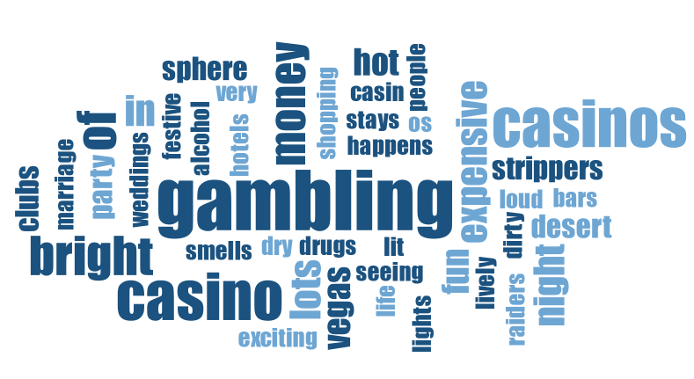
Word Clouds for Las Vegas (raw data and initial codes)
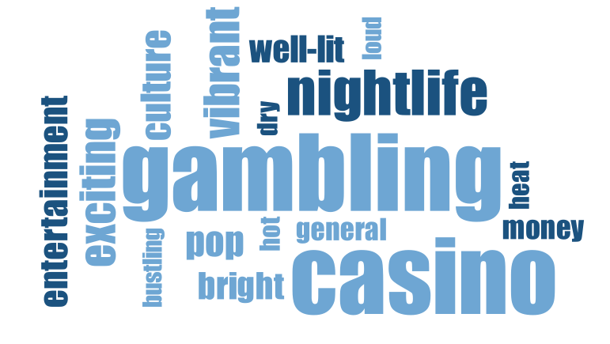

Las Vegas – Word Associations raw data Las Vegas – Word Associations initial codes
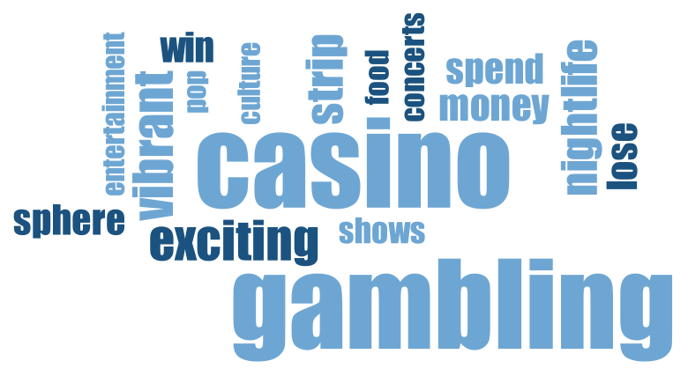
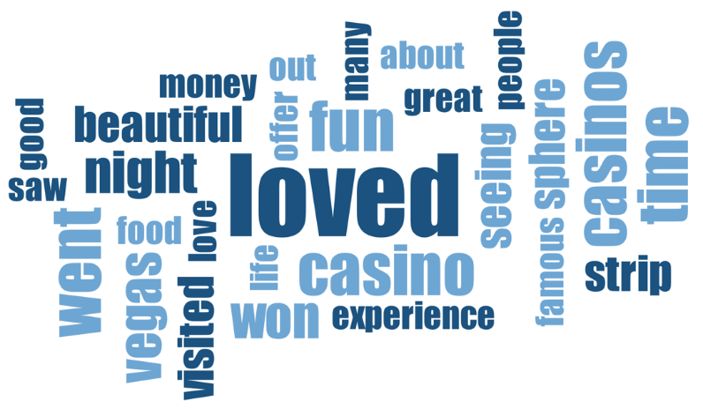

Las Vegas – Sentence Completion (+) raw data Las Vegas – Sentence Completion (+) initial codes

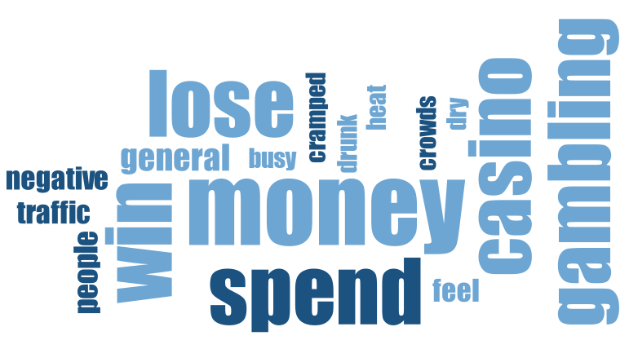
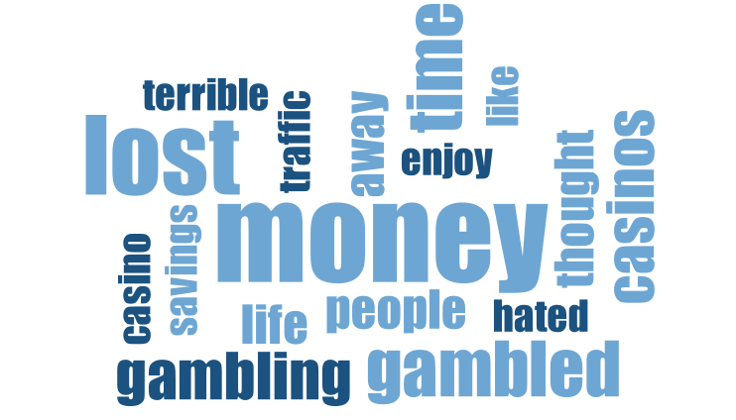

Las Vegas – Sentence Completion (-) raw data Las Vegas – Sentence Completion (-) initial codes
Source: VERBI Software (2019).
Summary Commentary for Las Vegas Word Clouds and Difference between WA and SC.
We used MAXQDA 2020 by VERBI Software (2019) to create word clouds for raw data and Initial Codes. Word clouds were created by first removing stop (common, uninformative) words from the data and then plotting the words with the highest frequencies, with word size proportionate to the word frequency. Word Association centers on the gambling/casino category itself “casinos, gambling, money”; SC+ narrow this to a winning narrative “won, loved, casino”, while SC- are dominated almost entirely by financial loss and gambling “lost, money, hated” in a sense all covering the same topic, but with opposite outcomes. The initial codes include larger categories including several conceptually related words such as spend/win/lose related to gambling as one code which is reflected in the same size words for these three words in the right word clouds for Las Vegas.
Stop words removed included: a, all, a lot, and, at, but, did, go, got, had, have, I, it, las, lot, much, of, see, so, the, to, very, was, yes. Additional stop words were: by, do, how, in, my, not, of, with.

Web Appendix D1. Data structure, Word Clouds, and Thematic Analysis of Word Associations and Sentence Completions for New York City, Nashville, Los Angeles, and New Orleans.
New York City Data Structure
Aggregate Theme | Secondary Category | Representative Inital Codes | Illustrative Data Extracts (Sentence Completions)
Iconic Attractions and Consumption | Cultural Icons, Entertainment & Specific Activities | Food; Shopping; Broadway/Performing Arts; Times Square; Sightseeing/ Museum; Statue of Liberty; Nick name; Empire State Building; Cost; Diversity | “Yes, I went to the MET, got a tattoo, and walked around central park with a bagel.” (Sentence Completion (+))  “Yes, I am so happy I was finally able to see a broadway show.” (Sentence Completion (+))  “Yes, I could not make it to Central Park.” (Sentence Completion (-))
Cats and Rats: A Polarizing Experience Leading to Deeply Divided Expressions | Sensory Overload & Contradictory Atmosphere | Dirty/Polluted; Cold; Very Loud; Exciting; Beautiful; Bright/Flashy; Extravagant; Smelly; Interesting; Noisy | “Yes, I could not get over the smell, the rats, and I got lost on the subway.” (Sentence Completion (-))  “Yes, I loved seeing the city at night.” (Sentence Completion (+))  “got jumped by a homeless person and attacked by pigeons.” (Sentence Completion (-))
 | Challenges, Risks & Negative Elements | Dangerous; Rude; Rats/Vermin; Homeless People; Negative feel; Unsafe/Safety Issues; Sick; Mafia; Poor; Prefer small towns
NYC as a Dynamic Cityscape | Dominant Urban Environment | Subway/Taxis/Traffic; Big City/Tall Buildings/Skyscrapers; Busy; Crowded/Compact; Walking; Active; Fast; Never been; City life; Waterways | “got there and it was impossible to get anywhere, the traffic was terrible and I kept bumping into people.” (Sentence Completion (-))  “Yes, I saw tall buildings and went to some really nice parks.” (Sentence Completion (+))  “was very overwhelmed with the crowds + traffic.” (Sentence Completion (-))

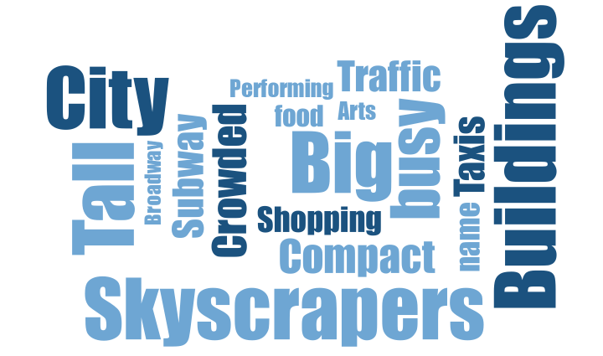
Word Clouds New York City
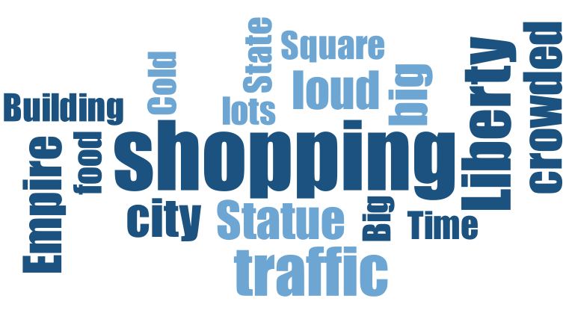
New York City — Word Association raw data New York City — Word Association initial codes

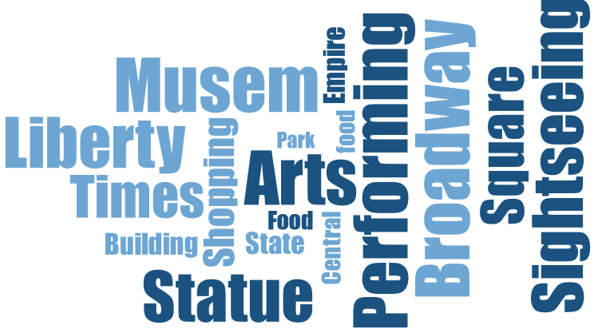
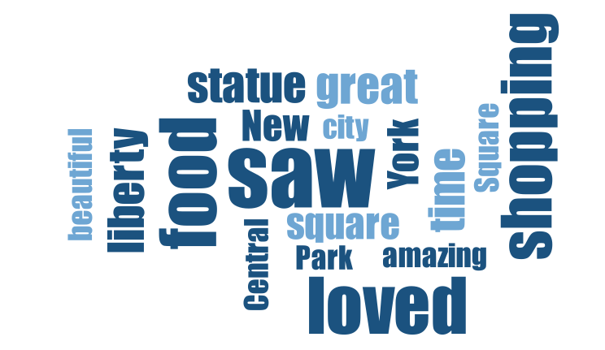

New York City — Sentence Completion (+) raw data New York City — Sentence Completion (+) initial codes

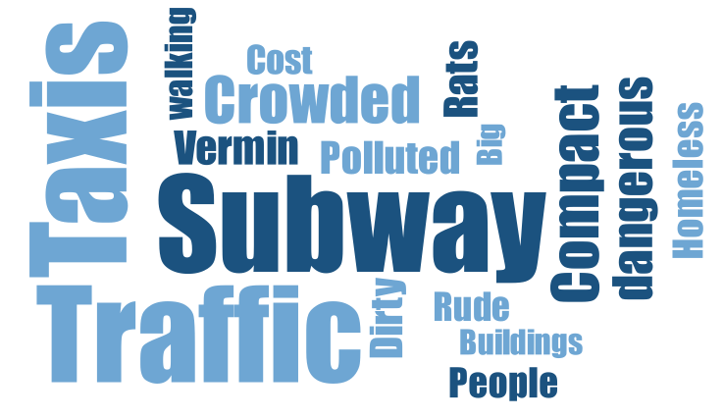
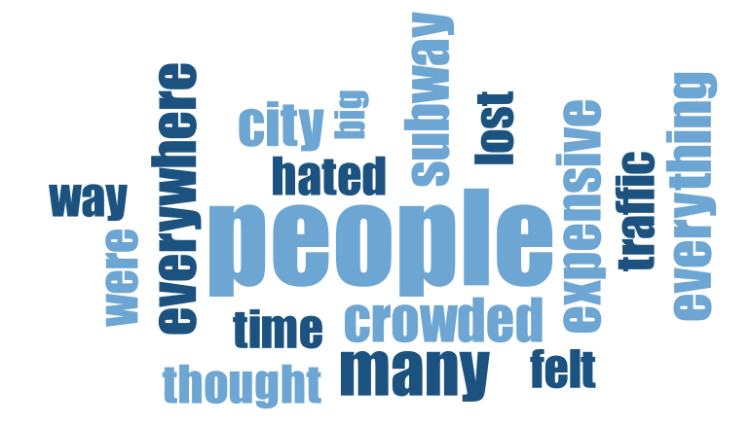
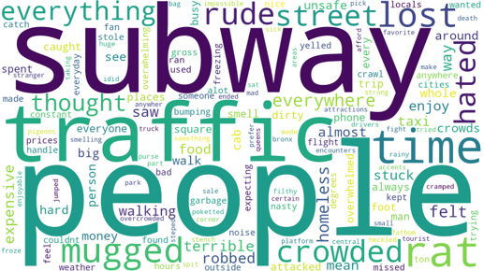
New York City — Sentence Completion (-) raw data New York City — Sentence Completion (-) initial codes
Source: VERBI Software. (2019).
Summary Commentary for New York City Word Clouds and Difference between WA and SC.
WA is heavily landmark-driven “Statue of Liberty, Times Square” and high density “people, crowded” words. While SC+ retain some landmarks but add “performing arts, museum.” SC- abandon landmarks entirely for a rawer/big city/subway/safety narrative “polluted, vermin, dangerous” with almost no vocabulary overlap with the other two.
Thematic Analysis New York City
We find that the young adults’ associations of NYC illustrate the city as densely populated and chaotic, emphasizing the sensory overload and constant motion that defines urban life in Manhattan and beyond (Queens, Bronx). The Big Apple is strongly associated with iconic, tourist-heavy landmarks and cultural institutions, marking it as a global capital of spectacle, history, and symbolic identity (Statue of Liberty, Broadway, Central Park, Macy’s). We find that young adults associate NYC as a hub for high culture, performance and fashion, reinforcing its image as a creative and expressive metropolis (performing arts, models, fashionable, technology, theatre). As shopping on various holidays were mentioned, NYC is seen as a consumption-oriented space, tied to global food culture and retail experiences (NY style Pizza, big Coke store), which aligns with the recognition that gastronomy and retail spaces serve as essential, value-adding ingredients in tourism production and destination identity formation (Mohamed et al., 2024; Richards, 2002). Young adults associate NYC with diversity and opportunity. The Big Apple is often framed as a city of dreams, work, and possibilities – a symbol of success and ambition (opportunities, full of life, cultural, spectacular, legendary, corporate job). However, as the informants reside in the South, they associate NYC with having a cold and unwelcoming environment. Beyond the arts and glamour, there is an undertone of discomfort and grittiness, often associated with northern winters, aging infrastructure, and perceived social disorder (cold, dirty, unsafe, homeless, bad traffic, rats, no nature). This duality highlights how projective techniques successfully unearth deeply seated environmental discontents and socio-cultural aversions such as anxieties regarding safety, homelessness, and pollution, that traditional quantitative surveys often fail to capture due to social desirability bias (Farhat & Chaney, 2024; Holder et al., 2023)

Data Structure Nashville
Aggregate Theme | Secondary Category | Representative Initial Codes | Illustrative Data Extracts (Sentence Completions)
A Vibrant Music and Entertainment Hub | The Country Music Experience | Country/Country Music; Music; Country Music Bars/Broadway; Concerts/Live Music; Shopping; Country Artists (Pop Culture); Dancing; Bright lights; Music City; Line Dancing | “Yes, I went to the rodeo and a wonderful country concert.” (Sentence Completion (+))  “Yes, I drank at the bars and listened to some good live music.” (Sentence Completion (+))  “Yes, I got to see some great musicians play.” (Sentence Completion (+))
A Vibrant Music and Entertainment Hub | Key Features & Landmarks | Famous sites; Sports; Historic; Country Music Hall of Fame; Museums; NASCAR; Dollywood; Dollywoood
Dynamic Urban Environment and Visitor Context | Social Experience & Atmosphere / Visitor Context | Night life; Fun, food, entertainment; Crowded Downtown; Traffic/Congestion; Loud; Smaller city; Vibrant Party/Nightlife Scene; Lively; Bachelorette Sightings; Trip Type & Duration | “Yes, I love Nashville for the food, people, and environment.” (Sentence Completion (+))  “Yes, the traffic was so bad we couldn't go anywhere.” (Sentence Completion (-))  “got arrested and got a DUI.” (Sentence Completion (-))
Dynamic Urban Environment and Visitor Context | Risk/Safety | Expensive; Boring; Drunk People; Dangerous; Bad hotel; Hot weather; Bad weather; Got lost; Lost wallet; Did not enjoy
Southern Culture and Experiential Flavor | Southern Charm & Identity | Cowboy Culture; South/The South; Good Food; Hot Chicken; Food; BBQ; Mountains; Moonshine/Whiskey; Food Poisoning/Getting Sick; Cabin | “Yes, I did! I got to try an authentic Nashville hot chicken sandwich!” (Sentence Completion (+))  “Yes, I could not go out after eating the Nashville hot chicken sandwich.” (Sentence Completion (-))  “Yes, I can't stand the southern lifestyle.” (Sentence Completion (-))

Word Clouds Nashville
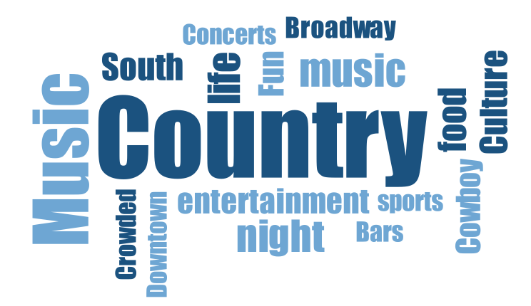
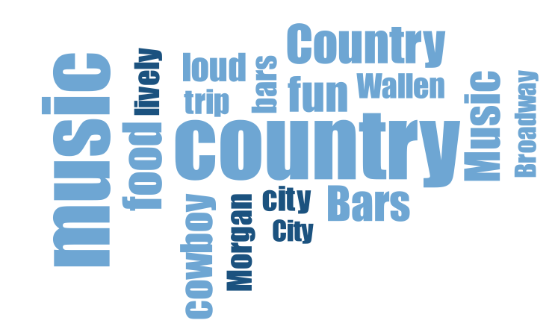
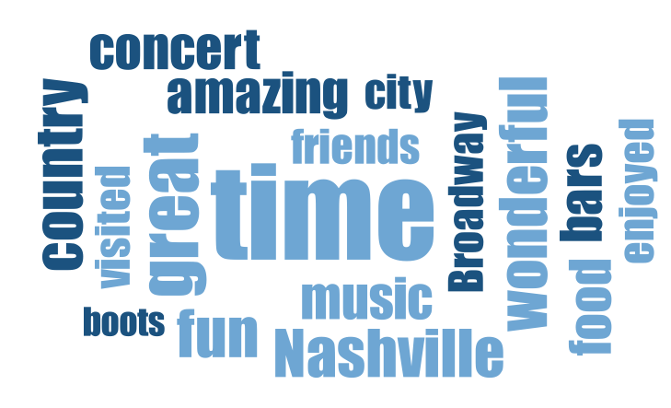
Nashville — Word Association raw data Nashville — Word Association initial data
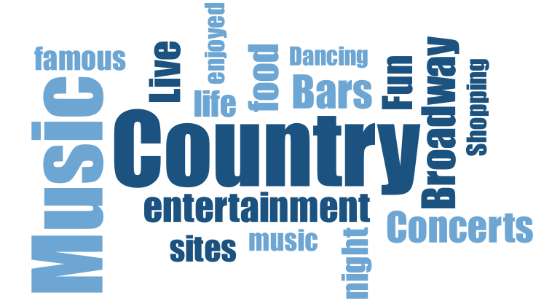

Nashville — Sentence Completion (+) raw data Nashville — Sentence Completion (+) initial codes

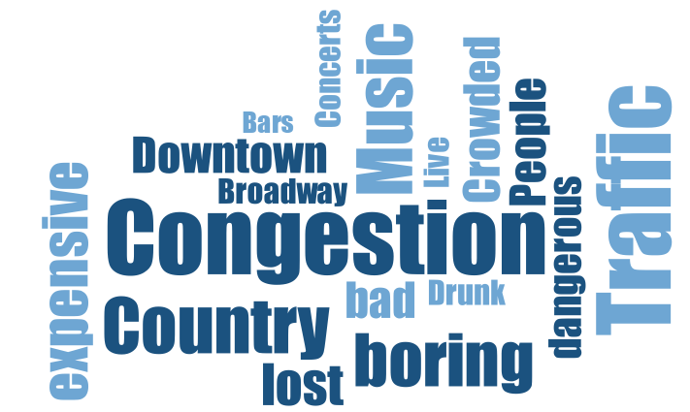
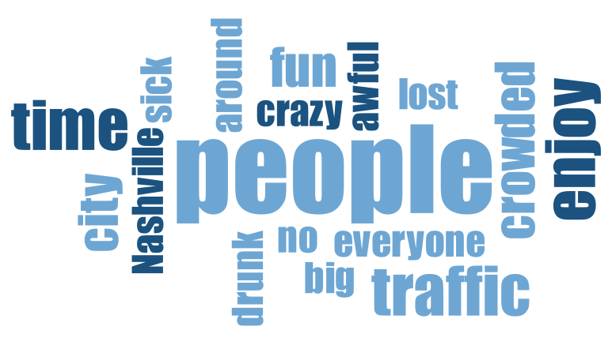

Nashville — Sentence Completion (-) raw data Nashville — Sentence Completion (-) initial codes
Source: VERBI Software. (2019).
Summary Commentary for Nashville Word Clouds and Difference between WA and SC.
Interestingly, for Nashville, WA and positive SC share a very consistent focus on “music and country,” with the most consistent pattern of any city. However, as the SC- shows there was a lot of statements about traffic congestion and safety concerns due to the “crazy” party atmosphere. Also, it was the one city where several respondents specifically mentioned that they were “bored” and “got lost” due to the drunk crowds and congestion.
Thematic Analysis Nashville
Associations of Nashville show a dominant theme as the city’s image as the Music City with references to country music artists, concerts and live music emphasizes Nashville’s brand as the epicenter of American country western and culture. The city is perceived as a lively, socially animated space that attracts party goers and celebrants of special occasions, especially bachelorette parties, nightlife, and music tourism “party bus,” “drinking,” bars,” “bachelorette trips,” “friend trips”. These findings illustrate how specific, activity-based associations successfully mold a destination’s brand personality, portraying it as young, exciting, and adventurous (e.g., Prayag, 2007). We find strong associations and projections of southern Americana and Western performativity. This reflects both authentic heritage and retro representation, as the “fake cowboy” and shopping for cowboy boots by visitors illustrates “bull riding,” “country/western”, “rodeo,” “cowboys.” We see strong associations of Nashville as a food mecca, valued for its regional cuisine, particularly spicy “hot”, and southern comfort foods, contributing to its appeal as a food tourism destination (barbeque, moonshine, comfort food). Similar to our findings about New York City, this confirms that destinations food images is no longer just a supporting service, but a primary pathway for tourists to discover local cultures, authentic traditions, and symbolic value (Lai et al., 2019; Mohamed et al., 2024). In contrast to the party-heavy theme, a softer narrative emerges by some who associate Nashville’s surrounding area with its natural beauty and relaxation “Smoky Mountains,” “cabin,” “cozy,” “peaceful.” The volume of tourist activity is notable, with Nashville associated with being a destination city for short-term visits, bachelorette trips, and photographic documentation (tours, taking pictures, quick trips), which functions as a tool for tourists to capture and validate their experiencescapes and social memories (Park et al., 2010; Soulard et al., 2021). Notably, Nashville's music-and-country identity was the most consistent of the five cities across projective techniques. Word association and both valences of sentence completion converged on the same core vocabulary, with negative associations departing from this theme only to introduce unrelated traffic and safety concerns.

Data Structure Los Angeles
Aggregate Theme | Secondary Category | Representative Initial Codes | Illustrative Data Extracts (Sentence Completions)
The Challenging, Crowded, and Gritty Urban Reality | The Urban Environment & Its Realities | Crowded; Bad Traffic; Big City/Huge/Populated; Homelessness; Dirty/Gross; Crime; Wildfires; Mobility challenges; Income division; Too Busy/Loud/Bustling | “Yes, I did. Traffic was quite unbearable, + I missed my dinner reservation.” (Sentence Completion (-))  “Yes, I hated all the crime.” (Sentence Completion (-))  “got dehydrated and sunburnt while walking and I got stuck in traffic for hours.” (Sentence Completion (-))
Sun, Surf, and Natural Escape | Diverse Leisure & Attractions | Sports; Sightseeing; Hollywood Sign; Food; Active; Good Food; Walk of fame; Enjoyed; Disneyland/Universal Studios; Disneyland | “Went to the Laker's and Dodger's games.” (Sentence Completion (+))  “Yes, I got to see the Hollywood sign.” (Sentence Completion (+))
Sun, Surf, and Natural Escape | Natural Settings & Weather | Beach/Palm Trees/Mountains; Nice Weather/Sunny; West coast; Hiking; Surfing; Hilly; Open; Hills; Nice Weather/Sunny/heat; Nice weather/ sunny | “Yes I loved the hiking trails in the area.” (Sentence Completion (+))  “Yes, I went to the beach and soaked up some sun. I even got a gorgeous tan.” (Sentence Completion (+))
Hollywood, Fame, and the Cost of Glamour | Hollywood, Fame & Celebrity | Famous People/Celebrities; Expensive; Hollywood; Stargazing/Shopping/Clubs; Movies; Actors/Influencers; Pop Culture / Celebrities; Night life; Exciting; Beautiful | “Yes, I loved Rodeo Drive.” (Sentence Completion (+))  “Yes, I got to meet a lot of celebrities.” (Sentence Completion (+))  “Yes, I hated how expensive everything was.” (Sentence Completion  (-))

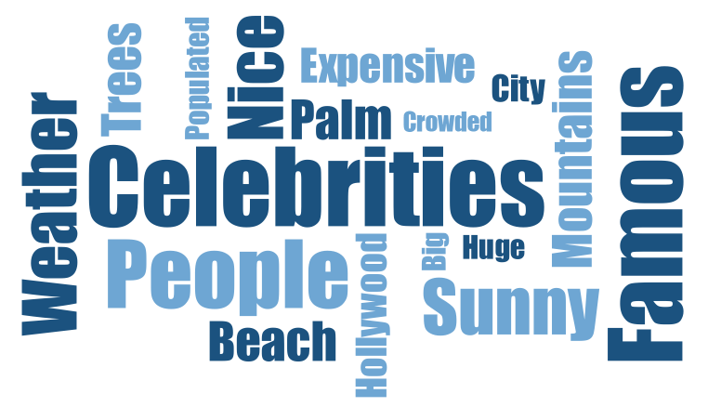
Word Clouds Los Angeles
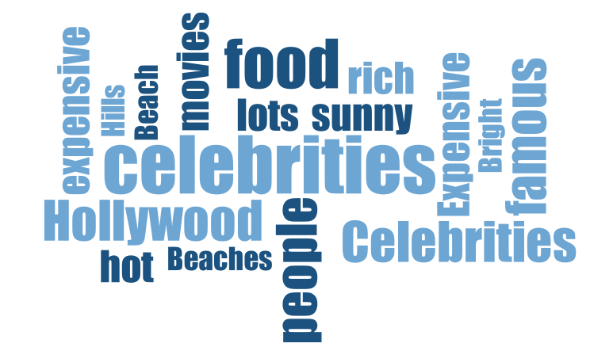
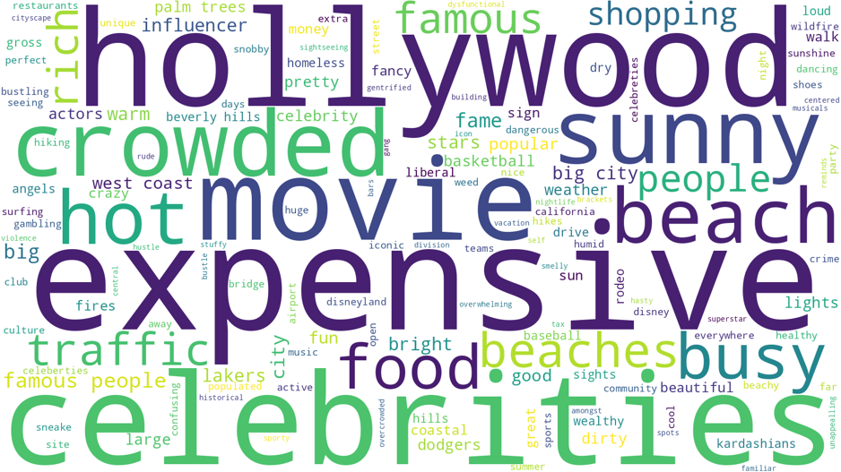
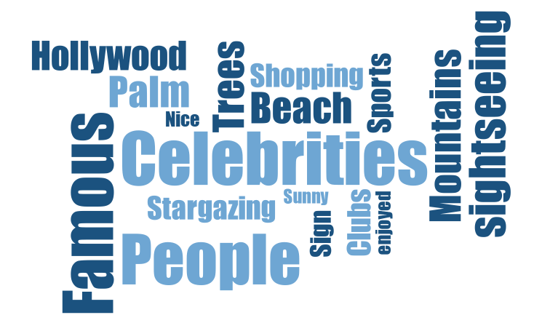
Los Angeles — Word Association raw data Los Angeles — Word Association initial codes
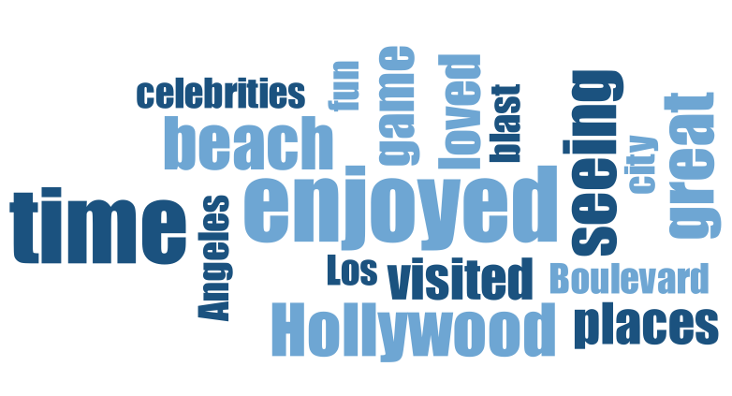

Los Angeles — Sentence Completion (+) raw data Los Angeles — Sentence Completion (+) initial coding

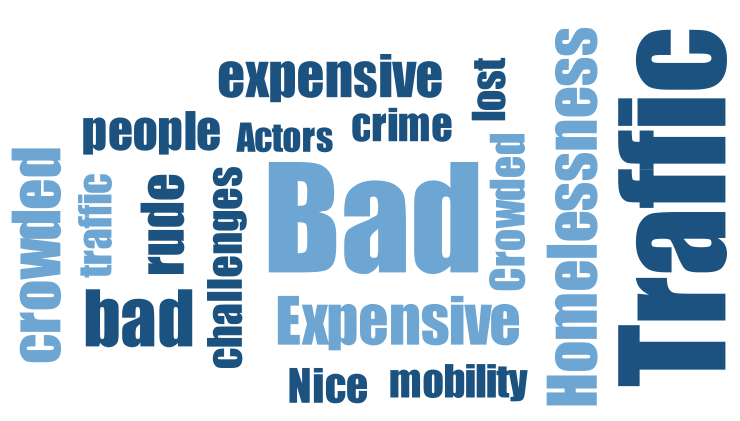
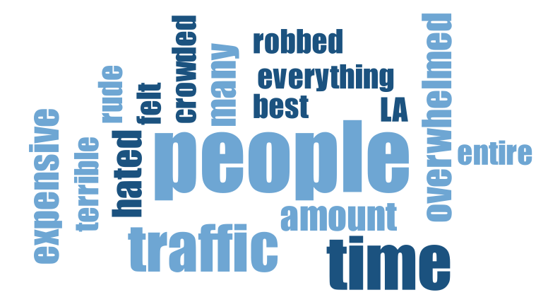
Los Angeles — Sentence Completion (-) raw data Los Angeles — Sentence Completion (-) initial coding
Source: VERBI Software. (2019).
Summary Commentary for Los Angeles Word Clouds and Difference between WA and SC.
WA balances fame and nature focused projections almost as co-equal “Hollywood, celebrities, beach, food, sunny.” SC+ preserve these threads, while SC- pivot entirely to a traffic/homelessness/rudeness narrative “traffic, stuck, homeless, rude” that shares almost no vocabulary with the positive SC.
Thematic Analysis Los Angeles
We find that associations for Los Angeles show the overwhelming framing of the city focusing on fame and the entertainment industry. Hollywood is a central motif, evoking both glamour and superficiality. There are, however, contrasting views of admiration (iconic and beautiful) and critique (fake people, and unrealistic lifestyles). The latter is also illustrated by Los Angeles being associated as a center for affluence and status. Luxury brands, upscale neighborhoods, retail, and restaurants represent wealth and success (expensive, Rodeo Drive, fancy, rich). This finding aligns with research on status and conspicuous consumption, which suggests that consumers seek out and associate with brands or destinations that confer and symbolize social standing and exclusivity (Kim et al., 2016; O’Cass & McEwen, 2004). The city is associated with a distinct natural appeal in terms of scenic beaches, with the backdrop of the nearby mountains (palm trees, beaches, sunny, warm, Venice, California Sun). The city is also associated with being a cultural melting pot, celebrated for is culinary diversity such as authentic Mexican food. Los Angeles is also a city of vibrancy and lifestyle appeal with an active nightlife and sports culture which provides a youthful association of the city. However, the associations also include themes of urban dysfunction and dystopian imagery such as socioeconomic disparity and natural disasters (crowded, dirty, gross, homelessness, traffic, wildfires). Such negative associations highlight the presence of explicit socio-cultural aversions, where place-avoidance behaviors are often driven by perceived threats, crowding, and visible decay of the urban environment (Holder et al., 2023).
Data Structure New Orleans
Aggregate Theme | Secondary Category | Representative First-Order Codes | Illustrative Data Extracts (Sentence Completions)
The Gritty, Challenging, and Potentially Unpleasant Urban Reality | The Challenging Urban Environment & Its Consequences | Unsafe; Dirty/Gross Town; Crime; Smelly; Crowded/Traffic; Homeless People; Weather; Loud; Crowded; Did not enjoy | “Yes, I was sad to see so much damage left from Katrina still.” (Sentence Completion (-))  “didn't feel safe walking around the whole time.” (Sentence Completion (-))  “Yes, the city smells terrible.” (Sentence Completion (-))
Bourbon Street, Mardi Gras, and the Music/Nightlife Scene | Music, Nightlife & Celebration | Bourbon Street; Mardi Gras; Jazz/Music/Blues; Party scene; Drinking; College formal; Wild; Fancy drinks; Crazy; Lively | “Yes, I was on Bourbon Street all night.” (Sentence Completion (+))  “got to experience Mardi Gras on Bourbon Street and I got so many beads!” (Sentence Completion (+))  “Yes, I enjoyed the nightlife.” (Sentence Completion (+))
History, Culture, and Local Identity | Heritage, Arts & Cultural Identity | Culture; Sports; History/Architecture; Exciting; Voodoo/Magic; Sightseeing; French Quarter; Southern; Pop culture; Shopping | “Yes, I loved the culture and atmosphere.” (Sentence Completion (+))  “Yes, I was very disappointed the Saints lost.” (Sentence Completion  (-))  “Yes I went on a bayou tour.” (Sentence Completion (+))
Food & Culinary Culture | Cuisine, Restaurants & Local Flavor | Good food; Famous restaurants; Food & Drink | “Yes, I loved it. The beignets were so fluffy and sweet.” (Sentence Completion (+))  “Yes, I had an amazing crawfish boil.” (Sentence Completion (+))  “Yes, I had great seafood.” (Sentence Completion (+))

Word Clouds New Orleans
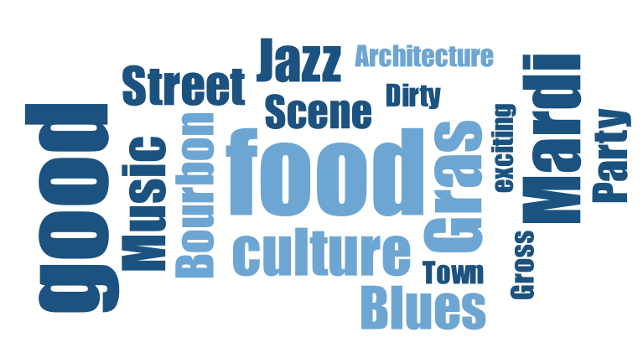
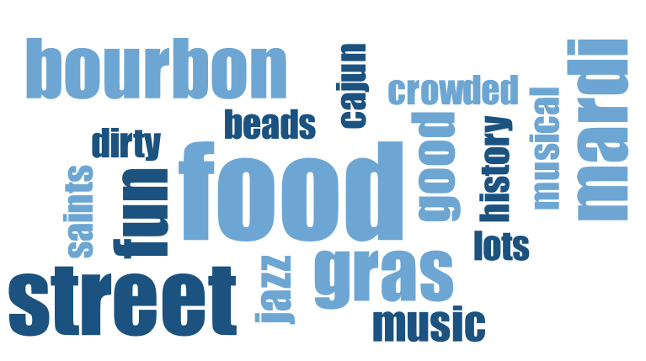

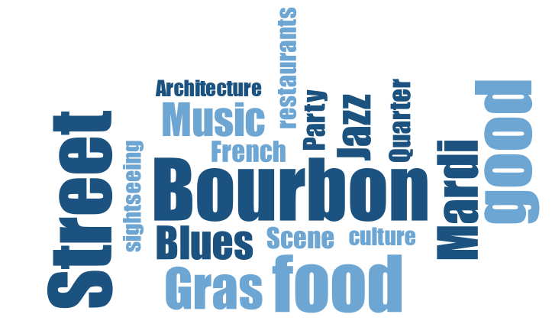
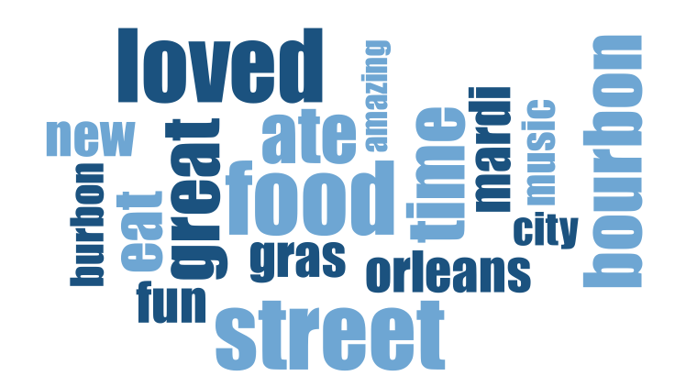
New Orleans — Word Association raw data New Orleans — Word Association initial codes

New Orleans — Sentence Completion (+) raw data New Orleans — Sentence Completion (+) initial codes

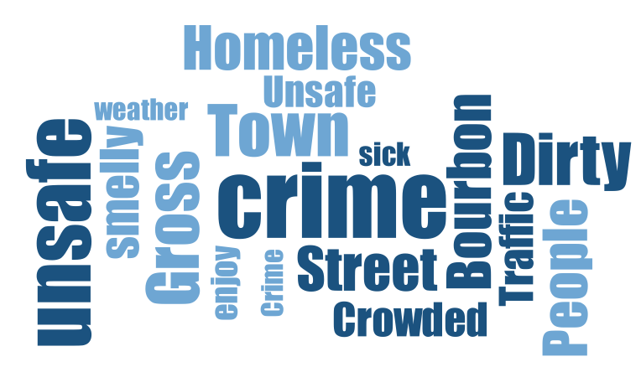
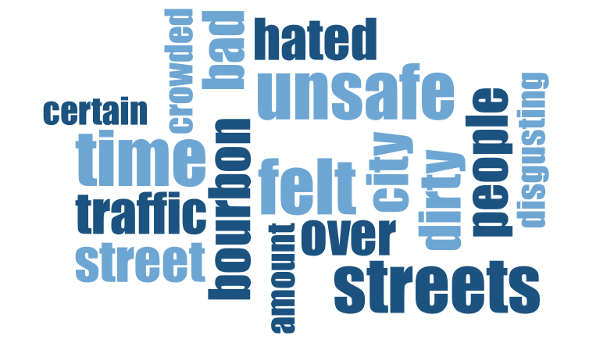

New Orleans — Sentence Completion (-) raw data New Orleans — Sentence Completion (-) initial codes
Source: VERBI Software. (2019).
Summary Commentary for New Orleans Word Clouds and Difference between WA and SC.
WA and SC+ are nearly identical “food, Bourbon Street, music, Mardi Gras” with SC+ adding more evaluative language such as “eat/ate, loved, music.” SC- replaces food and music entirely with safety and risk-oriented language “dirty, homeless, smelly, unsafe.”
Thematic Analysis New Orleans
Word associations for New Orleans center around revelry and public celebration, with Mardi Gras standing out as its most well-known representation. Terms like “party scene” and “crazy” highlight a festive yet uninhibited urban energy “Mardi Gras,” “beads,” “parades,” “party,” “Bourbon Street,” which can be understood through the concept of collective effervescence (e.g., Coghlan & Weiler, 2018; Collins, 2004), where shared social rituals generate intense emotional energy and feelings of elation among participants (Soulard et al., 2021). New Orleans is deeply associated with its musical heritage, particularly jazz and soul music. Music heard from clubs, bars, and street performers shape the city’s identity “jazz,” “soul,” “blues,” “street performers”. Young adults associate New Orleans as a foodie destination, emphasizing regional cuisine such as Cajun, Creole – food blended by African, French and Southern influences (rice and red beans, King Cake, Beignets, Cajun food). The city is associated with a mystical, uncanny, and spiritual dimension often filtered through folklore and popular culture “haunted,” “voodoo,” “city of voodoo,” “magic,” “strange,” “fever dream,” “devil teaching,” “Princess Tiana’s hometown” i.e., a Disney movie. Projective techniques are particularly adept at uncovering these deep-seated myths, fairy tales, and magical symbols that form an intangible but vital part of a brand’s narrative and consumer engagement (Kim et al., 2016; Levy, 1985). Associations of historical and aesthetic characters is prevalent in the city’s heritage (French Quarter, gorgeous architecture, unique, historic, interesting). Negative associations portray strong critiques about the city’s decay and dysfunction “dirty,” “smelly,” “homeless people,” “dangerous,” “crowded,” “potholes,” “stinky,” “gross town.” While the latter are tempered by beauty and culture, there are clear tensions between what visitors would like to see and experience compared to the urban reality and inequality, reflecting the often-paradoxical nature of destination images where contradictory feelings of fascination and discomfort coexist simultaneously within the consumer’s mind (Prayag, 2007). This fusion of food and place was reinforced methodologically: word association and positive sentence completions drew on nearly identical vocabulary “food,” “Bourbon Street,” “Mardi Gras,” suggesting that for New Orleans, culinary and cultural identity are not separable associations but a single, tightly integrated image.

Web Appendix D2. Frequency Analysis and Symbolic Analysis of Animal Associations for each City.
As described in our methods section in the main paper and shown in Web Appendix B, booklet stimuli, the study also asked respondents to associate each city with an animal. Animal metaphors have a long history of successful application in projective research because they serve as familiar, easily accessible vehicles for consumers to express complex, abstract perceptions of a brand’s personality (Brotherton, 2005; Hussey & Duncombe, 1999; Levy, 1985). As only animal names were listed, we first did a frequency analysis in excel where we counted the listings of animals. Las Vegas’ top five animals were Tiger (29), Lion (18), Snake (17), and Peacock (17) from there; it was a drop by six to Cheetah (11). New York City’s top five animals were: Rat (34), Pigeon (25), Lion (15), Giraffe (13) followed by Cat in fifth place (10). Los Angeles’ top five animals were Tiger (18), Lion (16), Cat (13), and Dogs (12), followed by Peacock (6) in fifth place. The top five animals for Nashville started with a clear winner Horse (64), Dog (23), Bear (12), Deer (8), and Cow as number five (6). Finally, New Orleans’ top five animal associations were Alligators and crocodiles (54), Tigers (15), Frogs/ toads (10), Snake (8), and Crawfish (7) as number five. We'd like to note that due to the large number of distinct categories and sparsity of these categories, unlike for the word associations and sentence completion data, the animal and celebrity associations were not analyzed using inferential statistical tests (e.g., chi-square). The low counts would violate the minimum expected cell-count assumption underlying chi-square testing (Agresti, 2012; Cochran, 1954), therefore making a frequency-based descriptive and symbolic analysis more appropriate for this data structure.
Web Appendix Table D2 shows the characteristics of the top two animal associations and our interpretations of their symbolism to the projected city. We found the analysis of the animals to be somewhat limited as we didn’t ask the respondents to elaborate on why they associated the animal with the city. As the association was limited to one word, it was not possible to do any advanced coding of the data, a methodological challenge consistent with previous research that highlights the difficulty of understanding the exact basis of a respondent’s metaphorical judgement without further context (Hussey & Duncombe, 1999). Without the use of echoic probing or laddering researchers risk projecting their own subjective biases onto the data (Boddy, 2005; Pich et al., 2015), however that is also part of the interpretive work that makes qualitative analysis insightful (Braun and Clarke, 2006). So, in particular for the animal associations and the celebrity associations below, in this study we rely on our own experience of visiting each city, our expertise, symbolism of animal characteristics in folklore and literature, and what we have learned about the cities in previous associations (word associations and sentence completions), utilizing a triangulation approach to cross-check and validate these symbolic interpretations against the broader qualitative data generated within the study (Boddy, 2005; Bond & Ramsey, 2010).

Web Appendix Table D2. Top two animal associations, characteristics and interpretive symbolism to city identity.
City | Animal | Characteristics | Interpretive symbolism to city identity
Las Vegas | Tiger | Power and Risk, Luxury and Exoticism, Mystery and Seduction | Las Vegas is seen as powerful, seductive, and potentially dangerous - a place where people test their luck and explore their fantasies. By evoking the tiger, respondents project a brand personality defined by thrilling excitement, fierce independence, and aspirational luxury, traits that frequently emerge when consumers assess high-status or socially dominant brands (Aaker, 1997; Hussey & Duncombe, 1999).
 | Lion | Regality and Power, Dominance and Authority, Spectacle and Grandeur, Strength and Confidence, Predatory Edge, Mythical Majesty | Las Vegas positions itself as the "king" of entertainment; the casino culture mirrors dominance with its high-stakes control and elite exclusivity. Lions are theatrical and majestic. The MGM grand features a lion. This aligns with extant projective techniques research findings where the lion metaphor consistently evokes themes of regal strength, aggressive power, and leadership, successfully translating the destination’s commanding presence into a recognizable human-like persona (Brotherton, 2005; Hussey & Duncombe, 1999).
New York | Rat | Intelligent, adaptive, elusive, survivalist, urban-dwelling | The rat is an enduring symbol of New Yorks underbelly - the literal and metaphorical creature that thrives in the city's subways, alleys, and underground systems. Rats represent grit but also critique of urban policy and cleanliness. The elicitation of such specific, non-glamorous creatures highlights the ability of projective techniques to bypass social desirability bias, unearthing the authentic, gritty, and sometimes discomforting realities of the urban cityscape (Holder et al., 2023).
 | Pigeon | Social, resilient, ubiquitous, unassuming, urban-adapted. | The pigeon has been referred to as the unofficial bird of NYC. Despite being labeled as pests, they are liked for their omnipresence in parks and sidewalks, ability to adapt and coexist with human and urban density. The pigeon may be a metaphor for the New Yorker, gritty, grounded and everywhere, reflecting the "common" and "everyday" traits that consumers often project onto familiar, ubiquitous subjects during animal association tasks (Hussey & Duncombe, 1999).
Los Angeles | Tiger | Fierce, rare, powerful, visually striking. | The tiger evokes celebrity allure - rare, bold, and mesmerizing. It mirrors the entertainment industry, where only the most distinctive and unique stands out. Suggests the predatory and assertive ambition seen in Hollywood success narratives. Similar to our interpretation of the tiger’s association with Las Vegas, the animal effectively projects the competitive, fast-moving, and dominant traits of the city's entertainment industry, operating as a symbol for exclusivity and high status (Hussey & Duncombe, 1999).
 | Lion | Regal, dominant, charismatic and proud | The lion is a symbol for leadership, authority, and charisma, parallelling film stars and influential cultural figures in Hollywood. Refers to grandeur in architecture and branding. Association with strength and maintaining dominance in a cutthroat, highly visible environment. Using apex predators like lions to symbolize a brand emphasizes themes of authority and being highly respected by others, which closely matches the desired aspirational identity and conspicuous consumption of Los Angeles (Hussey & Duncombe, 1999; Kim et al., 2016).
Nashville | Horse | Strong, loyal, hardworking, free-spirited, and enduring. | The horse is an important symbol of Southern tradition, country lifestyle and musical heritage. It reflects freedom, travel, and the rural identity that shapes Nashville's storytelling ethos. The horse is central to imagery in folk and country ballads, parades, and Tennessee’s agricultural history. In projective assessments, horses are frequently chosen by consumers to represent solid, dependable, and traditional brand identities, perfectly mirroring Nashville's heritage-based destination image (Brotherton, 2005).
 | Dog | Loyal, friendly, protective, and social | Dogs embody community spirit, unconditional loyalty, comfort, and echoing the Southern hospitality of Nashville. It frequently appears in domestic settings reinforcing the family and friends oriented and rooted character of the city. The "golden retriever" suggests warmth, friendliness, and middle-class Americana. Research shows that dog metaphors are overwhelmingly used by consumers to project feelings of friendliness, warmth, helpfulness, and a welcoming atmosphere, reinforcing Nashville's highly sociable and hospitable brand personality (Brotherton, 2005; Hussey & Duncombe, 1999).
New Orleans | Alligator and Crocodile | Native to Louisiana swamps and bayous. Powerful, stealthy, and territorial. Apex predators with ancient lineage. | Alligators represent the wild, untamed nature of the Louisiana wetlands. It is often associated with mystery, danger, and resilience and used as metaphors for survival and adaptation in challenging environments such as hurricanes, floods, or socio-economic adversity. Featured in Cajun and Creole folklore, and sometimes in voodoo symbolism as guardians or spirits of the swamp. Alligators are eaten as foods often in Cajun traditions. These native animals act as powerful symbols of the destination's authentic regional identity, demonstrating how local fauna helps shape the unique cultural and mythical boundaries of a tourist destination (Levy, 1985; Pabel & Pearce, 2015).
 | Tiger | Not native to Louisiana, but symbolically powerful. Fierce, solitary, and majestic predators. | Tigers are the mascot of LSU (Louisiana State University) a major cultural institution well known all over the state and South. Symbolizes strength, pride and Southern identity. Tigers are often used in Mardi Gras crews and parades to convey power and reality. Here we see a different meaning for tiger compared to both Las Vegas and Los Angeles, here the appropriation of tiger as a cultural and festival symbol demonstrates how projective techniques uncover the deep-seated so-called mytho-symbolic worlds and collective social rituals that define a city’s intangible energy and identity (Cian & Cervai, 2011; Soulard et al., 2021).
Source: Animals projected associations by informants and authors subjective interpretation based on folklore, culture, and symbolism in literature (Brotherton, 2005; Cervellon, 2014; Cian & Cervai, 2011; Holder et al. 2023; Hussey & Duncombe, 1999; International Fund for Animal Welfare 2024; Kim, 2006; Kim et al., 2016; Levy, 1985; Lloyd & Woodside, 2013; Osmond, 2024; Pabel & Pearce, 2015; Soulard et al., 2021)
Web Appendix D3. Frequency Analysis and Symbolic Analysis of Celebrity Associations for each City.
Next, we performed a frequency analysis of the celebrity association of each city. Again, each respondent only responded with one word without any justification or explanation of the connection with the city. Similar to probing for animal associations, personification-based projective techniques, such as associating a brand with a celebrity, are affective tools to uncover the intangible, symbolic dimensions of a brand’s image by allowing participants to transfer the perceived personality traits and lifestyles of the celebrity directly onto the destination (Hofstede et al., 2007; McCracken, 1989). The top three celebrities listed for Las Vegas were: Elvis Presley (37), Bruno Mars (11), and Lady Gaga (9). New York’s top three were Taylor Swift (22), Frank Sinatra (14) and Jay-Z (9). Los Angeles top three celebrity associations were Kim Kardashians (23), Taylor Swift (10), and Tom Cruize (9) (Hollywood icon Marilyn Monroe came in at (8)). Nashville’s top three celebrity associations were Morgan Wallen (40), Dolly Parton (26), and Luke Bryan and Jason Aldean shared the third position (11). Finally, New Orleans’ top three celebrity associations were fairly close in listings with Louis Armstrang (13), Lil Wayne (12), and Drew Brees and Boosie Badazz shared third place (11). By assigning specific types of celebrities such as contemporary pop stars, historic icons, or influential athletes respondents project distinct brand personalities and meaning structures onto each city, differentiating them beyond purely functional attributes (Hofstede et al., 2007; McCracken, 1989). We list the top celebrity association for each city in Web Appendix Table D3. Like the animal association task, we find that without further laddering or elaboration by the respondent on why they listed a specific celebrity association for a city, the underlying meanings of the findings are limited. Just like the above animal associations, because a celebrity's meaning can encompass multiple complex dimensions, such as their credibility, physical appearance, evoked feelings, professional performance, and personal values, the lack of echoic probing makes it difficult to definitively determine which specific meaning elements the consumer intends to transfer to the destination brand (Jain & Roy, 2016; Pich & Dean, 2015). Interestingly, for Las Vegas and New Orleans more traditional and now passed singers were listed, Elvis Presley and Louis Armstrong. This may be because their music has lived on, or that the respondents have been exposed to their music through their parents, or through movies and other media, and their strong historical contributions to a specific city’s identity. This aligns with McCracken’s (1989) Meaning Transfer Model, which posits that a celebrity's meaning is culturally constructed over time through their life story, accomplishments, and enduring media exposure, allowing their deeply ingrained symbolic value to become permanently intertwined with the brand's identity (Jain & Roy, 2016).
Web Appendix Table D3. Top celebrity association, characteristics and interpretive symbolism to city identity.
City | Celebrity | Characteristics | Symbolism to City Identity
Las Vegas | Elvis Presley | Iconic, Charismatic, Pioneering, King of Rock N Rol | Elvis is almost synonymous with Las Vegas as he is known for his legendary residency at the International Hotel. He symbolizes the Golden Era of Vegas Entertainment, embodying the city's history of glitz, glamour, and unforgettable performances. Sang the Song "Viva Las Vegas" in the film with the same name in 1964. By persistently associating the city with a historical icon like Elvis, respondents illustrate how a celebrity’s culturally constructed meaning, built over time through accomplishments and media exposure, can become permanently intertwined with a destination's brand identity, transferring deep-seated associations of vintage glamour and spectacle (Jain & Roy, 2016; McCracken, 1989).
New York | Taylor Swift | Versatile, Influential, Contemporary, Grit | Embodies the modern pop culture icon. Swift often references NYC in her music and lifestyle e.g., Welcome to New York (Album:1989). Represents the creative, hardworking, ambitious, and ever evolving spirit of New York. This reflects the process of personification where consumers transfer the dynamic, contemporary, and successful personality traits of an active celebrity directly onto the destination, allowing the city’s brand to remain culturally relevant and continuously updated in the minds of young adults (Aaker, 1997; Hofstede et al., 2007).
Los Angeles | Kim Kardashian | Influential, fashionable, entrepreneurial | Embodies the glamour, fashion, and celebrity culture known to LA. A symbol of social media influence and modern fame. Represents the entrepreneurial spirit of the city with ventures in beauty, fashion and media. Associating the city with a figure known primarily for fashion, beauty, and social media influence demonstrates how the specific meaning dimensions of a celebrity's physical appearance and high-status lifestyle are successfully transferred to the destination brand, reinforcing its positioning as a hub for conspicuous consumption and exclusivity (Jain & Roy, 2016; O'Cass & McEwen, 2004).
Nashville | Morgan Wallen | Contemporary, influential, controversial | Wallen represents the modern face of country music. His career reflects the popularity and challenges of today's music industry. It symbolizes the blend of old country roots with newer sounds and cultural influences. Here we find the association to be congruent between the celebrity’s expertise and talent in country music and the destination’s core functional and symbolic brand attributes (Jain & Roy, 2016; Kamins, 1990; Till & Busler, 2000).
New Orleans | Louis Armstrong | Iconic, Charismatic, father of jazz | A foundational figure in jazz, born and raised in New Orleans. Embodies the soul and musical heritage of the city. Symbolizes New Orleans' global influence on jazz and blues music genres. By anchoring the city to an authentic, historical figure, respondents project specific dimensions of meaning such as cultural credibility, nostalgia, and soul onto the destination, proving that a celebrity's values and life story can serve as a permanent foundation for a city’s brand personality (Jain & Roy, 2016; McCracken, 1989).
Sources: Celebrities projected associations by informants. Subjective interpretation by authors based on lived experiences and popular culture and news sources (Aaker, 1997; Hofstede et al., 2007; Jain & Roy, 2016; Kamins, 1990; McCracken, 1989; O'Cass & McEwen, 2004; Till & Busler, 2000; Simpson, 2024).

Web Appendix E. Deeper Insights and Discussion of the three Projective Techniques’ Findings
Our primary study uses several projective techniques to illustrate the benefits and limitations of projective techniques. We find that the word association directly related to a brand such as a city offers more specific, informative, and descriptive information about the destination, as it provides relatively unrestricted access to consumers' mental representations and spontaneous beliefs before cognitive defense mechanisms are activated (Ares & Deliza, 2010; Roininen et al., 2006; Vidal et al., 2013). Notably, food-related associations emerged as a primary aggregate theme in three of the five cities i.e., New York, Nashville, and New Orleans without any prompt specifically directing respondents toward cuisine. This unprompted recurrence supports the view that destination food image functions as a central pathway through which visitors access and construct a place's cultural identity, rather than a peripheral servicescape attribute (Lai et al., 2019; Mohamed et al., 2024).
In addition, we discovered that asking for associations about a city in terms of a celebrity and animal offers a different image of the destination. For example, in our analysis, we find that animal associations and related symbolism result in more accurate and insightful representation of a city destination compared to celebrity associations due to the personality traits of the animal, reflecting the universal human tendency to naturally attribute animate personality traits to commercial objects and places to simplify complex buying decisions (Aaker, 1997; d'Astous & Lévesque, 2003; Willems, 2022). For example, the fact that three cities share tiger as one of the two or three top animals, and two cities share lion as top two animals showcase similarities in terms of the city characteristics. Another finding is that cities do display animal characteristics such as the strong association of horses with Nashville and rats and pigeons with New York. The latter two illustrate negative sentiments towards the city while the former showcases the strength of the city and ties in with the country and cowboy (western) theme of the city.
As mentioned, we found less insight from our analysis of the celebrity associations as they were more varied for some of the cities and did not reflect distinct characteristics aiding in understanding consumers’ perception of a city. Several celebrities were listed for multiple cities, and in contrast to animal characteristics, it was not as clear why certain celebrities were listed for certain cities. This variance supports the understanding that celebrity meanings are highly complex, mutable, and heavily dependent on contextual factors such as the celebrity's life stage, recent media exposure, and history of overlapping endorsements, which can easily dilute or confuse the specific meaning transferred to the destination (Jain & Roy, 2016; Till, 2001; Walker et al., 1992).

The positive and negative sentence completions resulted in a lot of polarization in the thematic analysis process. By directly requesting a specific valence of associations you may see the worst-case scenario associated with a city which may not necessarily be a realistic association. However, understanding consumers’ fears and worry about visiting a destination can be insightful for city government agencies such as police, city planners (for traffic infrastructure), and visitors centers alike. Because sentence completion forces respondents to articulate specific thoughts within a given context, it is highly effective at bypassing social desirability bias and exposing underlying frustrations, vulnerabilities, and negative cognitive evaluations that users might typically mask in standard surveys or interviews (Doherty & Nelson, 2010; Kujala et al., 2014; Magnini et al., 2013). This diagnostic strength was consistent across all five cities: each produced a stable, well-populated theme built around safety concerns, dirtiness, and place-avoidance e.g., Los Angeles' "Urban Reality," New Orleans' "Gritty...Urban Reality," and New York's "Cats and Rats". The consistency of this pattern suggests that this darker side of destination image is not a city-specific pathology but a structural feature that projective techniques reliably surface regardless of a destination's overall brand strength (Holder et al., 2023). This divergence was consistent across all five cities: negative sentence completions did not simply recast the same associations in a negative tone but introduced a substantively different vocabulary of risk and harm e.g., "lost," "robbed," "unsafe," "homeless" that was largely absent from the word association and positive completion data. Word association tended to surface the destination's structural, nominal identity such as its landmarks and defining nouns while sentence completion, by requiring a narrative response, elicited outcome- and evaluation-focused language. Nashville was the partial exception: word association and both valences of sentence completion shared a consistent "music/country" core, with only the negative completions introducing unrelated content such as “traffic,” “safety”.
If the primary objective of this article had been destination repositioning strategy, additional validation studies could further align emergent associations with official brand positioning for the cities. However, our intent was to advance theoretical and methodological understanding of how latent destination meanings emerge through projective inquiry. From this perspective, the findings demonstrate that projective techniques surface symbolic, affective, and sometimes non-rational dimensions of destination image that more traditional survey methods may overlook, providing thick descriptions that capture the true emotional tenor and experiential quality of the destination (Little & Singh, 2014; Mulvey & Kavalam, 2010). One such latent dimension was an authenticity–performativity tension that appeared unprompted in two unrelated cities: Nashville's "fake cowboy" critique of commercialized western imagery and Los Angeles' critique of "fake people" and "unrealistic lifestyles" tied to its entertainment-industry image. Neither city was asked about authenticity directly, yet both produced this same underlying tension between staged, commercially constructed identity and lived experience, echoing MacCannell's (1973) concept of staged authenticity and Wang's (2017) existential authenticity framework. To our knowledge, these constructs have not previously been examined through projective destination-image data, and their spontaneous emergence here suggests projective techniques may be well suited to detecting authenticity-related tensions that direct survey items would need to prime respondents to articulate. Importantly, the combined use of multiple projective tasks illustrates the methodological robustness of triangulated design. Rather than serving as preliminarily tools, we find that projective techniques operate most powerfully when integrated iteratively, allowing researchers to interrogate consumer meaning structures from multiple perspectives. This multimethod integration strengthens interpretive validity and yields richer insights into destination image, brand personality, and symbolic positioning, by compensating for the inherent limitations and ambiguities of any single projective tool (Donoghue, 2000; Font & Hindley, 2017; Pich et al., 2015). Using one method, whether it is qualitative or quantitative, does not eliminate the option to use another method to study the same phenomena.
While our data analysis resulted in nuanced understandings of the various city destinations, we see value in conducting other types of studies using additional creative extensions e.g., laddering or visual elicitation tasks (Zaltman, 2003; Zayer et al., 2024). Using other methods may deepen exploration of affective dimensions; however, the present findings substantially advance understanding of how projective methods can diagnose destination image structures and inform tourism brand strategy.

Additional References for Web Appendix C-E
Aaker, J. L. (1997). Dimensions of brand personality. Journal of Marketing Research, 34, 347-356.
Brotherton, B. (2005). The nature of hospitality: Customer perceptions and implications. Tourism and Hospitality Planning & Development, 2(3), 139–153.
Cervellon, M. C. (2014). Coats of arms: The role of animal emblems in contemporary luxury and fashion industry. In Brand Mascots (pp. 267-276). Routledge.
Cian, L., & Cervai, S. (2011). The Multi-Sensory Sort (MuSeS): A new projective technique to investigate and improve the brand image. Qualitative Market Research: An International Journal, 14(2), 138-159.
Cochran, W. G. (1954). Some methods of strengthening the common χ² tests. Biometrics, 10(4), 417–451.
Coghlan, A., & Weiler, B. (2018). Examining transformative processes in volunteer tourism. Current Issues in Tourism, 21(5), 567-582.
Collins, R. (2004). Interaction ritual chains. Princeton University Press.
D'Astous, A., & Lévesque, M. (2003). A scale for measuring store personality. Psychology & Marketing, 20, 455-469.
Hofstede, A., van Hoof, J., Walenberg, N., & de Jong, M. (2007). Projective techniques for brand image research. Two personification-based methods explored. Qualitative Market Research: An International Journal, 10(3), 300–309
International Fund for Animal Welfare (2024). Animals with symbolic meaning around the world. May 6, 2024. Available at: https://www.ifaw.org/journal/animals-symbolic-meaning-world

Kamins, M. A. (1990). An investigation into the “match-up” hypothesis in celebrity advertising: When beauty may be only skin deep. Journal of Advertising, 19(1), 4-13.
Kim, H. J. (2006). Animal Symbolism of the Trademarks and Trade Characters. Journal of Korean Society of Design Science, 19(3), 71
Lai, M. Y., Khoo-Lattimore, C., & Wang, Y. (2019). Food and cuisine image in destination branding: Toward a conceptual model. Tourism and Hospitality Research, 19(2), 238–251.
Lloyd, S., & Woodside, A. G. (2013). Animals, archetypes, and advertising (A3): The theory and the practice of customer brand symbolism. Journal of Marketing Management, 29(1-2), 5-25.
MacCannell, D. (1973). Staged Authenticity: Arrangements of Social Space in Tourist Settings. American Journal of Sociology, 79, 589-603
McCracken, G. (1989). Who is the celebrity endorser? Cultural foundation of the endorsement process. Journal of Consumer Research, 16(3), 310–321
Osmond, C. (2024). Animal Adjectives - Complete List. Available at: https://grammarist.com/usage/animal-adjectives/
Pabel, A., & Pearce, P. L. (2015). Highlighting the benefits of tourism humour: The views of tourists. Tourism Management Perspectives, 16, 357-364.
Park, C. W., MacInnis, D. J., Priester, J., Eisingerich, A. B., & Iacobucci, D. (2010). Brand attachment and brand attitude strength: Conceptual and empirical differentiation of two critical brand equity drivers. Journal of Marketing, 74(6), 1–17
Pich, C., & Dean, D. (2015). Qualitative projective techniques in political brand image research from the perspective of young adults. Qualitative Market Research: An International Journal, 18(1), 115–144
Roininen, K., Arvola, A., & Lähteenmäki, L. (2006). Exploring consumers’ perceptions of local food with two different qualitative techniques: Laddering and word association. Food quality and preference, 17(1-2), 20-30.
Simpson K. (2024). All of Taylor Swift's New York Song References That Swifties Can Visit. US Weekly. April 19, 2024. available at https://www.aol.com/entertainment/taylor-swift-york-song-references-234143957.html
Soulard, J., McGehee, N. G., Stern, M. J., & Lamoureux, K. M. (2021). Transformative tourism: Tourists' drawings, symbols, and narratives of change. Annals of Tourism Research, 87, 103141.
Till, B. D., & Busler, M. (2000). The match-up hypothesis: Physical attractiveness, expertise, and the role of fit on brand attitude, purchase intent and brand beliefs. Journal of advertising, 29(3), 1-13.
VERBI Software. (2019). MAXQDA 2020 [computer software]. VERBI Software. Available from maxqda.com
Wang, N. (2017). Rethinking authenticity in tourism experience. In The political nature of cultural heritage and tourism (pp. 469-490). Routledge.
Willems, K. (2022). Brand personality appeal in retailing: Comparing fashion- and grocery retailing. Journal of Retailing and Consumer Services, 64, 102833.
Zaltman, G. (2003). How customers think: Essential insights into the mind of the market. Harvard Business Press.

Web Appendix F. Quantitative Analysis – Supporting Figures
Figure F1: Preprocessed (Stemmed and Removed Stop Words) Word Frequencies for Word Association
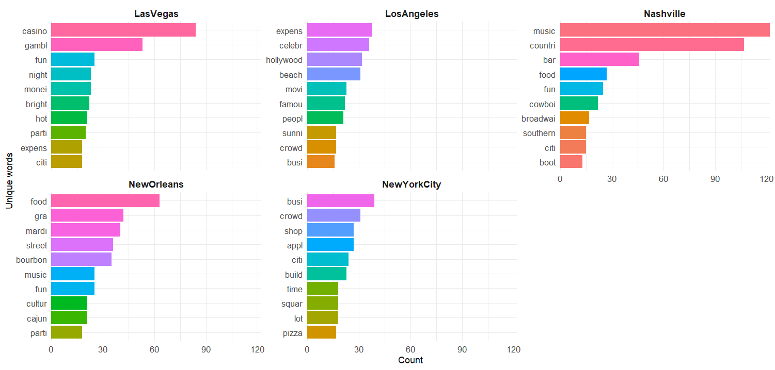

Figure F2: Preprocessed (Stemmed and Removed Stop Words) Bigram Frequencies for Negative Sentence Completion
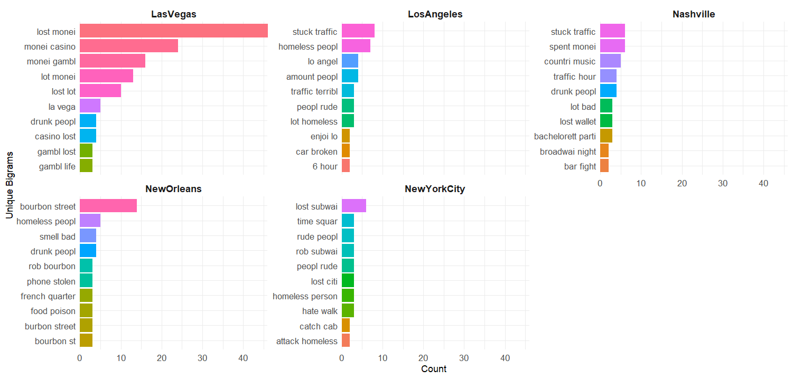

Figure F3: Preprocessed (Stemmed and Removed Stop Words) Bigram Frequencies for Positive Sentence Completion
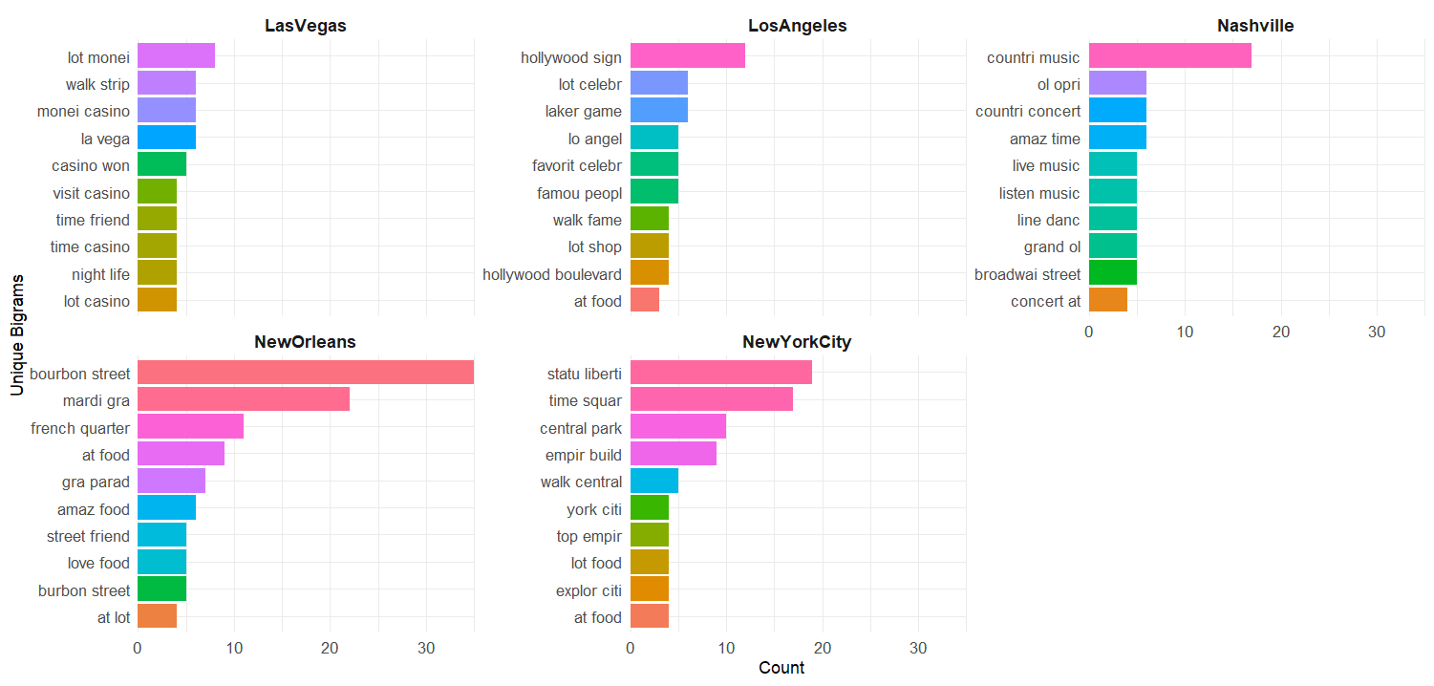

Figure F4: Preprocessed (Stemmed and Removed Stop Words) Bigram Frequencies for Word Association
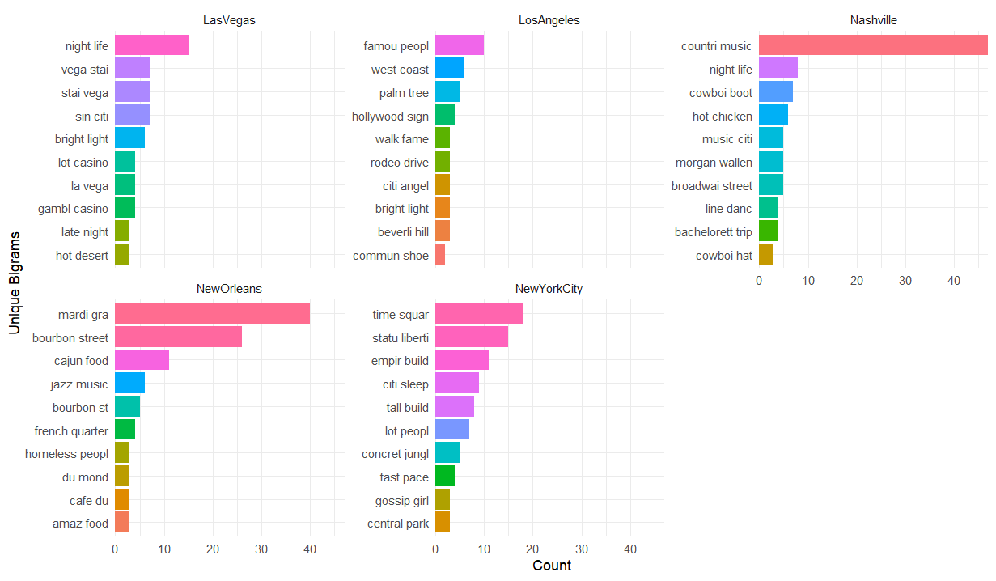

Figure F5: STM Topic Modeling Metrics for Negative and Positive Sentence Completion across k = 5 to 15
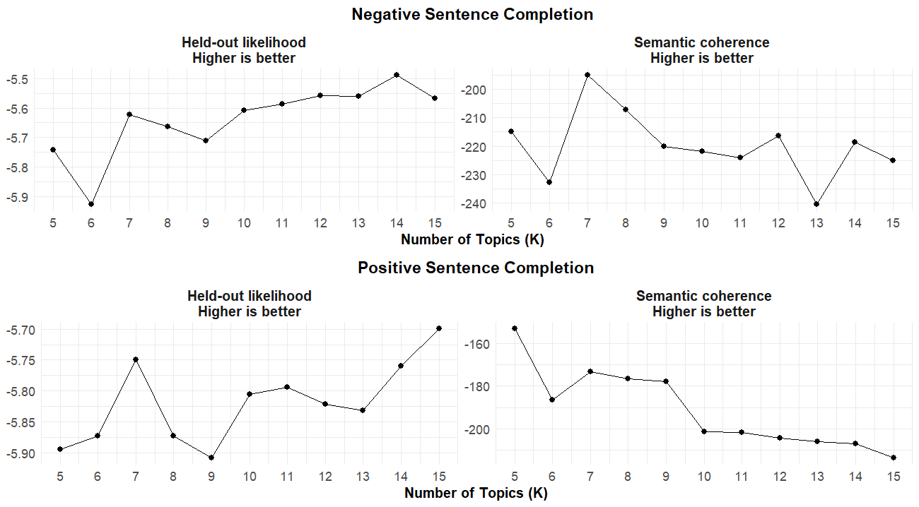

Figure F6: STM Topic Analysis Top Terms for Negative Sentence Completion
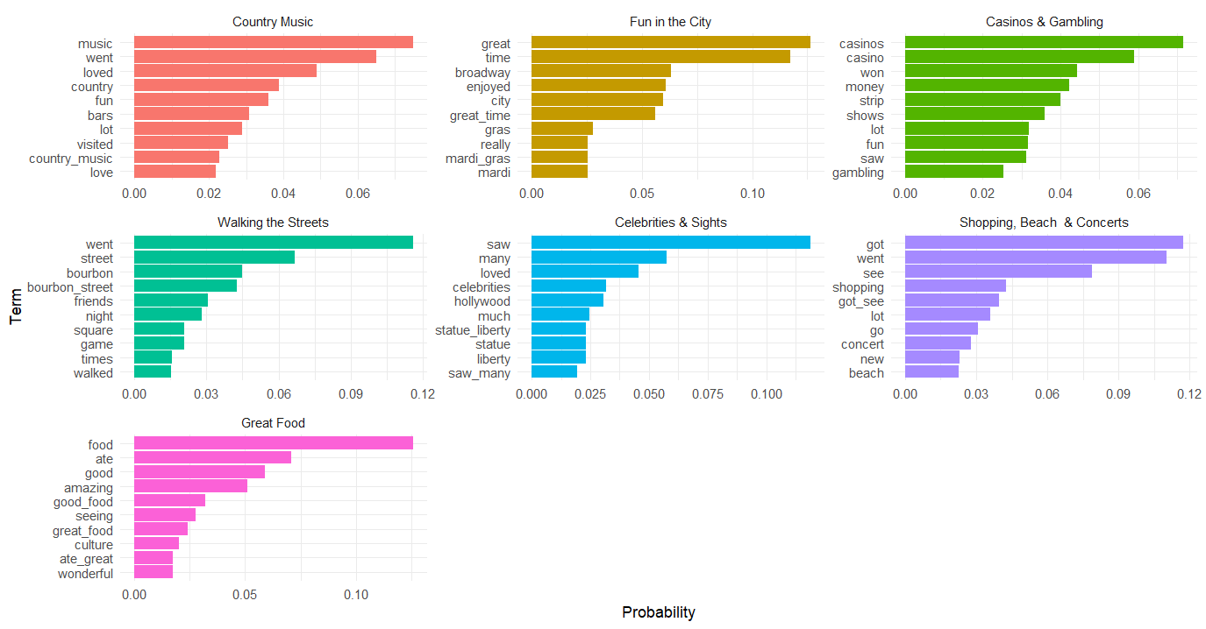
Each subgraph contains the top 10 word-topic probabilities for one of the 7 topics found in the STM analysis.
Figure F7: STM Topic Analysis Top Terms for Positive Sentence Completion

Each subgraph contains the top 10 word-topic probabilities for one of the 7 topics found in the STM analysis.
Figure F8: STM Topic Analysis Top Terms for Word Association
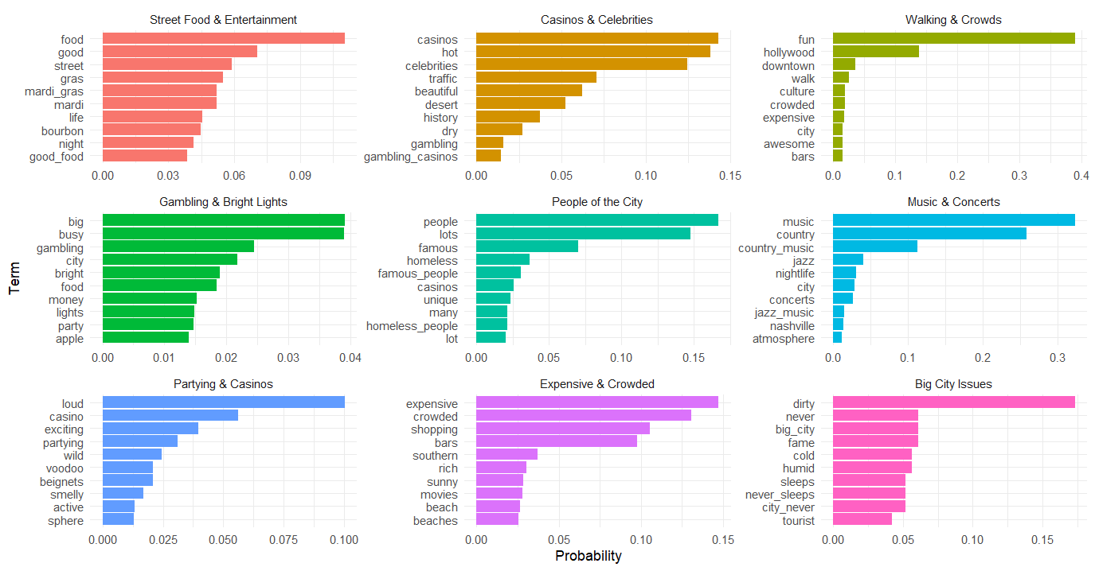
Each subgraph contains the top 10 word-topic probabilities for one of the 9 topics found in the STM analysis.
Figure F9: Correspondence Analysis Plot for Word Association
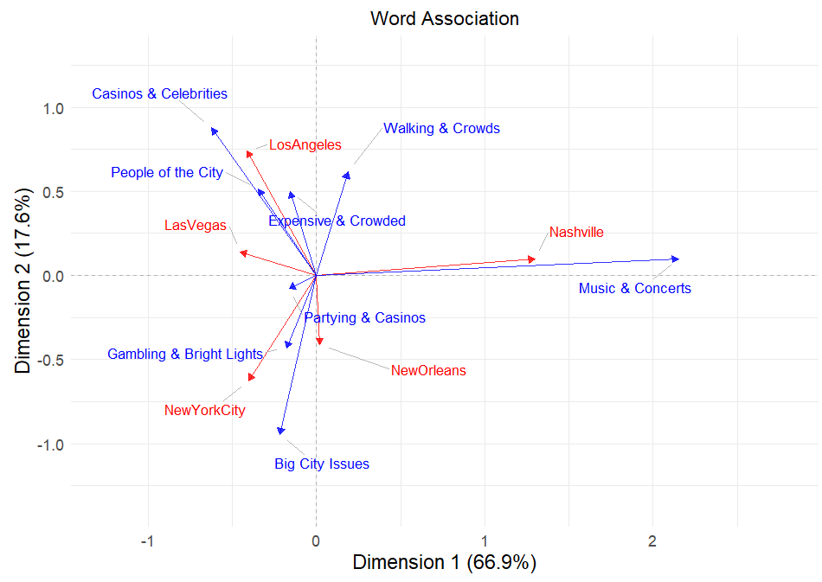

Table F1: Contingency Table for Negative Sentence Completion
Topic Category | Las Vegas | Los Angeles | Nashville | New Orleans | New York City
Bad Food | 3 | 1 | 5 | 9 | 3
Dirty | 4 | 17 | 7 | 20 | 40
Expense | 8 | 8 | 13 | 9 | 7
General Issues | 10 | 4 | 8 | 8 | 7
Homelessness | 12 | 32 | 21 | 25 | 28
Lost Money | 72 | 6 | 7 | 7 | 2
Nightlife | 11 | 13 | 33 | 35 | 8
Subway & Crowds | 2 | 6 | 2 | 2 | 11
Terrible Time | 12 | 11 | 11 | 17 | 10
Traffic | 32 | 59 | 57 | 32 | 46

Table F2: Contingency Table for Positive Sentence Completion
Topic Category | Las Vegas | Los Angeles | Nashville | New Orleans | New York City
Casino | 97 | 14 | 11 | 8 | 5
Celebrity | 3 | 35 | 1 | 0 | 0
City Sights | 22 | 35 | 44 | 81 | 73
Country Music | 4 | 0 | 27 | 0 | 0
Great Food | 33 | 49 | 69 | 64 | 61
Iconic Buildings | 2 | 2 | 0 | 0 | 16
Parks & Cafes | 0 | 1 | 1 | 7 | 7
Shows &  Entertainment | 5 | 13 | 11 | 7 | 6
Sports | 1 | 18 | 4 | 2 | 0

Table F3: Contingency Table for Word Association
Topic Category | Las Vegas | Los Angeles | Nashville | New Orleans | New York City
Attractions | 43 | 32 | 67 | 94 | 105
Big City | 100 | 68 | 39 | 40 | 155
Celebrity | 4 | 35 | 13 | 9 | 9
Cowboy | 31 | 11 | 51 | 9 | 7
Crowd | 32 | 105 | 21 | 41 | 72
Events | 27 | 7 | 22 | 63 | 16
Food | 239 | 255 | 161 | 246 | 187
Nightlife | 35 | 26 | 185 | 48 | 25
Partying | 115 | 74 | 67 | 82 | 39
Weather | 11 | 26 | 16 | 5 | 9

