Part 3

2020 Supplemental Results

Table S6. Canadian Institution Donor Weights, 2020 Title IX

Canadian Institution Donor Weights,  Synthetic Control |  |  |  | Canadian Institution Donor Weights,  Bias-Corrected Synthetic Control
Donor Institution 1 |  | 0 | Donor Institution 1 |  |  |  | 0
Donor Institution 2 |  | 0 | Donor Institution 2 |  |  |  | 0
Donor Institution 3 |  | 0.163 | Donor Institution 3 |  |  |  | 0.163
Donor Institution 4 |  | 0.068 | Donor Institution 4 |  |  |  | 0.068
Donor Institution 5 |  | 0.769 | Donor Institution 5 |  |  |  | 0.769
Donor Institution 6 |  | 0 | Donor Institution 6 |  |  |  | 0
Donor Institution 7 |  | 0 | Donor Institution 7 |  |  |  | 0
Donor Institution 8 |  | 0 | Donor Institution 8 |  |  |  | 0
Donor Institution 9 |  | 0 | Donor Institution 9 |  |  |  | 0
Donor Institution 10 |  | 0 | Donor Institution 10 |  |  |  | 0
Donor Institution 11 |  | 0 | Donor Institution 11 |  |  |  | 0

Table S7. Predictor Balance, 2020 Title IX Synthetic Control

Sexual Misconduct Reports Received by Title IX Offices per Student
Level of Measure | Predictor | Treated Unit | Synthetic Unit
State / Province
 | Minimum Wage | 8.91 | 12.66
 | Female Unemployment Rate | 5.04 | 6.08
 | Unemployment Rate | 4.44 | 6.44
 | Binge Drinking Rate | 0.16 | 0.25
 | UCR Sexual Assault Rate | 41.54 | 70.70
 | #MeToo Google Trends | 132.8 | 107
 | Proportion of Students in only Remote Learning | 0.315 | 0.29
Institution
 | Presence of Greek Life | 1.00 | 0.93
 | Presence of Division I Athletics | 0.91 | 1.00
 | Football, Wrestling, Hockey (0-3) | 1.31 | 1.76
 | Climate Survey Use | 0.57 | 0.16
 | RUCC | 1.55 | 1.40
 | National News Outlet Incident | 0.33 | 0.07
 | Proportion of Female Professors | 0.42 | 0.30
 | Proportion of Graduating Undergraduate Females | 0.64 | 0.60

Table S8. Predictor Balance, 2020 Title IX Bias-Corrected Synthetic Control

Sexual Misconduct Reports Received by Title IX Offices per Student
Level of Measure | Predictor | Treated Unit | Synthetic Unit
State / Province
 | Minimum Wage | 8.91 | 12.66
 | Female Unemployment Rate | 5.04 | 6.08
 | Unemployment Rate | 4.44 | 6.44
 | Binge Drinking Rate | 0.16 | 0.25
 | UCR Sexual Assault Rate | 41.54 | 70.70
 | #MeToo Google Trends | 132.8 | 107
 | Proportion of Students in only Remote Learning | 0.315 | 0.29
Institution
 | Presence of Greek Life | 1.00 | 0.93
 | Presence of Division I Athletics | 0.91 | 1.00
 | Football, Wrestling, Hockey (0-3) | 1.31 | 1.76
 | Climate Survey Use | 0.57 | 0.16
 | RUCC | 1.55 | 1.40
 | National News Outlet Incident | 0.33 | 0.07
 | Proportion of Female Professors | 0.42 | 0.30
 | Proportion of Graduating Undergraduate Females | 0.64 | 0.60

Figure S5. Gap in Predicted Reports of Sexual Misconduct per 1,000 Enrolled Students Pre- and Post-2020 Title IX Guidance per Bias-Corrected Synthetic Control, Academic Year 2017-2018 – Academic Year 2021-2022

Gap in Predicted Reports for Only Treated U.S. Institutions | Gap in Predicted Reports for Treated U.S. Institutions (bold)  & All Donor Institutions (grey)
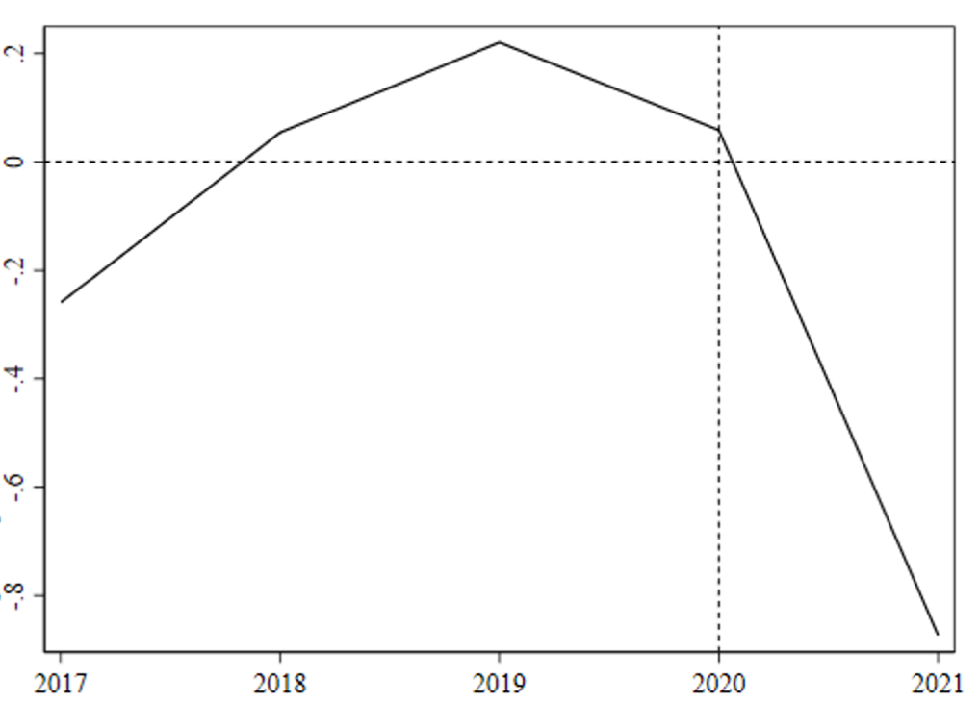 | 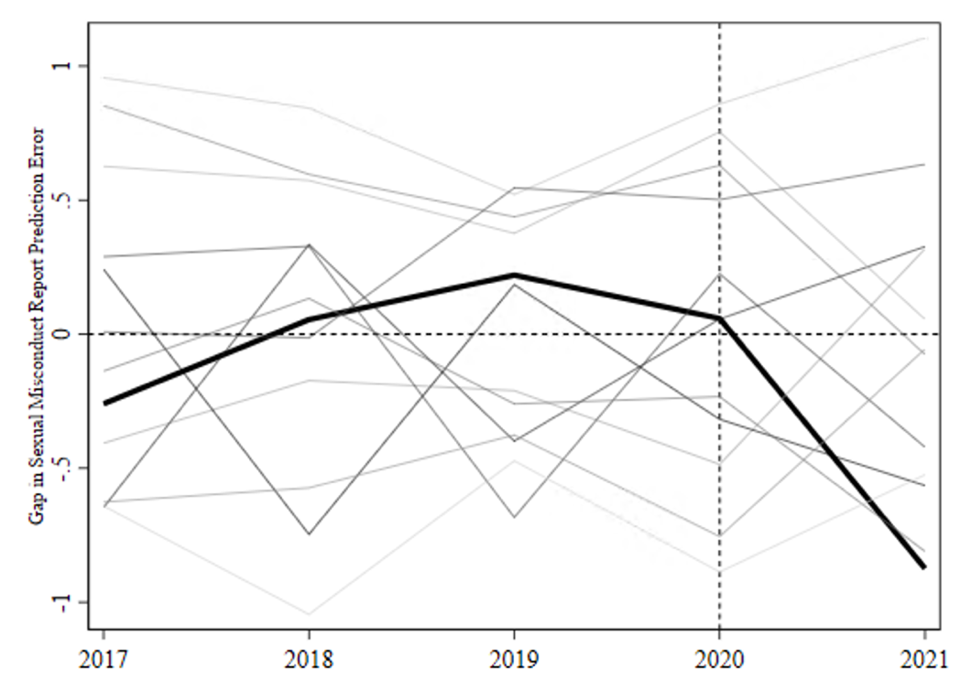

Figure S6. Ratios of Pre-Period : Post-Period Root Mean Squared Prediction Error (RMSPE), 2020 Title IX Bias-Corrected Synthetic Control

Ratios of Pre-Period : Post-Period Root Mean Squared Prediction Error (RMSPE),
2020 Title IX Bias-Corrected Synthetic Control
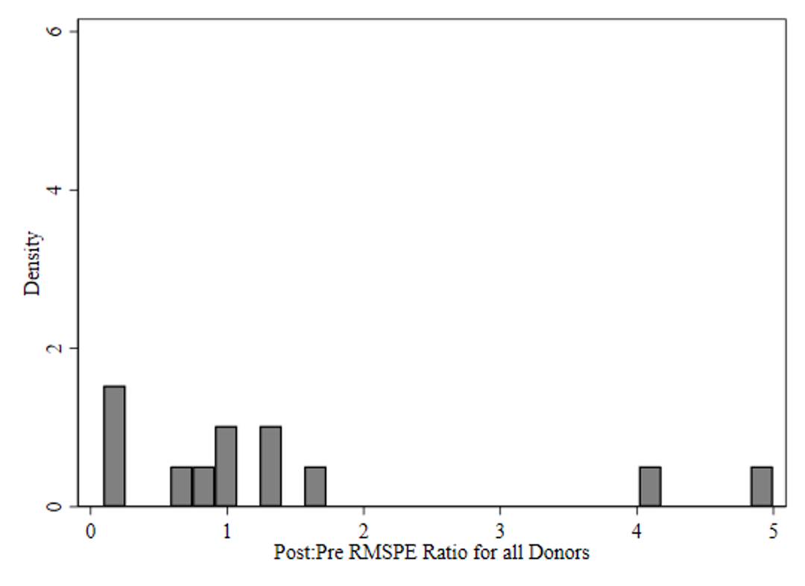
U.S.

Table S9. P-Values for Pre : Post Root Mean Squared Prediction Error, 2020 Title IX Bias-Corrected Synthetic Control

Unit | p-value for Pre : Post RMSPE
U.S. Institutions | 0.083
Donor Institution 1 | 0.167
Donor Institution 2 | 0.250
Donor Institution 3 | 0.333
Donor Institution 4 | 0.416
Donor Institution 5 | 0.500
Donor Institution 6 | 0.583
Donor Institution 7 | 0.667
Donor Institution 8 | 0.750
Donor Institution 9 | 0.833
Donor Institution 10 | 0.916
Donor Institution 11 | 0.999

