CODEBOOK

Scope & Purpose
This codebook documents the variables, sources, and construction rules used in the paper Inclusive Rhetoric, Exclusive Boundaries: Strategic Homonativism on the British Right. It enables replication of the analyses that locate UK parties in the “homonativist space” by combining (1) latent positioning from the Chapel Hill Expert Survey (CHES, 2002–2024) and (2) activated salience from original coding of party manifestos (drawn from MARPOR and party/archive PDFs). The unit of analysis is the party–election observation for the Conservative Party (CON), UKIP (UKIP), and Reform UK (RUK). Because CHES coverage is uneven (e.g., UKIP coded only from 2015; Reform UK from 2019), some positioning items are missing by design. The codebook specifies variable names, scales, transformations (e.g., salience balances), handling of missing data, and any recoding decisions used to produce line graphs, 2D matrices, and robustness checks (correlations and within-party deltas). It also summarises the manifesto coding scheme for sexuality, immigration, and transgender issues.

Dataset Construction
The analysis draws on two complementary datasets. First, the CHES (2002–2024) provides measures of party positioning on sexuality and immigration. CHES offers expert-coded ideological placements for European parties, updated regularly across survey waves. These data are used to capture the latent ideological positioning of British parties across elections. However, CHES does not contain items specific to transgender rights; as such, while sexuality and immigration positions can be mapped directly from CHES, transgender issues cannot, meaning that whilst salience on this issue can be traced through manifesto data, the ideological positioning of parties on this issue could not.

Second, a manifesto dataset was compiled from The Comparative Manifesto Project (MARPOR) and supplemented with original collection of missing or incomplete texts via the Party Archives and the Internet Archive’s Wayback Machine. These manifestos were coded at the quasi-statement level for references to sexuality (both liberal and conservative frames), immigration (nativist and multiculturalist frames), and transgender rights (pro- and anti-trans frames). The resulting dataset provides salience measures that capture the degree of emphasis parties placed on these issues in electoral campaigns.

Finally, these two data sources were merged to form a single, novel dataset of party–election observations, aligning CHES positioning data (to the closest election) with manifesto-based salience measures. To ensure comparability and consistency, only observations for which both CHES and manifesto data were available were retained for analysis. Where either source was missing (e.g., UKIP before 2015; Reform UK / Brexit Party prior to 2019), the party–election observation was removed. This integrated dataset forms the empirical foundation for the paper’s mapping of latent positioning, activated salience, and the conditions of mobilisation.

Variables
Party-Level Identifiers

Variable | Description | Coding/Scale | Notes
party | Party code | String (CON, UKIP, RUK) | Used for merging across datasets
elec_year | Year of general election | Integer (2001–2024) | Based on UK general election year
party_lab | Party label for figures and tables | String (Conservative, UKIP, Reform UK) | Simplified for presentation

CHES Positioning

CHES Item | Original Scale | Variable Name | Recoded Scale | Description / Notes
SOCIALLIFESTYLE | 0 = strongly support, 10 = strongly oppose | homosex | 0–10 | Position on LGBT rights, used for 2002–2019 survey rounds. Question wording refers to “rights for homosexuals.”
LGBTQ_RIGHTS | 0 = strongly support, 10 = strongly oppose | homosex | 0–10 | Position on LGBT rights, used for 2024 survey round. Question wording updated to specifically reference LGBTQ rights.
IMMIGRATE_POLICY | 0 = strongly favours liberal policy, 10 = strongly favours restrictive policy | imm_posit | 0–10 | Position on immigration policy, available consistently across all survey rounds (2002–2024).
— | — | ches_sex_bal | Continuous | Derived Balance : sexual-liberal vs sexual-conservative balance (5 – homosex).
— | — | ches_imm_bal | Continuous | Derived Balance: multiculturalist vs nativist balance (imm_posit – 5).

Manifesto Salience

Variable | Description | Coding/Scale | Notes
sexlib_sal | Share of words in quasi-statements coded as sexual-liberal | % of total manifesto words (0–100, standardised) | Calculated as proportion of total word count; standardised by multiplying by 100.
sexcon_sal | Share of words in quasi-statements coded as sexual-conservative | % of total manifesto words (0–100, standardised) | Same procedure as above.
nativ_sal | Share of words in quasi-statements coded as nativist | % of total manifesto words (0–100, standardised) | Same procedure as above.
multicul_sal | Share of words in quasi-statements coded as multiculturalist | % of total manifesto words (0–100, standardised) | Same procedure as above.
translib_s | Share of words in quasi-statements coded as pro-trans rights | % of total manifesto words (0–100, standardised) | Introduced to capture transgender discourse - Same procedure as above.
transcon_s | Share of words in quasi-statements coded as anti-trans | % of total manifesto words (0–100, standardised) | Introduced to capture transgender discourse - Same procedure as above.
sal_sex_bal | Sexuality balance: sexlib_sal – sexcon_sal | Continuous (can be negative or positive) | + values = more liberal emphasis; – values = more conservative emphasis.
sal_imm_bal | Immigration balance: nativ_sal – multicul_sal | Continuous (can be negative or positive) | + values = more nativist emphasis; – values = more multicultural emphasis.
homonativ | Flag for explicit homonativist appeal | Binary (0 = no, 1 = yes) | Coded qualitatively from manifesto text.

Coding Procedures: Scaling
The CHES variables were taken directly on their original 0–10 scales, where higher scores indicate more restrictive positions on immigration or more opposition to LGBT rights. No transformation was applied beyond harmonising item wording across survey waves (see Codebook Section ‘Analytical Constructs’). Manifesto salience measures were calculated as the share of words contained in all quasi-statements coded to a category divided by the total word count of the manifesto and then standardised by multiplying by 100 for interpretability. This ensures that salience reflects both the frequency and the relative length of coded arguments, rather than treating all statements equally regardless of size.

Coding Procedures: Missing Data Protocols
For comparability and consistency, only party–election observations for which both CHES positioning data and manifesto salience measures were available were retained for analysis. Observations with missing data on either side (e.g., UKIP prior to 2015, Reform UK / Brexit Party prior to 2019, or elections for which manifestos could not be located) were excluded. This approach avoids artificially inflating the sample with partial observations and ensures that all analyses reflect the joint availability of latent positioning and activated salience.

Coding Procedures: Manifesto Coding
The unit of measurement was the quasi-statement, defined as the smallest unit of text expressing a discrete political idea, claim, or proposal which forms an argument. Each quasi-statement was coded into one of six substantive categories, plus a binary mobilisation flag:
• Sexual-liberal: Statements endorsing equality, inclusion, or protection of sexual-minorities (e.g., “We will ensure equal marriage rights for same-sex couples”).
• Sexual-conservative: Statements rejecting or limiting rights for sexual-minorities (e.g., “Marriage should be reserved for a man and a woman”).
• Nativist: Statements advocating restrictive immigration, emphasising threats from outsiders, or displaying some form of hostility towards non-native peoples or foreign culture (e.g., “We will reduce immigration to protect British jobs”).
• Multiculturalist: Statements endorsing immigration, diversity, or minority inclusion (e.g., “Immigrants enrich our culture and economy”).
• Pro-trans: Statements explicitly defending transgender rights or recognition (e.g., “We will improve legal recognition and healthcare access for trans people”).
• Anti-trans: Statements explicitly opposing trans rights or framing “gender ideology” as harmful (e.g., “We will ban puberty blockers for minors”).
• Homonativist (flag): Explicit appeals fusing LGBT inclusion with exclusionary/nativist frames (e.g., “Britain defends gay rights, unlike intolerant migrants who threaten our way of life”).
For transparency, references to LGBT rights were coded as sexuality (sexual-liberal or sexual-conservative) unless transgender issues were explicitly demarcated as a separate subject. Transgender rights only emerged as a standalone political issue from 2015 onwards and so were coded separately only when clearly framed as such (e.g., debates on gender recognition, medical care, or “gender ideology”). This avoided double-coding references where “LGBT” was used as a collective label but without separate reference to trans issues, which would have otherwise inflated both categories and obscured their distinct trajectories. This approach treats sexuality and transgender issues as analytically connected but not interchangeable: sexuality is the longer-standing axis of liberal–conservative conflict, while transgender rights have emerged more recently as a distinct and politically charged frontier.

Quasi-statements, rather than sentences or paragraphs, were chosen as the unit of analysis to ensure greater precision in capturing political claims. Sentences often combine multiple arguments, while paragraphs may contain both supportive and restrictive framings within the same passage. By coding at the quasi-statement level, the analysis aligns with established manifesto research practices while also adapting them to the study of sexuality and immigration. This approach minimises both underestimation (from ignoring embedded arguments within longer text units) and overestimation (from treating single sentences containing multiple ideas as one claim). Weighting salience by word share further refines this approach by ensuring that longer or more detailed arguments count more heavily than short or symbolic mentions, producing a more accurate measure of the emphasis placed on each issue.

Analytical Constructs
This study distinguishes between three related but analytically distinct constructs: latent positioning, activated salience, and mobilised appeals. Together, these capture the continuum from parties’ underlying ideological placement, through their selective issue emphasis, to explicit electoral discourse. Treating these as separate yet connected dimensions makes it possible to map parties within a “homonativist space,” clarifying when conditions for homonativism are present and why mobilisation remains limited.

Latent positioning
Latent positioning refers to the underlying ideological stance of parties as measured by expert surveys. Here, latent positioning is derived from the CHES, 2002–2024. Two items were used: SOCIALLIFESTYLE (2002–2019) and LGBTQ_RIGHTS (2024) for sexuality, and IMMIGRATE_POLICY (2002–2024) for immigration. The two sexuality items were harmonised into a single measure, homosex, to ensure comparability across time. Both items are coded on a 0–10 scale (0 = strongly supportive of rights, 10 = strongly opposed). For immigration, the same consistent measure is available across all waves (0 = strongly liberal, 10 = strongly restrictive). These latent positioning scores are not interpreted as fixed ideological commitments, but as baseline expert assessments that anchor parties within the liberal–conservative and multiculturalist–nativist dimensions.

Activated Salience
Activated salience refers to the emphasis parties place on particular issues in their electoral campaigns, measured through manifesto content. Salience is calculated as the share of words contained in quasi-statements devoted to sexuality, immigration, and transgender rights, expressed as a percentage of the total manifesto word count (standardised by multiplying by 100). This approach weights salience by the volume of text rather than by the number of statements, ensuring that longer or more detailed discussions receive greater weight than brief symbolic mentions. Categories were defined as sexual-liberal, sexual-conservative, nativist, multiculturalist, pro-trans, and anti-trans. Derived balances (sal_sex_bal and sal_imm_bal) were created to represent the relative emphasis on liberal versus conservative framings within each issue domain. Activated salience thus captures when and how parties strategically emphasise sexuality and immigration, regardless of their underlying latent positions.

Mobilised Appeals
Mobilised appeals are qualitatively coded from manifesto text and refer to instances where sexuality and immigration are explicitly linked within the same frame. These “homonativist appeals” are rare but analytically distinct, as they move beyond latent positioning and selective salience to actively fuse liberal inclusion with exclusionary nationalism. Mobilisation is therefore identified through the presence of statements that simultaneously affirm sexual-liberal values while contrasting them with the perceived illiberalism of immigrants or minorities. Such appeals were flagged with a binary indicator (homonativ) in the dataset.

The Homonativist Space
Latent positioning and activated salience are treated as distinct categories rather than as steps in a linear progression. A party may be positioned in ways that would allow homonativist appeals (e.g., liberal on sexuality and nativist on immigration) without ever activating these issues in its campaign discourse. Conversely, a party may activate sexuality or immigration in salient terms even if its expert-coded latent positioning is ambiguous or absent.

Mobilised appeals, however, are conceptually nested within activated salience. Only parties that have made sexuality and immigration salient can then fuse these issues into explicit homonativist discourse. Mobilisation is therefore theorised as a sub-group of the activated category, representing the rare cases where parties take the additional step of linking liberal sexuality with exclusionary nationalism in their manifestos.

In schematic terms, this can be represented as:
- Latent positioning (CHES-derived): baseline ideological stance, may or may not translate into salience.
- Activated salience (manifesto-derived): selective issue emphasis, which may or may not reflect latent positioning.
- Mobilised appeals (manifesto text): a subset of activated cases, where sexuality and immigration are explicitly fused into homonativist discourse.

Thus, the “homonativist space” is defined by the intersection of sexual-liberal and nativist orientations, but only some party–election observations within this space become activated, and fewer still proceed to mobilisation – visualised in the diagram below.

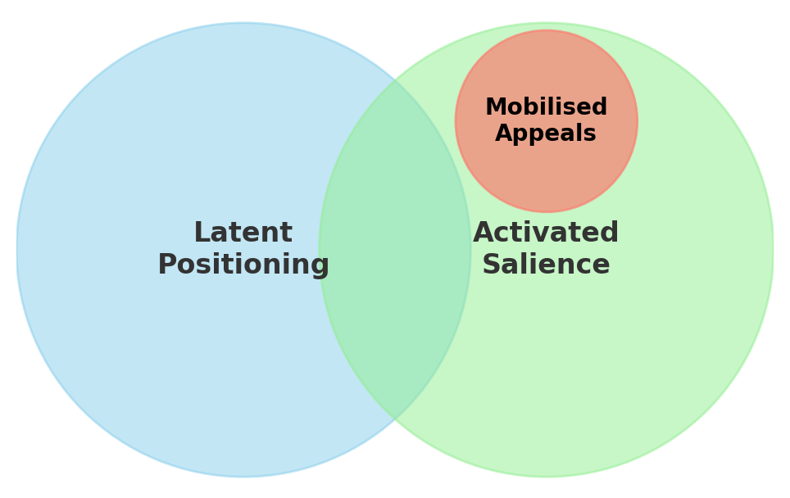

Robustness Checks
Robustness checks were carried out to assess whether latent positioning (CHES) aligns with, or diverges from, activated salience (manifestos). Two strategies were used: cross-sectional correlations and within-party change (“delta”) correlations.

Positioning was measured using the original 0–10 CHES scales for sexuality (homosex) and immigration (imm_posit), while activated salience was captured through balance scores derived from manifesto coding: sal_sex_bal = sexlib_sal – sexcon_sal (‒ = conservative emphasis, + = liberal emphasis) and sal_imm_bal = nativ_sal – multicul_sal (‒ = multicultural emphasis, + = nativist emphasis). To ensure comparability, only party–election observations with both CHES and manifesto data available were included.

For correlations, only complete pairs were used; for deltas, each party required at least two complete change pairs (i.e., three elections) on a given dimension to be included, with other cases set to missing. Cross-sectional tests computed Pearson’s correlation between latent positioning and salience balances for sexuality and immigration, both overall and by party. Delta tests examined whether within-party changes in positioning over time (d_homosex, d_imm_posit) were mirrored by changes in salience (d_sal_sex, d_sal_imm), reported both by party and in pooled estimates.

These checks provide leverage on the analytical distinction between latent positioning and activated salience: strong positive correlations suggest structural linkage, while weak or negative correlations point to strategic activation that diverges from baseline positioning. Mobilisation, identified qualitatively, was not subject to these quantitative checks, as it requires activation but is not implied by correlations. Small sample sizes for challenger parties such as UKIP and Reform UK limit the reliability of some party-specific delta estimates, and CHES lacks a transgender-rights item, meaning that trans salience could not be paired with positioning. All computations were conducted in R using standard functions from dplyr, stats, and ggplot2, and are fully replicable with the dataset described in this codebook.

