Supporting Information
Additional supporting information may be found online in the Supporting Information section at the end of the article.

Annex B. Income Polarization (Top 10% / Bottom 50%) from the WID data
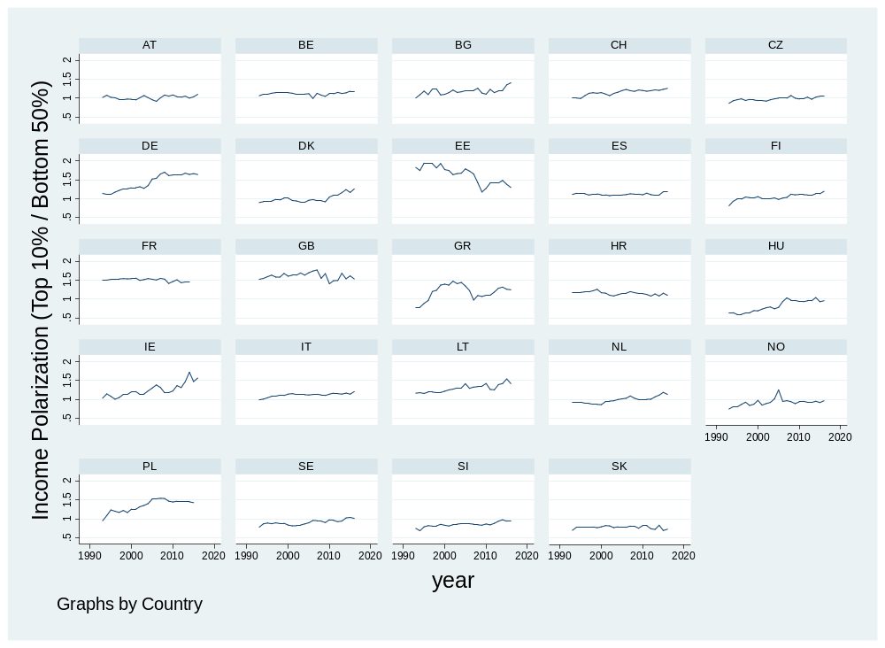

Annex C. Income Polarization (Top 10% / Bottom 50%) in the final (merged) sample
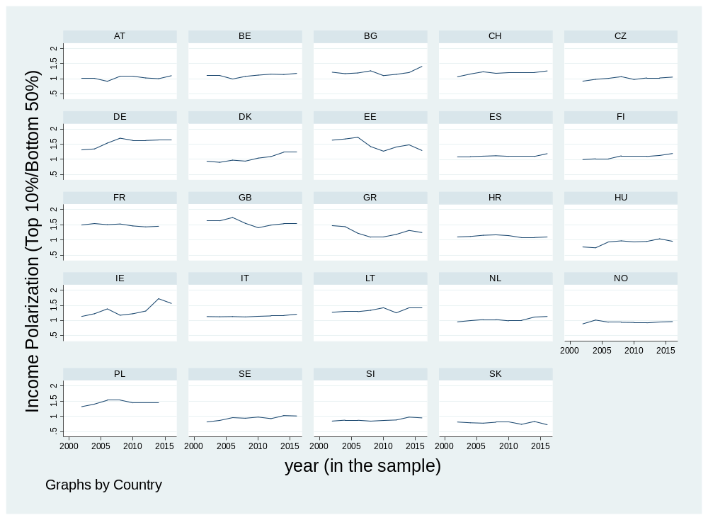

Annex D. Relative Trust Formula
$$∆Relative Trust \left(difference\right)=Trust \left(National:Parties, Politicians, Legal System, Parliament\right)-Trust \left(EU Parliament\right)$$

Annex E. The Expanded Index of Insecurity
The problem with the index of insecurity provided by Guiso et al. (2017) is that, as replicated, it is does not have enough coverage in ESS (as replicated by the author) and it does not allow one to grasp the effect of the growing insecurity of all the unskilled workers, beyond only those employed in the blue-collar manufacturing industry. This is also true, especially in the context of the Covid-19 pandemic, which uncovers the precarious position of all low-skilled workers in times of crisis as well as the imminent risk of eventual labour substitution due to robotization (automation) and AI. Guiso et al. (2017) propose an index, which is comprised of four values, each made up with equally weighted components, mainly coming from the ESS dataset. The index takes values from 0 – not insecure to 3 – very insecure in the following fashion:
3= finding it extremely hard to survive on current income (question in the ESS), has experienced unemployment in the last 7 years and is blue-collar manufacturing worker
2 = at least two are true
1 = at least one is true
0 = none is true
The Expanded Index of Insecurity is composed from three elements:
3= finding it hard or extremely hard to survive on current income, has experienced long-term unemployment (three months or more) and is an unskilled worker (according to the Erikson–Goldthorpe–Portocarero (EGP) occupational classification coding in Leiulfsrud, 2005).
2 = at least two are true
1 = at least one is true
0 = none is true
As seen below and compared to the Guiso et al. (2017) index, the Expanded Index of Insecurity has a much better coverage when using the ESS database, has a relatively similar distribution, with a larger number of the very insecure category due to the broader occupational definition of the most insecure. It is worth mentioning that although the occupational definition is more inclusive, bringing more of the sample population to the ends of the spectrum, a more restrictive question on long-term unemployment is filling out the middle of the distribution.

Table S2. Comparison of the two indices of insecurity (ESS 2002-2016).
Values of the index | Guiso et al. 2017 Index (re-coded) | Percent | Cumulative | The Expanded Index of Insecurity | Percent | Cumulative
0 (Secure) | 31,928 | 36.55 | 36.55 | 160,637 | 48.22 | 48.22
1 (Less secure) | 34,942 | 40.00 | 76.56 | 114,164 | 34.27 | 82.50
2 (Less insecure) | 20,097 | 23.01 | 99.56 | 47,950 | 14.39 | 96.89
3 (Insecure) | 381 | 0.44 | 100.00 | 10,351 | 3.11 | 100.00
Total | 87,348 | 100.00 |  | 333,102 | 100.00

Both indices are highly correlated (0.61), but the new index is more liberal with whom to classify as ‘insecure’. Borrowing the class classification from Norris and Inglehart and EGP classification, it includes all unskilled workers (instead of simply blue-collar manufacturing workers) who find it hard and extremely hard to survive on present income. This dramatically increases the number of observations and provides a better variability in the sample.

Annex F. Country-level Aggregation of the Expanded Index of Insecurity
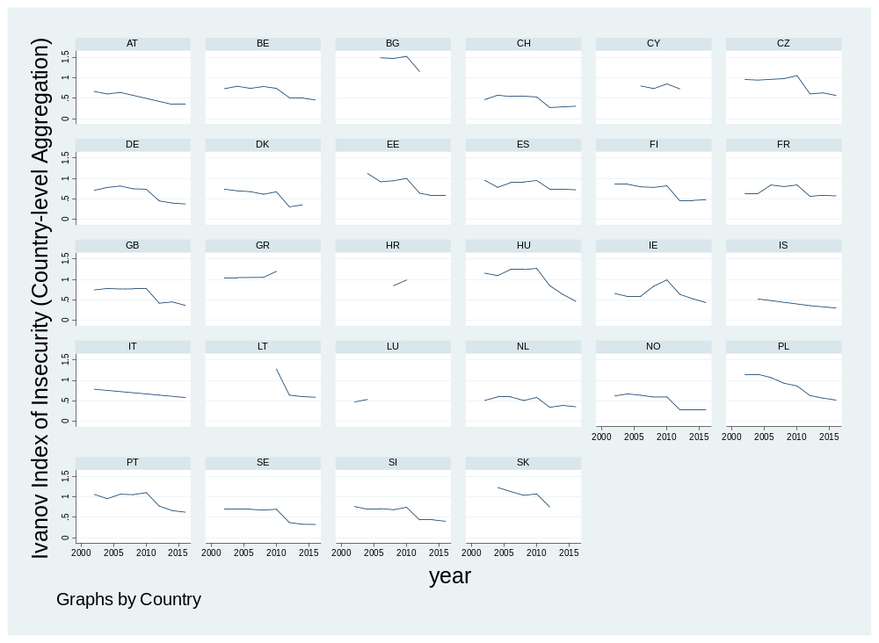

Annex G. Country-level aggregates of institutional trust in the sample
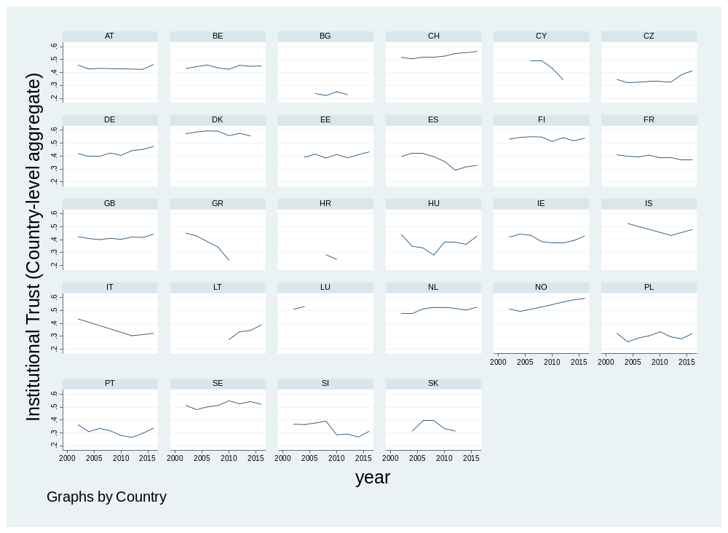

Annex H. Country-level aggregates of institutional trust (difference) in the sample
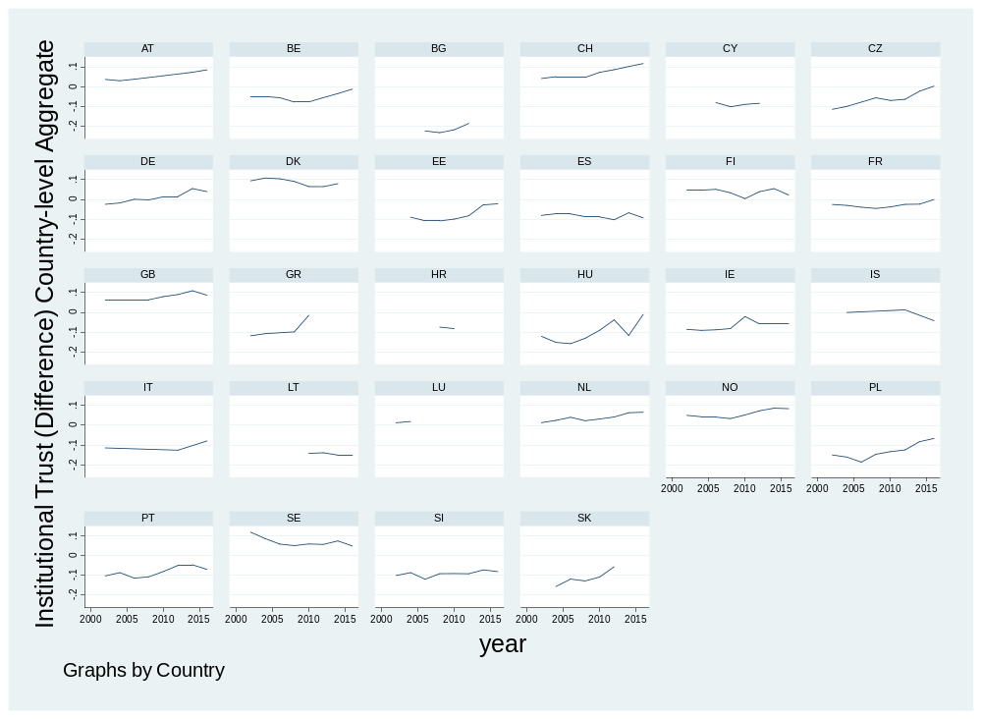

Annex I. Calculations of Variance-Partition Coefficient (VPC)
11.2% of variance in voting for populist parties can be attributed to differences between countries and across time:
- Total variance = 0.00764+0.060405=0.0680
- VPC (country-time)=0.00764/0.0680= 0.11235
For the three-level Country-time NUTS1 model additional 2.1% of variance in voting for populist parties can be attributed to regional differences at NUTS1 level on a reduced sample:
- VPC(NUTS1)= 0.0016/0.0759=0.021
- 2.1% of variance in voting for populist parties can be attributed to regional differences at NUTS1 level on a reduced sample

Annex K. Graph of the isolated groupings Institutional Trust and Insecurity Index
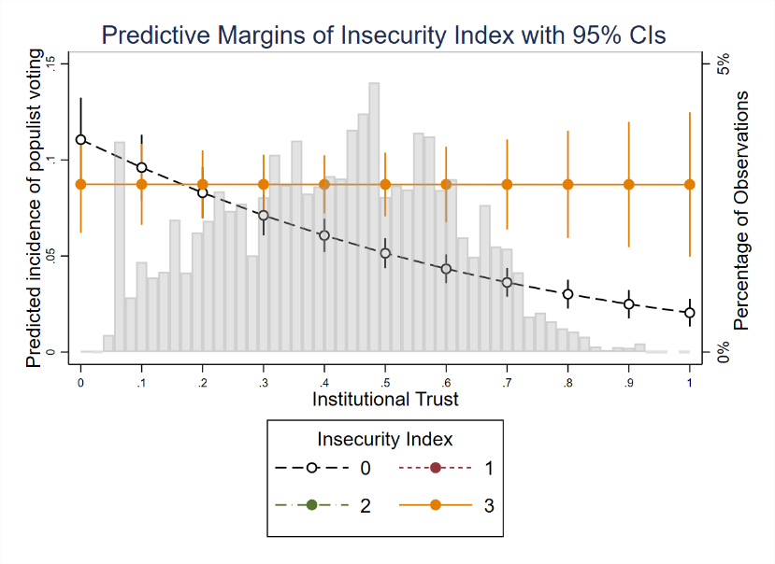
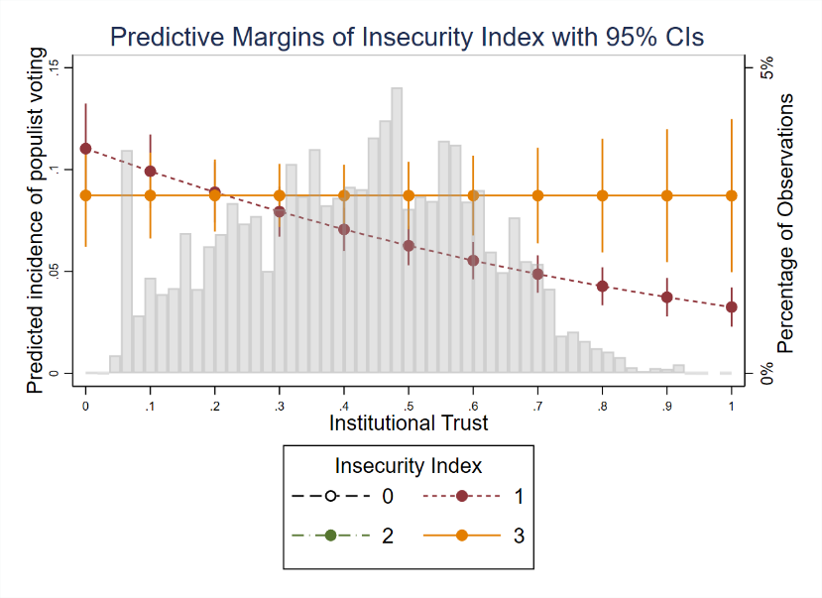

Annex L. Graph for the full distribution of Institutional Trust (NUTS1).
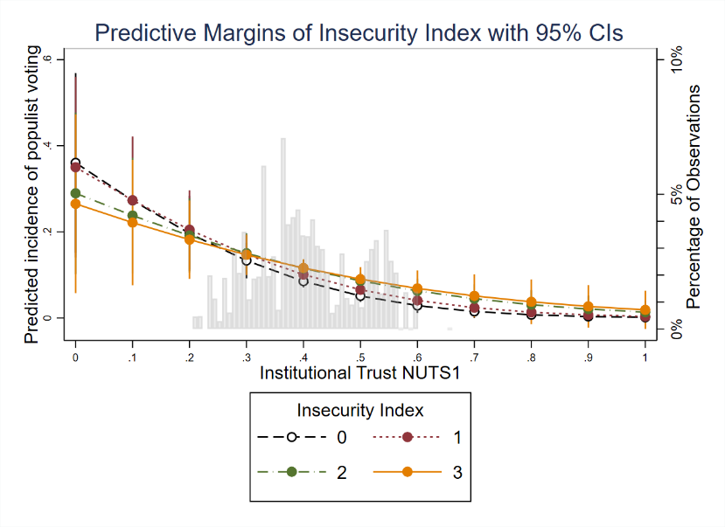

Annex M. Graph for the 90% percentiles of the distribution of Institutional Trust Difference (NUTS1).
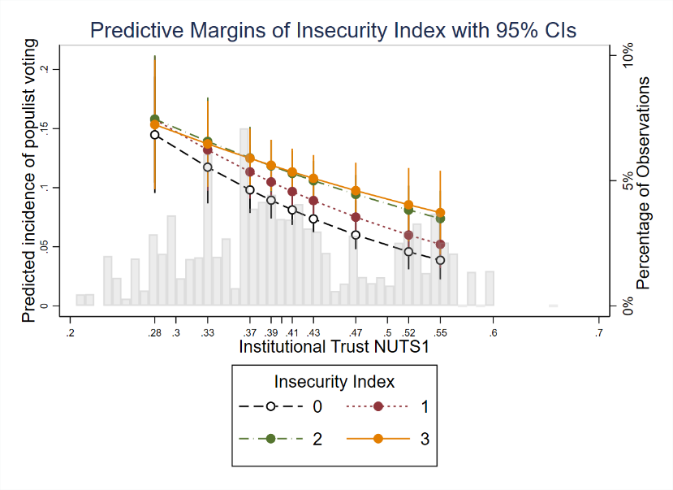

Annex N. Graphs of the isolated groupings of Relative Institutional Trust and Insecurity Index
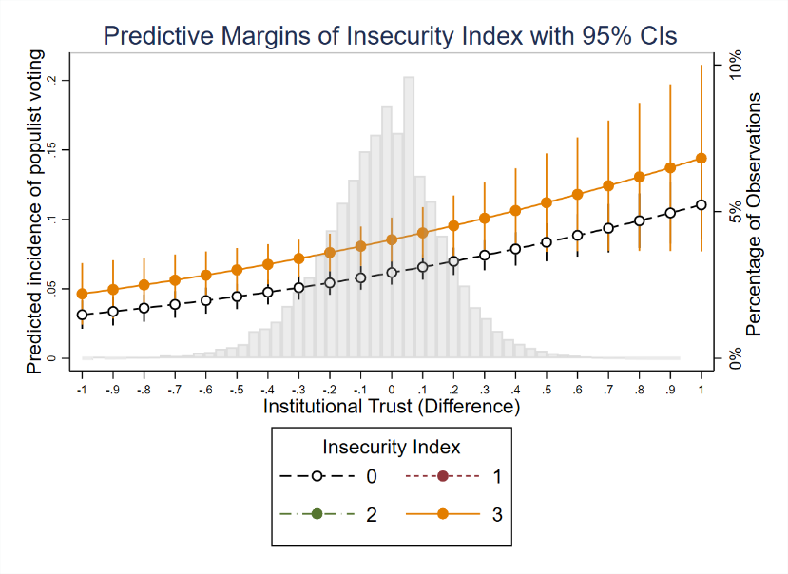
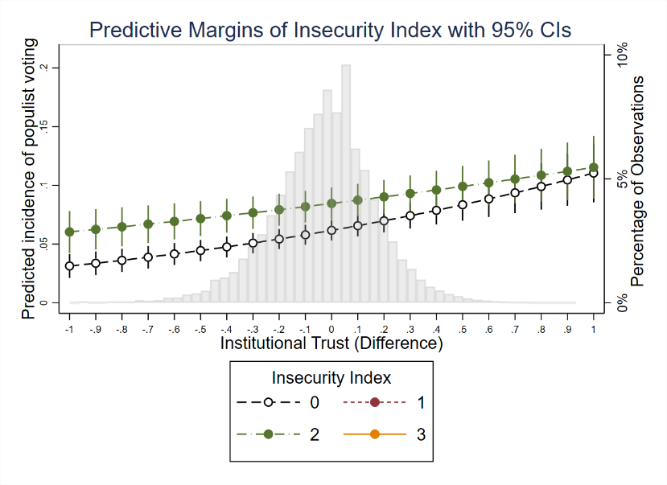

Annex O. Graph for the full distribution of the Relative Institutional Trust (difference) (NUTS1).
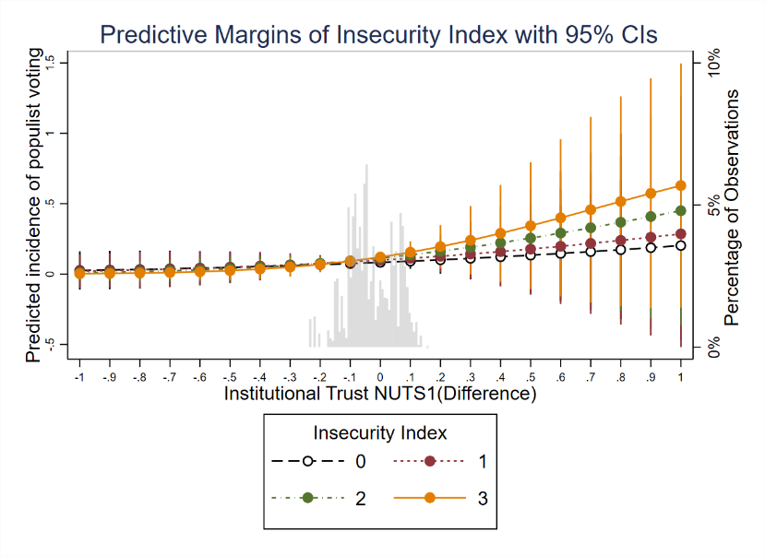

Annex P. Graph for the 90% percentiles of the distribution of the Relative Institutional Trust (difference) (NUTS1).
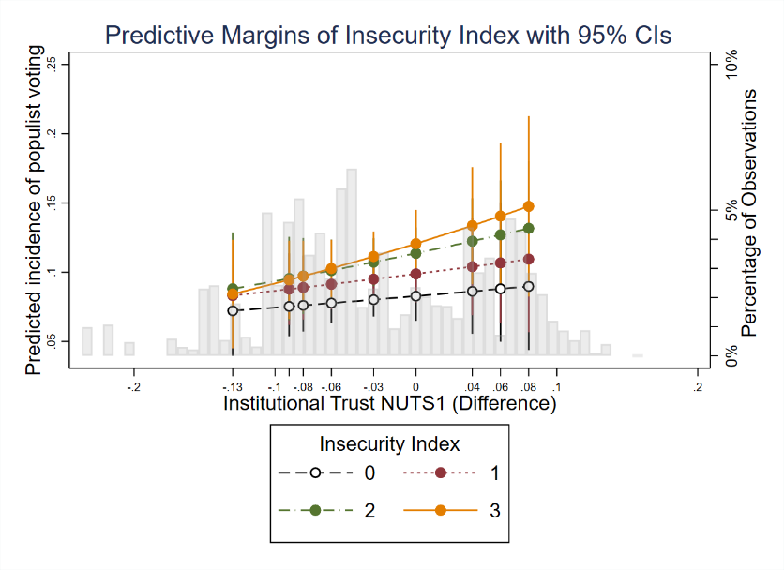

Annex Q. Table 4. Additional Robustness checks I. Multilevel Mixed-Effects Probit regressions.
 | (1.1) | (1.2) | (1.3) | (2.1) | (2.2) | (2.3)
VARIABLES | GDP Individual-Level Interaction | GDP per capita Individual-Level Interaction | GDP per capita (PPP) Individual-Level Interaction | GDP Regional-Level Interaction | GDP per capita Regional-Level Interaction | GDP per capita (PPP) Regional-Level Interaction
Age (log) | 0.270*** | 0.270*** | 0.270*** | 0.272*** | 0.272*** | 0.272***
 | (0.039) | (0.039) | (0.039) | (0.045) | (0.045) | (0.045)
Education (log) | 0.101*** | 0.101*** | 0.101*** | 0.097*** | 0.097*** | 0.097***
 | (0.027) | (0.027) | (0.027) | (0.031) | (0.031) | (0.031)
Gender (female=1) | -0.113*** | -0.113*** | -0.113*** | -0.110*** | -0.110*** | -0.110***
 | (0.015) | (0.015) | (0.015) | (0.018) | (0.018) | (0.018)
Insecurity(1) | -0.009 | -0.009 | -0.009 | -0.051 | -0.051 | -0.051
 | (0.036) | (0.036) | (0.036) | (0.092) | (0.092) | (0.092)
Insecurity(2) | 0.000 | -0.000 | -0.000 | -0.312** | -0.312** | -0.312**
 | (0.048) | (0.048) | (0.048) | (0.127) | (0.127) | (0.127)
Insecurity(3) | -0.207** | -0.207** | -0.207** | -0.329 | -0.327 | -0.327
 | (0.094) | (0.094) | (0.094) | (0.230) | (0.231) | (0.231)
Institutional Trust (individual) | -1.026*** | -1.026*** | -1.026*** | -2.464*** | -2.461*** | -2.460***
 | (0.143) | (0.142) | (0.142) | (0.844) | (0.845) | (0.845)
Insecurity(1)#Institutional Trust (individual/NUTS1) | 0.277*** | 0.278*** | 0.278*** | 0.435** | 0.434** | 0.434**
 | (0.092) | (0.092) | (0.092) | (0.212) | (0.212) | (0.212)
Insecurity(2)# Institutional Trust (individual/NUTS1) | 0.429*** | 0.429*** | 0.429*** | 1.320*** | 1.318*** | 1.318***
 | (0.133) | (0.133) | (0.133) | (0.344) | (0.344) | (0.344)
Insecurity(3)# Institutional Trust (individual/NUTS1) | 1.145*** | 1.146*** | 1.146*** | 1.427** | 1.421** | 1.421**
 | (0.227) | (0.227) | (0.227) | (0.597) | (0.599) | (0.599)
GDP (million, constant 2015 USD) | 0.000*** |  |  | 0.000**
 | (0.000) |  |  | (0.000)
Perception of Inequality | 0.017 | 0.017 | 0.017 | 0.011 | 0.011 | 0.011
 | (0.014) | (0.014) | (0.014) | (0.016) | (0.016) | (0.016)
Income Polarization | 0.463 | 0.555 | 0.534 | -0.451 | -0.720 | -0.693
 | (0.384) | (0.496) | (0.492) | (0.492) | (0.563) | (0.551)
GDP per capita (thousand, const. 2015 USD) |  | -0.013 |  | 0.009
 |  | (0.023) |  | (0.021)
GDP per capita (thousand, PPP) |  |  | -0.007 |  | 0.004
 |  |  | (0.021) |  | (0.017)
Immigration Attitudes | 0.115*** | 0.115*** | 0.115*** | 0.129*** | 0.129*** | 0.129***
 | (0.024) | (0.024) | (0.024) | (0.028) | (0.028) | (0.028)
Constant | -2.503*** | -2.341*** | -2.292*** | -1.187* | -0.689 | -0.709
 | (0.407) | (0.507) | (0.619) | (0.671) | (0.629) | (0.620)
Observations | 289,542 | 280,526 | 280,526 | 182,156 | 182,156 | 182,156
Number of clusters | 157 | 157 | 157 | 100 | 100 | 100
Country Dummies | YES | YES | YES | YES | YES | YES
Year Dummies | YES | YES | YES | YES | YES | YES
NUTS1 | NO | NO | NO | YES | YES | YES
The reference group of interactions is at insecurity equal to zero; Institutional trust is aggregated to NUTS1 level for Models 2.1-2.3; Robust standard errors in parentheses *** p<0.01, ** p<0.05, * p<0.1.

Annex R. Table 5. Additional Robustness checks II. Multilevel Mixed-Effects Probit regressions.
 | (1.1) | (1.2) | (1.3) | (2.1) | (2.2) | (2.3)
VARIABLES | GDP Individual-Level Interaction | GDP per capita Individual-Level Interaction | GDP per capita (PPP) Individual-Level Interaction | GDP Regional-Level Interaction | GDP per capita Regional-Level Interaction | GDP per capita (PPP) Regional-Level Interaction
Age (log) | 0.259*** | 0.259*** | 0.259*** | 0.273*** | 0.273*** | 0.273***
 | (0.039) | (0.039) | (0.039) | (0.045) | (0.045) | (0.045)
Education (log) | 0.074*** | 0.074*** | 0.074*** | 0.094*** | 0.094*** | 0.094***
 | (0.025) | (0.025) | (0.025) | (0.031) | (0.031) | (0.031)
Gender (female=1) | -0.100*** | -0.100*** | -0.100*** | -0.110*** | -0.110*** | -0.110***
 | (0.015) | (0.015) | (0.015) | (0.018) | (0.018) | (0.018)
Insecurity(1) | 0.128*** | 0.128*** | 0.128*** | 0.135*** | 0.135*** | 0.135***
 | (0.016) | (0.016) | (0.016) | (0.017) | (0.017) | (0.017)
Insecurity(2) | 0.207*** | 0.207*** | 0.207*** | 0.242*** | 0.242*** | 0.242***
 | (0.031) | (0.031) | (0.031) | (0.041) | (0.041) | (0.041)
Insecurity(3) | 0.214*** | 0.214*** | 0.214*** | 0.345*** | 0.344*** | 0.344***
 | (0.049) | (0.049) | (0.049) | (0.040) | (0.040) | (0.040)
Relative Institutional Trust (individual) | 0.400*** | 0.401*** | 0.400*** | 0.293 | 0.291 | 0.291
 | (0.078) | (0.078) | (0.078) | (0.864) | (0.863) | (0.863)
Insecurity(1)# Relative Institutional Trust (individual/NUTS1) | -0.155** | -0.155** | -0.155** | 0.338 | 0.335 | 0.336
 | (0.067) | (0.067) | (0.067) | (0.220) | (0.220) | (0.220)
Insecurity(2)# Relative Institutional Trust (individual/NUTS1) | -0.199* | -0.200* | -0.200* | 1.003*** | 0.998*** | 0.998***
 | (0.103) | (0.103) | (0.103) | (0.364) | (0.363) | (0.363)
Insecurity(3)# Relative Institutional Trust (individual/NUTS1) | -0.004 | -0.005 | -0.005 | 1.890*** | 1.874*** | 1.874***
 | (0.208) | (0.208) | (0.208) | (0.425) | (0.426) | (0.426)
GDP (million, constant 2015 USD) | 0.000*** |  |  | 0.000**
 | (0.000) |  |  | (0.000)
Perception of Inequality | 0.019 | 0.019 | 0.019 | 0.010 | 0.010 | 0.010
 | (0.015) | (0.015) | (0.015) | (0.017) | (0.017) | (0.017)
Income Polarization | 0.492 | 0.596 | 0.572 | -0.280 | -0.492 | -0.471
 | (0.387) | (0.495) | (0.490) | (0.471) | (0.528) | (0.515)
GDP per capita (thousand, const. 2015 USD) |  | -0.019 |  | -0.001
 |  | (0.022) |  | (0.019)
GDP per capita (thousand, PPP) |  |  | -0.012 |  | -0.006
 |  |  | (0.020) |  | (0.015)
Immigration Attitudes | 0.143*** | 0.143*** | 0.143*** | 0.131*** | 0.130*** | 0.130***
 | (0.023) | (0.023) | (0.023) | (0.028) | (0.028) | (0.028)
Constant | -2.918*** | -2.721*** | -2.608*** | -2.208*** | -1.657*** | -1.541***
 | (0.392) | (0.490) | (0.597) | (0.533) | (0.489) | (0.504)
Observations | 257,138 | 257,138 | 257,138 | 182,156 | 182,156 | 182,156
Number of clusters | 157 | 157 | 157 | 100 | 100 | 100
Country Dummies | YES | YES | YES | YES | YES | YES
Year Dummies | YES | YES | YES | YES | YES | YES
NUTS1 | NO | NO | NO | YES | YES | YES
The reference group of interactions is at insecurity equal to zero; Institutional trust is aggregated to NUTS1 level for Models 2.1-2.3; Robust standard errors in parentheses *** p<0.01, ** p<0.05, * p<0.1.

This is not to claim that other occupations on the low-high skilled spectrum are more resilient in the face of economic downturn, but is to point to the fact that low-skilled workers might have lower savings rates and thus lower economic buffer and requalification possibilities.

