Online Supplementary Material - Appendix
Table A1. Trust statistics
 | Armenia | Azerbaijan | Bulgaria | Estonia | Georgia | Kazakhstan
The Presidency | 1.806  (1.159) | 4.238  (1.071) | 2.258  (1.200) | 2.957  (1.310) | 2.705  (1.061) | 4.045  (1.073)
The government/cabinet of ministers | 1.776  (1.149) | 3.774  (1.275) | 2.107  (1.153) | 2.642  (1.181) | 2.464  (0.976) | 3.635  (1.168)
Regional government | 2.006  (1.301) | 3.692  (1.307) | 2.338  (1.174) | 3.137  (1.086) | 2.513  (0.986) | 3.545  (1.146)
Local government | 2.221  (1.420) | 3.668  (1.322) | 2.548  (1.284) | 3.216  (1.168) | 2.562  (1.006) | 3.454  (1.173)
The parliament | 1.756  (1.140) | 3.683  (1.321) | 1.965  (1.088) | 2.604  (1.168) | 2.435  (0.956) | 3.554  (1.147)
Courts | 1.923  (1.227) | 3.517  (1.369) | 1.945  (1.066) | 3.388  (1.206) | 2.539  (1.004) | 3.407  (1.230)
Political parties | 1.809  (1.146) | 3.215  (1.434) | 1.928  (1.071) | 2.336  (1.116) | 2.371  (0.941) | 3.338  (1.196)
Armed forces | 4.277  (1.195) | 4.429  (0.983) | 2.711  (1.280) | 3.845  (1.146) | 3.110  (1.170) | 3.686  (1.096)
The police | 2.904  (1.511) | 3.793  (1.358) | 2.510  (1.209) | 3.852  (1.078) | 2.930  (1.100) | 3.290  (1.121)
Banks and the financial system | 2.893  (1.402) | 2.925  (1.511) | 2.605  (1.267) | 3.458  (1.134) | 2.567  (1.065) | 3.365  (1.157)
Foreign investors | 3.048  (1.381) | 2.768  (1.517) | 2.439  (1.157) | 2.866  (1.063) | 2.538  (0.982) | 3.024  (1.206)
Non governmental organizations | 2.819  (1.316) | 2.732  (1.509) | 2.439  (1.102) | 3.003  (1.033) | 2.584  (1.001) | 3.106  (1.185)
Trade unions | 2.626  (1.262) | 3.041  (1.546) | 2.329  (1.119) | 3.164  (1.093) | 2.490  (0.967) | 3.324  (1.146)
Religious institutions | 2.685  (1.541) | 2.928  (1.555) | 2.553  (1.210) | 2.856  (1.221) | 2.995  (1.153) | 3.181  (1.244)
Note: The extent of trust is based on Likert-scale (1-Complete Distrust and 5-Complete Trust). Standard errors in parentheses.
Observations: Armenia-1070, Azerbaijan-1108, Bulgaria-973, Estonia-523, Georgia-958, and Kazakhstan-864

Table A2. Trust statistics
 | Kyrgyzstan | Lithuania | Moldova | Mongolia | Tajikistan | Ukraine
The Presidency | 3.343  (1.335) | 3.231  (1.253) | 1.661  (0.960) | 2.523  (1.194) | 4.702  (0.661) | 2.089  (1.036)
The government/cabinet of ministers | 2.821  (1.273) | 2.731  (1.146) | 1.639  (0.936) | 2.368  (1.106) | 4.349  (0.811) | 1.993  (1.036)
Regional government | 2.951  (1.271) | 3.011  (1.116) | 1.853  (1.049) | 2.312  (1.193) | 4.232  (0.879) | 2.214  (1.100)
Local government | 2.981  (1.296) | 3.079  (1.173) | 2.369  (1.331) | 2.687  (1.175) | 4.079  (0.971) | 2.363  (1.106)
The parliament | 2.652  (1.252) | 2.232  (1.058) | 1.652  (0.948) | 2.296  (1.107) | 4.093  (1.034) | 2.014  (1.007)
Courts | 2.475  (1.286) | 2.712  (1.169) | 1.670  (0.944) | 2.774  (1.205) | 3.858  (1.179) | 1.980  (1.046)
Political parties | 2.520  (1.264) | 2.146  (1.066) | 1.655  (0.949) | 2.165  (1.085) | 3.778  (1.131) | 2.079  (1.065)
Armed forces | 3.131  (1.328) | 3.409  (1.156) | 2.041  (1.119) | 3.765  (1.125) | 4.017  (1.031) | 2.814  (1.266)
The police | 2.766  (1.290) | 3.527  (1.126) | 1.926  (1.079) | 3.225  (1.145) | 3.733  (1.171) | 2.377  (1.112)
Banks and the financial system | 3.082  (1.306) | 3.225  (1.097) | 1.910  (1.064) | 3.420  (1.085) | 3.753  (1.063) | 2.291  (1.070)
Foreign investors | 2.682  (1.260) | 3.048  (0.967) | 2.146  (1.192) | 2.731  (1.082) | 3.546  (1.156) | 2.451  (1.133)
Non governmental organizations | 2.675  (1.226) | 3.102  (0.990) | 2.105  (1.147) | 2.809  (1.097) | 3.566  (1.092) | 2.452  (1.112)
Trade unions | 2.687  (1.265) | 3.107  (1.024) | 1.989  (1.089) | 2.963  (1.218) | 3.648  (1.044) | 2.433  (1.125)
Religious institutions | 2.901  (1.441) | 3.076  (1.196) | 3.077  (1.406) | 2.933  (1.336) | 3.735  (1.071) | 2.774  (1.207)
Note: The extent of trust is based on Likert-scale (1-Complete Distrust and 5-Complete Trust). Standard errors in parentheses.
Observations: Kyrgyzstan-1265, Lithuania-696, Moldova-1219, Mongolia-630, Tajikistan-1087, and Ukraine-1121

Table A3. Model fit, Reliability, and Validity Analysis
 | Armenia | Azerbaijan | Bulgaria | Estonia | Georgia | Kazakhstan | Kyrgyzstan
Factor Component | 2 | 2 | 2 | 3 | 1 | 2 | 2
Cumulative variance | 0.632 | 0.718 | 0.708 | 0.629 | 0.600 | 0.726 | 0.646
Bartlett Test of spericity (p value) | 0.000 | 0.000 | 0.000 | 0.000 | 0.000 | 0.000 | 0.000
KMO | 0.927 | 0.928 | 0.946 | 0.887 | 0.952 | 0.956 | 0.937
determinant of R-matrix | 0.000 | 0.000 | 0.000 | 0.000 | 0.000 | 0.000 | 0.000
Cronbach’s Alpha | 0.915 | 0.930 | 0.952 | 0.903 | 0.947 | 0.956 | 0.936
Convergent Validity | Satisfied | Satisfied | Satisfied | Satisfied | Satisfied | Satisfied | Satisfied
Discriminant Validity | Satisfied | Satisfied | Satisfied | Satisfied | Satisfied | Satisfied | Satisfied
Loevinger’s H coefficient | 0.50 | 0.56 | 0.63 | 0.44 | 0.60 | 0.65 | 0.54
 | Lithuania | Moldova | Mongolia | Tajikistan | Ukraine
Factor Component | 4 | 2 | 2 | 2 | 2
Cumulative variance | 0.645 | 0.718 | 0.593 | 0.716 | 0.665
Bartlett Test of spericity (p value) | 0.000 | 0.000 | 0.000 | 0.000 | 0.000
KMO | 0.870 | 0.928 | 0.913 | 0.939 | 0.815
determinant of R-matrix | 0.000 | 0.000 | 0.001 |  | 0.000
Cronbach’s Alpha | 0.879 | 0.930 | 0.909 | 0.945 | 0.980
Convergent Validity | Satisfied | Satisfied | Satisfied | Satisfied | Satisfied
Discriminant Validity | Satisfied | Satisfied | Satisfied | Satisfied | Satisfied
Loevinger’s H coefficient | 0.40 | 0.56 | 0.46 | 0.62 | 0.58

Table A4. Life satisfaction and well-being statement statistics
 | Armenia | Azerbaijan | Bulgaria | Estonia | Georgia | Kazakhstan
1. The economic situation in our country is better today than around 4 years ago | 1.805  (1.144) | 3.322  (0.905) | 2.254  (1.082) | 2.837  (1.108) | 2.320  (0.946) | 3.147  (1.092)
2. The political situation in our country is better today than around 4 years ago | 1.742  (1.029) | 3.477  (0.842) | 2.281  (1.087) | 2.415  (0.981) | 2.436  (0.998) | 3.331  (0.981)
3. I have done better in life than my parents | 2.314  (1.356) | 3.415  (0.926) | 2.934  (1.144) | 3.565  (1.051) | 2.702  (1.092) | 3.604  (0.988)
4. My household lives better nowadays than around 4 years ago | 2.139  (1.298) | 3.402  (0.932) | 2.595  (1.093) | 3.168  (1.030) | 2.554  (1.010) | 3.454  (1.025)
5. All things considered, I am satisfied with my life now | 2.362  (1.326) | 3.440  (0.880) | 2.984  (1.069) | 3.707  (0.936) | 2.760  (1.115) | 3.680  (0.923)
6. Children who are born now will have a better life than my generation | 2.323  (1.373) | 3.511  (0.899) | 2.954  (1.183) | 3.296  (1.093) | 3.052  (1.117) | 3.817  (0.944)
7. On the whole, I am satisfied with the present state of the economy | 1.833  (1.153) | 3.335  (0.925) | 2.132  (1.004) | 2.946  (1.075) | 2.347  (0.968) | 3.290  (1.007)
8. The gap between the rich and the poor in our country should be reduced | 4.575  (0.896) | 3.813  (0.711) | 3.976  (0.984) | 4.096  (0.819) | 3.335  (1.178) | 4.045  (0.828)
9. There is less corruption now than around 4 years ago | 1.928  (1.217) | 3.461  (0.885) | 2.138  (1.023) | 2.617  (1.051) | 2.652  (1.000) | 3.072  (1.165)
10. All things considered, I am satisfied with my job as a whole | 2.375  (1.426) | 3.412  (0.903) | 3.306  (1.112) | 3.796  (0.968) | 2.552  (1.143) | 3.612  (0.972)
11. All things considered, I am satisfied with my financial situation as a whole | 1.946  (1.214) | 3.272  (0.948) | 2.669  (1.126) | 3.165  (1.113) | 2.302  (1.076) | 3.254  (1.062)
Note: The statements are based on Likert-scale (1-Strongly Disagree and 5-Strongly Agree). The statement number 8 has been re-scaled. Standard errors in parentheses.
Observations: Armenia-560, Azerbaijan-837, Bulgaria-852, Estonia-654, Georgia-777, and Kazakhstan-1081

Table A5. Life satisfaction and well-being statement statistics
 | Kyrgyzstan | Lithuania | Moldova | Mongolia | Tajikistan | Ukraine
1. The economic situation in our country is better today than around 4 years ago | 3.222  (1.123) | 2.808  (1.088) | 1.883  (0.911) | 2.079  (0.991) | 3.897  (0.923) | 2.108  (1.062)
2. The political situation in our country is better today than around 4 years ago | 3.230  (1.105) | 2.562  (0.948) | 1.779  (0.840) | 1.961  (2.853) | 3.954  (0.867) | 2.231  (1.130)
3. I have done better in life than my parents | 3.487  (1.090) | 3.634  (1.032) | 3.026  (1.100) | 2.853  (1.092) | 3.740  (0.944) | 3.026  (1.153)
4. My household lives better nowadays than around 4 years ago | 3.643  (0.982) | 2.944  (1.063) | 2.551  (1.065) | 2.890  (1.118) | 3.839  (0.899) | 2.459  (1.126)
5. All things considered, I am satisfied with my life now | 3.750  (0.923) | 3.385  (1.028) | 2.646  (1.087) | 3.326  (1.068) | 3.909  (0.885) | 2.830  (1.129)
6. Children who are born now will have a better life than my generation | 3.832  (0.936) | 3.494  (0.974) | 2.790  (1.130) | 3.478  (1.062) | 3.942  (0.971) | 3.075  (1.184)
7. On the whole, I am satisfied with the present state of the economy | 3.242  (1.132) | 2.554  (0.942) | 2.242  (1.004) | 2.387  (1.055) | 3.701  (0.941) | 2.282  (1.166)
8. The gap between the rich and the poor in our country should be reduced | 3.816  (0.935) | 4.180  (0.885) | 3.471  (1.296) | 4.194  (0.875) | 3.931  (0.837) | 3.441  (1.233)
9. There is less corruption now than around 4 years ago | 2.737  (1.246) | 2.460  (1.039) | 1.982  (1.035) | 2.192  (1.071) | 3.516  (0.981) | 2.221  (1.129)
10. All things considered, I am satisfied with my job as a whole | 3.591  (0.997) | 3.563  (1.054) | 2.593  (1.092) | 3.364  (1.108) | 3.770  (0.879) | 2.959  (1.163)
11. All things considered, I am satisfied with my financial situation as a whole | 3.539  (0.999) | 2.824  (1.072) | 2.419  (1.045) | 2.896  (1.090) | 3.670  (0.952) | 2.423  (1.077)
Note: The statements are based on Likert-scale (1-Strongly Disagree and 5-Strongly Agree). The statement number 8 has been re-scaled.
Observations: Kyrgyzstan-1356, Lithuania-788, Moldova-1121, Mongolia-1390, Tajikistan-1106, and Ukraine-952

Table A6. Summary Statistics
 | Armenia |  |  |  | Azerbaijan |  |  |  | Bulgaria
 | Mean | Obs. | Min | Max | Mean | Obs. | Min | Max | Mean | Obs. | Min | Max
Satisfaction | 1.698 | 560 | 1 | 3 | 1.592 | 837 | 1 | 2 | 2.063 | 852 | 1 | 3
Trust | 0.277 | 1070 | 0 | 1 | 0.652 | 1108 | 0 | 1 | 0.391 | 973 | 0 | 1
Age | 58.841 | 1370 | 19 | 95 | 47.991 | 1481 | 19 | 88 | 56.044 | 1500 | 19 | 94
Female | 0.416 | 1370 | 0 | 1 | 0.180 | 1481 | 0 | 1 | 0.260 | 1500 | 0 | 1
Married | 0.620 | 1527 | 0 | 1 | 0.771 | 1510 | 0 | 1 | 0.538 | 1500 | 0 | 1
Higher education | 0.513 | 1527 | 0 | 1 | 0.313 | 1510 | 0 | 1 | 0.275 | 1500 | 0 | 1
Good health | 0.240 | 1527 | 0 | 1 | 0.467 | 1510 | 0 | 1 | 0.588 | 1500 | 0 | 1
Ever employed | 0.833 | 1527 | 0 | 1 | 0.390 | 1510 | 0 | 1 | 0.902 | 1500 | 0 | 1
Worked last 12 months | 0.369 | 1527 | 0 | 1 | 0.322 | 1510 | 0 | 1 | 0.564 | 1500 | 0 | 1
Second job | 0.248 | 1527 | 0 | 1 | 0.002 | 1510 | 0 | 1 | 0.023 | 1500 | 0 | 1
Entrepreneurship | 0.085 | 1527 | 0 | 1 | 0.023 | 1510 | 0 | 1 | 0.084 | 1500 | 0 | 1
Gender decision making | 0.200 | 1527 | 0 | 1 | 0.400 | 1510 | 0 | 1 | 0.500 | 1500 | 0 | 1
People trust | 0.441 | 1527 | 0 | 1 | 0.561 | 1510 | 0 | 1 | 0.441 | 1500 | 0 | 1
Government performance trust | 0.332 | 1527 | 0 | 1 | 0.211 | 1510 | 0 | 1 | 0.251 | 1500 | 0 | 1
Saving | 0.230 | 1527 | 0 | 1 | 0.046 | 1510 | 0 | 1 | 0.700 | 1500 | 0 | 1
Assets | 4.030 | 1527 | 0 | 7 | 3.576 | 1510 | 1 | 7 | 4.450 | 1500 | 0 | 7
Land | 0.165 | 1527 | 0 | 1 | 0.123 | 1510 | 0 | 1 | 0.282 | 1500 | 0 | 1
Detached house | 0.483 | 1527 | 0 | 1 | 0.907 | 1510 | 0 | 1 | 0.478 | 1500 | 0 | 1
Rural | 0.567 | 1527 | 0 | 1 | 0.629 | 1510 | 0 | 1 | 0.732 | 1500 | 0 | 1

Table A7. Summary Statistics
 | Georgia |  |  |  | Estonia |  |  |  | Kazakhstan
 | Mean | Obs. | Min | Max | Mean | Obs. | Min | Max | Mean | Obs. | Min | Max
Satisfaction | 1.817 | 777 | 1 | 3 | 2.334 | 654 | 1 | 3 | 1.551 | 1081 | 1 | 2
Trust | 0.392 | 958 | 0 | 1 | 0.487 | 523 | 0 | 1 | 0.513 | 864 | 0 | 1
Age | 58.688 | 1473 | 18 | 94 | 58.242 | 1498 | 19 | 95 | 48.332 | 1500 | 18 | 93
Female | 0.342 | 1473 | 0 | 1 | 0.560 | 1503 | 0 | 1 | 0.429 | 1500 | 0 | 1
Married | 0.659 | 1508 | 0 | 1 | 0.371 | 1503 | 0 | 1 | 0.631 | 1500 | 0 | 1
Higher education | 0.524 | 1508 | 0 | 1 | 0.614 | 1503 | 0 | 1 | 0.650 | 1500 | 0 | 1
Good health | 0.248 | 1508 | 0 | 1 | 0.331 | 1503 | 0 | 1 | 0.499 | 1500 | 0 | 1
Ever employed | 0.779 | 1508 | 0 | 1 | 0.955 | 1503 | 0 | 1 | 0.770 | 1500 | 0 | 1
Worked last 12 months | 0.365 | 1508 | 0 | 1 | 0.543 | 1503 | 0 | 1 | 0.610 | 1500 | 0 | 1
Second job | 0.027 | 1508 | 0 | 1 | 0.054 | 1503 | 0 | 1 | 0.031 | 1500 | 0 | 1
Entrepreneurship | 0.104 | 1508 | 0 | 1 | 0.135 | 1503 | 0 | 1 | 0.080 | 1500 | 0 | 1
Gender decision making | 0.582 | 1508 | 0 | 1 | 0.362 | 1503 | 0 | 1 | 0.399 | 1500 | 0 | 1
People trust | 0.311 | 1508 | 0 | 1 | 0.410 | 1503 | 0 | 1 | 0.551 | 1500 | 0 | 1
Government performance trust | 0.311 | 1508 | 0 | 1 | 0.511 | 1503 | 0 | 1 | 0.411 | 1500 | 0 | 1
Saving | 0.499 | 1508 | 0 | 1 | 0.980 | 1503 | 0 | 1 | 0.526 | 1500 | 0 | 1
Assets | 3.692 | 1508 | 0 | 7 | 4.809 | 1503 | 1 | 7 | 4.515 | 1500 | 0 | 7
Land | 0.477 | 1508 | 0 | 1 | 0.411 | 1503 | 0 | 1 | 0.354 | 1500 | 0 | 1
Detached house | 0.724 | 1508 | 0 | 1 | 0.256 | 1503 | 0 | 1 | 0.567 | 1500 | 0 | 1
Rural | 0.571 | 1508 | 0 | 1 | 0.640 | 1503 | 0 | 1 | 0.572 | 1500 | 0 | 1

Table A8. Summary Statistics
 | Kyrgyzstan |  |  |  | Lithuania |  |  |  | Moldova
 | Mean | Obs. | Min | Max | Mean | Obs. | Min | Max | Mean | Obs. | Min | Max
Satisfaction | 2.359 | 1356 | 1 | 3 | 1.609 | 788 | 1 | 2 | 2.074 | 1121 | 1 | 3
Trust | 0.449 | 1265 | 0 | 1 | 0.445 | 696 | 0 | 1 | 0.359 | 1219 | 0 | 1
Age | 50.574 | 1445 | 20 | 92 | 55.468 | 1501 | 18 | 95 | 52.349 | 1512 | 18 | 93
Female | 0.253 | 1445 | 0 | 1 | 0.573 | 1501 | 0 | 1 | 0.386 | 1512 | 0 | 1
Married | 0.710 | 1500 | 0 | 1 | 0.414 | 1501 | 0 | 1 | 0.614 | 1512 | 0 | 1
Higher education | 0.472 | 1500 | 0 | 1 | 0.588 | 1501 | 0 | 1 | 0.421 | 1512 | 0 | 1
Good health | 0.598 | 1500 | 0 | 1 | 0.367 | 1501 | 0 | 1 | 0.330 | 1512 | 0 | 1
Ever employed | 0.554 | 1500 | 0 | 1 | 0.863 | 1501 | 0 | 1 | 0.736 | 1512 | 0 | 1
Worked last 12 months | 0.390 | 1500 | 0 | 1 | 0.534 | 1501 | 0 | 1 | 0.410 | 1512 | 0 | 1
Second job | 0.024 | 1500 | 0 | 1 | 0.038 | 1501 | 0 | 1 | 0.025 | 1512 | 0 | 1
Entrepreneurship | 0.107 | 1500 | 0 | 1 | 0.083 | 1501 | 0 | 1 | 0.056 | 1512 | 0 | 1
Gender decision making | 0.569 | 1500 | 0 | 1 | 0.413 | 1501 | 0 | 1 | 0.311 | 1512 | 0 | 1
People trust | 0.570 | 1500 | 0 | 1 | 0.201 | 1501 | 0 | 1 | 0.310 | 1512 | 0 | 1
Government performance trust | 0.327 | 1500 | 0 | 1 | 0.150 | 1501 | 0 | 1 | 0.211 | 1512 | 0 | 1
Saving | 0.167 | 1500 | 0 | 1 | 0.916 | 1501 | 0 | 1 | 0.105 | 1512 | 0 | 1
Assets | 3.939 | 1500 | 0 | 7 | 4.707 | 1501 | 0 | 7 | 3.792 | 1512 | 0 | 7
Land | 0.327 | 1500 | 0 | 1 | 0.336 | 1501 | 0 | 1 | 0.288 | 1512 | 0 | 1
Detached house | 0.872 | 1500 | 0 | 1 | 0.310 | 1501 | 0 | 1 | 1.011 | 1512 | 0 | 1
Rural | 0.346 | 1500 | 0 | 1 | 0.719 | 1501 | 0 | 1 | 0.416 | 1512 | 0 | 1

Table A9. Summary Statistics
 |  | Mongolia |  |  |  |  | Tajikistan |  |  | Ukraine
 | Mean |  | Obs. | Min | Max | Mean | Obs. | Min | Max | Mean | Obs. | Min | Max
Satisfaction | 2.074 |  | 1390 | 1 | 3 | 2.00 | 1106 | 1 | 3 | 1.877 | 952 | 1 | 3
Trust | 0.359 |  | 630 | 0 | 1 | 0.649 | 1087 | 0 | 1 | 0.433 | 1121 | 0 | 1
Age | 52.349 |  | 1387 | 18 | 93 | 51.538 | 1414 | 18 | 92 | 50.589 | 1507 | 18 | 90
Female | 0.386 |  | 1387 | 0 | 1 | 0.178 | 1414 | 0 | 1 | 0.464 | 1507 | 0 | 1
Married | 0.614 |  | 1500 | 0 | 1 | 0.788 | 1510 | 0 | 1 | 0.582 | 1507 | 0 | 1
Higher education | 0.421 |  | 1500 | 0 | 1 | 0.319 | 1510 | 0 | 1 | 0.723 | 1507 | 0 | 1
Good health | 0.330 |  | 1500 | 0 | 1 | 0.576 | 1510 | 0 | 1 | 0.376 | 1507 | 0 | 1
Ever employed | 0.736 |  | 1500 | 0 | 1 | 0.568 | 1510 | 0 | 1 | 0.908 | 1507 | 0 | 1
Worked last 12 months | 0.410 |  | 1500 | 0 | 1 | 0.402 | 1510 | 0 | 1 | 0.533 | 1507 | 0 | 1
Second job | 0.025 |  | 1500 | 0 | 1 | 0.015 | 1510 | 0 | 1 | 0.020 | 1507 | 0 | 1
Entrepreneurship | 0.056 |  | 1500 | 0 | 1 | 0.089 | 1510 | 0 | 1 | 0.049 | 1507 | 0 | 1
Gender decision making | 0.392 |  | 1500 | 0 | 1 | 0.509 | 1510 | 0 | 1 |  | 1507
People trust | 0.510 |  | 1500 | 0 | 1 | 0.811 | 1510 | 0 | 1 | 0.311 | 1507 | 0 | 1
Government performance trust | 0.091 |  | 1500 | 0 | 1 | 0.639 | 1510 | 0 | 1 | 0.103 | 1507 | 0 | 1
Saving | 0.105 |  | 1500 | 0 | 1 | 0.114 | 1510 | 0 | 1 | 0.594 | 1507 | 0 | 1
Assets | 3.792 |  | 1500 | 0 | 7 | 3.035 | 1510 | 0 | 7 | 4.153 | 1507 | 0 | 7
Land | 0.288 |  | 1500 | 0 | 1 | 0.378 | 1507 | 0 | 1 | 0.362 | 1507 | 0 | 1
Detached house | 0.778 |  | 1500 | 0 | 1 | 0.943 | 1510 | 0 | 1 | 0.396 | 1507 | 0 | 1
Rural | 0.416 |  | 1500 | 0 | 1 | 0.267 | 1510 | 0 | 1 | 0.587 | 1507 | 0 | 1

Table A10. Latent Profile Fit Statistics
 | Model | N | df | AIC | BIC | Entropy
Armenia
 | One class | 560 | 22 | 19877.3 | 19972.52
 | Two class | 560 | 34 | 18546.97 | 18694.12 | 0.655
 | Three class | 560 | 46 | 18143.97 | 18343.06 | 0.672
 | Four class | 560 | 58 | 17837 | 18088.78 | 0.597
Azerbaijan
 | One class | 837 | 22 | 23912.44 | 24016.50
 | Two class | 837 | 34 | 19839.05 | 1999.87 | 0.675
 | Three class | 837 | 46 | 17873.41 | 18090.98 | 0.608
Bulgaria
 | One class | 852 | 22 | 28096.20 | 28200.65
 | Two class | 852 | 34 | 25695.72 | 25857.14 | 0.681
 | Three class | 852 | 46 | 24952.89 | 25171.28 | 0.717
 | Four class | 852 | 58 | 24582.26 | 24857.62 | 0.680
Georgia
 | One class | 777 | 22 | 25224.31 | 25326.73
 | Two class | 777 | 34 | 22897.44 | 23055.72 | 0.639
 | Three class | 777 | 46 | 22297.29 | 22511.44 | 0.733
 | Four class | 777 | 58 | 21933.05 | 22203.06 | 0.700
Estonia
 | One class | 654 | 22 | 20696.09 | 20794.72
 | Two class | 654 | 34 | 19563.31 | 19715.74 | 0.650
 | Three class | 654 | 46 | 19128.76 | 19334.99 | 0.651
Kazakhstan
 | One class | 1081 | 22 | 33670.77 | 33780.45
 | Two class | 1081 | 34 | 30659.40 | 30828.91 | 0.687
 | Three class | 1081 | 46 | 29928.76 | 30158.10 | 0.650
Kyrgyzstan
 | One class | 1356 | 22 | 43516.12 | 43630.79
 | Two class | 1356 | 34 | 40778.5 | 40955.71 | 0.606
 | Three class | 1356 | 46 | 39754.79 | 39994.56 | 0.651
 | Four class | 1356 | 58 | 39356.77 | 39659.08 | 0.625
Lithuania
 | One class | 788 | 22 | 24800.88 | 24903.61
 | Two class | 788 | 34 | 23565.47 | 23724.24 | 0.669
 | Three class | 788 | 46 | 23105.35 | 23320.15 | 0.648
Moldova
 | One class | 1121 | 22 | 36217.89 | 36329.37
 | Two class | 1121 | 34 | 33359.69 | 33530.43 | 0.692
 | Three class | 1121 | 46 | 32610.09 | 32841.10 | 0.693
 | Four class | 1121 | 58 | 31992.63 | 32283.90 | 0.665
Mongolia
 | One class | 1390 | 22 | 44559.77 | 44674.99
 | Two class | 1390 | 34 | 41767.90 | 41945.96 | 0.684
 | Three class | 1390 | 46 | 40591.92 | 40832.82 | 0.725
 | Four class | 1390 | 58 | 40082.39 | 40386.13 | 0.578
Tajikistan
 | One class | 1106 | 22 | 32415.36 | 32525.45 | 0.524
 | Two class | 1106 | 34 | 28844.76 | 29015.05 | 0.529
 | Three class | 1106 | 46 | 27125.67 | 27356.06 | 0.576
Ukraine
 | One class | 952 | 22 | 32507.86 | 32614.74
 | Two class | 952 | 34 | 29818.8 | 29983.99 | 0.669
 | Three class | 952 | 46 | 28603.63 | 28827.12 | 0.703
 | Four class | 952 | 58 | 28045.31 | 28327.11 | 0.693

Figure A1. Latent Profiles for Satisfaction (Armenia)  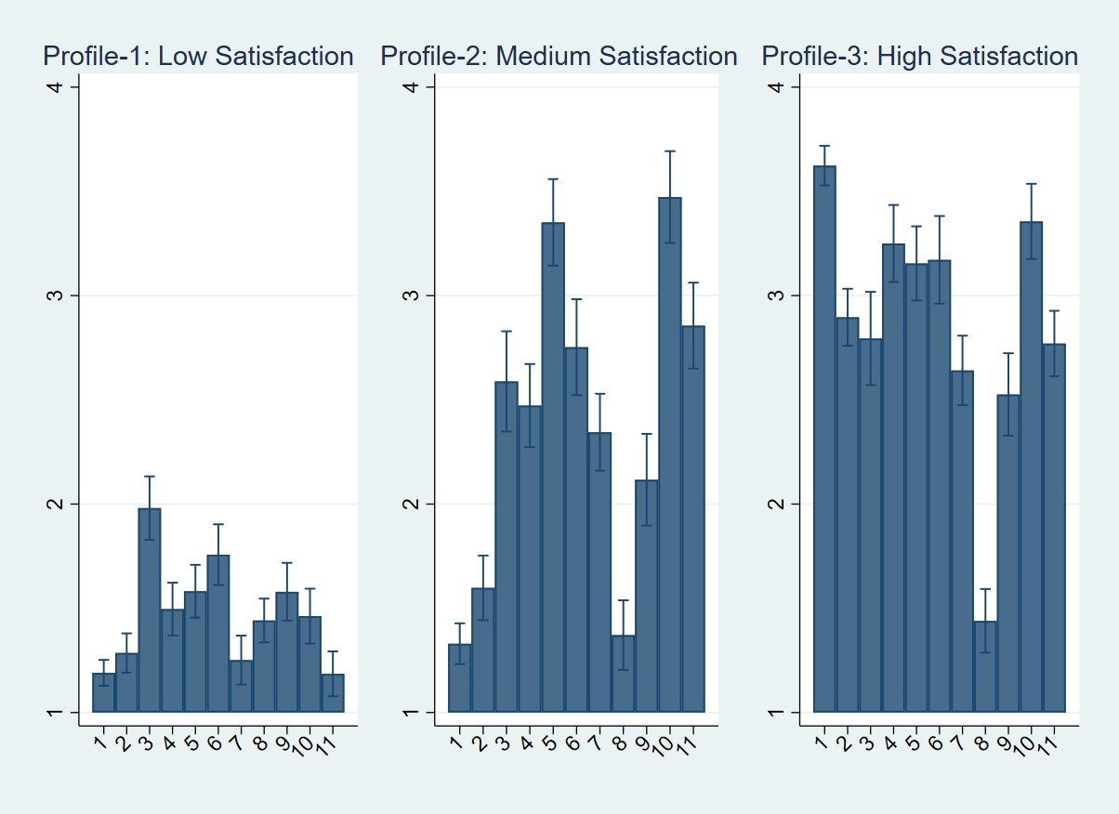 |  | Figure A2. Latent Profiles for Satisfaction (Bulgaria)  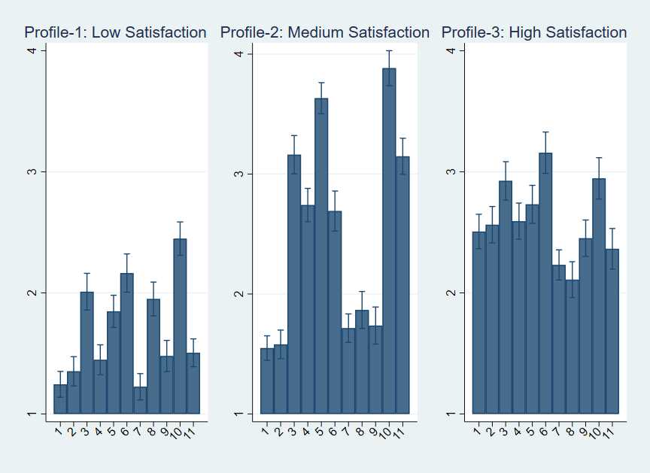
Figure A3. Latent Profiles for Satisfaction (Georgia)  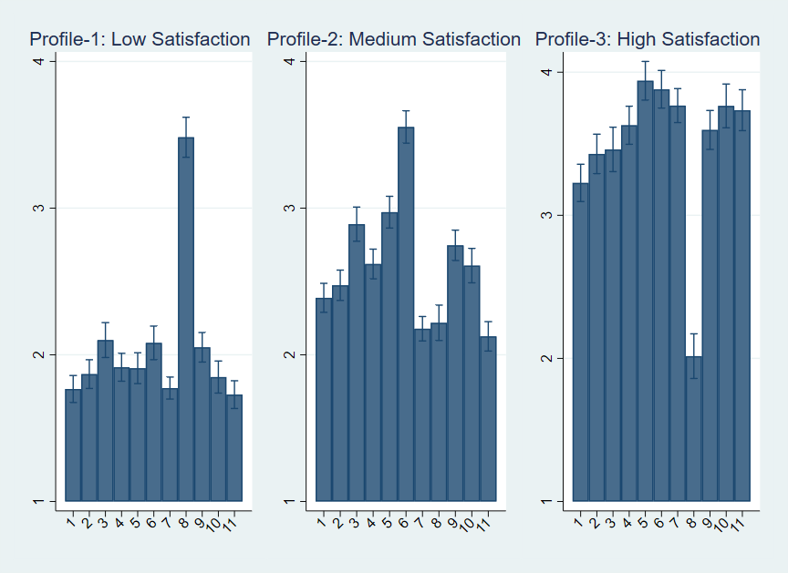 | Figure A4. Latent Profiles for Satisfaction (Kyrgyzstan)  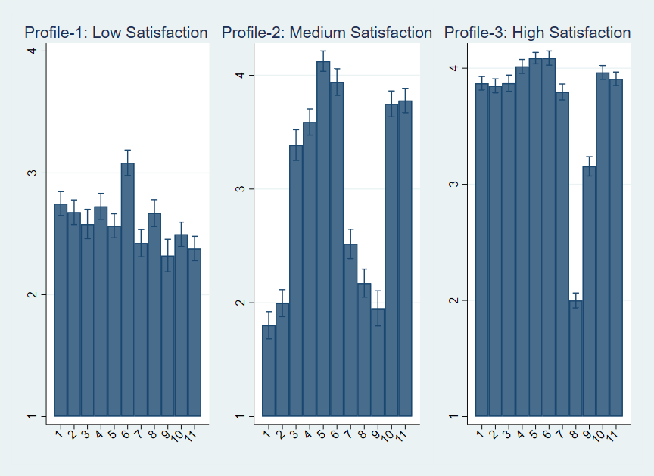
Figure A5. Latent Profiles for Satisfaction (Moldova)  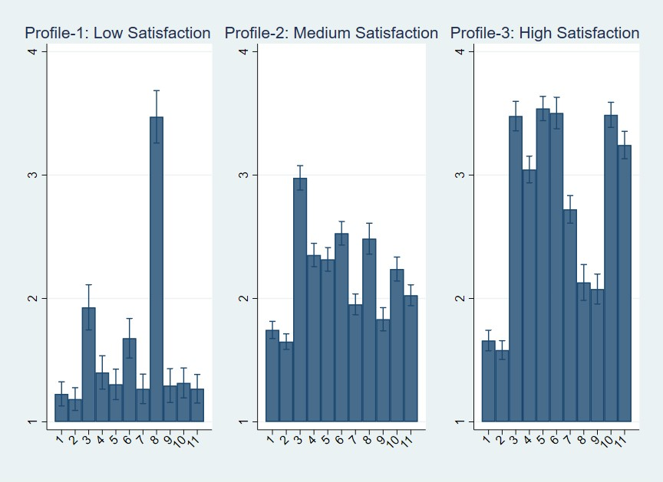 | Figure A6. Latent Profiles for Satisfaction (Mongolia)

Figure A7. Latent Profiles for Satisfaction (Estonia)  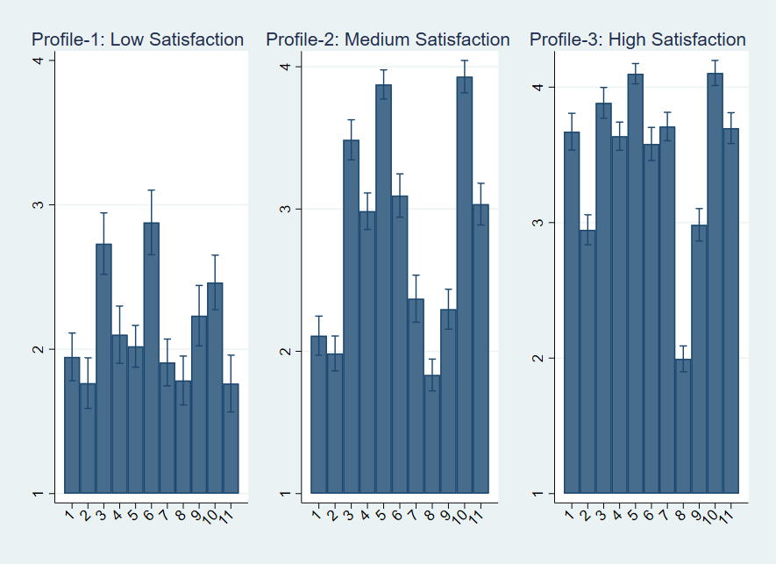 | Figure A8. Latent Profiles for Satisfaction (Tajikistan)  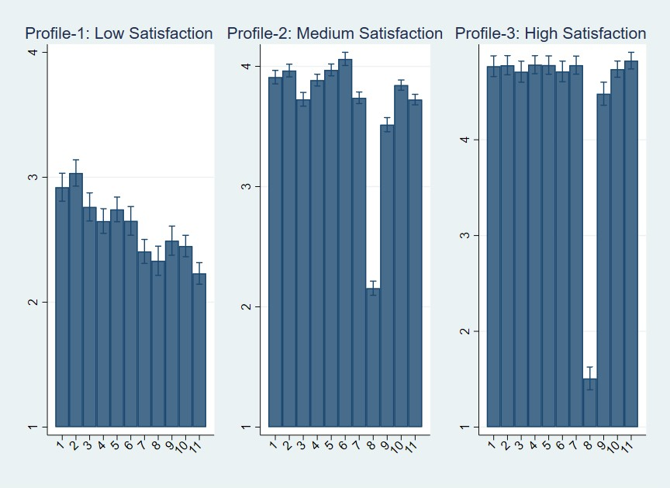
Figure A9. Latent Profiles for Satisfaction (Ukraine)  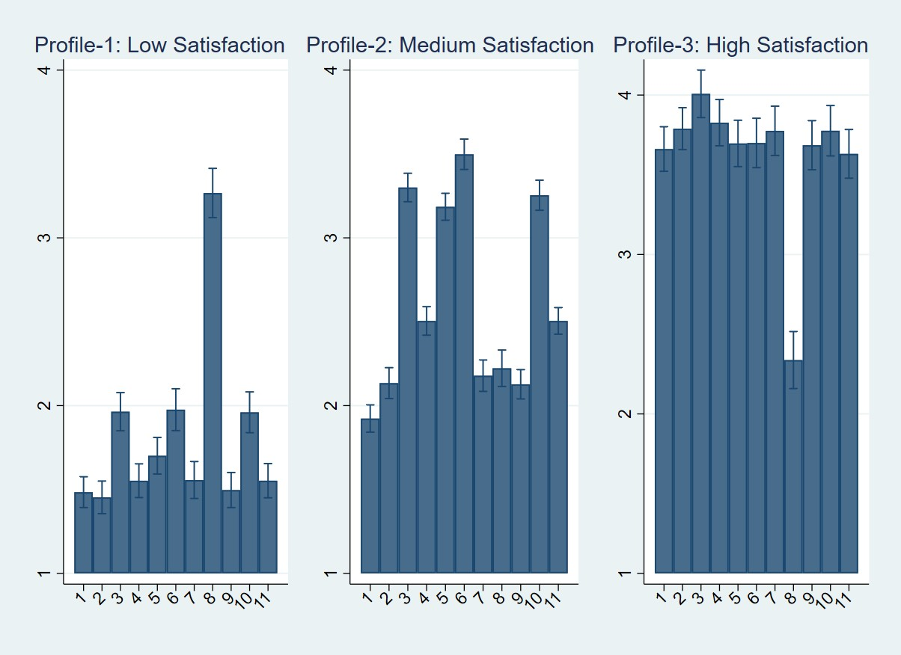 |  | Figure A10. Latent Profiles for Satisfaction (Kazakhstan)  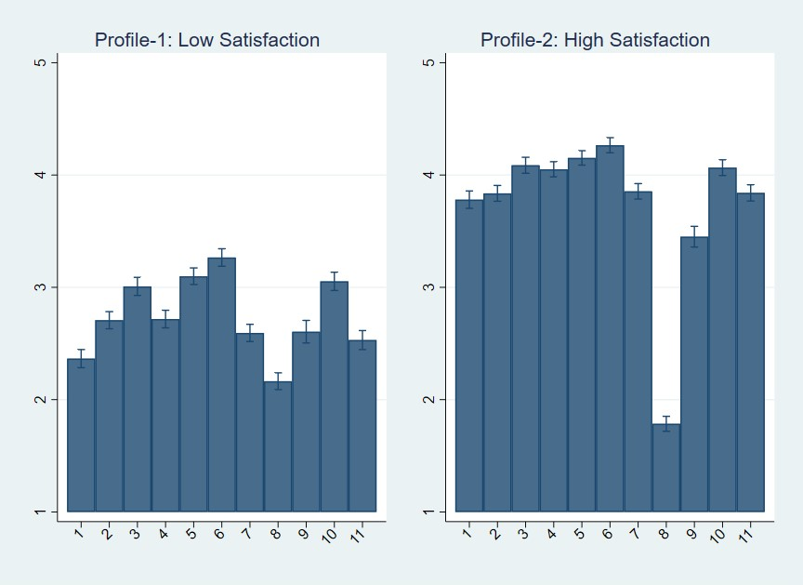
Figure A11. Latent Profiles for Satisfaction (Azerbaijan) 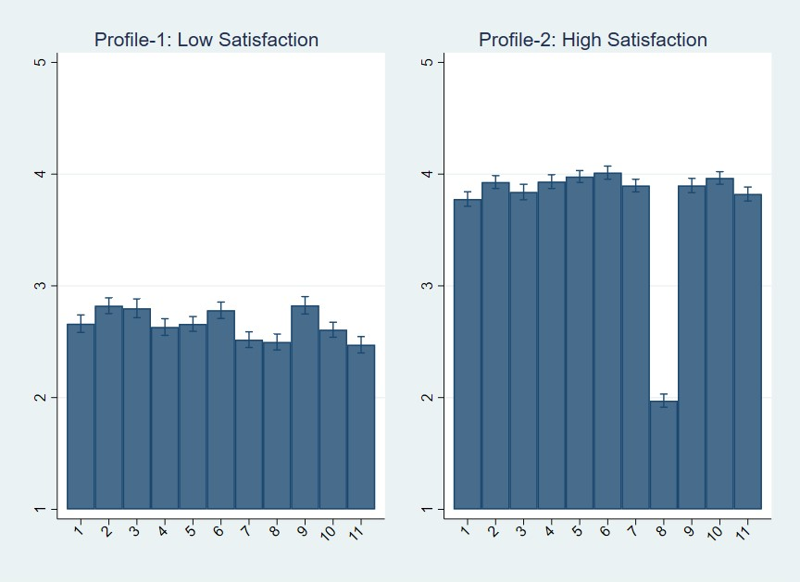 |  | Figure A12. Latent Profiles for Satisfaction (Lithuania)  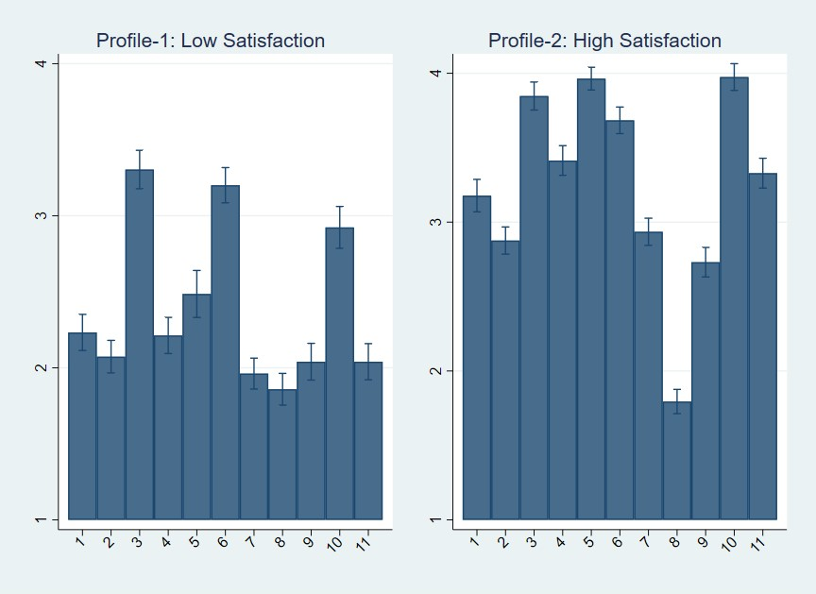

Figure A13. Latent Profiles for Satisfaction (Armenia)  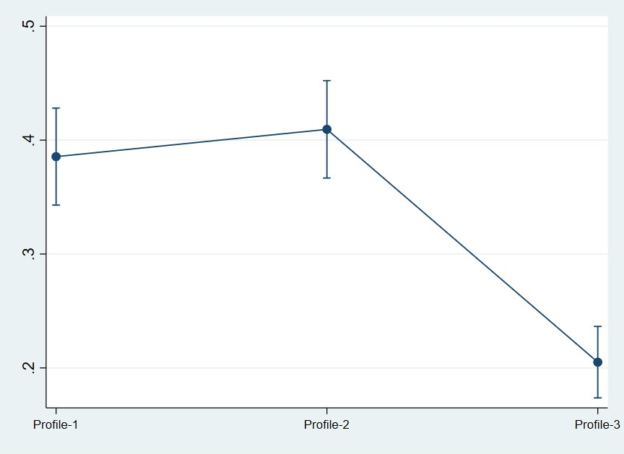 | Figure A14. Latent Profiles for Satisfaction (Bulgaria)  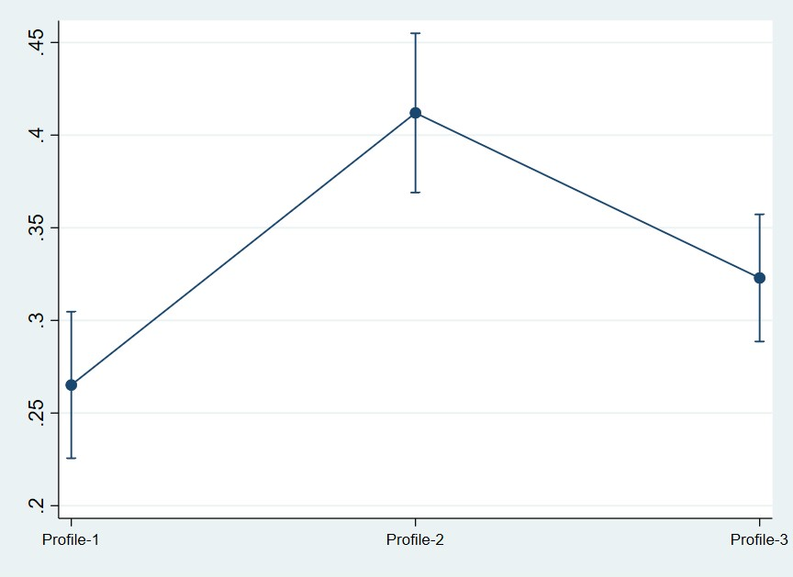

Figure A15. Latent Profiles for Satisfaction (Georgia) | Figure A16. Latent Profiles for Satisfaction (Kyrgyzstan)  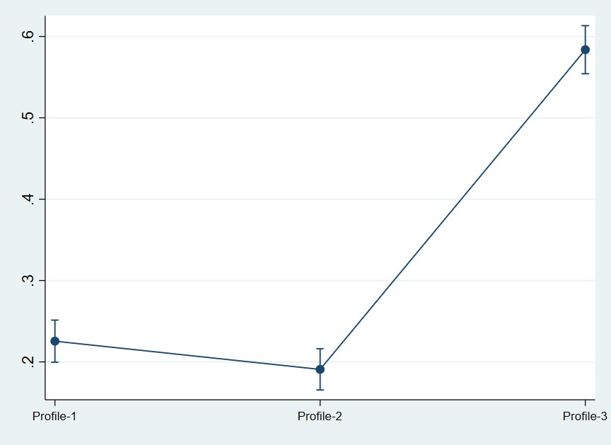

Figure A17. Latent Profiles for Satisfaction (Moldova)  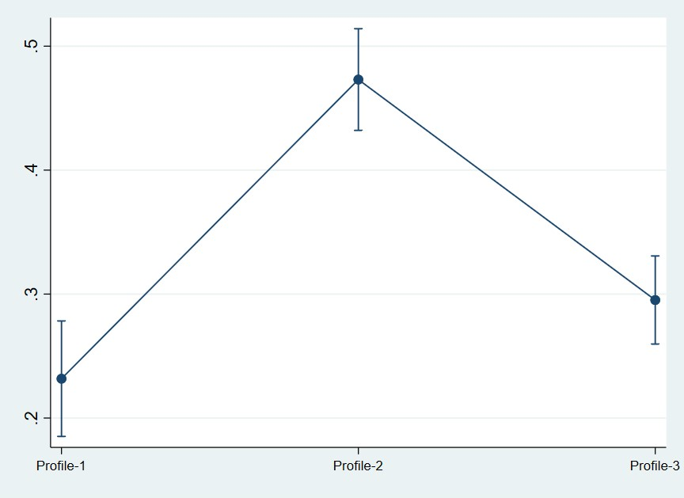 | Figure A18. Latent Profiles for Satisfaction (Mongolia)  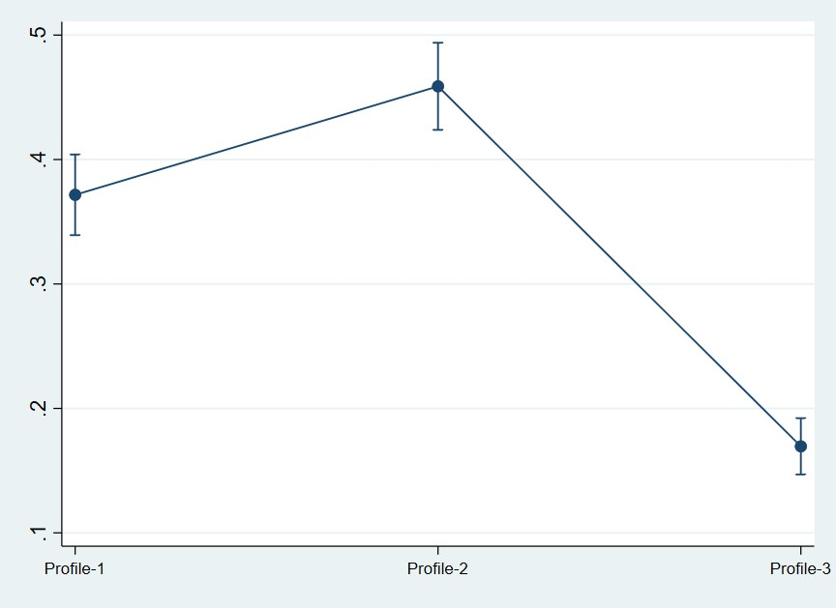

Figure A19. Latent Profiles for Satisfaction (Estonia)  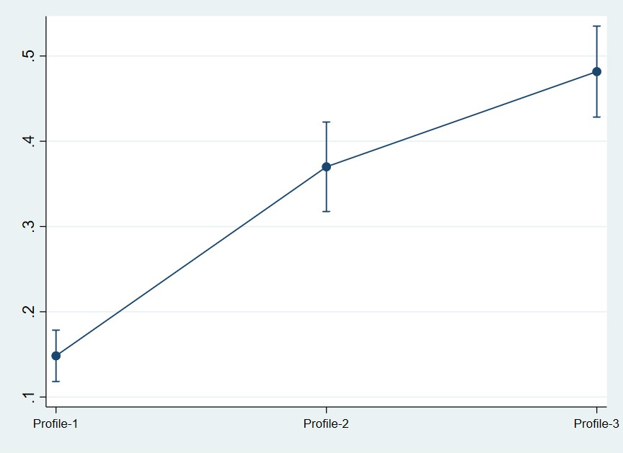 | Figure A20. Latent Profiles for Satisfaction (Tajikistan)  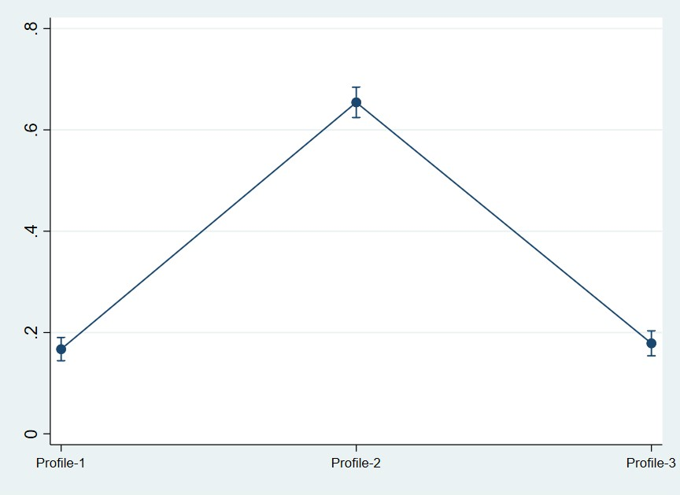
Figure A21. Latent Profiles for Satisfaction (Ukraine) 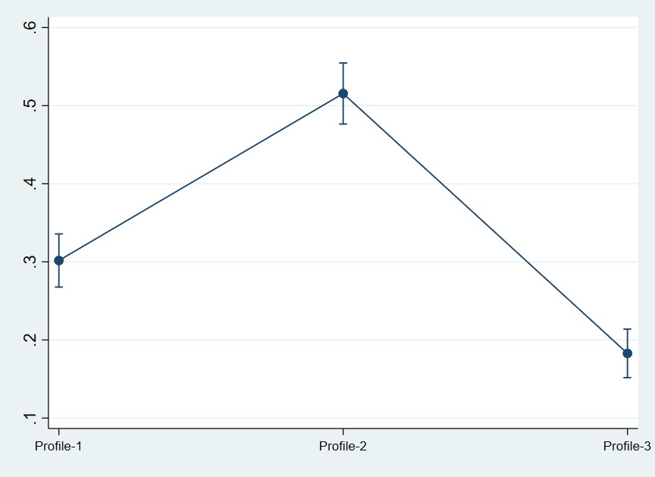 |  | Figure A22. Latent Profiles for Satisfaction (Kazakhstan)  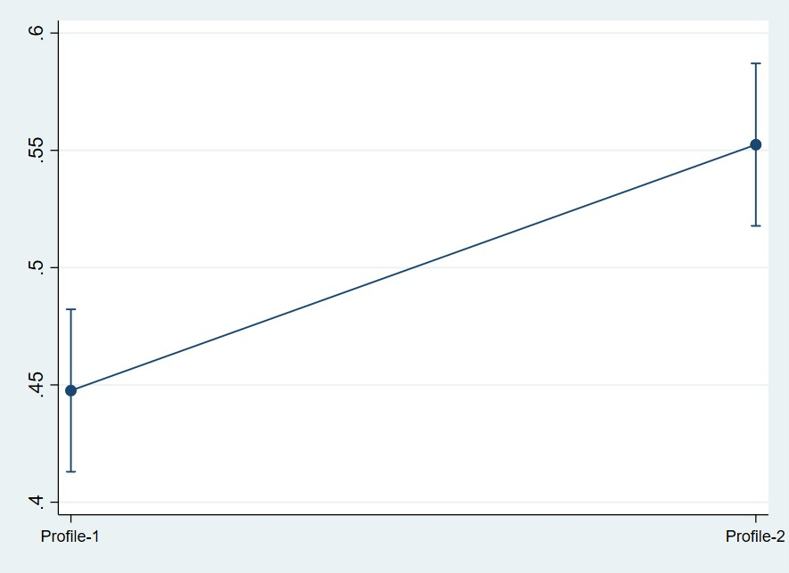
Figure 23. Latent Profiles for Satisfaction (Azerbaijan)  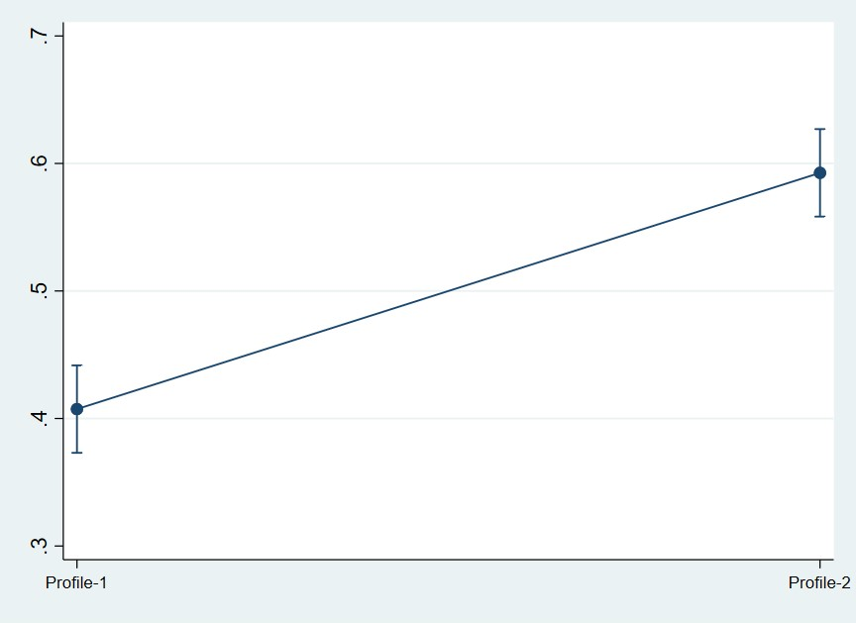 |  | Figure 24. Latent Profiles for Satisfaction (Lithuania)  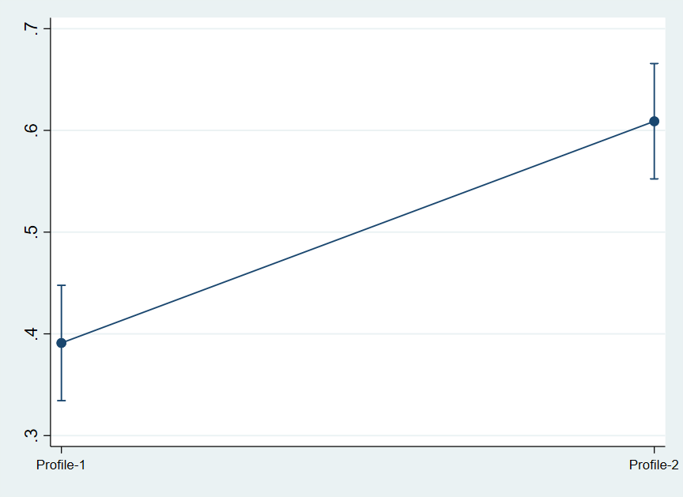

Table A11.First and Second Stage Regression Analysis (2SLS)
 | Armenia |  | Bulgaria |  | Estonia |  | Georgia
 | First Stage | Second Stage | First Stage | Second Stage | First Stage | Second Stage | First Stage | Second Stage
 | Trust | Life Satisfaction | Trust | Life Satisfaction | Trust | Life Satisfaction | Trust | Life Satisfaction
Direct democracy context | 0.300***  (0.034) |  | 0.179***  (0.020) |  | 0.169***  (0.029) |  | 0.211***  (0.019)
Trust |  | 1.830***  (0.548) |  | 3.496***  (0.491) |  | 3.064***  (0.689) |  | 1.689***  (0.357)
Observation | 416 |  | 653 |  | 586 |  | 586
Cragg-Donald Statistics (F-Stat.) | 76.990 |  | 76.881 |  | 30.936 |  | 116.027
 | Kyrgyzstan |  | Moldovia |  | Mongolia |  | Tajikistan
 | First Stage | Second Stage | First Stage | Second Stage | First Stage | Second Stage | First Stage | Second Stage
 | Trust | Life Satisfaction | Trust | Life Satisfaction | Trust | Life Satisfaction | Trust | Life Satisfaction
Direct democracy context | 0.098***  (0.014) |  | 0.123***  (0.019) |  | 0.125***  (0.022) |  | 0.205***  (0.018)
Trust |  | 3.896***  (0.548) |  | 2.753***  (0.689) |  | 5.641***  (1.027) |  | 3.995***  (0.400)
Observation | 1162 |  |  |  | 974 |  | 558
Cragg-Donald Statistics (F-Stat.) | 47.586 |  | 41.522 |  | 31.378 |  | 128.909
 | Ukraine |  | Azerbaijan |  | Kazakhstan |  | Lithuania
 | First Stage | Second Stage | First Stage | Second Stage | First Stage | Second Stage | First Stage | Second Stage
 | Trust | Life Satisfaction | Trust | Life Satisfaction | Trust | Life Satisfaction | Trust | Life Satisfaction
Direct democracy context | 0.189***  (0.024) |  | 0.131***  (0.016) |  | 0.172***  (0.011) |  | 0.091***  (0.026)
Trust |  | 3.613***  (0.580) |  | 3.187***  (0.482) |  | 3.219***  (0.440) |  | 4.457***  (1.373)
Observation | 841 |  | 677 |  | 864 |  | 458
Cragg-Donald Statistics (F-Stat.) | 57.695 |  | 61.287 |  | 38.451 |  | 11.715
Note: Standard errors in parentheses. Regional dummies are included. ***p < 0.01.**p < 0.05.*p < 0.1.

Table A12.The Relationship between Latent Profiles (Institutional Trust) and Life Satisfaction (a three-class model)
 | Armenia |  | Bulgaria |  | Estonia |  | Georgia
 | Medium Satisfaction | High Satisfaction | Medium Satisfaction | High Satisfaction | Medium Satisfaction | High Satisfaction | Medium Satisfaction | High Satisfaction
Trust | 2.321***  (0.810) |  | 3.430***  (0.860) |  | 1.380  (1.109) |  | 2.330***  (0.420)
Trust |  | 3.400***  (0.750) |  | 10.082***  (1.005) |  | 6.550***  (1.144) |  | 5.860***  (0.760)
Age | -0.001  (0.010) | -0.013  (0.009) | -0.002  (0.010) | 0.003  (0.013) | 0.150  (0.015) | -0.002  (0.016) | 0.003  (0.007) | 0.015  (0.010)
Female | 0.608*  (0.345) | 0.123  (0.340) | -0.112  (0.326) | -0.012  (0.408) | -0.143  (0.406) | -0.664  (0.429) | -0.648**  (0.254) | -0.846**  (0.332)
Married | 0.851**  (0.363) | -0.175  (0.345) | -0.083  (0.285) | -0.163  (0.355) | -0.175  (0.415) | 0.192  (0.431) | -0.342  (0.252) | 0.057  (0.323)
Higher education | -0.184  (0.322) | -0.105  (0.311) | 0.024  (0.282) | 0.865**  (0.356) | 0.507  (0.407) | 0.558  (0.420) | 0.074  (0.231) | -0.068  (0.296)
Good health | 1.597***  (0.326) | 0.943***  (0.326) | 0.408  (0.289) | 1.094***  (0.382) | 1.263***  (0.463) | 2.186***  (0.477) | 0.197  (0.252) | 0.669**  (0.307)
Ever employed | -0.468  (0.652) | 0.196  (0.598) | -0.564  (0.339) | -0.098  (0.679) | 0.862  (1.433) | 0.588  (1.279) | -0.289  (0.284) | -0.034  (0.382)
Worked last 12 months | 0.997**  (0.409) | 0.328  (0.362) | 0.342  (0.371) | -0.186  (0.462) | 0.353  (0.580) | -0.551  (0.600) | 0.555**  (0.269) | 0.567  (0.346)
Second job | 0.121  (0.628) | -0.370  (0.653) | 0.001  (0.610) | -0.720  (0.937) | 0.469  (0.635) | -0.062  (0.682) | 0.534  (0.894) | 1.373  (0.949)
Entrepreneurship | -0.749*  (0.430) | -0.578  (0.425) | 0.353  (0.410) | -0.468  (0.540) | -0.522  (0.559) | 0.218  (0.580) | 0.793**  (0.384) | 0.589  (0.479)
Gender decision making | -0.240  (0.463) | 0.116  (0.451) | 0.411  (0.762) | 0.122  (0.231) | 0.110  (0.241) | 0.442  (0.210) | 0.113  (0.282) | -0.042  (0.361)
People trust | -0.125  (0.582) | 0.823**  (0.209) | 0.331  (0.452) | 0.011  (0.410) | 0.310  (0.550) | 0.011  (0.410) | 0.564**  (0.256) | 0.272  (0.315)
Government performance trust | -0.125  (0.590) | 0.288  (0.510) | 0.411  (0.511) | 0.227  (0.411) | 0.333  (0.122) | 0.221  (0.131) | 0.841**  (0.374) | 1.233***  (0.415)
Saving | 0.340  (0.314) | 0.267  (0.305) | -0.033  (0.353) | -0.525  (0.444) | 16.173  (1045.669) | 18.418  (588.415) | 0.299  (0.242) | 0.572*  (0.309)
Assets | 0.417***  (0.150) | 0.498***  (0.141) | 0.330***  (0.117) | 0.412***  (0.149) | 0.336  (0.217) | 0.093  (0.223) | 0.200**  (0.077) | 0.293***  (0.101)
Land | 0.590  (0.391) | 0.334  (0.376) | 0.599*  (0.311) | 0.670*  (0.384) | -0.234  (0.391) | -0.099  (0.404) | -0.376  (0.258) | -0.347  (0.331)
Detached house | -0.972**  (0.431) | -0.544  (0.400) | 0.111  (0.339) | 0.114  (0.339) | -0.032  (0.565) | -0.214  (0.587) | -0.156  (0.283) | -0.001  (0.370)
Rural | -0.567  (0.504) | -0.053  (0.448) | -1.206***  (0.444) | -1.775***  (0.555) | -0.436  (0.480) | -0.664  (0.429) | -0.008  (0.264) | -0.001  (0.347)
R-squared | 0.164 |  | 0.320 |  | 0.191 |  | 0.191
Observation | 416 |  | 653 |  | 586 |  | 586
Note: Base profile: Low Satisfaction. Standard errors in parentheses. Regional dummies are included. ***p < 0.01.**p < 0.05.*p < 0.1.

Table A13. The Relationship between Latent Profiles (Institutional Trust) and Life Satisfaction (a three-class model)
 | Kyrgyzstan |  | Moldova |  | Mongolia |  | Tajikistan
 | Medium Satisfaction | High Satisfaction | Medium Satisfaction | High Satisfaction | Medium Satisfaction | High Satisfaction | Medium Satisfaction | High Satisfaction
Trust | 0.022  (0.605) |  | 3.300***  (0.720) |  | 2.400***  (0.530) |  | 7.500***  (0.770)
Trust |  | 2.305***  (0.410) |  | 6.550***  (0.870) |  | 6.101***  (0735) |  | 11.440***  (1.100)
Age | 0.015**  (0.007) | 0.010*  (0.006) | 0.005  (0.007) | 6.810***  (0.874) | 0.007  (0.008) | 0.012  (0.010) | -0.001  (0.008) | 0.004  (0.011)
Female | 0.109  (0.266) | 0.176  (0.228) | -0.186  (0.219) | 0.006  (0.008) | -0.363  (0.334) | -0.942**  (0.477) | -0.542*  (0.310) | -0.310  (0.407)
Married | -0.039  (0.251) | 0.072  (0.216) | 0.043  (0.227) | 0.075  (0.256) | -0.071  (0.297) | 0.100  (0.397) | -0.445  (0.316) | -0.499  (0.385)
Higher education | 0.052  (0.219) | 0.020  (0.181) | 0.342  (0.219) | 0.172  (0.266) | 0.139  (0.234) | -0.653**  (0.332) | 0.470*  (0.282) | 0.256  (0.346)
Good health | 0.597***  (0.215) | 0.894***  (0.179) | 0.621**  (0.251) | 0.671***  (0.251) | 0.620***  (0.225) | 0.921***  (0.292) | 0.381  (0.237) | 0.602*  (0.308)
Ever employed | -0.057  (0.287) | -0.165  (0.240) | -0.627**  (0.251) | 1.071***  (0.279) | -0.676*  (0.391) | -0.383  (0.502) | -0.219  (0.344) | 0.066  (0.427)
Worked last 12 months | 0.028  (0.289) | -0.038  (0.244) | 0.566**  (0.245) | -0.881***  (0.304) | 0.983**  (0.389) | 0.492  (0.509) | 0.178  (0.367) | -0.007  (0.451)
Second job | -0.173  (0.657) | -0.124  (0.564) | -0.048  (0.573) | 0.858***  (0.295) | -1.102  (0.757) | -0.077  (0.879) | -1.468  (0.971) | -0.133  (0.102)
Entrepreneurship | -0.052  (0.321) | -0.176  (0.268) | 0.253  (0.415) | 0.115  (0.638) | -0.007  (0.265) | 0.210  (0.352) | 0.038  (0.375) | -0.445  (0.529)
Gender decision making | 0.418  (0.273) | 0.344  (0.230) | -0.311  (0.120) | 0.311  (0.391) | 0.231  (0.306) | 0.505  (0.415) | -0.327***  (0.099) | 0.085  (0.123)
People trust | 0.438*  (0.253) | 0.726***  (0.209) | 0.662**  (0.300) | 0.310*  (0.250) | 0.407*  (0.231) | 0.557**  (0.209) | 0.030  (0.055) | 0.089  (0.105)
Government performance trust | 0.296  (0.264) | 0.659***  (0.218) | 0.135  (0.522) | 0.513  (0.611) | 0.960  (0.597) | 1.825***  (0.669) | -0.221***  (0.066) | -0.110**  (0.093)
Saving | 0.170  (0.296) | 0.076  (0.247) | -0.037  (0.327) | -0.088  (0.079) | 0.212  (0.326) | 0.028  (0.389) | 0.019  (0.394) | 0.650  (0.478)
Assets | 0.464***  (0.081) | 0.464***  (0.068) | 0.170**  (0.075) | 0.547  (0.355) | 0.522***  (0.091) | 0.303**  (0.119) | 0.066  (0.102) | 0.165  (0.125)
Land | -0.189  (0.248) | 0.015  (0.205) | 0.027  (0.243) | 0.212**  (0.088) | 0.354  (0.246) | -0.258  (0.340) | 0.148  (0.272) | 0.253  (0.342)
Detached house | -0.135  (0.355) | -0.053  (0.287) | -0.390  (0.318) | 0.323  (0.277) | -0.293  (0.281) | -0.577  (0.390) | -0.118  (0.588) | 0.321  (0.713)
Rural | -1.399***  (0.380) | -0.152  (0.256) | -0.334  (0.306) | -0.606  (0.383) | -0.162  (0.307) | 0.005  (0.387) | -0.502*  (0.304) | 0.246  (0.392)
R-squared | 0.137 |  | 0.199 |  | 0.194 |  | 0.173
Observation | 1162 |  | 1121 |  | 558 |  | 558
Note: Base profile: Low Satisfaction. Standard errors in parentheses. Regional dummies are included. ***p < 0.01.**p < 0.05.*p < 0.1.

Table A14.The Relationship between Latent Profiles (Institutional Trust) and Life Satisfaction (a three-class model)
 | Ukraine
 | Medium Satisfaction | High Satisfaction
Trust | 3.640***  (0.492)
Trust |  | 0.811***  (0.870)
Age | 0.014*  (0.008) | -0.013  (0.011)
Female | -0.099  (0.230) | 0.576*  (0.293)
Married | 0.535***  (0.238) | 0.449  (0.302)
Higher education | 0.321  (0.244) | -0.295  (0.316)
Good health | -0.294  (0.237) | -0.232  (0.311)
Ever employed | -0.590  (0.411) | -0.926*  (0.526)
Worked last 12 months | 0.776***  (0.278) | 0.357  (0.378)
Second job | -0.531  (0.689) | -0.567  (1.217)
Entrepreneurship | 0.751  (0.479) | 0.447  (0.668)
Gender decision making | -0.002  (0.080) | 0.001  (0.300)
People trust | 0.331  (0.055) | 0.211  (0.511)
Gender decision making | -0.011  (0.330) | 0.208  (0.442)
People trust | 0.230  (0.540) | 0.214  (0.431)
Government performance trust | 0.442  (0.750) | 0.216  (0.519)
Saving | -0.138  (0.244) | -0.182  (0.311)
Assets | 0.200  (0.094) | 0.101  (0.123)
Land | -0.743  (0.262) | -0.861**  (0.351)
Detached house | 0.131  (0.292) | -0.333  (0.374)
Rural | -0.365  (0.282) | -1.117***  (0.361)
R-squared | 0.287
Observation | 841
Note: Base profile: Low Satisfaction. Standard errors in parentheses. Regional dummies are included. ***p < 0.01.**p < 0.05.*p < 0.1.

Table A15. The Relationship between Latent Profiles (Institutional Trust) and Life Satisfaction (a two-class model)
 | Azerbaijan | Kazakhstan | Lithuania
 | High Satisfaction | High Satisfaction | High Satisfaction
Trust | 4.022***  (0.570) | 4.300***  (0.550) | 1.662***  (0.418)
Age | 0.001  (0.007) | 0.002  (0.006) | -0.001  (0.008)
Female | -1.050***  (0.375) | 0.040  (0.211) | -0.562**  (0.236)
Married | -0.616*  (0.329) | 0.436**  (0.216) | -0.036  (0.246)
Higher education | -0.099  (0.198) | -0.180  (0.185) | 0.191  (0.252)
Good health | 0.679***  (0.194) | 0.976***  (0.179) | 1.120***  (0.250)
Ever employed | 1.359***  (0.398) | -0.497  (0.316) | -0.631  (0.548)
Worked last 12 months | -1.269***  (0.380) | 0.398  (0.284) | 0.716*  (0.378)
Second job | 1.152  (1.649) | -0.515  (0.463) | 0.203  (0.428)
Entrepreneurship | 0.389  (0.587) | 0.192  (0.309) | -0.290  (0.349)
Gender decision making | -0.023  (0.139) | 0.314*  (0.190) | 0.215  (0.334)
People trust | 0.281**  (0.034) | 0.553*  (0.116) | 0.411  (0.912)
Government performance trust | 0.319  (0.519) | 0.561  (0.453) | 0.115  (0.412)
Saving | 1.206**  (0.600) | 0.373**  (0.182) | 0.269  (0.669)
Assets | 0.303***  (0.080) | 0.084  (0.073) | -0.014  (0.120)
Land | -0.190  (0.338) | -0.023  (0.191) | 0.405  (0.255)
Detached house | -0.499  (0.346) | 0.327  (0.254) | 0.636*  (0.359)
Rural | -0.250  (0.255) | 0.181  (0.234) | 0.536  (0.357)
R-squared | 0.187 | 0.237 | 0.156
Observation | 677 | 864 | 458
Note: Base profile: Low Satisfaction. Standard errors in parentheses. Regional dummies are included. ***p < 0.01.**p < 0.05.*p < 0.1.

There are 10 regional dummy variables.
There are 7 regional dummy variables.
There are 27 regional dummy variables.
There are 10 regional dummy variables.
There are 4 regional dummy variables.
There are 15 regional dummy variables.
There are 8 regional dummy variables.
There are 9 regional dummy variables.
There are 33 regional dummy variables.
There are 33 regional dummy variables.
There are 5 regional dummy variables.
There are 19 regional dummy variables.

