Online Appendix
Table A-1: Descriptive information on variables (only ALLBUS 2016)
 | Mean | Std. dev. | Min | Max | N
Dislike of foreigners | 2.41 | 1.43 | 1 | 7 | 3,157
Attachment to Land | 2.93 | 0.76 | 1 | 4 | 3,426
Attachment to former part of country | 2.68 | 0.91 | 1 | 4 | 3,248
Authoritarianism | 2.58 | 1.32 | 1 | 7 | 3,181
Left/right self-placement | 5.14 | 1.68 | 1 | 10 | 3,298
Contacts with foreigners | 1.90 | 1.29 | 0 | 4 | 2,992
Evaluation of economic situation in Germany | 3.65 | 0.75 | 1 | 5 | 3,440
Education (medium) | 0.32 | 0.47 | 0 | 1 | 3,449
Education (high) | 0.40 | 0.49 | 0 | 1 | 3,449
Age | 50.79 | 17.43 | 18 | 97 | 3,444

Table A-2: Identification with the Land in eastern and western Germany over time
 | Year | Mean | Standard dev. | N
East | 1991 | 2.83 | 0.86 | 1512
 | 2000 | 2.95 | 0.80 | 761
 | 2008 | 2.97 | 0.79 | 1074
 | 2016 | 3.04 | 0.73 | 1163
West | 1991 | 2.82 | 0.81 | 1498
 | 2000 | 2.84 | 0.79 | 1411
 | 2008 | 2.92 | 0.80 | 2361
 | 2016 | 2.90 | 0.77 | 2307

Table A-3: Identification with the Land in eastern Germany by cohorts

 |  | 1991 | 2000 | 2008 | 2016
-1949 | Mean | 2.86 | 3.03 | 3.07 | 3.15
 | Stand. dev. | 0.87 | 0.81 | 0.78 | 0.70
 | N | 821 | 334 | 414 | 314
1950-1975 | Mean | 2.80 | 2.90 | 2.97 | 3.09
 | Stand. dev. | 0.84 | 0.80 | 0.76 | 0.71
 | N | 691 | 347 | 470 | 534
1975- | Mean | - | 2,80 | 2.75 | 2.85
 | Stand. dev. | - | 0.77 | 0.86 | 0.77
 | N | - | 80 | 190 | 315

Table A-4: Identification with the former part of the country in eastern and western Germany over time
 | Year | Mean | Standard dev. | N
East | 1991 | 2.29 | 0.99 | 1494
 | 2000 | 2.82 | 0.85 | 730
 | 2008 | 2.73 | 0.93 | 1056
 | 2016 | 2.71 | 0.92 | 1141
West | 1991 | 2.85 | 0.79 | 1485
 | 2000 | 2.83 | 0.81 | 1352
 | 2008 | 2.76 | 0.87 | 2217
 | 2016 | 2.66 | 0.91 | 2163

Table A-5: Predictors of dislike of foreigners including identification with Land (linear regression), 2016

 | East | West
Attachment to Land | 0.460*  (0.191) | -0.030  (0.105)
Authoritarianism | 0.745***  (0.209) | 1.111***  (0.124)
Left/right self-placement | 1.485***  (0.237) | 1.115***  (0.146)
Contacts with foreigners | -1.151***  (0.191) | -0.655***  (0.092)
Evaluation of economic situation in Germany | -1.759***  (0.251) | -1.051***  (0.149)
Education (medium) | -0.610***  (0.132) | -0.334***  (0.071)
Education (high) | -1.094***  (0.150) | -0.782***  (0.073)
Age | 0.375  (0.315) | 0.442*  (0.175)
Constant | 3.646***  (0.321) | 2.724***  (0.175)
N | 1018 | 1843
adj. R² | 0.27 | 0.26

Standard errors in parentheses
* p < 0.05, ** p < 0.01, *** p < 0.001

Table A-6: Predictors of dislike of foreigners including identification with former part of the country (linear regression), 2016

 | East | West
Attachment to former part of the country | 0.493**  (0.162) | 0.008  (0.096)
Authoritarianism | 0.698***  (0.210) | 1.133***  (0.128)
Left/right self-placement | 1.556***  (0.238) | 1.095***  (0.151)
Contacts with foreigners | -1.142***  (0.192) | -0.648***  (0.095)
Evaluation of economic situation in Germany | -1.659***  (0.253) | -1.095***  (0.153)
Education (medium) | -0.641***  (0.132) | -0.326***  (0.073)
Education (high) | -1.091***  (0.151) | -0.764***  (0.075)
Age | 0.176  (0.328) | 0.466*  (0.194)
Constant | 3.716***  (0.317) | 2.704***  (0.177)
N | 1006 | 1744
adj. R² | 0.27 | 0.26
Standard errors in parentheses
* p < 0.05, ** p < 0.01, *** p < 0.001

Figure A-1: Visualization of the interactive effect of attachment to Land and East Germany on rejection of foreigners, 2016

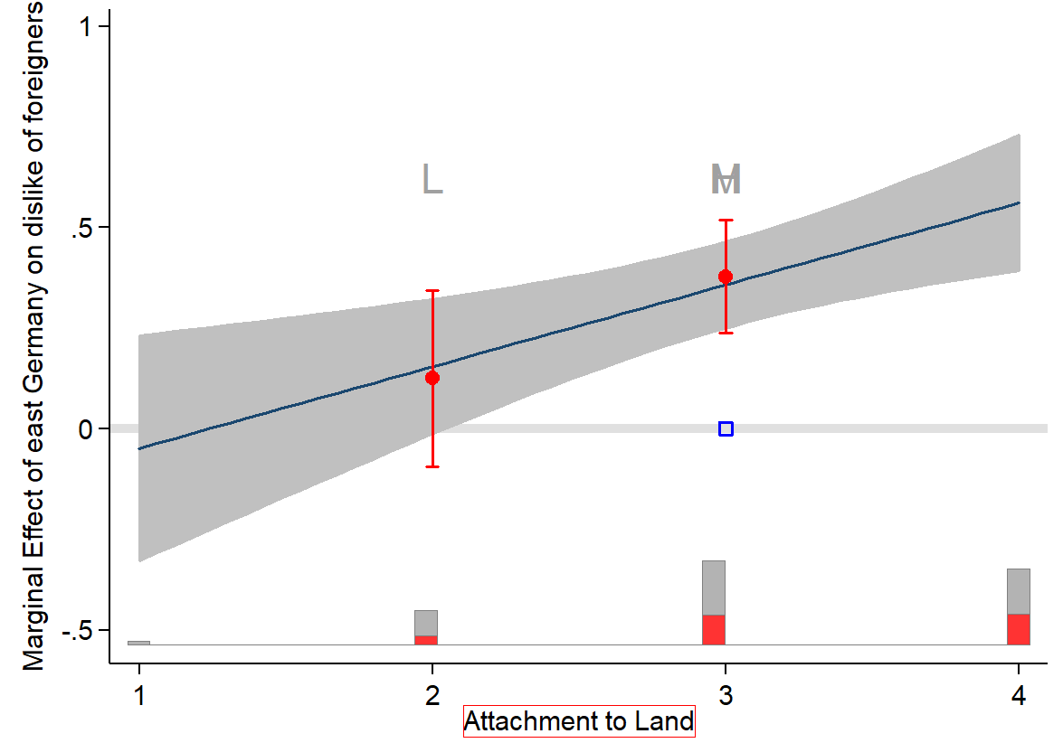
Note: Due to the limited variance of the variable Attachment to Land (only about 3% of the respondents do not feel attached to their Land at all) no more than two bins can be calculated in Figure A-1. L=Low, M=Medium, H=High. As only two bins could be calculated, M and H are at the same place.

Figure A-2: Visualization of the interactive effect of attachment to former part of country and East Germany on rejection of foreigners, 2016

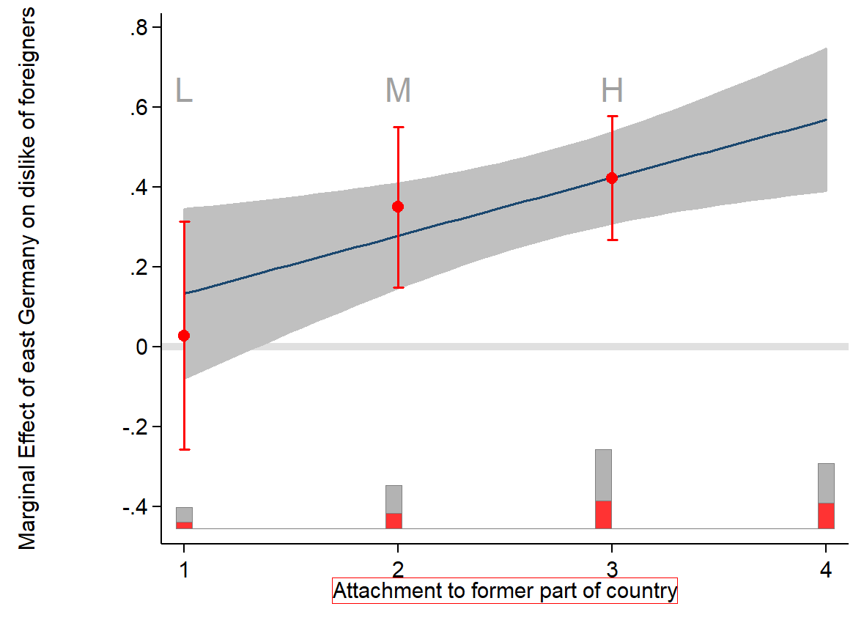
Note: L=Low, M=Medium, H=High.

