Online Appendices
Appendix A – The survey and sampling strategy
The aim of the survey was to interview a sample of roughly 600 respondents that are representative of the general population in each of the eight metropolitan areas. Due to administrative circumstances, we had to rely on two different recruitment strategies in the four countries.
In Switzerland, a random sample of 2257 valid individual addresses of the resident population (aged 18 to 75) in the Bern and Zurich metropolitan areas was drawn by the Swiss Statistical Office through its sampling frame based on population registers. Data was collected by the Swiss Survey Institute MIS Trend. Invitation letters to fill in an online questionnaire were sent to all these individuals, together with an unconditional incentive of 10 Swiss Francs (~10.12 US$). A first reminder was sent two weeks after the initial letter, a second reminder was sent after one month to those individuals who had not replied by then. The second reminder included a paper version of the questionnaire and a prepaid return envelope. Individual identifiers were used for each potential respondent in order to exclude multiple responses to the survey. All in all, 1166 respondents filled in the questionnaire (559 in the Bern metropolitan area, 607 in the Zurich metropolitan area), either online (n=936) or on paper (n=226). The response rate (calculated on the valid addresses) is 52 percent. The field phase of the survey in Switzerland lasted from mid-September 2015 to early January 2016.
In the remaining three countries, respondents were recruited from online-access panels and a quota-sampling strategy was applied to mirror the distribution of core features of the basic population (i.e. residence in the center city or the surrounding area, gender, age, employment status and education level). In these three countries, the survey was fielded by the international survey institute TNS Infratest. The field phase lasted from beginning of October to end of November. In this period between 606 and 667 complete interviews were conducted in each metropolitan area. Respondents were incentivized through coupons by the panel providers. Due to the quota sampling procedure used in Germany, France and the UK, response rates for these countries are not available, as the sample composition (i.e. the contacted people) changed in the course of the field phase to meet the quotas.
Table A.1 presents an overview of the composition of the eight metropolitan samples and their representativeness of the respective metropolitan population before and after weighting based on the aforementioned indicators. The biggest differences between the samples and the target populations are present for education level. Highly educated individuals are over- and less educated individuals under-represented in all eight metropolitan samples. While this non-response pattern constitutes a problem, it is a common issue in population-based surveys that can be counteracted to a certain extent through weighting procedures. The weights are calculated based on the indicators shown in Table A.1 with the -ipfweight- package in Stata. The largest weights are constrained to not exceed 5 and the lowest weights are constrained to be greater or equal to 0.2.

Table A.1 Sample-population comparison for selected indicators
 | Bern |  |  |  |  |  | Zurich |  |  |  |  |  | Berlin |  |  |  |  |  | Stuttgart
 | U | W | P | Δ1 | Δ2 |  | U | W | P | Δ1 | Δ2 |  | U | W | P | Δ1 | Δ2 |  | U | W | P | Δ1 | Δ2
Female | 47.5 | 51 | 51 | 3.5 | 0.1 |  | 43.9 | 49.8 | 49.8 | 5.9 | 0 |  | 48.9 | 49.9 | 49.9 | 1 | 0 |  | 48.3 | 49.9 | 49.9 | 1.6 | 0
Age Cohorts
<25 | 7.9 | 10.1 | 10.1 | 2.2 | 0 |  | 7.5 | 10 | 9.7 | 2.2 | −0.3 |  | 7.6 | 9.8 | 9.8 | 2.2 | 0 |  | 9.8 | 10.6 | 10.6 | 0.8 | 0
25-34 | 16.1 | 19 | 19 | 2.9 | 0 |  | 16.2 | 20.2 | 20.6 | 4.4 | 0.4 |  | 23.2 | 18.6 | 18.7 | −4.5 | 0.1 |  | 19.8 | 17 | 17 | −2.8 | 0
35-44 | 21.8 | 19.3 | 19.3 | −2.5 | 0 |  | 19.5 | 21.2 | 21.6 | 2.1 | 0.4 |  | 20.7 | 17.9 | 17.9 | −2.8 | 0 |  | 21.4 | 19.5 | 19.5 | −1.9 | 0
45-54 | 19.4 | 20.2 | 20.2 | 0.8 | −0.1 |  | 26 | 19.6 | 20.2 | −5.9 | 0.5 |  | 19.3 | 21.7 | 21.7 | 2.4 | 0 |  | 20.2 | 21.6 | 21.5 | 1.3 | −0.1
55-64 | 19.4 | 17 | 17 | −2.4 | 0 |  | 15.5 | 14.8 | 15.1 | −0.4 | 0.3 |  | 19.7 | 16.1 | 16.1 | −3.6 | 0 |  | 18.6 | 15.7 | 15.7 | −2.9 | 0
>65 | 15.1 | 14.4 | 14.4 | −0.7 | 0 |  | 15 | 14.2 | 12.8 | −2.2 | −1.4 |  | 9.4 | 15.9 | 15.9 | 6.5 | 0 |  | 10 | 15.6 | 15.6 | 5.6 | 0
Education
Low | 7.4 | 13.3 | 13.5 | 6.1 | 0.2 |  | 7.3 | 15.1 | 15 | 7.7 | −0.1 |  | 10.5 | 12.8 | 12.8 | 2.3 | 0 |  | 14.4 | 15.8 | 15.8 | 1.4 | 0
Medium | 46.5 | 47 | 47.1 | 0.6 | 0.1 |  | 48.4 | 44.6 | 44.1 | −4.3 | −0.5 |  | 55.7 | 52.2 | 52.2 | −3.5 | 0 |  | 50.1 | 51.7 | 51.7 | 1.6 | 0
High | 45.9 | 39.7 | 39.5 | −6.4 | −0.2 |  | 44.2 | 40.3 | 40.9 | −3.3 | 0.6 |  | 33.6 | 35 | 35 | 1.4 | 0 |  | 35.4 | 32.5 | 32.5 | −2.9 | 0
Employed | 74.2 | 72.6 | 72.6 | −1.6 | 0 |  | 79.6 | 73.1 | 72.7 | −6.9 | −0.4 |  | 68.9 | 56 | 56 | −12.9 | 0 |  | 70 | 68 | 68 | −2.0 | 0
Center | 34.1 | 35.4 | 35.9 | 1.8 | 0.5 |  | 29.2 | 30.3 | 31.8 | 2.6 | 1.5 |  | 76 | 68.4 | 69 | −7.0 | 0.6 |  | 25.1 | 23.4 | 23 | −2.1 | −0.4
 | Paris |  |  |  |  |  | Lyon |  |  |  |  |  | London |  |  |  |  |  | Birmingham
 | U | W | P | Δ1 | Δ2 |  | U | W | P | Δ1 | Δ2 |  | U | W | P | Δ1 | Δ2 |  | U | W | P | Δ1 | Δ2
Female | 46.5 | 51.8 | 51.5 | 5 | −0.3 |  | 52.6 | 51.5 | 51.4 | −1.2 | −0.1 |  | 53.9 | 50.6 | 50.6 | −3.3 | 0 |  | 52.6 | 51.6 | 50.7 | −1.9 | −0.9
Age Cohorts
<25 | 7.1 | 13.4 | 13.2 | 6.1 | −0.2 |  | 10.9 | 15.7 | 15.1 | 4.2 | −0.6 |  | 4.9 | 12.7 | 12.6 | 7.7 | −0.1 |  | 5.5 | 12.8 | 13.6 | 8.1 | 0.8
25-34 | 20.7 | 21 | 21.2 | 0.5 | 0.2 |  | 22 | 19.6 | 19.8 | −2.2 | 0.2 |  | 20.4 | 24.3 | 24.2 | 3.8 | −0.1 |  | 18.7 | 18.9 | 18.9 | 0.2 | 0
35-44 | 21.6 | 20.7 | 20.8 | −0.8 | 0.1 |  | 23.2 | 19.6 | 19.8 | −3.4 | 0.2 |  | 21.9 | 21 | 21.1 | −0.8 | 0.1 |  | 23.1 | 19.2 | 19.3 | −3.8 | 0.1
45-54 | 20.8 | 18.8 | 18.9 | −1.9 | 0.1 |  | 20.8 | 18 | 18.2 | −2.6 | 0.2 |  | 20 | 18.4 | 18.3 | −1.7 | −0.1 |  | 20.8 | 18.9 | 19 | −1.8 | 0.1
55-64 | 16.9 | 15.6 | 15.9 | −1.0 | 0.3 |  | 11.7 | 15.6 | 15.7 | 4 | 0.1 |  | 19.4 | 13.3 | 13.3 | −6.1 | 0 |  | 20.3 | 15.4 | 15.5 | −4.8 | 0.1
>65 | 12.8 | 10.5 | 10 | −2.8 | −0.5 |  | 11.2 | 11.4 | 11.4 | 0.2 | 0 |  | 13.2 | 10.4 | 10.4 | −2.8 | 0 |  | 11.4 | 15 | 13.6 | 2.2 | −1.4
Education
Low | 9 | 19.4 | 19.3 | 10.3 | −0.1 |  | 4.2 | 17.5 | 17.5 | 13.3 | 0 |  | 23.2 | 28 | 28 | 4.8 | 0 |  | 33 | 40.5 | 40.5 | 7.5 | 0
Medium | 33.1 | 38.1 | 38.3 | 5.2 | 0.2 |  | 37.3 | 42.9 | 42.9 | 5.6 | 0 |  | 17.7 | 26.3 | 26.3 | 8.6 | 0 |  | 23.8 | 31.1 | 31.2 | 7.4 | 0.1
High | 57.9 | 42.4 | 42.4 | −15.5 | 0 |  | 58.5 | 39.5 | 39.5 | −19.0 | 0 |  | 58.9 | 45.7 | 45.7 | −13.2 | 0 |  | 43.1 | 28.3 | 28.3 | −14.8 | 0
Employed | 69.3 | 65.3 | 65 | −4.8 | −0.3 |  | 68.6 | 63.8 | 63.8 | −4.8 | 0 |  | 66.7 | 67.3 | 68 | 1.3 | 0 |  | 63.5 | 57.7 | 57 | −6.5 | −0.7
Center | 18.8 | 20.1 | 20 | 1.2 | −0.1 |  | 28.8 | 28 | 29 | 0.2 | 1 |  | 33.7 | 24.2 | 24.2 | −9.5 | 0 |  | 52.2 | 41.6 | 42 | −10.2 | −0.6
Note. Cell entries are percentages; U=Sample unweighted, W= Sample weighted, P=Population, Δ1=Difference population-sample unweighted, Δ2=Difference population-sample weighted; Italics=Difference population-sample unweighted > 5 %-points.

Appendix B –Question Wording and Operationalization
Table B.1: Question Wording
 | Variable | Question Wording
Local Autonomy |  | Some say that things would work better, if more domestic political decisions would be taken at the local level, whereas others say that it would be better, if more domestic political decisions would be taken at the national level. What is your stance on this? Please situate yourself with respect to the following statements on the scale below.
Local Autonomy | Local vs. Central Decisions | a. Things would work better, if more decisions were taken by local politicians (0) VS Things would work better, if more decisions were taken by politicians on the national level (10)
Local Autonomy | Local vs. Central Representation | b. Local politicians know better what I expect from politics (0) VS Politicians on the national level know better what I expect from politics (10)
Local Autonomy | Local vs. Central Tax Collection | c. Local authorities should be able to determine their level of taxation (0) VS Taxes should be the same in the whole country and be determined by the national government (10)
Inter-local Cooperation |  | Please indicate to what extent you agree or disagree with the following statements [0=strongly disagree - 10=strongly agree]
Inter-local Cooperation | Local Decisions: Other Interests | - When making decisions, local politicians should take into account the interests of other localities in the [X] region.
Inter-local Cooperation | Local Resources: Sharing | - When a locality in the [X] region is facing financial difficulties, it should be supported by the other localities via equalization payments.
Inter-local Cooperation | Intermunicipal Cooperation | In the [X] region, there are problems in certain realms that go beyond the boundaries of a single local authority. There are several options to deal with these problems. Please indicate to what extent you would support the following possible solutions. [0=strongly disagree - 10=strongly agree]  - the cooperation of several local authorities in the corresponding problem areas
H₁: Local Ties | Residence Duration | How long have you been living in your locality?  1. Recently moved, less than 1 year  2. 1-3 years  3. 4-10 years  4. 11-20 years  5. More than 20 years  6. Have always lived here, apart from short stays (less than 1 year) elsewhere
H₁: Local Ties | Homeownership | Are you a tenant or are you the owner of your apartment/house?  1 Tenant  2 Owner
H₁: Local Ties | Commuting Frequency | [Suburb-City:] Please indicate how often you engage in the following activities in the city of [CITYNAME] ...  [City-Suburb/Suburb-Suburb:] Please indicate how often you engage in the same activities outside the city of [CITYNAME], meaning in other localities in the [CITYNAME] region [FILTER: (apart from your own locality)] ...  [FILTER: Only people in the surrounding area]  a. Shopping  b. Leisure activities (sports, cinema, theater, restaurants, etc.)  c. Club/Associational activities (social or political engagement, etc.)  b. Visiting friends and family  e. Working  [1=daily, 2=several times a week, 3=once a week, 4=once a month, 5=less than once a month, 6=never; 88=DK]
H₁: Local Ties | Association Membership | There are several ways to get involved outside of work and family, e.g., in a club or organisation. Can you please indicate each organisation of which you are an active member. By "active" we mean that you regularly participate in events, meetings, etc. of the respective organisation. [1=Yes, 2=No]  a. sports group/club  b. a church or religious/spiritual group  c. a social / charitable or non-profit institution (e.g., Red Cross, Oxfam)  d. an interest group (e.g., professional association, trade union, consumer protection group)  e. an environmental or a human rights organization  f. a political party  g. a game / hobby / leisure club  h. another not mentioned organisation
H₂: Place Attachment | Relative Local Attachment | How attached do you feel to... [0=not at all - 10=very strong]  A. the neighbourhood in which you live?  B. the local authority area in which you live?  C. the [X] region?  D. the [country] as a whole?  E. Europe?  F. the world, humanity as a whole?
H₃: GAL-TAN | GAL-TAN | Do you generally think of yourself as a supporter of a political party or is there some party that you feel closer to than the others?  a. Yes  b. No [=0]  If a.: Which party is that?  [no/other party=0, TAN party=1, GAL party=2]

Figure B.1: GAL-TAN Salience and Position of Political Parties
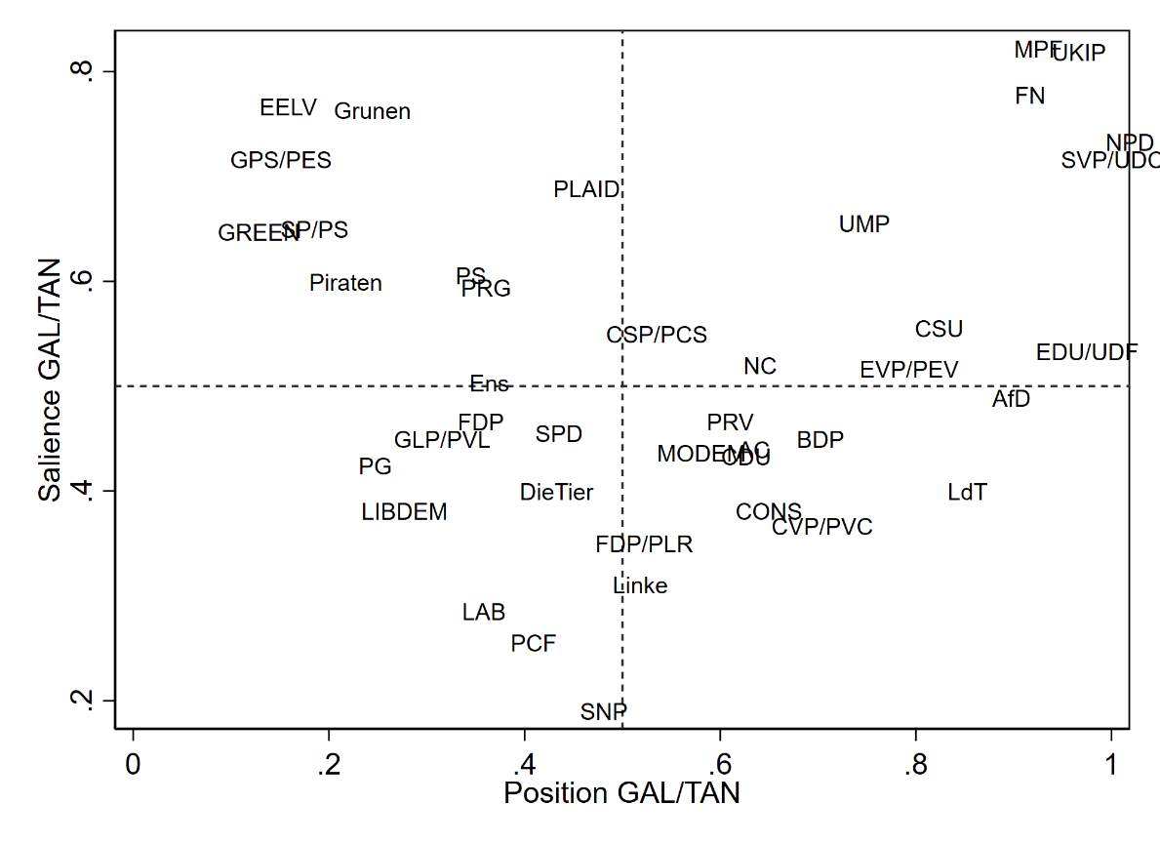

Appendix C – Additional Tables and Figures, Robustness Checks
Table C.1 Exploratory Factor Analysis for Eight Metropolitan Areas
 | Bern |  |  | Zurich |  |  | Berlin |  |  |  | Stuttgart
 | LA | LC |  | LA | LC |  | LA |  | LC |  | LA | LC
Intermunicipal Decisions: Other Interests | .09 | .79 |  | -.08 | .73 |  | -.05 |  | .74 |  | .09 | .84
Intermunicipal Resources: Sharing | -.09 | .64 |  | -.25 | .60 |  | -.07 |  | .70 |  | -.36 | .48
Intermunicipal Cooperation | -.00 | .76 |  | .22 | .75 |  | .19 |  | .79 |  | .22 | .75
Local vs. Central Decisions | .89 | -.05 |  | .84 | -.03 |  | .90 |  | .03 |  | .87 | .07
Local vs. Central Interest Representation | .93 | .08 |  | .81 | .01 |  | .90 |  | .07 |  | .90 | .15
Local vs. Central Tax Collection | .40 | -.04 |  | .67 | .06 |  | .40 |  | -.20 |  | .45 | -.29
Eigenvalues | 2.03 | 1.43 |  | 2.13 | 1.28 |  | 1.98 |  | 1.54 |  | 2.04 | 1.47
Variance (%) | 31.3 | 28.0 |  | 33.4 | 25.8 |  | 30.9 |  | 28.8 |  | 32.8 | 27.3
N | 419 |  |  | 462 |  |  | 522 |  |  |  | 490
 | Paris |  |  | Lyon |  |  | London |  |  |  | Birmingham
 | LA | LC |  | LA | LC |  | LA |  | LC |  | LA | LC
Intermunicipal Decisions: Other Interests | .00 | .78 |  | .08 | .80 |  | -.02 |  | .81 |  | .05 | .84
Intermunicipal Resources: Sharing | -.15 | .72 |  | -.16 | .73 |  | -.09 |  | .75 |  | -.01 | .82
Intermunicipal Cooperation | .10 | .80 |  | .08 | .82 |  | .11 |  | .75 |  | -.05 | .82
Local vs. Central Decisions | .89 | -.02 |  | .89 | .07 |  | .90 |  | -.01 |  | .88 | -.04
Local vs. Central Interest Representation | .91 | -.04 |  | .88 | .02 |  | .88 |  | .01 |  | .90 | .02
Local vs. Central Tax Collection | .84 | .06 |  | .75 | -.08 |  | .72 |  | -.01 |  | .76 | .01
Eigenvalues | 2.65 | 1.51 |  | 2.22 | 1.83 |  | 2.43 |  | 1.49 |  | 2.60 | 1.64
Variance (%) | 41.3 | 31.8 |  | 36.5 | 31.2 |  | 37.1 |  | 31.4 |  | 38.0 | 36.3
N | 517 |  |  | 531 |  |  | 516 |  |  |  | 525

Table C.2: Correlation Matrix of Dependent Variable Items
 | Local/Central:Decisions | Local/Central: Representation | Local/Central: Taxes | Local Decisions: Other Interests | Local Resources: Sharing
Local/Central: Representation | .724***
Local/Central: Taxes | .378*** | .367***
Local Decisions: Other Interests | -.095*** | -.082*** | -.099***
Local Resources: Sharing | -.185*** | -.196*** | -.134*** | .389***
Intermunicipal Cooperation | -.079*** | -.046** | -.091*** | .341*** | .305***
Note. **p<.01, ***p<.001.

Table C.3. Local Ties Correlation Matrix
 | >3 Years Residence (=1) | Homeowner (=1) | Commuter (=1)
Homeowner (=1) | 0.189***
Commuter (=1) | 0.009 | -0.054**
Local Association Member (=1) | 0.006 | 0.038* | -0.079***
Note. *p<.05 **p<.01, ***p<.001.

Table C.4. Descriptive Statistics
 | N | Mean | SD | Min | P25 | P50 | P75 | Max
Local Autonomy | 3982 | .51 | .20 | 0 | .39 | .50 | .64 | 1
Inter-local Cooperation | 3982 | .66 | .17 | 0 | .56 | .67 | .77 | 1
>3 Years Residence (=1) | 5042 | .81 | .39 | 0 | 1 | 1 | 1 | 1
Homeowner (=1) | 4996 | .46 | .50 | 0 | 0 | 0 | 1 | 1
Commuting Frequency | 5044 | .14 | .40 | 0 | 0 | 0 | 0 | 3.15
Local Association Member (=1) | 5044 | .58 | .49 | 0 | 0 | 1 | 1 | 1
Relative Local Attachment | 5009 | .44 | .29 | 0 | .20 | .50 | .70 | 1
GAL-TAN: No/Other Party | 5044 | .83 | .37 | 0 | 1 | 1 | 1 | 1
GAL-TAN: TAN Party | 5044 | .09 | .28 | 0 | 0 | 0 | 0 | 1
GAL-TAN: GAL Party | 5044 | .08 | .27 | 0 | 0 | 0 | 0 | 1
Gender (Female=1) | 5036 | .50 | .50 | 0 | 0 | 0 | 1 | 1
Age: < 25 | 5044 | .08 | .27 | 0 | 0 | 0 | 0 | 1
Age: 25-34 | 5044 | .20 | .40 | 0 | 0 | 0 | 0 | 1
Age: 35-44 | 5044 | .22 | .41 | 0 | 0 | 0 | 0 | 1
Age: 45-54 | 5044 | .21 | .41 | 0 | 0 | 0 | 0 | 1
Age: 55-64 | 5044 | .17 | .38 | 0 | 0 | 0 | 0 | 1
Age: >= 65 | 5044 | .12 | .32 | 0 | 0 | 0 | 0 | 1
Education: Low | 4900 | .14 | .35 | 0 | 0 | 0 | 0 | 1
Education: Medium | 4900 | .39 | .49 | 0 | 0 | 0 | 1 | 1
Education: High | 4900 | .47 | .50 | 0 | 0 | 0 | 1 | 1
Income: Low | 5017 | .28 | .45 | 0 | 0 | 0 | 1 | 1
Income: Medium | 5017 | .42 | .49 | 0 | 0 | 0 | 1 | 1
Income: High | 5017 | .30 | .46 | 0 | 0 | 0 | 1 | 1
Local-National Trust | 4737 | .74 | 2.10 | -10 | 0 | 0 | 2 | 10
Center (=1) | 5044 | .38 | .48 | 0 | 0 | 0 | 1 | 1
log(Population) (std.) | 5033 | -.00 | 1.00 | -5.50 | -.66 | .04 | .85 | 1.63
Local Median Income (std.) | 4828 | .00 | 1.00 | -1.31 | -.97 | -.30 | .70 | 1.70
Unemployment Rate (std.) | 5044 | .00 | 1.00 | -2.64 | -.77 | -.05 | .67 | 4.33

Table C.5: Random Effects ANOVA
 | Local Autonomy |  |  |  | Local Cooperation
 | LAU2 | Metro  Area | Country |  | LAU2 | Metro  Area | Country
Constant (γ₀₀) | .514 | .510 | .511 |  | .656 | .658 | .658
 | (.004) | (.008) | (.010) |  | (.003) | (.007) | (.008)
Level-1 Variance (σ²) | .035 | .037 | .038 |  | .026 | .027 | .027
 | (.001) | (.001) | (.001) |  | (.001) | (.000) | (.000)
Level-2 Variance (τ₀₀) | .003 | .001 | .000 |  | .001 | .000 | .000
 | (.000) | (.000) | (.000) |  | (.000) | (.000) | (.000)
Total Variance (σ²+τ₀₀) | .039 | .038 | .038 |  | .027 | .027 | .027
N (Level-2) | 1231 | 8 | 4 |  | 1231 | 8 | 4
Intra-Class Correlationª | .075 | .014 | .010 |  | .038 | .012 | .010
 | (.016) | (.008) | (.008) |  | (.012) | (.007) | (.007)
LR χ² | 38.27 | 41.13 | 33.58 |  | 15.87 | 33.10 | 31.08
p > χ² | .000 | .000 | .000 |  | .000 | .000 | .000
Note. ª ICC= $\frac{τ_{00}}{σ^{2}+τ_{00}}$; Standard errors in parenthesis, N (Level-1)=3982.

Table C.6. Regression Models for Local Autonomy
 | Controls | H1 | H2 | H3 | Full
Hypothesis 1: Local Ties
>3 Years Residence (=1) |  | .001 |  |  | -.004
 |  | (.946) |  |  | (.681)
Homeowner (=1) |  | -.023* |  |  | -.023*
 |  | (.015) |  |  | (.014)
Commuting Frequency |  | -.032 |  |  | -.031
 |  | (.050) |  |  | (.062)
Local Association Member (=1) |  | .008 |  |  | .007
 |  | (.377) |  |  | (.447)
Hypothesis 2: Place Attachment
Relative Local Attachment |  |  | .021 |  | .015
 |  |  | (.133) |  | (.283)
Hypotheses 3: GAL-TAN
GAL-TAN (B=No/Other Party)
TAN Party |  |  |  | .045** | .046**
 |  |  |  | (.003) | (.002)
GAL Party |  |  |  | .006 | .005
 |  |  |  | (.646) | (.664)
Controls
Gender (Female=1) | -.002 | -.003 | -.002 | -.000 | -.000
 | (.775) | (.694) | (.834) | (.987) | (.950)
Age Cohorts (B= <25)
25-34 | -.022 | -.022 | -.023 | -.023 | -.024
 | (.135) | (.151) | (.131) | (.120) | (.127)
35-44 | .002 | .006 | .002 | .000 | .005
 | (.902) | (.684) | (.888) | (.994) | (.716)
45-54 | .021 | .027 | .021 | .018 | .025
 | (.174) | (.079) | (.177) | (.227) | (.094)
55-64 | .022 | .029 | .023 | .019 | .028
 | (.139) | (.053) | (.124) | (.200) | (.060)
≥65 | .019 | .025 | .018 | .016 | .023
 | (.257) | (.139) | (.281) | (.339) | (.179)
Education (B=Low)
Medium | .006 | .009 | .006 | .006 | .010
 | (.673) | (.500) | (.656) | (.665) | (.484)
High | -.001 | .002 | .001 | .001 | .006
 | (.950) | (.856) | (.965) | (.916) | (.655)
Income (B=Low)
Medium | .002 | .005 | .002 | .001 | .005
 | (.845) | (.586) | (.847) | (.889) | (.609)
High | .013 | .020 | .013 | .013 | .021*
 | (.233) | (.054) | (.246) | (.224) | (.048)
log(Population) (std.) | -.009 | -.014* | -.009 | -.008 | -.014*
 | (.206) | (.033) | (.206) | (.220) | (.040)
Center (=1) | -.004 | .016 | -.005 | -.003 | .015
 | (.809) | (.317) | (.745) | (.855) | (.342)
Local Median Income (std.) | .001 | .001 | .001 | .001 | .001
 | (.921) | (.858) | (.903) | (.918) | (.838)
Unemployment Rate (std.) | -.013* | -.011* | -.013* | -.014* | -.012*
 | (.021) | (.048) | (.022) | (.018) | (.045)
Metropolitan Area (B=Bern)
Zurich | .043** | .043** | .043** | .042** | .043**
 | (.004) | (.004) | (.004) | (.004) | (.004)
Berlin | .040 | .035 | .037 | .043* | .036
 | (.053) | (.096) | (.074) | (.035) | (.085)
Stuttgart | .026 | .026 | .025 | .029 | .029
 | (.094) | (.090) | (.107) | (.057) | (.060)
Lyon | .062*** | .068*** | .061*** | .062** | .066***
 | (.001) | (.000) | (.001) | (.001) | (.001)
Paris | .043* | .049** | .042* | .044* | .050**
 | (.015) | (.006) | (.017) | (.015) | (.006)
London | -.016 | -.010 | -.016 | -.014 | -.007
 | (.298) | (.523) | (.319) | (.402) | (.649)
Birmingham | .020 | .028 | .021 | .022 | .030
 | (.240) | (.111) | (.233) | (.214) | (.095)
Constant | .474*** | .464*** | .465*** | .468*** | .455***
 | (.000) | (.000) | (.000) | (.000) | (.000)
Level-1 Variation | .029*** | .029*** | .029*** | .029*** | .029***
 | (.000) | (.000) | (.000) | (.000) | (.000)
Level-2 Variation | .008*** | .007*** | .008*** | .008*** | .007***
 | (.000) | (.000) | (.000) | (.000) | (.000)
N | 3630 | 3604 | 3623 | 3630 | 3597
Municipalities | 1148 | 1142 | 1147 | 1148 | 1141
Log. Lik. | 968.79 | 965.25 | 971.79 | 976.92 | 976.28
LR χ² | 84.25 | 113.26 | 86.18 | 92.05 | 121.31
p > χ² | .000 | .000 | .000 | .000 | .000
AIC | -1889.59 | -1874.50 | -1893.58 | -1901.84 | -1890.56
BIC | -1740.86 | -1701.19 | -1738.70 | -1740.72 | -1698.74
Note. Entries are coefficients obtained from a linear multilevel regression model in Stata (-mixed-), p-values in parentheses; *p<.05 **p<.01 ***p<.001.

Table C.7. Regression Models for Inter-local Cooperation
 | Controls | H1 | H2 | H3 | Full
Hypothesis 1: Local Ties
>3 Years Residence (=1) |  | -.009 |  |  | -.004
 |  | (.325) |  |  | (.640)
Homeowner (=1) |  | .007 |  |  | .007
 |  | (.422) |  |  | (.405)
Commuting Frequency |  | -.004 |  |  | -.004
 |  | (.843) |  |  | (.847)
Local Association Member (=1) |  | .035*** |  |  | .035***
 |  | (.000) |  |  | (.000)
Hypothesis 2: Place Attachment
Relative Local Attachment |  |  | -.018 |  | -.015
 |  |  | (.111) |  | (.187)
Hypotheses 3: GAL-TAN
GAL-TAN (B=No/Other Party)
TAN Party |  |  |  | -.056*** | -.056***
 |  |  |  | (.000) | (.000)
GAL Party |  |  |  | .034*** | .034***
 |  |  |  | (.001) | (.001)
Controls
Gender (Female=1) | -.007 | -.006 | -.007 | -.010 | -.009
 | (.382) | (.426) | (.386) | (.176) | (.206)
Age Cohorts (B= <25)
25-34 | -.026 | -.025 | -.025 | -.025 | -.023
 | (.071) | (.100) | (.075) | (.081) | (.123)
35-44 | -.027* | -.022 | -.027* | -.025 | -.021
 | (.047) | (.106) | (.049) | (.062) | (.126)
45-54 | -.021 | -.016 | -.021 | -.019 | -.015
 | (.132) | (.285) | (.140) | (.173) | (.326)
55-64 | -.017 | -.015 | -.018 | -.015 | -.014
 | (.223) | (.331) | (.210) | (.283) | (.343)
≥65 | .012 | .012 | .013 | .016 | .015
 | (.424) | (.458) | (.404) | (.294) | (.359)
Education (B=Low)
Medium | .030* | .028* | .029* | .029* | .026*
 | (.022) | (.033) | (.027) | (.026) | (.044)
High | .060*** | .053*** | .058*** | .054*** | .046***
 | (.000) | (.000) | (.000) | (.000) | (.000)
Income (B=Low)
Medium | .010 | .009 | .010 | .010 | .008
 | (.295) | (.359) | (.300) | (.291) | (.379)
High | .009 | .006 | .009 | .009 | .005
 | (.397) | (.614) | (.403) | (.379) | (.638)
log(Population) (std.) | .002 | .003 | .003 | .002 | .003
 | (.645) | (.594) | (.611) | (.715) | (.644)
Center (=1) | .011 | .017 | .012 | .009 | .015
 | (.331) | (.239) | (.310) | (.450) | (.306)
Local Median Income (std.) | -.007 | -.007 | -.006 | -.006 | -.006
 | (.145) | (.141) | (.158) | (.189) | (.201)
Unemployment Rate (std.) | -.000 | -.001 | -.001 | .001 | .000
 | (.928) | (.872) | (.912) | (.901) | (.980)
Metropolitan Area (B=Bern)
Zurich | -.030* | -.027 | -.030* | -.028* | -.024
 | (.031) | (.058) | (.031) | (.044) | (.079)
Berlin | .016 | .022 | .019 | .019 | .027
 | (.316) | (.174) | (.247) | (.261) | (.112)
Stuttgart | -.016 | -.012 | -.015 | -.017 | -.013
 | (.229) | (.356) | (.252) | (.212) | (.351)
Lyon | -.038* | -.030 | -.038* | -.031* | -.022
 | (.012) | (.052) | (.015) | (.047) | (.164)
Paris | -.028 | -.017 | -.028 | -.022 | -.010
 | (.057) | (.266) | (.068) | (.152) | (.530)
London | .029* | .037** | .028* | .033* | .041**
 | (.038) | (.009) | (.045) | (.019) | (.004)
Birmingham | .011 | .018 | .012 | .018 | .025
 | (.489) | (.285) | (.469) | (.271) | (.138)
Constant | .636*** | .614*** | .645*** | .638*** | .620***
 | (.000) | (.000) | (.000) | (.000) | (.000)
Level-1 Variation | .023*** | .023*** | .023*** | .022*** | .022***
 | (.000) | (.000) | (.000) | (.000) | (.000)
Level-2 Variation | .004*** | .004*** | .004*** | .004*** | .004***
 | (.000) | (.000) | (.000) | (.000) | (.000)
N | 3630 | 3604 | 3623 | 3630 | 3597
Groups | 1148 | 1142 | 1147 | 1148 | 1141
Log. Lik. | 1491.41 | 1481.28 | 1489.51 | 1515.39 | 1502.74
LR χ² | 96.61 | 113.81 | 98.39 | 134.54 | 168.89
p > χ² | 0.000 | 0.000 | 0.000 | 0.000 | 0.000
AIC | -2934.82 | -2906.56 | -2929.02 | -2978.79 | -2943.49
BIC | -2786.09 | -2733.25 | -2774.15 | -2817.66 | -2751.66
Note. Entries are coefficients obtained from a linear multilevel regression model in Stata (-mixed-), p-values in parentheses; *p<.05 **p<.01 ***p<.001.

Figure C.1: Effects of Metropolitan Governance Structures and Country Differences on Attitudes towards Local Autonomy and Local Cooperation
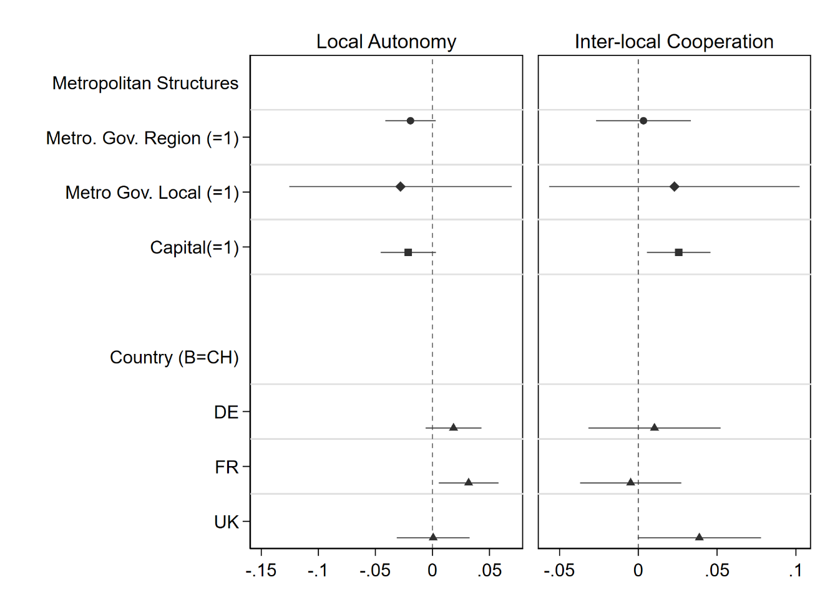

Figure C.2: Local Autonomy, Individual Items
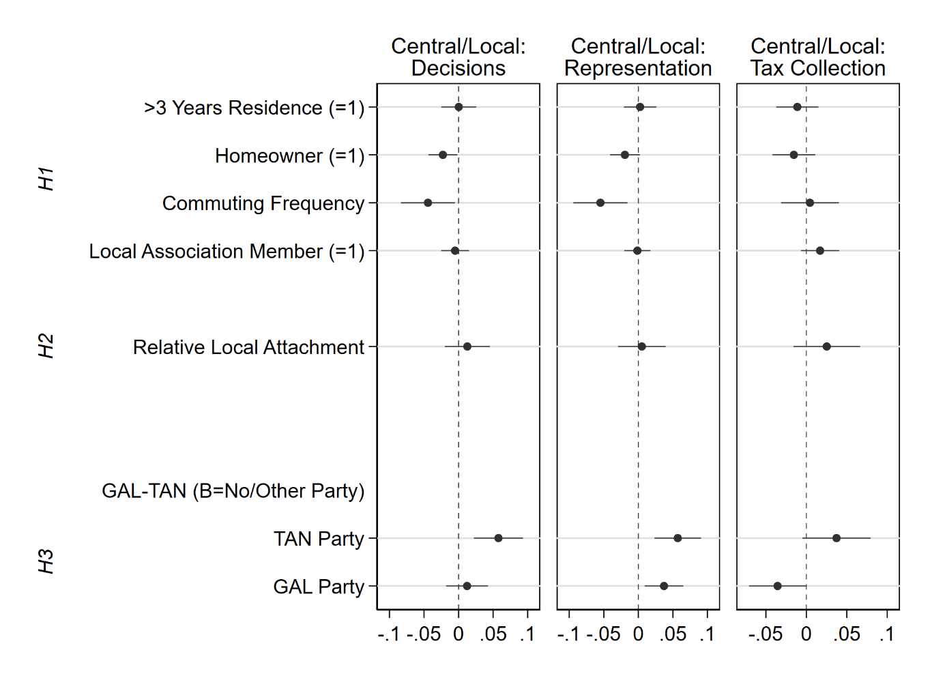

Figure C.3: Inter-local Cooperation, Individual Items
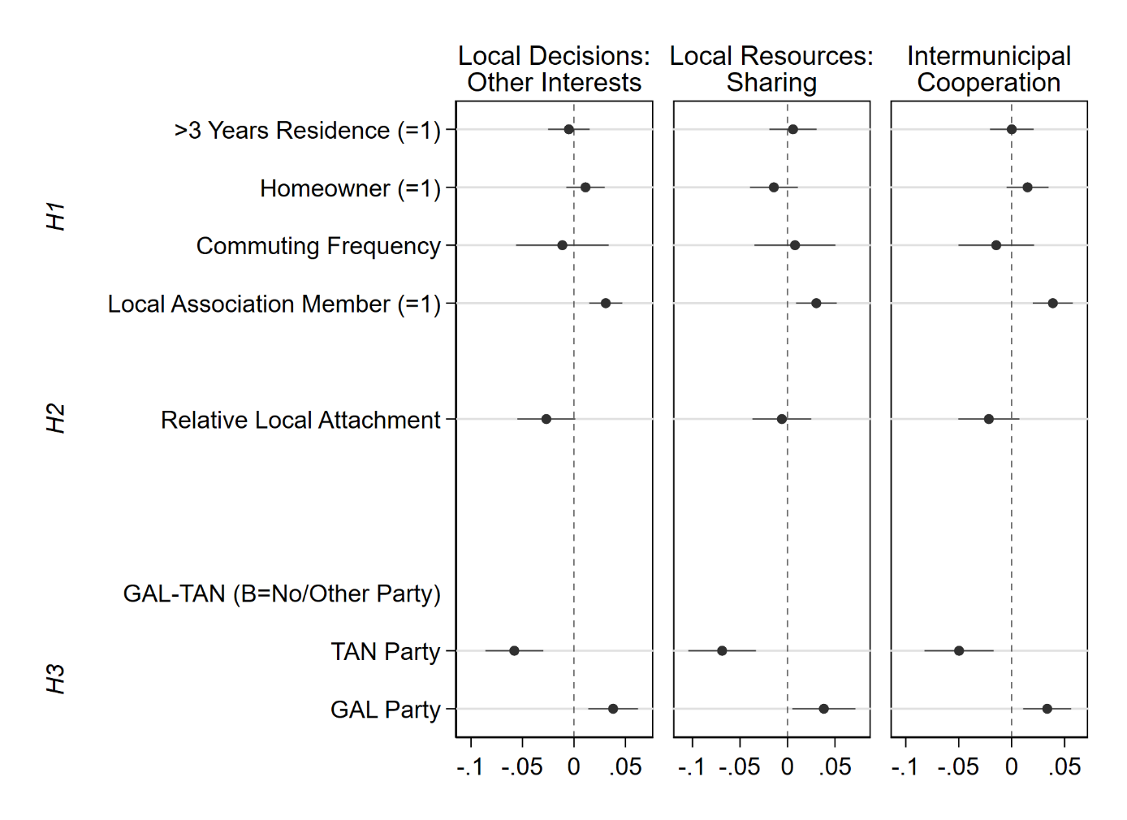

Figure C.4: Absolute and Relative Local Attachment
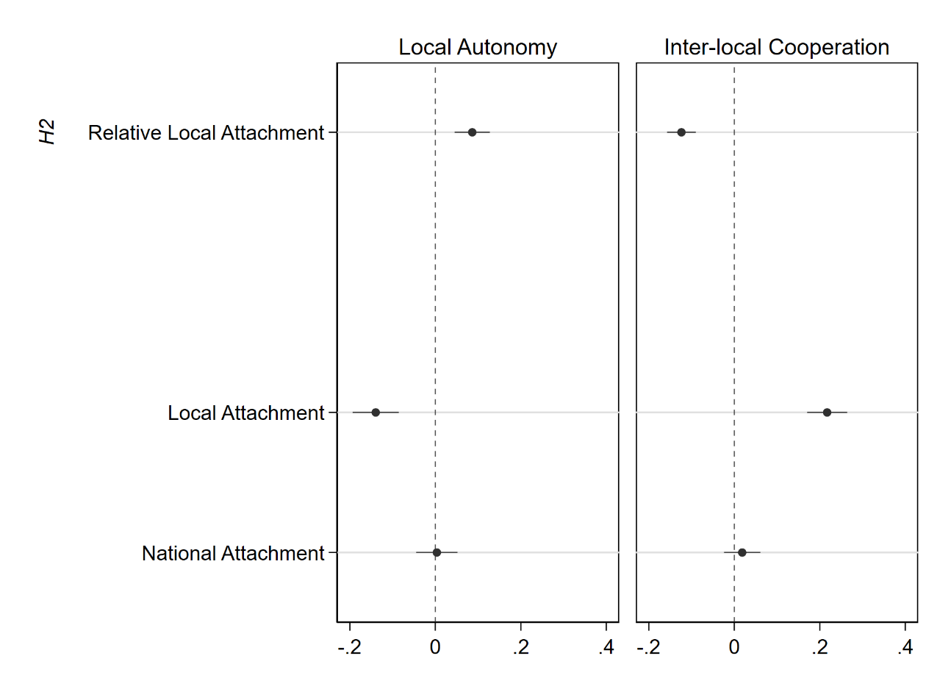

Figure C.5: Relative Trust and GAL-TAN
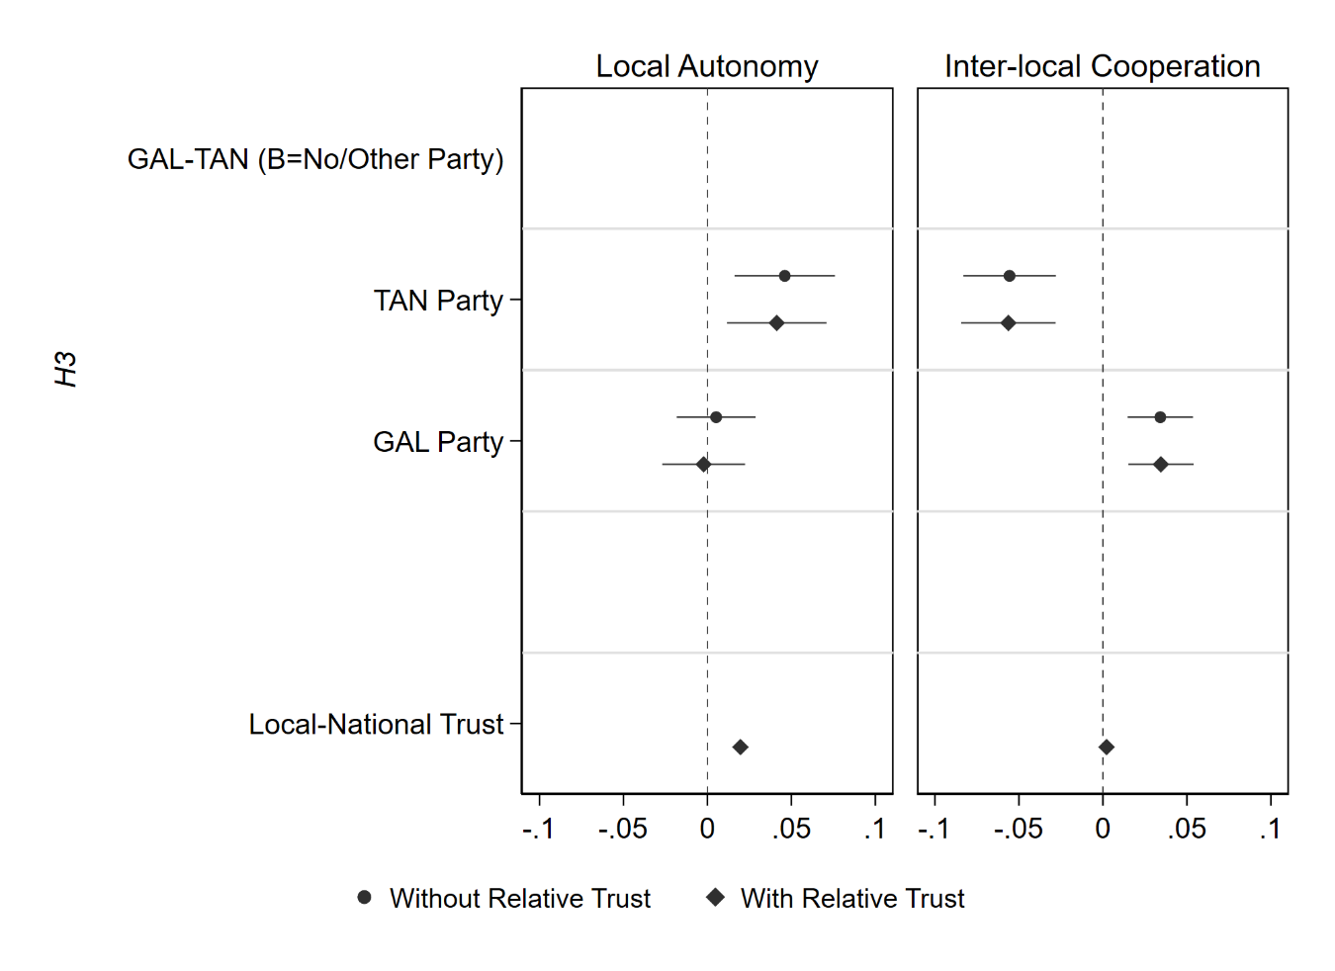
In Figure C.5, we test whether partisanship matters not because of the underlying political ideology associated with scale politics but because of government-opposition dynamics: if your preferred party is in power at the local level but not at the national one, we might expect that you prefer local autonomy over centralization and vice versa. Moreover, if your party is in government at the local level, you might be more reluctant to engage in cooperation since your party’s leeway to act would be constrained. We cannot test this alternative explanation about multilevel government-opposition dynamics directly for several reasons. First, Switzerland and Germany are consensus democracies with oversized government coalitions where government-opposition dynamics are much less pronounced than in the UK, which makes it more difficult to assign clear roles. Second, all countries but the UK have intermediate elected government tiers which means it is not a priori clear which government tier the local level should be compared to. Third and finally, data on parties’ local government participation is very difficult if not impossible (for Switzerland) to obtain. However, we approximate this alternative explanation with the relative political trust in local compared to national government. It is reasonable to assume that citizens’ relative trust in the local government is higher when they dislike the party which rules at the national level and support the party that rules at the local level and vice versa. When we include this indicator in the regression model, we indeed find that persons with a higher relative local trust are more in favor of local autonomy (figure C.5). However, this does not affect the results for GAL and TAN party support. This suggests that the politics of scale and the associated ideology operates independently of government-opposition dynamics.

Figure C.6: Models with Multiple Imputation
