Supplementary material

Figure A1. Trends of VIF in Austria over time, by party.
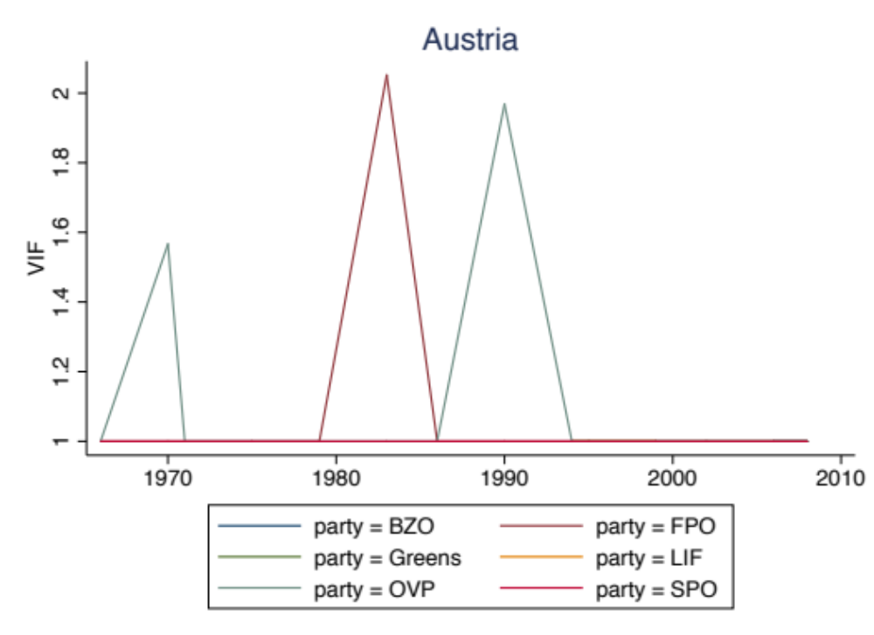

Figure A2. Trends of VIF in Belgium over time, by party.
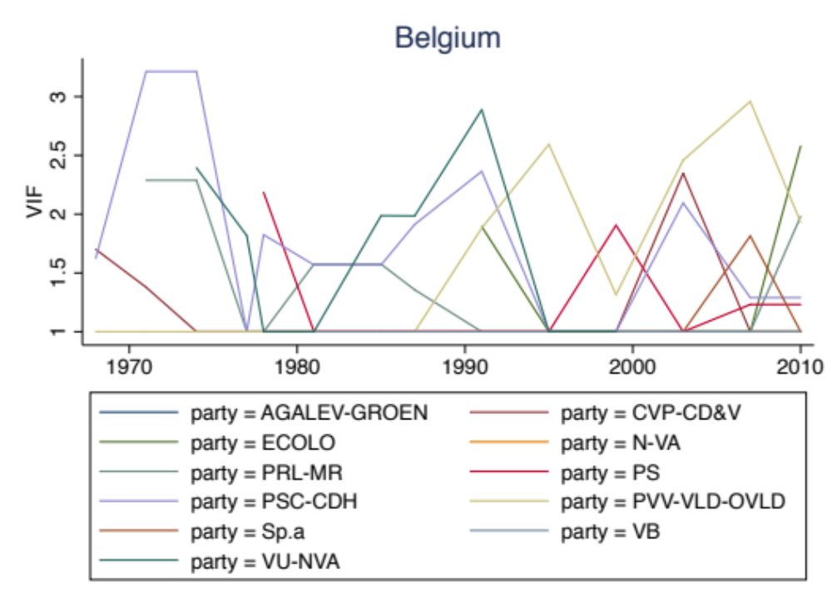

Figure A3. Trends of VIF in Denmark over time, by party.
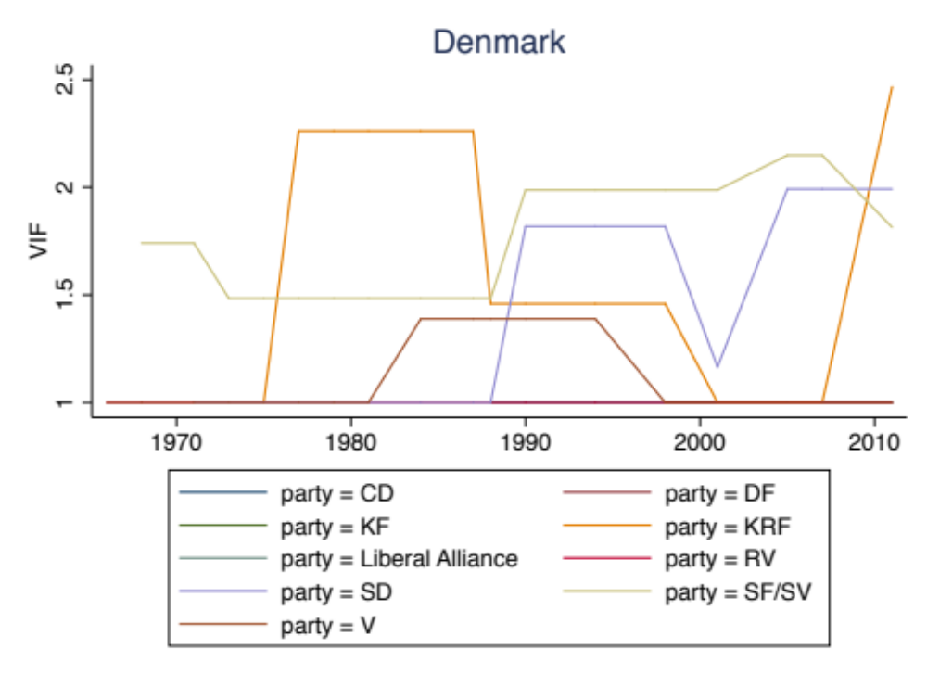

Figure A4. Trends of VIF in Germany over time, by party.
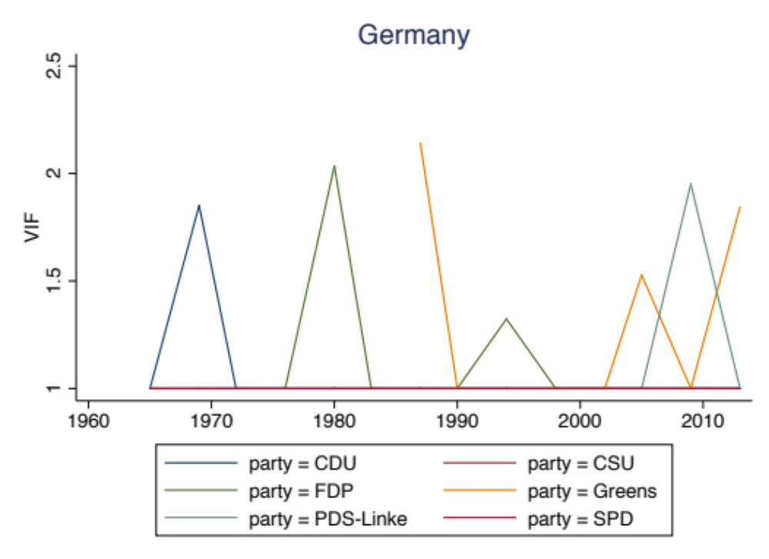

Figure A5. Trends of VIF in Greece over time, by party.
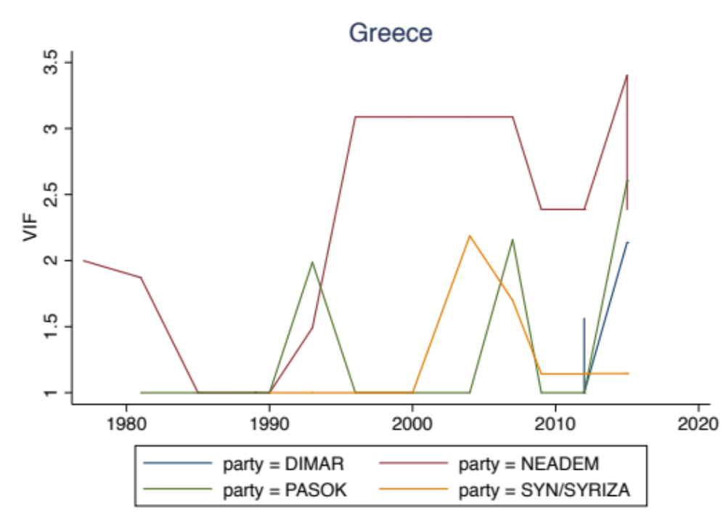

Figure A6. Trends of VIF in Ireland over time, by party.
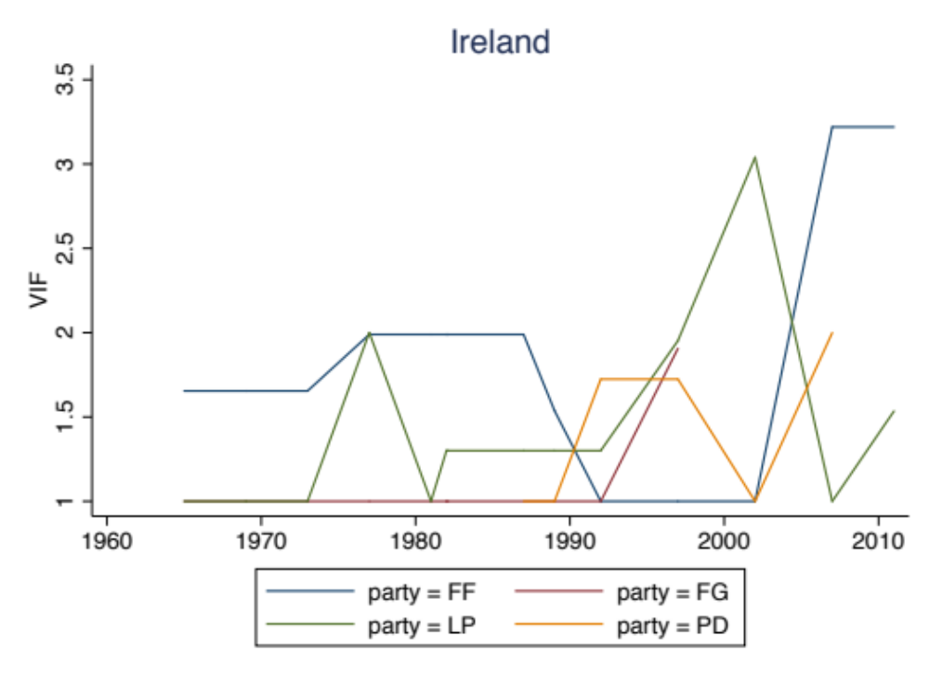

Figure A7. Trends of VIF in Italy over time, by party.
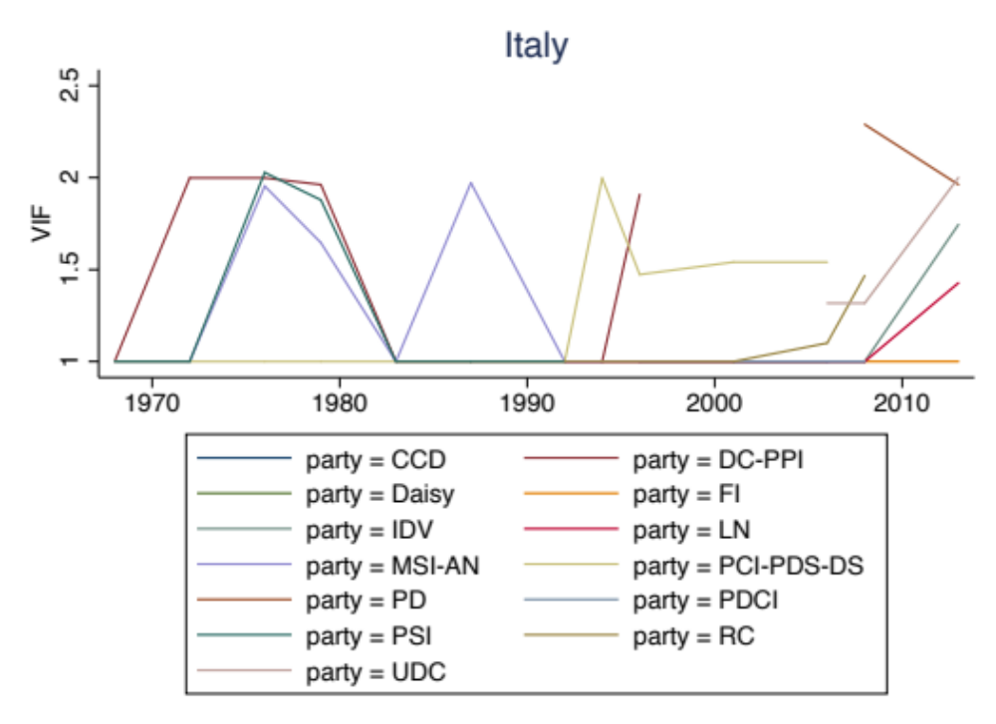

Figure A8. Trends of VIF in Norway over time, by party.
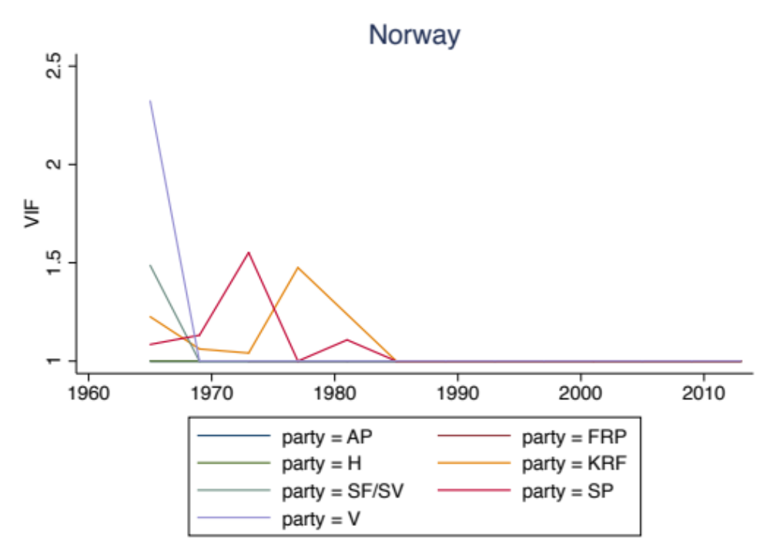

Figure A9. Trends of VIF in Portugal over time, by party.
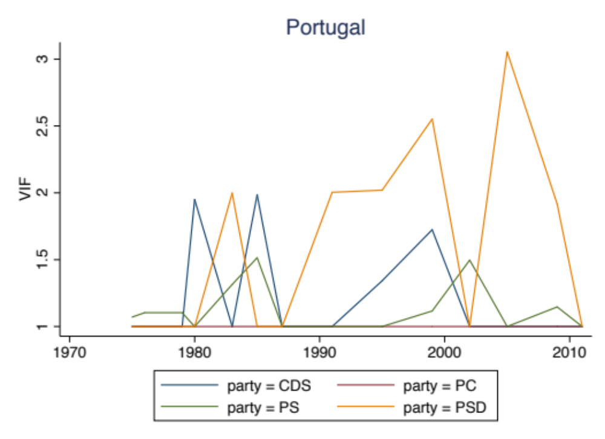

Figure A10. Trends of VIF in Spain over time, by party.
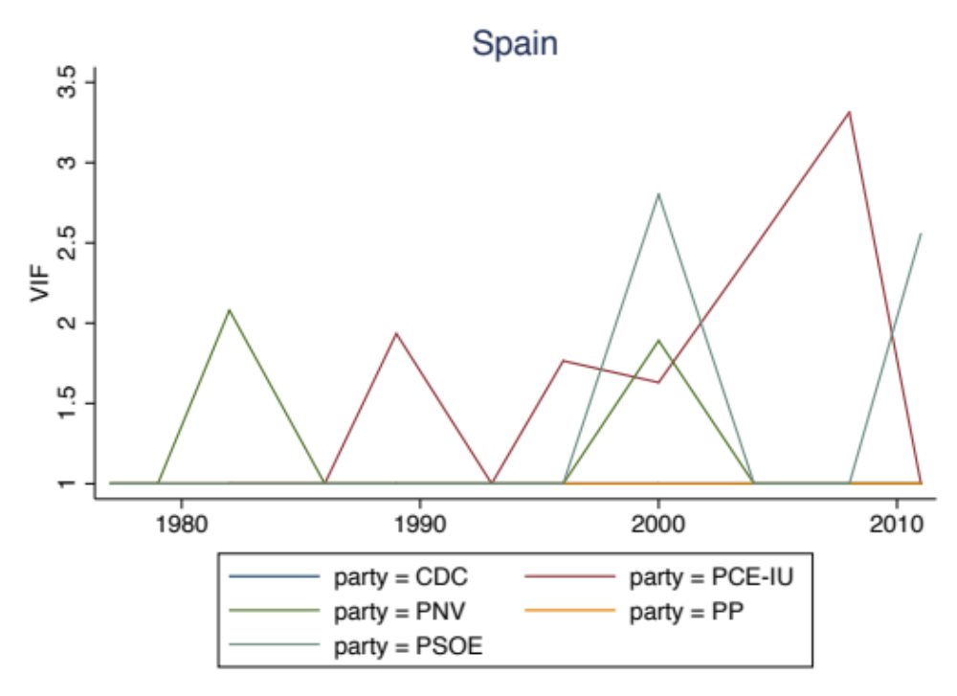

Figure A11. Trends of VIF in United Kingdom over time, by party.
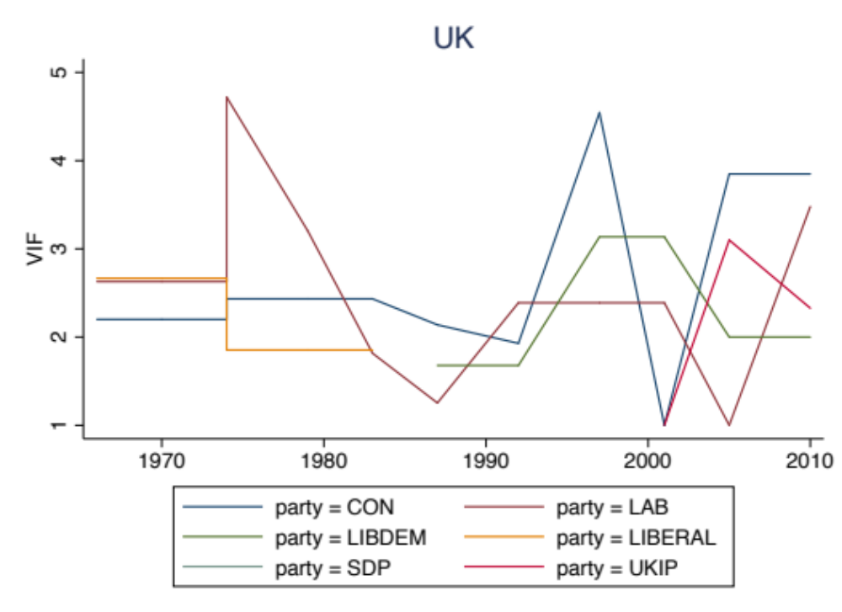

Table A1. Replication of Model 3 of Table 2 with Average District Magnitude (raw or logged) instead of Disproportionality
 | Model A |  | Model B
 | b | se | b | se
Average District Magnitude | -0.566*** | 0.134
Average District Magnitude (logged) |  |  | -0.778*** | 0.138
Personal vote | 0.746*** | 0.122 | 0.618*** | 0.111
ENEP | -0.418*** | 0.124 | -0.363** | 0.12
Electoral volatility | -0.127 | 0.137 | -0.099 | 0.135
Membership/Electorate | -0.243 | 0.208 | -0.168 | 0.201
Selectorate (reference: 1)
0 | 0.154* | 0.062 | 0.135* | 0.061
2 | 0.364*** | 0.067 | 0.332*** | 0.067
Party size | -0.055 | 0.121 | -0.075 | 0.118
Party age | 0.031 | 0.111 | -0.023 | 0.107
Left-right placement | -0.194 | 0.134 | -0.151 | 0.132
Time | 0.079 | 0.089 | 0.113 | 0.088
Constant | 1.327*** | 0.1 | 1.623*** | 0.116
Random-effects: Var. of party intercepts | 0.041 |  | 0.036
Wald χ2 | 118.547*** |  | 140.415***
N observations | 667 |  | 667
N of parties | 70 |  | 70
N of countries | 11 |  | 11
Note. Multilevel mixed-effects model; b coefficient and standard errors (se) reported; +p < .10; *p < .05, **p < .01, ***p < .001.

Table A2. Replication of Model 3 of Table 2 with different controls
 | Model A |  | Model B |  | Model C
 | b | se | b | se | b | se
Disproportionality | 0.418* | 0.17 | 0.532*** | 0.161 | 0.525*** | 0.156
Personal vote | 0.468** | 0.143 | 0.417** | 0.132 | 0.373** | 0.129
ENEP | -0.361* | 0.142 | -0.266⁺ | 0.142 | -0.279* | 0.13
Electoral volatility | -0.233 | 0.15 | -0.357* | 0.14 | -0.323* | 0.149
Membership/Electorate | -0.252 | 0.225 | -0.437* | 0.212 | -0.249 | 0.213
Selectorate (reference: 1)
0 | 0.208** | 0.069 | 0.169** | 0.06 | 0.215*** | 0.061
2 | 0.379*** | 0.072 |  |  | 0.356*** | 0.069
Candidacy (reference: 1)
0 | -0.049 | 0.103
2 | 0.066 | 0.084
Party size | -0.117 | 0.134 | 0.12 | 0.125 | -0.036 | 0.123
Party age | 0.135 | 0.129 | 0.128 | 0.119 | 0.097 | 0.113
Left-right placement | -0.19 | 0.144 | -0.105 | 0.131 | -0.128 | 0.138
Time | -0.044 | 0.095 | -0.073 | 0.085
Decade (reference: 1960s)
1970s |  |  |  |  | 0.092 | 0.094
1980s |  |  |  |  | -0.034 | 0.094
1990s |  |  |  |  | -0.001 | 0.097
2000s |  |  |  |  | 0.002 | 0.098
2010s |  |  |  |  | 0.064 | 0.118
Constant | 1.265*** | 0.118 | 1.174*** | 0.101 | 1.173*** | 0.121
Random-effects: Var. of party intercepts | 0.054 |  | 0.051 |  | 0.045
Wald χ2 | 100.139*** |  | 69.39*** |  | 113.944***
N observations | 594 |  | 555 |  | 667
N of parties | 63 |  | 65 |  | 70
N of countries | 11 |  | 11 |  | 11
Note. Model A includes a control for Candidacy; Model B excludes the races held with the most open selectorate, that is, party members or voters; Model C replaces the linear trend variable Time with a categorical variable for decades; Multilevel mixed-effects model; b coefficient and standard errors (se) reported; +p < .10; *p < .05, **p < .01, ***p < .001.

Table A3. Replication of Model 3 of Table 2 with different model specifications
 | Model A |  | Model B |  | Model C
 | b | se | b | pcse | b | se
Disproportionality | 0.405* | 0.178 | 0.614** | 0.196 | 0.648*** | 0.156
Personal vote | 0.379* | 0.159 | 0.369** | 0.143 | 0.370** | 0.122
ENEP | -0.471** | 0.176 | -0.166 | 0.129 | -0.167 | 0.12
Electoral volatility | -0.154 | 0.166 | -0.274⁺ | 0.161 | -0.274⁺ | 0.145
Membership/Electorate | -0.02 | 0.169 | -0.116 | 0.173 | -0.11 | 0.186
Selectorate (reference: 1)
0 | 0.121* | 0.055 | 0.217** | 0.069 | 0.220*** | 0.06
2 | 0.340*** | 0.068 | 0.430*** | 0.092 | 0.428*** | 0.077
Party size | -0.002 | 0.096 | 0.044 | 0.13 | 0.049 | 0.117
Party age | -0.028 | 0.084 | 0.057 | 0.103 | 0.044 | 0.098
Left-right placement | -0.107 | 0.117 | -0.026 | 0.132 | -0.03 | 0.136
Time | 0.007 | 0.088 | -0.082 | 0.099 | -0.079 | 0.105
Constant | 1.276*** | 0.106 | 1.098*** | 0.114 | 1.094*** | 0.105
Random-effects: Var. of country intercepts | 0.030
Wald χ2 | 59.807*** |  | 67.572*** |  | 140.617***
N observations | 667 |  | 667 |  | 664
N of parties | 70 |  | 70 |  | 67
N of countries | 11 |  | 11 |  | 11
Note. Model A sets a Multilevel mixed-effects model with only country as random intercepts; Model B sets Prais-Winsten AR1 regression; Model C sets Generalized Estimating Equation (GEE) regression; b coefficient, panel-corrected standard errors (pcse), and standard errors (se) are reported; +p < .10; *p < .05, **p < .01, ***p < .001.

