Appendix 1: Operationalization
Populist vote (right-wing or left-wing): A dichotomous variable that takes the value 1 if the ESS respondent reported voting for a party that is classified as populist according to the PopuList and zero otherwise. If the populist party is also classified as far-right by the PopuList, the dichotomous variable right-wing populist party takes the value 1. Similarly, the left-wing populist vote variable take the value 1 if the populist party is classified as both populist and far left.
Mainstream vote (mainstream right and mainstream left): The mainstream parties were coded according to their overall left-right score in Chapel Hill Expert Survey (CHES) 2014 and 2017. The overall left-right score is between 0 and 10 with lower values denoting left-wing parties and higher ones denoting right-wing parties. The cut-off point between left-wing and right-wing parties is 5.
Extremist vote (far-right and far-left): These parties are coded as far-right and far-left by the PopuList classification but not as populist parties. Far right parties that are not populists is an extremely limited category; I only identify 4 such parties in this study: Vuzrazhdane in Bulgaria, National Popular Front in Cyprus, Tricolor Flame Social Movement and CasaPound in Italy. Far left parties that are not populists are more numerous. Examples include the French Communist Party and Hungarian Worker’s Party.
Political efficacy: Scores from factor analysis. Survey questions that were used in the analysis can be found in Appendix 2. Items included form a strong factor with an EV equals to 2.98. The EV for the second factor is also slightly above 1 but I chose to include only the first one for the sake of simplicity. Questions about political trust and efficacy have commonly been employed in populism studies (Geurkink et al. 2020). Though not the same, my political efficacy scale is similar to what Kriesi and Schulte-Cloos (2020) call political disaffection/dissatisfaction. Their scale is composed of satisfaction and trust questions while mine considers also the influence/participation questions.
Cultural grievances: Scores from factor analysis. Survey questions that were used in the analysis can be found in Appendix 2. Items form a strong factor with an Eigenvalue of 1.57. Anti-immigration has largely been cited as the strongest grievance (Hainmueller and Hopkins 2014) and can in fact be employed alone. Yet, right-wing populists are also very vocal about erosion of Christian values, customs and traditions. With a few notable exceptions such as Geert Wilders, right-wing populists have opposed LGBT rights.
Economic grievances: Scores from factor analysis. Survey questions that were used in the analysis can be found in Appendix 2. Items form a strong factor with an Eigenvalue of 1.44. Satisfaction with economy and feeling about income are meant to capture the economic insecurity. Also, populist movements, especially left-wing ones in Latin America, have long been identified as redistributionist movements.
Income: Household's total net income, all sources
Education: Years of full-time education completed
Age: Age of respondent
Appendix 2: Survey questions used in the factor analysis and the loadings
Efficacy questions
stfgov | How satisfied with the national government (0: dissatisfied-10: satisfied)
psppsgva | Political system allows people to have a say in what government does (1: not at all-5: a great deal)
psppipla | Political system allows people to have influence on politics (1: not at all-5: a great deal)
cptppola | Confident in own ability to participate in politics (0:not at all confident-10: completely confident)
trstplt | Trust in politicians (0: no trust at all-10:complete trust)
stfdem | How satisfied with the way democracy works in country(0:dissatisfied-10: satisfied)

Efficacy loadings
 | Factor 1 | Factor 2
Satisfaction with government | 0.837
Satisfaction with democracy | 0.731 | 0.228
Have a say in government does | 0.356 | 0.641
Have influence on politics |  | 0.452
Trust in politicians | 0.664 | 0.286
Confident in participating in politics | 0.306 | 0.828
SS loadings | 1.895 | 1.438
Proportion Var | 0.316 | 0.24
Cumulative Var | 0.316 | 0.555

Cultural grievances questions
imptrad* | Important to follow traditions and customs (1: very much like me-6: not like me at all)
ipfrule* | Important to do what is told and follow rules (1: very much like me-6: not like me at all)
imwbcnt* | Immigrants make country worse or better place to live (0:worse-10 better)
freehms | Gays and lesbians free to live life as they wish (1: agree strongly-5:disagree strongly)
*The variable is reverse coded for easier interpretability.
Cultural grievances loadings
 | Factor 1
Important to follow traditions | 0.466
Important to follow rules | 0.364
Immigrants make country worse | 0.442
Gays and lesbians free | 0.481
SS loadings | 0.777
Proportion Var | 0.197

Economic grievances questions
stfeco* | How satisfied with present state of economy in country (0: dissatisfied-10: satisfied)
gincdif* | Government should reduce differences in income levels (1: agree strongly-5: disagree strongly)
hincfel | Feeling about household's income nowadays (1:living comfortably-4 very difficult)

*The variable is reverse coded for easier interpretability.
Economic grievances loadings
 | Factor 1
Satisfaction with economy | 0.618
Redistribution | 0.287
Feeling about income | 0.519
SS loadings | 0.734
Proportion Var | 0.245

Appendix 3: Descriptive Statistics
Table 1: Descriptive statistics of the variables (N=33598)
Variable name | Mean | Standard Deviation | Min-Max
Populist Vote | 0.20 | 0.40 | 0-1
Right-wing populist vote | 0.13 | 0.34 | 0-1
Left-wing populist vote | 0.03 | 0.17 | 0-1
Political efficacy | 0 | 1 | -2.5-3.23
Cultural grievances | 0 | 1 | -2.83-3.29
Economic grievances | 0 | 1 | -2.39-3.26
Gender | 1.50 | 0.5 | 1-2
Age | 53.18 | 16.73 | 17-98
Level of Education | 13.84 | 3.90 | 0-54

Appendix 4: Party coding decisions made by the author
In countries where the electoral system allows voters to cast more than one vote (Germany and Lithuania), only the vote in the first ballot (the direct vote for a member of parliament in that constituency) is coded.
In countries where electoral alliances possible, parties that entered into an alliance with a populist party were coded as populist.
Following parties coded differently from the PopuList classification:
Team Stronach-Austira (coded as right-wing populist)
Ljist Dedecker-Belgium (coded as right-wing populist)
Lutte Ouvrière-France (coded as far left)
Nouveau Parti Anti-Capitaliste-France (coded as far left)
Following mainstream parties were coded as neither mainstream left or mainstream right:
G!LT-Austria
Obedinenie DOST-Bulgaria
Hungarian Two-tailed Dog Party-Hungary
Independent Alliance- Ireland

Appendix 5: Predicted probabilities plots from interactive models in the main text
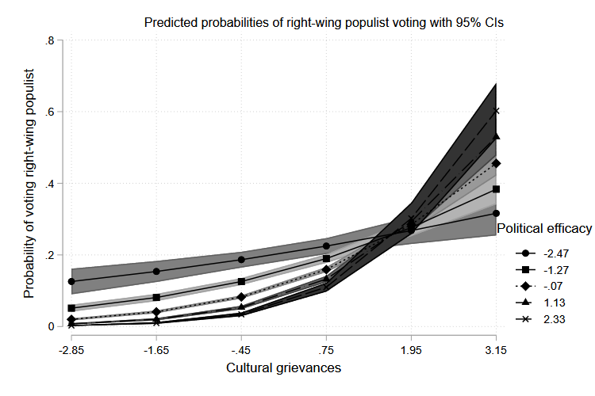
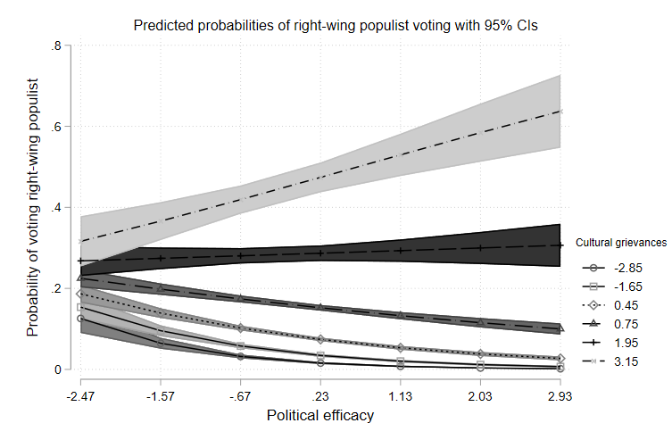
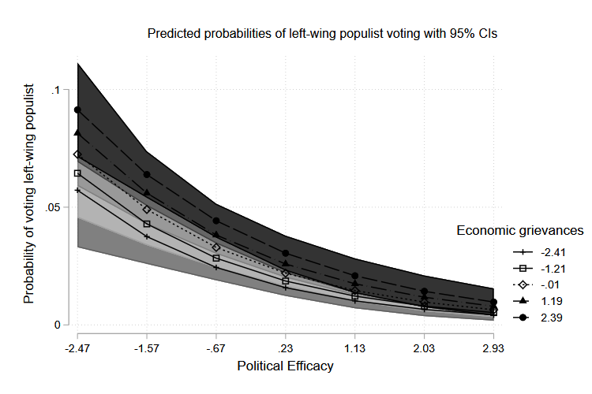
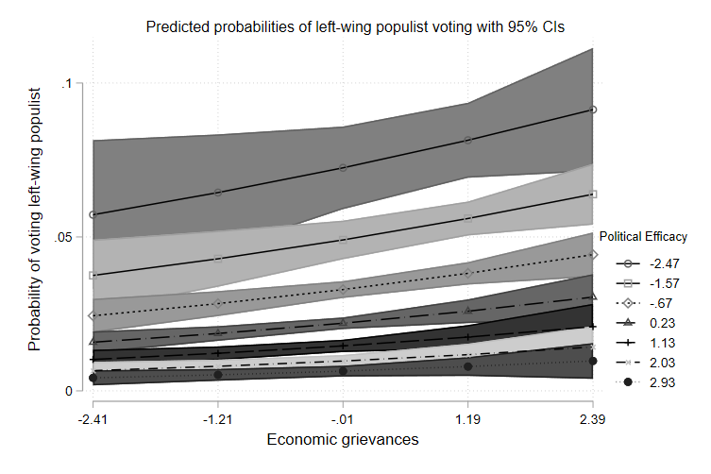

Appendix 6: Regression estimates
Table 2 replicates the same analysis in the main paper, this time comparing populist voters to mainstream voters instead of all populists. In models 8 and 9, right-wing populist voters and left-wing populist voters are being compared to their respective mainstream counterparts. Models 10-12 are the same with 7-9 with interactions added.
Table 2: Populist vs. mainstream comparison
 |  | Dependent variable:
 |  | Populist vote |  | RW populist vote | LW populist vote |  | Populist vote |  | RW populist vote |  | LW populist vote
 |  | (7) |  | (8) | (9) |  | (10) |  | (11) |  | (12)
Political Efficacy |  | -0.210*** |  | -0.414*** | -0.499*** |  | -0.292*** |  | -0.480*** |  | -0.454***
 |  | (0.020) |  | (0.028) | (0.052) |  | (0.021) |  | (0.030) |  | (0.056)
Economic Grievances |  | 0.082*** |  | 0.066** | 0.01 |  | 0.113*** |  | 0.101*** |  | 0.007
 |  | (0.022) |  | (0.032) | (0.04) |  | (0.023) |  | (0.034) |  | (0.046)
Cultural Grievances |  | 0.311*** |  | 0.430*** | -0.300*** |  | 0.377*** |  | 0.458*** |  | -0.242***
 |  | (0.019) |  | (0.028) | (0.041) |  | (0.020) |  | (0.029) |  | (0.049)
Education |  | -0.044*** |  | -0.081*** | 0.013 |  | -0.042*** |  | -0.079*** |  | 0.014
 |  | (0.005) |  | (0.007) | (0.011) |  | (0.005) |  | (0.007) |  | (0.012)
Age |  | -0.017*** |  | -0.018*** | -0.010*** |  | -0.017*** |  | -0.018*** |  | -0.010***
 |  | (0.001) |  | (0.001) | (0.003) |  | (0.001) |  | (0.001) |  | (0.003)
Gender |  | -0.307*** |  | -0.380*** | -0.445*** |  | -0.311*** |  | -0.384*** |  | -0.445***
 |  | (0.032) |  | (0.046) | (0.081) |  | (0.032) |  | (0.046) |  | (0.009)
Income |  | -0.052*** |  | -0.077*** | -0.075*** |  | -0.050*** |  | -0.075*** |  | -0.075***
 |  | (0.007) |  | (0.010) | (0.017) |  | (0.007) |  | (0.010) |  | (0.002)
Efficacy*Economic |  |  |  |  |  |  | 0.059*** |  | 0.069** |  | 0.062*
 |  |  |  |  |  |  | (0.015) |  | (0.023) |  | (0.037)
Efficacy*Cultural |  |  |  |  |  |  | 0.233*** |  | 0.164*** |  | 0.161***
 |  |  |  |  |  |  | (0.016) |  | (0.025) |  | (0.041)
Observations |  | 31,252 |  | 18,541 | 11,697 |  | 31,252 |  | 18,541 |  | 11,697
Log Likelihood |  | -12,645.000 |  | -6,214.802 | -2,005.480 |  | -12,525.680 |  | -6,185.582 |  | -1,995.110
Akaike Inf. Crit. |  | 25,348.000 |  | 12,487.600 | 4,068.960 |  | 25,113.360 |  | 12,433.160 |  | 4,052.219
Note: |  | *p<0.1; **p<0.05; ***p<0.01
Below graphs show the predicted probabilities from Model 9 where the comparison is between mainstream left-wing voters and populist voters. Consistent with the theory, it is the political inefficacy that makes left-wing populist voting more likely. The model further reveals that left-wing populist voters do not have significantly more economic grievances than mainstream left voters.

Predicted probabilities of voting left-wing populist (Model 9)
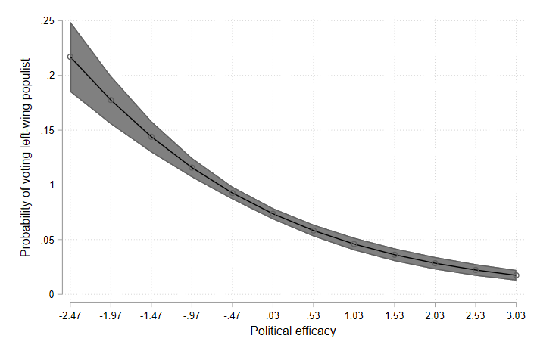

Predicted probabilities of voting left-wing populist (Model 9)
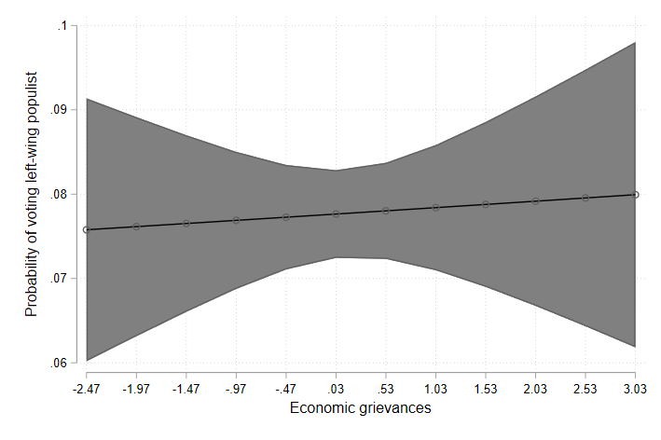

Models 13 and 14 in Table 3 compare right-wing and left-wing populist voters to far right and far left voters. Model 15 compares right-wing populist voters to left-wing populist voters. The last three models are again the same as first three models with interaction terms added.

Table 3: Populist vs. extremist comparison
Dependent variable:
 |  |  | RW populist vote  (13) | LW populist vote  (14) |  | RW populist vote  (15) |  | RW populist vote  (16) |  | LW populist vote  (17) | RW populist vote  (18)
Political Efficacy |  |  | 1.225 | -0.602*** |  | -0.465*** |  | 2.216 |  | -0.495*** | -0.571***
 |  |  | (0.859) | (0.103) |  | (0.057) |  | (1.401) |  | (0.115) | (0.063)
Economic Grievances |  |  | -0.040 | -0.189* |  | -0.236*** |  | -0.903 |  | -0.156 | -0.113*
 |  |  | (0.798) | (0.103) |  | (0.059) |  | (1.313) |  | (0.106) | (0.067)
Cultural Grievances |  |  | 0.280 | 0.146 |  | 0.696*** |  | -0.317 |  | 0.213** | 0.750***
 |  |  | (0.647) | (0.092) |  | (0.056) |  | (1.373) |  | (0.096) | (0.063)
Education |  |  | -0.239 | -0.059*** |  | -0.070*** |  | -0.241 |  | -0.059*** | -0.069***
 |  |  | (0.158) | (0.021) |  | (0.014) |  | (0.157) |  | (0.022) | (0.014)
Age |  |  | 0.050 | -0.024*** |  | -0.00000 |  | 0.052 |  | -0.023*** | -0.0002
 |  |  | (0.039) | (0.005) |  | (0.003) |  | (0.039) |  | (0.005) | (0.003)
Gender |  |  | 18.870 | -0.380** |  | -0.107 |  | 19.070 |  | -0.387** | -0.105
 |  |  | (3,504.26) | (0.150) |  | (0.089) |  | (3,405.55) |  | (0.151) | (0.089)
Income |  |  | 0.017 | -0.047 |  | 0.057*** |  | -0.031 |  | -0.045 | 0.061***
 |  |  | (0.246) | (0.032) |  | (0.020) |  | (0.251) |  | (0.032) | (0.020)
Efficacy*Economic |  |  |  |  |  |  |  | -0.661 |  | 0.088 | 0.164***
 |  |  |  |  |  |  |  | (0.853) |  | (0.068) | (0.045)
Efficacy*Cultural |  |  |  |  |  |  |  | -0.406 |  | 0.220*** | 0.086*
 |  |  |  |  |  |  |  | (0.855) |  | (0.082) | (0.049)
Observations |  |  | 4,536 | 2,288 |  | 6,616 |  | 4,536 |  | 2,288 | 6,616
Log Likelihood |  |  | -16.985 | -556.88 |  | -1,561.12 |  | -16.462 |  | -552.197 | -1,551.145
Akaike Inf. Crit. |  |  | 83.970 | 1,161.761 |  | 3,178.250 |  | 86.925 |  | 1,156.395 | 3,162.289
Note: |  |  | *p<0.1; **p<0.05; ***p<0.01

There seems to be no difference between right-wing populist and far right voters in terms of efficacy and cultural grievances. This is not surprising as many scholars use these terms interchangeably or even combine them as radical right-wing populist parties. Yet, the results of this comparison should be taken with a grain of salt because of the very small number of individuals in the sample who declared voting for a far-right party that is not populist.
Left-wing populist voters differ from far-left voters both in terms of political efficacy and economic grievances; they are less efficacious, in line with the theory and also have less economic grievances.
Predicted probabilities of voting left-wing populist (Model 14)
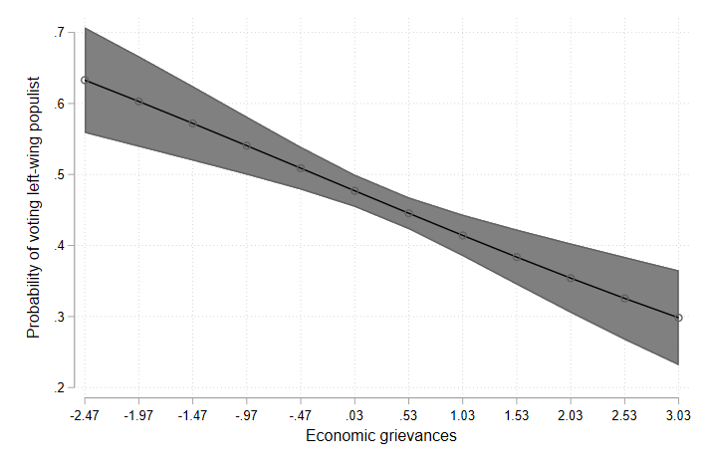

Predicted probabilities of voting left-wing populist (Model 14)
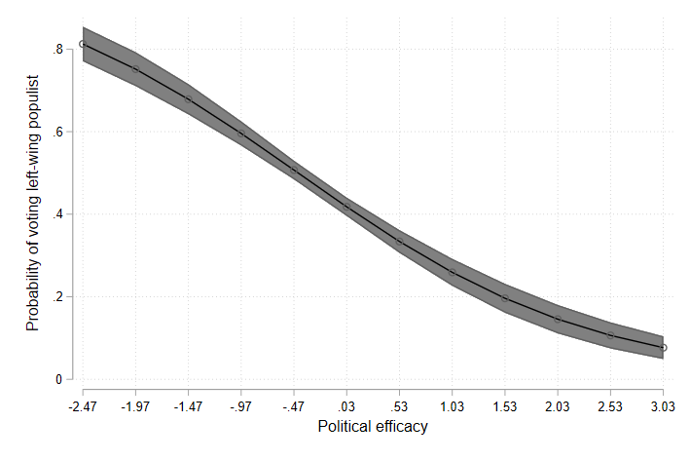
Finally, Model 15 suggest that right-wing populist voters feel less efficacious than left-wing populist voters. As hypothesized, having more cultural grievances increases the likelihood of a right-wing populist vote and economic grievances have the same effect for left-wing populist vote.

Appendix 7: Adding the second efficacy factor as a predictor
 | Dependent variable:
 | Populist vote
 | (1) | (2)
First factor | -0.185*** | -0.154***
 | (0.020) | (0.022)
Second factor |  | -0.066***
 |  | (0.023)
Economic Grievances | 0.049** | 0.059***
 | (0.022) | (0.022)
Cultural Grievances | 0.322*** | 0.317***
 | (0.018) | (0.018)
Education | -0.046*** | -0.044***
 | (0.005) | (0.005)
Age | -0.017*** | -0.017***
 | (0.001) | (0.001)
Gender | -0.284*** | -0.291***
 | (0.032) | (0.032)
Income | -0.046*** | -0.044***
 | (0.007) | (0.007)
Observations | 33,598 | 33,598
Log Likelihood | -13,163.100 | -13,158.950
Akaike Inf. Crit. | 26,384.200 | 26,377.910
Note: | *p<0.1; **p<0.05; ***p<0.01

While the AIC slightly favors the second model, the BIC favors the first one. The addition of the second factor also does not improve Pseudo R², which stays the same at 0.30.
Appendix 8: Using the anti-immigration question instead of cultural grievances battery
 | Dependent variable:
 | Right-wing populist vote
 | (1) | (2)
Political efficacy | -0.208*** | -0.075***
 | (0.023) | (0.024)
Economic Grievances | -0.082*** | -0.118***
 | (0.027) | (0.027)
Cultural Grievances | 0.576***
 | (0.022)
Anti-immigration |  | 0.302***
 |  | (0.010)
Education | -0.071*** | -0.074***
 | (0.006) | (0.006)
Age | -0.016*** | -0.011***
 | (0.001) | (0.001)
Gender | -0.303*** | -0.297***
 | (0.038) | (0.038)
Income | -0.030*** | -0.032***
Observations | 33,598 | 33,598
Log Likelihood | -9,478.116 | -9,301.022
Akaike Inf. Crit. | 19,014.230 | 18,660.040
Note: | *p<0.1; **p<0.05; ***p<0.01

All of the variables retain their significance.
Appendix 9: Checking for potential multicollinearity
It is possible that income variable is correlated with feeling about income variable that is included in the economic grievances battery. To rule multicollinearity out, I run two models with these variables and calculate Variance Inflation scores. As a rule of thumb, VIF scores above 10 suggest multicollinearity and VIF scores of 1.18 and 1.35 are way below the threshold.
Dependent variable: Populist vote
 | Est. | S.E. | z val. | p | VIF
(Intercept) | -1.29 | 0.03 | -37.906 | 0
Economic grievances | 0.36 | 0.01 | 24.6 | 0 | 1.18
Income | -0.03 | 0.01 | -5.07 | 0 | 1.18
Dependent variable: Populist vote
 | Est. | S.E. | z val. | p | VIF
(Intercept) | -2.02 | 0.06 | -33.22 | 0
Feeling about income | 0.4 | 0.02 | 20.71 | 0 | 1.3
Income | -0.02 | 0 | -4.25 | 0 | 1.3

Appendix 10: Confusion Matrices
 |  | Confusion Matrix and Statistics for Logistic Regression
 |  | Predicted
 |  | 0 | 1 |  | Accuracy: | 0.8257
Truth | 0 | 6455 | 338 |  | Sensitivity: | 0.8486
Truth | 1 | 1098 | 503 |  | Specificity: | 0.6205
 |  | Confusion Matrix and Statistics for Random Forest Classifier
 |  | Predicted
 |  | 0 | 1 |  | Accuracy: | 0.8404
Truth | 0 | 6532 | 261 |  | Sensitivity: | 0.8582
Truth | 1 | 1079 | 522 |  | Specificity: | 0.6667

Appendix 11: Further investigating the effect of age
The effect of age turns out to be the opposite of what the literature established. To further investigate this and also to check for non-linear effects, I estimate a model that contains a quadratic age variable. The predicted probabilities from this model, plotted below, demonstrates that age indeed has a non-linear effect. It slightly increases populist voting until around age 30 and people above 30 becomes less likely to vote for populist parties as they age.
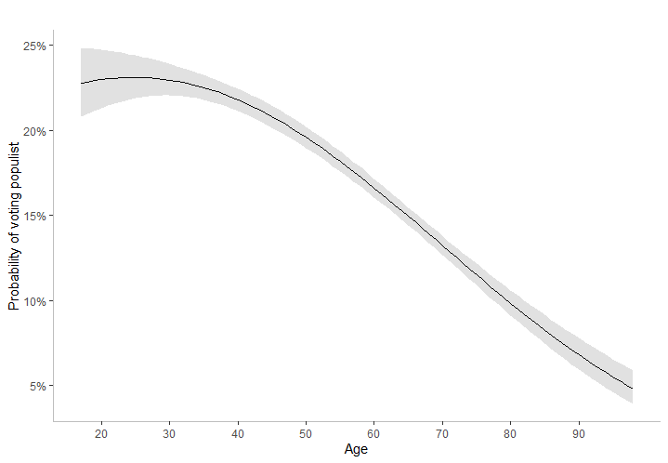
Appendix 12: Country estimates
 | Dependent variable:
 | Populist vote
 | Austria | Belgium | Bulgaria | Swit'land | Cyprus | Czechia
Political efficacy | -0.422*** | -1.128*** | 0.640*** | -0.670*** | 0.710 | 0.216***
 | (0.070) | (0.171) | (0.128) | (0.151) | (0.837) | (0.070)
Economic Grievances | 0.158** | -0.635*** | 0.215 | -0.206 | 0.078 | 0.014
 | (0.078) | (0.169) | (0.139) | (0.161) | (0.979) | (0.072)
Cultural Grievances | 0.569*** | 0.402** | -0.102 | 0.741*** | 1.101 | 0.081
 | (0.069) | (0.171) | (0.123) | (0.135) | (1.026) | (0.065)
Education | -0.102*** | -0.180*** | 0.022 | -0.132*** | -0.303 | 0.003
 | (0.023) | (0.041) | (0.024) | (0.040) | (0.273) | (0.017)
Age | -0.024*** | -0.026*** | -0.001 | -0.016** | -0.102 | -0.001
 | (0.004) | (0.009) | (0.007) | (0.007) | (0.075) | (0.004)
Gender | -0.292** | -0.112 | -0.139 | -0.175 | 0.417 | 0.105
 | (0.114) | (0.265) | (0.191) | (0.224) | (1.650) | (0.105)
Income | -0.080*** | -0.014 | 0.098** | -0.001 | -0.122 | 0.011
 | (0.025) | (0.064) | (0.047) | (0.049) | (0.426) | (0.024)
Constant | 1.706*** | -0.124 | -0.071 | 1.705** | 2.711 | -0.929**
 | (0.435) | (0.948) | (0.668) | (0.749) | (6.769) | (0.397)
Observations | 2,336 | 2,247 | 485 | 630 | 243 | 1,707
Log Likelihood | -1,004.038 | -251.803 | -316.041 | -267.996 | -9.469 | -1,080.529
Akaike Inf. Crit. | 2,024.076 | 519.607 | 648.083 | 551.992 | 34.938 | 2,177.058
Note: | *p<0.1; **p<0.05; ***p<0.01

 | Dependent variable:
 | Populist vote
 | Germany | Estonia | Spain | Finland | France | G. Britain
Political efficacy | -0.784*** | -0.503*** | -0.288** | -0.728*** | -0.681*** | -0.381***
 | (0.073) | (0.125) | (0.122) | (0.087) | (0.077) | (0.109)
Economic Grievances | 0.277*** | -0.051 | 0.427*** | -0.043 | -0.177** | -0.087
 | (0.075) | (0.131) | (0.123) | (0.091) | (0.081) | (0.119)
Cultural Grievances | -0.034 | 0.631*** | -0.870*** | 0.445*** | 0.438*** | 0.477***
 | (0.064) | (0.112) | (0.112) | (0.072) | (0.062) | (0.099)
Education | 0.055*** | 0.064** | -0.001 | -0.046** | -0.048*** | -0.123***
 | (0.020) | (0.029) | (0.022) | (0.020) | (0.017) | (0.031)
Age | -0.010*** | -0.003 | -0.023*** | -0.025*** | -0.013*** | -0.017***
 | (0.004) | (0.006) | (0.007) | (0.004) | (0.004) | (0.006)
Gender | -0.569*** | -0.693*** | -0.126 | -1.015*** | -0.059 | -0.479**
 | (0.124) | (0.193) | (0.186) | (0.139) | (0.111) | (0.189)
Income | -0.114*** | -0.005 | -0.027 | -0.074*** | -0.001 | -0.012
 | (0.024) | (0.046) | (0.042) | (0.028) | (0.023) | (0.037)
Constant | -0.839* | -2.915*** | -1.091* | 2.014*** | 0.538 | 0.496
 | (0.437) | (0.704) | (0.616) | (0.448) | (0.421) | (0.666)
Observations | 3,052 | 2,099 | 903 | 2,433 | 1,770 | 2,378
Log Likelihood | -966.572 | -431.934 | -368.163 | -810.974 | -990.724 | -468.173
Akaike Inf. Crit. | 1,949.145 | 879.867 | 752.326 | 1,637.949 | 1,997.448 | 952.346
Note: | *p<0.1; **p<0.05; ***p<0.01

 | Dependent variable:
 | Populist vote
 | Hungary | Ireland | Italy | Lithuania | Netherlands | Norway
Political efficacy | 0.805*** | -0.364*** | 0.213*** | -0.275 | -0.773*** | -0.585***
 | (0.103) | (0.087) | (0.077) | (0.185) | (0.085) | (0.104)
Economic Grievances | -0.320** | 0.346*** | 0.112 | -0.281 | 0.197** | -0.256**
 | (0.126) | (0.090) | (0.084) | (0.206) | (0.095) | (0.113)
Cultural Grievances | 0.472*** | -0.202*** | 0.538*** | 0.465*** | -0.028 | 0.828***
 | (0.094) | (0.077) | (0.077) | (0.165) | (0.087) | (0.104)
Education | -0.116*** | -0.055** | -0.054*** | -0.036 | -0.075*** | -0.071***
 | (0.028) | (0.024) | (0.017) | (0.049) | (0.019) | (0.021)
Age | -0.033*** | -0.033*** | -0.025*** | -0.001 | -0.015*** | -0.014***
 | (0.006) | (0.005) | (0.004) | (0.011) | (0.004) | (0.005)
Gender | -0.230 | -0.628*** | 0.017 | -0.069 | -0.273** | -0.687***
 | (0.165) | (0.140) | (0.119) | (0.258) | (0.132) | (0.168)
Income | -0.054 | -0.099*** | -0.014 | 0.037 | -0.072** | -0.066**
 | (0.034) | (0.032) | (0.029) | (0.061) | (0.029) | (0.032)
Constant | 5.062*** | 1.641*** | 2.191*** | -2.117* | 1.360*** | 0.949*
 | (0.624) | (0.533) | (0.407) | (1.177) | (0.463) | (0.492)
Observations | 1,000 | 2,254 | 1,313 | 722 | 2,036 | 2,099
Log Likelihood | -461.089 | -733.481 | -826.899 | -231.505 | -781.930 | -590.876
Akaike Inf. Crit. | 938.177 | 1,482.962 | 1,669.799 | 479.011 | 1,579.860 | 1,197.752
Note: | *p<0.1; **p<0.05; ***p<0.01

 | Dependent variable:
 | Populist vote
 | Poland | Sweden | Slovenia
Political efficacy | 1.381*** | -0.916*** | -0.220***
 | (0.104) | (0.157) | (0.084)
Economic Grievances | 0.379*** | 0.147 | -0.160*
 | (0.115) | (0.163) | (0.087)
Cultural Grievances | 0.698*** | 0.580*** | 0.133*
 | (0.095) | (0.160) | (0.074)
Education | -0.091*** | -0.111** | 0.003
 | (0.026) | (0.047) | (0.022)
Age | -0.018*** | -0.016** | -0.014***
 | (0.005) | (0.008) | (0.004)
Gender | -0.043 | -1.164*** | -0.345***
 | (0.146) | (0.279) | (0.130)
Income | -0.033 | 0.013 | -0.067**
 | (0.033) | (0.051) | (0.032)
Constant | 2.406*** | 1.385 | 1.009**
 | (0.541) | (0.926) | (0.478)
Observations | 1,155 | 1,111 | 1,049
Log Likelihood | -583.889 | -232.474 | -691.177
Akaike Inf. Crit. | 1,183.779 | 480.949 | 1,398.354
Note: | *p<0.1; **p<0.05; ***p<0.01

Bibliography
Bakker, Ryan, Liesbet Hooghe, Seth Jolly, Gary Marks, Jonathan Polk, Jan Rovny, Marco Steenbergen, and Milada Anna Vachudova. n.d. “1999 − 2019 Chapel Hill Expert Survey Trend File.” Chesdata. Accessed May 28, 2021. https://www.chesdata.eu/our-surveys.
Geurkink, Bram, Andrej Zaslove, Roderick Sluiter, and Kristof Jacobs. 2020. “Populist Attitudes, Political Trust, and External Political Efficacy: Old Wine in New Bottles?” Political Studies 68 (1): 247–67. https://doi.org/10.1177/0032321719842768.
Hainmueller, Jens, and Daniel J. Hopkins. 2014. “Public Attitudes Toward Immigration.” Annual Review of Political Science 17 (1): 225–49. https://doi.org/10.1146/annurev-polisci-102512-194818.
Kriesi, Hanspeter, and Julia Schulte-Cloos. 2020. “Support for Radical Parties in Western Europe: Structural Conflicts and Political Dynamics.” Electoral Studies 65 (June): 102138. https://doi.org/10.1016/j.electstud.2020.102138.

