Online Appendix for: Revolving Door Benefits?

Contents
Appendix A: Coding instructions for classifying meeting topics 2
Appendix B: Hiring Revolvers is Not Associated with Shorter or Less Diverse Subject Descriptions 6
Appendix C: Alternative DiD Estimator 7
Appendix D: Testing for Differential Pre-Treatment Trends 9
Appendix E: Temporal Dynamics in Effect of Revolvers on Meetings with Commission 9
Appendix F: Does The Revolving Door Complement Traditional Lobbying Strategies? 12
Appendix G: Results for Other EU Institutions 13
Appendix H: Linear Group Trends 14
Appendix I: Results from a Quarterly Panel 15
Appendix J: Including Never-Treated Interest Groups 16

Appendix A: Coding instructions for classifying meeting topics
Below, we describe our instructions for classifying the subject headers of meetings into four mutually exclusive categories: 1) High specificity, 2) Medium specificity, 3) High abstraction and 4) Not policy relevant/other. Each of these categories represent one indicator variable, and each meeting subject should be categorized as zero or one on each of the four variables.
See the attached spreadsheet for an example of how the classifications should be entered into the dataset.
Coders are advised to use Google searches in uncertain cases.

1. High specificity
Meetings related to specific (sets of) policies. They are recognizable in that are they will refer to a specific name of a policy initiative, package, directive, regulation or an act.
Clear-cut cases:
When it is explicitly stated that the meeting is on an initiative, directive, package, regulation, act, a specific regulatory decision (e.g. an antidumping case), a white paper, a green paper, or some other way of describing a formal proposal. This holds in any situation, where a named policy is mentioned.

Less clear cases:
Sometimes the subject line will not include direct indicators that the meeting was related to specific policy. In those cases, it can often be unclear whether the subject of a meeting is very broad or on a specific (set of) proposals that have been given a broad name. When it is difficult to classify the meeting subject for this reason, a quick Google search can typically reveal the correct level.
Example: The APCO Worldwide meetings with the Commission on “Digital Skills” (May 22, 2015) and “Digital Health” (Jan 21, 2017). Quick Google searches on these two subject lines reveal that the Commission has initiatives under both those names. This indicates that the meetings were related to these specific policies.
Another example: “Neighbourhood and Enlargement negotiations” (Avisa Partners meeting, Jan 2, 2018). This is a reference to specific political negotiations and should be classified as “high specificity”.
Sometimes the Commission meets with organized interests about a report, or because they have written a report. These meetings are only highly specific, if the topic of the report is mentioned.
There are some examples of very wide policy events or packages (e.g. Brexit, the EMU, the sovereign debt crisis). These are not examples of specific policies. However, if the meeting mentions a specific policy in relation to these topics (e.g. invocation of Article 50), this is highly specific.

2. Medium specificity
Meetings related to issues concerning a specific economic sector/industry of operation. They are recognizable in that they 1) refer to an issue that is relevant to a clearly delineated economic sector, but 2) do not mention specific policies by name.
By “clearly delineated economic sector” we mean that the subject refers to a (sub-)category of the 2-digit NAICS sector classification, which can be found here: https://en.wikipedia.org/wiki/North_American_Industry_Classification_System. This 2-digit system is further sub-dividable, and any reference to a lower level than the top 2-digit one also counts as a reference to a sector.
If the meeting makes reference to any specific group in society (e.g. consumers) this counts as medium specific as well.
Clear-cut cases:
Subject lines that directly mention a recognized economic sector or a specific product that is relevant to such a sector.
Example 1: “Transport” (APCO Worlwide meeting, March 23, 2015) is a reference to a specific sector of operation.
On the other hand, the subject line “Trade” (AccelorMittal meeting Feb 18, 2015) is an example of something that could appear “medium specific”. However, since it does not refer to any specific sector or industry, it should be placed in the “high abstraction” category.
Two examples of lower than the 2-digit level: “economic developments in the railway sector”, “economic outlook of the steel industry” both refer to clearly delineated sectors of operation.
Less clear cases:
Some subject headings refer to relatively specific concepts, but without also referring to a particular sector for which the meeting was important. These should be categorized as “high abstraction”, not “medium specificity”.
Two examples: “Data protection, free flow of data, research programmes” (BNP Paribas meeting, Sept. 4, 2018). While data might seem like something that is clearly delineated, the subject makes no reference to a specific sector.
“Pressing challenges for European labour markets and recent government reactions” (Bertelsmann Stiftung meeting, March 27, 2018). Although ‘labour markets’ seems relatively specific, no reference is made to a particular labor market of a sector.
Some subject headings use very general descriptions but the policy matters for a particular sector. All meetings, where the topic is on a particular good that is directly relevant to a specific sector, should be categorized as medium specific.
Example 1: “Financial services agenda” (BNP Paribas meeting, May 17, 2017) seems broad but refers to a particular sector (financial services). Similarly, mentions of “financial services” or “financial policy” refers to that sector.
Example 2: “Illegal content online” (Computer & Communications Industry Association meeting, February 1, 2018), because the meeting explicitly focused on “online” content, it should be categorized as medium specific, because it refers to a good produced by a specific sector.
Example 3: “Securitisation" (BNP Paribas, May 6, 2015) refers to the particular process of securitization within the financial industry. Therefore, it should be classified as medium specific.

3. Low specificity (high abstraction)
Meetings related to general outlook, broad policy questions. They are recognizable in that are they will 1) refer to very general policy matters, general policy areas or political visions, that 2) are not directly relatable to a specific sector or a specific policy. (2) are identifiable in that they do not refer to specific sectors of operation nor specific policies.
Clear-cut cases:
“Exchange of views on the EU Tax agenda” (AccelorMittal meeting, April 24, 2019). “Clean economy”, “Future of Europe”, “industrial policy of Europe”.

Less clear cases:
“Better regulation” (mentioned in many meetings) sounds very general, but is a reference to the Commission’s guidelines that aim at securing high quality in their development of new regulations. Make sure to apply Google searches in uncertain cases.

Sometimes the meeting will be on a specific proposal that the organized interest wishes to advance or some form of policy report that the organized interest has authored. These meetings should be classified as “High abstraction”, this is in keeping with one of our goals which is to measure the stage of the policy process that they discuss. The same goes for meetings in roundtables of, e.g., CEOs etc.

4. Non-Policy Relevant or Undefined
Meetings that are “introductory” or concern formalities (e.g. meetings to coordinate or hand over calenders).
Meetings with CEOs, coalitions of organized interests, etc., should be coded as undefined whenever no policy relevant topic for the meeting is mentioned.
Meetings that otherwise do not fall under the described categories.

Appendix B: Hiring Revolvers is Not Associated with Shorter or Less Diverse Subject Descriptions
As noted in the main text, we could expect organized interests that hire revolvers to try to avoid disclosing the content of their meetings. To test whether this drives our finding that organized interests have more meetings about agenda-setting when they hire former Commissioners, we pursue two strategies in Table B1. In column 1, we investigate whether the meetings are described with fewer words by calculating the total number of words in a subject description. In column 2, we estimate a similar model, but use the type-token ratio as the dependent variable, i.e. we divide the number of unique words with the total number of words used in a subject description. The former would capture if descriptions are strictly shorter, while the latter captures whether the descriptions of the meetings are less complex linguistically. To avoid post-treatment bias, we impute zeros for months when no meeting was held. In both cases, we cannot reject the null and estimate small differences-in-differences coefficients. This supports the interpretation of the findings we present in the main text.
Table B1: Hiring Revolvers and Linguistic Diversity of Meeting Subjects
 | Dependent variable:
 | Subject Length | Lexical Diversity
 | (1) | (2)
Hire Commission Revolver | -1.649 | 0.015
 | (1.361) | (0.011)
Organized Interest FE? | Yes | Yes
Month FE? | Yes | Yes
Year X Organized Interest FE? | Yes | Yes
Observations | 306 | 306
Residual Std. Error | 4.820 | 0.043
Note: Robust standard errors with organized interest-level clustering in parentheses. *, ** and *** indicates statistical significance at the 10, 5 and 1 per cent levels. Dependent variables: in column 1: the number of words in a subject description. In column 2: the type-token ratio.

Appendix C: Alternative DiD Estimator
The fixed effects estimator of the difference-in-differences may be biased in the presence of staggered treatments and heterogeneous treatment effects over time. To make sure that our results are not driven by this, we estimate the difference-in-differences using the Imai et al. (forthcoming) estimator. This technique estimates a separate difference-in-differences for each treatment event, and selects a clean control group that has not yet been treated. After estimating each difference-in-difference, the technique averages them all into a few estimates that are allowed to vary over the treated period. In Figure C1, we apply this technique. The main concern is that staggered treatment timing will bias the fixed effects estimator. However, the Imai et al. estimator (forthcoming) requires a lot more statistical power, since it estimates separate difference-in-differences for each treatment event. Therefore, if the two techniques produce comparable estimates, one should prefer the fixed effects estimator, since the Imai et al. (forthcoming) estimator will tend to be much less precise.
For comparison with our baseline results, we also present the estimate of the average effect throughout the treated period. In Panel A, we do not adjust for additional features besides matching exactly on year. Thereby, this specification is directly comparable to our baseline fixed effects models in the paper.
As we can see, the estimate is very similar, indicating that the results of the fixed effects regression are not biased by heterogeneous effects over time. The uncertainty in Figure C1 is much larger, however. A feature of the Imai et al (forthcoming) technique is that it allows for flexibly matching on covariates. In Panel B, we use Mahalanobis distance to match on the pre-treatment dependent variable, and we also match exactly on the type of organized interest. This increases the estimates significantly.
Overall, this analysis reassures us that our baseline fixed effects regressions provide reasonable estimates.
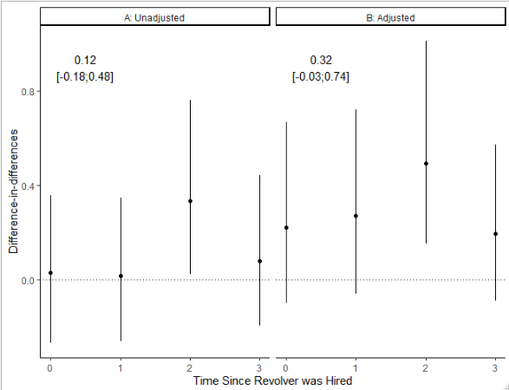
Figure C1: Robustness to Heterogeneous Effects over Time. Note: The figure shows estimates from the Imai et al (Forthcoming) DiD estimator. The dependent variable is a binary indicator of an agenda-setting meeting that month. Lines are 90% bootstrapped confidence intervals with clustering for organized interest. Both models match exactly on year. The model in Panel B uses Mahalanobis distance matching on the pre-treatment dependent variable and also matches exactly on type of organized interest.

Appendix D: Testing for Differential Pre-Treatment Trends
The assumption of parallel trends is fundamentally untestable. However, if the trends prior to treatment are informative about the trends after treatment, we can use pre-treatment trends as a placebo. In that case, we want to investigate whether hiring a Commission revolver is related to differential trends in access before the hiring takes place.
To investigate this, in Table D1, we follow Angrist and Pischke (2008) and add a one-year lead to the treatment indicator for Commission revolvers. As we can see in Table D1, we find no strong evidence of a differential pre-trend.
D1: Hiring Former EU Official or Politician and Meeting Content
 | Dependent variable:
 | Agenda-Setting? | ln Agenda-Setting +.5
 | (1) | (2)
Hire Commission Revolver₊₁₂ | -0.084 | -0.095
 | (0.105) | (0.115)
Organized Interest FE? | Yes | Yes
Month FE? | Yes | Yes
Organized Interest X Year FE? | Yes | Yes
Observations | 594 | 594
Residual Std. Error | 0.333 | 0.436
Note: Differential pre-treatment trends are tested by applying one- and two-year lags to the independent variable, respectively. Robust standard errors with clustering at the organized interest-level in parentheses. Coefficients are from unstandardized OLS regressions.

Appendix E: Temporal Dynamics in Effect of Revolvers on Meetings with Commission
In Figure E1, we present estimates of how effects vary across time. To do so, we add leads of lengths one through twelve to the dependent variable and estimate separate models for each. When comparing the estimates to the baseline specification, this corresponds to estimating which time-periods drives the effect – from one through twelve months into the future. As we can see, the effects on meetings overall remain statistically insignificant. However, we estimate that the effect on agenda-setting meetings is present for some months after the revolver arrives. Overall, it is safe to conclude that it is short-lived.

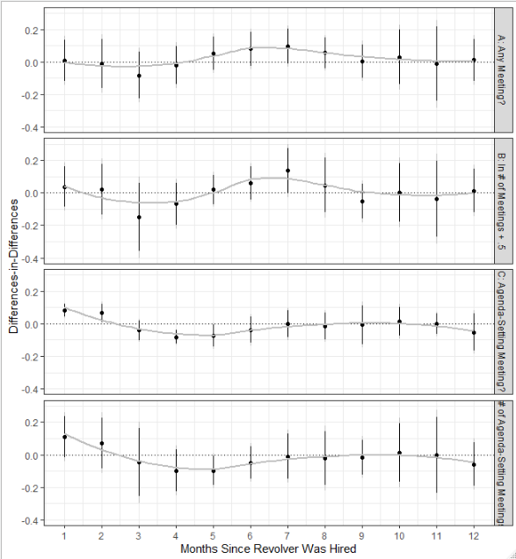
Figure E1: Temporal Dynamics in Effects on General and Agenda-Setting Meetings. Note: Each estimate is from a separate model, each applying a one-month lead to the respective dependent variable. Estimates are from regressions with fixed effects for organized interest, month, and an interaction between organized interest and year. Confidence intervals are 95 per cent (grey) and 90 per cent (black) with clustering for organized interest.

Appendix F: Does The Revolving Door Complement Traditional Lobbying Strategies?
As we explain in the main text, a serious threat to identification is if organized interests pursue other influence-seeking strategies simultaneously with hiring a revolver. In Table F1, we leverage data on yearly lobbying expenditures to investigate whether this is the case. In column 1, we investigate whether hiring a revolver is associated with a higher (natural log) of lobbying expenditures in the same year, as the hiring occurs. In column two, we investigate whether hiring a revolver generally succeeds a change in expenditure, by using the lagged expenditure as the dependent variables. In columns three and four, we use the difference in expenditure between the year of hiring and the previous and next year respectively, to investigate whether expenditures change when revolvers are hired. While there is some tendency for organized interests to decrease their spending before they hire Commission officials (but not Commissioners) and increase them afterwards, none of the estimates are statistically significant. This reassures us that our main results are unlikely to be driven by other strategies.
F1: Hiring Revolvers and Lobbying Expenditures
 | Dependent variable:
 | ln Expenditure | ln Expenditure t-1 | FD Expenditure t+1 | FD Expenditure t-1
 | (1) | (2) | (3) | (4)
Hire Commission Official | -0.023 | 0.048 | 0.031 | 0.045
 | (0.101) | (0.070) | (0.075) | (0.065)
Organized Interest FE? | Yes | Yes | Yes | Yes
Month FE? | Yes | Yes | Yes | Yes
Observations | 847 | 581 | 515 | 581
Residual Std. Error | 0.588 | 0.523 | 0.616 | 0.445
Note: Robust standard errors with organized interest-level clustering in parentheses. Estimates are from unstandardized regression models.

Appendix G: Results for Other EU Institutions
Table G1 shows the estimated effect of hiring revolvers from other EU institutions on gaining agenda-setting meetings with the Commission. We estimate sizable coefficients, which are too noisy to be considered statistically significant.
G1: Meetings and Revolvers from the European Parliament and Permanent Representation
 | Dependent variable:
 | Agenda-Setting Meeting? | ln # Agenda-Setting + .5
 | (1) | (2)
Hire EU Politician | 0.117 | 0.214
 | (0.167) | (0.239)
Organized Interest FE? | Yes | Yes
Month FE? | Yes | Yes
Organized Interest X Year FE? | Yes | Yes
Observations | 467 | 467
Residual Std. Error | 0.286 | 0.413
Note: Coefficients are from unstandardized OLS regressions. Robust standard errors with interest organized interest-level clustering in parentheses. . *, ** and *** indicates statistical significance at the 10, 5 and 1 per cent level.

Appendix H: Linear Group Trends
In the main results, we interact year and group dummies to control for unobserved differential shocks happening annually to the individual group. A different way confounding can happen is if groups follow different time-trends. This could threaten our results, if confounders affecting both hiring and meetings could trend within a year, rather than at a yearly level. To test whether our results can be driven by this, we use an alternative specification, where we interact the group fixed effects with a linear time trend. The results are presented in H1 – they are very similar to the results presented in the main paper.

H1: Hiring Former Commission Employees and Linear Trends in Commission Meetings
 | Dependent variable:
 | Meeting? | ln # Meetings + .5
 | (1) | (2)
Hire EU Official | 0.061 | 0.086
 | (0.048) | (0.052)
Organized Interest FE? | Yes | Yes
Year-Month FE? | Yes | Yes
Organized Interest X Year-Month Trend? | Yes | Yes
Organized Interest X Year FE? | No | No
Spending X Year-Month FE? | No | No
Observations | 849 | 849
Residual Std. Error | 0.420 | 0.684
Note: Coefficients are from unstandardized OLS regressions. Robust standard errors with interest organized interest-level clustering in parentheses. . *, ** and *** indicates statistical significance at the 10, 5 and 1 percent level.

Appendix I: Results from a Quarterly Panel
In Table I1, we aggregate our data into a year-quarter dataset, and present the results from four specifications: each our two dependent variables and with, respectively, an interaction between year and group fixed effects and an interaction between groups and linear time. The results largely resemble the monthly panel, although the specification in column 4 is significant at the 10 per cent level.

I1: Hiring Former Commission Employees and Commission Meetings (Quarterly Panel)
 | Dependent variable:
 | Meeting? |  | ln # Meetings + .5
 | (1) | (2) | (3) | (4)
Hire EU Official | 0.058 | 0.097 | 0.167 | 0.191*
 | (0.059) | (0.057) | (0.103) | (0.099)
Organized Interest FE? | Yes | Yes | Yes | Yes
Year-Month FE? | Yes | Yes | Yes | Yes
Organized Interest X Year FE? | Yes | No | Yes | No
Organized Interest X Time Trend | No | Yes | No | Yes
Observations | 849 | 849 | 849 | 849
Residual Std. Error | 0.378 | 0.378 | 0.692 | 0.692
Note: Data from a quarterly panel. Coefficients are from unstandardized OLS regressions. Robust standard errors with interest organized interest-level clustering in parentheses. *, ** and *** indicates statistical significance at the 10, 5 and 1 per cent level.

Appendix J: Including Never-Treated Interest Groups
In the main paper, we constrain our analysis to include only groups that at some point are treated. In Table J1 and Figure J1, we include all groups that never hire revolvers. This does not change the results substantially.

J1: Including Never-Treated Groups
 | Dependent variable:
 | Meeting? | ln # Meetings + .5
 | (1) | (2)
Hire EU Official | 0.048 | 0.122
 | (0.053) | (0.083)
Organized Interest FE? | Yes | Yes
Year-Month FE? | Yes | Yes
Organized Interest X Year FE? | Yes | Yes
Spending X Year-Month FE? | No | No
Observations | 305,156 | 305,156
Residual Std. Error | 0.202 | 0.255
Note: Never-treated groups included. Coefficients are from unstandardized OLS regressions. Robust standard errors with interest organized interest-level clustering in parentheses. *, ** and *** indicates statistical significance at the 10, 5 and 1 per cent level.

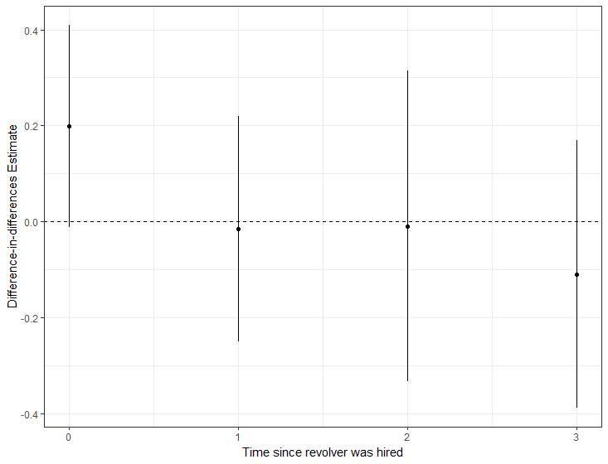
Figure J1: Including Never-Treated in the Imai et al Estimation.

References
Angrist, J. D., & Pischke, J. S. (2008). Mostly harmless econometrics: An empiricist's companion. Princeton: Princeton University Press.
Imai, K., Kim, I. S., & Wang, E. H. (forthcoming). Matching methods for causal inference with time-series cross-sectional data. American Journal of Political Science.

