Appendix

Table A.1: Correspondence between ISCED 2011 and ISCED 1997 as used by the European LFS and the ESS
IDCED 1997 (until 2013) as used by the European LFS 2013 | ISCED 2011(since 2014) as used by the ESS 2014 | Education level | Value
ISCED 1 | ISCED I | less than lower secondary | 0
ISCED 2 | ISCED II | lower secondary | 0
ISCED 3 a,b,c | ISCED IIIa,b | upper secondary | 0
ISCED 4a,b | ISCED IV | Post-secondary non-tertiary education | 1
ISCED 5 | ISCED V1, ISCED V2 | Tertiary education | 1

IDCED stands for International Standard Classification of Education and is a classification that tries to make the degree of education obtained by people through differing educational programs in countries around the word comparable. The LFS 2013 recorded its education data by the ISCED 1997 levels which was the standard ISCED measure when the data was collected. However, the ESS 2014 documents respondent’s education level by the ISCED 2011 which is a revision of the ISCED 1997 that was introduced as standard measure in 2014. We matched the ESS data for education with the LFS data as shown in Table A.1. to obtain a consistent measurement for education. This consistency is essential for us to combine the ESS individual data on respondent’s education and the aggregated LFS data about high- and low-skilled immigration exposure.

Table A.2: Multilevel ordered logistic regression models
 | (1) | (2) | (3) | (4) | (5) | (6)
 | Skill level of immigrants is important | Important if immigrants have skills country needs | Skill level of immigrants is important | Skill level of immigrants is important | Important if immigrants have skills country needs | Important if immigrants have skills country needs
High-skilled respondent | 0.16*** | 0.12*** |  | 0.19*** |  | 0.10***
 | (0.023) | (0.024) |  | (0.031) |  | (0.031)
Low-skilled respondent |  |  | -0.22*** |  | -0.14***
 |  |  | (0.032) |  | (0.033)
Exposure to low-skilled | 0.00 | -0.00 | -0.00 | 0.00 | -0.00 | -0.00
immigrants | (0.002) | (0.002) | (0.003) | (0.002) | (0.003) | (0.002)
Exposure to | 0.01*** | 0.01** | 0.01*** | 0.01*** | 0.01** | 0.01*
high-skilled immigrants | (0.003) | (0.003) | (0.003) | (0.003) | (0.003) | (0.003)
Low Skill-level* |  |  | 0.01*** |  | 0.00
exposure low skill |  |  | (0.003) |  | (0.003)
High Skill-level* |  |  |  | -0.00 |  | 0.00
exposure high skill |  |  |  | (0.002) |  | (0.002)
Male | 0.12*** | 0.20*** | 0.12*** | 0.12*** | 0.20*** | 0.20***
 | (0.022) | (0.022) | (0.022) | (0.022) | (0.022) | (0.022)
Age | -0.00*** | 0.00*** | -0.00*** | -0.00*** | 0.00*** | 0.00***
 | (0.001) | (0.001) | (0.001) | (0.001) | (0.001) | (0.001)
Political ideology | 0.04*** | 0.03*** | 0.03*** | 0.04*** | 0.03*** | 0.03***
 | (0.005) | (0.005) | (0.005) | (0.005) | (0.005) | (0.005)
Economy | 0.03*** | -0.01** | 0.03*** | 0.03*** | -0.01** | -0.01**
 | (0.006) | (0.006) | (0.006) | (0.006) | (0.006) | (0.006)
Identity | 0.06 | 0.04 | 0.05 | 0.06 | 0.04 | 0.04
 | (0.041) | (0.041) | (0.041) | (0.041) | (0.041) | (0.041)
Nativism score | -0.10*** | -0.12*** | -0.10*** | -0.10*** | -0.12*** | -0.12***
 | (0.001) | (0.001) | (0.001) | (0.001) | (0.001) | (0.001)
cut1 | -6.12*** | -6.93*** | -6.32*** | -6.11*** | -7.06*** | -6.94***
 | (0.138) | (0.129) | (0.140) | (0.138) | (0.132) | (0.129)
cut2 | -5.73*** | -6.58*** | -5.93*** | -5.72*** | -6.72*** | -6.59***
 | (0.137) | (0.128) | (0.139) | (0.137) | (0.131) | (0.128)
cut3 | -5.17*** | -6.07*** | -5.37*** | -5.16*** | -6.21*** | -6.08***
 | (0.136) | (0.127) | (0.138) | (0.136) | (0.130) | (0.127)
cut4 | -4.61*** | -5.62*** | -4.81*** | -4.60*** | -5.75*** | -5.62***
 | (0.135) | (0.126) | (0.137) | (0.135) | (0.129) | (0.126)
cut5 | -4.19*** | -5.24*** | -4.39*** | -4.18*** | -5.38*** | -5.25***
 | (0.135) | (0.125) | (0.137) | (0.135) | (0.128) | (0.126)
cut6 | -3.27*** | -4.39*** | -3.47*** | -3.26*** | -4.52*** | -4.40***
 | (0.134) | (0.124) | (0.136) | (0.134) | (0.127) | (0.125)
cut7 | -2.69*** | -3.82*** | -2.89*** | -2.68*** | -3.95*** | -3.83***
 | (0.134) | (0.124) | (0.136) | (0.134) | (0.127) | (0.124)
cut8 | -1.86*** | -2.98*** | -2.06*** | -1.86*** | -3.11*** | -2.98***
 | (0.133) | (0.123) | (0.135) | (0.133) | (0.126) | (0.123)
cut9 | -0.75*** | -1.81*** | -0.95*** | -0.74*** | -1.94*** | -1.82***
 | (0.133) | (0.122) | (0.135) | (0.133) | (0.125) | (0.123)
cut10 | -0.07 | -1.02*** | -0.27** | -0.06 | -1.15*** | -1.03***
 | (0.133) | (0.122) | (0.135) | (0.133) | (0.125) | (0.123)
Country variance | 0.21*** | 0.16*** | 0.21*** | 0.21*** | 0.16*** | 0.16***
 | (0.069) | (0.052) | (0.068) | (0.069) | (0.052) | (0.055)
Observations | 26,772 | 26,785 | 26,772 | 26,772 | 26,785 | 26,785
Number of groups | 19 | 19 | 19 | 19 | 19 | 19
Standard errors in parentheses, *** p<0.01, ** p<0.05, * p<0.1
Table A.3: Multilevel logistic regression models

 | (1) | (2) | (3) | (4) | (5) | (6)
 | Skill level of immigrants is important | Important if immigrants have skills country needs | Skill level of immigrants is important | Skill level of immigrants is important | Important if immigrants have skills country needs | Important if immigrants have skills country needs
High-skilled respondent | 0.19*** | 0.18*** |  | 0.25*** |  | 0.21***
 | (0.031) | (0.033) |  | (0.040) |  | (0.044)
Low-skilled respondent |  |  | -0.27*** |  | -0.23***
 |  |  | (0.042) |  | (0.046)
Exposure to low-skilled | -0.00 | -0.00 | -0.01** | -0.00 | -0.01* | -0.00
immigrants | (0.003) | (0.003) | (0.004) | (0.003) | (0.004) | (0.003)
Exposure to | 0.01** | 0.01* | 0.01** | 0.01*** | 0.01* | 0.01**
high-skilled immigrants | (0.004) | (0.004) | (0.004) | (0.004) | (0.004) | (0.004)
Low Skill-level* |  |  | 0.01*** |  | 0.01*
exposure low skill |  |  | (0.004) |  | (0.004)
High Skill-level* |  |  |  | -0.01** |  | -0.00
exposure high skill |  |  |  | (0.003) |  | (0.003)
Male | 0.17*** | 0.27*** | 0.18*** | 0.18*** | 0.27*** | 0.27***
 | (0.029) | (0.031) | (0.029) | (0.029) | (0.031) | (0.031)
Age | -0.00*** | 0.00*** | -0.00*** | -0.00*** | 0.00*** | 0.00***
 | (0.001) | (0.001) | (0.001) | (0.001) | (0.001) | (0.001)
Political ideology | 0.03*** | 0.04*** | 0.03*** | 0.03*** | 0.04*** | 0.04***
 | (0.007) | (0.008) | (0.007) | (0.007) | (0.008) | (0.008)
Economy | 0.07*** | 0.03*** | 0.07*** | 0.07*** | 0.03*** | 0.03***
 | (0.007) | (0.008) | (0.007) | (0.007) | (0.008) | (0.008)
Identity | 0.12** | 0.09 | 0.12** | 0.12** | 0.09 | 0.09
 | (0.052) | (0.057) | (0.052) | (0.052) | (0.057) | (0.057)
Nativism score | -0.10*** | -0.13*** | -0.10*** | -0.10*** | -0.13*** | -0.13***
 | (0.002) | (0.002) | (0.002) | (0.002) | (0.002) | (0.002)
Country variance | 0.23*** | 0.16*** | 0.22*** | 0.22*** | 0.16*** | 0.16***
 | (0.074) | (0.055) | (0.073) | (0.074) | (0.054) | (0.055)
Constant | 2.97*** | 4.26*** | 3.21*** | 2.95*** | 4.47*** | 4.24***
 | (0.153) | (0.153) | (0.157) | (0.153) | (0.159) | (0.154)
Observations | 26,772 | 26,785 | 26,772 | 26,772 | 26,785 | 26,785
Number of groups | 19 | 19 | 19 | 19 | 19 | 19
Standard errors in parentheses, *** p<0.01, ** p<0.05, * p<0.1

Table A.4: Components of the nativism scale

Wording of the Question | Category
And, using this card, would you say that [country]’s cultural life is generally undermined or enriched by people coming to live here from other countries? | 0 = Cultural life is undermined  10 = Cultural life is enriched
How important should it be for them [=Immigrants] to be able to speak [country’s official language(s)]? | 0 = Extremely unimportant  10 = Extremely important  [Reverse-coded for analysis]
How important should it be for them [=Immigrants] to come from a Christian background? | 0 = Extremely unimportant  10 = Extremely important  [Reverse-coded for analysis]
How important should it be for them [=Immigrants] to be white? | 0 = Extremely unimportant  10 = Extremely important  [Reverse-coded for analysis]
How important should it be for them [=Immigrants] to be committed to the way of life in [country]? | 0 = Extremely unimportant  10 = Extremely important  [Reverse-coded for analysis]
Using this card, do you think the religious beliefs and practices in [country] are generally undermined or enriched by people coming to live here from other countries? | 0 =Religious beliefs and practices undermined  10 = Religious beliefs and practices enriched

Figure A.1: Summary statistics of the dependent variables

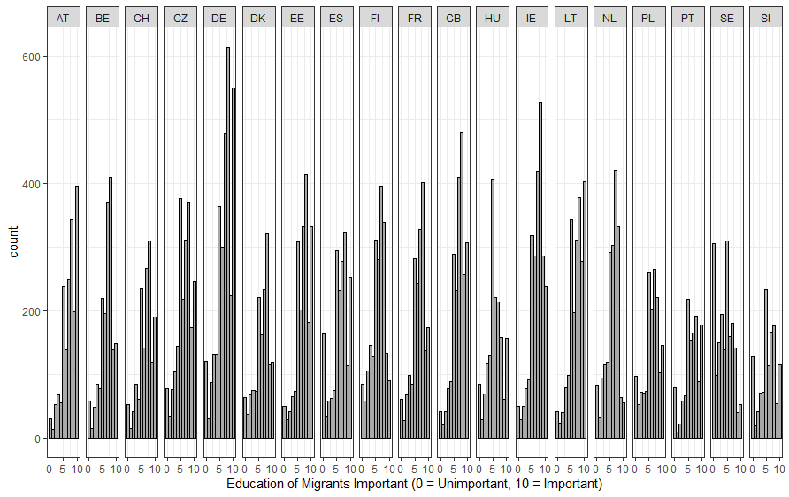
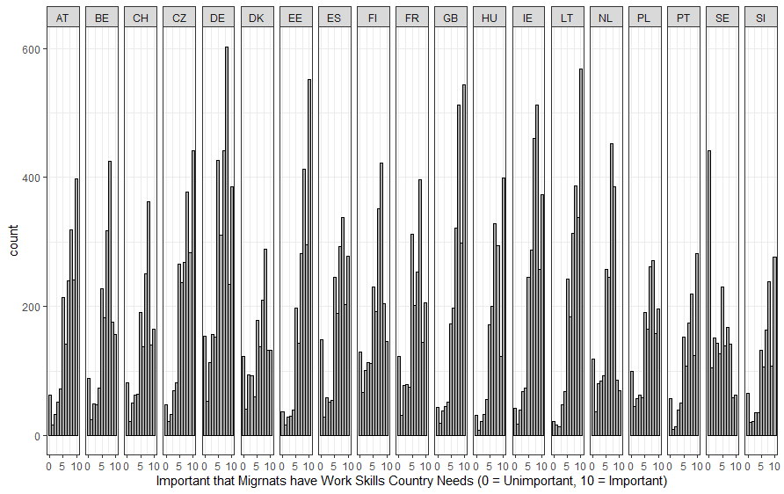

Figure A.2: Interaction effects based on university education as measure of high-skill level – Dependent variable = High education of migrants important

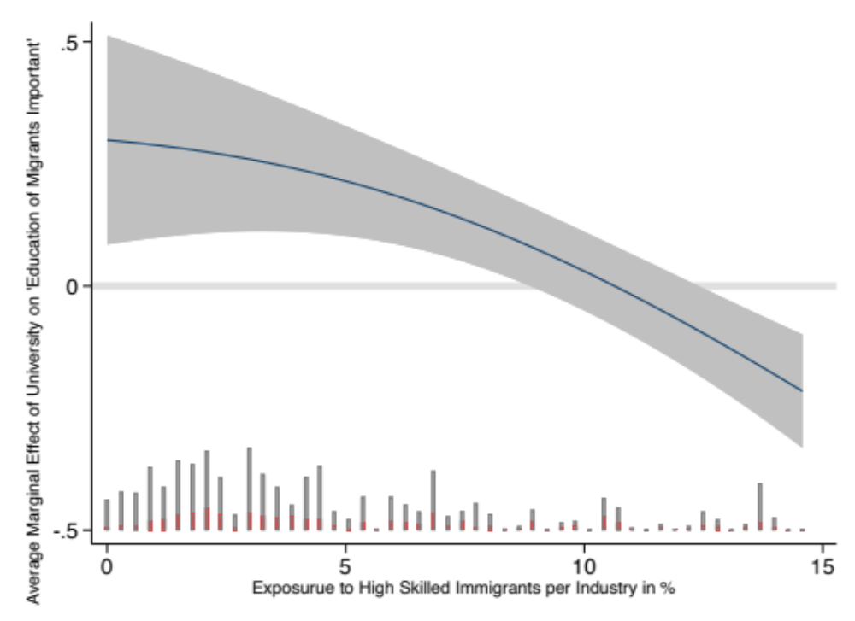

Figure A.3: Summary statistics of Exposure to low skilled immigrants and Exposure to high skilled immigrants by sector and country

