Supplementary Material for “Future scenarios of global plastic waste generation and disposal”
Laurent Lebreton^{1,2,} *, Anthony Andrady³
¹ The Ocean Cleanup Foundation, Rotterdam, The Netherlands
² The Modelling House, Raglan, New Zealand
³ North Carolina State University, Raleigh NC, U.S.A.
* laurent.lebreton@theoceancleanup.com

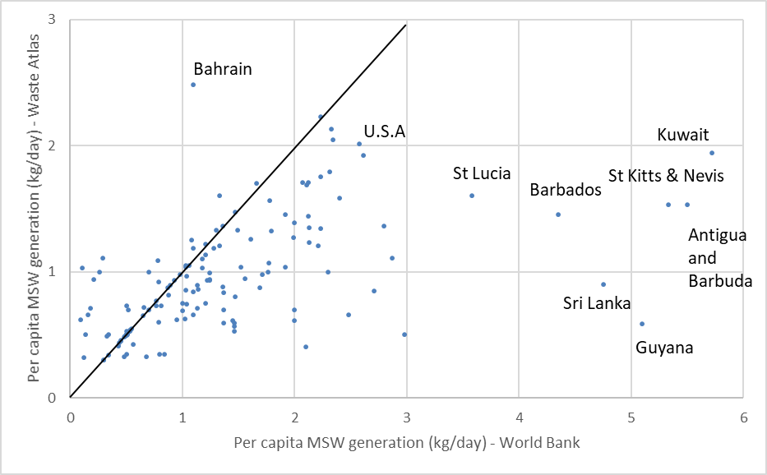
Supplementary Figure 1: Comparison between per capita municipal solid waste (MSW) generation reported by the World Bank (Hoornweg and Bhada-Tata, 2012) and by Waste Atlas (2016). Values of per capita MSW generation are generally in good agreement for most of the 160 countries of comparison. However, the World Bank reported significantly higher values for some Caribbean countries, Kuwait and Sri Lanka with more than 5 kg per day of per capita MSW generation. These values represented more than twice the consumption of citizens in industrialised countries (e.g. USA with 2.0 – 2.6 kg per day and per capita). This discrepancy motivated the selection of self-reported figures in this study as provided by Waste Atlas.

A) Per capita MSW generation (kg/year) | B) Unsound disposal fraction (%)
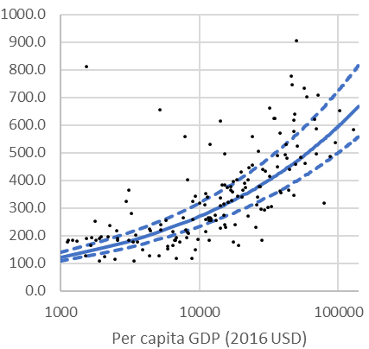 | 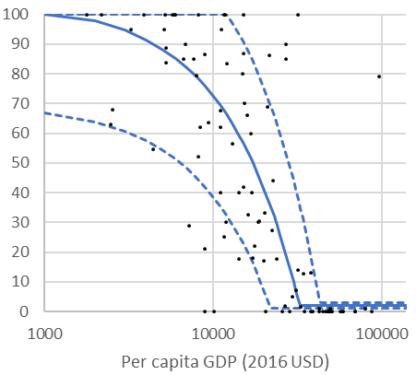
Supplementary Figure 2: A) Per capita municipal solid waste (MSW) in kg y⁻¹ vs per capita GDP in 2016 US Dollar for n = 160 countries (Waste Atlas, 2016). Low, mid and high prediction function (blue lines) determined for equation (1) of the main manuscript. B) Unsound disposal (i.e. mismanaged) fraction in % vs per capita GDP in 2016 US Dollar for n = 95 countries. Low, mid and high prediction function (blue lines) determined for equation (5) of the main manuscript.

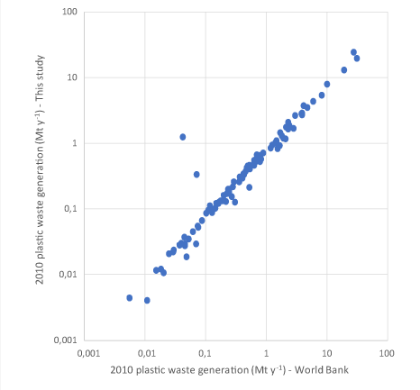
Supplementary Figure 3: Comparison between total plastic waste generation per country using data from the World Bank (Hoornweg and Bhada-Tata, 2012) and as computed in this study for 2010. Only countries with available data for both per capita municipal solid waste (MSW) generation and fraction of plastic in MSW are represented.

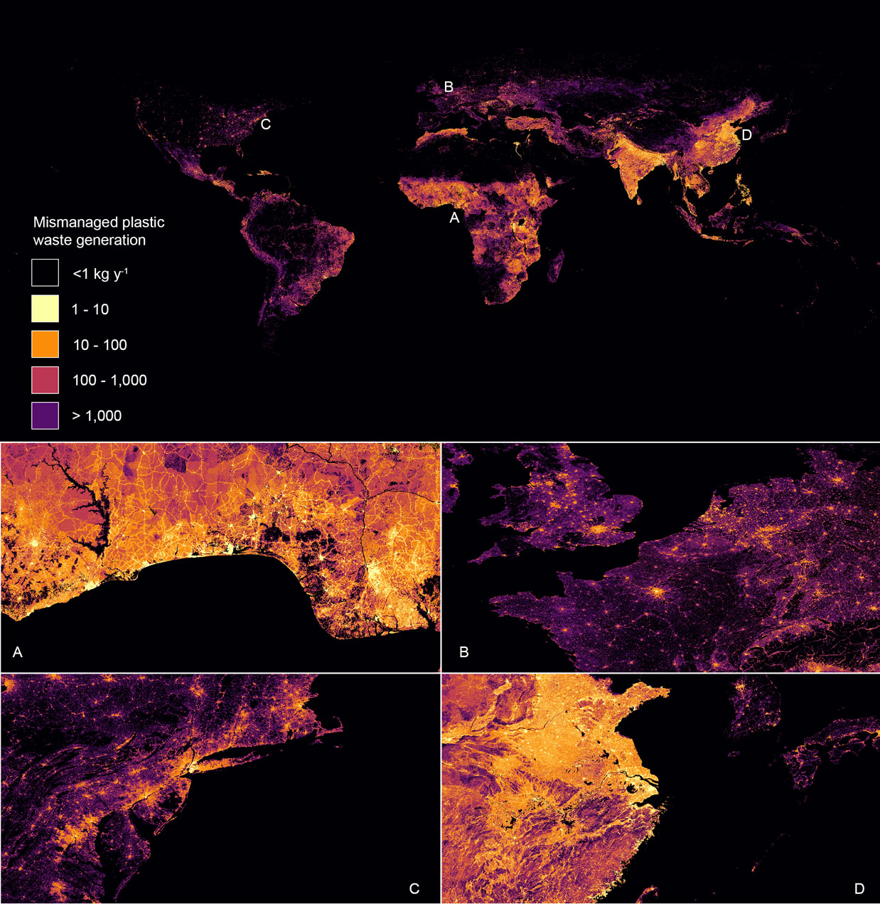
Supplementary Figure 4: Mismanaged plastic waste (MPW) for 2015 showing most waste is generated near urban centres and transportations axes.
Continent | Region | Countries
Africa | Eastern Africa | Burundi, Comoros, Djibouti, Eritrea, Ethiopia, Kenya, Madagascar, Malawi, Mauritius, Mozambique, Rwanda, Uganda, United Republic of Tanzania, Seychelles, South Sudan, Sudan, Zambia, Zimbabwe
 | Middle Africa | Angola, Cameroon, Central African Republic, Chad, Congo, Democratic Republic of the Congo, Equatorial Guinea, Gabon, Sao Tome and Principe
 | Northern Africa | Algeria, Egypt, Libya, Morocco, Tunisia
 | Southern Africa | Botswana, Lesotho, Namibia, South Africa, Swaziland
 | Western Africa | Benin, Burkina Faso, Cabo Verde, Côte d'Ivoire, Gambia, Ghana, Guinea, Guinea-Bissau, Liberia, Mali, Mauritania, Niger, Nigeria, Senegal, Sierra Leone, Togo
Asia | Central Asia | Kazakhstan, Kyrgyzstan, Tajikistan, Turkmenistan, Uzbekistan
 | Eastern Asia | China, Hong Kong SAR, Japan, Macao SAR, Mongolia, Republic of Korea, Taiwan
 | South-Eastern Asia | Brunei Darussalam, Cambodia, Indonesia, Lao People's Democratic Republic, Malaysia, Myanmar, Philippines, Singapore, Thailand, Timor-Leste, Vietnam
 | Southern Asia | Afghanistan, Bangladesh, Bhutan, India, Iran (Islamic Republic of), Nepal, Pakistan, Sri Lanka
 | Western Asia | Armenia, Azerbaijan, Bahrain, Cyprus, Georgia, Iraq, Israel, Jordan, Kuwait, Lebanon, Oman, Qatar, Saudi Arabia, State of Palestine, Turkey, United Arab Emirates, Yemen
Europe | Eastern Europe | Belarus, Bulgaria, Czech Republic, Hungary, Poland, Republic of Moldova, Romania, Russian Federation, Slovakia, Ukraine
 | Northern Europe | Denmark, Estonia, Finland, Iceland, Ireland, Latvia, Lithuania, Norway, Sweden, United Kingdom
 | Southern Europe | Albania, Bosnia and Herzegovina, Croatia, Greece, Italy, Malta, Portugal, San Marino, Serbia, Slovenia, Spain, TFYR Macedonia
 | Western Europe | Austria, Belgium, France, Germany, Luxembourg, Netherlands, Switzerland
Latin America and Caribbean | Caribbean | Antigua and Barbuda, Bahamas, Barbados, Dominica, Dominican Republic, Grenada, Haiti, Jamaica, Puerto Rico, Saint Kitts and Nevis, Saint Lucia, Saint Vincent and the Grenadines, Trinidad and Tobago
 | Central America | Belize, Costa Rica, El Salvador, Guatemala, Honduras, Mexico, Nicaragua, Panama
 | South America | Argentina, Bolivia (Plurinational State of), Brazil, Chile, Colombia, Ecuador, Guyana, Paraguay, Peru, Suriname, Uruguay, Venezuela (Bolivarian Republic of)
Northern America | Northern America | Canada, United States of America
Oceania | Australia/New Zealand | Australia, New Zealand
 | Melanesia/Polynesia | Fiji, Papua New Guinea, Samoa, Solomon Islands, Tonga, Tuvalu, Vanuatu
 | Micronesia | Kiribati, Marshall Islands, Micronesia (Fed. States of), Palau

Supplementary Table 1: List of countries (n = 188) considered in this study with corresponding regions and continents.
Regions | 2020 |  |  | 2040 |  |  | 2060
Regions | low | mid | high | low | mid | high | low | mid | high
Eastern Africa | 3,59 | 7,22 | 8,77 | 7,08 | 14,28 | 17,65 | 11,58 | 23,85 | 30,26
Middle Africa | 1,60 | 2,87 | 3,45 | 3,31 | 5,78 | 7,02 | 5,68 | 9,98 | 12,36
Northern Africa | 3,23 | 4,00 | 4,43 | 5,62 | 6,57 | 7,03 | 7,81 | 9,22 | 10,06
Southern Africa | 0,32 | 0,92 | 1,60 | 0,46 | 1,37 | 2,55 | 0,57 | 1,72 | 3,27
Western Africa | 3,19 | 5,38 | 6,36 | 6,56 | 11,49 | 14,42 | 11,48 | 20,62 | 26,78
Central Asia | 0,38 | 1,01 | 1,55 | 0,57 | 1,58 | 2,59 | 0,73 | 2,08 | 3,53
Eastern Asia | 19,08 | 21,30 | 22,32 | 25,78 | 29,82 | 32,69 | 28,20 | 33,52 | 37,92
South-Eastern Asia | 11,59 | 13,91 | 14,83 | 17,68 | 21,06 | 22,60 | 22,12 | 27,04 | 29,99
Southern Asia | 20,18 | 23,44 | 24,79 | 34,62 | 41,44 | 45,84 | 47,54 | 58,61 | 67,13
Western Asia | 2,83 | 3,76 | 5,07 | 4,13 | 5,69 | 8,16 | 5,08 | 7,64 | 11,88
Eastern Europe | 1,02 | 2,84 | 5,70 | 1,09 | 3,15 | 6,64 | 1,07 | 3,25 | 7,12
Northern Europe | 0,03 | 0,06 | 0,55 | 0,04 | 0,07 | 0,67 | 0,05 | 0,08 | 0,77
Southern Europe | 0,35 | 0,50 | 2,12 | 0,40 | 0,58 | 2,35 | 0,41 | 0,60 | 2,49
Western Europe | 0,01 | 0,11 | 1,27 | 0,01 | 0,13 | 1,42 | 0,01 | 0,14 | 1,54
Caribbean | 0,56 | 0,73 | 0,87 | 0,75 | 0,97 | 1,18 | 0,86 | 1,14 | 1,41
Central America | 1,36 | 1,59 | 1,69 | 2,05 | 2,41 | 2,61 | 2,66 | 3,21 | 3,58
South America | 5,44 | 6,21 | 6,44 | 7,34 | 8,21 | 8,44 | 8,55 | 9,70 | 10,18
Northern America | 0,03 | 0,31 | 3,16 | 0,03 | 0,37 | 3,80 | 0,04 | 0,43 | 4,38
Australia/New Zealand | 0,001 | 0,008 | 0,121 | 0,001 | 0,010 | 0,160 | 0,001 | 0,013 | 0,197
Melanesia | 0,060 | 0,154 | 0,235 | 0,104 | 0,270 | 0,414 | 0,153 | 0,401 | 0,619
Micronesia | 0,000 | 0,001 | 0,002 | 0,001 | 0,002 | 0,003 | 0,001 | 0,002 | 0,004
Polynesia | 0,001 | 0,003 | 0,005 | 0,002 | 0,004 | 0,007 | 0,002 | 0,006 | 0,010
WORLD | 74,86 | 96,34 | 115,31 | 117,63 | 155,27 | 188,24 | 154,59 | 213,25 | 265,48
Supplementary Table 2: Projections of MPW generation per subcontinental regions under scenario A (business as usual) in Mt y⁻¹ for 2020, 2040 and 2060. Low, mid and high values correspond to our confidence intervals.

Regions | 2020 |  |  | 2040 |  |  | 2060
Regions | low | mid | high | low | mid | high | low | mid | high
Eastern Africa | 3,45 | 7,05 | 8,57 | 5,47 | 12,34 | 15,38 | 6,05 | 17,03 | 22,05
Middle Africa | 1,58 | 2,84 | 3,42 | 2,82 | 5,20 | 6,33 | 3,79 | 7,66 | 9,63
Northern Africa | 2,73 | 3,46 | 3,87 | 1,29 | 1,87 | 2,04 | 0,01 | 0,12 | 1,23
Southern Africa | 0,27 | 0,85 | 1,52 | 0,02 | 0,32 | 1,27 | 0,02 | 0,08 | 0,45
Western Africa | 3,11 | 5,29 | 6,25 | 5,13 | 9,63 | 12,16 | 6,06 | 13,31 | 17,56
Central Asia | 0,32 | 0,90 | 1,41 | 0,25 | 0,92 | 1,47 | 0,16 | 0,70 | 1,33
Eastern Asia | 12,79 | 14,95 | 15,91 | 0,05 | 0,51 | 5,38 | 0,05 | 0,56 | 6,14
South-Eastern Asia | 9,03 | 11,26 | 12,11 | 5,02 | 7,59 | 10,35 | 0,56 | 1,86 | 6,43
Southern Asia | 17,66 | 20,81 | 22,13 | 11,70 | 16,32 | 18,26 | 3,72 | 5,96 | 12,82
Western Asia | 2,18 | 3,06 | 4,33 | 0,49 | 0,68 | 2,76 | 0,51 | 0,78 | 2,72
Eastern Europe | 0,77 | 1,66 | 4,34 | 0,16 | 0,56 | 1,65 | 0,08 | 0,20 | 1,32
Northern Europe | 0,004 | 0,05 | 0,52 | 0,01 | 0,06 | 0,63 | 0,01 | 0,07 | 0,72
Southern Europe | 0,22 | 0,37 | 1,09 | 0,04 | 0,13 | 0,95 | 0,01 | 0,09 | 0,95
Western Europe | 0,01 | 0,12 | 1,27 | 0,01 | 0,13 | 1,43 | 0,01 | 0,14 | 1,55
Caribbean | 0,47 | 0,63 | 0,76 | 0,26 | 0,39 | 0,57 | 0,24 | 0,38 | 0,59
Central America | 0,99 | 1,21 | 1,30 | 0,55 | 0,78 | 1,27 | 0,16 | 0,40 | 1,01
South America | 4,58 | 5,32 | 5,62 | 0,95 | 1,60 | 2,67 | 0,02 | 0,24 | 2,51
Northern America | 0,03 | 0,31 | 3,16 | 0,04 | 0,38 | 3,81 | 0,04 | 0,43 | 4,38
Australia/New Zealand | 0,001 | 0,008 | 0,088 | 0,001 | 0,010 | 0,117 | 0,001 | 0,013 | 0,145
Melanesia | 0,058 | 0,151 | 0,231 | 0,076 | 0,228 | 0,356 | 0,068 | 0,268 | 0,430
Micronesia | 0,0004 | 0,001 | 0,002 | 0,0004 | 0,001 | 0,002 | 0,0004 | 0,001 | 0,002
Polynesia | 0,001 | 0,003 | 0,005 | 0,001 | 0,003 | 0,006 | 0,00002 | 0,003 | 0,005
WORLD | 60,27 | 80,31 | 97,89 | 34,34 | 59,64 | 88,85 | 21,57 | 50,29 | 93,98
Supplementary Table 3: Projections of MPW generation per subcontinental regions under scenario B (waste management improves as economy grows) in Mt y⁻¹ for 2020, 2040 and 2060. Low, mid and high values correspond to our confidence intervals.
Regions | 2020 |  |  | 2040 |  |  | 2060
Regions | low | mid | high | low | mid | high | low | mid | high
Eastern Africa | 3,15 | 6,14 | 7,53 | 2,94 | 5,61 | 6,16 | 3,33 | 7,84 | 8,93
Middle Africa | 1,53 | 2,58 | 2,72 | 1,63 | 2,44 | 2,52 | 2,22 | 3,61 | 3,84
Northern Africa | 2,22 | 2,76 | 3,05 | 0,52 | 0,75 | 0,81 | 0,00 | 0,05 | 0,49
Southern Africa | 0,27 | 0,78 | 1,16 | 0,01 | 0,15 | 0,49 | 0,01 | 0,04 | 0,17
Western Africa | 3,11 | 4,88 | 5,09 | 3,13 | 4,57 | 4,82 | 3,69 | 6,32 | 6,97
Central Asia | 0,32 | 0,82 | 1,07 | 0,15 | 0,42 | 0,56 | 0,10 | 0,32 | 0,50
Eastern Asia | 12,79 | 14,94 | 15,88 | 0,02 | 0,26 | 2,67 | 0,03 | 0,28 | 3,05
South-Eastern Asia | 5,19 | 6,80 | 7,43 | 1,27 | 2,19 | 3,19 | 0,20 | 0,70 | 2,20
Southern Asia | 17,55 | 20,59 | 24,57 | 6,73 | 9,24 | 10,18 | 2,23 | 3,41 | 7,04
Western Asia | 1,80 | 2,57 | 3,55 | 0,25 | 0,34 | 1,21 | 0,27 | 0,40 | 1,25
Eastern Europe | 0,63 | 1,45 | 3,61 | 0,08 | 0,30 | 0,76 | 0,04 | 0,09 | 0,55
Northern Europe | 0,004 | 0,04 | 0,44 | 0,00 | 0,02 | 0,25 | 0,00 | 0,03 | 0,29
Southern Europe | 0,19 | 0,30 | 0,85 | 0,02 | 0,05 | 0,37 | 0,00 | 0,04 | 0,37
Western Europe | 0,01 | 0,10 | 1,06 | 0,01 | 0,06 | 0,60 | 0,01 | 0,06 | 0,65
Caribbean | 0,44 | 0,56 | 0,59 | 0,15 | 0,18 | 0,22 | 0,15 | 0,17 | 0,23
Central America | 0,91 | 1,10 | 1,47 | 0,27 | 0,35 | 0,66 | 0,09 | 0,20 | 0,61
South America | 3,64 | 4,23 | 5,08 | 0,53 | 0,82 | 1,27 | 0,01 | 0,10 | 1,06
Northern America | 0,03 | 0,26 | 2,63 | 0,02 | 0,16 | 1,58 | 0,02 | 0,18 | 1,82
Australia/New Zealand | 0,001 | 0,008 | 0,175 | 0,001 | 0,009 | 0,094 | 0,001 | 0,011 | 0,118
Melanesia | 0,058 | 0,139 | 0,178 | 0,046 | 0,105 | 0,136 | 0,041 | 0,123 | 0,163
Micronesia | 0,0004 | 0,001 | 0,001 | 0,000 | 0,001 | 0,001 | 0,0003 | 0,001 | 0,001
Polynesia | 0,001 | 0,003 | 0,004 | 0,001 | 0,002 | 0,002 | 0,00001 | 0,001 | 0,002
WORLD | 53,83 | 71,05 | 88,14 | 17,78 | 28,03 | 38,54 | 12,44 | 23,97 | 40,31
Supplementary Table 4: Projections of MPW generation per subcontinental regions under scenario c (fraction of plastic in municipal solid waste is reduced to 10% by 2020 and 5% by 2040 and waste management improves as economy grows) in Mt y⁻¹ for 2020, 2040 and 2060. Low, mid and high values correspond to our confidence intervals.

REFERENCES
Hoornweg D and Bhada-Tata P (2012) What a Waste : A Global Review of Solid Waste Management. World Bank, http://hdl.handle.net/10986/17388.
Waste Atlas (2016) D-Waste [Online] Waste Atlas. Available at: http://www.atlas.d-waste.com/
[Accessed 4 August 2016].

