Supporting Information for

RURAL UNEMPLOYMENT PUSHES MIGRANTS TO URBAN AREAS IN JIANGSU PROVINCE, CHINA

Contents of this file

Text S1 to S4
Table S1 to S4, Figure S1 to S3

Introduction

This supporting information provides data sources table, auxiliary socio-economic time series (including related descriptions), division method of agricultural and non-agricultural income, and RUMiC (Rural-Urban Migration in China) survey data.

Variable / Data Name | Data Source | Temp Step
Precipitation | Climate Research Unit (CRU) (CRU, 1985-2015; Harris et al., 2014) | Monthly (converted to yearly)
Total Population, Jiangsu | Statistical Yearbook of Jiangsu (Bureau of Statistics of Jiangsu, 1987–2016) | Yearly
Rural Population, Jiangsu | Statistical Yearbook of Jiangsu | Yearly
Total Population Natural Growth, Jiangsu | Statistical Yearbook of Jiangsu | Yearly
Labor Participation Rate, China | The World Bank, 2017a | Yearly
Personal Average Income (Rural and Urban), Jiangsu | Statistical Yearbook of Jiangsu | Yearly
Rural Income Categories, Jiangsu | Statistical Yearbook of Jiangsu | Yearly
TFP Growth for Rural Agriculture | Sun et al. (2008) | Yearly
TFP (Index) at Constant National Prices for China | Federal Reserve Bank of St. Louis, 2014b | Yearly
Cobb-Douglas Elasticities for Rural Agriculture | Sun et al. (2008) | -
Cobb-Douglas Elasticities (Labor Share) for Rural Non-Agriculture | Federal Reserve Bank of St. Louis, 2014a | Yearly
Rural Agricultural Factors of Productivity | Statistical Yearbook of Jiangsu | Yearly
Gross Capital Formation of China (% of GDP) | The World Bank, 2017b | Yearly
GDP Index of China | Statistical Yearbook of China (National Bureau of Statistics of China, 2016) | Yearly
Rural Agricultural Labor | Statistical Yearbook of Jiangsu | Yearly
Rural Non-agricultural Labor | Statistical Yearbook of Jiangsu | Yearly
Urban Unemployment Rate | Statistical Yearbook of Jiangsu | Yearly
RUMiC 2008 and 2009 survey data | CHIP dataset (CIID, BNU, 2019) | Yearly
Table S1. Data Resources used.

Text S1. Labor Resources in China
Rural labor supply has been calculated using population ages above 15 years and a participation rate time series for China from the World Bank dataset, which shows the proportion of economically active population within total population.
The labor participation rate in China has decreased gradually by about 10% in 30 years.

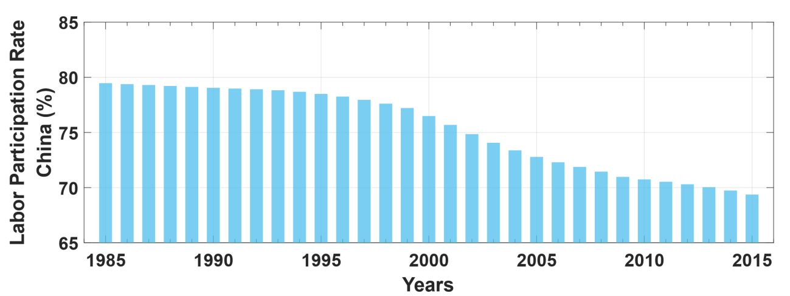
Figure S1. Labor Participation Rate in China (1985~2015, World Bank Open Data (Labor force participation rate, total (% of total population ages 15+)), 2017a).

Text S2. Labor and Capital Input in Rural Non-agricultural Sectors
For rural non-agricultural sectors, a time series of Gross Capital Formation (GCF) (as a percentage of national GDP, with the base year 2010) for China, obtained from the World Bank (World Bank Open Data (Gross capital formation (% of GDP)), 2017b), has been used for estimating the GCF growth from 1985 to 2013. The calculated GCF growth is applied to the Cobb-Douglas production function to represent the growth of capital input in non-agricultural production (Roobavannan et al., 2017).

Time series of labor and capital shares in non-agricultural productions are obtained from the Federal Reserve Bank of St. Louis (Federal Reserve Bank of St. Louis, 2014a). As shown in figure S2a, starting from approximately 0.65, the share of labor input in non-agricultural production gradually decreased to approximately 0.55 in 2013, showing the influence of technological (i.e. capital intensification) development on labor demand.

In figure S2b, the GCF growth reached its lowest point in 1990, which indicates a short stagnation of capital growth in secondary and tertiary production. After this stagnation, the growth rate of GCF in China bounced back to the first high point in 1992. From 1994 to 2000 the growth rate of GCF stays constant around 0.05. After 2000, the GCF growth rate kept fluctuating between a range of approx. 0.05 and 0.2.

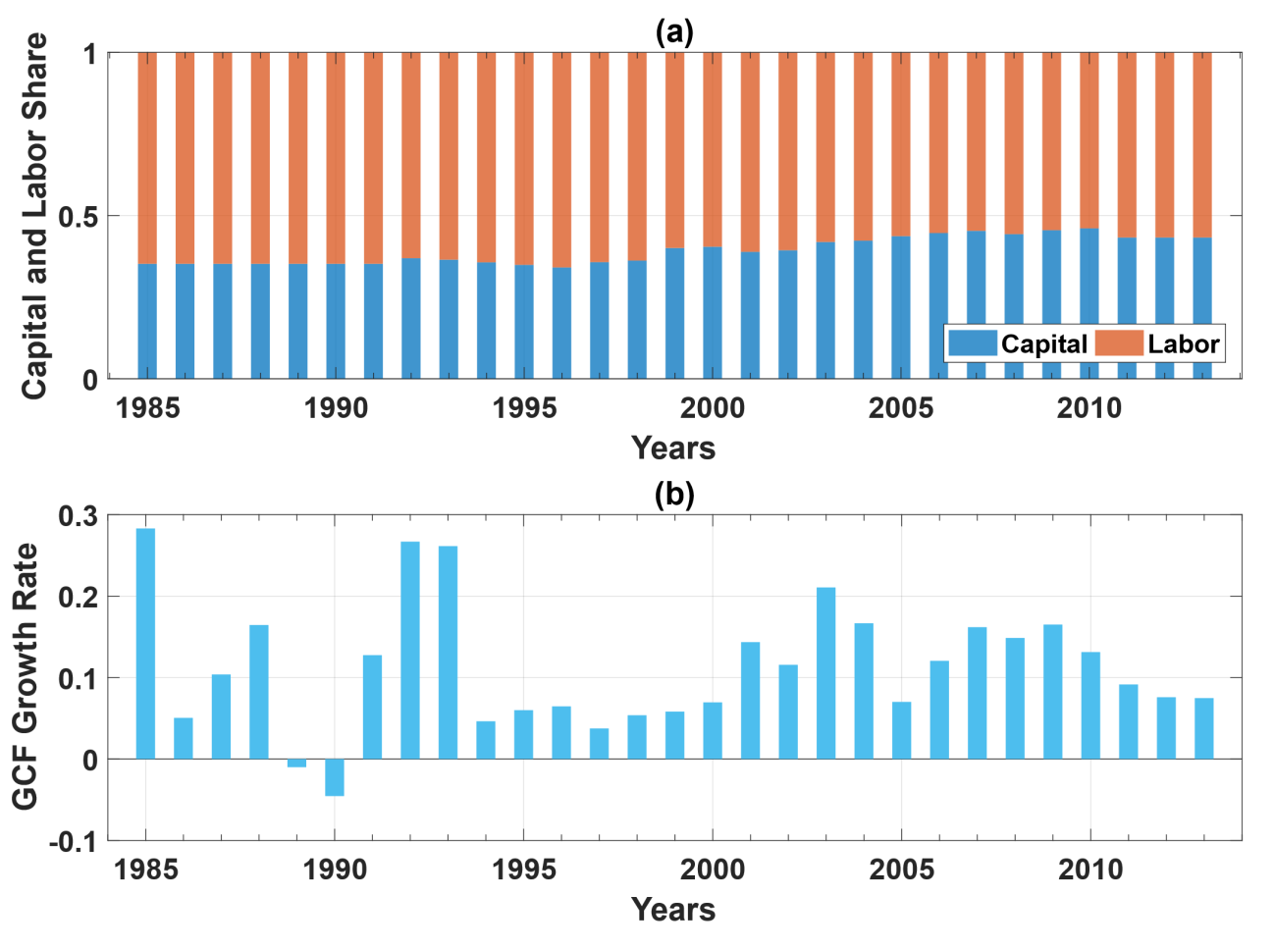
Figure S2. (a)Share of Capital and Labor in Rural Non-agriculture; (b) Growth of Gross Capital Formation.
Text S3. Technology Evolution: Total Factor Productivity (TFP) Growth Rate
As an important input for C-D function, Total Factor of Productivity (TFP) reflects regional technology conditions. Measurements of TFP includes country-level analysis of TFP for China (Feenstra et.al., 2015; Li, 2009; Wu, 2016) and regional estimations of TFP for Jiangsu (Li and Huang, 2008; Shiu and Heshmati, 2006; Zhu and Ying, 2011). TFP analysis for different industries in Jiangsu province include agricultural TFP (Sun et al., 2008), industrial TFP (Li, 2010; Wang and Li, 2009), and TFP for service sectors (Song et.al., 2017). Wang and Li (2009) made comparisons between different sectors in Jiangsu under the generalized category of industry. Contributions of TFP to production (Xu, 2011) and the driving factors of TFP (Cao, 2017; Sun et al., 2008) has also been explored within Jiangsu to reveal the relationship between productivity and TFP, and the process of the evolution of TFP itself. Chen and Wu (2010) studied the correlations between TFP and labor/capital input in production in Jiangsu. From the spatial analysis perspective, Niu et al. (2012) carried out a spatial distribution evolution analysis on production efficiency and TFP decomposition within Jiangsu.

For rural agricultural production, we applied two values of TFP growth rate from Sun et al. (2008). We set the TFP growth before (and including) the year 2000 as 3.76% and the TFP growth from 2001 as 4.38%. For rural non-agricultural sectors, we applied a series of TFP growth rate from the Federal Reserve Bank of St. Louis (Federal Reserve Bank of St. Louis, 2014b), which is shown in figure S4.1.

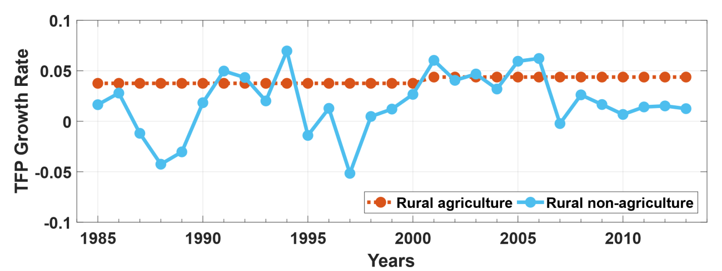
Figure S3. TFP Growth Rate for Rural Agricultural and Non-agricultural Sectors.

Text S4. Division of Agricultural and Non-agricultural Income
The estimation of labor demand for agricultural and non-agricultural sectors of rural Jiangsu requires corresponding total income values, $M_{j}$ (see equation 8c). Personal average net income series (real income) in rural areas are generated using absolute value in base year 2010 and real growth rate series of income from Statistical Yearbook of Jiangsu (Bureau of Statistics of Jiangsu, 1987~2016). The original personal average net income series is divided into agricultural and non-agricultural income respectively based on the ratio of agriculture and non-agriculture income. To divide the total income into different categories, a detailed nominal income data between 1985 and 2013 from Statistical Yearbook (Bureau of Statistics of Jiangsu, 1987~2016) is applied to estimate the ratio of rural agricultural and non-agricultural net income. After removing transfer income and property income, the personal average net income series is divided using the estimated ratio of rural agricultural and non-agricultural income. The two new series of income obtained are then applied to Cobb-Douglas production function for further calculation of labor demand.

(a)
Why did you leave your rural hometown? (Please choose the most important one)
RUMiC 2008
Reasons |  | Frequency | Percent | Valid Percent | Cumulative Percent
Valid | 1.Didn’t like farming | 104 | 11.0 | 12.3 | 12.3
Valid | 2.Have been studying, cannot farm | 43 | 4.6 | 5.1 | 17.4
Valid | 3.No future in hometown, don’t like rural life-style | 184 | 19.5 | 21.7 | 39.1
Valid | 4.Too poor at home, want to reduce family expenditure | 30 | 3.2 | 3.5 | 42.6
Valid | 5.Too poor at home, want to assist with family expenditure | 162 | 17.2 | 19.1 | 61.7
Valid | 6.Prefer city life | 44 | 4.7 | 5.2 | 66.9
Valid | 7.Many other villagers are working well in the city, would like to try | 75 | 8.0 | 8.9 | 75.8
Valid | 8.Open mind, accumulate work experience | 148 | 15.7 | 17.5 | 93.3
Valid | 9.The whole family is in city | 32 | 3.4 | 3.8 | 97.0
Valid | 10.Take care of family members | 2 | .2 | .2 | 97.3
Valid | 11.Study in another province | 3 | .3 | .4 | 97.6
Valid | 12.Allocated a job by school | 4 | .4 | .5 | 98.1
Valid | 13.Want to make more money | 1 | .1 | .1 | 98.2
Valid | 14.Go out to try my luck | 2 | .2 | .2 | 98.5
Valid | 15.Land was taken over | 2 | .2 | .2 | 98.7
Valid | 16.Introduced to a job by friends | 1 | .1 | .1 | 98.8
Valid | 17.Slack season in farming | 1 | .1 | .1 | 98.9
Valid | 18.Was dispatched by the company I worked for | 1 | .1 | .1 | 99.1
Valid | 19.To cater to need of the country | 1 | .1 | .1 | 99.2
Valid | 20.Personal reasons | 1 | .1 | .1 | 99.3
Valid | 21.To be a soldier | 3 | .3 | .4 | 99.6
Valid | 22.Do not want to study | 2 | .2 | .2 | 99.9
Valid | 23.Not applicable | 1 | .1 | .1 | 100.0
Valid | Total | 847 | 89.9 | 100.0
Missing |  | 95 | 10.1
Total |  | 942 | 100.0

(b)
Why did you leave your rural hometown? (Please choose the most important one)
RUMiC 2009
Reasons |  | Frequency | Percent | Valid Percent | Cumulative Percent
Valid | 1.Didn’t like farming | 71 | 10.0 | 11.1 | 11.1
 | 2.Have been studying, cannot farm | 64 | 9.0 | 10.0 | 21.2
 | 3.No future in hometown, don’t like rural life-style | 179 | 25.1 | 28.1 | 49.2
 | 4.Too poor at home, want to reduce family expenditure | 36 | 5.1 | 5.6 | 54.9
 | 5.Too poor at home, want to assist with family expenditure | 77 | 10.8 | 12.1 | 66.9
 | 6.Prefer city life | 7 | 1.0 | 1.1 | 68.0
 | 7.Many other villagers are working well in the city, would like to try | 101 | 14.2 | 15.8 | 83.9
 | 8.Open mind, accumulate work experience | 80 | 11.2 | 12.5 | 96.4
 | 9.The whole family is in city | 23 | 3.2 | 3.6 | 100.0
 | Total | 638 | 89.6 | 100.0
Missing |  | 74 | 10.4
Total |  | 712 | 100.0
Table S2a, b. Question: Why did you leave your rural hometown?

Have you been back to your home village for longer than 3 months after migrating?
RUMiC 2008 |  | Frequency | Percent | Valid Percent | Cumulative Percent
Valid | Yes | 112 | 11.9 | 13.1 | 13.1
 | No | 740 | 78.6 | 86.9 | 100.0
 | Total | 852 | 90.4 | 100.0
Missing |  | 90 | 9.6
Total |  | 942 | 100.0
RUMiC 2009 |  | Frequency | Percent | Valid Percent | Cumulative Percent
Valid | Yes | 53 | 7.4 | 8.1 | 8.1
Valid | No | 598 | 84.0 | 91.9 | 100.0
Valid | Total | 651 | 91.4 | 100.0
Missing |  | 61 | 8.6
Total |  | 712 | 100.0
Table S3. Question: Have you been back to your home village for longer than 3 months after migrating to the city?

If you were still in your home village, how much do you estimate you could earn?
Statistics |  | RUMiC 2008 | RUMiC 2009
N | Valid | 849 | 599
N | Missing | 93 | 113
Mean |  | 739.81 | 754.04
Median |  | 800.00 | 800.00
Std. Deviation |  | 390.257 | 619.842
Range |  | 5000 | 10000
Minimum |  | 0 | 0
Maximum |  | 5000 | 10000
Table S4. Question: If you were still in your home village, how much do you estimate you could earn every month?

References
Bureau of Statistics of Jiangsu (1987–2016) Statistical yearbook of Jiangsu. China Statistics Press http://tj.jiangsu.gov.cn/col/col64418/index.html

Cao M (2017) Study on the temporal evolution and regional differentiation of agricultural total factor productivity: Based on the empirical analysis of Jiangsu province. Sci Technol Ind 17(6):14–16. https://doi.org/10.3969/j.issn.1671-1807.2017.06.003

Chen C, Wu Y (2010) Research on correlation between total factor productivity and capital together with labor input: an empirical analysis based on Jiangsu Province. Mod Manag Sci 2010(9):44–45. https://doi.org/10.3969/j.issn.1007-368X.2010.09.016

China Institute for Income Distribution, Beijing Normal University (2019) CHIP dataset. China Institute for Income Distribution, Beijing Normal University http://www.ciidbnu.org/chip/

CRU (1985–2015) CRU TS4.01: Climatic Research Unit (CRU) Time-Series (TS) version 4.01 of high-resolution gridded data of month-by-month variation in climate (Jan. 1901–Dec. 2016). https://crudata.uea.ac.uk/cru/data/hrg/

Federal Reserve Bank of St. Louis (2014a) Share of labour compensation in GDP at current national prices for China. Federal Reserve Bank of St. Louis. https://fred.stlouisfed.org/series/LABSHPCNA156NRUG

Federal Reserve Bank of St. Louis (2014b) Total factor productivity at constant national prices for China. Federal Reserve Bank of St. Louis. https://fred.stlouisfed.org/series/RTFPNACNA632NRUG

Feenstra RC, Inklaar R, Timmer MP (2015) The next generation of the Penn World Table. Am Econ Rev 105(10):3150–3182. https://doi.org/10.1257/aer.20130954

Harris I. P. D. J., Jones P. D., Osborn T. J., and Lister D. H. (2014). Updated high‐resolution grids of monthly climatic observations–the CRU TS3. 10 Dataset. International journal of climatology, 34(3), 623-642. doi: https://doi.org/10.1002/joc.3711

Li G (2010) Industrial TFP growth and industry difference in Jiangsu Province: 2002–2008—industry analysis based on DEA-Malmquist. Market Weekly 8: 22–24

Li K. W (2009) China's total factor productivity estimates by region, investment sources and ownership. Econ Syst 33(3):213–230. https://doi.org/10.1016/j.ecosys.2009.06.003

Li X, Huang X (2008) An empirical analysis of total factor productivity in Jiangsu Province. Fin Perspect J 2008(2):34–38

National Bureau of Statistics of China (2016) China Statistical Yearbook. China Statistics Press http://www.stats.gov.cn/tjsj/ndsj/

Niu P, Lu Y, Peng Q (2012) Total factor productivity and its spatial variation in Jiangsu from 1993 to 2009. Econ Geogr 32(11):27–33

Roobavannan M, Kandasamy J, Pande S, Vigneswaran S, Sivapalan M (2017) Allocating environmental water and impact on basin unemployment: role of a diversified economy. Ecol Econ 136:178–188. https://doi.org/10.1016/j.ecolecon.2017.02.006

Shiu A, Heshmati A (2006) Technical change and total factor productivity growth for Chinese provinces: a panel data analysis. IZA Discussion Papers, No. 2133, Institute for the Study of Labor (IZA), Bonn

Song C, Wang XA, Zhang Y (2017) Changes and characteristics of service industry’s TFP of Jiangsu Province. J Wuxi Inst Commer 17(2):7–12. https://doi.org/10.3969/j.issn.1671-4806.2017.02.002

Sun X, Fan J, Hu H (2008) Regional agricultural TFP measurement and decomposition of China: based on empirical analysis of Nanjing City. Technol Econ 27(1):73–79. https://doi.org/10.3969/j.issn.1002-980X.2008.01.014

Wang Y, Li G (2009) Comparative analysis of industrial total factor productivity in Jiangsu Province—based on the DEA-malmquist method. Mod Bus Trade Ind 21(20):83–84

Xu M (2011) An empirical analysis of total factor productivity and economic growth in Jiangsu Province. Econ Vis (Late Issue) 2011(4):14–15. https://doi.org/10.3969/j.issn.1672-3309(x).2011.04.07

World Bank Open Data (Labor force participation rate, total (% of total population ages 15+)) (2017a) https://data.worldbank.org/indicator/SL.TLF.CACT.ZS?locations=CN

World Bank Open Data (Gross capital formation (% of GDP)) (2017b) https://data.worldbank.org/indicator/NE.GDI.TOTL.ZS?locations=CNandview=chart

Wu H. X (2016) Sustainability of China's growth model: a productivity perspective. China World Econ 24(5):42–70. https://doi.org/10.1111/cwe.12174

Zhu Y, Ying R (2011) Modernization quality and agricultural total factor productivity: empirical analysis based on the household survey from Jiangsu. East China Econ Manage 25(11):1–5. https://doi.org/10.3969/j.issn.1007-5097.2011.11.001

