Supplementary Information

Social Touch in Mother-infant Interaction Affects Infants’ Subsequent Social Engagement and Object Exploration

Mother-Infant Interaction Procedures
Instructions
To ensure natural interaction between the mothers and infants, we provided different instructions to mothers as follows. In the More PC Condition, mothers were told to play with infants in the same way they would at home, and to actively touch their infant’s body. In the Less PC, mothers were told to play with infants in the same way as they would at home and to play facing their infant with less physical contact and let them move freely. Similarly, we did not limit all touch in the Less PC Condition. Specifically, mothers could freely touch infants in the following instances: when they thought the infants needed help (e.g., they were about to fall), when infants became fussy, or when the mothers subjectively felt they wanted to touch their infants. Therefore, although there was touching between mothers and infants in both conditions, the relative amount of frequency was different. In the Less PC Condition, except for the amount of touch, the mothers had no restrictions on their behavior (e.g., eye contact, smile, utterances). In neither condition did the mothers use toys. In all other respects, there were no restrictions on the play behaviors.
Procedure
Each mother and infant started from the state of face-to-face (sitting or sagittal position), but afterward, their postures were free. The experimenter told mothers to start free play, and after that, the experimenter left to sit behind a partition. Three video cameras (HDR-CX700, HDR-SR1, and HDR-CX535, SONY, Tokyo, Japan) were placed in a position where the infant’s face and body, the mother’s face and body, and the entire mother and child were reflected, respectively. When the posture and position of the mother and infants changed, the experimenter adjusted the position of the video camera from behind the partition. When breastfeeding was engaged in after the mother-infant interaction (n = 2 in Less PC condition), the data were excluded from the analysis since breastfeeding, as a form of social touch, could affect infants’ subsequent task performance.
Social preference task
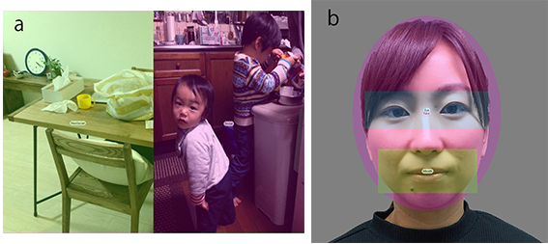
Figure S1. Examples of the stimuli for each test with accompanying Areas of Interest (AOI): (a) Social preferential looking, and (b) Face scanning.

Supplementary Results
Relationship among Tasks
We examined the relationships between the infants’ performance on the three tasks. We subtracted the value of each pre-task from that of each post-task’s value. We then used these differences in a bivariate correlation analysis (Pearson’s r) using the subtracted value for each task, with Bonferroni corrections. We found a significant positive correlation between the amount of change in Evasive Behavior in Stranger Approach, and the Latency to First Touch in the Object Exploration Task, r(38) = .38, p = .048. Specifically, the larger the decrease in the infants’ Evasive Behaviors toward the stranger, the larger the decrease in the Latency to First Touch. The increase in the duration of object manipulation showed a marginally significant negative correlation to the decreases in Evasive Behaviors toward the stranger, r(38) = -.28, p = .09. We found no other significant correlations between the tasks (rs -.26–.10, ps > .16).

