Daniel Fellmanª, Richard Bränströmª, Agneta Herlitzª
ªDepartment of Clinical Neuroscience, Karolinska Institute, Stockholm, Sweden

Corresponding Authors:
Daniel Fellman, PhD
Email: daniel.fellman[at]ki.se
Agneta.Herlitz, PhD
Email: Agneta.Herlitz[at]ki.se

Supplementary Materials S1
Revisiting a basic question: Does gender-typed early environment affect sex differences in academic strengths and occupational choices?

Variable distributions
Figure 1A-D shows that the distributions in the academic strengths score at age 16 were different across gender in Study 1. Of the girls, 47.2 % (n = 3,942) had a academic strengths score > 0, 30.1 % (n = 2,509) a score of 0, and 22.7 % (n = 1,898) a score < 0. This indicate that over twice as many girls had a verbally aligned academic strengths than a numerically aligned academic strengths (see Figure 1A). Conversely, among the boys, 46.7 % (n = 4,147) of the boys had a academic strengths score < 0, 30.0 % (n = 2,664) a score of 0, and 23.3 % (n = 2,073) a score > 0, indicating that their relative strength, was more numerical than verbal (see Figure 1B). This pattern was largely the same in occupational demands. The majority of the girls worked in verbally demanding occupations at age 35 (score > 0; 63.5 %, n = 3,045) (see Figure 1C), whereas the majority of the boys worked in numerically demanding occupations at age 35 (score < 0; 58.0 %, n = 5,149) (see Figure 1D).

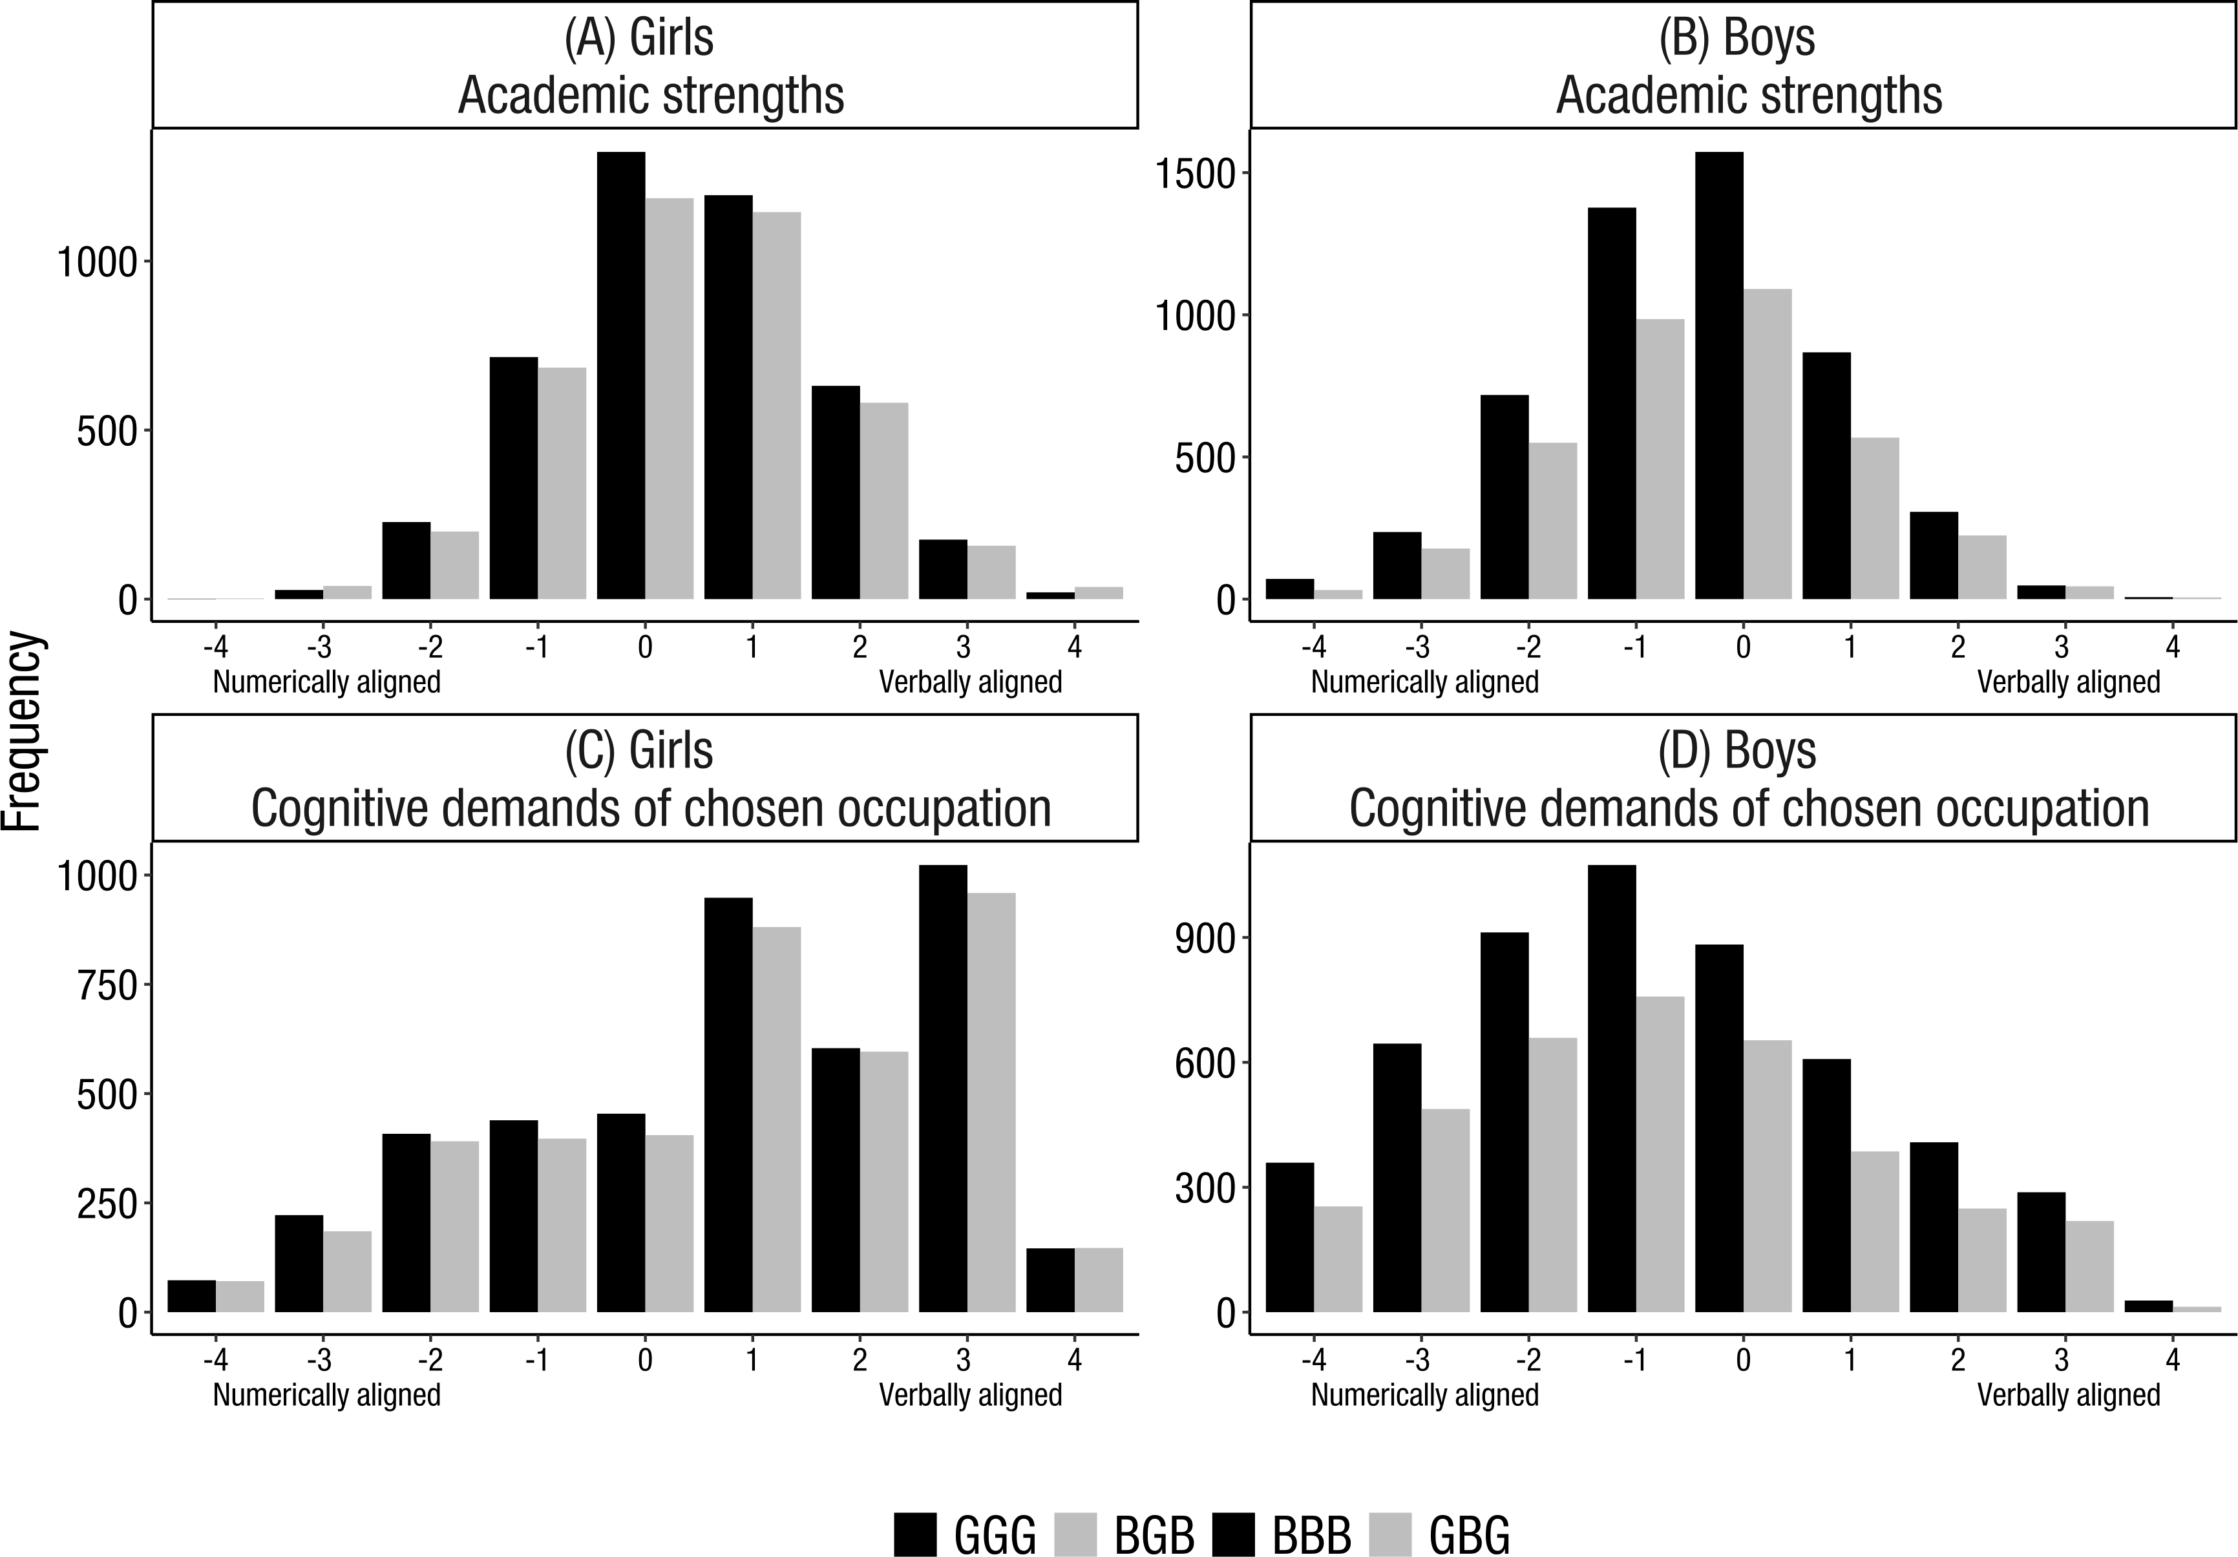
Figure 1. Distribution in the academic strengths score at 16 years of age among (A) girls and (B) boys in Study 1. Higher grades in technical/numerical subjects relative to verbal/language subjects is designated by the negative values of the academic strengths profile. Positive values of the profile indicate higher grades in verbal/language subjects relative to technical/numerical subjects. Distribution in occupation at 35 years of age among (C) girls and (D) boys. Positive values indicate a choice of occupation with more verbal demands whereas lower values indicate a choice of occupation with more numerical demands. GGG = Mid-born girls with younger and older sisters; BGB = Mid-born girls with younger and older brother; BBB = Mid-born boys with younger and older brothers; GBG = Mid-born boys with younger and older sister. Note. The score range in the cognitive demands of chosen occupation did not consist of integers, but of decimal numbers ranging between -3.94 to 4.50. However, these decimal numbers were rounded to integers for illustrative purposes in this figure.

Table 1. Means, standard deviations, and within-gender sibship composition comparisons in the school subjects in Study 1.
School subjects |  | Girls |  |  |  |  |  | Boys
 |  | GGG |  | BGB |  | Cohen’s d |  | BBB |  | GBG |  | Cohen’s d
 |  | M (SD) |  | M (SD) |  | Cohen’s d |  | M (SD) |  | M (SD) |  | Cohen’s d
Numerical
 | Technics | 3.234 (0.726) |  | 3.203 (0.743) |  | 0.043 |  | 3.289 (0.799) |  | 3.286 (0.795) |  | 0.004
 | Math | 3.323 (0.89) |  | 3.296 (0.885) |  | 0.030 |  | 3.238 (0.945) |  | 3.222 (0.942) |  | 0.017
 | Physics | 3.302 (0.922) |  | 3.248 (0.942) |  | 0.057 |  | 3.226 (1.004) |  | 3.206 (0.989) |  | 0.020
 | Chemistry | 3.328 (0.938) |  | 3.273 (0.944) |  | 0.059 |  | 3.119 (1.011) |  | 3.092 (1.011) |  | 0.027
Verbal
 | Swedish | 3.542 (0.815) |  | 3.536 (0.834) |  | 0.007 |  | 2.988 (0.854) |  | 2.976 (0.849) |  | 0.014
 | English | 3.433 (0.822) |  | 3.388 (0.859) |  | 0.053 |  | 3.125 (0.857) |  | 3.104 (0.863) |  | 0.024
Other
 | Religion | 3.513 (0.88) |  | 3.494 (0.899) |  | 0.022 |  | 3.057 (0.936) |  | 3.04 (0.923) |  | 0.018
 | History | 3.403 (0.917) |  | 3.382 (0.929) |  | 0.023 |  | 3.154 (0.976) |  | 3.144 (0.971) |  | 0.010
 | Biology | 3.486 (0.903) |  | 3.436 (0.906) |  | 0.055 |  | 3.115 (0.948) |  | 3.101 (0.938) |  | 0.014
 | Crafts | 3.543 (0.767) |  | 3.496 (0.772) |  | 0.061 |  | 3.352 (0.786) |  | 3.336 (0.768) |  | 0.021
 | Geography | 3.438 (0.866) |  | 3.404 (0.881) |  | 0.040 |  | 3.157 (0.934) |  | 3.145 (0.921) |  | 0.012
 | Music | 3.591 (0.82) |  | 3.565 (0.819) |  | 0.032 |  | 3.165 (0.887) |  | 3.162 (0.869) |  | 0.003
 | Civics and society | 3.4 (0.886) |  | 3.393 (0.899) |  | 0.008 |  | 3.145 (0.956) |  | 3.119 (0.945) |  | 0.027
 | Physical education | 3.393 (0.865) |  | 3.365 (0.877) |  | 0.032 |  | 3.564 (0.924) |  | 3.559 (0.903) |  | 0.006
 | Drawing | 3.637 (0.773) |  | 3.587 (0.775) |  | 0.064 |  | 3.109 (0.817) |  | 3.068 (0.788) |  | 0.052
 | Homemaking | 3.704 (0.756) |  | 3.689 (0.756) |  | 0.020 |  | 3.065 (0.803) |  | 3.051 (0.767) |  | 0.018
Note. Student's t-test was used in the statistical analyses.
GGG = Mid-born girls with younger and older sisters; BGB = Mid-born girls with younger and older brother; BBB = Mid-born boys with younger and older brothers; GBG = Mid-born boys with younger and older sisters
Cohen’s d = (M_{sibship composition1} -M_{sibship composition2})/sd_{pooled})
A positive d value indicates an effect favouring GGG against BGB, and BBB against GBG

Table 2 Descriptive statistics of the dependent variables and covariates in Study 1
Variable | M | SD | Min | Max | Range
Academic strengths at age 16 | -0.01 | 1.37 | -4 | 4 | 8
Cognitive demands of chosen occupation at age 35 | 0.04 | 2.01 | -3.94 | 4.5 | 8.44
Grade Point Average | 3.31 | 0.67 | 1 | 5 | 4
Birth country (Sweden vs. foreign-born) | 0.03 | 0.17 | 0 | 1 | 1
Birth age (mother) | 26.91 | 3.59 | 16 | 44 | 28
Education (mother) | 3.77 | 1.53 | 1 | 7 | 6
Sibship type (same parents vs. not same parents) | 0.9 | 0.3 | 0 | 1 | 1
Age difference (last-born vs. mid-born) | 2.88 | 1.07 | 1 | 5 | 4
Age difference (mid-born vs. first-born) | 3.54 | 1.19 | 1 | 5 | 4

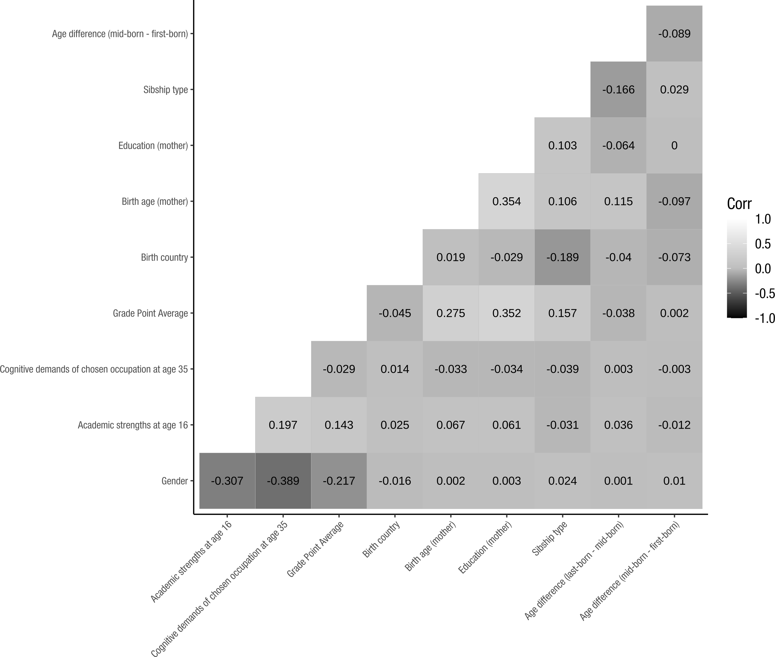
Figure 2. Correlation coefficients between the key-dependent variables and the covariates.
Note. Pearson’s r correlations are depicted between two continuous variables; Point-biserial correlations are depicted when one of the variables in an intercorrelation is binary.

Regression analyses

Table 3. Multiple regression analysis for gender predicting academic strengths adjusted by the covariates
Predictor | B | B 95 % CI | β | Sig. | Cohen’s f ²
Intercept | -0.524 | [-0.712, -0.336] | 0.397 | < .001
Gender | -0.8 | [-0.839, -0.76] | -0.584 | < .001 | 0.325
Grade Point Average | 0.134 | [0.102, 0.167] | 0.066 | < .001 | 0.083
Birth country (Sweden vs. foreign-born) | 0.148 | [0.031, 0.264] | 0.108 | 0.013 | 0.025
Birth age (mother) | 0.015 | [0.009, 0.021] | 0.038 | < .001 | 0.05
Education (mother) | 0.028 | [0.014, 0.042] | 0.031 | < .001 | 0.026
Sibship type (same parents vs. not same parents) | -0.15 | [-0.218, -0.081] | -0.109 | < .001 | 0.039
Age difference (last-born vs. mid-born) | 0.041 | [0.022, 0.059] | 0.032 | < .001 | 0.033
Age difference (mid-born vs. first-born) | -0.001 | [-0.017, 0.015] | -0.001 | 0.906 | 0.001

Table 4. Multiple regression analysis for sibship composition among mid-born girls predicting academic strengths adjusted by the covariates.
Predictor | B | B 95 % CI | β | Sig. | Cohen’s f ²
Intercept | -0.584 | [-0.845, -0.322] | 0.061 | < .001
Sibship composition | 0.007 | [-0.031, 0.045] | 0.006 | 0.715 | 0.003
Grade Point Average | 0.199 | [0.152, 0.246] | 0.101 | < .001 | 0.103
Birth country (Sweden vs. foreign) | 0.126 | [-0.031, 0.283] | 0.099 | 0.116 | 0.022
Birth age (mother) | 0.01 | [0.001, 0.018] | 0.028 | 0.021 | 0.031
Education (mother) | 0.002 | [-0.018, 0.022] | 0.003 | 0.833 | 0.003
Sibship type (same parents vs. not same parents) | -0.091 | [-0.184, 0.002] | -0.072 | 0.056 | 0.029
Age difference (last-born vs. mid-born) | 0.047 | [0.021, 0.073] | 0.04 | < .001 | 0.039
Age difference (mid-born vs. first-born) | -0.003 | [-0.026, 0.02] | -0.003 | 0.788 | 0.003

Table 5. Multiple regression analysis for sibship composition among mid-born boys predicting academic strengths adjusted by the covariates.
Predictor | B | B 95 % CI | β | Sig. | Cohen’s f ²
Intercept | -1.298 | [-1.561, -1.035] | 0.141 | < .001
Sibship composition | -0.011 | [-0.051, 0.028] | -0.008 | 0.578 | 0.005
Grade Point Average | 0.078 | [0.033, 0.124] | 0.039 | 0.001 | 0.066
Birth country (Sweden vs. foreign-born) | 0.193 | [0.02, 0.366] | 0.145 | 0.029 | 0.029
Birth age (mother) | 0.02 | [0.011, 0.028] | 0.052 | < .001 | 0.066
Education (mother) | 0.051 | [0.031, 0.071] | 0.059 | < .001 | 0.05
Sibship type (same parents vs. not same parents) | -0.214 | [-0.315, -0.114] | -0.161 | < .001 | 0.049
Age difference (last-born vs. mid-born) | 0.033 | [0.006, 0.06] | 0.026 | 0.016 | 0.025
Age difference (mid-born vs. first-born) | 0.002 | [-0.022, 0.025] | 0.001 | 0.894 | 0.001

Table 6. Multiple regression analysis for gender predicting cognitive demands of chosen occupation at age 35 adjusted by the covariates.
Predictor | B |  | B 95 % CI |  |  | β |  | Sig. | Cohen’s f ²
Intercept | 2.157 |  | [1.889, 2.424] |  |  | 0.428 |  | < .001
Gender | -1.673 |  | [-1.73, -1.616] |  |  | -0.831 |  | < .001 | 0.426
Grade Point Average | -0.365 |  | [-0.411, -0.319] |  |  | -0.121 |  | < .001 | 0.128
Birth country (Sweden vs. foreign-born) | 0.001 |  | [-0.164, 0.167] |  |  | 0.000 |  | 0.986 | 0.002
Birth age (mother) | -0.001 |  | [-0.009, 0.008] |  |  | -0.002 |  | 0.833 | < 0.001
Education (mother) | 0.015 |  | [-0.005, 0.035] |  |  | 0.011 |  | 0.15 | 0.011
Sibship type (same parents vs. not same parents) | -0.078 |  | [-0.176, 0.019] |  |  | -0.012 |  | 0.115 | 0.012
Age difference (last-born vs. mid-born) | -0.004 |  | [-0.031, 0.022] |  |  | -0.002 |  | 0.764 | 0.002
Age difference (mid-born vs. first-born) | 0.002 |  | [-0.021, 0.026] |  |  | 0.001 |  | 0.855 | 0.001
Table 7. Multiple regression analysis for sibship composition among mid-born girls predicting cognitive demands of chosen occupation at age 35 adjusted by the covariates.
Predictor |  | B |  | B 95 % CI | β |  | Sig. |  | Cohen’s f ²
Intercept |  | 3.176 |  | [2.791, 3.56] | -0.004 |  | < .001
Sibship composition |  | 0.024 |  | [-0.055, 0.103] | 0.013 |  | 0.553 |  | 0.01
Grade Point Average |  | -0.596 |  | [-0.664, -0.528] | -0.203 |  | < .001 |  | 0.222
Birth country (Sweden vs. foreign-born) |  | -0.127 |  | [-0.355, 0.102] | -0.068 |  | 0.276 |  | 0.012
Birth age (mother) |  | -0.004 |  | [-0.016, 0.008] | -0.008 |  | 0.519 |  | 0.017
Education (mother) |  | -0.041 |  | [-0.07, -0.012] | -0.033 |  | 0.006 |  | 0.03
Sibship type (same parents vs. not same parents) |  | 0 |  | [-0.136, 0.136] | 0 |  | 0.997 |  | 0.001
Age difference (last-born vs. mid-born) |  | -0.006 |  | [-0.044, 0.031] | -0.004 |  | 0.747 |  | 0.004
Age difference (mid-born vs. first-born) |  | 0.002 |  | [-0.031, 0.035] | 0.001 |  | 0.908 |  | 0.001

Table 8. Multiple regression analysis for sibship composition among mid-born boys predicting cognitive demands of chosen occupation at age 35 adjusted by the covariates.
Predictor | B | B 95 % CI | β | Sig. | Cohen’s f ²
Intercept | -0.359 | [-0.726, 0.007] | 0.016 | 0.055
Sibship composition | -0.073 | [-0.15, 0.005] | -0.04 | 0.065 | 0.017
Grade Point Average | -0.171 | [-0.233, -0.108] | -0.062 | < .001 | 0.044
Birth country (Sweden vs. foreign-born) | 0.122 | [-0.117, 0.361] | 0.011 | 0.318 | 0.013
Birth age (mother) | 0.003 | [-0.009, 0.015] | 0.005 | 0.649 | 0.018
Education (mother) | 0.069 | [0.041, 0.097] | 0.058 | < .001 | 0.052
Sibship type (same parents vs. not same parents) | -0.147 | [-0.286, -0.009] | -0.023 | 0.037 | 0.022
Age difference (last-born vs. mid-born) | -0.003 | [-0.04, 0.034] | -0.002 | 0.862 | 0.002
Age difference (mid-born vs. first-born) | 0.005 | [-0.027, 0.038] | 0.003 | 0.747 | 0.003

Supplementary Materials S2
Revisiting a basic question: Does gender-typed early environment affect sex differences in academic strengths and occupational choices?

Variable distributions
Figure 1A-D depicts the gender and group distributions in Study 2. With respect to academic strengths, most of the girls had a verbally aligned academic strengths (score > 0; 49.7 %, n = 28,854), and the remaining ones had either an equally weighted profile (score = 0; 29.3 %, n = 17,005), or a numerically aligned profile (score < 0; 21.1 %, n = 12,246). Conversely, most of the boys had a numerically aligned academic strengths (score < 0; 44.5 %, n = 26,606), and the remaining ones had either an equally weighted profile (score = 0; 30.0%, n = 19,992), or a verbally aligned profile (score > 0; 25.6 %, n = 15,282). Concerning occupational demands, most of the girls worked in a verbally demanding occupation (score > 0; 64.3 %, n = 37,353), whereas most of the boys worked in a numerically demanding occupation (score < 0; 67.7 %, n = 40,509).

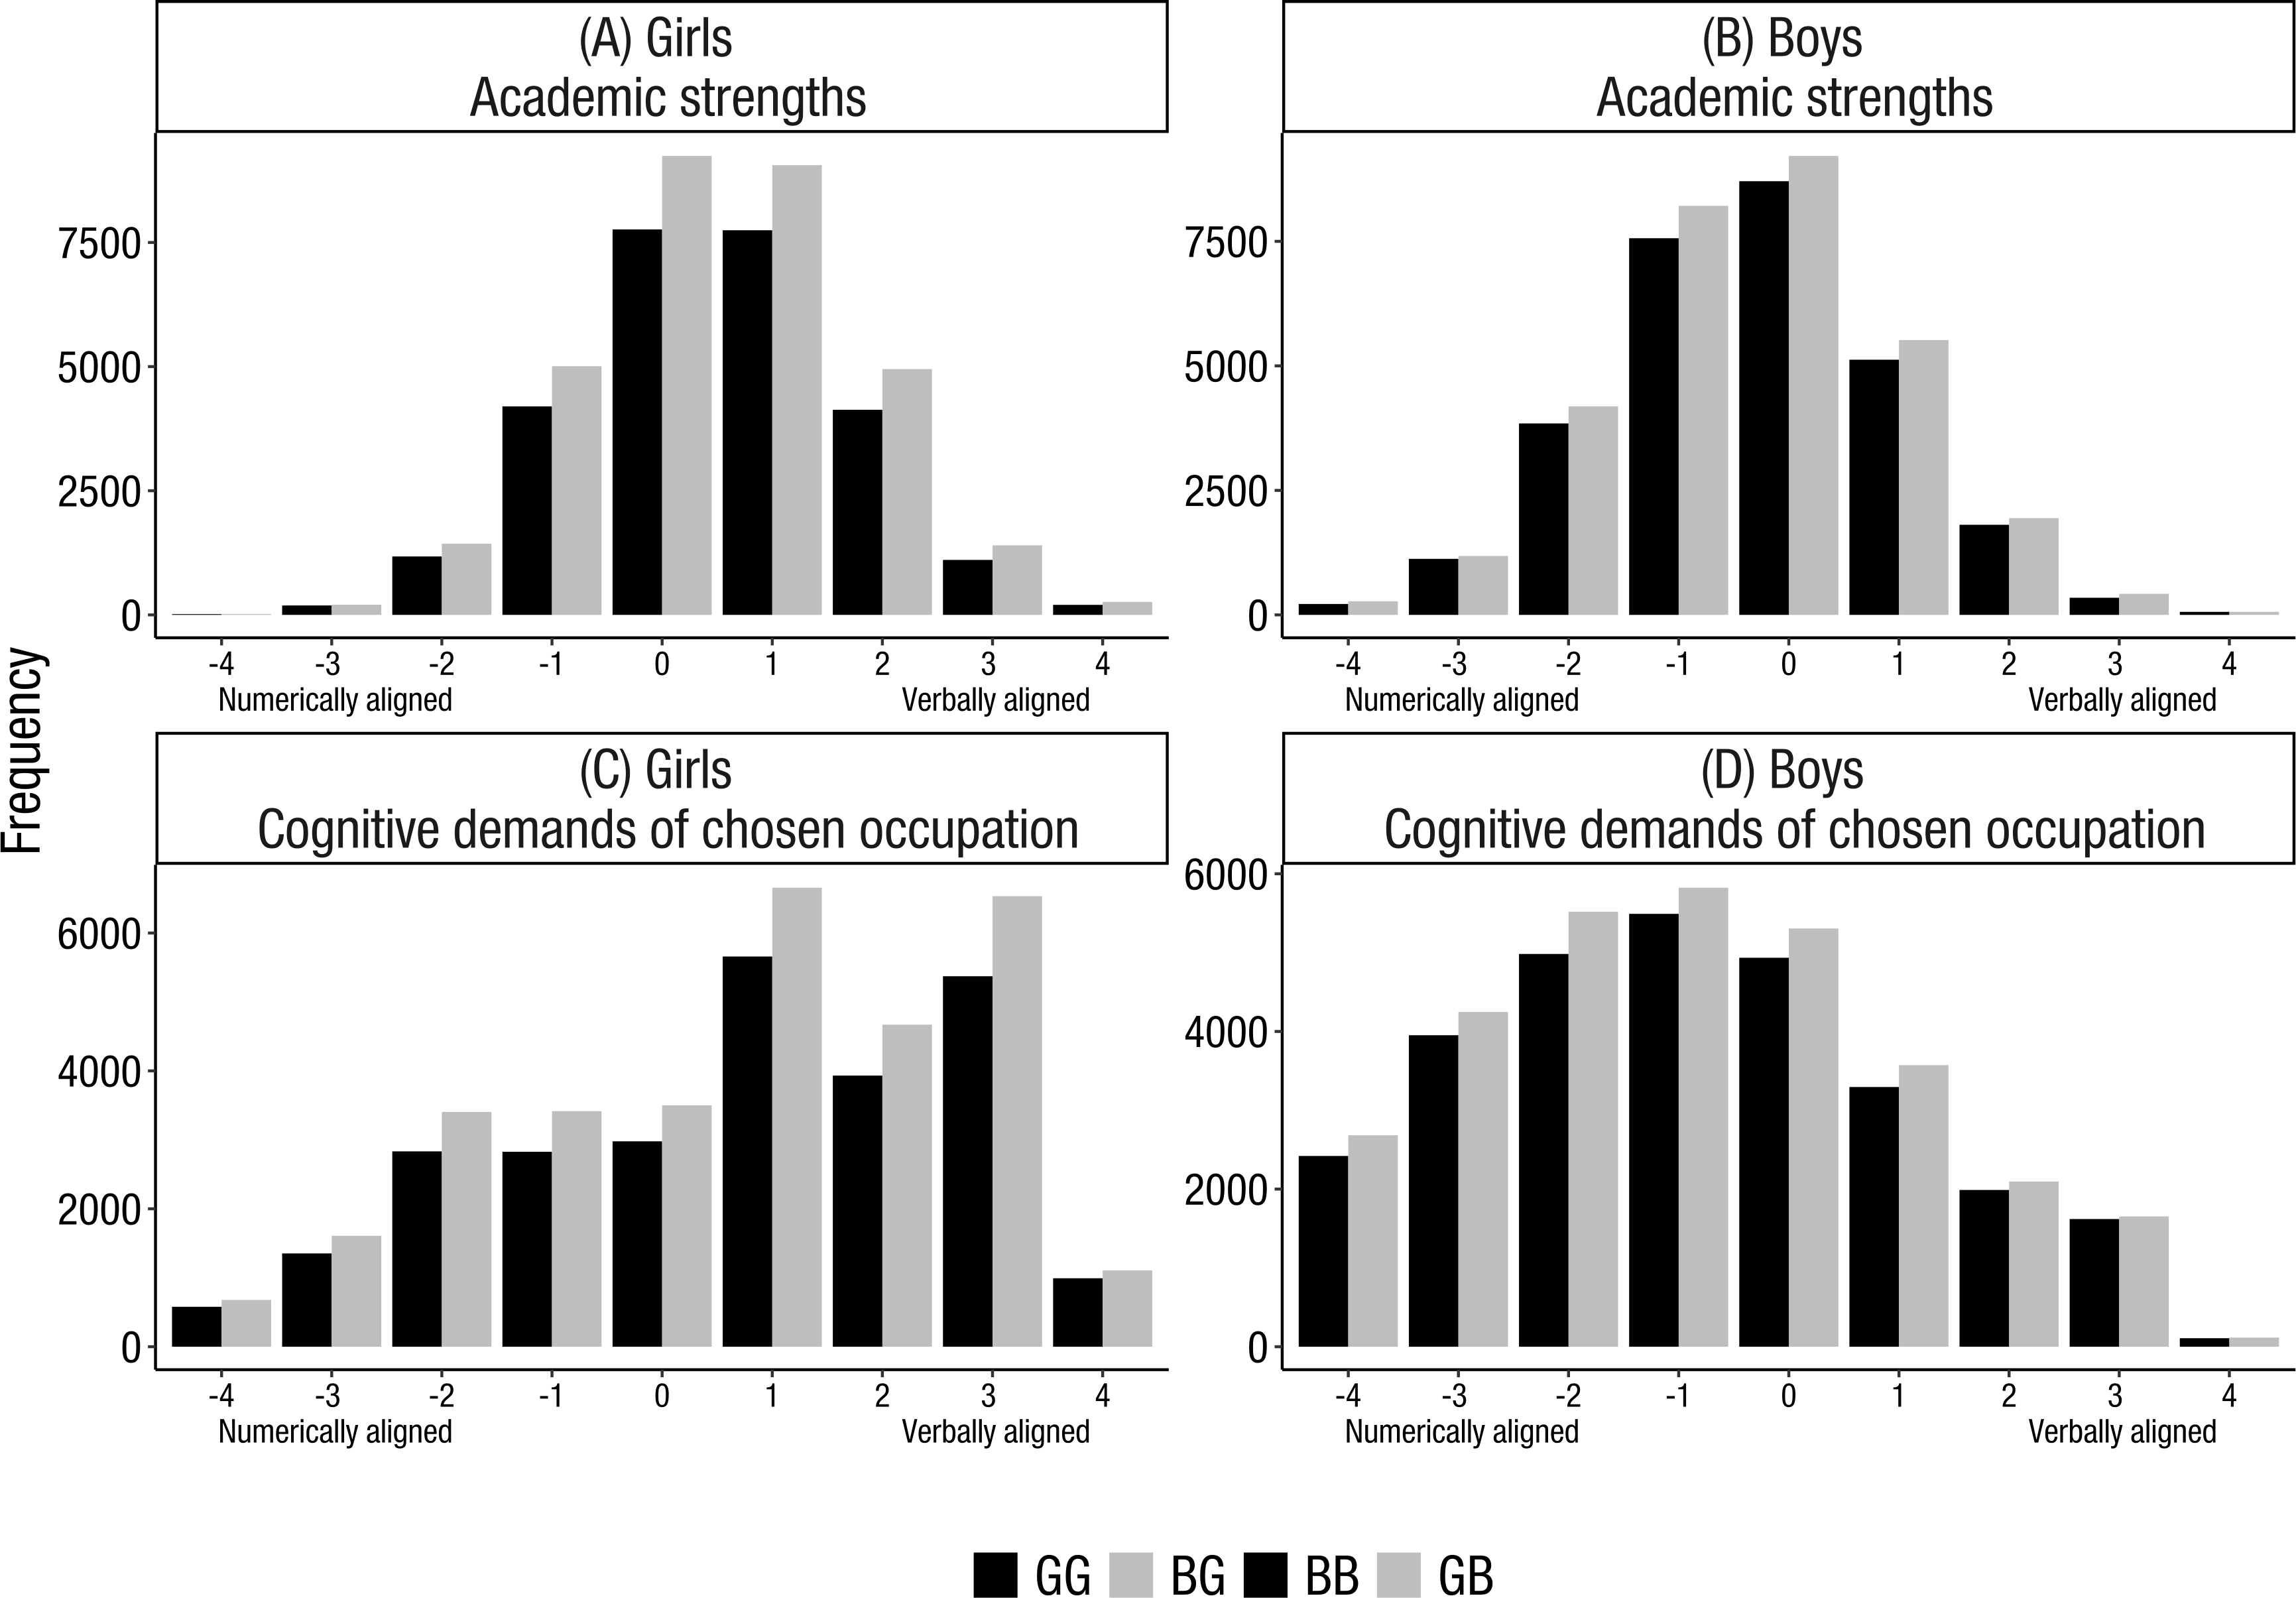
Figure 1. Distribution in the academic strengths score at 16 years of age among (A) girls and (B) boys in Study 2. Higher grades in technical/numerical subjects relative to verbal/language subjects is designated by the negative values of the academic strengths profile. Positive values of the profile indicate higher grades in verbal/language subjects relative to technical/numerical subjects. Distribution in occupation at 35 years of age among (C) girls and (D) boys in study 2. Positive values indicate a choice of occupation with more verbal demands in whereas lower values indicate a choice of occupation with more numerical demands. GG = Last-born girls with older sister; BG = Last-born girls with older brother; BB = Last-born boys with older brother; GB = Last-born boys with older sister. Note. The score range in the cognitive demands did not consist of integers, but of decimal numbers ranging between -3.94 to 4.50. However, these decimal numbers were rounded to integers for illustrative purposes in this figure.

Table 1. Means, standard deviations, and within-gender sibship composition comparisons in the school subjects in Study 2.
School subjects |  | Girls |  |  |  |  |  | Boys
 |  | GG |  | BG |  | Cohen’s D |  | BB |  | GB |  | Cohen’s D
 |  | M (SD) |  | M (SD) |  | Cohen’s D |  | M (SD) |  | M (SD) |  | Cohen’s D
Numerical
 | Technics | 3.161 (0.805) |  | 3.159 (0.802) |  | 0.002 |  | 3.181 (0.792) |  | 3.175 (0.79) |  | 0.008
 | Math | 3.166 (0.931) |  | 3.163 (0.925) |  | 0.002 |  | 3.173 (0.923) |  | 3.183 (0.933) |  | -0.012
 | Physics | 3.1 (0.998) |  | 3.106 (0.999) |  | -0.006 |  | 3.115 (1.001) |  | 3.117 (0.994) |  | -0.002
 | Chemistry | 3.054 (1.005) |  | 3.062 (1.008) |  | -0.008 |  | 3.081 (1.01) |  | 3.083 (1.004) |  | -0.002
Verbal
 | Swedish | 3.162 (0.901) |  | 3.153 (0.897) |  | 0.010 |  | 3.159 (0.901) |  | 3.169 (0.897) |  | -0.011
 | English | 3.192 (0.88) |  | 3.199 (0.875) |  | -0.009 |  | 3.211 (0.883) |  | 3.198 (0.879) |  | 0.015
Other
 | Religion | 3.13 (0.974) |  | 3.142 (0.976) |  | -0.012 |  | 3.144 (0.973) |  | 3.147 (0.979) |  | -0.003
 | History | 3.122 (0.996) |  | 3.127 (0.991) |  | -0.005 |  | 3.135 (0.984) |  | 3.141 (0.991) |  | -0.006
 | Biology | 3.132 (0.971) |  | 3.147 (0.974) |  | -0.015 |  | 3.157 (0.971) |  | 3.157 (0.963) |  | 0.000
 | Crafts | 3.354 (0.805) |  | 3.343 (0.804) |  | 0.013 |  | 3.345 (0.805) |  | 3.344 (0.802) |  | 0.001
 | Geography | 3.126 (0.945) |  | 3.139 (0.944) |  | -0.014 |  | 3.156 (0.945) |  | 3.156 (0.944) |  | 0.000
 | Music | 3.263 (0.893) |  | 3.268 (0.893) |  | -0.005 |  | 3.282 (0.898) |  | 3.279 (0.88) |  | 0.003
 | Civics and society | 3.104 (0.974) |  | 3.123 (0.974) |  | -0.02 |  | 3.132 (0.965) |  | 3.136 (0.973) |  | -0.004
 | Physical education | 3.387 (0.939) |  | 3.385 (0.93) |  | 0.002 |  | 3.401 (0.941) |  | 3.389 (0.931) |  | 0.013
 | Drawing | 3.29 (0.855) |  | 3.279 (0.846) |  | 0.014 |  | 3.284 (0.853) |  | 3.287 (0.849) |  | -0.004
 | Homemaking | 3.271 (0.865) |  | 3.277 (0.866) |  | -0.007 |  | 3.276 (0.868) |  | 3.282 (0.859) |  | -0.008
Note. GG = Last-born girls with older sister; BG = Last-born girls with older brother; BB = Last-born boys with older brother; GB = Last-born boys with older sister
Cohen’s D = (M_{sibship composition1} -M_{sibship composition2})/sd_{pooled})
A positive D value indicates an effect favouring GG against BG, and BB against GB

Table 2 Descriptive statistics of the dependent variables and covariates in Study 2.
Variable | M | SD | Min | Max | Range
Academic strengths at age 16 | 0.07 | 1.36 | -4 | 4 | 8
Cognitive demands of chosen occupation at age 35 | -0.05 | 2.03 | -3.94 | 4.5 | 8.44
Grade Point Average | 3.38 | 0.64 | 1 | 5 | 4
Birth country (Sweden vs. Foreign-born) | 0.04 | 0.21 | 0 | 1 | 1
Birth age (mother) | 25.58 | 4 | 13 | 51 | 38
Education (mother) | 3.75 | 1.45 | 1 | 7 | 6
Sibship type (same parents vs. not same parents) | 0.95 | 0.23 | 0 | 1 | 1
Age difference between siblings | 3.22 | 1.09 | 1 | 5 | 4

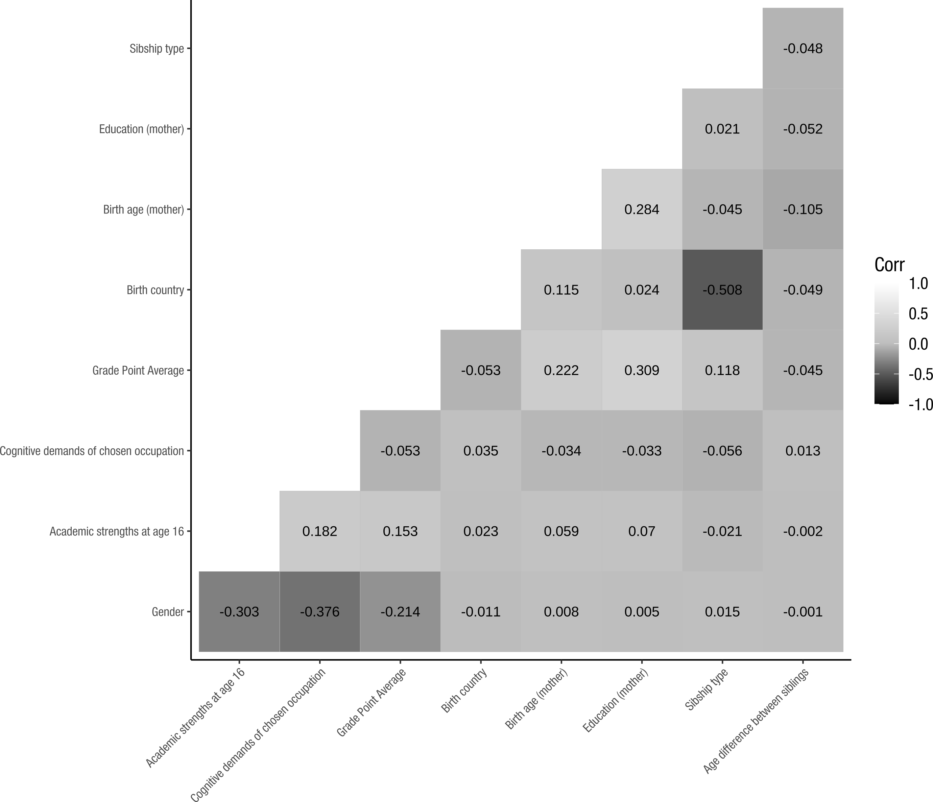
Figure 2. Correlation coefficients between the dependent variables and the covariates.
Note. Pearson’s r correlations are depicted between two continuous variables; Point biserial correlations are depicted when one of the variables in an intercorrelation is binary.
Regression analyses
Table 3. Multiple regression analysis for gender predicting academic strengths at age 16 adjusted by the covariates.
Predictor | B | B 95 % CI | β | Sig. | Cohen’s f ²
Intercept | -0.4 | [-0.473, -0.328] | 0.291 | < .001
Gender | -0.779 | [-0.794, -0.764] | -0.574 | < .001 | 0.32
Grade Point Average | 0.16 | [0.148, 0.173] | 0.076 | < .001 | 0.096
Birth country (Sweden vs. foreign-born) | 0.066 | [0.024, 0.107] | 0.01 | 0.002 | 0.027
Birth age (mother) | 0.011 | [0.009, 0.013] | 0.032 | < .001 | 0.041
Education (mother) | 0.036 | [0.031, 0.042] | 0.039 | < .001 | 0.038
Sibship type (same parents vs. not same parents) | -0.119 | [-0.157, -0.081] | -0.02 | < .001 | 0.018
Age difference between siblings | 0.008 | [0.001, 0.014] | 0.006 | 0.03 | 0.006

Table 4. Multiple regression analysis for sibship composition among last-born girls predicting academic strengths at age 16 adjusted by the covariates.
Predictor | B | B 95 % CI | β | Sig. | Cohen’s f ²
Intercept | -0.509 | [-0.61, -0.407] | -0.005 | < .001
Sibship composition | 0.012 | [-0.009, 0.032] | 0.009 | 0.262 | 0.003
Grade Point Average | 0.186 | [0.168, 0.204] | 0.09 | < .001 | 0.107
Birth country (Sweden vs. foreign-born) | 0.072 | [0.015, 0.13] | 0.012 | 0.014 | 0.027
Birth age (mother) | 0.011 | [0.009, 0.014] | 0.036 | < .001 | 0.042
Education (mother) | 0.03 | [0.022, 0.037] | 0.034 | < .001 | 0.032
Sibship type (same parents vs. not same parents) | -0.08 | [-0.132, -0.028] | -0.015 | 0.003 | 0.013
Age difference between siblings | 0.002 | [-0.007, 0.012] | 0.002 | 0.668 | 0.002

Table 5. Multiple regression analysis for sibship composition among last-born boys predicting academic strengths at age 16 adjusted by the covariates.
Predictor | B | B 95 % CI | β | Sig. | Cohen’s f ²
Intercept | -1.088 | [-1.191, -0.986] | 0.002 | < .001
Sibship composition | -0.005 | [-0.026, 0.016] | -0.004 | 0.658 | 0.001
Grade Point Average | 0.137 | [0.12, 0.155] | 0.067 | < .001 | 0.085
Birth country (Sweden vs. foreign-born) | 0.062 | [0.002, 0.122] | 0.009 | 0.044 | 0.027
Birth age (mother) | 0.01 | [0.007, 0.013] | 0.031 | < .001 | 0.04
Education (mother) | 0.042 | [0.035, 0.05] | 0.047 | < .001 | 0.043
Sibship type (same parents vs. not same parents) | -0.162 | [-0.217, -0.106] | -0.027 | < .001 | 0.024
Age difference between siblings | 0.013 | [0.003, 0.023] | 0.011 | 0.009 | 0.011

Table 6. Multiple regression analysis for gender predicting cognitive demands of chosen occupation adjusted by the covariates.
Predictor | B | B 95 % CI | β | Sig. | Cohen’s f ²
Intercept | 2.484 | [2.379, 2.589] | 0.411 | < .001
Sibship composition | -1.644 | [-1.666, -1.622] | -0.81 | < .001 | 0.411
Grade Point Average | -0.436 | [-0.454, -0.417] | -0.138 | < .001 | 0.149
Birth country (Sweden vs. foreign-born) | 0.083 | [0.023, 0.143] | 0.008 | 0.007 | 0.025
Birth age (mother) | -0.003 | [-0.006, 0] | -0.006 | 0.032 | 0.003
Education (mother) | 0.019 | [0.011, 0.027] | 0.014 | < .001 | 0.013
Sibship type (same parents vs. not same parents) | -0.268 | [-0.323, -0.213] | -0.03 | < .001 | 0.028
Age difference between siblings | 0.009 | [0, 0.019] | 0.005 | 0.059 | 0.005

Table 7. Multiple regression analysis for sibship composition among last-born girls predicting cognitive demands of chosen occupation adjusted by the covariates.
Predictor | B | B 95 % CI | β | Sig. | Cohen’s f ²
Intercept | 3.545 | [3.395, 3.696] | 0.005 | < .001
Sibship composition | -0.016 | [-0.046, 0.014] | -0.008 | 0.304 | 0.001
Grade Point Average | -0.662 | [-0.689, -0.635] | -0.213 | < .001 | 0.228
Birth country (Sweden vs. foreign-born) | -0.151 | [-0.236, -0.066] | -0.017 | 0.001 | 0.007
Birth age (mother) | -0.01 | [-0.014, -0.006] | -0.021 | < .001 | 0.023
Education (mother) | -0.011 | [-0.022, 0] | -0.008 | 0.059 | 0.008
Sibship type (same parents vs. not same parents) | -0.209 | [-0.286, -0.132] | -0.026 | < .001 | 0.023
Age difference between siblings | 0.007 | [-0.007, 0.021] | 0.004 | 0.34 | 0.004

Table 8. Multiple regression analysis for sibship composition among last-born boys predicting cognitive demands of chosen occupation adjusted by the covariates.
Predictor | B | B 95 % CI | β | Sig. | Cohen’s f ²
Intercept | -0.024 | [-0.168, 0.12] | 0.01 | 0.743
Gender | -0.035 | [-0.064, -0.005] | -0.019 | 0.022 | 0.007
Grade Point Average | -0.241 | [-0.266, -0.217] | -0.084 | < .001 | 0.076
Birth country (Sweden vs. foreign-born) | 0.316 | [0.231, 0.401] | 0.034 | < .001 | 0.056
Birth age (mother) | 0.004 | [0, 0.008] | 0.008 | 0.052 | 0.016
Education (mother) | 0.05 | [0.039, 0.061] | 0.039 | < .001 | 0.036
Sibship type (same parents vs. not same parents) | -0.335 | [-0.412, -0.257] | -0.04 | < .001 | 0.035
Age difference between siblings | 0.012 | [-0.001, 0.026] | 0.007 | 0.077 | 0.007

Supplementary Materials S3
Revisiting a basic question: Does gender-typed early environment affect sex differences in academic strengths and occupational choices?

Sensitivity analyses
For assuring that our sibship compositions would have been raised in the same family, we performed sensitivity analyses where we included only those sibship compositions where all siblings had identical parents. Although this approach does not entirely rule out the possibility that the siblings has been raised in different families, it certainly reduces this risk of doing so. Moreover, we also probed for possible spacing effects, by specifying an interaction term between sibship composition and age difference (in years) between the first-born and last-born child on the respective target outcome.
Study 1
When the sibship compositions with non-identical parents were excluded, there were no effect of sibship composition on academic strengths (GGG vs. BGB β = 0.003, 95 % CI [-0.040, 0.046], p = .064, f ² = 0.004; BBB vs. GBG β = 0.013, 95 % CI [-0.055, 0.029], p = .309, f ² = 0.009), nor on the cognitive demands of chosen occupation (GGG vs. BGB β = 0.022, 95 % CI [-0.021, 0.065], p = .548, f ² = 0.009; BBB vs. GBG β = -0.039, 95 % CI [-0.088, 0.001], p = .056, f ² = 0.020). Regarding spacing effects, the results showed that the effect of sibship composition was not moderated by age differences (in years) between the siblings neither in academic strengths (GGG vs. BGB β = 0.042, 95 % CI [-0.001, 0.085], p = .053, f ² = 0.003; BBB vs. GBG β = 0.019, 95 % CI [-0.023, 0.061], p = .368, f ² = 0.005), nor cognitive demands of chosen occupation (GGG vs. BGB β = -0.008, 95 % CI [-0.051, 0.035], p = .709, f ² = 0.010; BBB vs. GBG β = -.010, 95 % CI [-0.052, 0.032], p = .640, f ² = 0.017). Thus, the results and conclusions were identical to those in the main analyses.
Study 2
With respect to the sensitivity analysis where the siblings with non-identical parents were excluded, sibship composition was unrelated to academic strengths within both sexes (GG vs. BG β = 0.006, 95 % CI [-0.011, 0.023], p = .492, f ² = 0.001; BB vs. GB β = -0.005, 95 % CI [-0.021, 0.012], p = .571, f ² = 0.003) The relationship between cognitive demands of chosen occupation and sibship compositions girls was also statistically non-significant (GG vs. BG β = -0.013, 95 % CI [-0.029, 0.004], p = .127, f ² = 0.003). However, the relationship between cognitive demands of chosen occupations among boys remained significant (BB vs. GB β = -0.010, 95 % CI [-0.036, -0.004], p = .017, f ² = 0.010). Concerning spacing effects, the results showed that the relationship between sibship composition and academic strengths at age 16 was not moderated by age differences between the siblings (GG vs. BG β = 0.011, 95 % CI [-0.005, 0.027], p = .181, f ² = 0.003; BB vs. GB β = 0.010, 95 % CI [-0.006, 0.026], p = .207, f ² = 0.003). Likewise, the relationship between sibship composition and cognitive demands of chosen occupation was not moderated by sibling age differences (GG vs. BG β = 0.008, 95 % CI [-0.008, 0.025], p = .309, f ² = 0.001; BB vs. GB β = -.009, 95 % CI [-0.025, 0.007], p = .277, f ² = 0.007). Thus, we conclude that none of the sensitivity analysis in Study 2 affected the results and conclusions deducted from the main analyses.

