Supplementary Information

Growth rates of modern science: A latent piecewise growth curve approach to model publication numbers from established and new literature databases

Lutz Bornmann, Robin Haunschild, Rüdiger Mutz

Table S1. Results of the mixed effects segmented regression model with four (M₈) or five (M₉) segments and missing imputation

Model part | Parameter | All publications (M₈) |  |  | Life Sciences (M₈) |  |  | Physical and Technical Sciences (M₉)
Model part | Parameter | Value | Standard error | Doubling time [Year] | Value | Standard error | Doubling time [Year] | Value | Standard error | Double time
Fixed effects
Intercept | b₀ | 4.538 | 1.49* |  | 1.017 | 0.845 |  | -0.034 | 1.105
Slopes
Segment 1 | b₁ | 0.028 | 0.007* | 24.5 | 0.041* | 0.009 | 17.0 | 0.032 | 0.458 | 21.8
Segment 2 | b₂ | 0.055* | 0.003* | 12.6 | 0.079* | 0.026 | 8.8 | 0.226* | 0.050 | 3.1
Segment 3 | b₃ | 0.037* | 0.004* | 18.7 | 0.046* | 0.006 | 15.2 | 0.047 | 0.399 | 14.8
Segment 4 | b₄ | 0.049541 | 0.003* | 14.0 | 0.047 | 0.022 | 14.8 | -0.0282 | 0.022 | 24.5
Segment 5 | b₅ |  |  |  |  |  |  | 0.058* | 0.003 | 12.9
Ending year of segment
Segment 1 | a₁ | 1809.1* | 1.23 |  | 1808.4* | 0.68 |  | 1793.5* | 0.67
Segment 2 | a₂ | 1881.1* | 5.59 |  | 1847.6* | 1.35 |  | 1809.5* | 1.28
Segment 3 | a₃ | 1952.0* | 2.82 |  | 1939.8* | 11.91 |  | 1936.2* | 1.95
Segment 4 | a₄ |  |  |  |  |  |  | 1943.3* | 0.83
Random effects
u_{0j} | σ_{u0} | 2.802* | 1.026 |  | 1.670* | 0.601 |  | 2.207* | 0.783
u_{1j} | σ_{u1} | 0.012* | 0.005 |  | 0.017* | 0.006 |  | 0.696 | 0.729
 | r_{u1u0} | -.97 | 0.028 |  | -.958* | 0.046 |  | -.885* | 0.109
u_{2j} | σ_{u2} | 0.005* | 0.002 |  | 0.050* | 0.018 |  | 8.61* | 3.128
u_{3j} | σ_{u3} | 0.009* | 0.003 |  | 0.012* | 0.005 |  | 36.447 | 86.958
u_{4j}/u_{5j} | σ_{u4}/σ_{u5} | 0.005430* | 0.002 |  | 0.04* | 0.002 |  | 0.645* | 0.233
ɛ_{j} | σ²_{ɛ} | 0.036* | 0.005 |  | 0.0425* | 0.009 |  | 0.051* | 0.003

Note. *p<.05

Table S2. Results of the fixed effects segmented regression model (M₈) with seven segments for growth domestic product (M₈) and eight segments for publication counts (M₉) for the UK data

Model part | Parameter | Gross domestic product |  |  | Publication counts
Model part | Parameter | Value | Standard error | Doubling time | Value | Standard error | Doubling time
Intercept | b₀ | 4.245* | 0.024 |  | 2.897* | 0.0197
Slopes
Segment 1 | b₁ | 0.008* | 0.001 | 84.6 | 0.075* | 0.002 | 9.7
Segment 2 | b₂ | 0.042* | 0.002 | 16.9 | 0.0576* | 0.001 | 12.4
Segment 3 | b₃ | 0.005* | 0.002 | 144.8 | 0.0363* | 0.000 | 19.4
Segment 4 | b₄ | 0.023* | 0.000 | 30.0 | 0.0519* | 0.003 | 13.7
Segment 5 | b₅ | 0.068* | 0.002 | 10.6 | 0.0259* | 0.007 | 27.1
Segment 6 | b₆ | 0.135* | 0.005 | 5.5 | 0.0658* | 0.004 | 10.9
Segment 7 | b₇ | 0.043* | 0.002 | 16.3 | 0.0830* | 0.001 | 8.7
Segment 8 | b₈ |  |  |  | 0.0622* | 0.001 | 11.5
Ending year of segment
Segment 1 | a₁ | 1779.8* | 1.333 |  | 1805.0* | 1.444
Segment 2 | a₂ | 1810.3* | 1.443 |  | 1844.1* | 0.792
Segment 3 | a₃ | 1843.0* | 2.311 |  | 1926.7* | 1.648
Segment 4 | a₄ | 1934.8* | 0.968 |  | 1939.7* | 1.501
Segment 5 | a₅ | 1968.5* | 0.911 |  | 1947.7* | 1.021
Segment 6 | a₆ | 1987.3* | 0.687 |  | 1959.4* | 1.789
Segment 7 | a₇ |  |  |  | 1983.1* | 1.117
ɛ_{j} |  | 0.0115 |  |  | 0.0019

Note. *p<.05

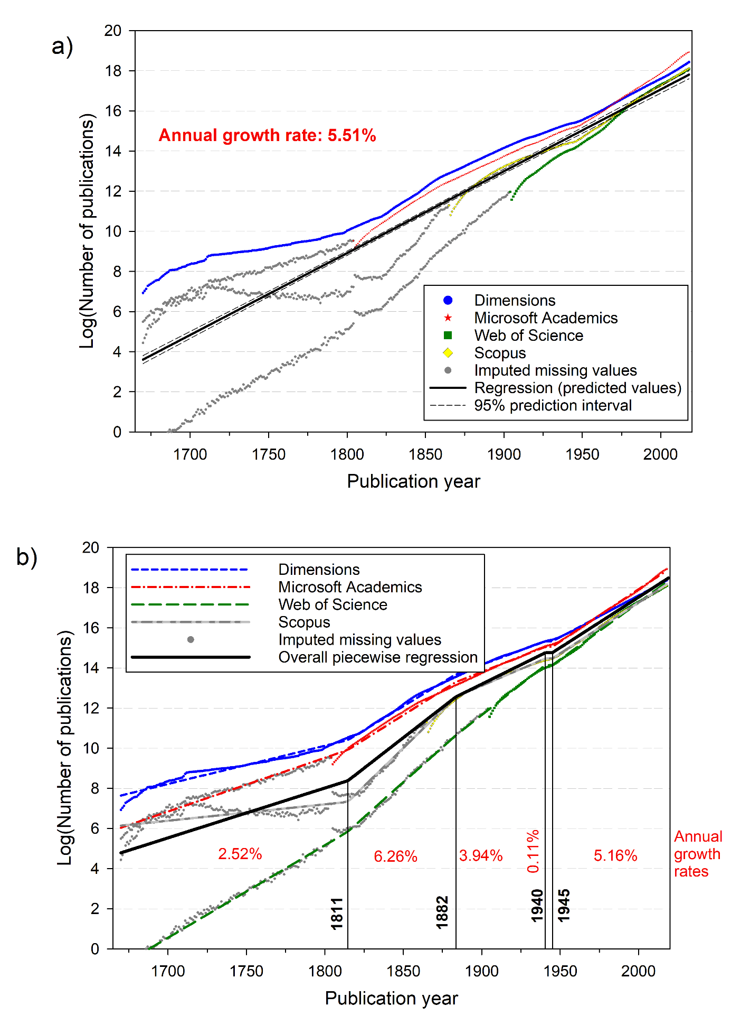

Figure S6. Plots for a) unrestricted growth (M₁) and b) segmented unrestricted growth (M₉) based on the number of publications from four bibliographic databases with all documents (known and unknown document types)

