Supplementary Informations
Finding pathways to synergistic development of Sustainable Development Goals in China
Junze Zhang^{1,2}, Shuai Wang², Wenwu Zhao², Michael E Meadows^{3,4,5}, Bojie Fu^{1,2*}
¹ State Key Laboratory of Urban and Regional Ecology, Research Center for Eco-Environmental Sciences, Chinese Academy of Sciences, Beijing, China
² State Key Laboratory of Earth Surface Processes and Resource Ecology, Faculty of Geographical Science, Beijing Normal University, Beijing, China
³ Department of Environmental & Geographical Science, University of Cape Town, Rondebosch, South Africa
⁴ School of Geographical and Oceanographic Sciences, Nanjing University, Nanjing, China
⁵ College of Geography and Environmental Sciences, Zhejiang Normal University, Jinhua, China
* email: bfu@rcees.ac.cn

Supplementary Methods
This study uses an integrated assessment approach to quantify the change of Sustainable Development Goals (SDGs) in China; all data were obtained from various government departments (see Table S1). Data used directly in the analysis are available in Supplementary Information; all other data collated and processing codes can be obtained from the corresponding author following reasonable request. Here, we introduce the procedure for assessing the progress in SDGs in detail, including the selection of indicators, setting of target and baseline values, normalization, and aggregation.
Selection of indicators. The selection of indicators may have a substantial impact on the results of any comprehensive assessment [1]. In our study, whenever possible, we used the official SDG indicators approved by the United Nations Statistics Division in 2017 [2] in addition to those applied in the 2019 Sustainable Development Report (SDR) [3] and related published literature [4]. However, in cases where the identical indicators proved unobtainable, we utilized indicators that corresponded as closely as possible to those according to official SDGs and SDG targets [5]. Generally, we complied with the criteria for selecting indicators in the SDR [3] with some adjustments necessitated by issues of scale and data availability. Firstly, selected indicators must be considered to have policy relevance, i.e. provide evidence suitable for the monitoring and implementation of SDGs; secondly, indicators must be universally, or at least broadly accessible, i.e. indicator are available across provinces to allow for inter-provincial comparisons; thirdly, indicators need to have reasonable reference ranges or thresholds that can be used to determine whether they are in a reasonable state; fourthly, indicators must exhibit timeliness, be available continuously or at regulated intervals to facilitate monitoring of trends; and fifthly, indicators much be statistical reliable to ensure that the data meets the quality standards of official statistics.
Considering that the indicator related to SDG14 (Life Below Water) can be obtained in only 11 provinces, SDG14 was not considered in this assessment. The list of SDG indicators includes a total of 88 indicators, which correspond to 71 SDG targets and 16 SDGs (Table S1). Fig. S1 summarizes the number of SDG targets and indicators contained in each SDG and as a proportion of the number of official SDG targets and indicators. Differences in the number of indicators included in each SDG are due to the uneven distribution of relevant official indicators. Overall, the number of indicators available for most SDGs accounts for about 50% of the number of official SDG indicators (Fig. S1), and, therefore, obtaining more appropriate data in the future remains a priority. The current selection of indicators fully aligns with the principles used in compiling the SDR [3] and may be considered reasonable, although data availability may improve in the future and more suitable indicators may replace existing ones.
Indicator baseline and target values. In quantifying SDG progress, a reasonable target value for each indicator to be completed by 2030 was established [6]. Although some SDGs and targets have indicators with clear and readily measurable target values, for example, no poverty (SDG 1) and gender equality (SDG 5), others are more difficult to assess. A meaningful baseline value for each indicator against which progress may be calculated was set [6], following which, to facilitate comparison, each SDG indicator value was normalized on a scale from 0 to 100, where 0 denotes the baseline and 100 represents the target value. Normalization is, however, very sensitive to extreme data values [3] and the selection of baseline and target values in the dataset can affect the achievement scores. To minimize the possible effect of extreme values on both tails of the data distribution, we, therefore, formulated the target and baseline values for the SDG indicators according to the method used in the SDR [3].
Regarding target values, firstly we adopted those used in the SDR or cited literature [3,4]. Secondly, we used the absolute or relative quantitative thresholds of SDGs and targets [5]. Thirdly, we employed the principle of “leave no one behind” [5] to determine the target value for the SDGs where no explicit target is stated, as is the case for SDG9 (Industry, Innovation, and Infrastructure) and SDG6 (Clean Water and Sanitation). Fourthly, for all other indicators, we set the target value equal to the mean of the top five values exhibited at provincial and national levels. For baseline values, we also initially adopted those used in the SDR or cited literature as appropriate [3,4]. To ensure representability of the baseline values chosen for other SDG indicators, we collated the data for each indicator in all 31 provinces from 1990 (or from when the data became available) to 2018 and determined the lowest 2.5% value for each one following the method in the SDR [3] (Table S2).
Normalization of indicator values. The attributes of each SDG indicator, i.e., whether positive, negative, or neutral, affect the normalization calculation method [7]. For some indicators, more positive scores imply progress in sustainable development, for example, an increase in the availability of wastewater treatment, whereas in other cases, such as poverty reduction, more negative scores are advantageous. In still others, such as the ratio of research and development expenditure to GDP, narrowing the gap between the data and the target value indicates improvement. Therefore, ‘positive’ and ‘negative’ indicators are affected by both baseline and target values simultaneously, while others (‘intermediate’ indicators) are only affected by the target value [7]. The particular characteristics of the indicator in question, therefore, necessitated adjustment of the normalization method such that, after determining the target and baseline values of the SDG indicator, we used the following formulae to normalize the positive, negative, and intermediate indicator:
Positive: $x^{'}= \frac{x – x_{min}}{x_{max}- x_{min}}$ × 100 (Equation 1)
Negative: $x^{'}= \frac{x_{max} - x}{x_{max}- x_{min}}$ × 100 (Equation 2)
Intermediate: $x^{'}=\left\{\begin{aligned}100- \frac{x_{int}-x}{\max\left(x_{int}-\min\left(x\right), \max\left(x\right) - x_{int}\right)}× 100, x< x_{int} \\ 100- \frac{x- x_{int}}{\max\left(x_{int}-\min\left(x\right), \max\left(x\right) - x_{int}\right)} × 100, x> x_{int} \\ 100, x= x_{int} \end{aligned}\right\}$(Equation 3)
where x is the original data value for each SDG indicator, x_{max} and x_{min} represent the target and baseline values of the original data for both of the positive and negative indicators, x_{int} is the target value of the original data for moderate indicators, and x' is the normalized score for a given SDG indicator. Any resulting values > 100 were set to =100, while negative values were set to = 0, thus ensuring that the rescaled variables are comparable, i.e. the higher the score, the better the performance.
Score aggregation. Similar to the method used in the SDR [3], national and provincial level scores for 2015 and 2018 of all SDG targets, individual SDGs and the SDG index were calculated using arithmetic means. We first aggregated the scores of the SDG indicators into the scores of SDG targets, and then aggregated the SDG target scores into the scores of individual SDGs. The SDG index score was then computed as the mean of scores for 16 SDGs. In order to minimize subjectivity, all SDGs were given the same weight and, therefore, afforded the same level of importance. Finally, we compared the changes in the SDG index scores and the scores of each SDG in 2015 and 2018 at national and provincial levels. In addition, note that the scores for each SDG at the national level were calculated using the raw indicator data at the national level, rather than the average of the SDG scores for each province. This enables more appropriate comparison of the differences among different SDGs at national and provincial levels.

Supplementary Tables
Table S1. Indicators selected in this study and their data sources.
Goals | Targets | Indicators |  | Time range | Data source
Goal 1. End poverty in all its forms everywhere
1 | 1.2 By 2030, reduce at least by half the proportion of men, women and children of all ages living in poverty in all its dimensions according to national definitions | 1.2.1 | Rural poverty incidence (%) | 2010-2018 | Poverty Monitoring Report of Rural China (2019) [8]
1 | 1.3 Implement nationally appropriate social protection systems and measures for all, including floors, and by 2030 achieve substantial coverage of the poor and the vulnerable | 1.3.1 | Unemployment insurance coverage rate (%) | 2000-2018 | China Labour Statistical Yearbook (2001-2019) [9]
1 | 1.4 By 2030, ensure that all men and women, in particular the poor and the vulnerable, have equal rights to economic resources, as well as access to basic services, ownership and control over land and other forms of property, ... | 1.4.1 | The penetration rate of sanitary toilet in rural area (%) | 2008-2018 | China Rural Statistical Yearbook (2009-2019) [10]
1 | 1.5 By 2030, build the resilience of the poor and those in vulnerable situations and reduce their exposure and vulnerability to climate-related extreme events and other economic, social and environmental shocks and disasters | 1.5.1 | The proportion of the population affected by natural disasters to the total population (%) | 2005-2018 | China Statistical Yearbook on Environment (2006-2019) [11]
1 | 1.5 | 1.5.2 | The direct economic losses caused by natural disasters as a percentage of GDP (%) | 2005-2018 | China Statistical Yearbook on Environment (2006-2019) [11]
Goal 2. End hunger, achieve food security and improved nutrition and promote sustainable agriculture
2 | 2.1 By 2030, end hunger and ensure access by all people, in particular the poor and people in vulnerable situations, including infants, to safe, nutritious and sufficient food all year round | 2.1.1 | Number of patients with foodborne diseases (per million population) | 2012-2018 | China Health Statistics Yearbook (2013-2019) [12]
2 | 2.1 | 2.1.2 | Cereal yield per unit area (tons/ha) | 1991-2018 | China Statistics Yearbook (1992-2019) [13]
2 | 2.2 By 2030, end all forms of malnutrition, including achieving, by 2025, the internationally agreed targets on stunting and wasting in children under 5 years of age, and address the nutritional needs of adolescent girls, … | 2.2.2 | Proportion of moderate to severe malnutrition in children under 5 years old (%) | 2002-2018 | China Social Statistical Yearbook (2003-2019) [14]
2 | 2.a Increase investment, including through enhanced international cooperation, in rural infrastructure, agricultural research and extension services, technology development and … | 2.a.1 | Agriculture orientation index for government expenditures | 2007-2018 | China Statistical Yearbook (2008-2019) [13]
Goal 3. Ensure healthy lives and promote well-being for all at all ages
3 | 3.1 By 2030, reduce the global maternal mortality ratio to less than 70 per 100,000 live births | 3.1.1 | Maternal mortality (per 100,000 live births) | 2004-2018 | China Health Statistical Yearbook (2005-2019) [12]
3 | 3.1 | 3.1.2 | Proportion of births attended by skilled health personnel (%) | 2002-2018 | China Health Statistical Yearbook (2003-2019) [12]
3 | 3.2 By 2030, end preventable deaths of newborns and children under 5 years of age, with all countries aiming to reduce neonatal mortality to at least as low as 12 per 1,000 live births and … | 3.2.1 | Percentage of infants with birth weight <2500 grams (%) | 2002-2018 | China Health Statistical Yearbook (2003-2019) [12]
3 | 3.2 | 3.2.2 | Perinatal mortality rate | 2002-2018 | China Health Statistical Yearbook (2003-2019) [12]
3 | 3.3 By 2030, end the epidemics of AIDS, tuberculosis, malaria and neglected tropical diseases and combat hepatitis, water-borne diseases and other communicable diseases | 3.3.1 | AIDS incidence per 100,000 population | 2002-2018 | China Health Statistical Yearbook (2003-2019) [12]
3 | 3.3 | 3.3.2 | Tuberculosis incidence per 100,000 population | 2002-2018 | China Health Statistical Yearbook (2003-2019) [12]
3 | 3.3 | 3.3.3 | Malaria incidence per 100,000 population | 2002-2018 | China Health Statistical Yearbook (2003-2019) [12]
3 | 3.3 | 3.3.4 | Hepatitis B incidence per 100,000 population | 2002-2018 | China Health Statistical Yearbook (2003-2019) [12]
3 | 3.3 | 3.3.5 | Schistosomiasis incidence per 100,000 population | 2005-2018 | China Health Statistical Yearbook (2006-2019) [12]
3 | 3.6 By 2020, halve the number of global deaths and injuries from road traffic accidents | 3.6.1 | Death rate due to road traffic injuries (per 100,000 population) | 1999-2018 | China Statistical Yearbook (2000-2019) [13]
3 | 3.8 Achieve universal health coverage, including financial risk protection, access to quality essential health-care services and access to safe, effective, quality and affordable essential medicines and vaccines for all | 3.8.1 | The proportion of urban residents covered by basic medical insurance in the total population (%) | 2007-2018 | China Labour Statistical Yearbook (2008-2019) [9]
3 | 3.9 By 2030, substantially reduce the number of deaths and illnesses from hazardous chemicals and air, water and soil pollution and contamination | 3.9.1 | Keshan disease incidence per 100,000 population | 2002-2018 | China Health Statistical Yearbook (2003-2019) [12]
3 | 3.b Support the research and development of vaccines and medicines for the communicable and non-communicable diseases that primarily affect developing countries, provide access to affordable essential medicines and vaccines, … | 3.b.2 | The proportion of local medical and health expenditure in the fiscal budget (%) | 2007-2018 | China Statistical Yearbook (2008-2019) [13]
3 | 3.c Substantially increase health financing and the recruitment, development, training and retention of the health workforce in developing countries, … | 3.c.1 | Number of health worker per 10,000 population | 2008-2018 | China Health Statistical Yearbook (2009-2019) [12]
Goal 4. Ensure inclusive and equitable quality education and promote lifelong learning opportunities for all
4 | 4.3 By 2030, ensure equal access for all women and men to affordable and quality technical, vocational and tertiary education, including university | 4.3.1 | Proportion of population aged 6 and over without education (%) | 2004-2018 | China Statistical Yearbook (2005-2019) [13]
4 | 4.4 By 2030, substantially increase the number of youth and adults who have relevant skills, including technical and vocational skills, for employment, decent jobs and entrepreneurship | 4.4.1 | Percentage of population receiving higher education (%) | 2004-2018 | China Statistical Yearbook (2005-2019) [13]
4 | 4.5 By 2030, eliminate gender disparities in education and ensure equal access to all levels of education and vocational training for the vulnerable, including persons with disabilities, indigenous peoples and children in vulnerable situations | 4.5.1 | Difference in the ratio of male and female educated over 6 years old (%) | 2004-2018 | China Statistical Yearbook (2005-2019) [13]
4 | 4.6 By 2030, ensure that all youth and a substantial proportion of adults, both men and women, achieve literacy and numeracy | 4.6.1 | Percentage of illiterate and semi-illiterate population over 15 (%) | 1996-2018 | China Statistical Yearbook (1997-2019) [13]
4 | 4.a Build and upgrade education facilities that are child, disability and gender sensitive and provide safe, non-violent, inclusive and effective learning environments for all | 4.a.1 | The ratio of the number of pupils in school to the number of computers | 2003-2018 | Educational Statistics Yearbook of China (2004-2019) [15]
4 | 4.b By 2020, substantially expand globally the number of scholarships available to developing countries, in particular least developed countries, small island developing States and African countries, … | 4.b.1 | Education expenditure as a percentage of fiscal expenditure | 2007-2018 | China Statistical Yearbook (2008-2019) [13]
4 | 4.c By 2030, substantially increase the supply of qualified teachers, including through international cooperation for teacher training in developing countries, especially least developed countries and small island developing States | 4.c.1 | The ratio of the teacher-student ratio of urban elementary schools to that of rural elementary schools | 1999-2018 | Educational Statistics Yearbook of China (2000-2019) [15]
Goal 5. Achieve gender equality and empower all women and girls
5 | 5.5 Ensure women’s full and effective participation and equal opportunities for leadership at all levels of decision-making in political, economic and public life | 5.5.1 | Proportion of female employees in civil affairs deparment | 1997-2018 | China Civil Affairs Statistical Yearbook (1998-2019) [16]
5 | 5.5 | 5.5.2 | Proportion of female employees in urban units | 2000-2018 | China Labour Statistical Yearbook (2001-2019) [9]
5 | 5.6 Ensure universal access to sexual and reproductive health and reproductive rights as agreed in accordance with the Programme of Action of the International Conference on Population and Development… | 5.b.1 | Mobile phone penetration rate (the number of mobile phones per 100 people) | 2005-2018 | China Statistical Yearbook (2006-2019) [13]
Goal 6. Ensure availability and sustainable management of water and sanitation for all
6 | 6.1 By 2030, achieve universal and equitable access to safe and affordable drinking water for all | 6.1.1 | The proportion of the population benefiting from the treated water in the total population of the sick area — Endemic fluorosis (water type) (%) | 2002-2018 | China Health Statistical Yearbook (2003-2019) [12]
6 | 6.2 By 2030, achieve access to adequate and equitable sanitation and hygiene for all and end open defecation, paying special attention to the needs of women and girls and those in vulnerable situations | 6.2.1 | The penetration rate of sanitary toilet in rural area (%) | 2008-2018 | China Rural Statistical Yearbook (2009-2019) [10]
6 | 6.3 By 2030, improve water quality by reducing pollution, eliminating dumping and minimizing release of hazardous chemicals and materials, halving the proportion of untreated wastewater… | 6.3.1 | Sewage treatment rate in cities (%) | 2002-2018 | China Urban Construction Statistical Yearbook (2003-2019) [17]
6 | 6.4 By 2030, substantially increase water-use efficiency across all sectors and ensure sustainable withdrawals and supply of freshwater to address water scarcity… | 6.4.1 | Water-use efficiency (m³/RMB) | 2003-2018 | China Statistical Yearbook (2004-2019) [13]
6 | 6.4 | 6.4.2 | Ratio of total water consumption to total water resources (%) | 2003-2018 | China Statistical Yearbook (2004-2019) [13]
6 | 6.a By 2030, expand international cooperation and capacity-building support to developing countries in water- and sanitation-related activities and programmes, … | 6.a.1 | Investment in environmental pollution control as a percentage of GDP (%) | 2003-2018 | China Statistical Yearbook on Environment (2004-2019) [11]
Goal 7. Ensure access to affordable, reliable, sustainable and modern energy for all
7 | 7.1 By 2030, ensure universal access to affordable, reliable and modern energy services | 7.1.2 | Gas penetration rate in cities (%) | 1999-2018 | China Statistical Yearbook (2000-2019) [13]
7 | 7.2 By 2030, increase substantially the share of renewable energy in the global energy mix | 7.2.1 | Proportion of clean energy power generation to total power generation (%) | 1995-2018 | China Energy Statistical Yearbook (1996-2019) [18]
7 | 7.3 By 2030, double the global rate of improvement in energy efficiency | 7.3.1 | Energy intensity (ton standard coal per 10,000 RMB) | 2000-2018 | China Energy Statistical Yearbook (2001-2019) [18]
Goal 8. Promote sustained, inclusive and sustainable economic growth, full and productive employment and decent work for all
8 | 8.1 Sustain per capita economic growth in accordance with national circumstances and, in particular, at least 7 per cent gross domestic product growth per annum in the least developed countries | 8.1.1 | Annual growth rate of real GDP per capita (%) | 1994-2018 | China Statistical Yearbook (1995-2019) [13]
8 | 8.4 Improve progressively, through 2030, global resource efficiency in consumption and production and endeavour to decouple economic growth from environmental degradation, … | 8.4.2 | Wood consumption per unit of added value of construction industry (m³/10,000 yuan) | 2004-2018 | China Statistical Yearbook on Construction (2005-2019) [19]
8 | 8.5 By 2030, achieve full and productive employment and decent work for all women and men, including for young people and persons with disabilities, and equal pay for work of equal value | 8.5.2 | The urban registered unemployment rate (%) | 1999-2018 | China Statistical Yearbook (2000-2019) [13]
8 | 8.6 By 2020, substantially reduce the proportion of youth not in employment, education or training | 8.6.1 | Proportion of employed persons who have never attended school (%) | 1996-2018 | China Labour Statistical Yearbook (1997-2019) [9]
8 | 8.8 Protect labour rights and promote safe and secure working environments for all workers, including migrant workers, in particular women migrants, and those in precarious employment | 8.8.1 | The determination of work-related injuries per 10,000 employed persons | 2006-2018 | China Labour Statistical Yearbook (2007-2019) [9]
8 | 8.8 | 8.8.2 | Work-related injury insurance coverage rate (%) | 2003-2018 | China Labour Statistical Yearbook (2004-2019) [9]
8 | 8.9 By 2030, devise and implement policies to promote sustainable tourism that creates jobs and promotes local culture and products | 8.9.1 | The added value of the tertiary industry as a proportion of GDP (%) | 1996-2018 | China Statistical Yearbook (1997-2019) [13]
Goal 9. Build resilient infrastructure, promote inclusive and sustainable industrialization and foster innovation
9 | 9.1 Develop quality, reliable, sustainable and resilient infrastructure, including regional and trans-border infrastructure, to support economic development and human well-being, … | 9.1.2 | Railway passenger density (the ratio of passenger turnover to mileage of operating lines) | 1990-2018 | China Statistical Yearbook (1991-2019) [13]
9 | 9.2 Promote inclusive and sustainable industrialization and, by 2030, significantly raise industry’s share of employment and gross domestic product, in line with national circumstances, … | 9.2.1 | The ratio of industrial added value to gross national product (%) | 2000-2018 | China Statistical Yearbook (2001-2019) [13]
9 | 9.3 Increase the access of small-scale industrial and other enterprises, in particular in developing countries, to financial services, including affordable credit, and their integration into value chains and markets | 9.3.1 | The sales output value of small industrial enterprises as a percentage of the industrial sales output value (%) | 2001-2018 | China Industry Statistical Yearbook (2002-2019) [9]
9 | 9.4 By 2030, upgrade infrastructure and retrofit industries to make them sustainable, with increased resource-use efficiency and greater adoption of clean and environmentally sound technologies and … | 9.4.1 | Waste gas emissions per unit of industrial added value (m³/RMB) | 1993-2018 | China Statistical Yearbook on Environment (1994-2019) [11]
9 | 9.5 Enhance scientific research, upgrade the technological capabilities of industrial sectors in all countries, in particular developing countries, including, by 2030, encouraging innovation and … | 9.5.1 | Research and development expenditure as a proportion of GDP (%) | 2006-2018 | China Statistical Yearbook on Science and Technology (2007-2019) [21]
9 | 9.5 | 9.5.2 | Researchers (in full-time equivalent) as a proportion of total population (%) | 2009-2018 | China Statistical Yearbook on Science and Technology (2010-2019) [21]
9 | 9.a Facilitate sustainable and resilient infrastructure development in developing countries through enhanced financial, technological and technical support to African countries, least developed countries, … | 9.a.1 | Investment in environmental pollution control as a percentage of GDP (%) | 2003-2018 | China Statistical Yearbook on Environment (2004-2019) [11]
9 | 9.c Significantly increase access to information and communications technology and strive to provide universal and affordable access to the Internet in least developed countries by 2020 | 9.c.1 | Number of 4G mobile phones used per 100 people | 2014-2018 | China Statistical Yearbook (2015-2019) [13]
Goal 10. Reduce inequality within and among countries
10 | 10.1 By 2030, progressively achieve and sustain income growth of the bottom 40 per cent of the population at a rate higher than the national average | 10.1.1 | Ratio of income of urban and rural residents (income of rural residents = 1) | 2006-2018 | China Rural Statistical Yearbook (2007-2019) [10]
10 | 10.4 Adopt policies, especially fiscal, wage and social protection policies, and progressively achieve greater equality | 10.4.1 | Proportion of total wages of employed persons in urban units to regional GDP | 2000-2018 | China Labour Statistical Yearbook (2001-2019) [9]
10 | 10.5 Improve the regulation and monitoring of global financial markets and institutions and strengthen the implementation of such regulations | 10.5.1 | The proportion of non-performing loans of commercial banks to total loans (%) | 2006-2018 | Almanac of China’s Finance and Banking (2007-2019) [22]
Goal 11. Make cities and human settlements inclusive, safe, resilient and sustainable
11 | 11.1 By 2030, ensure access for all to adequate, safe and affordable housing and basic services and upgrade slums | 11.1.1 | Basic pension insurance coverage rate | 2010-2018 | China Labour Statistical Yearbook (2011-2019) [9]
11 | 11.2 By 2030, provide access to safe, affordable, accessible and sustainable transport systems for all, improving road safety, notably by expanding public transport, … | 11.2.1 | Number of buses per 10,000 people | 1996-2018 | China Statistical Yearbook (1997-2019) [13]
11 | 11.3 By 2030, enhance inclusive and sustainable urbanization and capacity for participatory, integrated and sustainable human settlement planning and management in all countries | 11.3.1 | The ratio of the growth rate of construction land to the growth rate of urban population | 2013-2018 | China Urban Construction Statistical Yearbook (2014-2019) [17]
11 | 11.5 By 2030, significantly reduce the number of deaths and the number of people affected and substantially decrease the direct economic losses relative to global gross domestic product caused by disasters, … | 11.5.1 | The proportion of the population affected by natural disasters to the total population (%) | 2005-2018 | China Statistical Yearbook on Environment (2006-2019) [11]
11 | 11.5 | 11.5.2 | The direct economic losses caused by natural disasters as a percentage of GDP (%) | 2005-2018 | China Statistical Yearbook on Environment (2006-2019) [11]
11 | 11.6 By 2030, reduce the adverse per capita environmental impact of cities, including by paying special attention to air quality and municipal and other waste management | 11.6.1 | Harmless treatment rate of household waste (%) | 2003-2018 | China Statistical Yearbook (2004-2019) [13]
11 | 11.6 | 11.6.2 | Proportion of days with air quality reaching level 2 or higher within a year | 2005-2018 | China Environment Yearbook (2006-2019) [23]
11 | 11.7 By 2030, provide universal access to safe, inclusive and accessible, green and public spaces, in particular for women and children, older persons and persons with disabilities | 11.7.1 | Park green area per capita (m²/person) | 1999-2018 | China Statistical Yearbook (2000-2019) [13]
Goal 12. Ensure sustainable consumption and production patterns
12 | 12.2 By 2030, achieve the sustainable management and efficient use of natural resources | 12.2.1 | SO₂ emissions per capita (kg/person) | 2002-2018 | China Statistical Yearbook (2003-2019) [13]
12 | 12.2 | 12.2.2 | Wood consumption per unit of added value of construction industry (m³/10,000 yuan) | 2004-2018 | China Statistical Yearbook on Construction (2005-2019) [19]
12 | 12.4 By 2020, achieve the environmentally sound management of chemicals and all wastes throughout their life cycle, in accordance with agreed international frameworks, and … | 12.4.2 | Amount of hazardous waste generated per capita (kg/person) | 1999-2018 | China Statistical Yearbook on Environment (2000-2019) [11]
12 | 12.5 By 2030, substantially reduce waste generation through prevention, reduction, recycling and reuse | 12.5.1 | Comprehensive utilization rate of industrial solid waste (%) | 2000-2018 | China Statistical Yearbook (2001-2019) [13]
Goal 13. Take urgent action to combat climate change and its impacts
13 | 13.1 Strengthen resilience and adaptive capacity to climate-related hazards and natural disasters in all countries | 13.1.1 | The proportion of the population affected by natural disasters to the total population (%) | 2005-2018 | China Statistical Yearbook on Environment (2006-2019) [11]
13 | 13.2 Integrate climate change measures into national policies, strategies and planning | 13.2.1 | SO₂ emissions per capita (kg/person) | 2002-2018 | China Statistical Yearbook (2003-2019) [13]
Goal 15. Protect, restore and promote sustainable use of terrestrial ecosystems, sustainably manage forests, combat desertification, and halt and reverse land degradation and halt biodiversity loss
15 | 15.1 By 2020, ensure the conservation, restoration and sustainable use of terrestrial and inland freshwater ecosystems and their services, in particular forests, wetlands, mountains and drylands, … | 15.1.1 | Forest cover rate | 2004-2018 | China Statistical Yearbook (2005-2019) [13]
15 | 15.1 | 15.1.2 | The area of wetland ecological nature reserve accounts for the proportion of forestry system nature reserve area | 2009-2018 | China Forestry and Grassland Yearbook (2010-2019) [24]
15 | 15.2 By 2020, promote the implementation of sustainable management of all types of forests, halt deforestation, restore degraded forests and substantially increase afforestation and reforestation globally | 15.2.1 | The area of forest ecological nature reserves accounts for the proportion of forestry system nature reserves | 2009-2018 | China Forestry and Grassland Yearbook (2010-2019) [24]
15 | 15.3 By 2030, combat desertification, restore degraded land and soil, including land affected by desertification, drought and floods, and strive to achieve a land degradation-neutral world | 15.3.1 | The proportion of desertified land in total land area (%) | 2004-2018 | China Statistical Yearbook on Environment (2005-2019) [11]
15 | 15.4 By 2030, ensure the conservation of mountain ecosystems, including their biodiversity, in order to enhance their capacity to provide benefits that are essential for sustainable development | 15.4.1 | The proportion of the area of wild animal and plant nature reserves in the area of nature reserves in the forestry system | 2009-2018 | China Forestry and Grassland Yearbook (2010-2019) [24]
15 | 15.5 Take urgent and significant action to reduce the degradation of natural habitats, halt the loss of biodiversity and, by 2020, protect and prevent the extinction of threatened species | 15.5.1 | Ecological protection and construction investment as a percentage of forestry investment | 2011-2018 | China Forestry and Grassland Yearbook (2012-2019) [24]
15 | 15.a Mobilize and significantly increase financial resources from all sources to conserve and sustainably use biodiversity and ecosystems | 15.a.1 | Forestry investment as a percentage of GDP | 2011-2018 | China Forestry and Grassland Yearbook (2012-2019) [24]
15 | 15.b Mobilize significant resources from all sources and at all levels to finance sustainable forest management and provide adequate incentives to developing countries to advance such management, … | 15.b.1 | State investment as a percentage of forestry investment | 2011-2018 | China Forestry and Grassland Yearbook (2012-2019) [24]
Goal 16. Promote peaceful and inclusive societies for sustainable development, provide access to justice for all and build effective, accountable and inclusive institutions at all levels
16 | 16.7 Ensure responsive, inclusive, participatory and representative decision-making at all levels | 16.7.1 | Proportion of female employees in administrative agencies of civil affairs departments | 1997-2018 | China Civil Affairs Statistical Yearbook (1998-2019) [16]
16 | 16.10 Ensure public access to information and protect fundamental freedoms, in accordance with national legislation and international agreements | 16.10.2 | The proportion of rural cable radio and television users to the total number of households in rural area | 2010-2018 | China Statistical Yearbook of the Tertiary Industry (2011-2019) [25]
Goal 17. Strengthen the means of implementation and revitalize the Global Partnership for Sustainable Development
17 | 17.1 Strengthen domestic resource mobilization, including through international support to developing countries, to improve domestic capacity for tax and other revenue collection | 17.1.1 | Local government general budget revenue as a percentage of GDP | 2000-2018 | Finance Yearbook of China (2001-2019) [26]
17 | 17.1 | 17.1.2 | Local government tax as a percentage of fiscal revenue | 2002-2018 | China Statistical Yearbook (2003-2019) [13]
17 | 17.6 Enhance North-South, South-South and triangular regional and international cooperation on and access to science, technology and innovation and enhance knowledge-sharing on mutually agreed terms, … | 17.6.2 | Number of computers per 100 households | 2015-2018 | China Statistical Yearbook (2016-2019) [13]
17 | 17.8 Fully operationalize the technology bank and science, technology and innovation capacity-building mechanism for least developed countries by 2017 and enhance the use of enabling technology, in particular information and communications technology | 17.8.1 | Internet penetration rate (Internet users as a percentage of the total population) | 2002-2018 | China Statistical Yearbook (2003-2019) [13]

Table S2. Descriptive statistics of SDG indicators and their attribute characteristics.
Goals | Targets | Indicators | Target value | Baseline value | Attributes | Sample size | Minimum | Maximum | Average | Standard Deviation | Percentile: 2.5% | Percentile: 97.5%
1 | 1.2 | 1.2.1 | 0 | 72.6 | Negative | 253 | 0.2 | 49.2 | 10.05 | 9.15 | 0.74 | 38.32
1 | 1.3 | 1.3.1 | 100 | 3.44175 | Positive | 608 | 2.39 | 57.6 | 10.82 | 7.62 | 3.39 | 31.53
1 | 1.4 | 1.4.1 | 100 | 9.7 | Positive | 344 | 32.6 | 99.8 | 71.95 | 16.46 | 38.39 | 98.48
1 | 1.5 | 1.5.1 | 0 | 67.15 | Negative | 411 | 0 | 107.1 | 24.63 | 19.02 | 0.52 | 67.14
1 | 1.5 | 1.5.2 | 0 | 5 | Negative | 407 | 0 | 17.6 | 1.02 | 1.54 | 0.01 | 5.01
2 | 2.1 | 2.1.1 | 0 | 77.4162 | Negative | 217 | 0.13 | 108.38 | 20.45 | 19.24 | 1.75 | 80.03
2 | 2.1 | 2.1.2 | 8.6 | 0.2 | Positive | 890 | 2.42 | 8.02 | 5.12 | 1.06 | 3.02 | 6.89
2 | 2.2 | 2.2.2 | 0 | 42.3 | Negative | 544 | 0.06 | 9.59 | 1.84 | 1.46 | 0.13 | 5.43
2 | 2.a | 2.a.1 | 9.79 | — | Moderate | 384 | 0.32 | 19.7 | 1.73 | 2.39 | 0.53 | 9.08
3 | 3.1 | 3.1.1 | 3.5 | 117 | Negative | 480 | 1.1 | 310.43 | 27.92 | 35.86 | 3.60 | 116.71
3 | 3.1 | 3.1.2 | 100 | 10 | Positive | 544 | 26.74 | 100 | 92.75 | 12.86 | 52.87 | 100.00
3 | 3.2 | 3.2.1 | 0.5 | 5 | Negative | 544 | 0.97 | 5.95 | 2.48 | 0.94 | 1.13 | 4.75
3 | 3.2 | 3.2.2 | 1 | 20 | Negative | 544 | 2.02 | 25.8 | 8.45 | 4.47 | 2.81 | 20.08
3 | 3.3 | 3.3.1 | 0 | 12 | Negative | 504 | 0.01 | 18.15 | 1.93 | 2.93 | 0.03 | 12.31
3 | 3.3 | 3.3.2 | 0 | 173 | Negative | 511 | 19.52 | 304.94 | 76.90 | 35.80 | 26.66 | 173.38
3 | 3.3 | 3.3.3 | 0 | 23 | Negative | 500 | 0 | 112.91 | 1.75 | 8.33 | 0.01 | 23.06
3 | 3.3 | 3.3.4 | 0 | 229 | Negative | 512 | 7.79 | 413.29 | 80.12 | 52.52 | 12.44 | 228.76
3 | 3.3 | 3.3.5 | 0 | 7 | Negative | 239 | 0 | 39.9 | 0.58 | 2.92 | 0.00 | 6.64
3 | 3.6 | 3.6.1 | 1 | 14 | Negative | 639 | 1.71 | 21.79 | 6.69 | 3.04 | 2.86 | 13.75
3 | 3.8 | 3.8.1 | 100 | 11.5 | Positive | 384 | 6.65 | 117.6 | 45.60 | 27.98 | 11.54 | 105.74
3 | 3.9 | 3.9.1 | 0 | 78 | Negative | 276 | 0.01 | 81.44 | 7.66 | 16.75 | 0.07 | 77.25
3 | 3.b | 3.b.2 | 10 | 4 | Positive | 384 | 3.77 | 10.56 | 6.94 | 1.53 | 4.34 | 10.12
3 | 3.c | 3.c.1 | 108 | 30 | Positive | 352 | 22 | 155 | 55.47 | 18.07 | 29.83 | 108.35
4 | 4.3 | 4.3.1 | 0 | 34 | Negative | 448 | 1.51 | 45.54 | 7.76 | 6.45 | 2.13 | 34.30
4 | 4.4 | 4.4.1 | 50 | 3 | Positive | 448 | 0.89 | 48.65 | 10.70 | 6.97 | 3.13 | 30.63
4 | 4.5 | 4.5.1 | 0 | 9 | Negative | 448 | -0.48 | 10.88 | 4.54 | 2.13 | 0.67 | 8.94
4 | 4.6 | 4.6.1 | 0 | 40 | Negative | 639 | 1.23 | 66.18 | 10.34 | 8.92 | 1.85 | 39.60
4 | 4.a | 4.a.1 | 4 | 75 | Negative | 512 | 3.52 | 160.67 | 23.24 | 19.97 | 4.87 | 74.94
4 | 4.b | 4.b.1 | 21 | — | Moderate | 384 | 9.89 | 22.22 | 16.44 | 2.59 | 11.18 | 20.96
4 | 4.c | 4.c.1 | 1 | — | Moderate | 640 | 0.44 | 2.6 | 1.23 | 0.37 | 0.69 | 2.15
5 | 5.5 | 5.5.1 | 50 | 19 | Positive | 704 | 11.04 | 56.3 | 30.49 | 6.03 | 19.44 | 43.30
5 | 5.5 | 5.5.2 | 50 | 32 | Positive | 608 | 31.14 | 45.2 | 36.71 | 2.77 | 32.24 | 42.80
5 | 5.b | 5.b.1 | 100 | 20 | Positive | 448 | 13 | 189.5 | 74.99 | 32.78 | 20.01 | 139.04
6 | 6.1 | 6.1.1 | 100 | 14 | Positive | 486 | 1.92 | 148.57 | 68.98 | 24.34 | 13.59 | 103.01
6 | 6.2 | 6.2.1 | 100 | 9.7 | Positive | 344 | 32.6 | 99.8 | 71.95 | 16.46 | 38.39 | 98.48
6 | 6.3 | 6.3.1 | 100 | 19 | Positive | 534 | 0.06 | 98.6 | 71.21 | 23.31 | 18.94 | 96.86
6 | 6.4 | 6.4.1 | 0.0024 | 0.125 | Negative | 512 | 0 | 0.27 | 0.02 | 0.03 | 0.00 | 0.12
6 | 6.4 | 6.4.2 | 12.5 | 647 | Negative | 512 | 0.53 | 915.47 | 76.51 | 139.31 | 0.80 | 647.57
6 | 6.a | 6.a.1 | 3.1 | 0.45 | Positive | 512 | 0.05 | 4.66 | 1.33 | 0.69 | 0.44 | 3.20
7 | 7.1 | 7.1.2 | 100 | 35 | Positive | 639 | 23.5 | 113.84 | 83.91 | 15.74 | 46.60 | 100.00
7 | 7.2 | 7.2.1 | 84 | 0.05 | Positive | 377 | 0 | 95.67 | 25.70 | 25.70 | 0.05 | 89.05
7 | 7.3 | 7.3.1 | 0.31 | 4 | Negative | 590 | 0.25 | 23 | 1.31 | 1.48 | 0.40 | 4.00
8 | 8.1 | 8.1.1 | 7 | — | Moderate | 800 | -27.9 | 46.03 | 13.28 | 7.85 | 0.68 | 31.40
8 | 8.4 | 8.4.2 | 0.29 | 3.45 | Negative | 480 | 0.14 | 27.15 | 1.18 | 1.42 | 0.29 | 3.34
8 | 8.5 | 8.5.2 | 0.5 | 25.9 | Negative | 629 | 0.62 | 6.5 | 3.52 | 0.72 | 1.43 | 4.50
8 | 8.6 | 8.6.1 | 0 | 32 | Negative | 703 | 0.14 | 67.5 | 7.02 | 8.62 | 0.44 | 32.17
8 | 8.8 | 8.8.1 | 2 | 54 | Negative | 415 | 0.9 | 66.66 | 13.79 | 12.54 | 2.15 | 54.12
8 | 8.8 | 8.8.2 | 100 | 3 | Positive | 507 | 0.06 | 106.07 | 23.98 | 19.23 | 3.11 | 86.95
8 | 8.9 | 8.9.1 | 67 | 27 | Positive | 735 | 24.6 | 80.98 | 41.15 | 8.71 | 29.64 | 66.57
9 | 9.1 | 9.1.2 | 2102 | 51 | Positive | 906 | 5 | 3462.86 | 844.52 | 576.21 | 51.32 | 2102.93
9 | 9.2 | 9.2.1 | 57.2 | 7.86 | Positive | 608 | 6.81 | 55.75 | 37.71 | 9.67 | 7.91 | 51.16
9 | 9.3 | 9.3.1 | 60.6 | — | Moderate | 544 | 13.77 | 74.66 | 33.74 | 10.28 | 15.98 | 52.55
9 | 9.4 | 9.4.1 | 0.76 | 13 | Moderate | 828 | 0.4 | 25.39 | 4.54 | 3.10 | 1.05 | 12.52
9 | 9.5 | 9.5.1 | 3.7 | — | Moderate | 416 | 0.17 | 6.17 | 1.44 | 1.06 | 0.25 | 5.43
9 | 9.5 | 9.5.2 | 1.56 | — | Moderate | 320 | 0.05 | 1.84 | 0.36 | 0.33 | 0.07 | 1.47
9 | 9.a | 9.a.1 | 3.1 | — | Moderate | 512 | 0.05 | 4.66 | 1.33 | 0.69 | 0.44 | 3.20
9 | 9.c | 9.c.1 | 100 | 0.3493 | Moderate | 158 | 0.18 | 146.92 | 49.78 | 32.40 | 3.85 | 120.29
10 | 10.1 | 10.1.1 | 1 | — | Moderate | 416 | 1.85 | 4.6 | 2.86 | 0.54 | 2.06 | 4.16
10 | 10.4 | 10.4.1 | 30.6 | 7.04 | Moderate | 608 | 6.84 | 39.84 | 13.53 | 4.97 | 7.41 | 27.85
10 | 10.5 | 10.5.1 | 0 | 16.51 | Moderate | 416 | 0.23 | 24.6 | 2.90 | 3.80 | 0.48 | 16.27
11 | 11.1 | 11.1.1 | 100 | 21 | Moderate | 288 | 13.83 | 87.97 | 55.40 | 13.67 | 21.43 | 73.11
11 | 11.2 | 11.2.1 | 26 | — | Moderate | 735 | 3 | 35.2 | 10.72 | 4.45 | 4.37 | 24.18
11 | 11.3 | 11.3.1 | 1.12 | — | Moderate | 190 | -183.95 | 16.46 | -0.06 | 14.84 | -9.99 | 7.81
11 | 11.5 | 11.5.1 | 0 | 67.15 | Negative | 411 | 0 | 107.1 | 24.63 | 19.02 | 0.52 | 67.14
11 | 11.5 | 11.5.2 | 0 | 5 | Negative | 407 | 0 | 17.6 | 1.02 | 1.54 | 0.01 | 5.01
11 | 11.6 | 11.6.1 | 100 | 23 | Positive | 501 | 9.73 | 100 | 76.19 | 23.42 | 23.03 | 100.00
11 | 11.6 | 11.6.2 | 100 | 40 | Positive | 448 | 13.42 | 100.3 | 78.75 | 16.23 | 41.37 | 100.00
11 | 11.7 | 11.7.1 | 21.2 | — | Moderate | 637 | 0.42 | 29.38 | 9.74 | 3.68 | 3.44 | 17.91
12 | 12.2 | 12.2.1 | 0.5 | 68.3 | Negative | 544 | 0.28 | 64.47 | 16.85 | 12.48 | 1.03 | 56.54
12 | 12.2 | 12.2.2 | 0.29 | 3.45 | Negative | 480 | 0.14 | 27.15 | 1.18 | 1.42 | 0.29 | 3.34
12 | 12.4 | 12.4.2 | 0.88 | 140 | Negative | 605 | 0.12 | 848.94 | 28.00 | 79.04 | 0.94 | 141.20
12 | 12.5 | 12.5.1 | 100 | 20.9 | Positive | 602 | 1.52 | 136.06 | 63.14 | 22.41 | 20.67 | 99.15
13 | 13.1 | 13.1.1 | 0 | 67.15 | Negative | 411 | 0 | 107.1 | 24.63 | 19.02 | 0.52 | 67.14
13 | 13.2 | 13.2.1 | 0.5 | 68.3 | Negative | 544 | 0.28 | 64.47 | 16.85 | 12.48 | 1.03 | 56.54
15 | 15.1 | 15.1.1 | 63 | 2.9 | Positive | 480 | 2.9 | 66.8 | 30.15 | 17.67 | 4.20 | 63.00
15 | 15.1 | 15.1.2 | 93.92 | 0.22 | Positive | 308 | 0.2 | 97.16 | 28.32 | 25.29 | 0.22 | 94.78
15 | 15.2 | 15.2.1 | 88.99 | 1.7 | Positive | 310 | 1.34 | 90.5 | 47.70 | 25.15 | 1.78 | 86.91
15 | 15.3 | 15.3.1 | 0 | 46.64 | Negative | 465 | 0 | 46.69 | 7.93 | 11.65 | 0.00 | 46.64
15 | 15.4 | 15.4.1 | 100 | 1.47 | Positive | 300 | 0.84 | 100 | 21.67 | 20.71 | 2.31 | 100.00
15 | 15.5 | 15.5.1 | 92 | 15 | Positive | 256 | 5.04 | 97 | 59.91 | 19.72 | 15.47 | 92.63
15 | 15.a | 15.a.1 | 4.9 | — | Moderate | 256 | 0.04 | 6.93 | 0.80 | 0.99 | 0.06 | 4.95
15 | 15.b | 15.b.1 | 59.291 | — | Moderate | 256 | 2.39 | 100 | 59.29 | 27.85 | 4.69 | 100.00
16 | 16.7 | 16.7.1 | 50 | — | Moderate | 704 | 11.04 | 56.3 | 30.49 | 6.03 | 19.44 | 43.30
16 | 16.10 | 16.10.2 | 100 | 1.5 | Positive | 284 | 0.1 | 93.3 | 31.47 | 21.60 | 1.50 | 85.05
17 | 17.1 | 17.1.1 | 18.6 | — | Moderate | 608 | 4.4 | 22.73 | 9.35 | 3.23 | 4.89 | 18.36
17 | 17.1 | 17.1.2 | 100 | 62 | Positive | 544 | 56.95 | 100.03 | 82.49 | 13.14 | 62.23 | 100.00
17 | 17.6 | 17.6.2 | 100 | 20 | Positive | 128 | 18.72 | 131.18 | 54.17 | 19.43 | 20.62 | 113.88
17 | 17.8 | 17.8.1 | 100 | 2.34 | Positive | 544 | 1.12 | 77.77 | 31.14 | 20.43 | 2.41 | 72.11

Table S3. The non-parametric test results on the difference of scores of SDG index and each SDG between 2015 and 2018, both at the national and provincial levels. All results are greater than 0.05, and thus there is no significant difference.

 | Index (N=16) | SDG1 (N=4) | SDG2 (N=3) | SDG3 (N=8) | SDG4 (N=7) | SDG5 (N=2) | SDG6 (N=5) | SDG7 (N=3) | SDG8 (N=6) | SDG9 (N=7) | SDG10 (N=3) | SDG11 (N=6) | SDG12 (N=3) | SDG13 (N=2) | SDG15 (N=7) | SDG16 (N=2) | SDG17 (N=3)
China | 0.546 | 0.564 | 0.827 | 0.294 | 0.848 | 0.439 | 0.754 | 0.275 | 0.749 | 0.371 | 0.827 | 0.873 | 0.827 | 0.121 | 0.949 | 0.439 | 0.827
Anhui | 0.327 | 0.564 | 0.827 | 0.180 | 0.949 | 0.439 | 0.465 | 0.513 | 0.631 | 0.609 | 0.513 | 0.631 | 0.827 | 0.439 | 0.949 | 1.000 | 0.827
Beijing | 0.522 | 0.827 | 0.275 | 0.749 | 0.404 | 0.683 | 0.465 | 0.796 | 0.378 | 0.798 | 0.822 | 0.873 | 0.827 | 1.000 | 0.949 | 0.121 | 0.827
Chongqing | 0.678 | 0.468 | 0.827 | 0.958 | 0.655 | 0.439 | 0.530 | 0.275 | 0.873 | 0.125 | 0.827 | 0.873 | 0.513 | 0.439 | 0.949 | 1.000 | 0.513
Fujian | 0.792 | 0.724 | 0.827 | 0.338 | 0.949 | 0.683 | 0.834 | 0.827 | 0.749 | 0.609 | 0.827 | 0.423 | 0.827 | 0.121 | 0.949 | 0.439 | 0.827
Gansu | 0.522 | 0.773 | 0.827 | 0.345 | 0.848 | 0.439 | 0.347 | 0.275 | 0.200 | 0.898 | 0.827 | 0.749 | 0.827 | 1.000 | 0.749 | 0.439 | 0.827
Guangdong | 0.763 | 0.724 | 0.827 | 0.565 | 0.655 | 0.683 | 0.402 | 0.827 | 0.873 | 0.370 | 0.513 | 0.749 | 0.513 | 0.439 | 0.749 | 0.439 | 0.827
Guangxi | 0.451 | 0.149 | 0.827 | 0.275 | 0.749 | 0.439 | 0.402 | 0.513 | 0.749 | 0.798 | 0.513 | 0.522 | 0.827 | 0.121 | 0.749 | 1.000 | 0.827
Guizhou | 0.327 | 0.386 | 0.827 | 0.355 | 0.565 | 0.439 | 0.564 | 0.827 | 0.522 | 0.306 | 0.827 | 0.749 | 0.827 | 0.439 | 0.848 | 0.439 | 0.827
Hainan | 0.429 | 0.248 | 0.827 | 0.749 | 0.277 | 1.000 | 0.386 | 0.827 | 0.337 | 0.371 | 0.827 | 0.522 | 0.827 | 0.439 | 0.949 | 1.000 | 0.827
Hebei | 0.386 | 0.564 | 0.827 | 0.495 | 0.848 | 0.439 | 0.917 | 0.513 | 0.873 | 0.371 | 0.827 | 0.873 | 0.827 | 0.121 | 0.565 | 1.000 | 0.275
Heilongjiang | 0.763 | 1.000 | 0.827 | 0.600 | 0.749 | 0.439 | 0.917 | 0.513 | 0.522 | 1.000 | 0.827 | 0.631 | 0.513 | 1.000 | 0.949 | 0.439 | 0.827
Henan | 0.327 | 1.000 | 0.827 | 0.461 | 0.655 | 0.439 | 0.602 | 0.275 | 0.873 | 0.443 | 0.827 | 0.522 | 0.827 | 1.000 | 0.482 | 1.000 | 0.827
Hubei | 0.792 | 0.564 | 0.827 | 0.817 | 0.949 | 0.439 | 0.917 | 0.275 | 0.631 | 0.522 | 0.827 | 0.522 | 0.513 | 0.439 | 0.848 | 1.000 | 0.513
Hunan | 0.522 | 0.386 | 0.827 | 0.338 | 0.655 | 0.439 | 0.834 | 0.827 | 0.749 | 1.000 | 0.827 | 0.522 | 0.827 | 0.439 | 0.949 | 0.439 | 0.275
Jiangsu | 0.940 | 0.513 | 0.827 | 0.338 | 0.655 | 0.683 | 0.917 | 0.513 | 0.749 | 0.481 | 0.827 | 0.749 | 0.827 | 0.121 | 0.949 | 1.000 | 0.513
Jiangxi | 0.624 | 0.386 | 0.827 | 0.224 | 0.655 | 0.439 | 0.465 | 0.513 | 0.522 | 0.522 | 0.827 | 0.631 | 0.513 | 0.439 | 0.848 | 1.000 | 0.513
Jilin | 0.821 | 0.773 | 0.827 | 0.431 | 0.848 | 0.439 | 0.917 | 0.513 | 0.873 | 0.898 | 0.827 | 0.631 | 0.275 | 0.439 | 0.949 | 0.439 | 0.827
Liaoning | 0.407 | 0.773 | 0.827 | 0.462 | 0.949 | 0.439 | 0.465 | 0.827 | 0.631 | 0.701 | 0.827 | 0.631 | 0.827 | 0.121 | 0.655 | 1.000 | 0.827
Inner Mongolia | 0.429 | 0.564 | 1.000 | 0.141 | 0.749 | 0.439 | 0.754 | 0.827 | 0.631 | 1.000 | 0.513 | 1.000 | 0.513 | 0.121 | 0.848 | 1.000 | 0.275
Ningxia | 0.572 | 0.386 | 0.513 | 0.482 | 0.749 | 0.439 | 0.917 | 0.827 | 0.631 | 0.798 | 0.827 | 0.873 | 0.275 | 0.439 | 0.423 | 1.000 | 0.827
Qinghai | 0.228 | 0.564 | 0.827 | 0.180 | 0.406 | 0.439 | 0.530 | 0.827 | 0.749 | 0.522 | 0.513 | 0.262 | 0.658 | 0.121 | 0.949 | 1.000 | 0.513
Shaanxi | 0.678 | 0.564 | 0.827 | 0.248 | 0.949 | 0.439 | 0.754 | 0.275 | 0.522 | 0.306 | 0.827 | 0.873 | 0.827 | 0.121 | 0.949 | 0.121 | 0.827
Shandong | 0.910 | 0.724 | 0.827 | 0.834 | 0.848 | 0.439 | 0.347 | 0.827 | 0.810 | 0.443 | 0.827 | 0.749 | 0.513 | 0.121 | 0.848 | 1.000 | 0.513
Shanghai | 0.821 | 0.827 | 0.513 | 0.848 | 0.749 | 0.683 | 1.000 | 0.658 | 0.810 | 0.608 | 0.827 | 0.855 | 0.827 | 0.439 | 0.834 | 1.000 | 0.513
Shanxi | 0.327 | 0.564 | 0.827 | 0.462 | 0.749 | 0.439 | 0.754 | 0.513 | 0.522 | 0.522 | 0.827 | 0.749 | 0.827 | 0.121 | 0.655 | 1.000 | 0.827
Sichuan | 0.498 | 0.773 | 0.513 | 0.462 | 0.848 | 0.439 | 0.602 | 0.658 | 1.000 | 0.443 | 0.827 | 0.873 | 0.275 | 0.439 | 0.949 | 1.000 | 0.827
Tianjin | 0.214 | 0.564 | 0.827 | 0.655 | 0.848 | 0.439 | 0.917 | 0.658 | 0.688 | 0.798 | 0.513 | 1.000 | 0.827 | 0.221 | 0.873 | 0.121 | 0.275
Tibet | 0.152 | 0.289 | 0.827 | 0.110 | 0.655 | 0.439 | 0.086 | 0.683 | 0.631 | 0.370 | 0.513 | 0.749 | 0.683 | 0.439 | 0.482 | 0.221 | 0.376
Xinjiang | 0.572 | 0.564 | 0.827 | 0.565 | 0.406 | 1.000 | 0.916 | 0.513 | 0.749 | 0.609 | 0.827 | 0.749 | 0.827 | 0.439 | 0.898 | 1.000 | 0.827
Yunnan | 0.546 | 0.248 | 0.513 | 0.462 | 0.565 | 0.439 | 0.917 | 0.658 | 0.522 | 0.609 | 0.513 | 0.631 | 0.275 | 0.121 | 0.655 | 1.000 | 0.513
Zhejiang | 0.706 | 0.275 | 0.827 | 0.949 | 0.848 | 0.683 | 0.602 | 0.827 | 0.873 | 0.442 | 0.827 | 0.522 | 0.827 | 0.121 | 0.848 | 1.000 | 0.827

Supplementary Figures

Figure S1. The number of SDG targets and indicators in this study and their proportions to the official number.
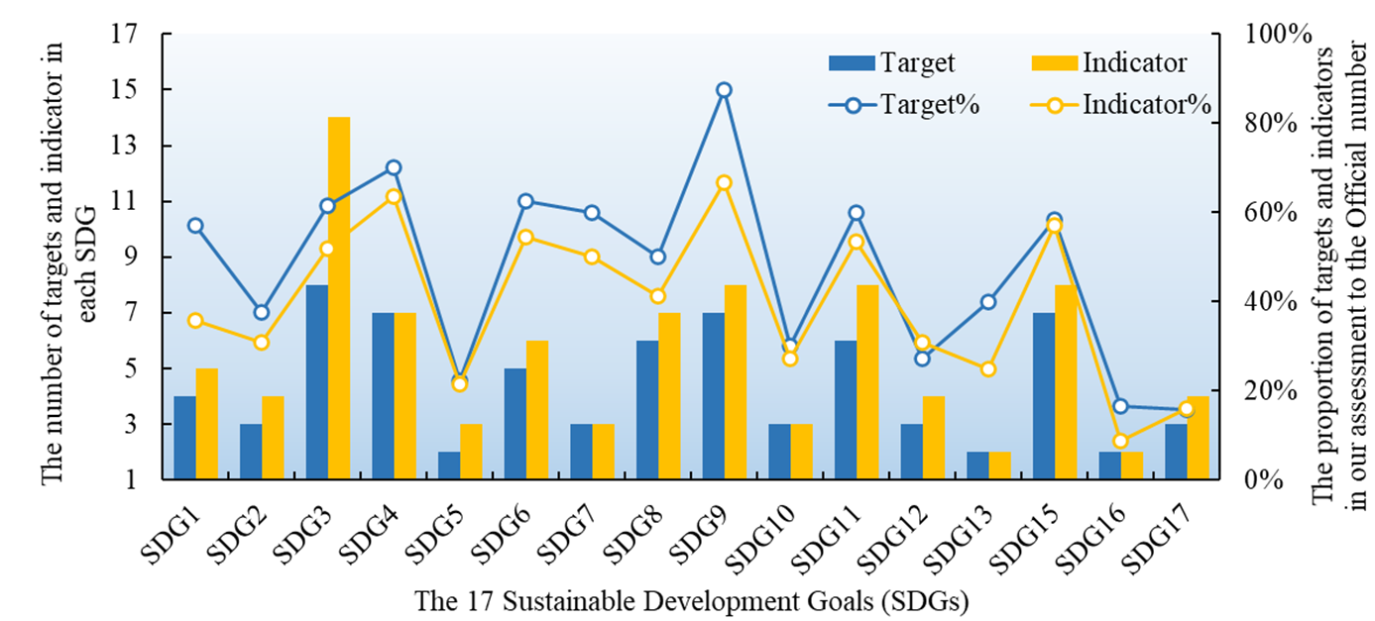

Figure S2. Results of cluster analysis. (A) Gap statistics. (B) Hierarchical clustering structure.
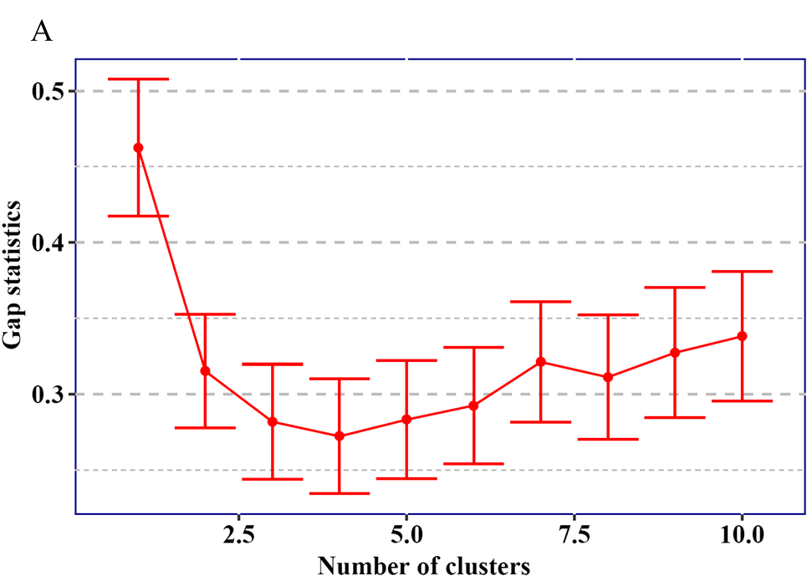
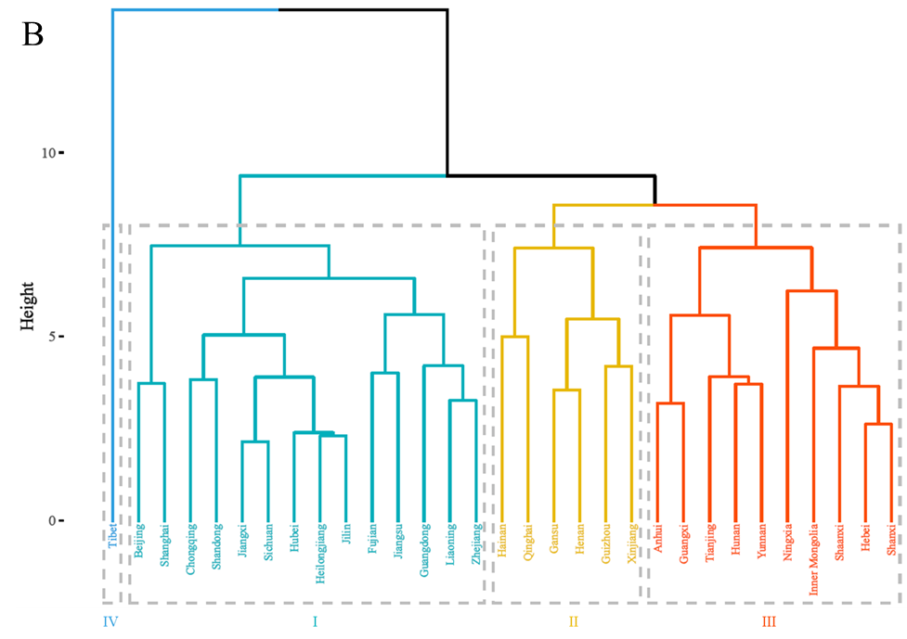

Figure S3. The systematic classification framework of SDGs: “Essential Needs”, “Governance”, and “Objectives”. Revised from the Fu et al. [27]
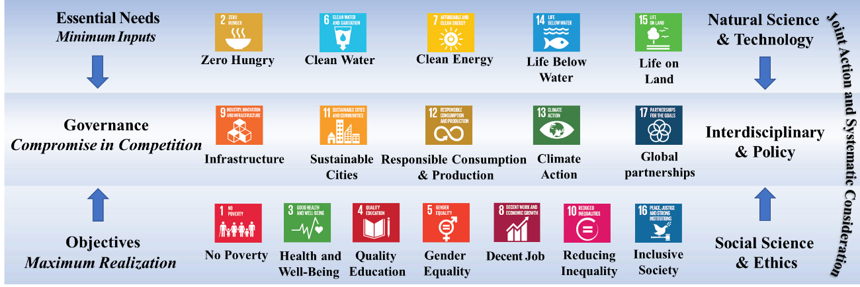

It is widely recognized that identifying the nature and scale of interactions among SDGs is valuable in promoting the implementation of SDGs as a whole and realizing the promise that “no one will be left behind” [27,28]. However, examining the interrelationships between each SDG one by one increases the complexity of the problem, making consensus difficult to achieve [29,30], and a systematic classification of the SDGs into coherent groups has therefore been attempted [27]. Although SDGs are commonly classified into social, economic, and environmental grouping [31,32], it has been criticized as lacking a sound theoretical foundation [33]. Moreover, indicators of the various SDGs may meet all three attributes (social, economic, and environmental) simultaneously [29]. Consequently, the conventional classification framework has been considered arbitrary and unable to clearly express the systematic integrity of SDGs [33].
In response to such deficiencies, we used a novel classification framework that divides the SDGs into three categories: “Essential Needs”, “Governance” and “Objectives” (Figure S3) [27]. The framework is based on the principle that sustainable development must strike a balance between environmental protection and socio-economic development such that its achievement requires cooperation across multiple sectors of society, through effective governance measures that produce maximum output with minimum input [27]. Among these categories, “Essential Needs” is fundamental to human survival, including SDG2 (Zero Hunger), SDG6 (Clean Water and Sanitation), SDG7 (Affordable and Clean Energy), SDG14 (Life Below Water), and SDG15 (Life on Land). “Objectives” refers to the pursuit of wealth and spiritual dimensions while meeting basic survival requirements, including SDG1 (No Poverty), SDG3 (Good Health and Well-Being), SDG4 (Quality Education), SDG5 (Gender Equality), SDG8 (Decent Job and Economic Growth), SDG10 (Reduced Inequalities) and SDG16 (Peace, Justice and Strong Institutions). “Governance” represents the critical coordination measures to guarantee the synergy between “Essential Needs” and “Objectives”, including SDG9 (Industry, Innovation and Infrastructure), SDG11 (Sustainable Cities and Communities), SDG12 (Responsible Production and Consumption), SDG13 (Climate Action) and SDG17 (Partnerships for the Goals).
The framework states that ensuring the achievement of the SDGs in “Essential Needs” requires a reduction in waste and an increase in resource use efficiency and would therefore benefit from innovative developments in natural sciences and technological instruments. However, achieving the SDGs in “Objectives” requires a more equitable distribution pattern of goods and services and therefore relies more on institutional measures, i.e., the contribution of social science and ethics. Additionally, the SDGs in “Governance” category are designed to reconcile the trade-offs between “Essential Needs” and “Objectives” and will consequently rely on an interdisciplinary approach to ensure their implementation. It is important to emphasize that since SDG14 is not considered in this assessment, the “Essential Needs” category in this study is only composed of SDGs 2, 6, 7, and 15.

Figure S4. The SDG index scores (the middle circle) and 16 individual SDG scores of China and its 31 provinces in 2018.
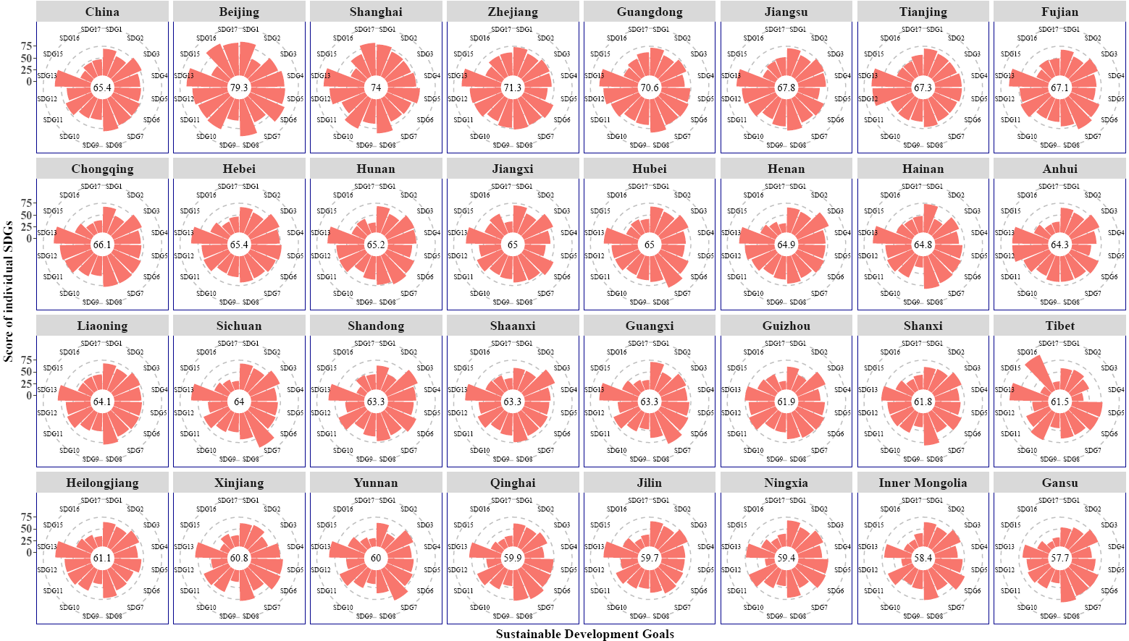

Figure S5. The results of Pearson’s correlation analysis among the SDG scores in 2015.
A
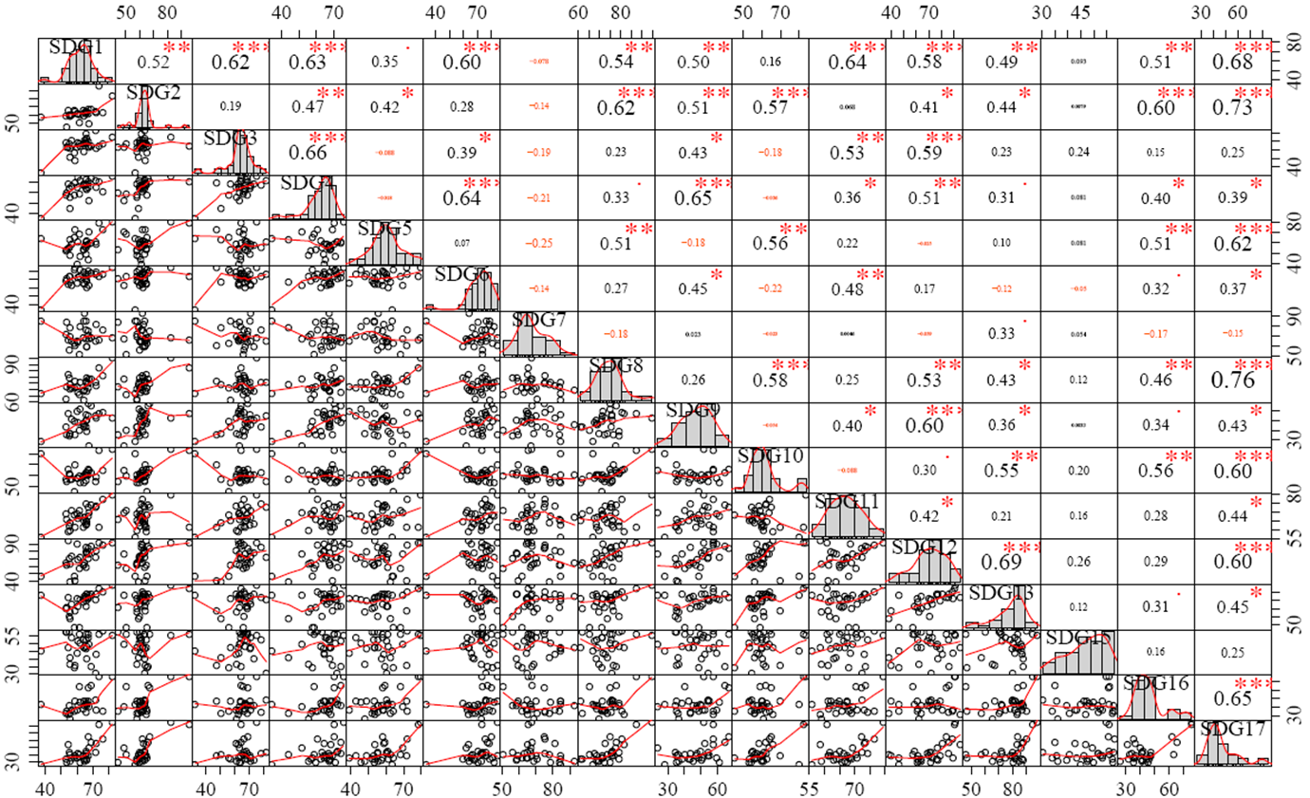
B

Figure S6. The results of Pearson’s correlation analysis among the SDG scores in 2018.
A
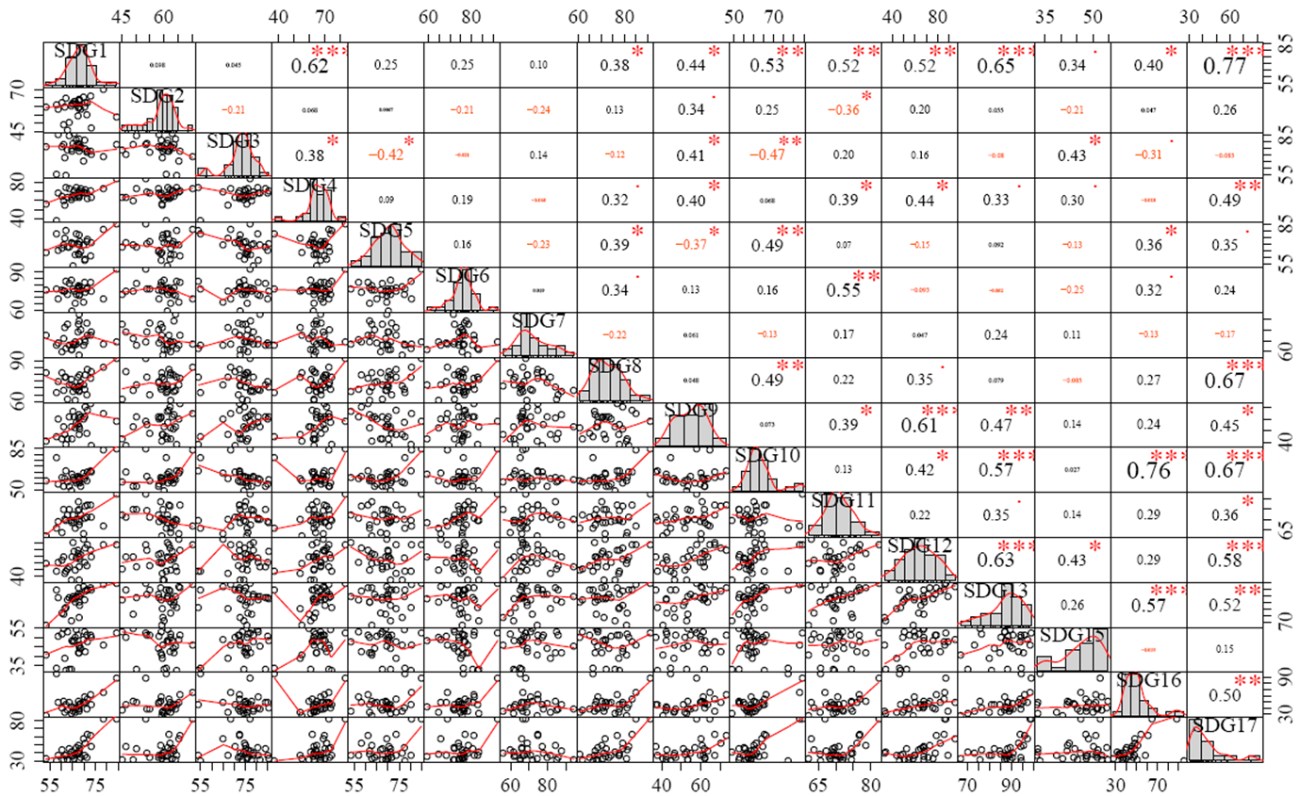
B

References
[1]. Allen C, Reid M and Thwaites J et al. Assessing national progress and priorities for the Sustainable Development Goals (SDGs): experience from Australia. Sustain Sci 2020; 15: 521-38.
[2]. United Nations Statistics Division (2017) SDG Indicators. https://unstats.un.org/sdgs/indicators/indicators-list/. (Accessed July 23 2021).
[3]. Sachs J, Schmidt-Traub G and Kroll C et al. Sustainable Development Report 2019. New York: Bertelsmann Stiftung and Sustainable Development Solutions Network, 2019.
[4]. Xu ZC, Chau SN and Chen X et al. Assessing progress towards sustainable development over space and time. Nature 2020; 577: 74-8.
[5]. United Nations. Transforming Our World: The 2030 Agenda for Sustainable Development. New York: United Nations, 2015.
[6]. Schmidt-Traub G, Kroll C and Teksoz K et al. National baselines for the Sustainable Development Goals assessed in the SDG Index and Dashboards. Nat Geosci 2017; 10: 547-55.
[7]. Zhu J, Sun X and He Z. Research on China’s sustainable development evaluation indicators in the framework of SDGs. China Pop Resour Environ 2018; 28: 9-18.
[8]. Department of Household Surveys of the National Bureau of Statistics of China. Poverty Monitoring Report of Rural China. (China Statistics Press, 2019).
[9]. Department of Population and Employment Statistics of the National Bureau of Statistics & Department of Planning and Finance of the Ministry of Human Resources and Social Security. China Labour Statistical Yearbook (in Chinese). (China Statistics Press, 1997-2019).
[10]. Department of Rural Social and Economic Surveys of the National Bureau of Statistics of China. China Rural Statistical Yearbook (in Chinese). (China Statistics Press, 2009-2019).
[11]. National Bureau of Statistics & Ministry of Environmental Protection of the People's Republic of China. China Statistical Yearbook on Environment (in Chinese). (China Statistics Press, 1994-2019).
[12]. Ministry of Health of the People’s Republic of China. China Health Statistical Yearbook (in Chinese). (Pecking Union Medical College Press, 2003-2019).
[13]. National Bureau of Statistics of the People’s Republic of China. China Statistical Yearbook (in Chinese). (China Statistics Press, 1991-2019).
[14]. Department of Social, Science and Technology, and Cultural Statistics National Bureau of Statistics of China. China Social Statistical Yearbook. (China Statistics Press, 2003-2019).
[15]. Ministry of Education of the People’s Republic of China. Educational Statistics Yearbook of China (in Chinese). (People’s Education Press, 2000-2019).
[16]. Ministry of Civil Affairs of the People’s Republic of China. China Civil Affairs Statistical Yearbook (in Chinese). (China Statistics Press, 1998-2019).
[17]. Ministry of Housing Urban-Rural Development People’s Republic of China. China Urban Construction Statistical Yearbook (in Chinese). (China Statistics Press, 2003-2019).
[18]. Department of Energy Statistics of the National Bureau of Statistics of China. China Energy Statistical Yearbook (in Chinese). (China Statistics Press, 1996-2019).
[19]. The Department of Investment and Construction Statistics of the National Bureau of Statistics of China. China Statistical Yearbook on Construction (in Chinese). (China Statistics Press, 2005-2019).
[20]. Department of Industry Statistics of the National Bureau of Statistics of China. China Industry Statistical Yearbook (in Chinese). (China Statistics Press, 2001-2019).
[21]. Department of Social, Science and Technology, and Cultural Statistics National Bureau of Statistics & Department of Strategy and Planning Ministry of Science and Technology of China. China Statistical Yearbook on Science and Technology (in Chinese). (China Statistics Press, 2007-2019).
[22]. Editorial Office of the Almanac of China's Finance and Banking. Almanac of China's Finance and Banking. (The Almanac of China’s Finance and Banking Magazine Company Limited, 2007-2019).
[23]. Editorial Board of China Environment Yearbook. China Environmental Yearbook (in Chinese). (China Environment Yearbook Press, 2001-2019).
[24]. National Forestry and Grassland Administration of China. China Forestry and Grassland Yearbook (in Chinese). (China Forestry Press, 2010-2019).
[25]. National Bureau of Statistics of the People’s Republic of China. China Statistical Yearbook of the Tertiary Industry (in Chinese). (China Statistics Press, 2011-2019).
[26]. Ministry of Finance of the People’s Republic of China. Finance Yearbook of China (in Chinese). (China Financial & Economic Publishing House, 2001-2019).
[27]. Fu BJ, Wang S and Zhang JZ et al. Unravelling the Complexity in Achieving the 17 Sustainable Development Goals. Natl Sci Rev 2019; 6: 386-8.
[28]. Nilsson M, Griggs D and Visbeck M. Map the interactions between Sustainable Development Goals. Nature 2016; 534: 320-2.
[29]. Bain PG, Kroonenberg PM and Johansson L et al. Public views of the Sustainable Development Goals across countries. Nat Sustain 2019; 2: 819-25.
[30]. McGowan PJK, Stewart GB and Long G et al. An imperfect vision of indivisibility in the Sustainable Development Goals. Nat Sustain 2019; 2: 43-5.
[31]. Reid AJ, Brooks JL and Dolgova L et al. Post-2015 Sustainable Development Goals still neglecting their environmental roots in the Anthropocene. Environ Sci Policy 2017; 77: 179-84.
[32]. Scherer L, Behrens P and de Koning A et al. Trade-offs between social and environmental Sustainable Development Goals. Environ Sci Policy 2018; 90: 65-72.
[33]. Purvis B, Mao Y and Robinson D. Three pillars of sustainability: in search of conceptual origins. Sustain Sci 2019; 14: 681-95.

