Supplementary Materials for

The Personality Traits of Self-Made and Inherited Millionaires

This file includes:

Supplementary Text
Figures S1 to S6
Tables S1 to S13

Author information

Marius. Leckelt^{1,3}+, Johannes König²+*, David Richter^{2,4}, Mitja D. Back³†, Carsten Schröder^{2,4}†
¹University of Mainz, Germany
²German Institute for Economic Research/SOEP (DIW), Berlin, Germany
³University of Münster, Germany
⁴Free University of Berlin, Germany

+Shared first-authorship
†Shared last-authorship.
*Corresponding author: Joahnnes König Email: JKoenig@diw.de

Robustness Checks for Group Definitions

This supplementary section pursues two objectives: The first is to investigate the robustness of our findings to reasonable variations in the criteria separating the self-mades and inheritors. In short, we study whether our criteria are well-behaved. The second objective is to investigate the information content of the self-ratings with respect to the importance of different sources of current wealth. To this end, we correlate the group definitions with objective measures of a) self-made economic success and b) being born into wealth. For example, one would expect that inheritors received higher inheritances and that self-mades have higher shares of business assets than the other groups.
As a preparatory step to understand the self-ratings on wealth accumulation (Figure S1), Figure S2 provides the distributions of answers for the rich and the non-rich, and Figure S3 gives the distributions of answers for self-mades and inheritors. Figure S2 indicates that the rich rate several factors as important to their current wealth: prime among them is self-employment or entrepreneurship, followed by real estate and financial investments as well as inheritances and gifts.
Part of the variation in Figure S3 is mechanical, because the group definitions rely on double criteria for the self-ratings: (a) Self-mades rate the importance of entrepreneurship and self-employment in increasing their individual wealth higher than 3, and the importance of gifts and inheritance and marriage 3 or lower. (b) Inheritors rate the importance of either gifts or inheritances or marriage higher than 3, and the importance of entrepreneurship and self-employment 3 or lower. However, about 80 percent of the inheritors do not consider self-employment and entrepreneurship to have been a relevant factor in their wealth (rating of 0). Conversely, self-mades typically do not rate gifts, inheritances, or marriage as important. These low ratings are not mechanically determined by the double criteria for constructing the groups. Rather, both inheritors and self-mades have a more monocausal view of wealth accumulation: they attribute their wealth either to intergenerational transfers or to self-made economic success.
Objective 1: To check the robustness of our findings with respect to the group definitions, we tighten the double criteria and study the implications for our results.
Tight definition of inheritors:
1. They rate the importance of either gifts or inheritances or marriage in increasing their individual wealth higher than 4.
2. They rate the importance of entrepreneurship and self-employment in increasing their individual wealth 4 or below.
Tight definition of self-mades:
1. They rate the importance of entrepreneurship and self-employment in increasing their individual wealth higher than 4.
2. They rate the importance of either gifts and inheritances and marriage in increasing their individual wealth 4 or below.
The downside of tightening the definition is that it reduces the group sizes: The share of inheritors among the rich (non-rich) drops from 12 to 8 percent (5 to 2 percent), and the share of self-mades among the rich (non-rich) drops from 46 to 36 percent (3 to 2 percent) (Table S7). The benefit of the tightening is that it makes the groups more homogeneous with respect to the core factors contributing to individual net wealth. Hence, we expect their personality profiles to be more pronounced.
For the more tightly defined groups, just as in the main body of the paper, we calculate trait-by-trait predictive margins as well as kernel densities, means, and standard deviations for the distance from the prototypical personality profile. Figure S4 provides the trait-by-trait comparison for the tighter groups along with the original group definition. Overall, the results for the tighter and original group definitions are very similar. Further, consistent with our expectation, the more tightly defined self-made group has a profile that is more pronounced and closer to the prototypical personality profile of the rich than the original definition, both among the rich and the non-rich. For the inheritors, there are no relevant systematic differences. Figure S5 provides kernel density plots of the distance from the prototypical personality profile of the rich and non-rich for the original and the strictly defined groups. Again, the results are very similar when the group delineation is varied. Consistent with expectations, tightening the definition for the rich and non-rich self-mades implies smaller distances from the prototypical profile of the rich, although the change for the rich self-mades is small. Distances for the rich and non-rich inheritors tend to slightly increase with the tighter definition. The summary statistics in Table S8 confirm these visual assessments.
In sum, the tighter definition of the groups behaves as expected: if we can detect differences in individual traits and in the distance measure, they are in the expected direction for each of the more tightly defined groups.
As another robustness check, following the advice of a referee, we excluded observations on the “middle” value of the scale, i.e. 3, from the inheritors and self-mades in an alternative definition of the groups. The predictive margins for the alternative definition in Table S13 and the trait-by-trait personality profiles in Figure S6 are almost identical to the original definition.
Objective 2: We evaluate the suitability of our group classifications by comparing objective outcomes across the groups. The expectation is that the group definitions according to the double criteria based on the self-assessments will also lead to a stratification of the groups with respect to objective characteristics that relate to the manner in which wealth was obtained.
Objective outcomes relating to being born into wealth are the share of heirs; the mean, median, and standard deviation of capitalized inheritances conditional on receiving an inheritance; and the inheritance ratio, that is, the ratio of capitalized inheritances to current net wealth. The higher this ratio, the greater the importance of inheritances relative to wealth today. Table S11 shows that among both the rich and the non-rich, inheritors inherited more often, inherited higher amounts, and that they have a higher inheritance ratio than self-mades, supporting that the self-rating scales correspond to objective circumstances. For example, the inheritance ratio of rich inheritors is 53 percent, while it is 16 percent for rich self-mades. Conditional on receiving an inheritance, rich inheritors have received about 2.7 million euros, while rich self-mades have received only about 578,000 euros, although rich self-mades are wealthier than rich inheritors at the mean (4.2 million euros vs. 3 million euros; see Table S5).
Objective outcomes relating to self-made economic success are self-employment, business ownership, and the share of the individual’s portfolio allocated to private businesses. Table S12 shows, regardless of being rich or non-rich, that being classified self-made is a strong predictor of self-employment, business ownership, and having a substantial fraction of one’s wealth invested in private businesses. As an example, the fraction of rich self-mades in self-employment is 77 percent (self-mades can also be retired), while among rich inheritors, this fraction is only 36 percent. As another example, the share of rich self-mades in self-employment with more than ten employees is also substantially higher (53 percent) than among rich inheritors (15 percent). In terms of business wealth, rich self-mades are more likely to hold at least some of their wealth in the form of a private business (89 percent) compared to rich inheritors (49 percent). The mean differences in the amount of business wealth held by rich self-mades and rich inheritors are not large, but at the median self-mades own about 487,000 euros more. Rich self-mades also hold substantially more of their portfolio in the form of private businesses (49 percent) than rich inheritors do (25 percent).
In sum, all results show that categorizing the groups along the self-assessments also leads to a stratification according to objective outcomes, as intended. Further, the fact that the group of heirs includes the self-employed, and that the group of self-mades also includes people who have received inheritances or are not self-employed (mainly because they have retired) shows that a grouping based on a simple objective criterion would fall short.
Calculation of the distance to a prototypical personality profile
In order to calculate each person’s difference from a prototypical rich personality profile, we followed Obschonka et al. (2013). This profile, consistent with Leckelt et al. (2019), had the maximum scores on Extraversion, Openness, Conscientiousness, and Risk tolerance, while having the lowest scores on Neuroticism and Agreeableness. We then estimated each person’s squared differences between the prototypical and their personal values for each of the personality traits. Next, we summed the six squared differences. This resulted in a measure of closeness to the prototypical rich personality profile, where a distance of 0 indicates a perfect match and larger numbers indicate a greater distance, or larger dissimilarity, from the prototypical profile.

References
Leckelt, M., Richter, D., Schröder, C., Küfner, A. C. P., Grabka, M. M., & Back, M. D. (2019). The rich are different: Unravelling the perceived and self‐reported personality profiles of high‐net‐worth individuals. British Journal of Psychology, 110(4), 769–789. https://doi.org/10.1111/bjop.12360
Obschonka, M., Schmitt-Rodermund, E., Silbereisen, R. K., Gosling, S. D., & Potter, J. (2013). The regional distribution and correlates of an entrepreneurship-prone personality profile in the United States, Germany, and the United Kingdom: A socioecological perspective. Journal of Personality and Social Psychology, 105(1), 104–122. https://doi.org/10.1037/a0032275

Table S1. Characteristics of the Rich Individuals
Characteristics
Observations | 1,125
Male % | 74.13
Age | 56.19
Retired % | 9.24
University degree % | 51.29
Married % | 74.20
No. of children | 0.62
Wealth (€)
Less than 1 million | 0.00
1–2 million % | 65.33
3–6 million % | 21.60
6–10 million % | 7.56
More than 10 million % | 5.51
Source of wealth/influence factors
Self-Employment/Entrepreneurship % | 78.31
Inheritances % | 44.98
Dependent employment % | 37.07
Lottery winnings % | 1.33
Marriage % | 12.89
Financial transactions % | 31.38
Real estate transactions % | 75.20
Annual net household income (€)
Less than 20k % | 3.20
20–49k % | 17.69
50–99k % | 40.98
100–149k % | 20.71
150–500k % | 15.02
More than 500k % | 2.40
Note. Source of Wealth percentages are the shares of respondents
reporting a positive influence of this source on their current wealth. Based on data from the SOEP-P.

Table S2. Percentiles of Individual-Level Wealth (€) in the Combined Sample as well as in the Sample of Rich Individuals
Sample | 1.00% | 5.00% | 10.00% | 25.00% | 50.00% | 75.00% | 90.00% | 95.00% | 98.40% | 99.00%
Combined sample | -28,000 | -2,227 | 0 | 1,500 | 29,700 | 152,070 | 321,569 | 509,000 | 1,000,000 | 1,348,073
Rich individuals | 1,002,600 | 1,023,000 | 1,050,000 | 1,162,500 | 1,505,000 | 2,494,943 | 4,515,000 | 7,815,000 |  | 31,123,000
Note. Data based on SOEP v36 (doi:10.5684/soep-core.v36eu)

Variable | Description | Coding/Scale | Based on
Age | age of individual | Continuous | initial Information /  first page of the personal questionnaire
Age categories | three age categories (1=young, 2=middle aged, 3=old) | categorical (1 if age lower than 40, 2, if age between 40 and 60, 3 if older than 60) | generation using age
Gender | gender of individual | categorical (1=male,0=female) | initial Information /  first page of the personal questionnaire
Married | current marital status | categorical (0=not married, 1=married) | generated variable pgfamstd (see pgen documentation)
Number of children | number of children living in the household | count variable | generated variable d11107 (see pequiv documentation)
High education | completed education status with respect to high school | categorical (1=completed at least 12 years of schooling ,0=completed less than 12 years) | generated variable pgbilzeit (see pgen documentation)
University degree | completed a university degree | categorical (0=no,1=yes) | generated variable pgisced (see pgen documentation)
Net wealth | gross wealth minus liabilities | Continuous | questions 108 to 139 of the personal questionnaire
Rich | status of having 1 million euros in individual net wealth | categorical (0=no,1=yes) | generation using net wealth
Big Five personality traits | personality traits: Agreeableness, Openness, Neuroticism, Conscientiousness, Extraversion | categorical (1 to 7) | generation using the answers to question 164 of the personal questionnaire
Risk tolerance | willingness to take risks | categorical (0 to 10) | question 4 of the personal questionnaire
Wealth accumulation scales | factors having contributed to current wealth accumulation (self-employment/entrepreneurship, dependent employment, financial transactions, real-estate transactions, inheritances, gifts, marriage, lottery) | categorical (-5 to 5) | question 143 of the personal questionnaire
Inheritor | wealth accumulation classification: wealth from inheritances, gifts, or marriage and not self-employment/entrepreneurship | categorical (0=no,1=yes) | generation using the wealth accumulation scales
Self-made | Wealth accumulation classification: wealth from inheritances, gifts, or marriage and not self-employment/entrepreneurship | categorical (0=no,1=yes) | generation using the wealth accumulation scales
Household disposable income | annual disposable household income | Continuous | generated variable hghinc (see hgen documentation)
Retired | retirement status of individual | categorical (0=no,1=yes) | generated variable pglfs ( see pgen documentation)
Self-employed | currently self-employed | categorical (0=no,1=yes) | generated variable pgstib ( see pgen documentation)
Self-employed with more than 10 employees | currently self-employed and running a business with more than 10 employees | categorical (0=no,1=yes) | generated variable pgstib ( see pgen documentation)
Business assets | current net value of private business assets | Continuous | generation using questions 130 to 132 of the personal questionnaire
Business asset ratio | ratio of business assets to current net wealth | Continuous | generation using business assets and net wealth
Inheritance | capitalized inheritances (capitalized using 10-year federal bond yields by the Bundesbank. Series BBK01.WU0004) | Continuous | based on questions 141 and 142 of the personal questionnaire
Heir | having received a gift or inheritance | categorical (0=no,1=yes) | based on question 141 of the personal questionnaire
Inheritance ratio | ratio of capitalized inheritances to current net wealth | Continuous | generation using capital inheritances and net wealth
Table S3. Variable Descriptions
Note. Personal questionnaire: https://www.diw.de/de/diw_01.c.806386.de/s_12262.html ;
Household questionnaire: https://www.diw.de/de/diw_01.c.806452.de/s_12261.html ;
pgen documentation: https://www.diw.de/documents/publikationen/73/diw_01.c.745953.de/diw_ssp0834.pdf ;
hgen documentation: https://www.diw.de/documents/publikationen/73/diw_01.c.745947.de/diw_ssp0831.pdf ;
pequiv documentation: https://www.diw.de/documents/publikationen/73/diw_01.c.809647.de/diw_ssp0922.pdf .

Table S4. Correlation Table for Personality Traits – All Observations (SOEP and SOEP-P combined)
 | N | M | SD | Risk-taking | Neuroticism | Openness | Extraversion | Conscientiousness | Agreeableness
Risk-taking | 24846 | 5.157 | 2.393 | 1.000
Neuroticism | 24846 | 3.576 | 1.272 | -0.207 | 1.000
Openness | 24846 | 4.597 | 1.205 | 0.230 | -0.041 | 1.000
Extraversion | 24846 | 4.923 | 1.151 | 0.221 | -0.181 | 0.324 | 1.000
Conscientiousness | 24846 | 5.791 | 0.929 | 0.019 | -0.155 | 0.146 | 0.219 | 1.000
Agreeableness | 24846 | 5.417 | 0.973 | -0.062 | -0.143 | 0.126 | 0.091 | 0.278 | 1.000
Note. Boldface indicates significance at p < .0.05. Data based on SOEP v36 (doi:10.5684/soep-core.v36eu)

Table S5. Descriptive Statistics of Individuals Categorized as Self-mades or Inheritors as well as those Mixed/Unspecified with Regard to Demographic Information, Wealth, Income, and Personality
 |  |  | male | age | retired | university degree | married | children in house- | net wealth | net HH income per month | Risk tolerance | N | O | E | C | A
 |  |  |  |  |  |  |  | hold
Non-Rich | Self-made | Mean | 0.701 | 55.736 | 0.117 | 0.46 | 0.739 | 0.54 | 302,187 | 5,976 | 6.401 | 3.069 | 4.971 | 5.166 | 6.050 | 5.443
Non-Rich | Self-made | SD | 0.458 | 12.554 | 0.321 | 0.499 | 0.44 | 0.91 | 562,921 | 6,482 | 2.373 | 1.247 | 1.240 | 1.156 | 0.881 | 1.021
Non-Rich | Inheritor | Mean | 0.354 | 51.733 | 0.195 | 0.352 | 0.67 | 0.621 | 215,339 | 4,431 | 4.815 | 3.628 | 4.688 | 4.940 | 5.711 | 5.456
Non-Rich | Inheritor | SD | 0.478 | 16.16 | 0.396 | 0.478 | 0.47 | 0.997 | 200,297 | 9,631 | 2.251 | 1.309 | 1.230 | 1.200 | 0.947 | 0.974
Non-Rich | Mixed/ | Mean | 0.462 | 49.16 | 0.171 | 0.259 | 0.583 | 0.626 | 90,079 | 3,501 | 5.065 | 3.618 | 4.563 | 4.904 | 5.779 | 5.417
Non-Rich | Unspecified | SD | 0.499 | 17.606 | 0.377 | 0.438 | 0.493 | 1.015 | 149,356 | 2,630 | 2.376 | 1.262 | 1.200 | 1.148 | 0.930 | 0.969
Rich | Self-made | Mean | 0.843 | 56.147 | 0.039 | 0.518 | 0.764 | 0.605 | 4,217,474 | 11,446 | 7.037 | 2.785 | 5.074 | 5.261 | 6.037 | 5.411
Rich | Self-made | SD | 0.364 | 10.355 | 0.193 | 0.5 | 0.425 | 0.958 | 6,715,656 | 13,598 | 2.093 | 1.223 | 1.122 | 1.117 | 0.896 | 0.979
Rich | Inheritor | Mean | 0.471 | 54.904 | 0.147 | 0.551 | 0.691 | 0.772 | 3,088,292 | 10,262 | 5.324 | 3.289 | 4.723 | 4.944 | 5.848 | 5.537
Rich | Inheritor | SD | 0.501 | 11.113 | 0.355 | 0.499 | 0.464 | 1.135 | 5,041,597 | 21,264 | 2.28 | 1.318 | 1.301 | 1.171 | 0.892 | 0.976
Rich | Mixed/ | Mean | 0.708 | 56.6 | 0.136 | 0.496 | 0.739 | 0.597 | 4,272,172 | 11,396 | 6.426 | 3.09 | 4.927 | 5.118 | 5.876 | 5.239
Rich | Unspecified | SD | 0.455 | 11.725 | 0.343 | 0.501 | 0.44 | 0.93 | 11,724,025 | 78,359 | 2.148 | 1.19 | 1.153 | 1.11 | 0.889 | 1.031
Note. Responses to the items male, retired, university degree, and married were coded as yes = 1 and no = 0. N = Neuroticism, O = Openness, E = Extraversion, C = Conscientiousness, A = Agreeableness. Data based on SOEP v36 (doi:10.5684/soep-core.v36eu).

Table S6. Rank Correlations for the Wealth Accumulation Items in the sample of the rich
 | Self-employment | Employment | Finance | Real estate | Marriage | Inheritance | Gift
Employment | -0.058
Finance | 0.134 | 0.165
Real estate | 0.250 | 0.212 | 0.213
Marriage | 0.030 | 0.096 | 0.087 | 0.190
Inheritance | 0.113 | 0.106 | 0.140 | 0.263 | 0.122
Gift | 0.127 | 0.086 | 0.143 | 0.202 | 0.108 | 0.165
Lottery | 0.087 | 0.011 | 0.164 | 0.090 | 0.159 | 0.183 | 0.244
Note. Spearman’s rho for the wealth accumulation items shown in Figure S1. Data based on SOEP v36 (doi:10.5684/soep-core.v36eu)

Table S7. Share of Observations for Self-Mades, Inheritors, and the Mixed/Unspecified Group, Once for the Original and Once for the Tight Definition
 |  | Self-made |  | Inheritor |  | Mixed/Unspecified
 |  | Original | Tight | Original | Tight | Original | Tight
Non-rich (N=23,721) | % | 0.03 | 0.02 | 0.05 | 0.02 | 0.93 | 0.96
Rich (N=1,125) | % | 0.46 | 0.36 | 0.12 | 0.08 | 0.42 | 0.55
Note. Original definition of self-mades, inheritors, and mixed/unspecified is as described in the main text. Tight definition moves
the threshold value from 3 to 4. See the supplementary text. Data based on SOEP v36 (doi:10.5684/soep-core.v36eu).

Table S8. Means and Standard Deviations of Distance from Prototypical Personality Profile for Rich and Non-Rich Inheritors, Self-Mades, and the Mixed/Unspecified with Original and Tight Definition
 |  | Self-made |  | Inheritor |  | Mixed/Unspecified
 |  | Original | Tight | Original | Tight | Original | Tight
Non-rich | Mean | 81.81 | 79.92 | 97.00 | 96.00 | 95.69 | 95.65
 | SD | 28.90 | 28.16 | 33.01 | 31.91 | 33.49 | 33.49
Rich | Mean | 73.65 | 72.50 | 92.27 | 94.78 | 77.15 | 77.97
 | SD | 25.00 | 24.05 | 33.52 | 36.53 | 25.08 | 25.70
Note. Original definition of self-mades, inheritors, and mixed/unspecified is as described in the main text. Tight definition moves
the threshold value from 3 to 4. See the supplementary text. Data based on SOEP v36 (doi:10.5684/soep-core.v36eu).

Table S9. OLS and Median Regressions of Distance from Prototypical Personality Profile of the Rich
 |  | (1) | (2)
 | Mean |  |  | Median
Sample (1 = rich) | -16.293*** |  |  | -13.000***
 | (1.153) |  |  | (1.413)
Self-made | -11.471*** |  |  | -11.111***
 | (1.152) |  |  | (1.398)
Self-made x Rich | -1.238 |  |  | -3.222**
 | (1.571) |  |  | (1.613)
Inheritor | -0.067 |  |  | 0.444
 | (1.031) |  |  | (1.406)
Inheritor x Rich | 12.615*** |  |  | 8.667***
 | (2.932) |  |  | (3.064)
Gender (1 = male) | -13.442*** |  |  | -12.111***
 | (0.718) |  |  | (0.913)
Age Category 2 | 7.544*** |  |  | 8.000***
 | (0.689) |  |  | (1.003)
Age Category 3 | 11.575*** |  |  | 11.889***
 | (0.797) |  |  | (1.110)
Gender x Age Category 2 | 0.490 |  |  | -1.333
 | (0.946) |  |  | (1.118)
Gender x Age Category 3 | 0.342 |  |  | -2.000
 | (1.084) |  |  | (1.447)
High education (1 = yes) | -5.435*** |  |  | -3.889***
 | (0.411) |  |  | (0.448)
Constant | 97.920*** |  |  | 91.111***
 | (0.562) |  |  | (0.722)
N | 24,846 |  |  | 24,846
Note. First column is OLS with robust standard errors, second column is a median regression with
200 bootstrap replications. Standard errors in parentheses. * p < 0.10, ** p < 0.05, *** p < 0.01. Data based on SOEP v36 (doi:10.5684/soep-core.v36eu).

Table S10. OLS Regressions of Individual Net Wealth on the Distance from the Prototypical Personality Profile and Single Traits
 | (1) | (2) | (3) | (4) | (5) | (6) | (7)
Distance | -28,272***
 | (9,173)
Risk Tolerance |  | 431,598***
 |  | (140,724)
Neuroticism |  |  | -53,642
 |  |  | (224,985)
Openness |  |  |  | 384,370*
 |  |  |  | (214,451)
Conscientiousness |  |  |  |  | -192,956
 |  |  |  |  | (263,824)
Extraversion |  |  |  |  |  | 252,296
 |  |  |  |  |  | (291,120)
Agreeableness |  |  |  |  |  |  | -103,667
 |  |  |  |  |  |  | (329,657)
Controls | ✓ | ✓ | ✓ | ✓ | ✓ | ✓ | ✓
N | 517 | 517 | 517 | 517 | 517 | 517 | 517
Note. Controls are as in Table 2 of the main text. Robust standard errors in parentheses. * p < 0.10, ** p < 0.05, *** p < 0.01. Data based on SOEP v36 (doi:10.5684/soep-core.v36eu).

Table S11. Descriptive Statistics of the Share of Heirs, Capitalized Inheritance, Inheritance Ratio Among Inheritors, Self-Mades, and Others
Share of Heirs
 | Self-Mades |  | Inheritors |  | Mixed/Unspecified
 | Non-rich | Rich | Non-rich | Rich | Non-rich | Rich
Mean | 0.25 | 0.32 | 0.57 | 0.76 | 0.17 | 0.44
SD | 0.43 | 0.47 | 0.50 | 0.43 | 0.37 | 0.50
 | Capitalized Inheritance if > 0
Mean | 134,690 | 578,702 | 267,636 | 2,695,403 | 100,700 | 1,948,323
Median | 43,162 | 198,681 | 151,596 | 849,182 | 38,026 | 402,271
SD | 221,380 | 2,399,831 | 524,018 | 9,626,414 | 208,832 | 12,828,414
 | Inheritance Ratio
Mean | 0.33 | 0.16 | 0.72 | 0.53 | 0.53 | 0.34
SD | 0.34 | 0.21 | 0.33 | 0.34 | 0.38 | 0.30
Note. Capitalized inheritances are the sum of all gifts and inheritances capitalized using the time-series on
ten-year federal bond yields by the Bundesbank. See: http://www.bundesbank.de/Navigation/DE/Statistiken/Zeitreihen_Datenbanken/Makrooekonomische_Zeitreihen/its_details_value_node.html?nsc=true&nsc=true&tsId=BBK01.WU0004. The inheritance ratio is calculated as the sum of all capitalized inheritances
divided by current net wealth. Data based on SOEP v36 (doi:10.5684/soep-core.v36eu).

Table S12. Descriptive Statistics of the Share of Self-Employed, Self-Employed Under Age 66, Self-Employed with More
than 10 Employees, Share of Those with Positive Business Assets, Business Assets and the Ratio of Business Assets
to Net Wealth Among Inheritors, Self-Mades, and Others
 | Share of Self-Employed
 | Self-Mades |  | Inheritors |  | Mixed/Unspecified
 | Non-rich | Rich | Non-rich | Rich | Non-rich | Rich
Mean | 0.63 | 0.77 | 0.06 | 0.36 | 0.06 | 0.54
SD | 0.48 | 0.42 | 0.24 | 0.48 | 0.24 | 0.50
 | Share of Self-Employed if Age<66
Mean | 0.73 | 0.81 | 0.07 | 0.42 | 0.07 | 0.62
SD | 0.45 | 0.40 | 0.26 | 0.50 | 0.25 | 0.48
 | Share of Self-Employed with More than 10 Employees
Mean | 0.20 | 0.53 | 0.01 | 0.15 | 0.01 | 0.28
SD | 0.40 | 0.50 | 0.11 | 0.36 | 0.09 | 0.45
 | Share with Positive Business Assets
Mean | 0.49 | 0.89 | 0.05 | 0.49 | 0.04 | 0.66
SD | 0.50 | 0.32 | 0.21 | 0.50 | 0.21 | 0.48
 | Business Assets if >0
Mean | 142,244 | 2,747,729 | 114,925 | 2,781,093 | 80,053 | 3,446,307
Median | 76,000 | 1,487,357 | 16,000 | 1,000,000 | 25,000 | 1,000,000
SD | 183,960 | 4,451,812 | 183179 | 5,596,064 | 145,287 | 11,556,681
 | Ratio of Business Assets to Net Wealth
Mean | 0.18 | 0.49 | 0.01 | 0.25 | 0.02 | 0.34
SD | 0.29 | 0.34 | 0.09 | 0.34 | 0.11 | 0.36
Note. Data based on SOEP v36 (doi:10.5684/soep-core.v36eu).

Table S13. Predictive Margins and 95%-CIs from Regression Analyses Predicting Personality Traits for Alternative Group Definitions
Group Margins |  | Risk Tolerance | Neuroticism | Openness | Extraversion | Conscientiousness | Agreeableness
 | Mixed/Unspecified | 5.089 | 3.604 | 4.579 | 4.912 | 5.783 | 5.420
 |  | (5.06;5.119) | (3.589;3.62) | (4.564;4.594) | (4.898;4.927) | (5.772;5.795) | (5.407;5.432)
Non-Rich | Self-made | 6.300 | 3.244 | 4.957 | 5.234 | 6.030 | 5.507
 |  | (6.11;6.491) | (3.143;3.345) | (4.855;5.059) | (5.14;5.329) | (5.956;6.104) | (5.424;5.59)
 | Inheritor | 4.939 | 3.602 | 4.635 | 4.918 | 5.672 | 5.414
 |  | (4.801;5.076) | (3.523;3.681) | (4.561;4.708) | (4.845;4.991) | (5.615;5.729) | (5.355;5.473)
 | Mixed/Unspecified | 6.573 | 2.974 | 4.970 | 5.163 | 5.947 | 5.354
 |  | (6.45;6.696) | (2.904;3.044) | (4.902;5.037) | (5.097;5.228) | (5.895;5.998) | (5.296;5.412)
Rich | Self-made | 6.883 | 2.849 | 5.074 | 5.229 | 6.088 | 5.457
 |  | (6.684;7.081) | (2.735;2.963) | (4.967;5.181) | (5.123;5.335) | (6.008;6.167) | (5.365;5.55)
 | Inheritor | 5.610 | 3.104 | 4.856 | 4.821 | 5.907 | 5.513
 |  | (5.168;6.053) | (2.853;3.355) | (4.616;5.096) | (4.586;5.055) | (5.733;6.08) | (5.323;5.704)
Note. Robust 95% confidence intervals based on robust standard errors in parentheses. OLS regression controlled for socio-demographic characteristics. Data based on SOEP v36 (doi:10.5684/soep-core.v36eu).

143. To what extent have the following factors affected the development of your current assets?
☞
Please answer on the scale below,
ranging from -5, meaning reduced significantly, to +5, meaning increased significantly.
-5 -4 -3 -2 -1 0 +1 +2 +3 +4 +5
Self-employment / Entrepreneurship............
Dependent employment ...............................
Financial business........................................
Property ownership ...................................... Marriage .......................................................
Inheritance....................................................
Gift / transfer.................................................
Lottery / gambling.........................................

Figure S1: Questionnaire asking for source of an individual’s wealth
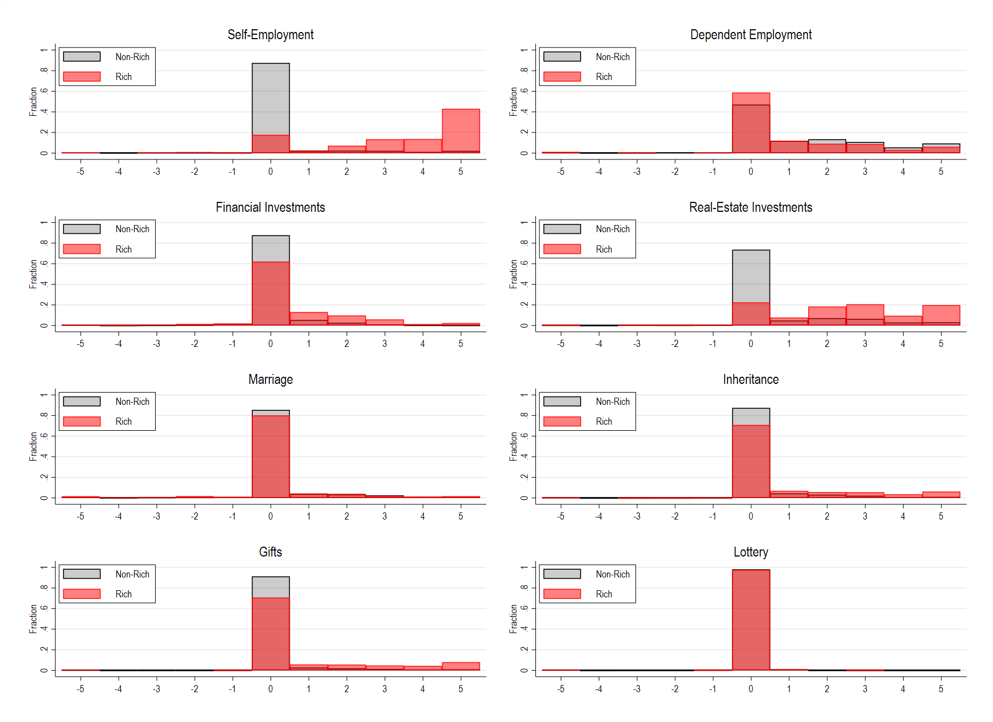
Figure S2. Histograms of answers given to influence factor scales for rich and non-rich.

Note. Data based on SOEP v36 (doi:10.5684/soep-core.v36eu).
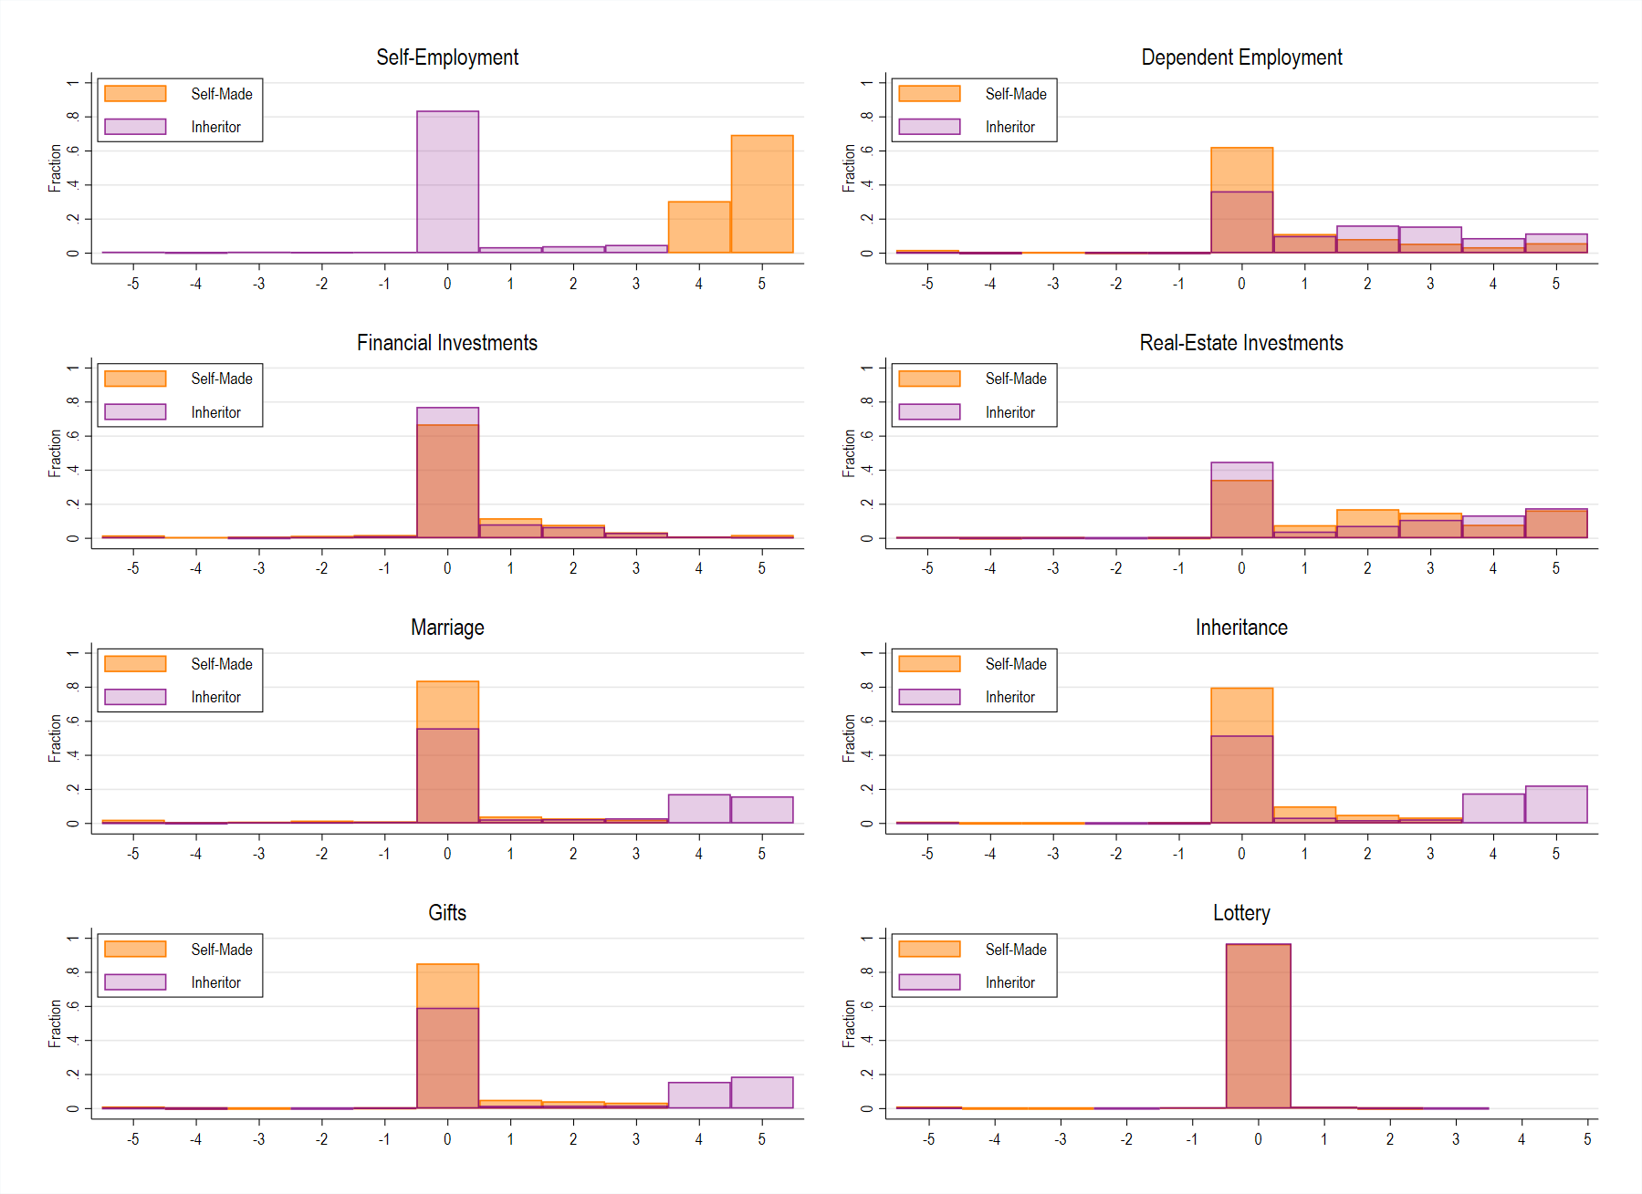
Figure S3. Histograms of answers given to influence factor scales for self-made and inheritors.
Note. Data based on SOEP v36 (doi:10.5684/soep-core.v36eu).

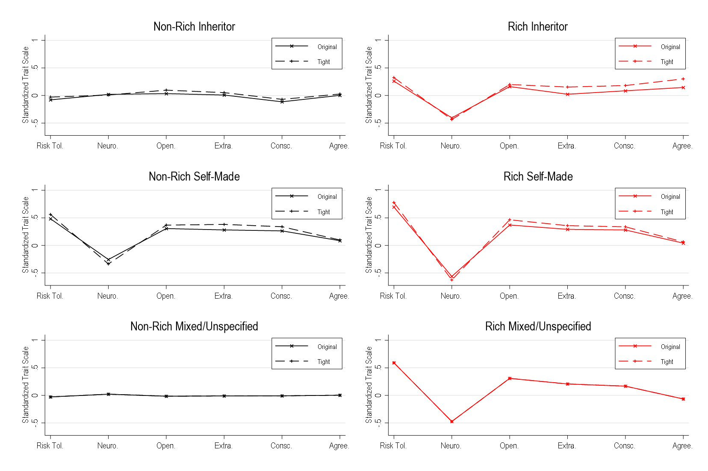
Figure S4. Trait-by-trait personality profile on a standardized trait scale for rich and non-rich self-made, inheritors, and mixed/unspecified group comparing the tight to the original definition
Note. Original definition of self-mades, inheritors, and mixed/unspecified is as described in the main text.
Tight definition moves the threshold value from 3 to 4. See the supplementary text. Data based on SOEP v36 (doi:10.5684/soep-core.v36eu).
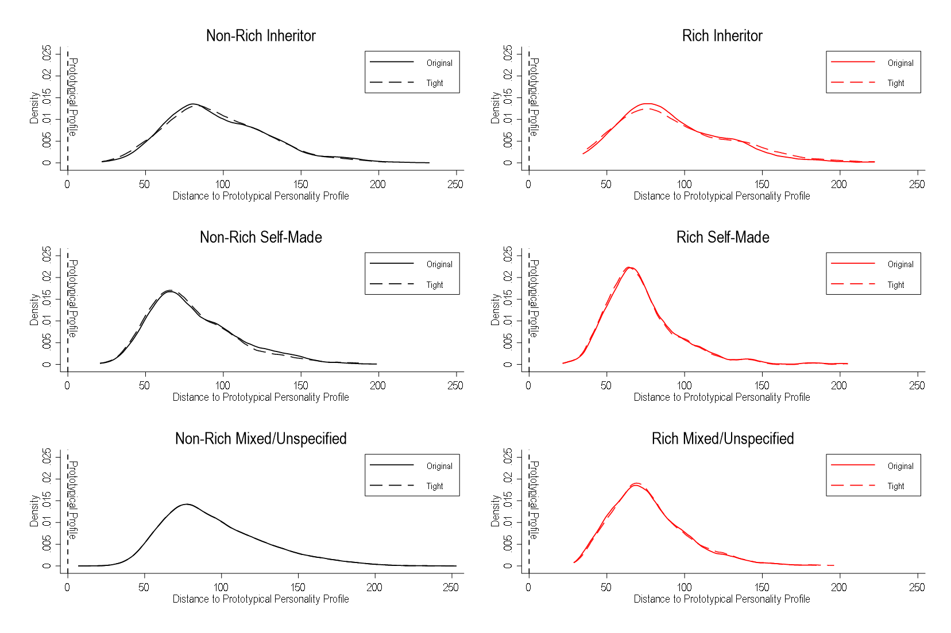
Figure S5. Kernel density of distance from prototypical personality profile for rich and non-rich inheritors, self-mades, and the mixed/unspecified with the original and tight definition.
Note. Original definition of self-mades, inheritors, and mixed/unspecified is as described in the main text.
Tight definition moves the threshold value from 3 to 4. See the supplementary text. Data based on SOEP v36 (doi:10.5684/soep-core.v36eu).
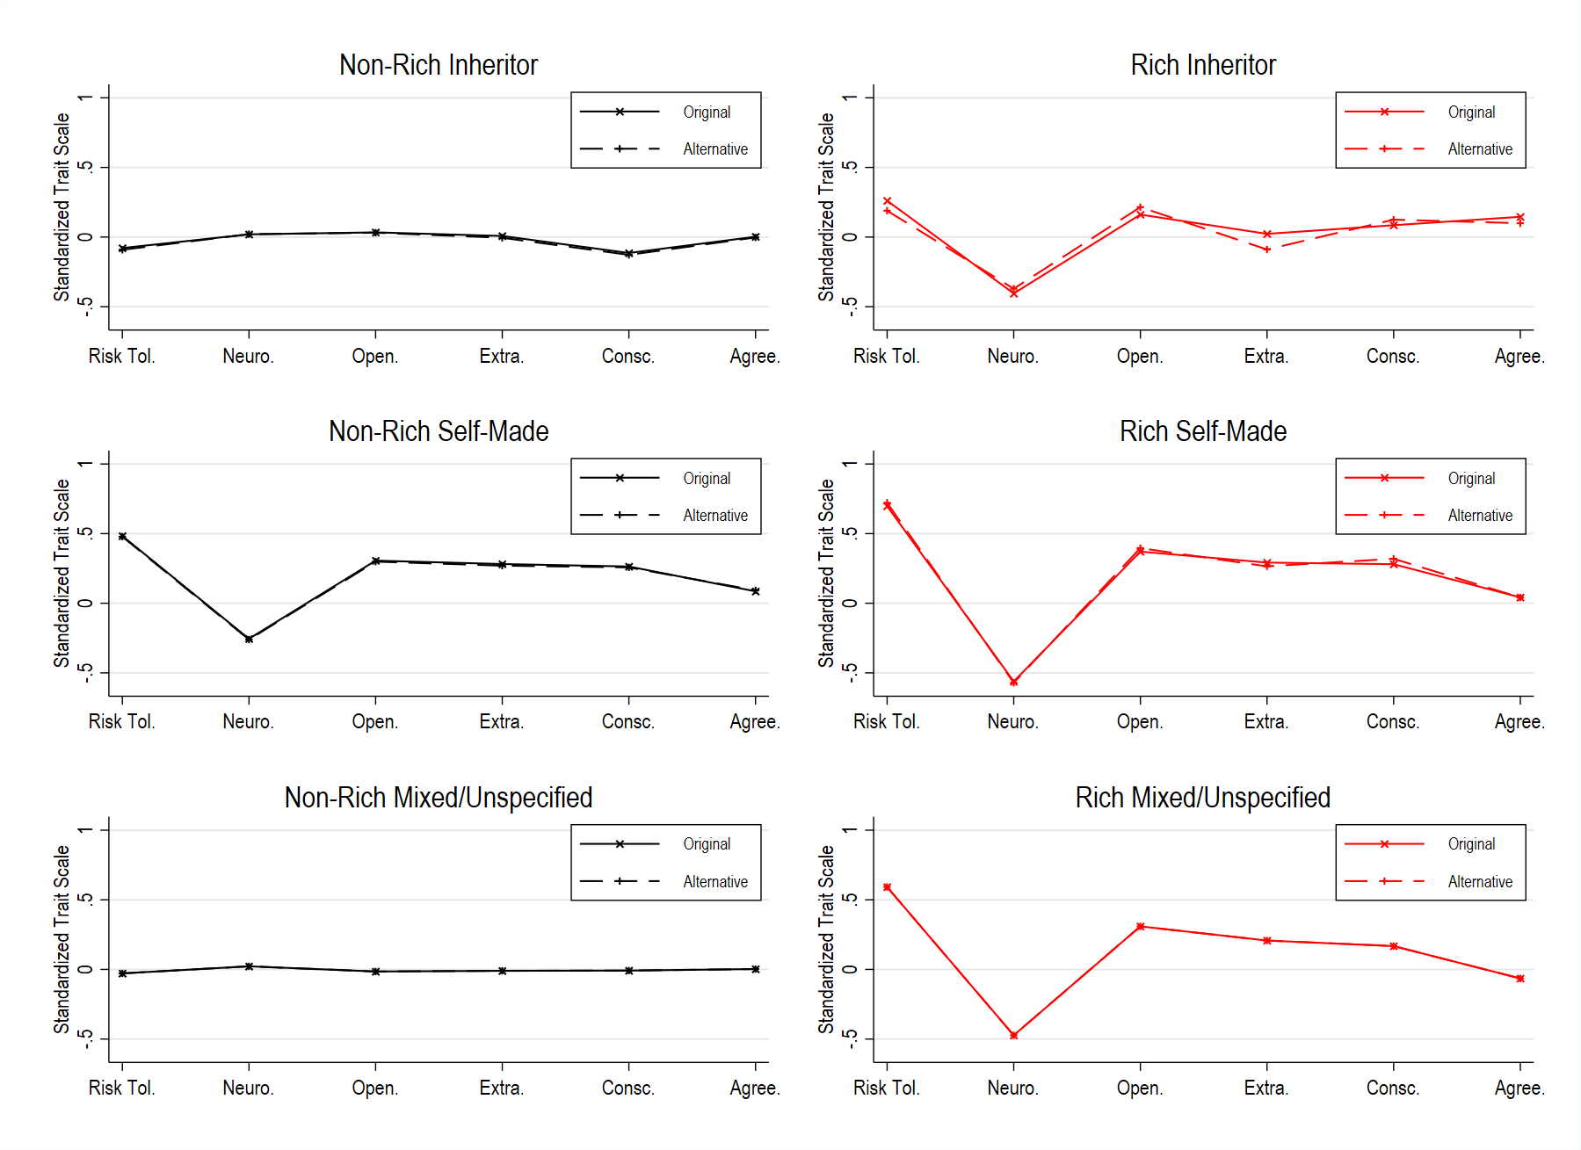
Figure S6 Trait-by-trait personality profile on a standardized trait scale for rich and non-rich self-made, inheritors, and mixed/unspecified group comparing the alternative definition to the original definition.
Note. Original definition of self-mades, inheritors, and mixed/unspecified is as described in the main text.
Alternative definition excludes scale value 3. Data based on SOEP v36 (doi:10.5684/soep-core.v36eu).

