Generosity during COVID-19: investigating socioeconomic shocks and game framing
Lotti, Lorenzo* & Pethiyagoda, Shanali*
*University College of London, UCL Bartlett School of Environment, Energy and Resources. Central House, 14 Upper Woburn Place, London WC1H 0NN, UK.

Corresponding Author: Dr Lorenzo Lotti – l.lotti@ucl.ac.uk

Appendix 1: Robustness checks
Table 3: OLS regressions on amount donated
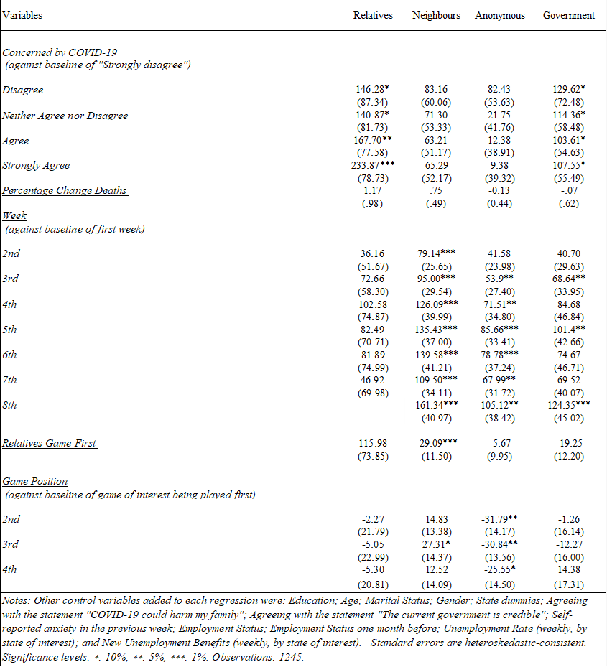

Table 4: 2nd quartile (Q.5) regressions on amount donated
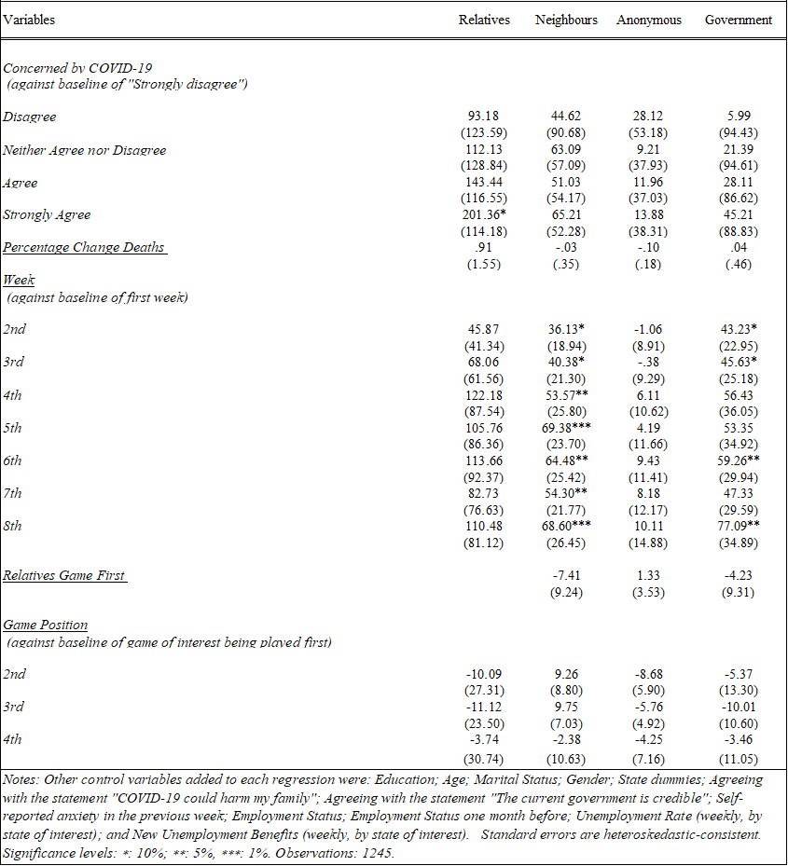

Table 5: 3rd quartile (Q.75) regressions on amount donated
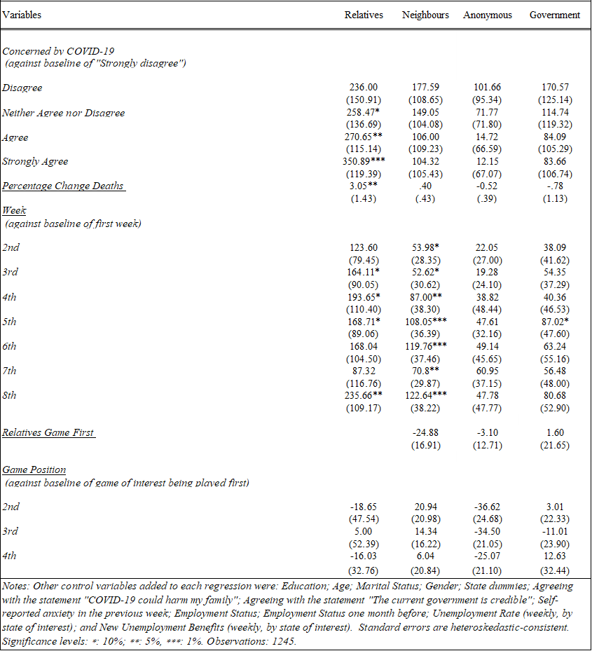

Table 6: Logit regressions on probability of donating
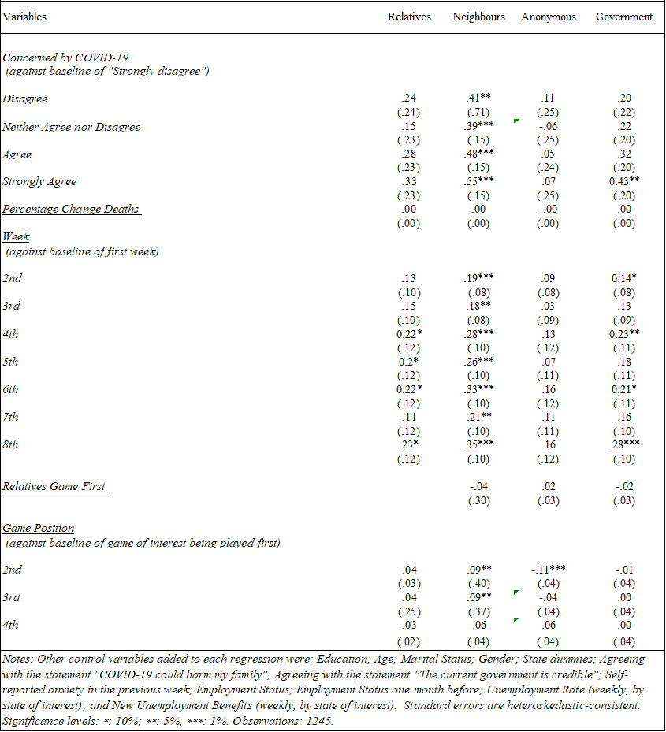

Table 7: Tobit regression with weeks as discrete variable
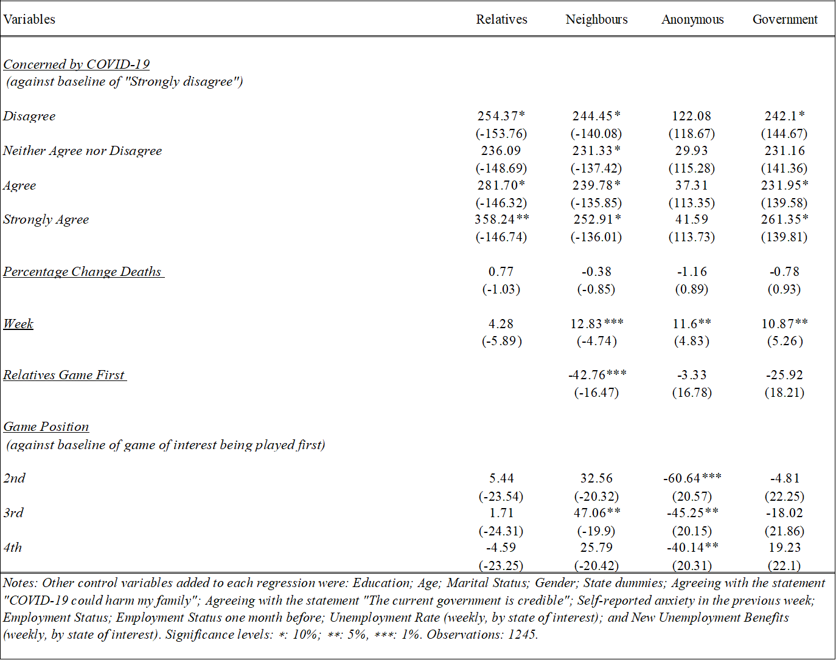

Table 8: Tobit regression about other controls
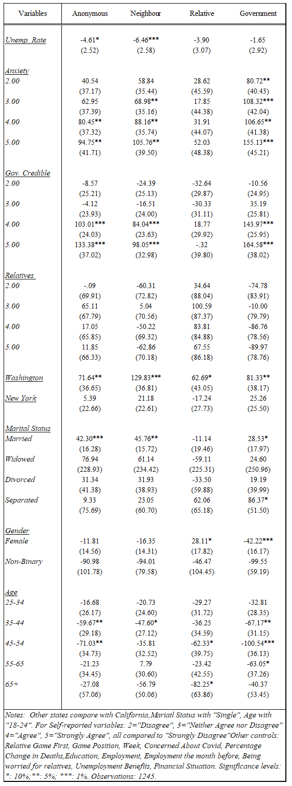

Appendix 2: State-differentiated sociodemographic indicators and COVID-19 trends

Table 9: Sociodemographic indicators by State (2019)
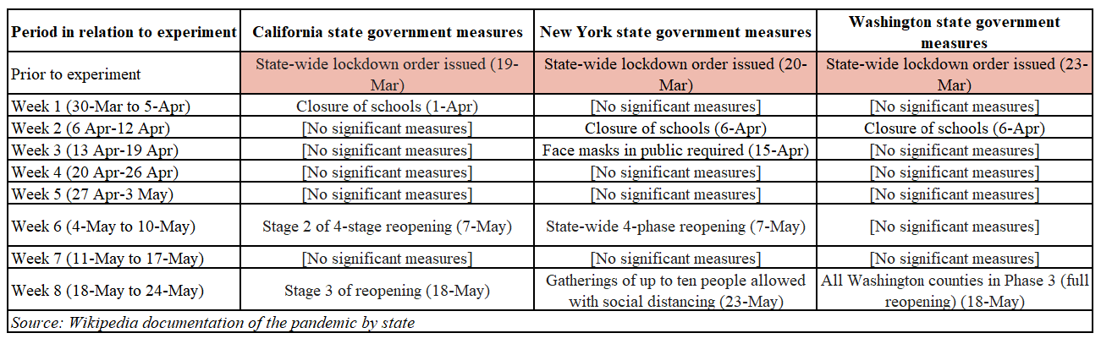
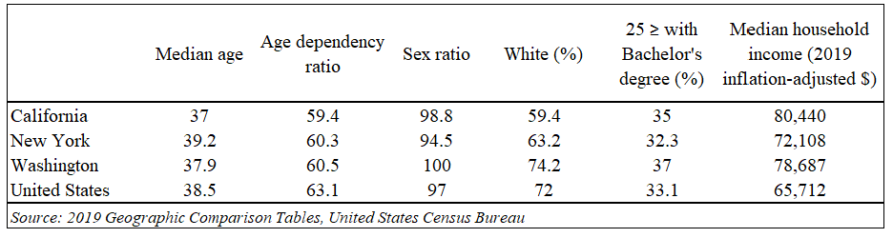
Table 10: COVID-19 policy measures by State

Figure 7: Daily COVID-19 cases per 100,000 population, by state.
Daily COVID-19 cases recorded in California, New York and Washington states, for every 100,000 people in the population.

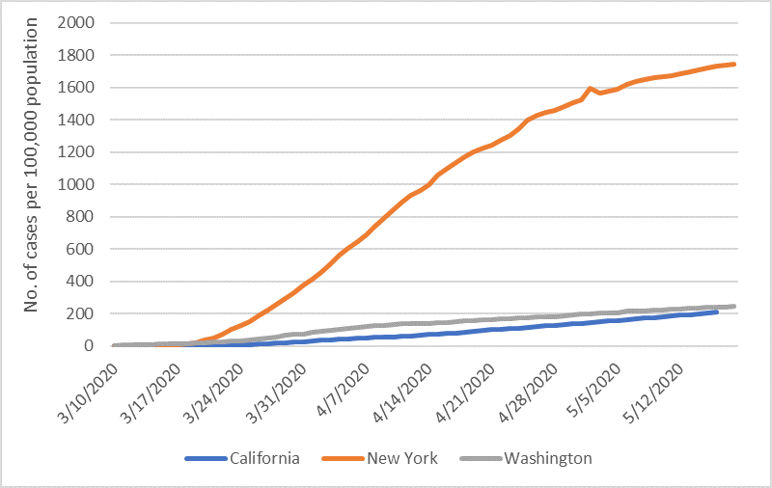

Figure 8: Daily COVID-19 deaths per 100,000 population, by state.
Daily COVID-19 deaths recorded in California, New York and Washington states, for every 100,000 people in the population.

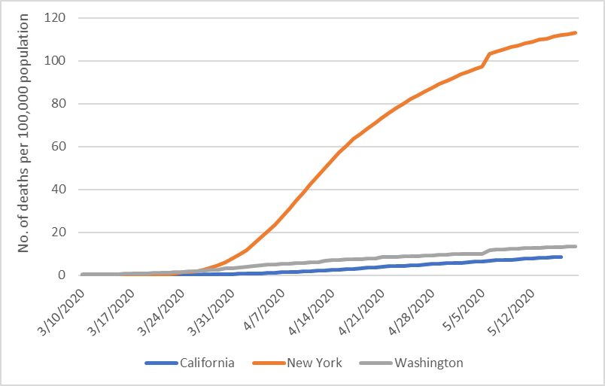
Figure 9: Percentage change in COVID-19 deaths, by state.
Rate of change in COVID-19 deaths recorded in California, New York and Washington states.
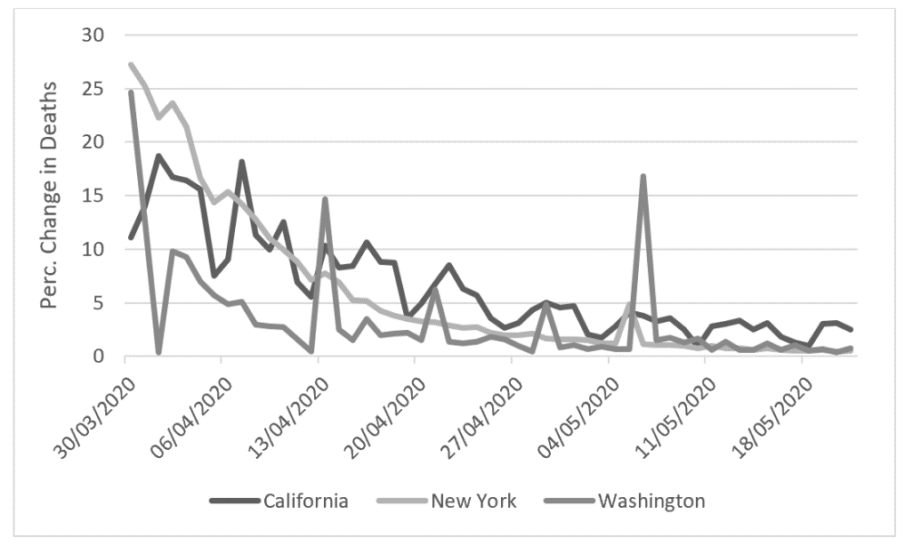

Figure 10: Percentage change in COVID-19 cases, by state.
Rate of change in COVID-19 cases recorded in California, New York and Washington states.
