Supplementary file to: Psychometric Properties of the 21-item Depression, Anxiety, and Stress Scale (DASS-21) among Malaysians during COVID-19: A Methodological Study
- Arulmani Thiyagarajan¹, Tyler G James² and Roy Rillera Marzo^{3, 4, 5}
¹Department of Clinical Epidemiology, Leibniz Institute for Prevention Research and Epidemiology - BIPS, Germany
²Department of Family Medicine, University of Michigan, USA
³Department of Community Medicine, International Medical School, Management and Science University, Malaysia
⁴Department of Community Medicine, Faculty of Medicine, Asia Metropolitan University, Malaysia
⁵Global Public Health Jeffrey Cheah School of Medicine and Health Sciences, Monash University, Malaysia

Supplementary table 1: Overall DASS-21 item properties using AIC, BIC, -2loglikelihood
Supplementary table 2: Anxiety subscale item properties using AIC, BIC, -2loglikelihood
Supplementary table 3: Depression subscale item properties using AIC, BIC, -2loglikelihood
Supplementary table 4: Stress subscale item properties using AIC, BIC, -2loglikelihood
Supplemental Figure 1: DASS-21 depression sub-scale item information function under the Graded Response Model.
Supplemental Figure 2: DASS-21 depression sub-scale Categorical Response under the Graded Response Model.
Supplemental Figure 3: DASS-21 depression sub-scale Operation Characteristic Curves under the Graded Response Model.
Supplemental Figure 4: DASS-21 anxiety sub-scale item information function under the Graded Response Model.
Supplemental Figure 5: DASS-21 anxiety sub-scale Categorical Response under the Graded Response Model.
Supplemental Figure 6: DASS-21 anxiety sub-scale Operation Characteristic Curves under the Graded Response Model.
Supplemental Figure 7: DASS-21 stress sub-scale item information function under the Graded Response Model.
Supplemental Figure 8: DASS-21 stress sub-scale Categorical Response under the Graded Response Model.
Supplemental Figure 9: DASS-21 stress sub-scale Operation Characteristic Curves under the Graded Response Model.

Supplementary table 1: Overall DASS-21 item properties using AIC, BIC, -2loglikelihood
Model type | Akaike Information Criterion (AIC) | Bayesian Information Criterion (BIC) | -2 logLikelihood
Graded Response Model (GRM) | 42015.21 | 42424.99 | -20923.61
Graded Rating Scale Model (GRSM) | 42461.78 | 42676.43 | -21186.89
Generalized Partial Credit Model (GPCM) | 42262.09 | 42671.87 | -21047.04
Partial Credit Model (PCM) | 43170.5 | 43477.83 | -21522.25

Supplementary table 2: Anxiety subscale item properties using AIC, BIC, -2loglikelihood
Model type | Akaike Information Criterion (AIC) | Bayesian Information Criterion (BIC) | -2 logLikelihood
Graded Response Model (GRM) | 15190 | 15326 | -7566.8
Graded Rating Scale Model (GRSM) | 15311 | 15389 | -7639.4
Generalized Partial Credit Model (GPCM) | 15256 | 15392 | -7599.9

Supplementary table 3: Depression subscale item properties using AIC, BIC, -2loglikelihood
Model type | Akaike Information Criterion (AIC) | Bayesian Information Criterion (BIC) | -2 logLikelihood
Graded Response Model (GRM) | 14302 | 14439 | -7123.1
Graded Rating Scale Model (GRSM) | 14320 | 14398 | -7143.9
Generalized Partial Credit Model (GPCM) | 14377 | 14514 | -7160.5

Supplementary table 4: Stress subscale item properties using AIC, BIC, -2loglikelihood
Model type | Akaike Information Criterion (AIC) | Bayesian Information Criterion (BIC) | -2 logLikelihood
Graded Response Model (GRM) | 14879 | 15016 | -7411.7
Graded Rating Scale Model (GRSM) | 14951 | 15029 | -7459.6
Generalized Partial Credit Model (GPCM) | 14981 | 15117 | -7462.5

Supplemental figure 1: DASS-21 depression sub-scale item information function under the graded response model.
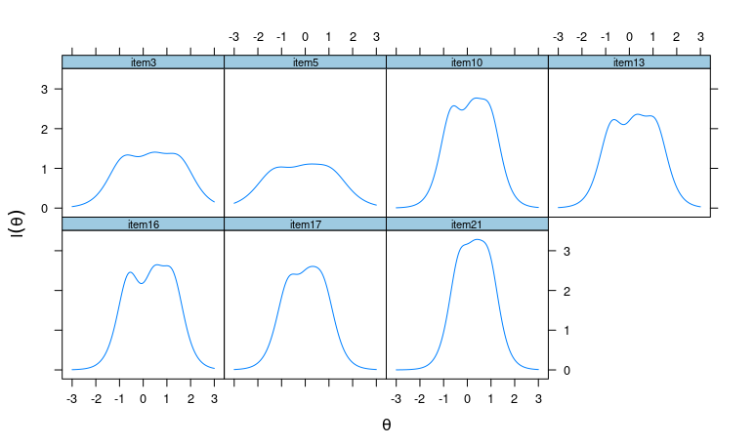

Supplemental figure 2: DASS-21 depression sub-scale categorical response under the graded response model.
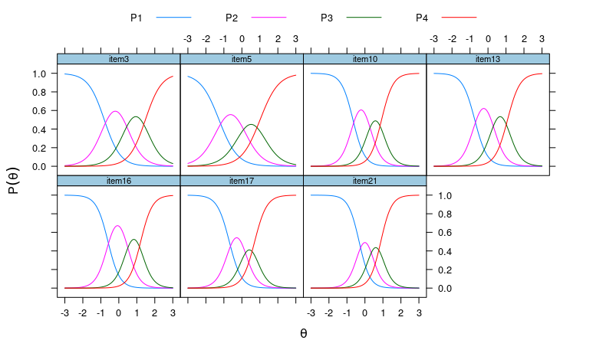

Supplemental figure 3: DASS-21 depression sub-scale operation characteristic curves under the graded response model.
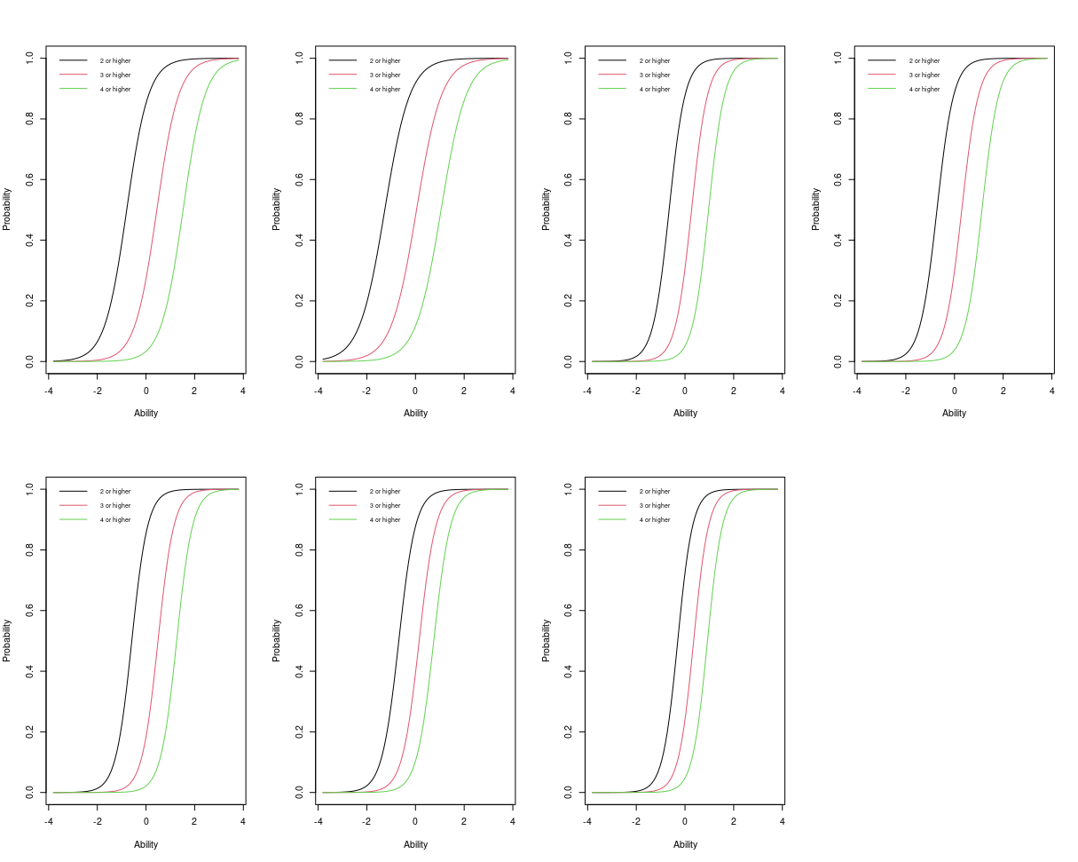

Supplemental figure 4: DASS-21 anxiety sub-scale item information function under the graded response model. 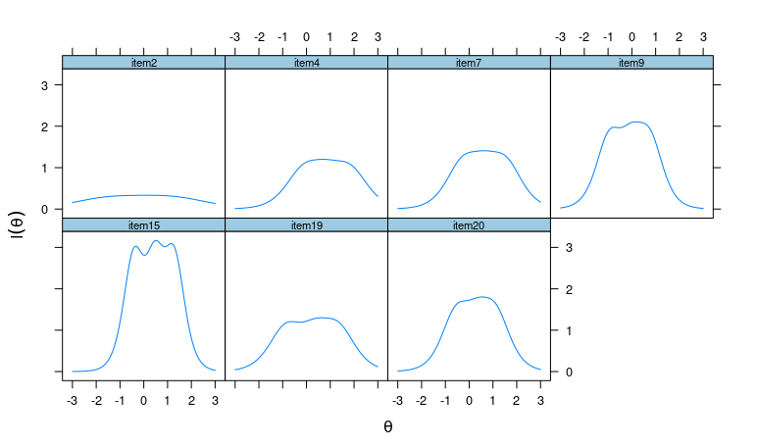

Supplemental figure 5: DASS-21 anxiety sub-scale categorical response under the graded response model.
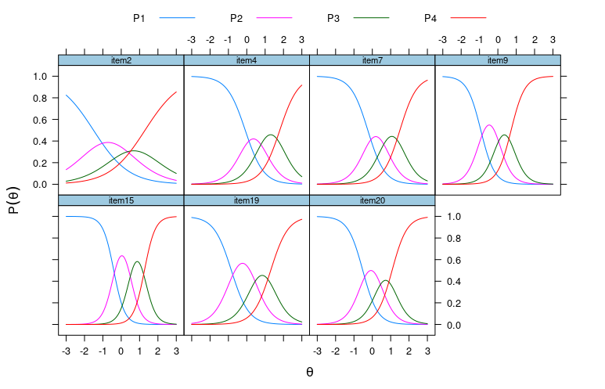

Supplemental figure 6: DASS-21 anxiety sub-scale operation characteristic curves under the graded response model.
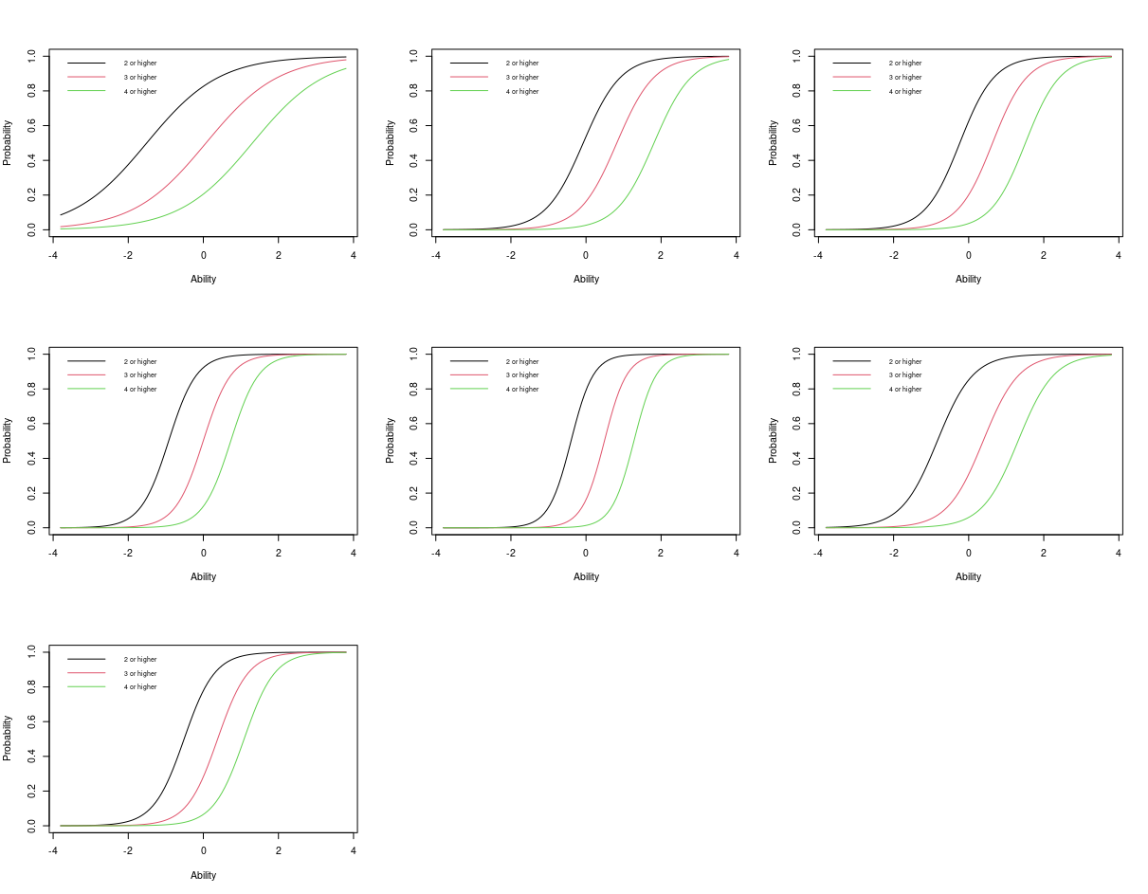

Supplemental figure 7: DASS-21 stress sub-scale item information function under the graded response model.
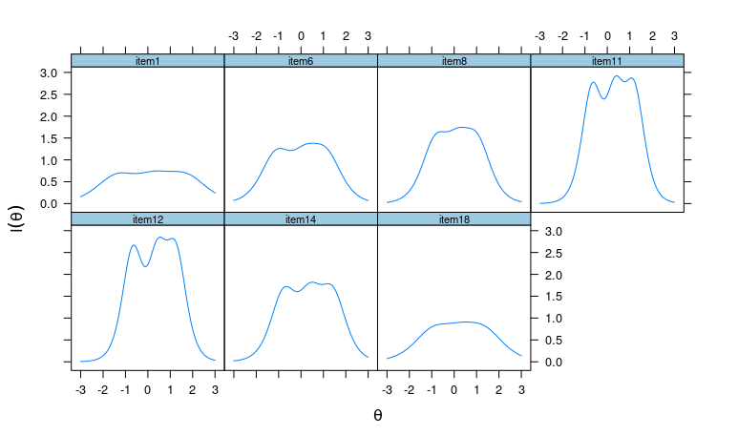

Supplemental figure 8: DASS-21 stress sub-scale categorical response under the graded response model.
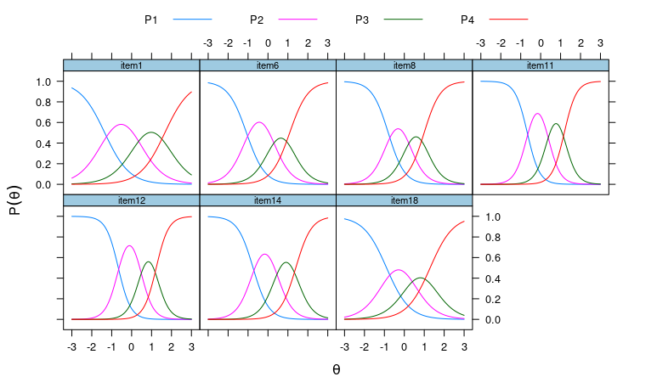

Supplemental figure 9: DASS-21 stress sub-scale operation characteristic curves under the graded response model.
