Supplemental Files

Pre-graduate Teaching of Human Parasitology for Medical Laboratory Technologist Programs in Japan

Sho Sekine
Morinomiya University of Medical Science
1-26-16 Nankokita, Suminoe-ku, Osaka-shi, Osaka 559-8611 JAPAN
Tel: +81-6-4703-5890
Fax: +81-6-4703-5891
sho_sekine@morinomiya-u.ac.jp

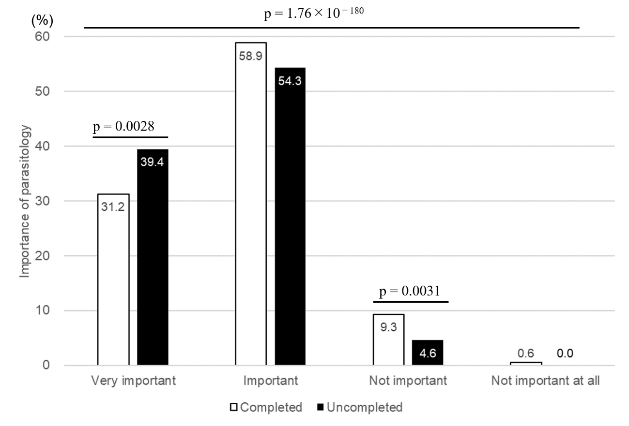

Supplement Fig. 1 Comparison of the perception of importance before and after the parasitological course.
Students who had completed lectures (n = 525) and those who had not (n = 518) were asked how importantly they perceived parasitology. White bars indicate results for students who have completed the course; black bars indicate results for students who have not. The results of the statistical treatment using the χ-square test showed that the responses of the two groups of students differ significantly (completed vs. uncomplete) (χ2 (1) = 826.031, p = 1.76$×$10^{－180}). Subsequently, residual analysis was performed because the χ-square test was unable to determine which component of the cross-table contributed to the significant difference. The results showed that the number of students who regarded parasitology as important had declined significantly (adjusted residual value: 2.990, p = 0.0028). In addition, the number of students who believed parasitology was unimportant increased significantly (adjusted residual value: 2.958, p = 0.0031).

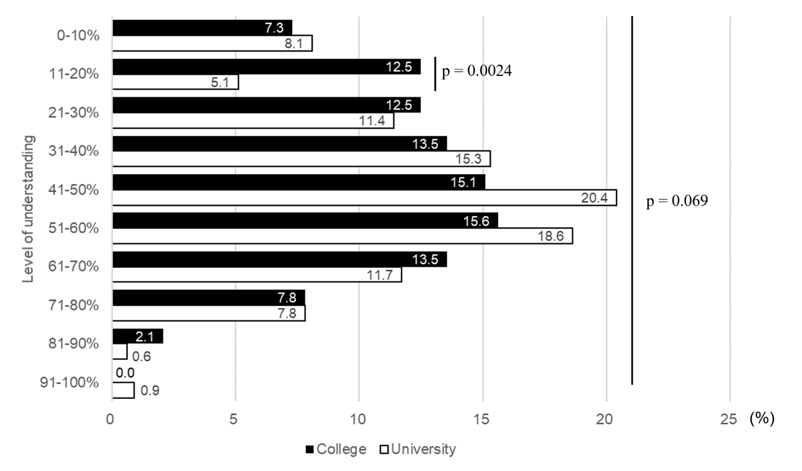

Supplement Fig. 2 Comparison of the understanding of parasitology between university and college students.
University students (n = 333) and college students (n = 192) who had already completed parasitological lectures were asked about their level of understanding thereof. Black bars indicate results for college students; white bars indicate results for university students. Comparison of the understanding of parasitology between university (n = 333) and college students (n = 192) yielded no statistically significant difference overall (Fig. 1) (χ2 (9) = 15.902, p = 0.069). However, when each column was statistically processed for residual analysis, the percentage of students who reported 11%–20% comprehension was 12.5% for college students and 5.1% for university students, indicating a significant difference between observed and expected frequencies (adjusted residual value: 3.041, p = 0.0024). No significant differences were found for the other columns.

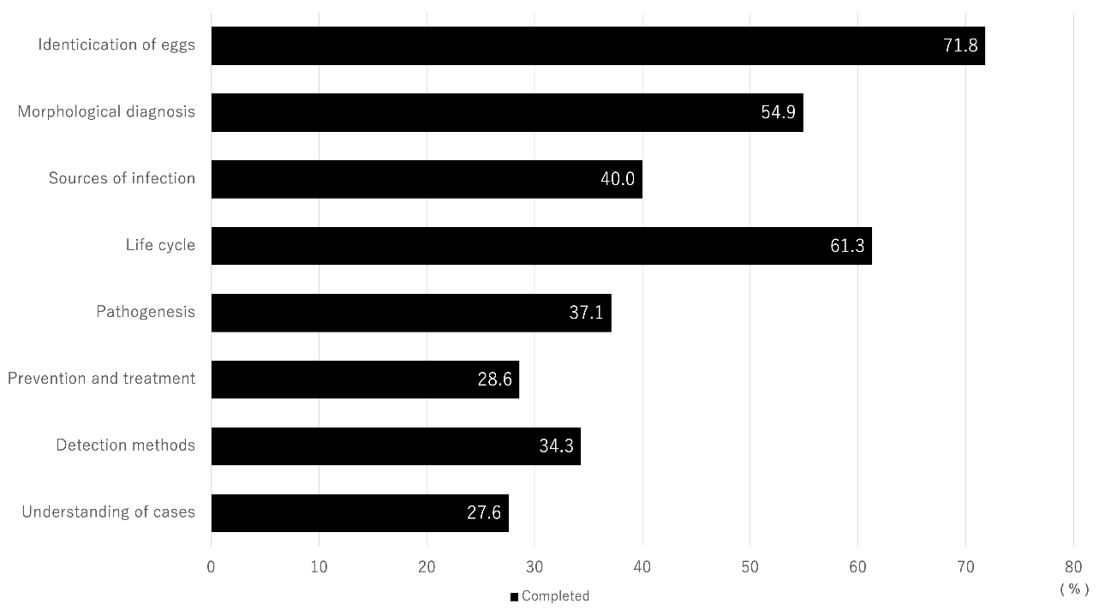

Supplement Fig. 3 Areas of parasitology that students found difficult after the course.
Students who had complete parasitological course (n = 525) ware asked which areas they found difficult. This questionnaire allowed multiple responses, so the sum of each column does not add up to 100%.

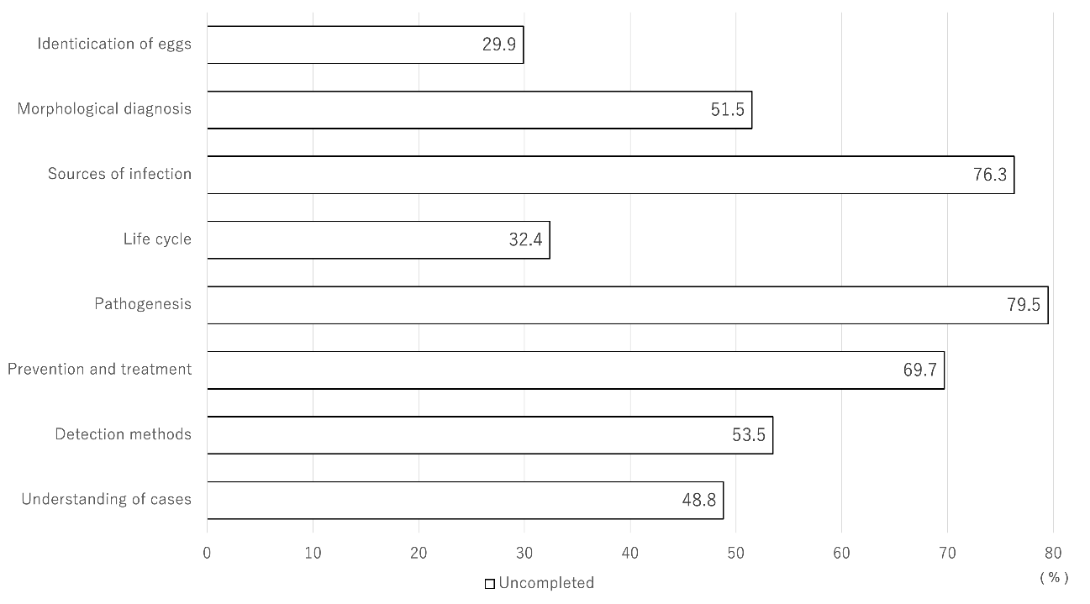

Supplement Fig. 4 Areas of parasitology that students felt they wanted to learn about prior to taking the course.
Students who had not yet completed the parasitological course (n = 518) were asked which areas they were interested in. This questionnaire allowed multiple responses, so the sum of each column does not add up to 100%.

Supplement table
The following is the dataset used for the analysis of this study. In cases where answers contained information that could be used to identify individuals or schools, the relevant portions have been removed.
https://doi.org/10.7910/DVN/KOEBLH

